Exploring Azure Compute

**Azure Virutal Machines :**

* Software emulations of physical computers
* Can remote into server to manage
* Install middleware, runtimes, applications
* You are responsible for patching security updates
  + Azure offer some services to make it easier
* Benefits :
  + Offers « lift and shift » approach to cloud migration
  + Ability to install COTS products
  + Density of application

**Containers in Azure :**

* Packages application and dependencies
* Solves problems with deploying applications
* Need a container runtime on server
* Can host multiple containers on a single VM
* Several services in Azure to host containers.
* Virtual Machines virtualize the hardware, Containers virtualize the OS.
* The host could be a physical or a virtual server. And on top of OS there is a runtime, like hypervisors for VM, but now for containers.

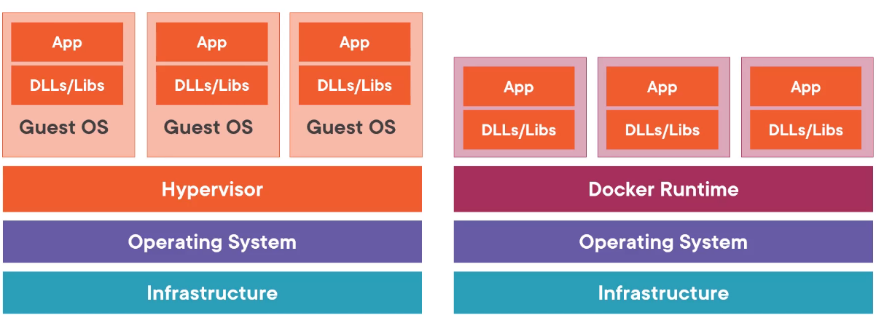

* Azure container registry, like Docker Hub.
* Docker is a standard for container format, Runtime for Docker containers.
* Azur PAAS Container hosting (ACI) : is a service that provides to host containers without having to patch or maintain the environment. It host a single container per image.

**Azure App Service :**

* It is a PAAS offering for hosting
  + Web apps
  + Mobile app backends
  + API apps
  + Web jobs
* Framework Runtime pre-installed on servers.
* You can choose wether the underlying VMs to be linux or windows based.
* Benefits :
  + Azure manages underlying virtual machines
  + Built-in authentication options to speed dev