**NGO Project Funding and Expenditure Tracking Project**

This repository contains the foundational components for a database-driven system designed to track funding sources, allocations, and expenditures across NGO projects. It aims to promote transparency, accountability, and efficient financial management within nonprofit operations.

Contents:

SQL scripts for database and table creation

Screenshots of the system interface and data workflows

README documentation for setup and usage

Key Features:

Tracks donor contributions and project-specific funding

Monitors expenditure categories and transaction history

Supports reporting and audit readiness

CONCEPTUAL ERD

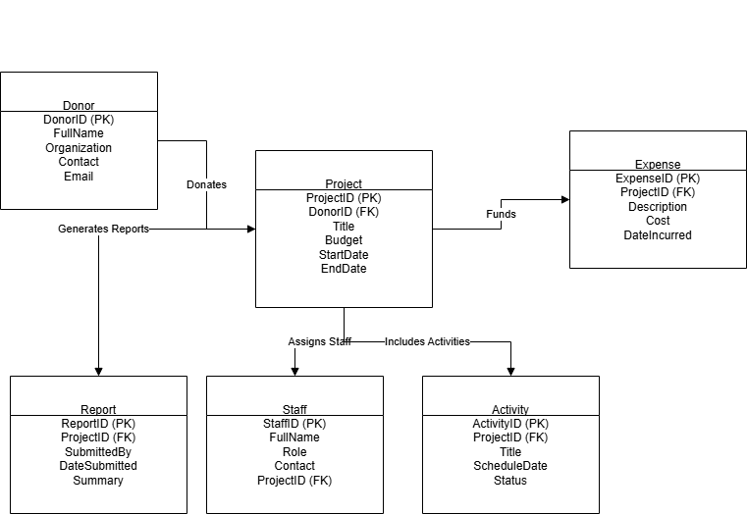

LOGICAL ERD

