CREATE USER BranchDB_A IDENTIFIED BY "12345";
CREATE USER BranchDB_B IDENTIFIED BY "12345";

GRANT CONNECT, RESOURCE TO BranchDB_A;
GRANT CONNECT, RESOURCE TO BranchDB_B;

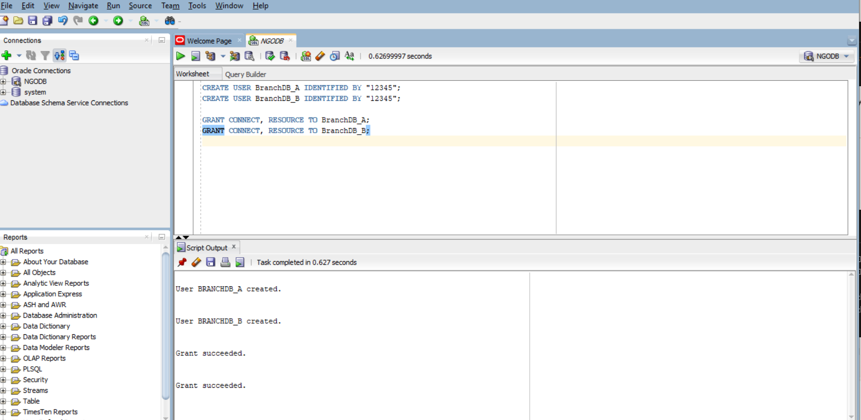

CREATE TABLE Donor (
DonorID INT PRIMARY KEY,
FullName VARCHAR2(100),
Organization VARCHAR2(100),
Contact VARCHAR2(50),
Email VARCHAR2(100)
);

CREATE TABLE Project (
ProjectID INT PRIMARY KEY,
DonorID INT REFERENCES Donor(DonorID),
Title VARCHAR2(150),
Budget NUMBER(12,2),
StartDate DATE,
EndDate DATE
);
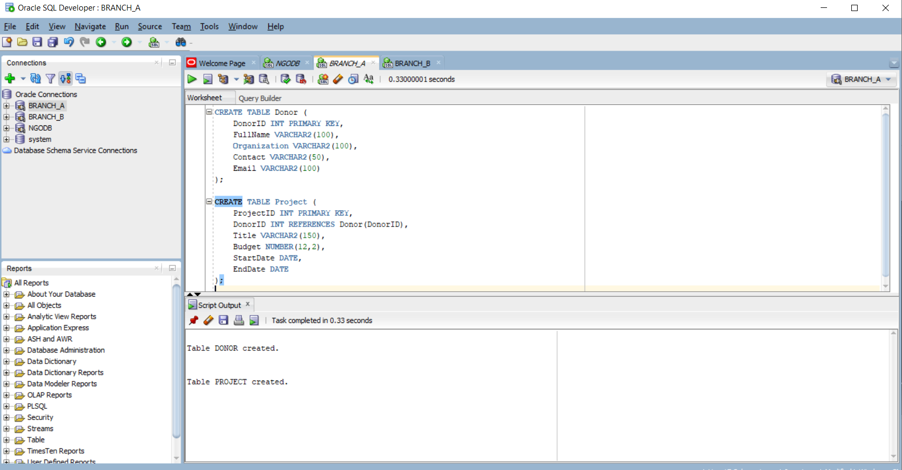

CREATE TABLE Expense (
ExpenseID INT PRIMARY KEY,
ProjectID INT,
Description CLOB,
Cost NUMBER(10,2),
DateIncurred DATE
);

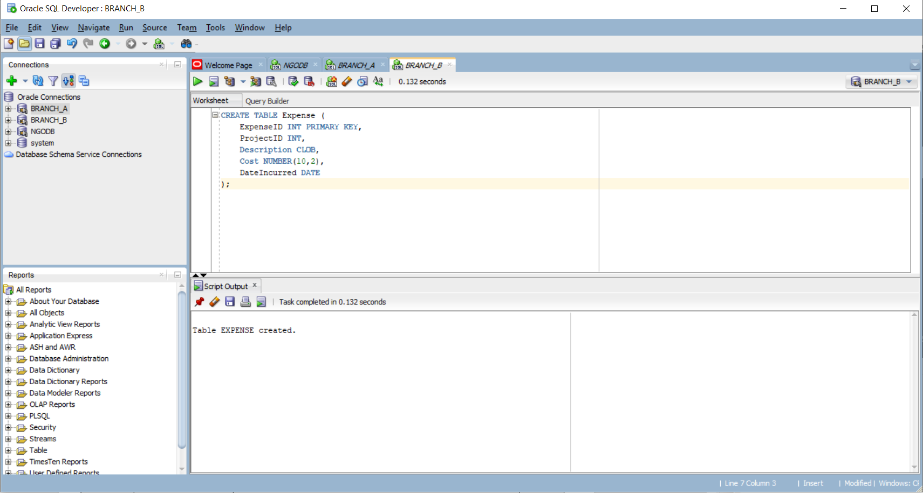

- Vertical fragmentation:
-- Fragment 1: Identity
CREATE TABLE Staff_Identity (
StaffID NUMBER PRIMARY KEY,
FullName VARCHAR2(100),
Role VARCHAR2(50)
);

-- Fragment 2: Contact and Assignment
CREATE TABLE Staff_Contact (
StaffID NUMBER PRIMARY KEY,
Contact VARCHAR2(100),
ProjectID NUMBER
);

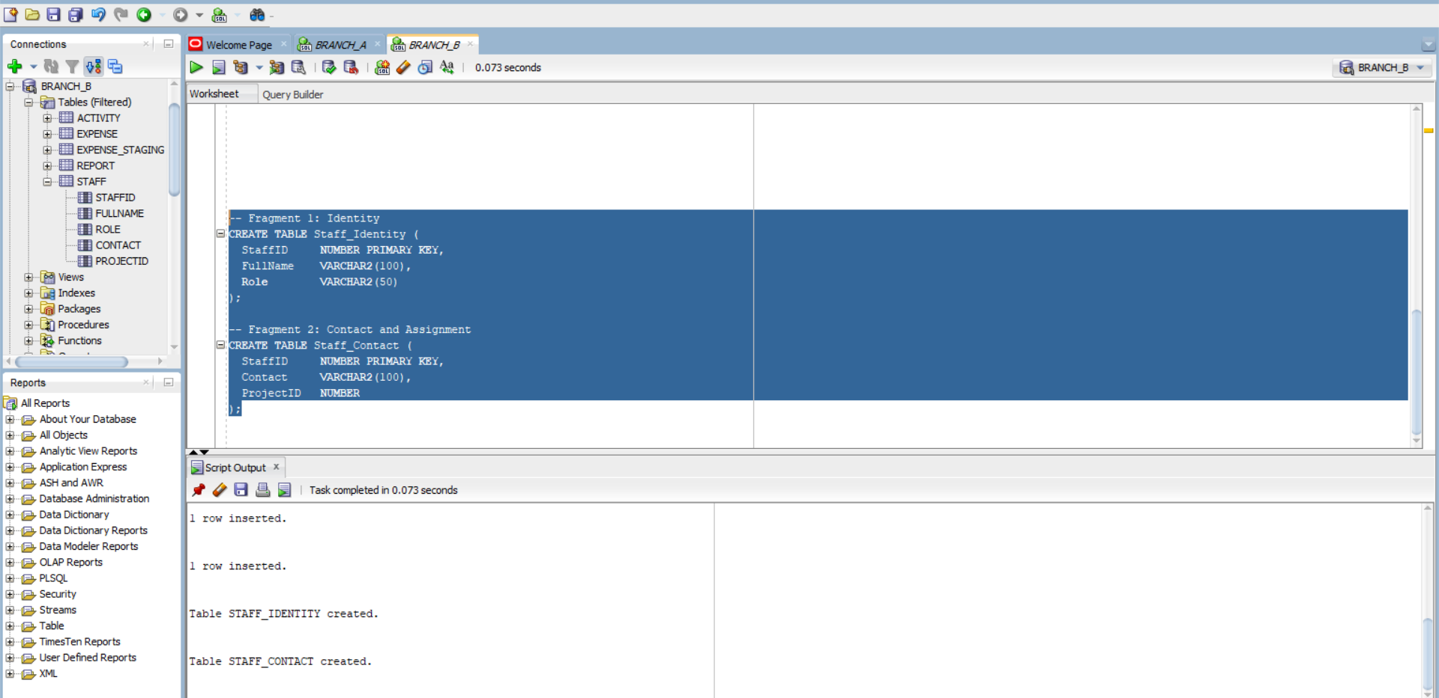
Check Vertical fragmentation:
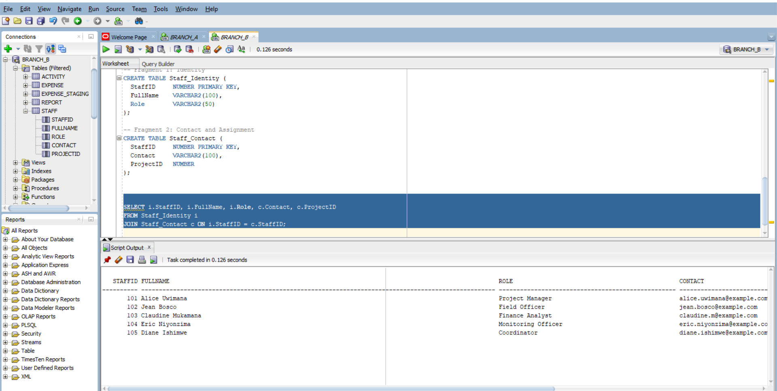

- Horizontal fragmentation: Split Staff records by region:
Assume I add Region into staff table as attribute
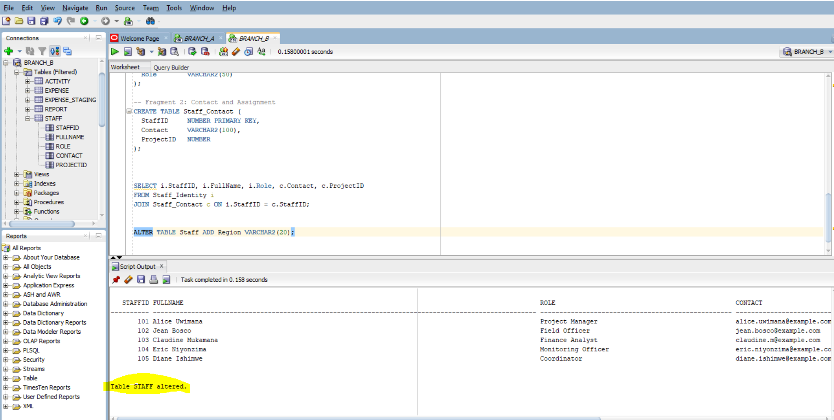

Then I insert data:
-- West region staff (stored in Branch B)
INSERT INTO Staff (StaffID, FullName, Role, Contact, ProjectID, Region)
VALUES (1011, 'Claudine Mukamana', 'Finance Analyst', 'claudine.m@example.com', 102, 'West');

INSERT INTO Staff (StaffID, FullName, Role, Contact, ProjectID, Region)
VALUES (112, 'Eric Niyonzima', 'Monitoring Officer', 'eric.niyonzima@example.com', 102, 'West');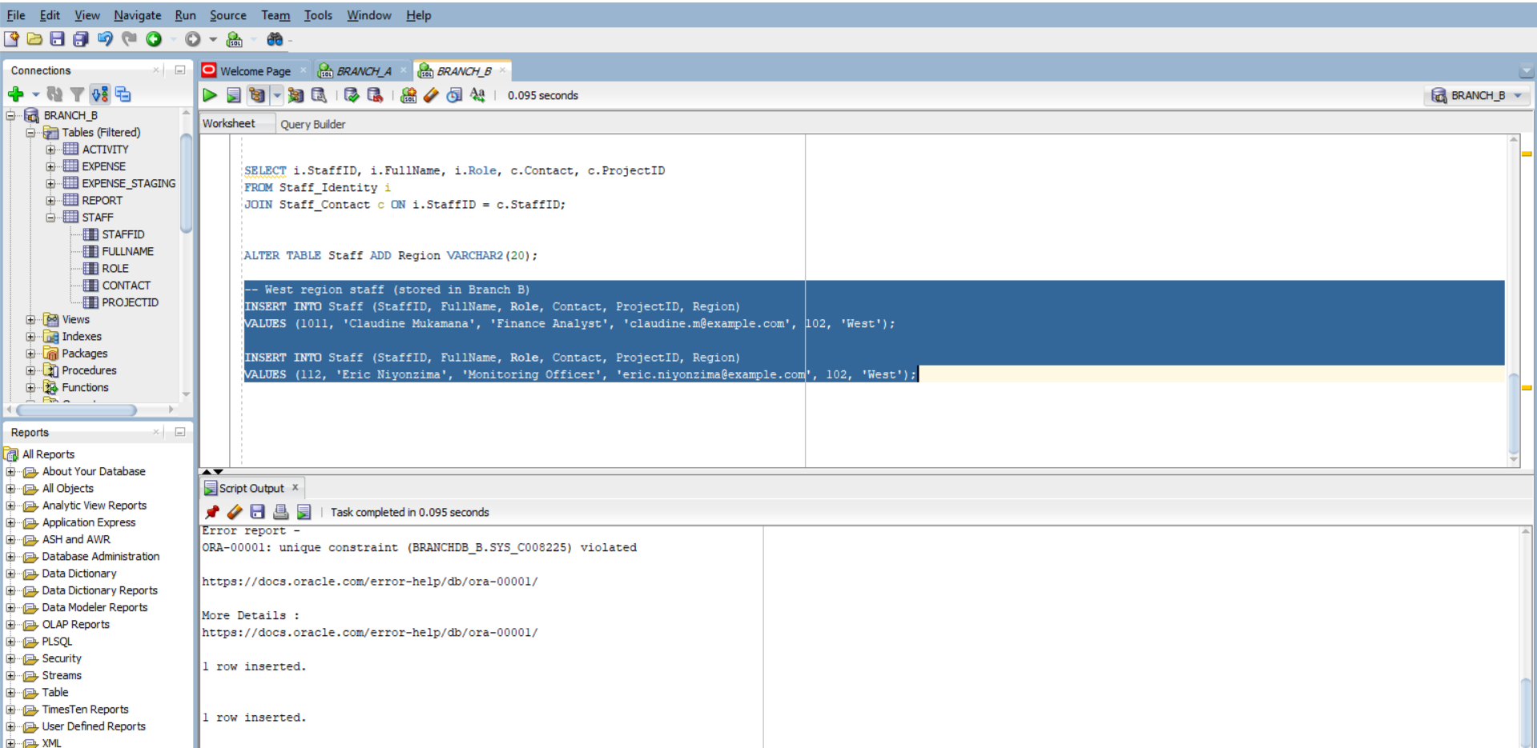

Then Create a Materialized View on Branch A:
-- On Branch A
CREATE MATERIALIZED VIEW Staff_East AS
SELECT StaffID, FullName, Role, Contact, ProjectID, Region
FROM Staff@branch_b_link
WHERE Region = 'East';

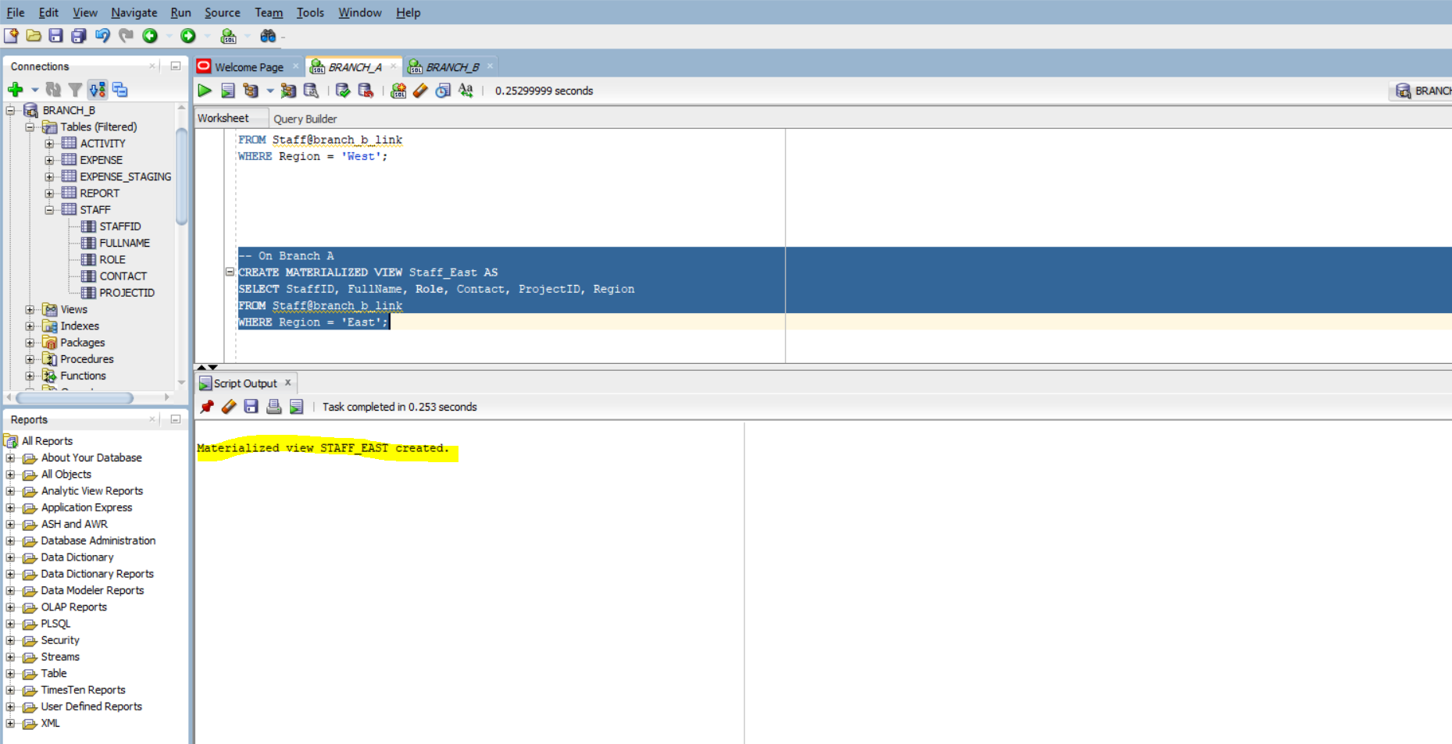

Insert rows in East Region:
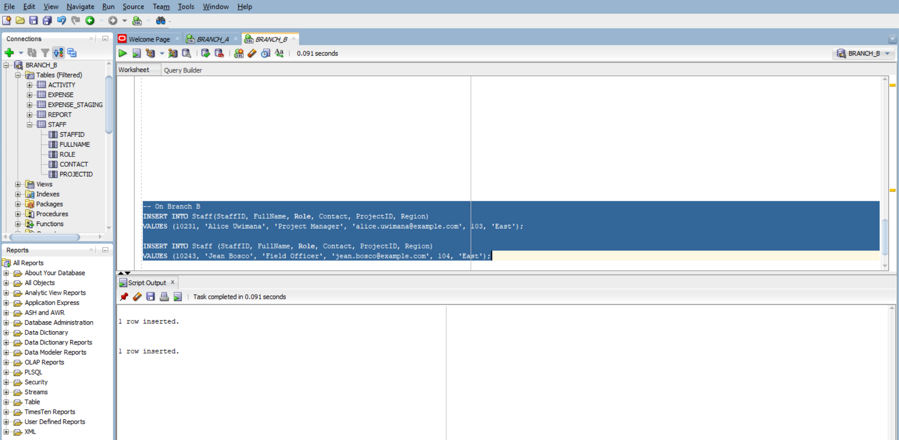

Reconstruct Full Staff Table
To query all staff across both fragments:

SELECT * FROM Staff_East
UNION ALL
SELECT * FROM Staff@branch_b_link WHERE Region = 'West';

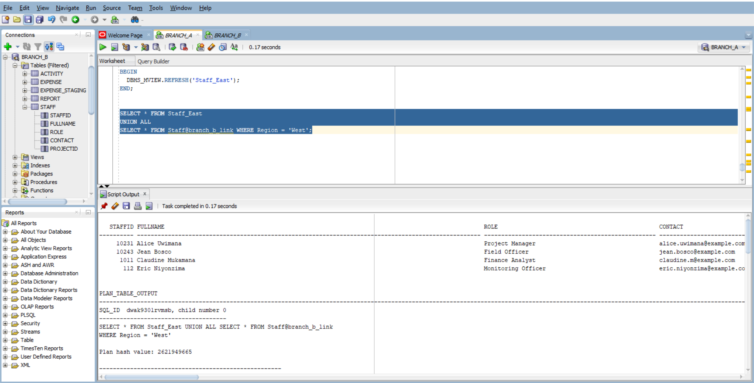

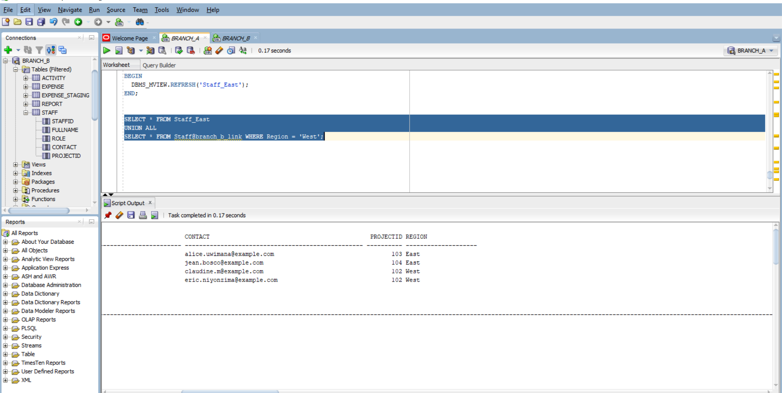

GRANT SELECT ON BranchDB_A.Project TO BranchDB_B;
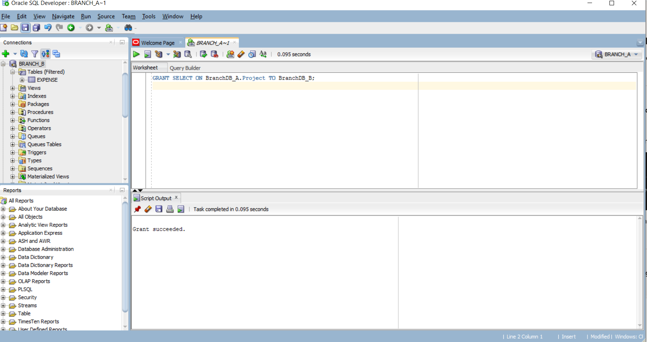
GRANT CREATE SYNONYM TO BranchDB_B;
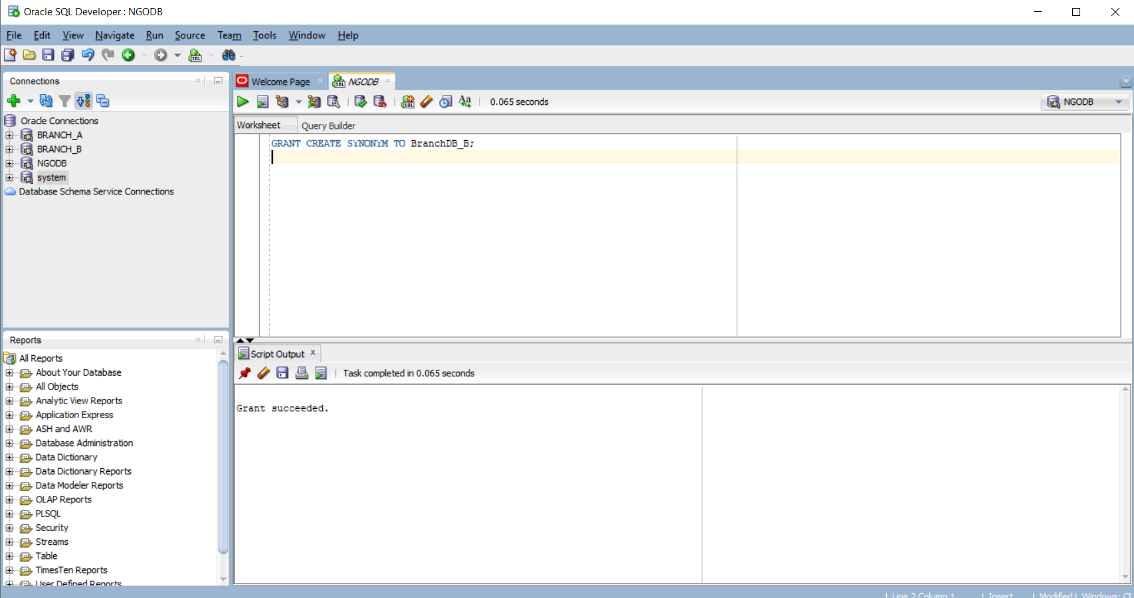

GRANT SELECT ON BranchDB_A.Project TO BranchDB_B;

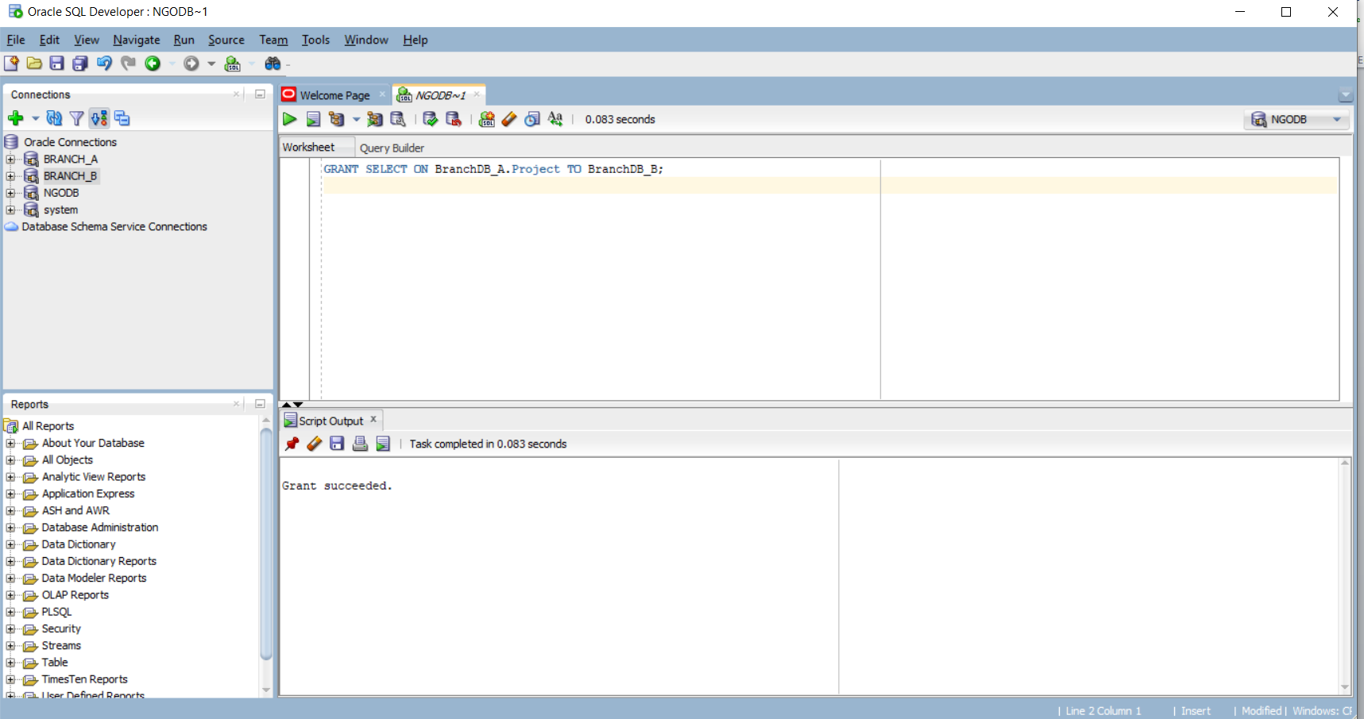

GRANT CREATE SYNONYM TO BranchDB_B;
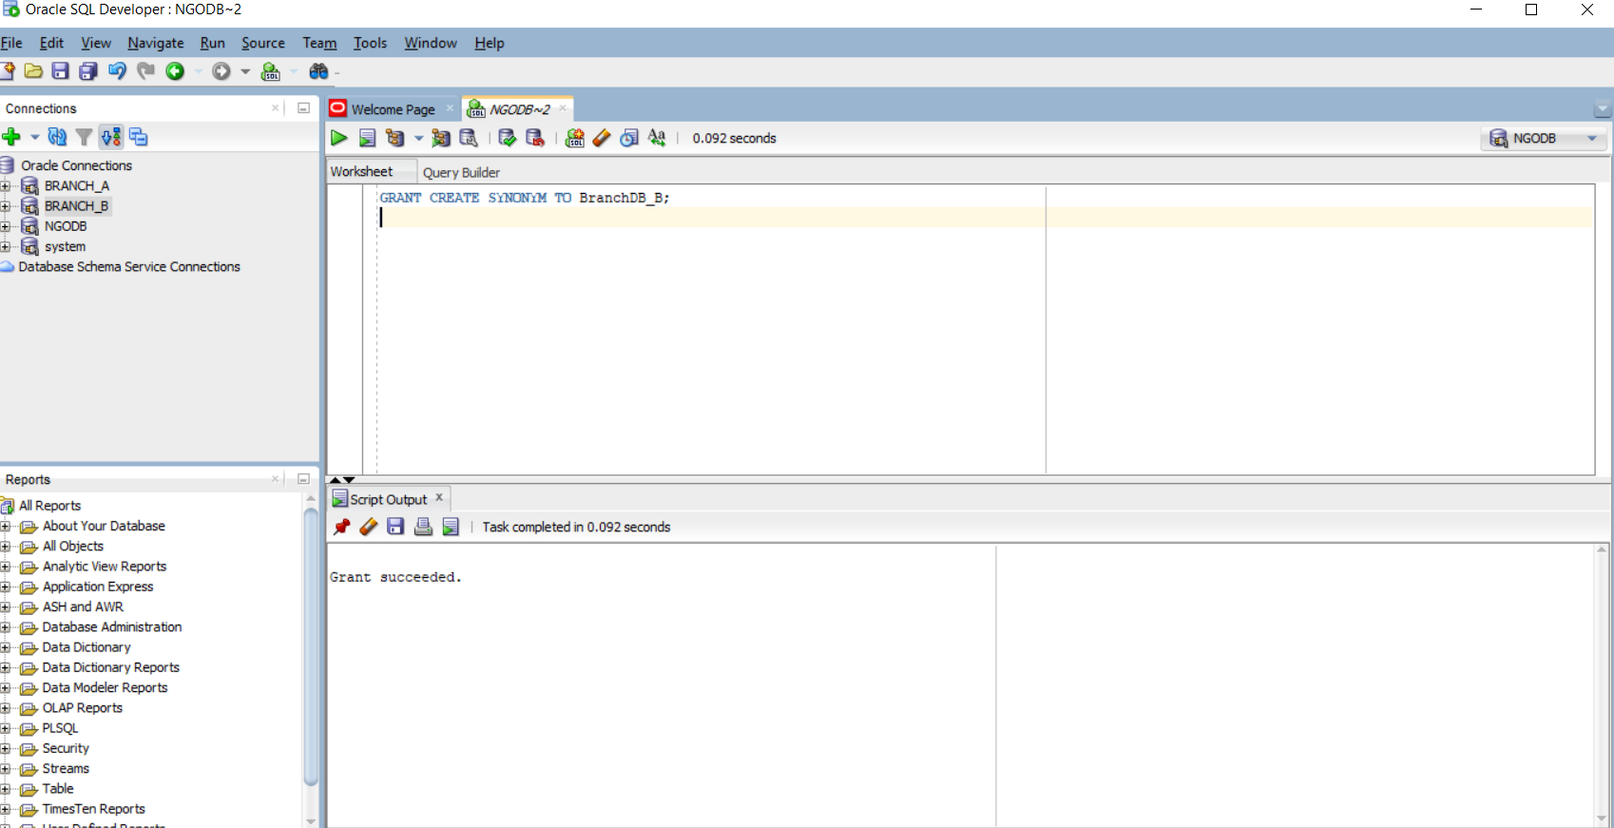

GRANT CREATE TABLE TO BranchDB_B;
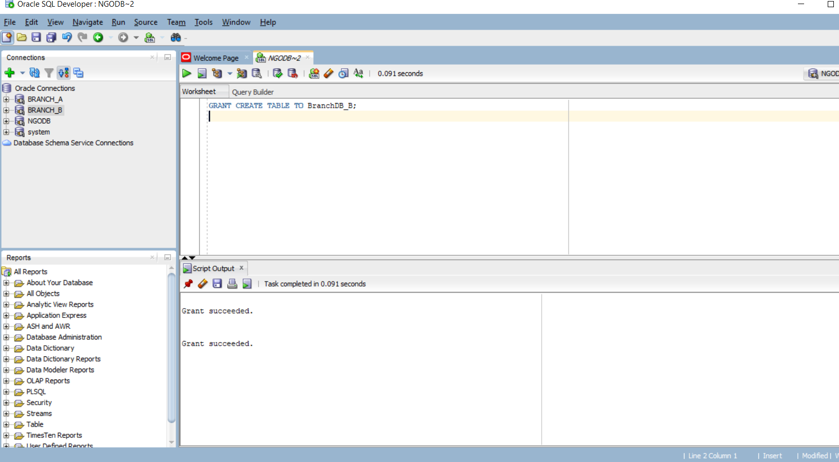

-- Switch to the correct container
ALTER SESSION SET CONTAINER = XEPDB1;

-- Grant basic privileges to both users
GRANT CONNECT, RESOURCE TO BranchDB_A;
GRANT CONNECT, RESOURCE TO BranchDB_B;

-- Allow both users to create tables and synonyms
GRANT CREATE TABLE TO BranchDB_A;
GRANT CREATE TABLE TO BranchDB_B;

GRANT CREATE SYNONYM TO BranchDB_A;
GRANT CREATE SYNONYM TO BranchDB_B;

-- Grant SELECT access from BranchDB_A to BranchDB_B
GRANT SELECT ON BranchDB_A.Project TO BranchDB_B;

-- (Optional) Grant SELECT on Donor if needed for reporting or joins
GRANT SELECT ON BranchDB_A.Donor TO BranchDB_B;

CREATE TABLE Staff (
StaffID INT PRIMARY KEY,
FullName VARCHAR2(100) NOT NULL,
Role VARCHAR2(50),
Contact VARCHAR2(50),
ProjectID INT,
FOREIGN KEY (ProjectID) REFERENCES BranchDB_A.Project(ProjectID)
);

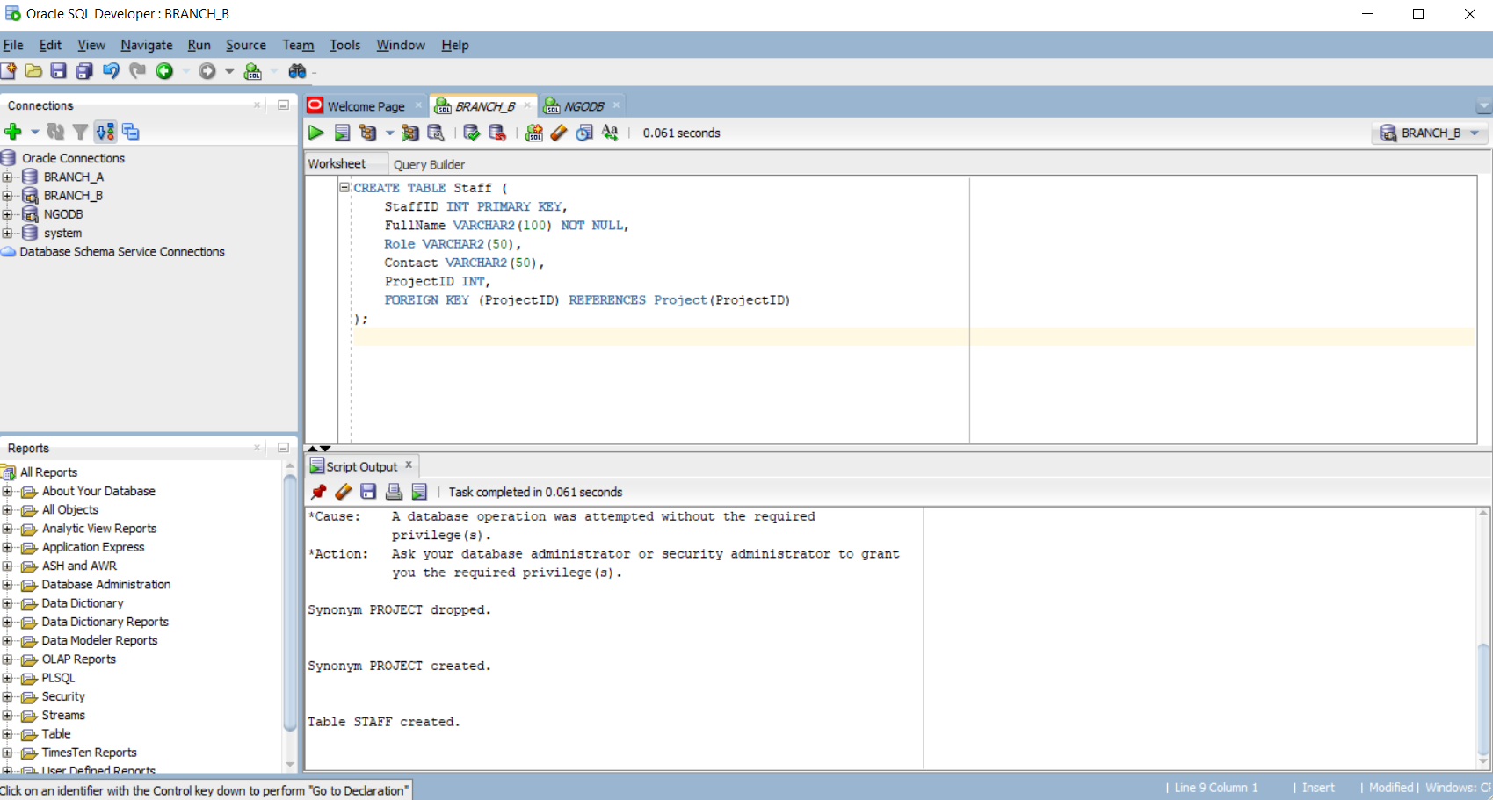

CREATE TABLE Activity (
ActivityID INT PRIMARY KEY,
Title VARCHAR2(150),
ScheduleDate DATE,
Status VARCHAR2(50),
ProjectID INT,
FOREIGN KEY (ProjectID) REFERENCES Project(ProjectID)
);

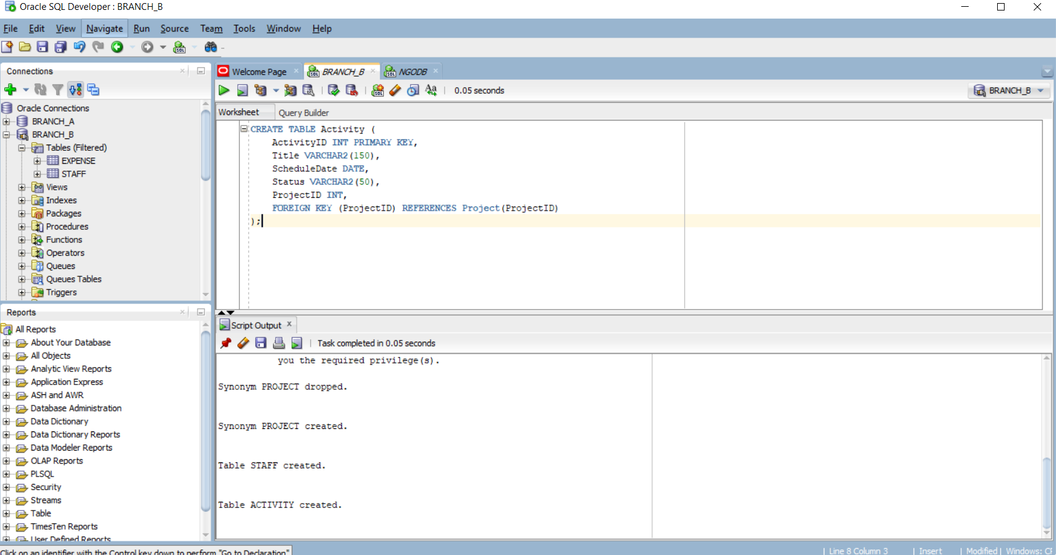

CREATE TABLE Report (
ReportID INT PRIMARY KEY,
SubmittedBy VARCHAR2(100),
DateSubmitted DATE,
Summary CLOB,
ProjectID INT,
FOREIGN KEY (ProjectID) REFERENCES Project(ProjectID)
);
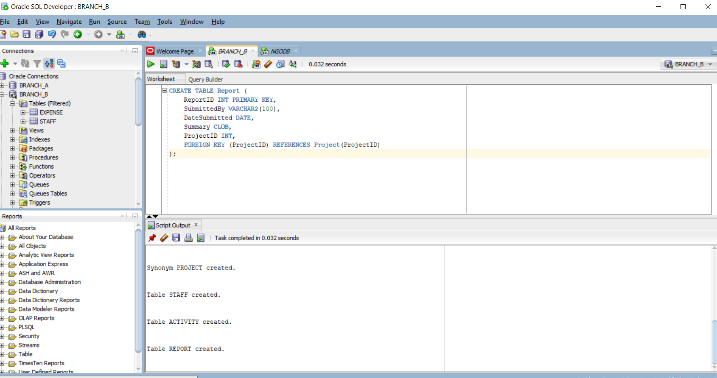
Permission to insert data into tables
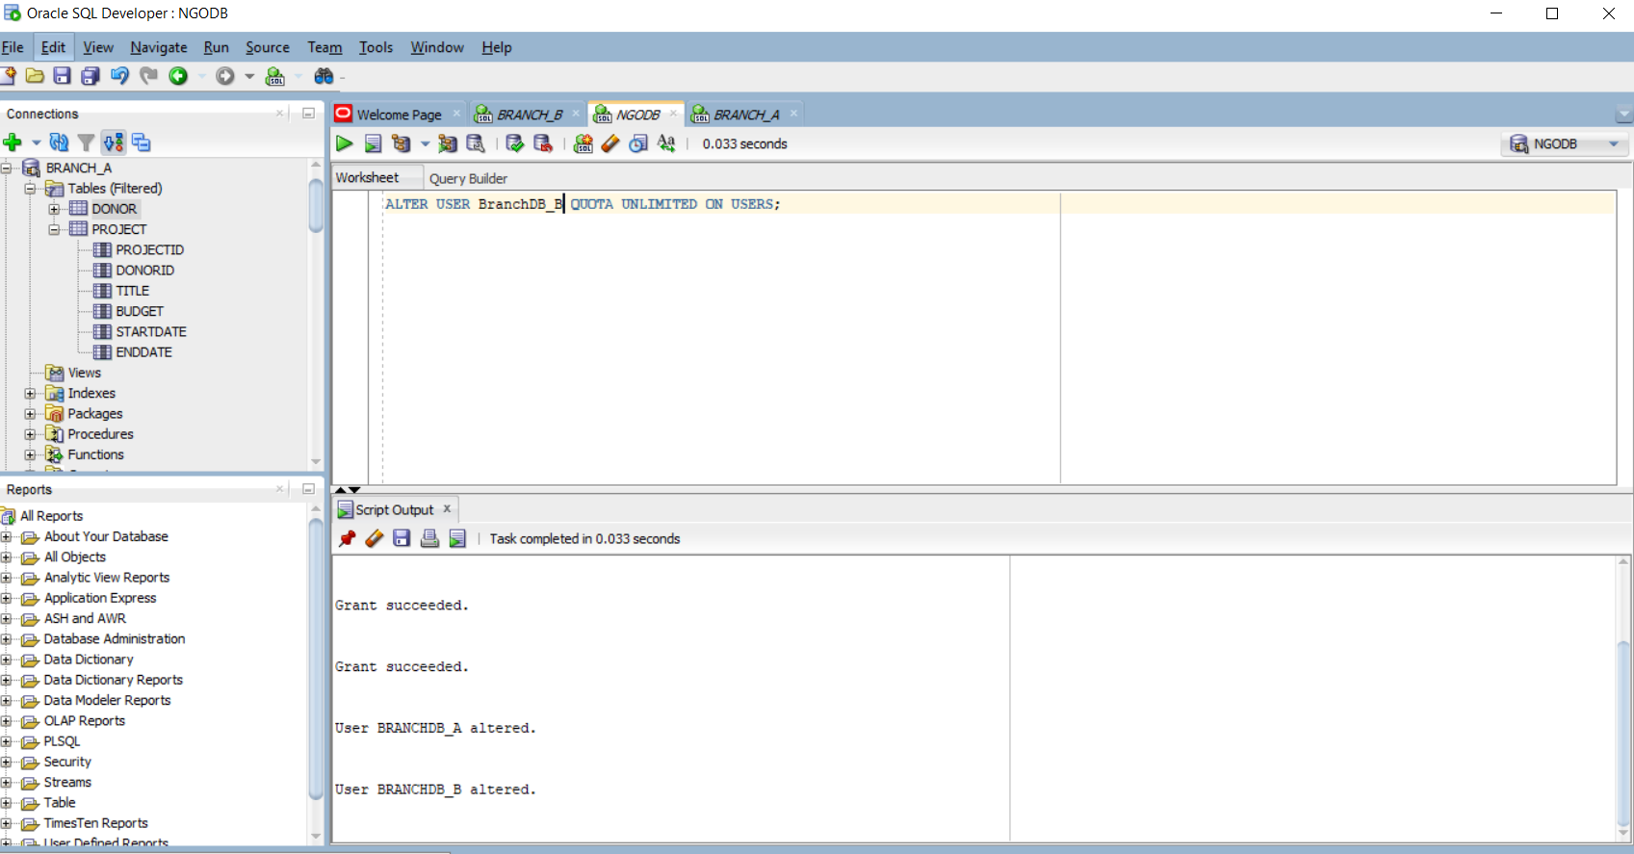

-- On Branch 2
CREATE DATABASE LINK NGO_LINK2
CONNECT TO ngoadmin IDENTIFIED BY "12345"
USING 'XEPDB1';
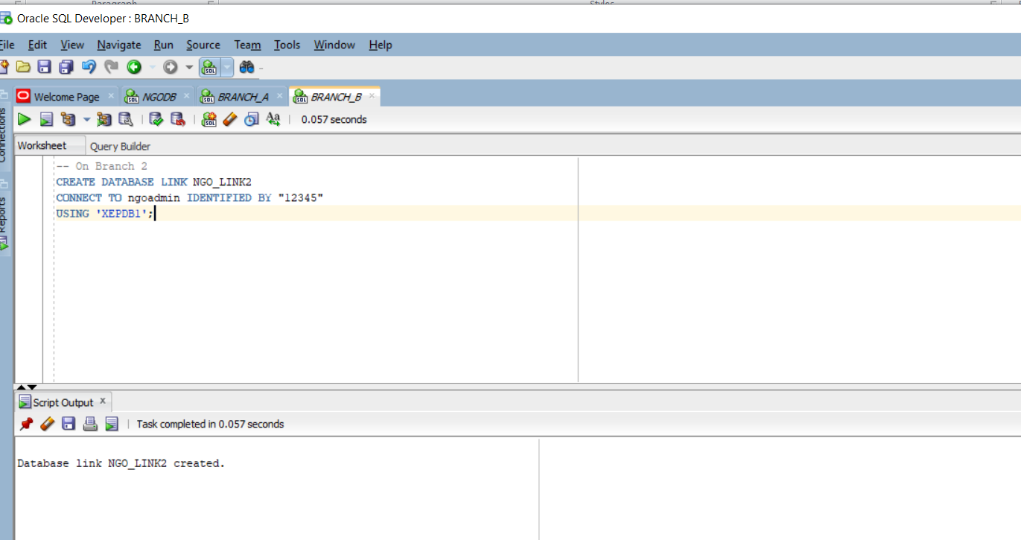

-- On Branch 1
CREATE DATABASE LINK NGO_LINK1
CONNECT TO ngoadmin IDENTIFIED BY "12345"
USING 'XEPDB1';
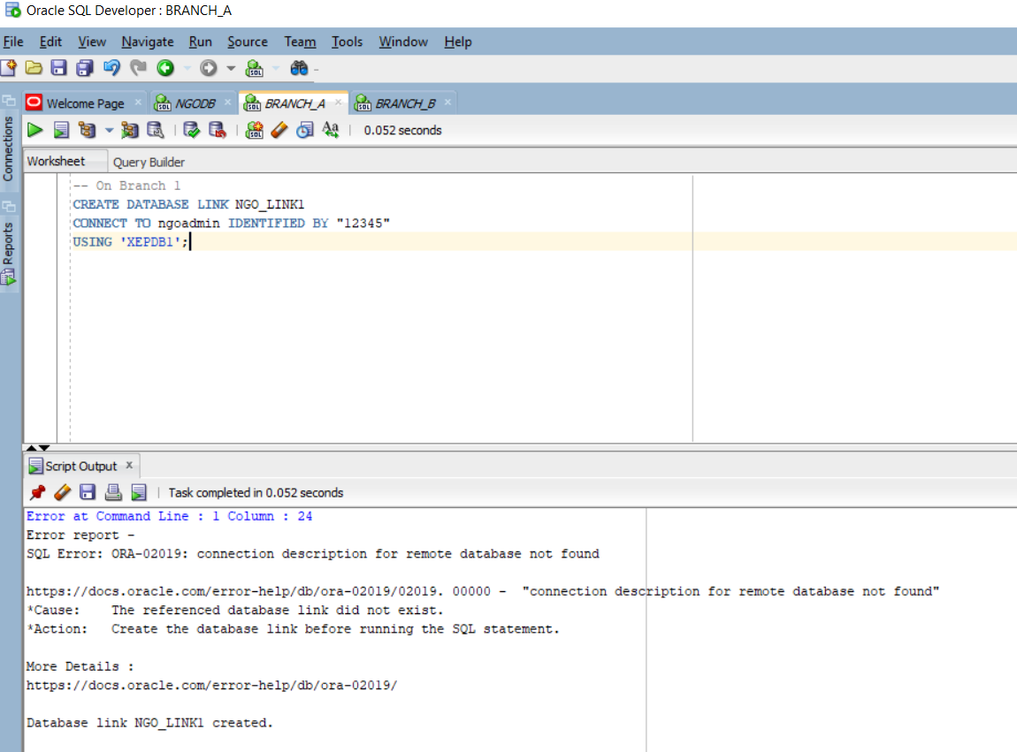
-- To Branch 1
CREATE DATABASE LINK branch_A_link
CONNECT TO branchdb_a IDENTIFIED BY "12345"
USING 'XEPDB1';
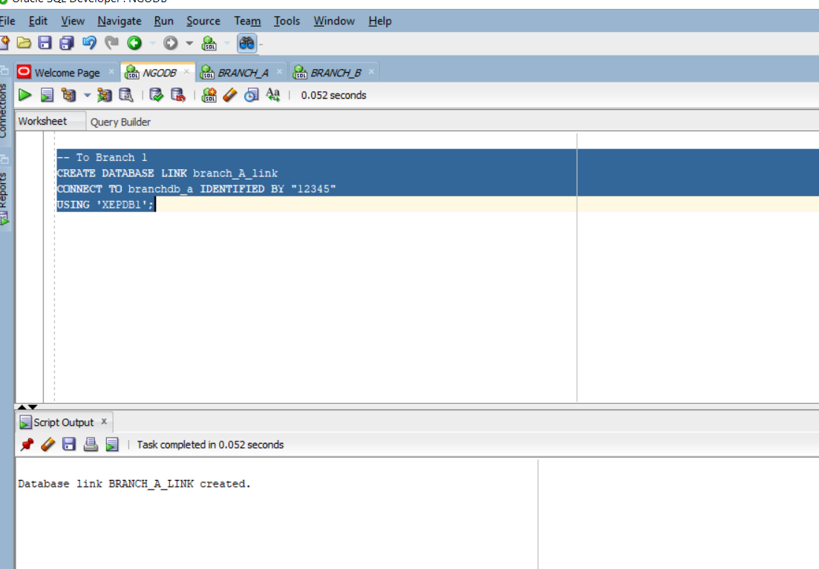

Link A
CREATE DATABASE LINK branch_b_link
CONNECT TO brancHDB_B IDENTIFIED BY "12345"
USING 'XEPDB1';

Link B

CREATE DATABASE LINK branch_a_link
CONNECT TO brancHDB_a IDENTIFIED BY "12345"
USING 'XEPDB1';

Rmote select

SELECT * FROM Report@branchdb_b_link;
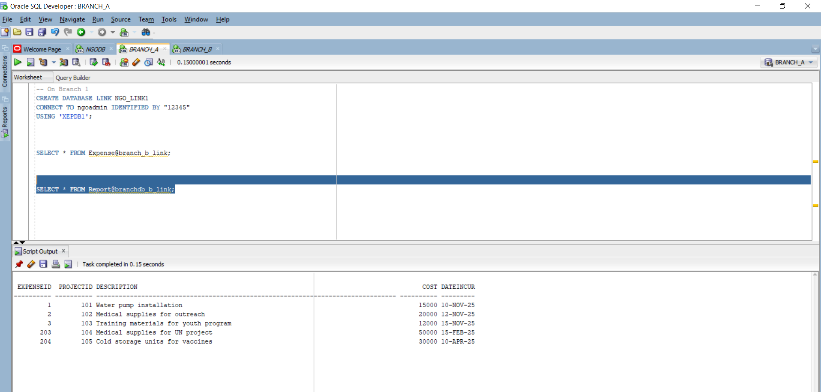

Joint selection:

SELECT
d.FullName AS DonorName,
p.ProjectID,
p.Title AS ProjectTitle,
e.ExpenseID,
e.Cost,
e.DateIncurred
FROM
Project p
JOIN
Donor d ON p.DonorID = d.DonorID
JOIN
Expense@branch_b_link e ON p.ProjectID = e.ProjectID;

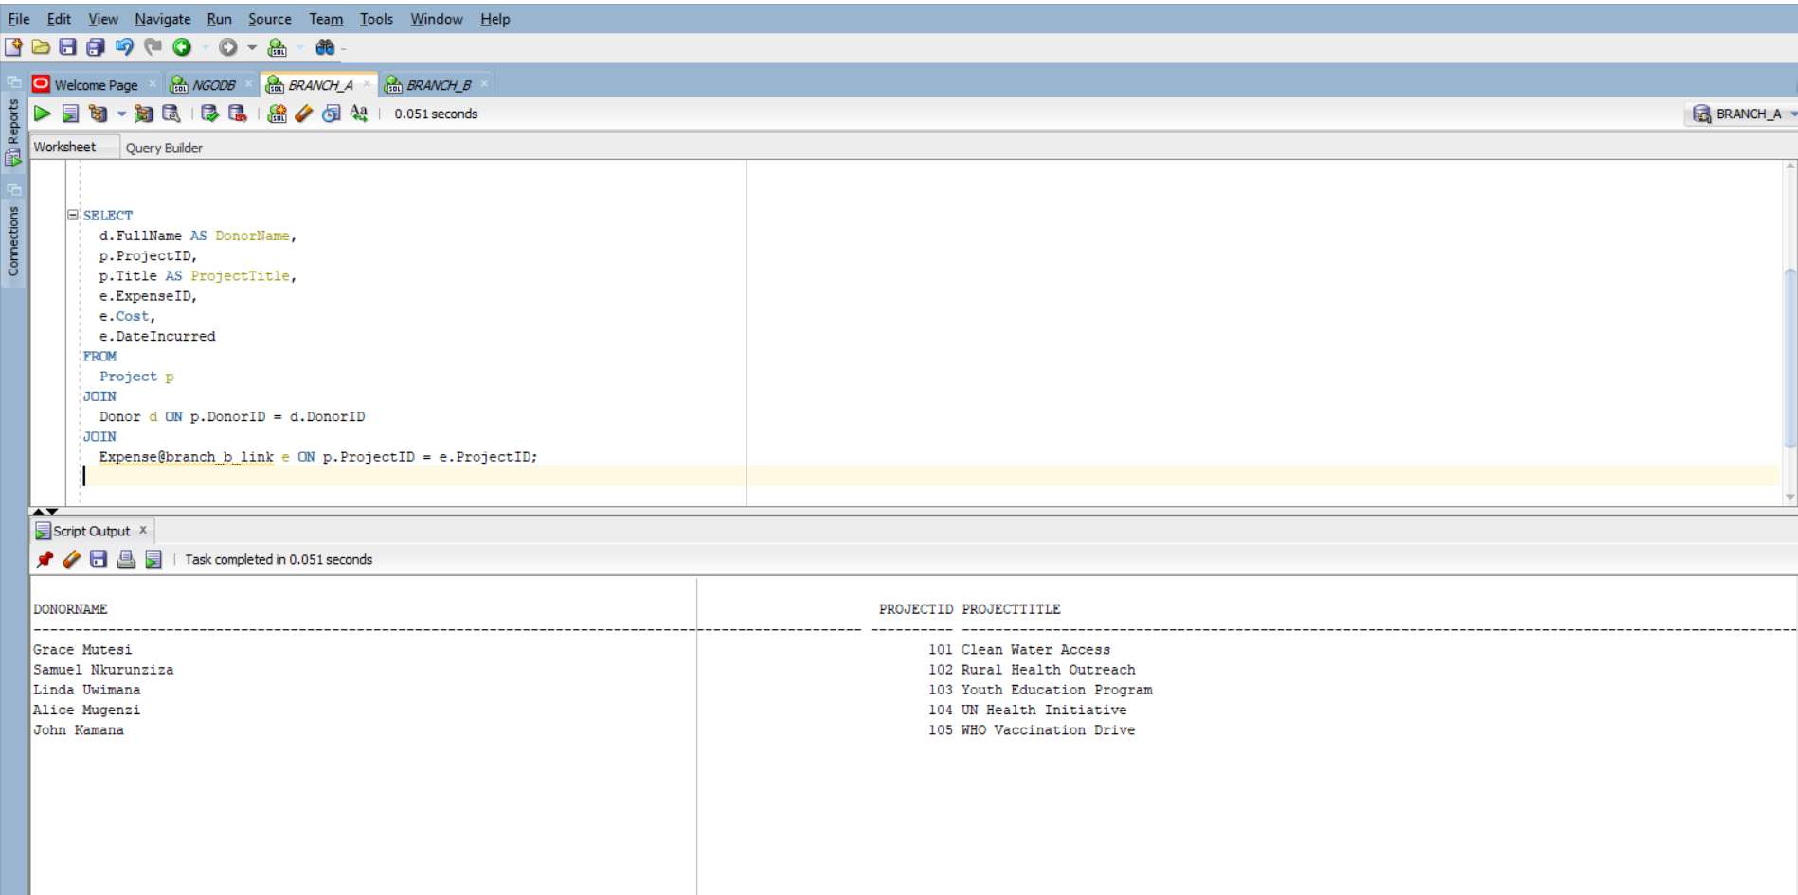

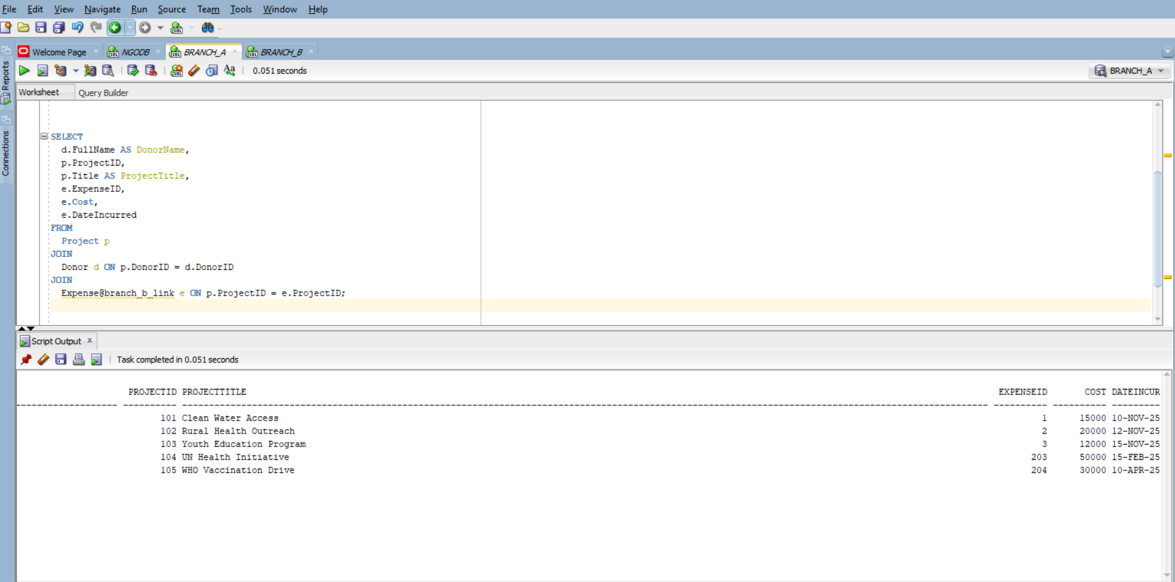

REMOTE UPDATE:
UPDATE Expense@branch_b_link
SET Cost = 5000
WHERE ProjectID = 101;

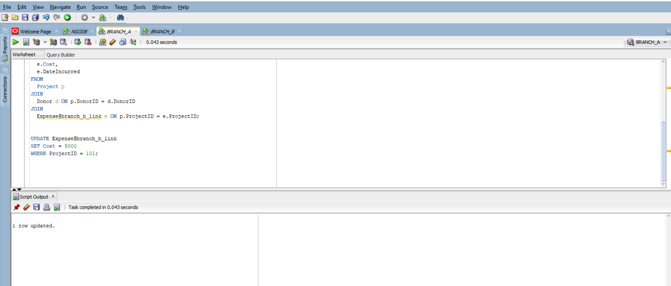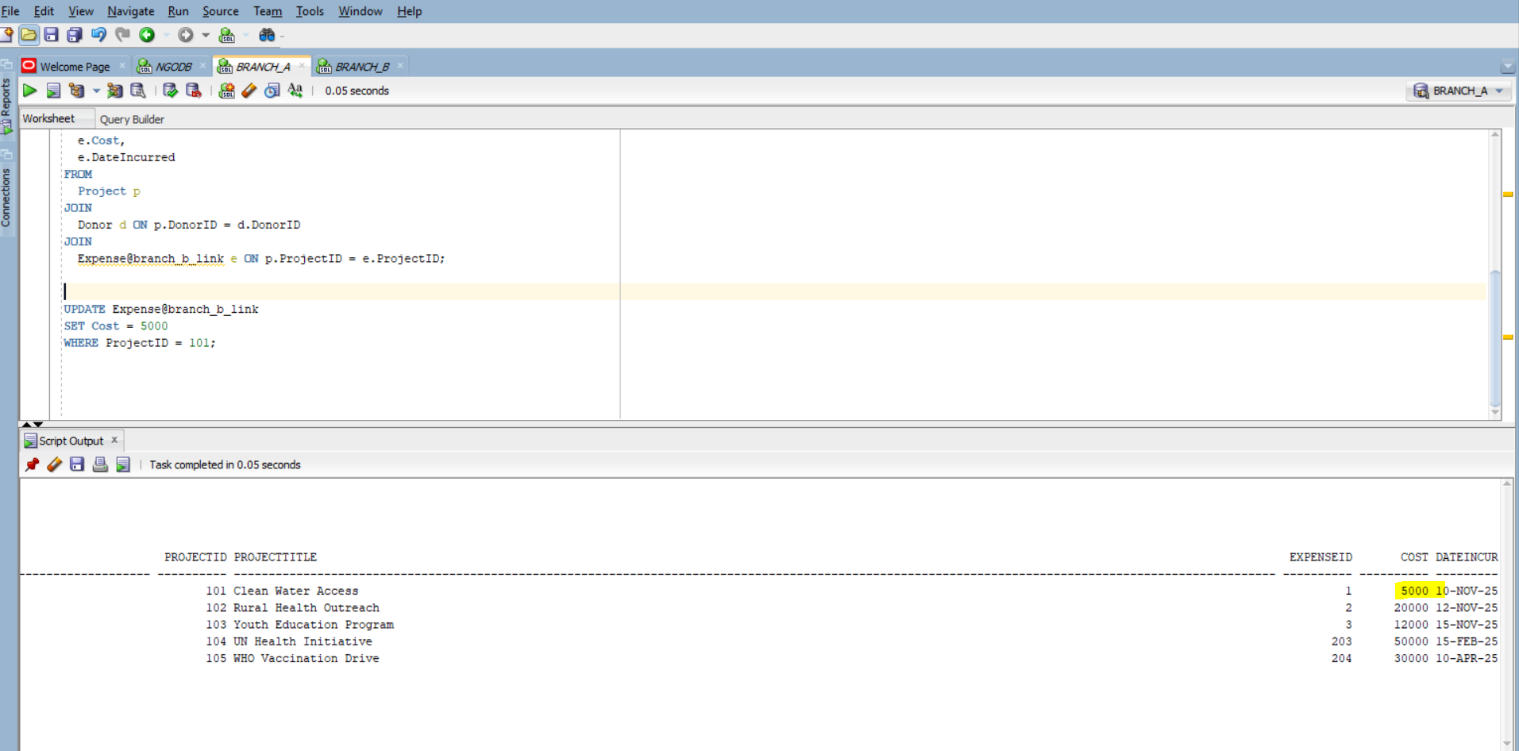

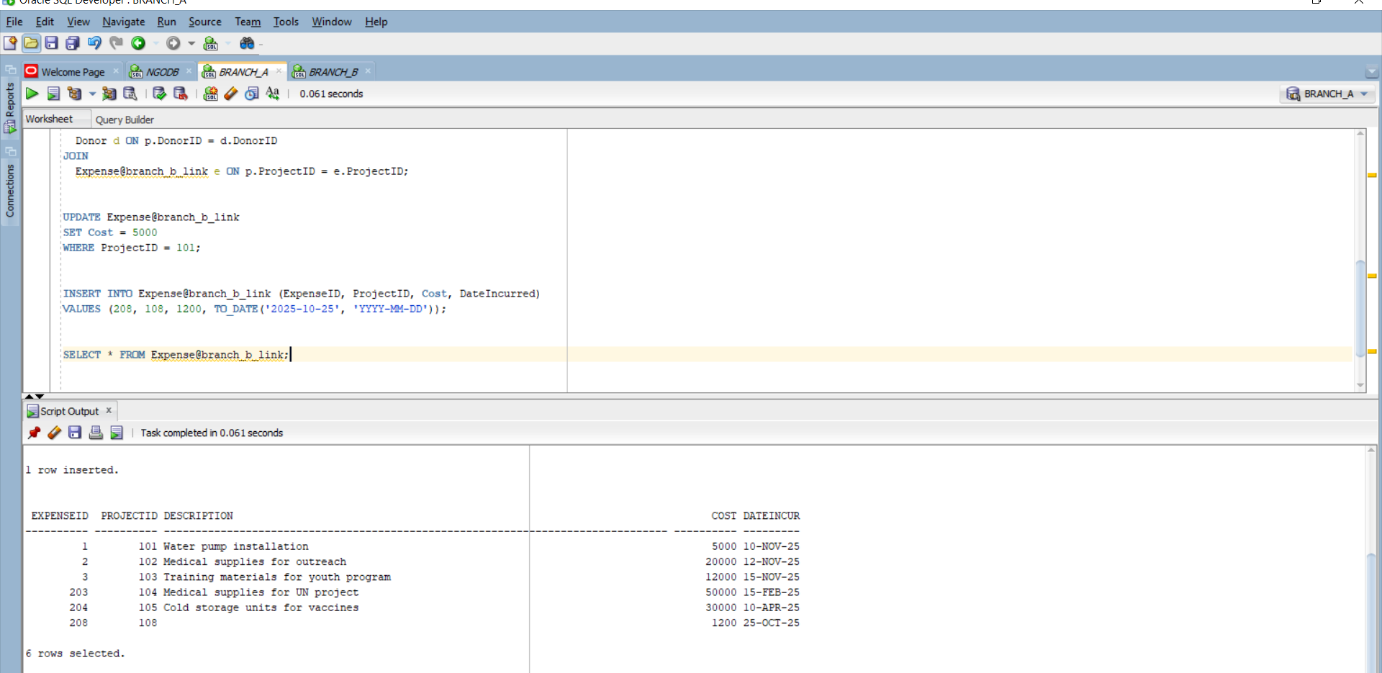

INSERT INTO Expense@branch_b_link (
ExpenseID,
ProjectID,
Cost,
Description,
DateIncurred

)
VALUES (
301,
109,
2500,
'Procurement of medical supplies',
TO_DATE('2025-10-26', 'YYYY-MM-DD')

);

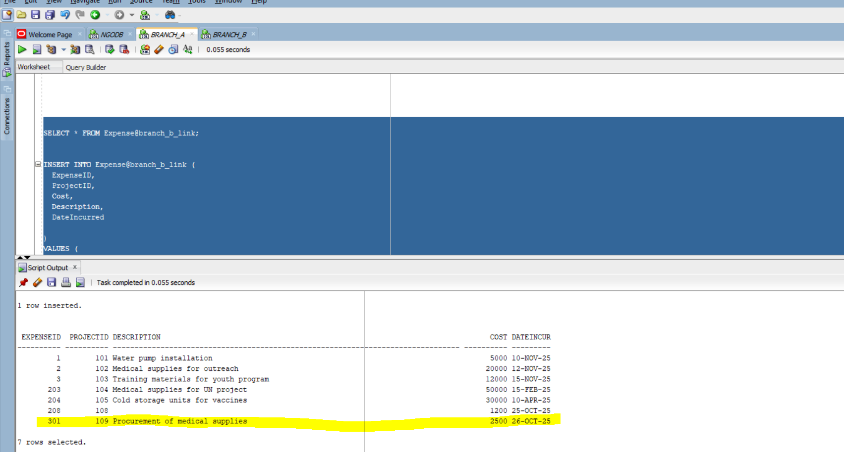
3.1. Serial execution:

EXPLAIN PLAN FOR
SELECT * FROM Expense@branch_b_link
WHERE Cost > 1000;

SELECT * FROM TABLE(DBMS_XPLAN.DISPLAY);

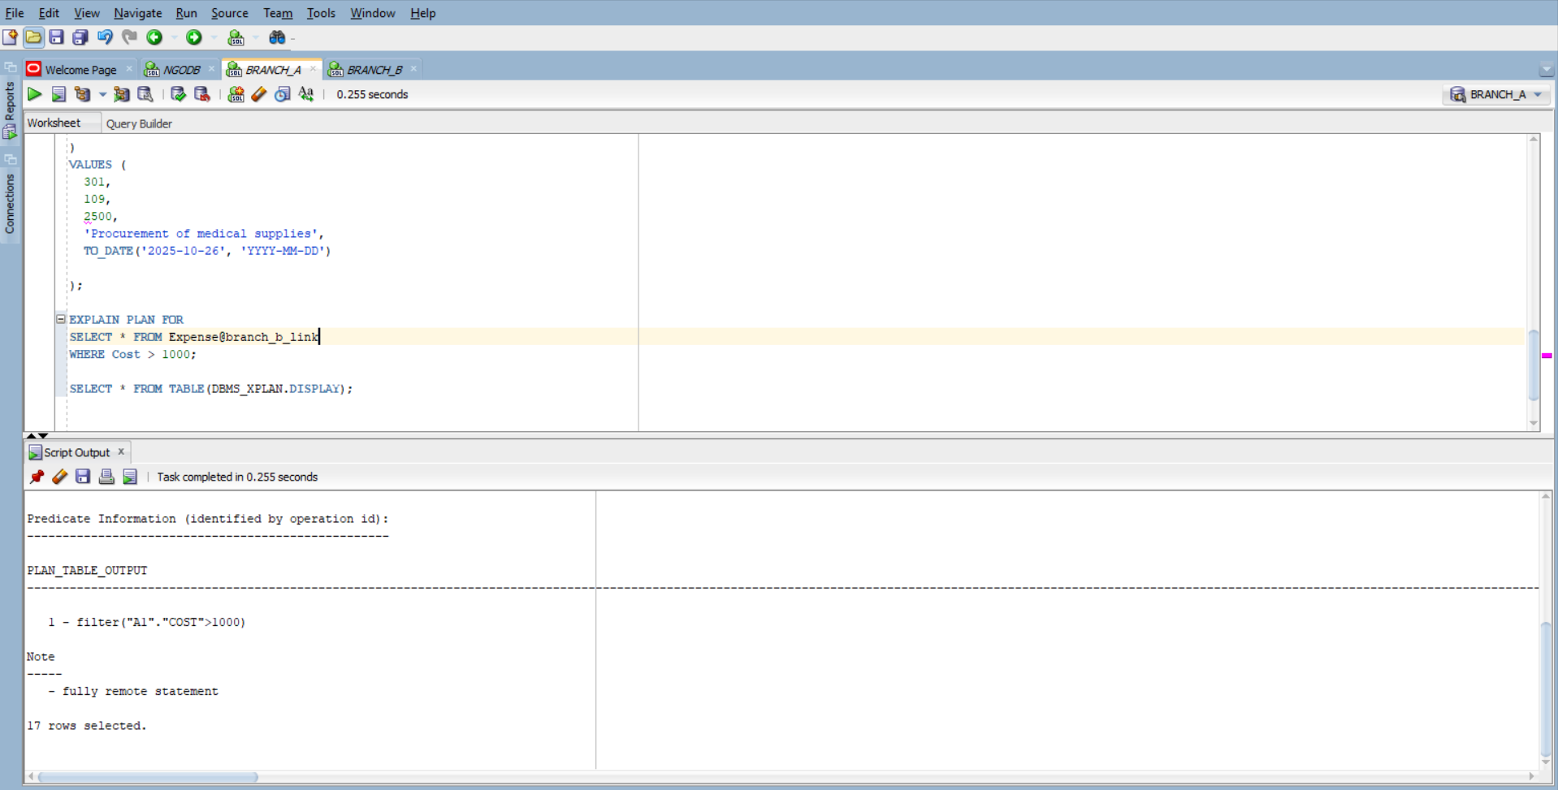

SELECT * FROM TABLE(DBMS_XPLAN.DISPLAY);

SET TIMING ON;
SELECT * FROM Expense@branch_b_link
WHERE Cost > 1000;
SET TIMING OFF;

View the plan:

SELECT * FROM TABLE(DBMS_XPLAN.DISPLAY);

Execution time:

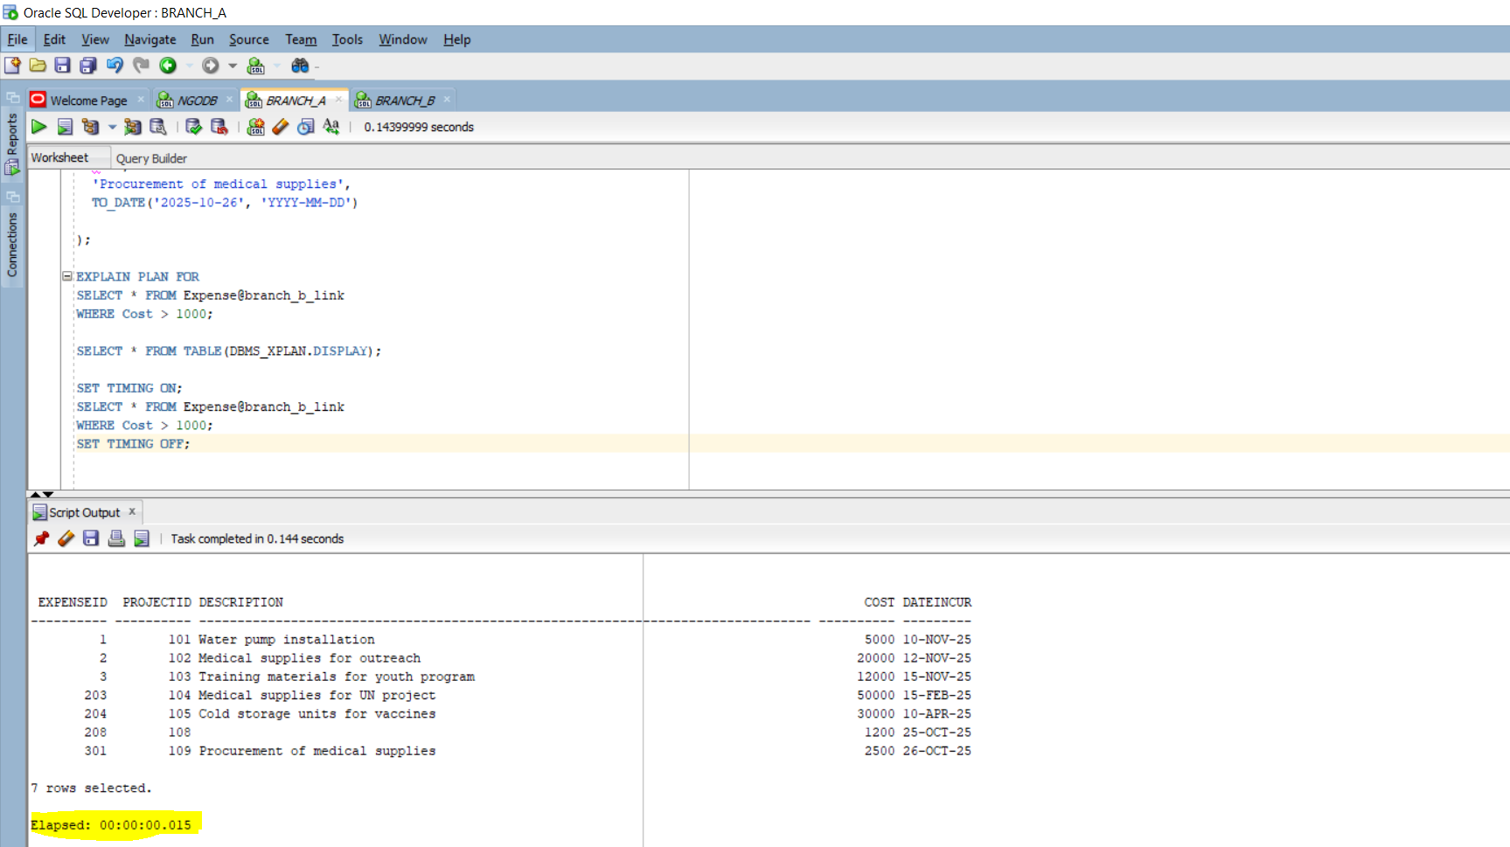

3. 2. Parallel Execution

EXPLAIN PLAN FOR
SELECT /*+ PARALLEL(Expense, 8) */ * FROM Expense@branch_b_link
WHERE Cost > 1000;

SELECT * FROM TABLE(DBMS_XPLAN.DISPLAY);

EXPLAIN PLAN FOR
SELECT * FROM Expense WHERE Cost > 1000;

SELECT * FROM TABLE(DBMS_XPLAN.DISPLAY);
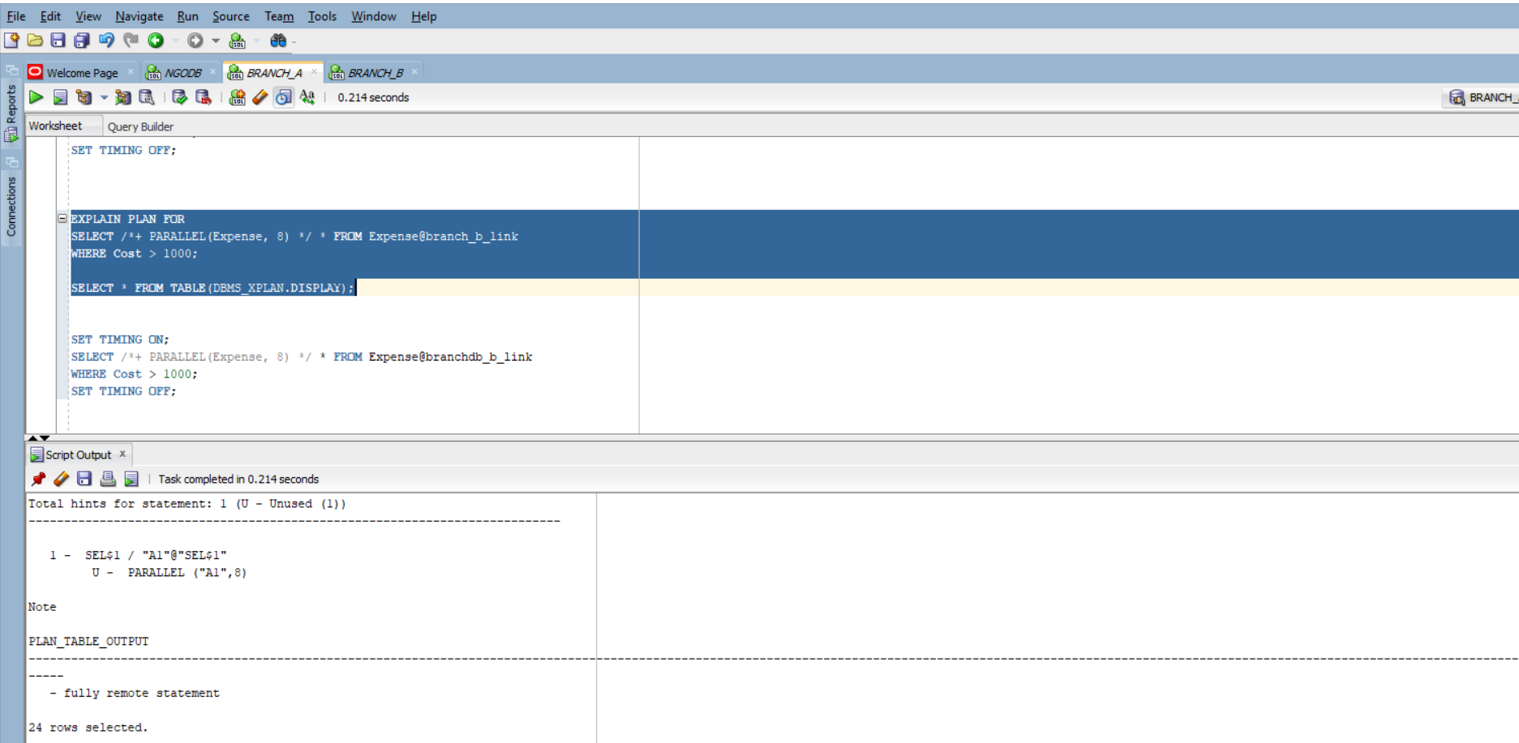

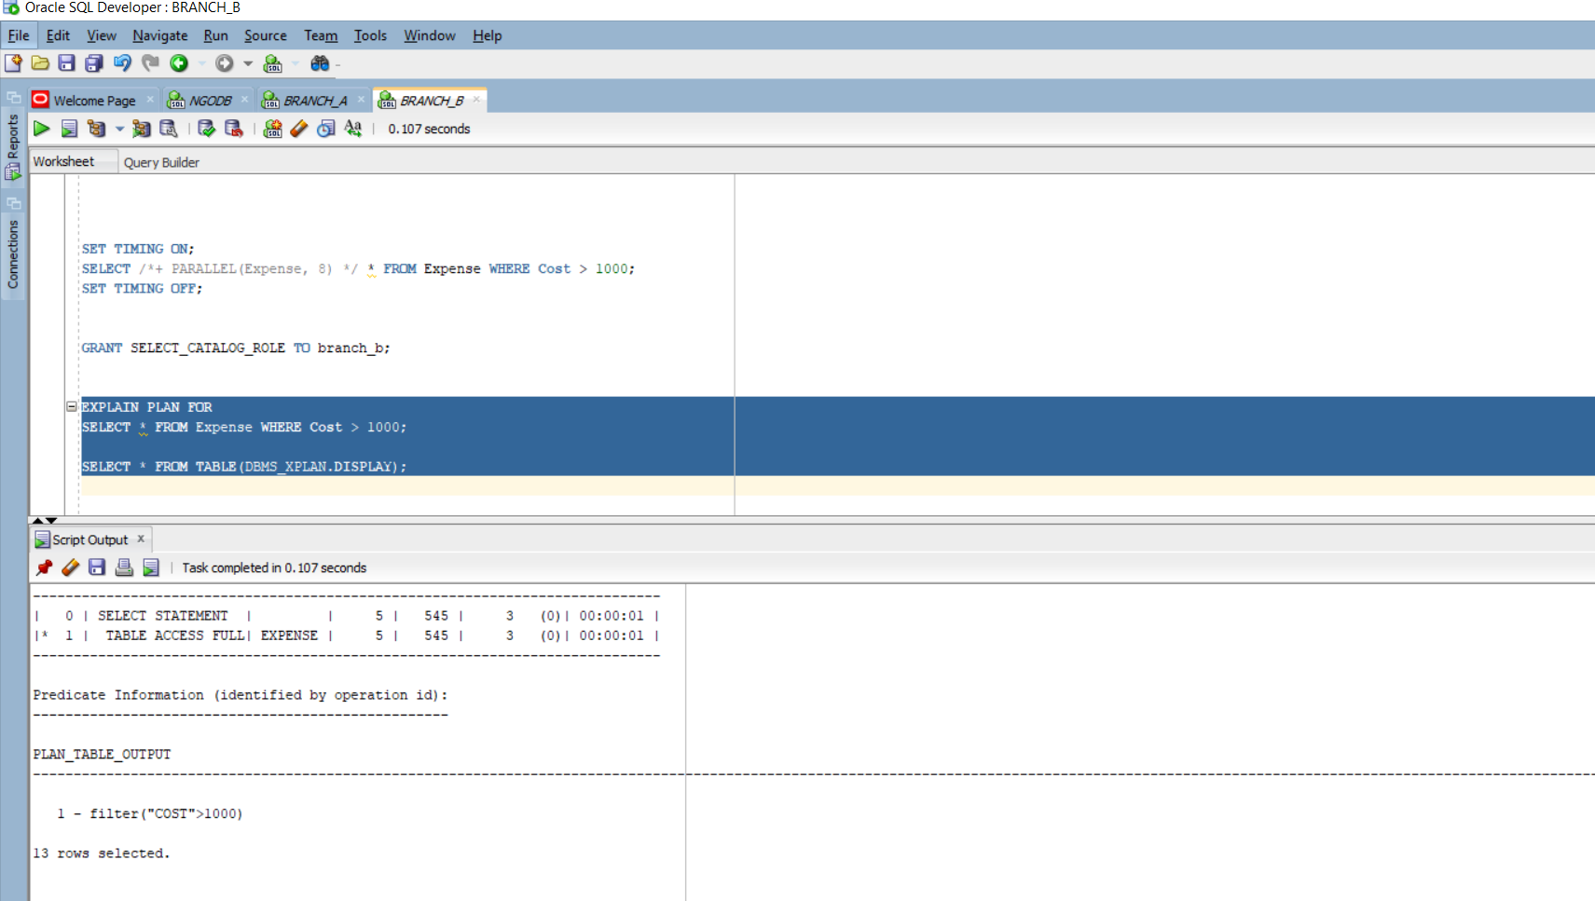

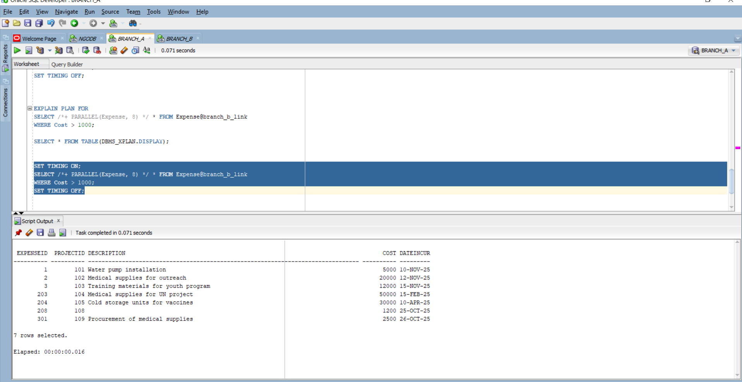



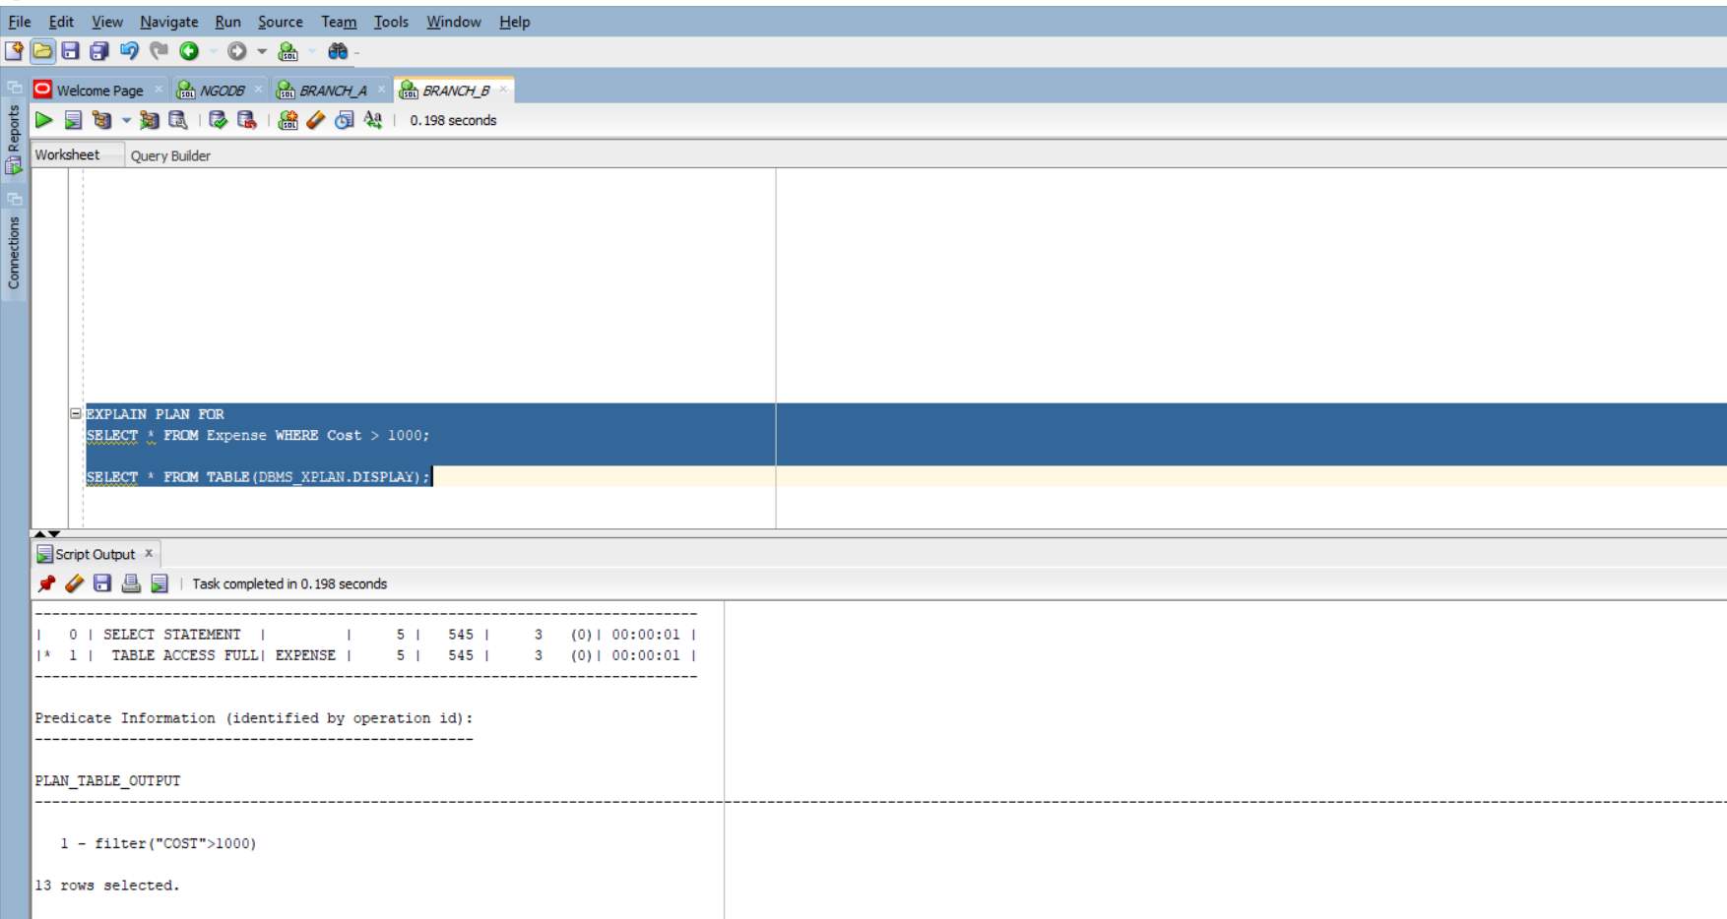

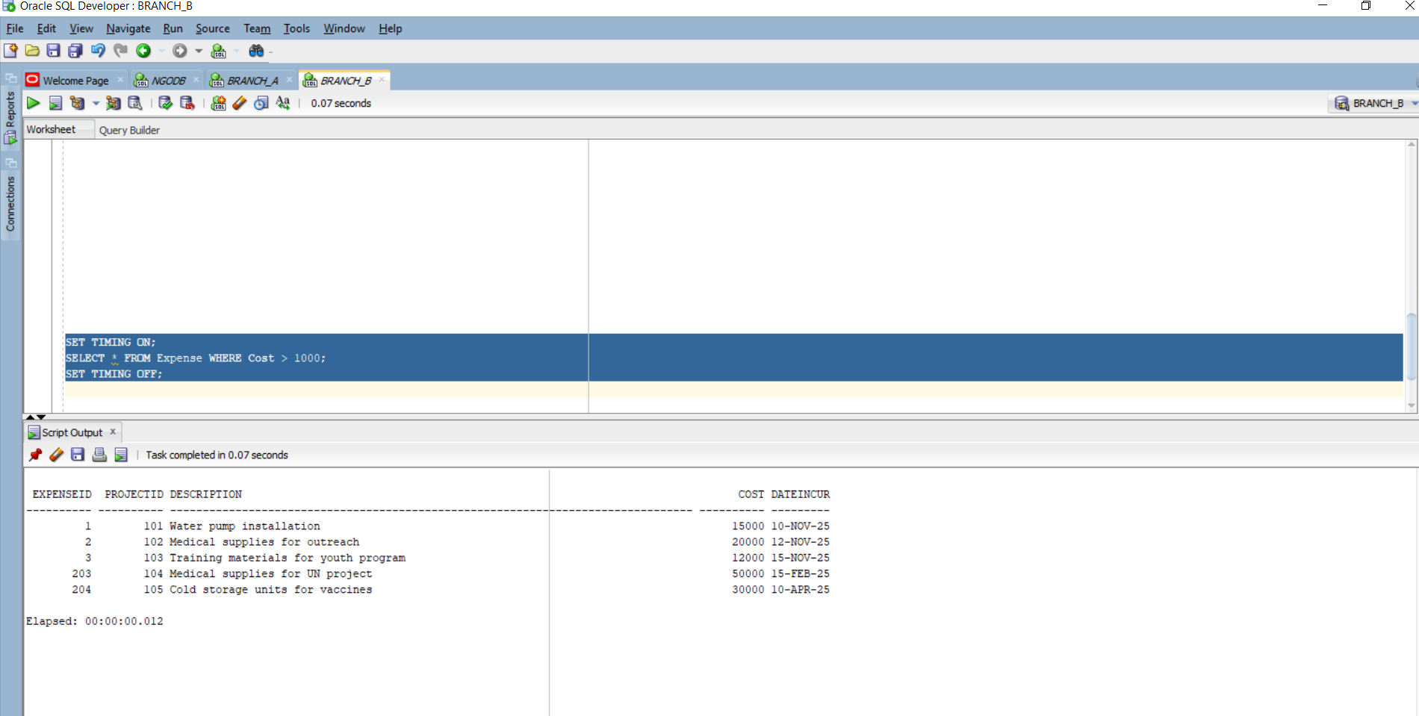

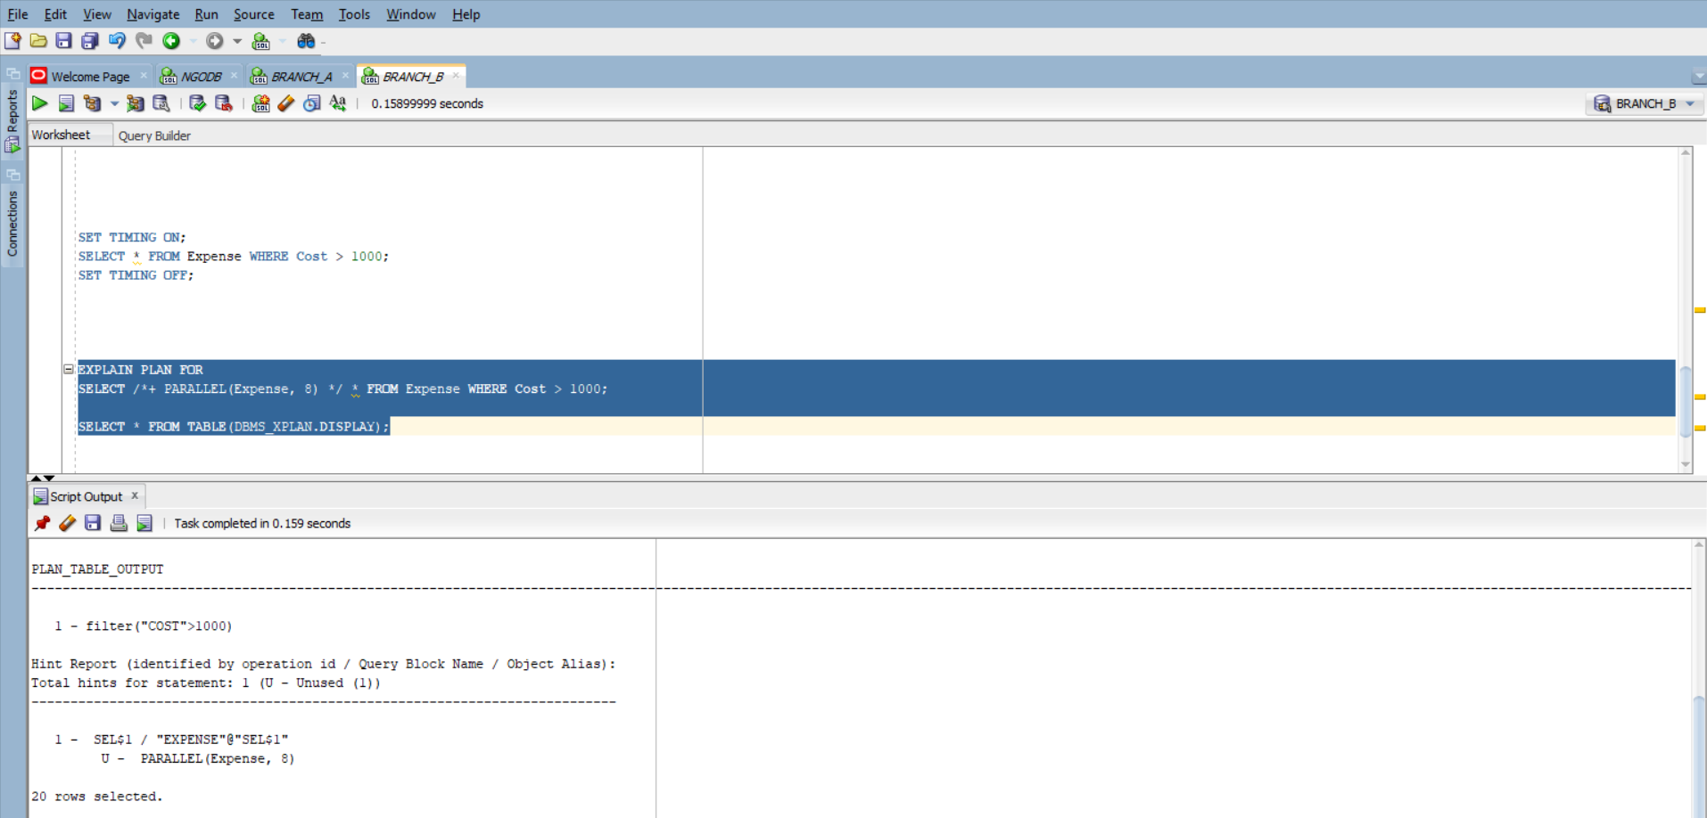

4.

BEGIN
-- Insert into local table (BranchDB_A)
INSERT INTO Donor (DonorID, FullName)
VALUES (1001, 'Global Health Fund');

-- Insert into remote table (BranchDB_B)
INSERT INTO Expense@branch_b_link (ExpenseID, ProjectID, Cost, DateIncurred, Description)
VALUES (501, 12, 3000, SYSDATE, 'Emergency supplies');

-- Single commit for both
COMMIT;
END;
/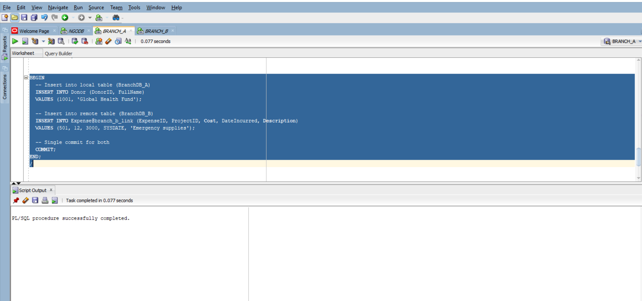
BEGIN
-- Update local table (BranchDB_A)
UPDATE Donor
SET FullName = 'Global Health Fund International'
WHERE DonorID = 1001;

-- Update remote table (BranchDB_B)
UPDATE Expense@branch_b_link
SET Cost = 3500,
Description = 'Emergency medical supplies'
WHERE ExpenseID = 501;

-- Commit both updates
COMMIT;
END;
/
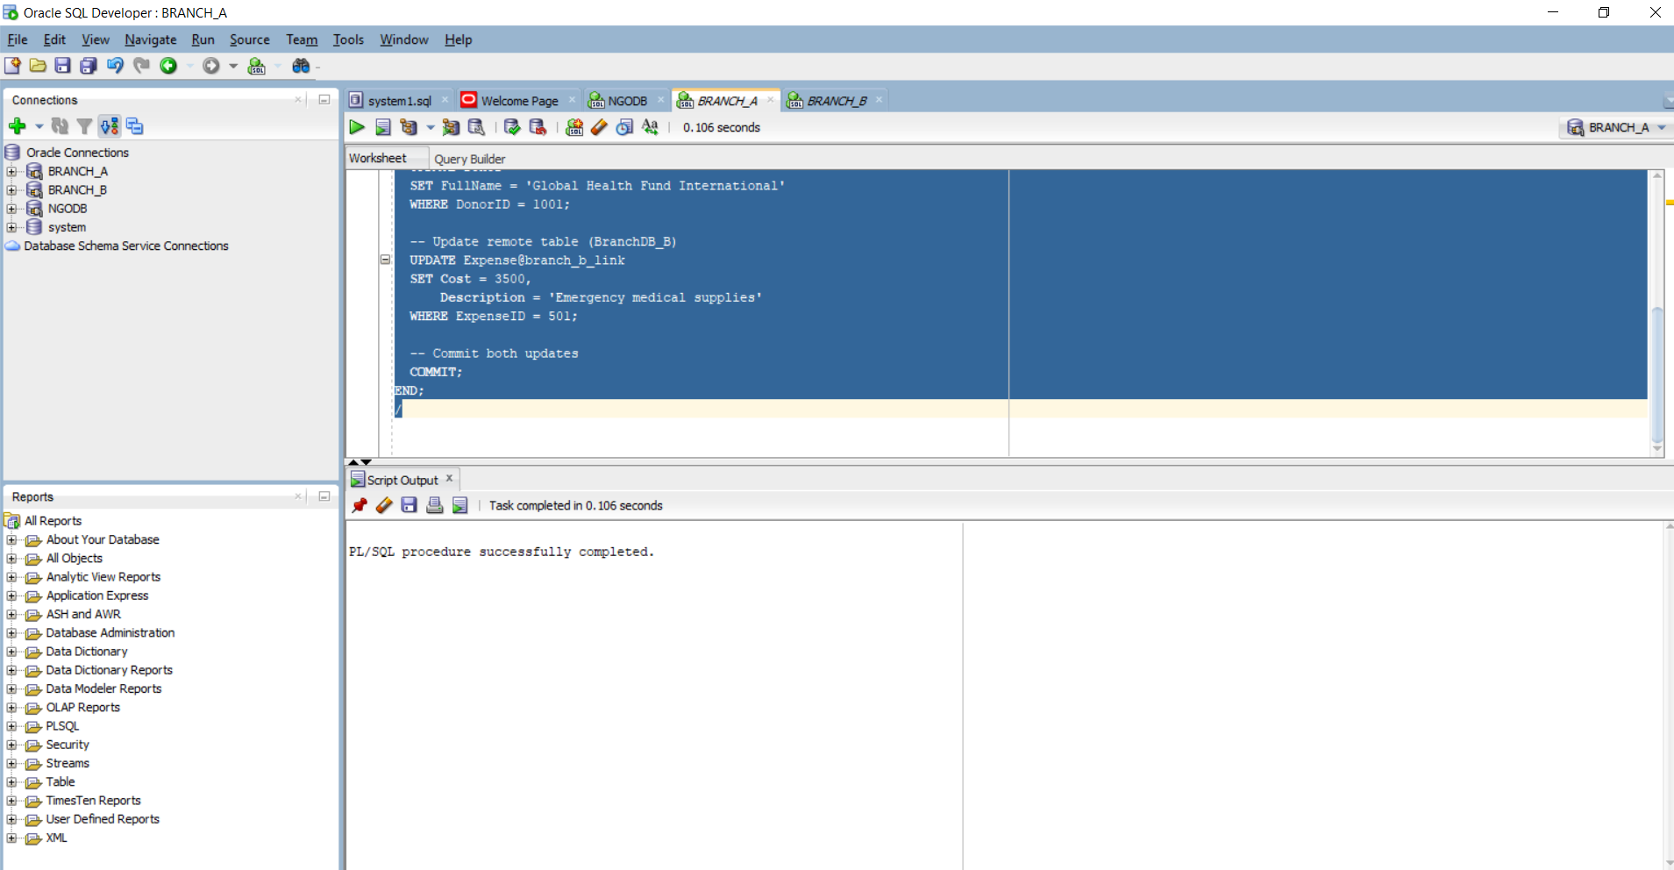

SELECT LOCAL_TRAN_ID, GLOBAL_TRAN_ID, STATE, MIXED, ADVICE
FROM DBA_2PC_PENDING;

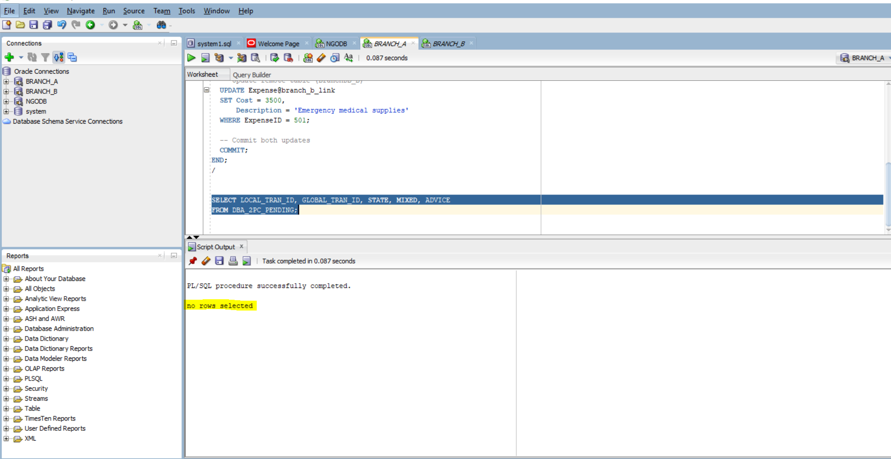

5.

BEGIN
-- Option A: Insert all columns
INSERT INTO Donor VALUES (1004, 'Global Health Fund', 'GHF Org', '123456789', 'ghf@example.com');

-- Remote insert via loopback link
INSERT INTO Expense@branch_b_link VALUES (505, 111, 'Emergency supplies',4000, SYSDATE );

-- Delay before commit
DBMS_LOCK.SLEEP(60); -- 60 seconds to simulate failure

COMMIT;
END;
/
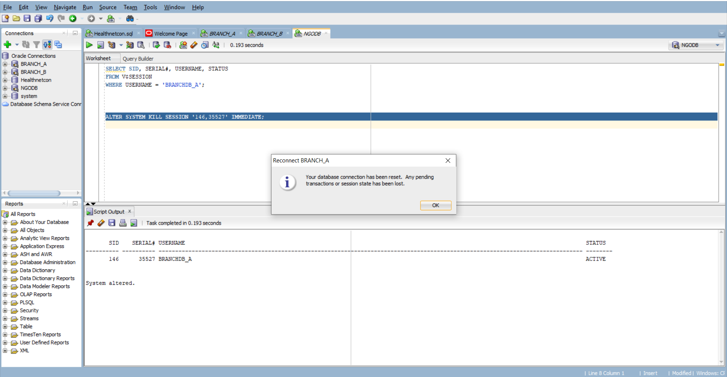

ALTER SYSTEM KILL SESSION '278,39323' IMMEDIATE;

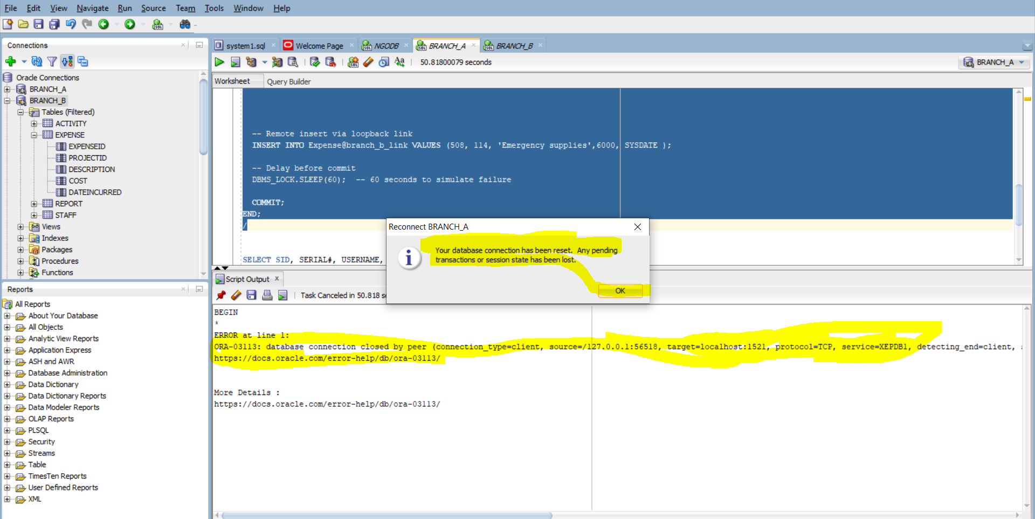

6.

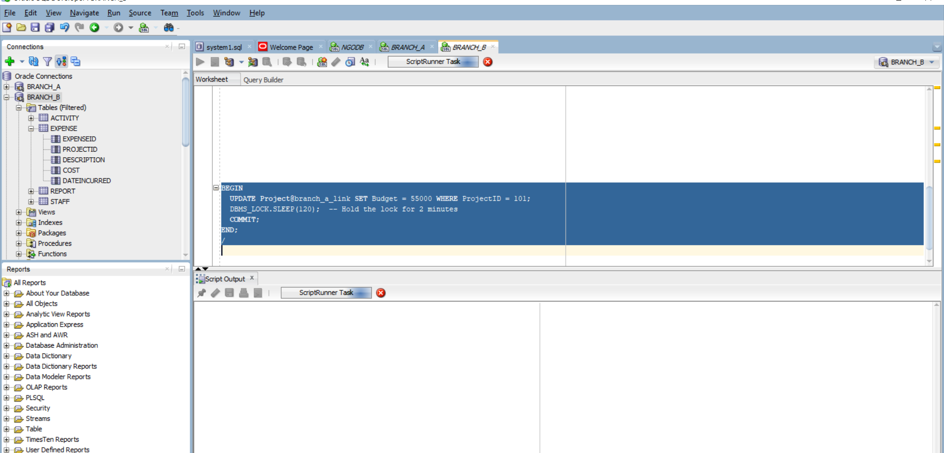
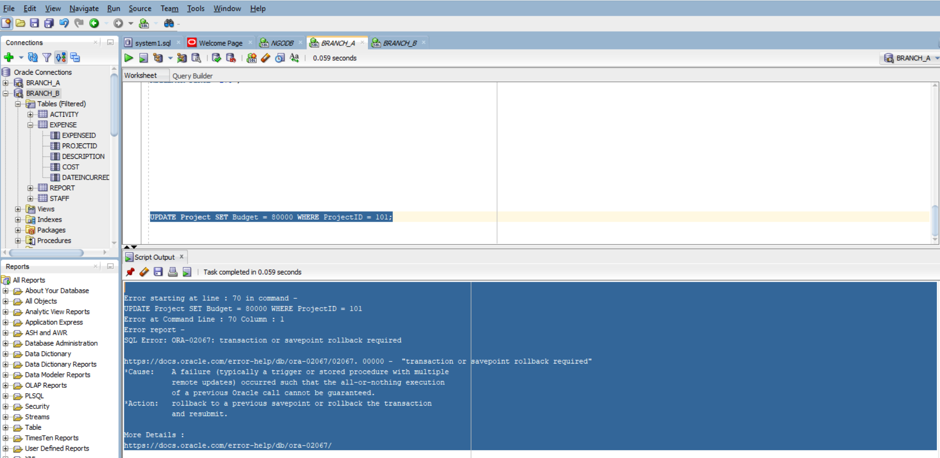

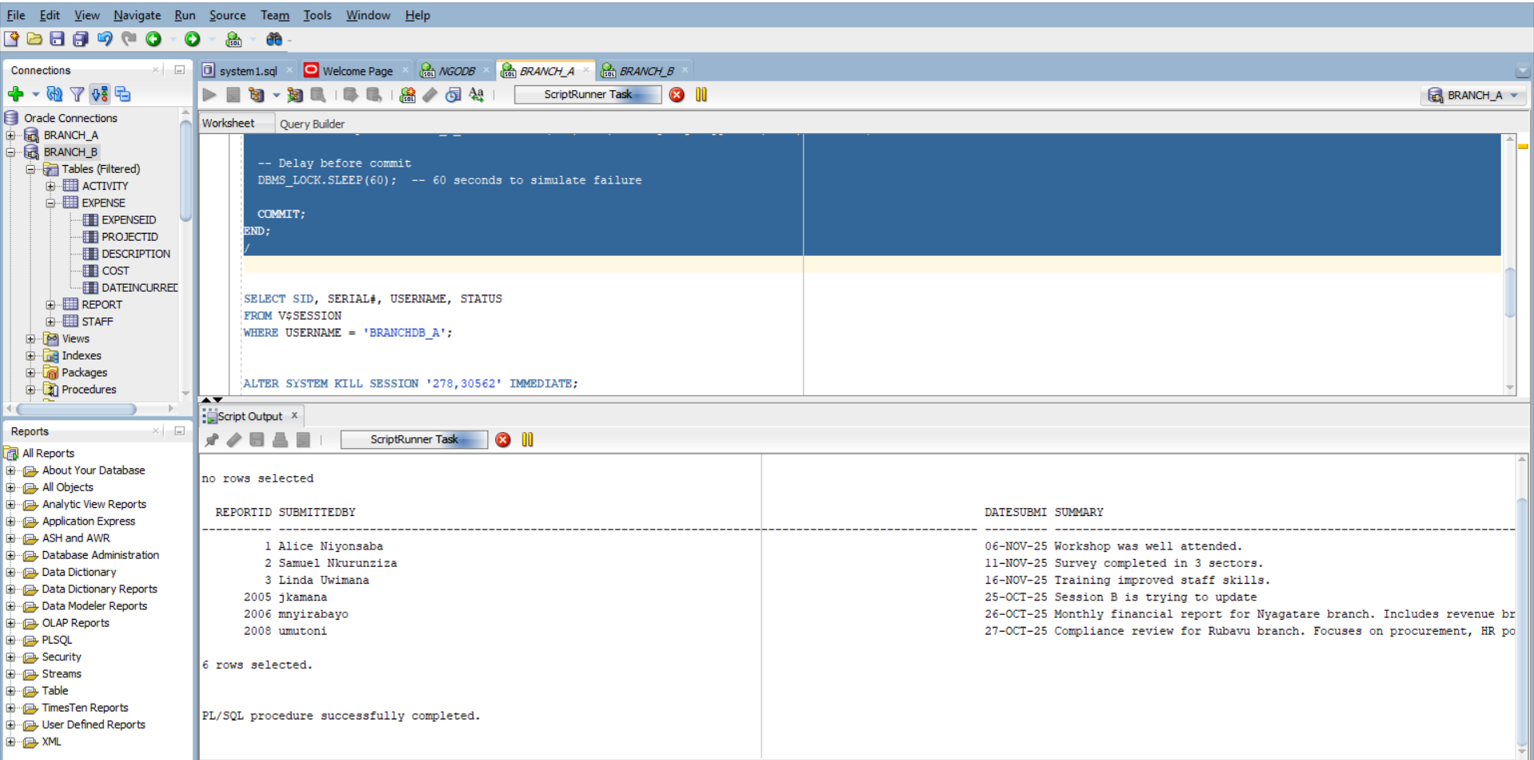
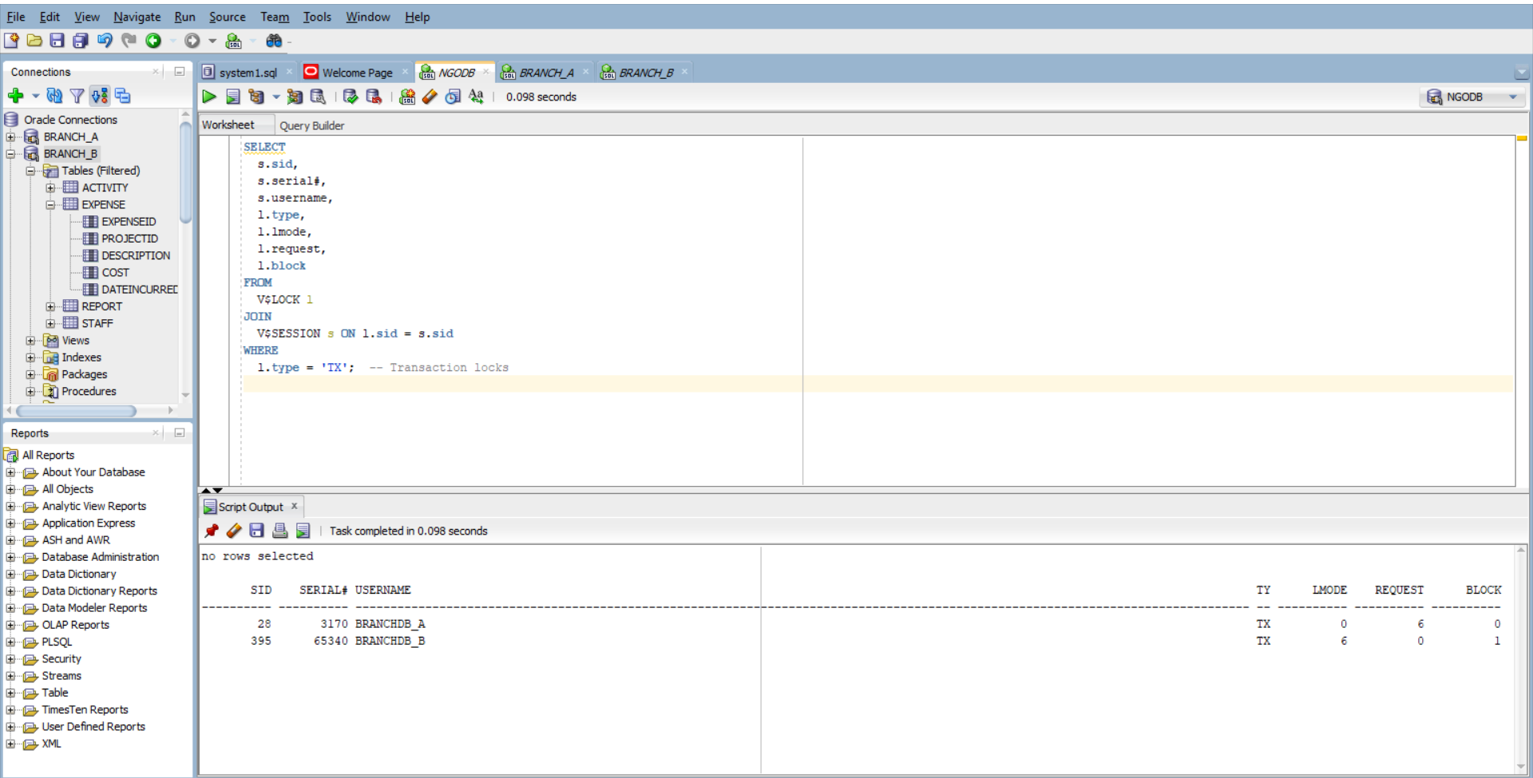
Session 395 (BRANCHDB_B)
• LMODE = 6 → This session holds an exclusive lock (row-level lock).
• REQUEST = 0 → It’s not waiting for any other lock.
• BLOCK = 1 → It is blocking other sessions.
This is the active session that updated the row first and is holding the lock.

Session 28 (BRANCHDB_A)
- LMODE = 0 → It does not hold a lock yet.
- REQUEST = 6 → It is requesting an exclusive lock.
- BLOCK = 0 → It is not blocking anyone.
This session is waiting for the lock held by BRANCHDB_B.

7.
Simulation of an ETL (Extract, Transform, Load) process using Oracle's Parallel DML (Data Manipulation Language) capabilities. The focus was on evaluating performance improvements in terms of execution time and query cost when applying parallelism to data transformation operations on the Expense table
ALTER SESSION ENABLE PARALLEL DML;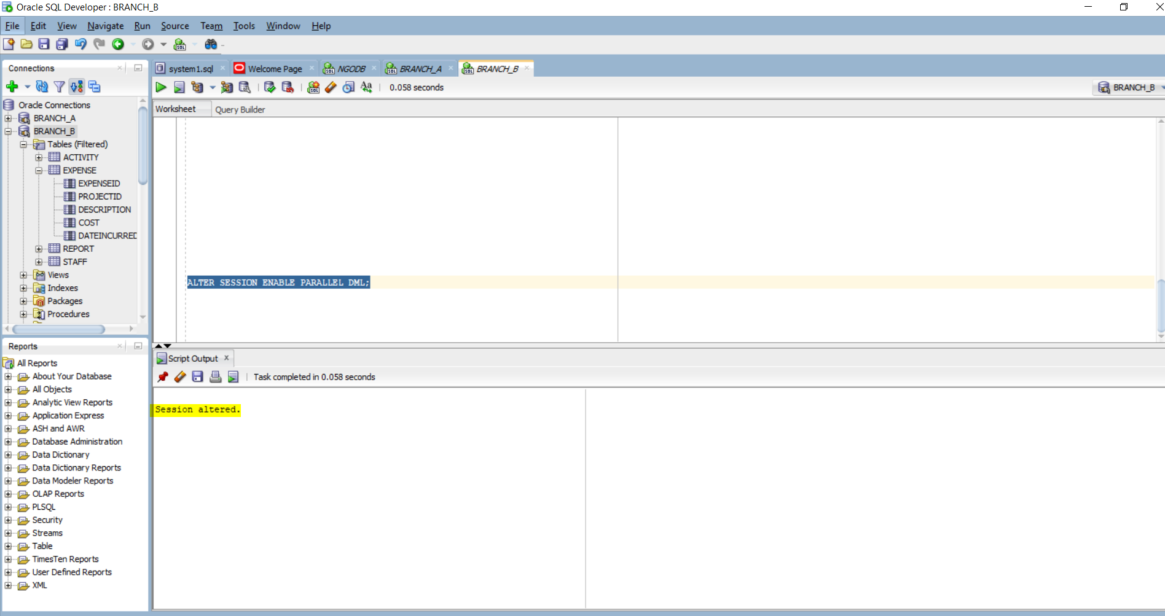

ALTER TABLE expense PARALLEL (DEGREE 4);

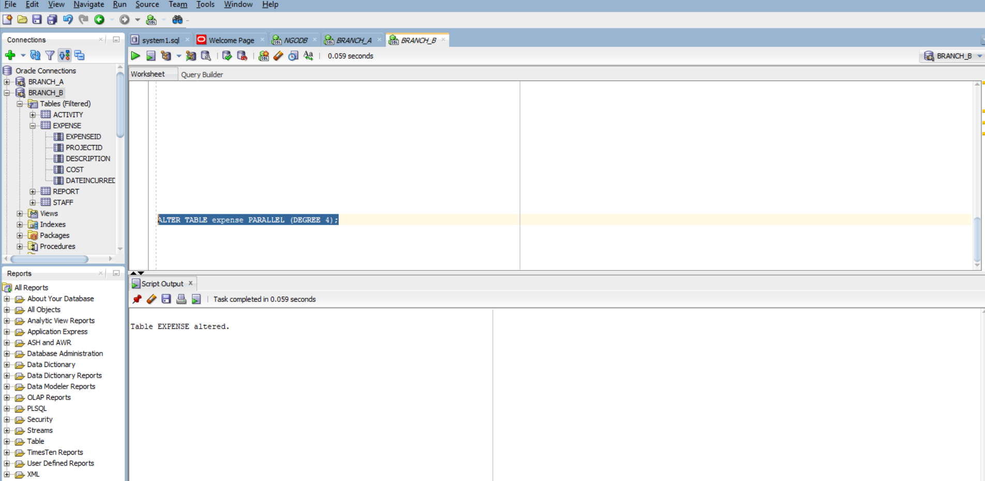

CREATE TABLE Expense_Staging AS
SELECT * FROM Expense;
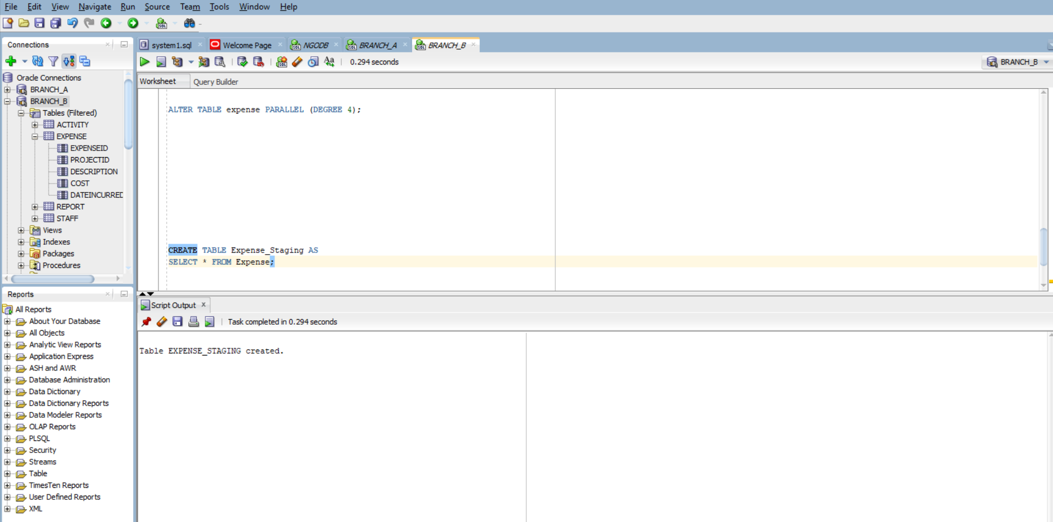

INSERT /*+ PARALLEL(Expense, 4) */ INTO Expense
SELECT /*+ PARALLEL(Expense_Staging, 4) */
ExpenseID + 1000,
ProjectID,
Description || ' [ETL]',
Cost * 1.05,
DateIncurred
FROM Expense_Staging;

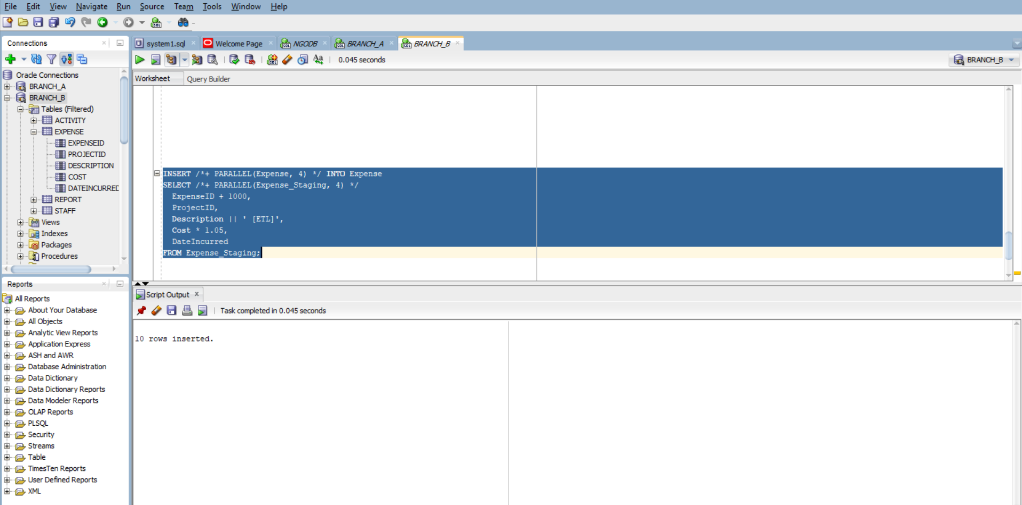
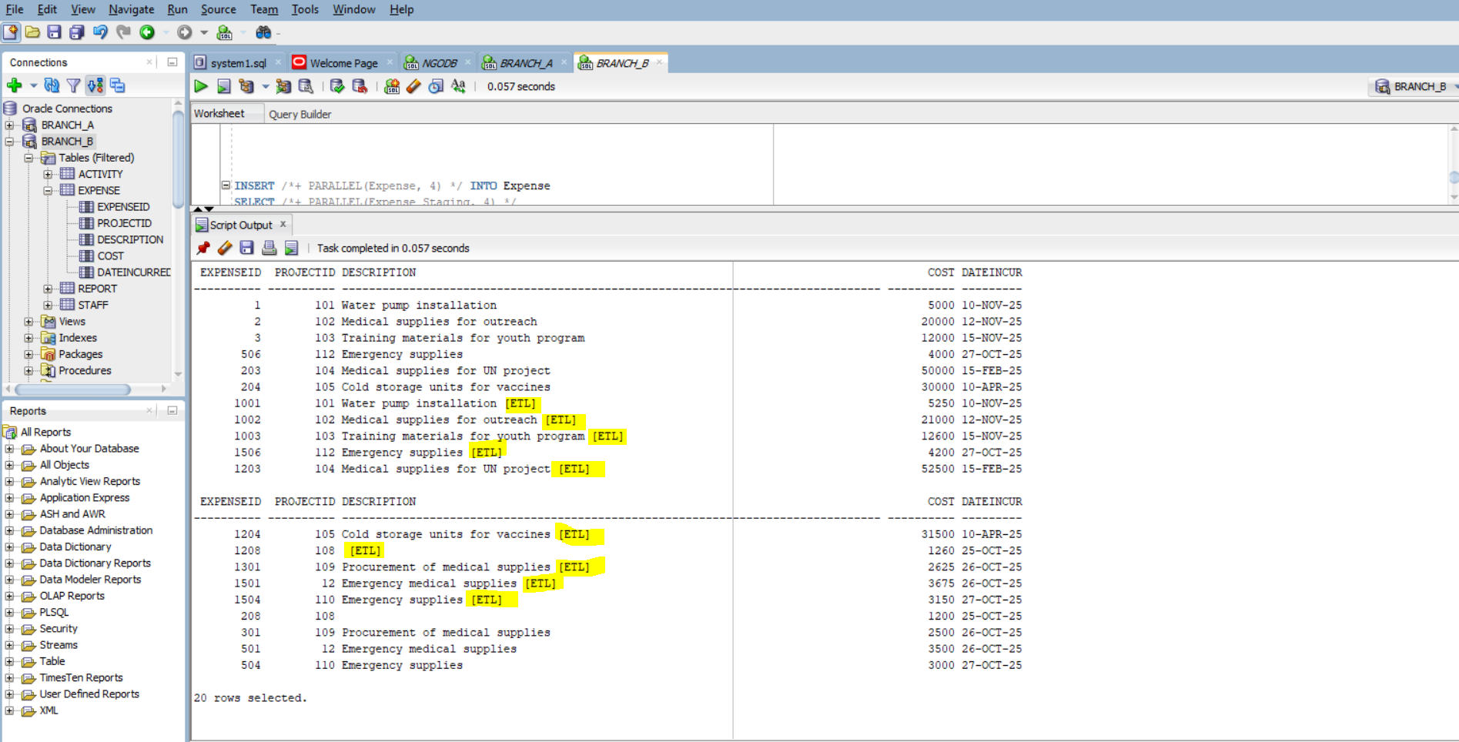

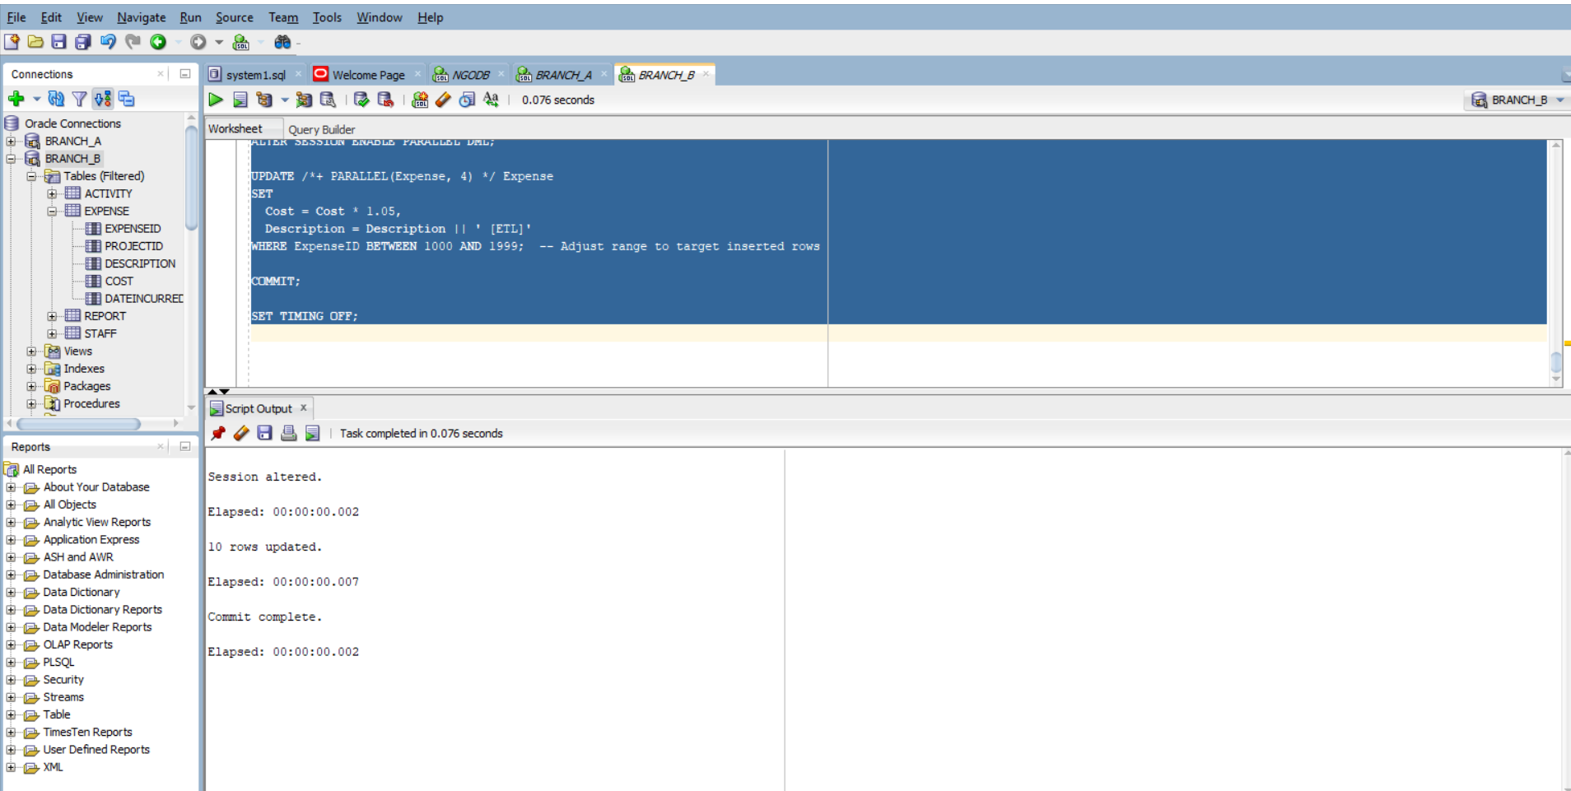
• Adds 1000 to ExpenseID
• Appends [ETL] to Description
• Increases Cost by 5%
SET TIMING ON;
SET AUTOTRACE ON EXPLAIN;

ALTER SESSION ENABLE PARALLEL DML;

UPDATE /*+ PARALLEL(Expense, 4) */ Expense
SET
Cost = ROUND(Cost * 1.08, 2), -- Increase cost by 8%
Description = REPLACE(Description, '[ETL]', '[ETL v2]') -- Tag with new version
WHERE ExpenseID BETWEEN 1000 AND 1999; -- Target previously inserted rows

COMMIT;

SET AUTOTRACE OFF;
SET TIMING OFF;
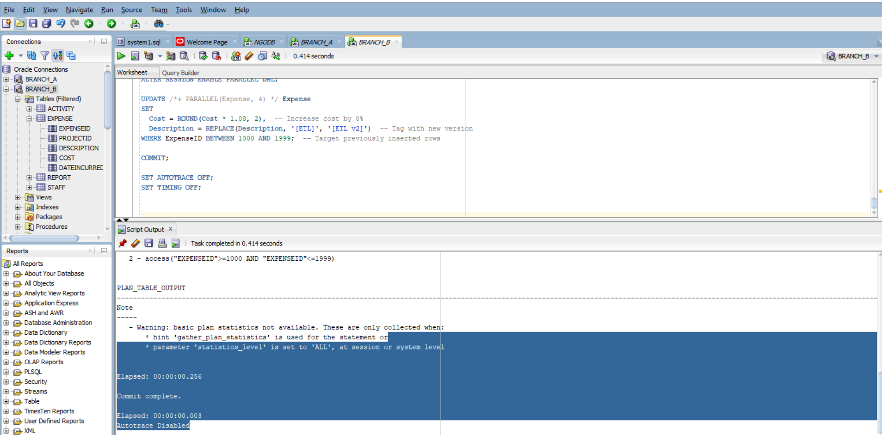
8. A THREE TIER DIAGRAM WITH DATA FLOW:
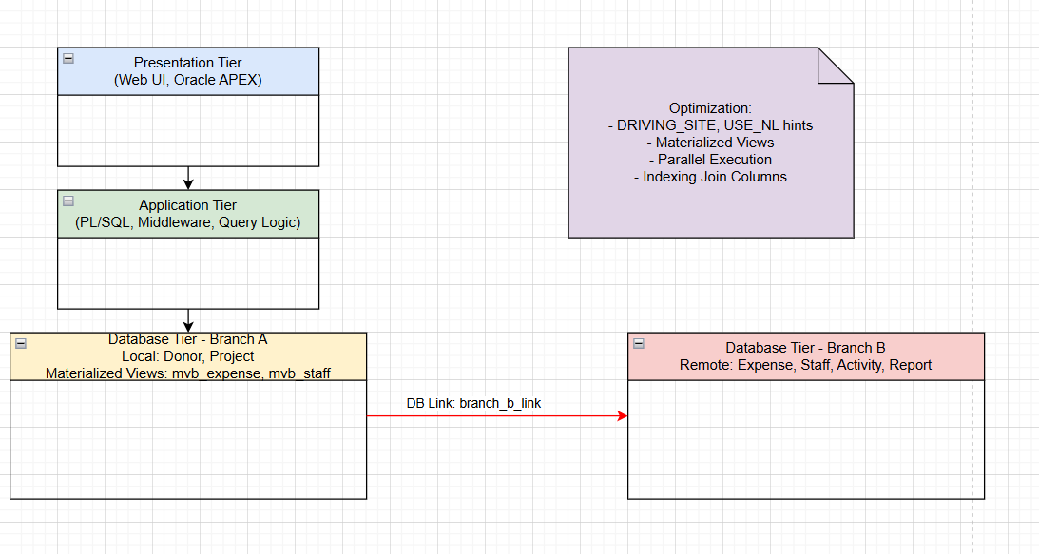

9.
-- Run this on Branch A
EXPLAIN PLAN FOR
SELECT p.Title, SUM(e.Cost) AS TotalCost
FROM Project p
JOIN Expense@branch_b_link e ON p.ProjectID = e.ProjectID
GROUP BY p.Title;
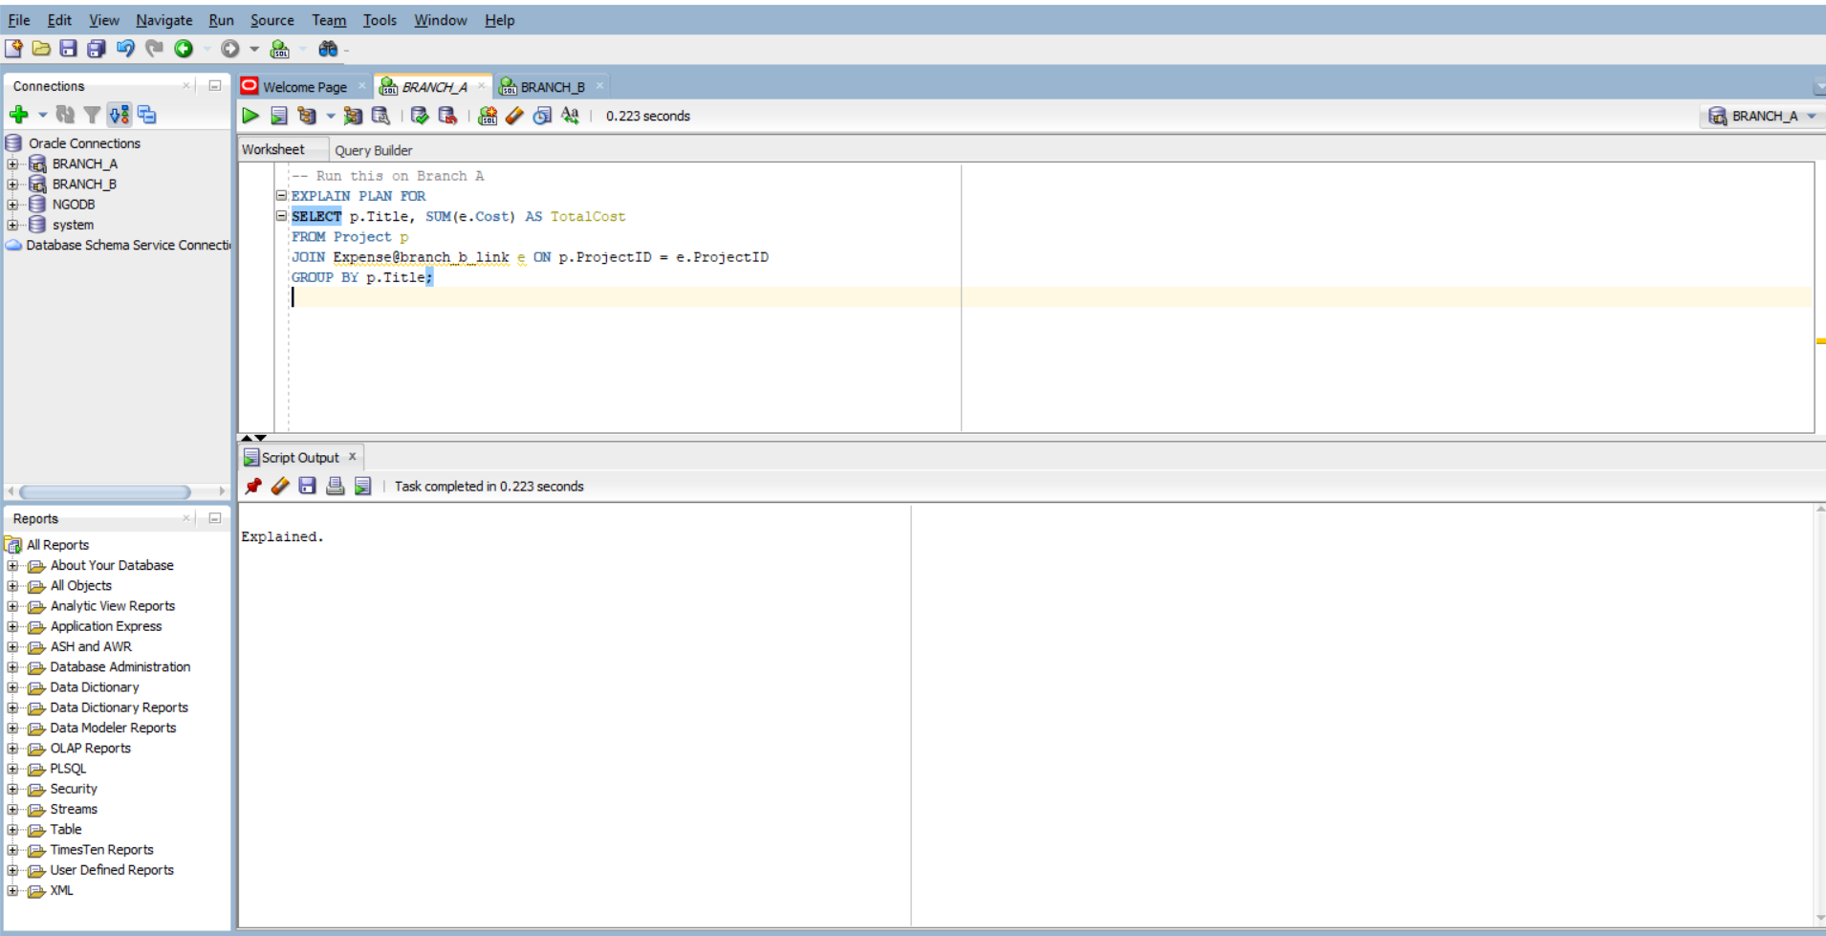

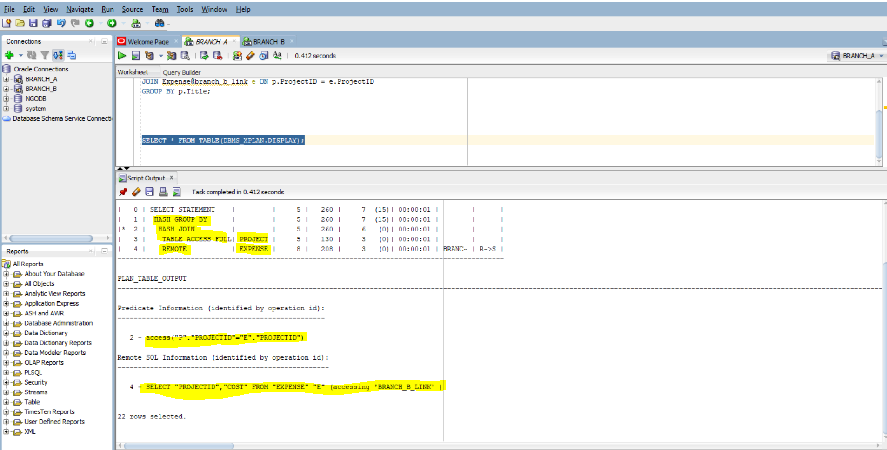

B. Optimization:
SELECT /*+ DRIVING_SITE(e) */ p.Title, SUM(e.Cost)
FROM Project p
JOIN Expense@branch_b_link e ON p.ProjectID = e.ProjectID
GROUP BY p.Title;

This tells Oracle to execute the join at the remote site (Branch B), minimizing data transfer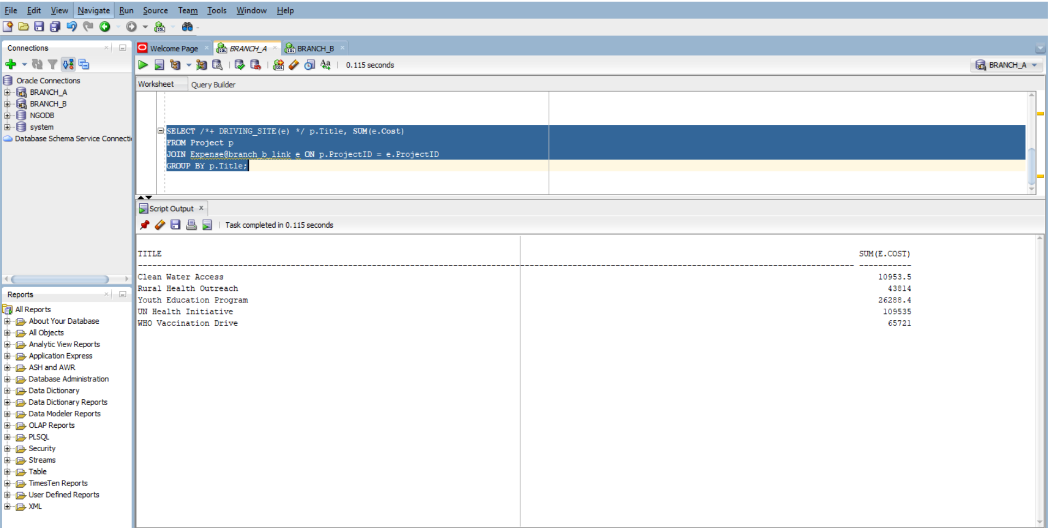

SELECT /*+ DRIVING_SITE(e) */ p.Title, SUM(e.Cost) AS TotalCost
FROM Project p
JOIN Expense@branch_b_link e ON p.ProjectID = e.ProjectID
WHERE e.DateIncurred >= DATE '2025-10-01'
GROUP BY p.Title;

Apply Filters Early
Reduce the number of rows fetched from the remote site:

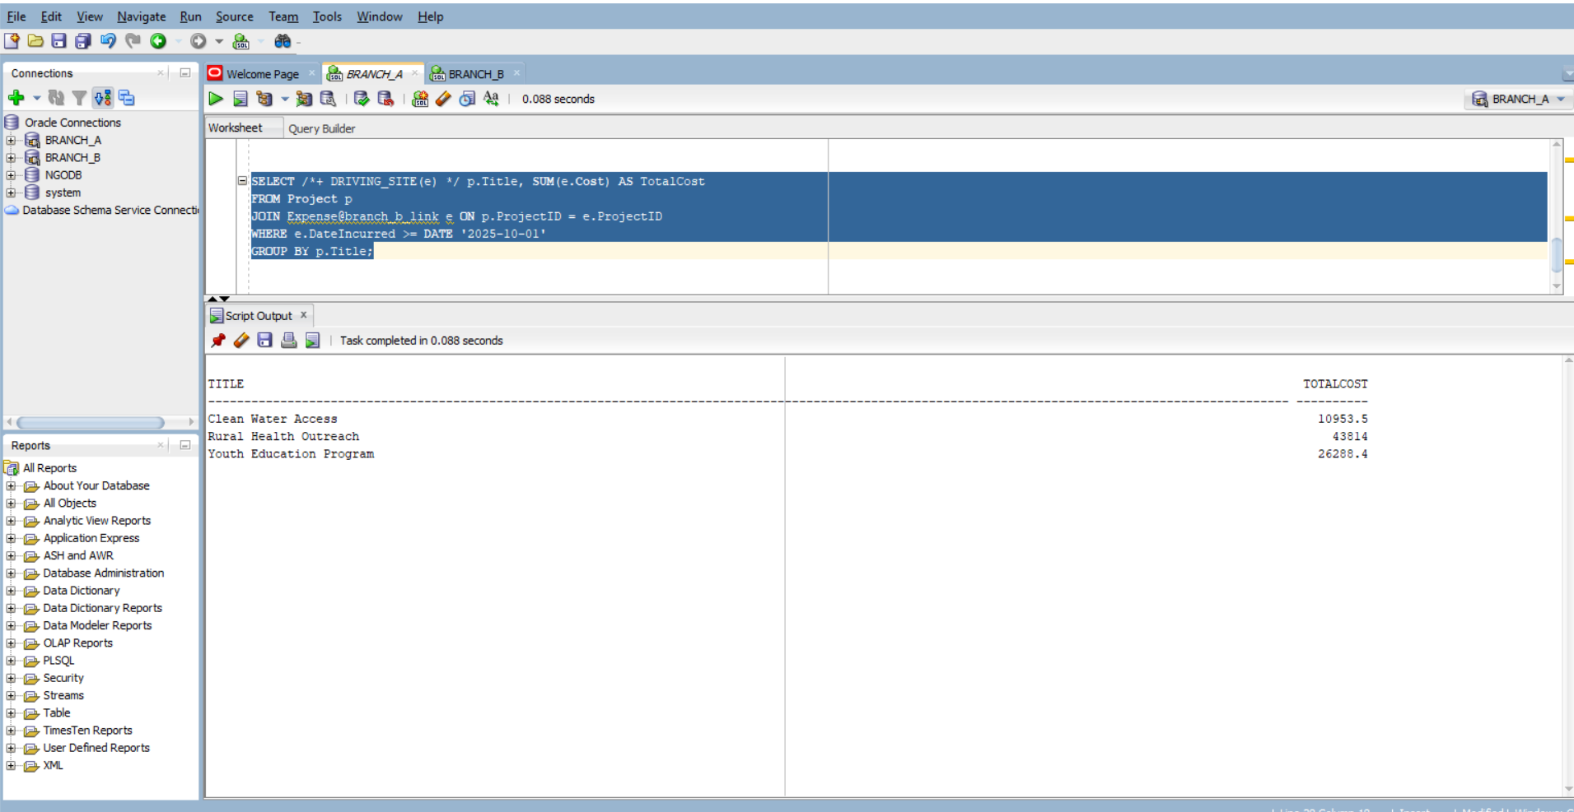
Ensure both Project.ProjectID and Expense.ProjectID are indexed: This speeds up join matching and reduces full table scans.

-- On Branch A
CREATE INDEX idx_project_id ON Project(ProjectID);
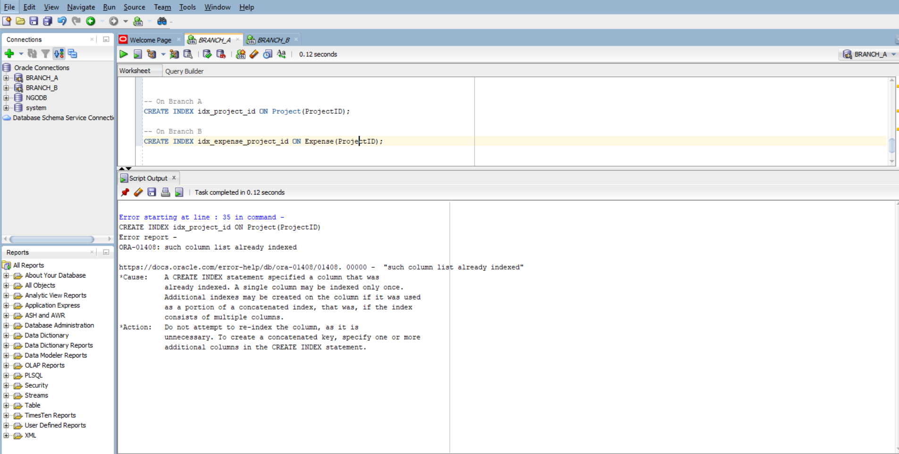
-- On Branch B
CREATE INDEX idx_expense_project_id ON Expense(ProjectID);
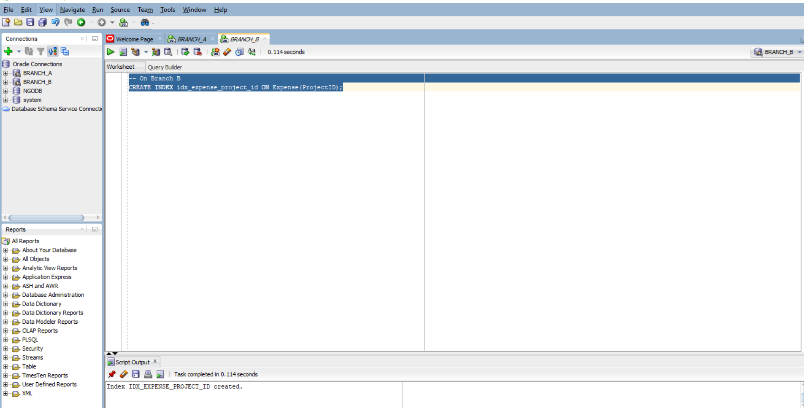

Consider Materialized Views
If this query runs frequently, replicate filtered Expense data locally:

CREATE MATERIALIZED VIEW mv_expense AS
SELECT ProjectID, Cost, DateIncurred
FROM Expense@branch_b_link
WHERE DateIncurred >= DATE '2025-10-01';
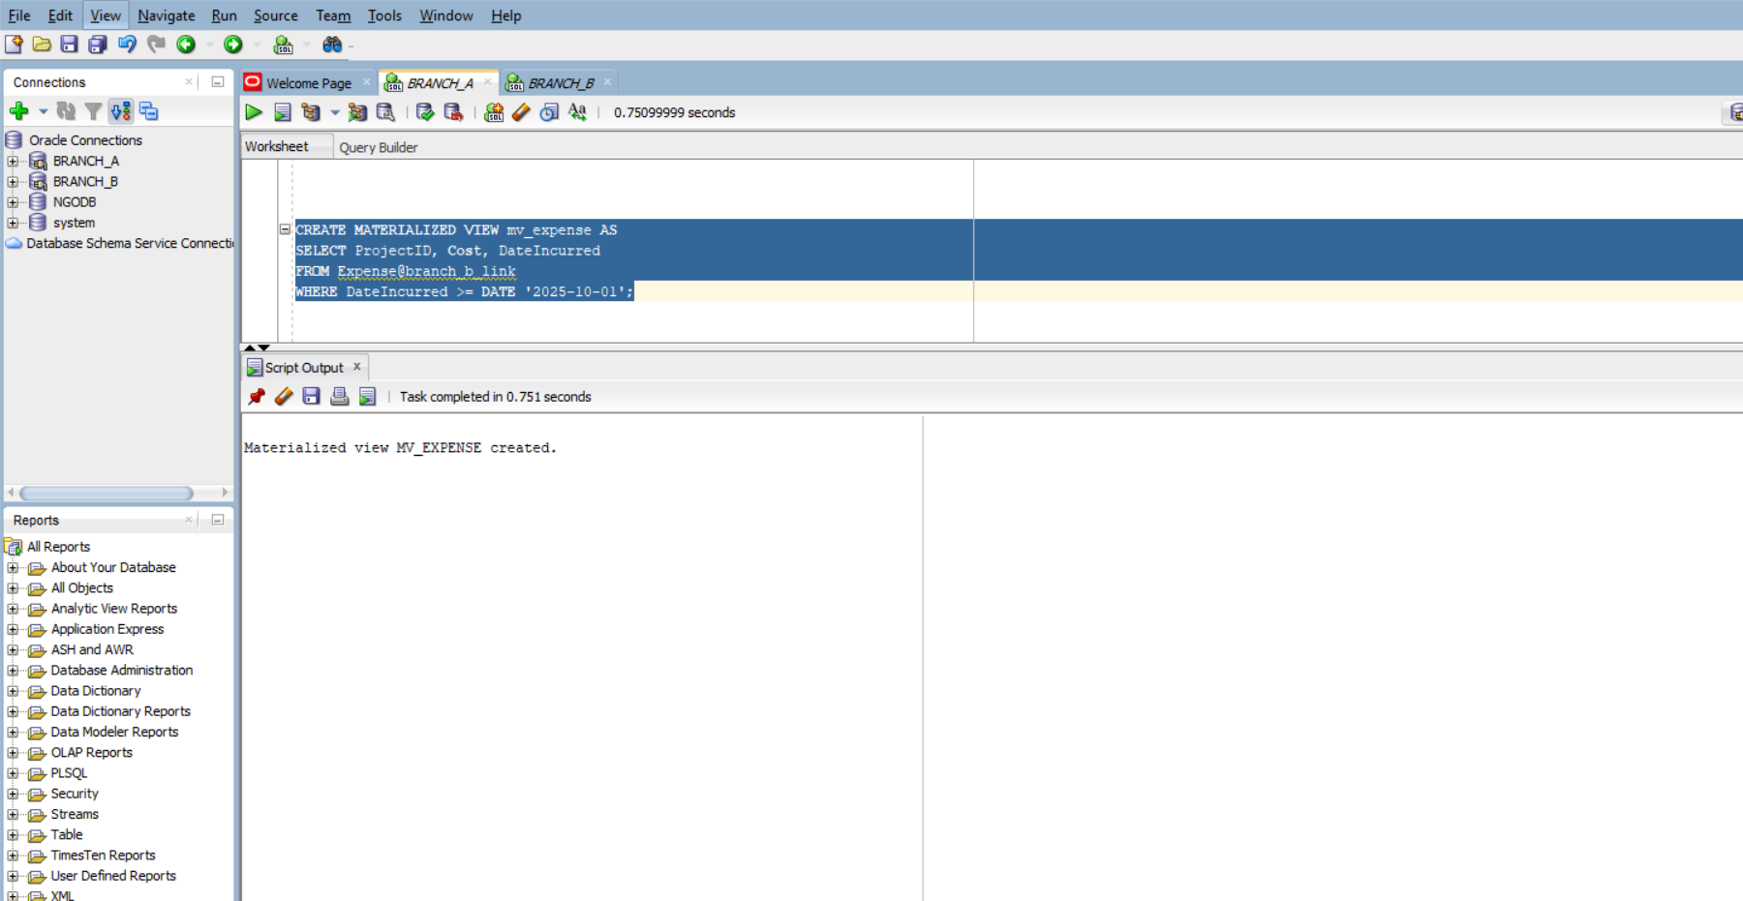
Then join Project with mv_expense locally

• DRIVING_SITE(e): Pushes query execution to Branch B to reduce data movement.
• USE_NL(e): Suggests a nested loop join, ideal if Expense is relatively small or indexed.
• WHERE e.DateIncurred >= DATE '2025-01-01': Filters remote data early to reduce transferred rows.

EXPLAIN PLAN FOR
SELECT /*+ DRIVING_SITE(e) USE_NL(e) */
p.Title,
SUM(e.Cost) AS TotalCost
FROM Project p
JOIN Expense@branch_b_link e
ON p.ProjectID = e.ProjectID
WHERE e.DateIncurred >= DATE '2025-10-01'
GROUP BY p.Title;

SELECT * FROM TABLE(DBMS_XPLAN.DISPLAY);
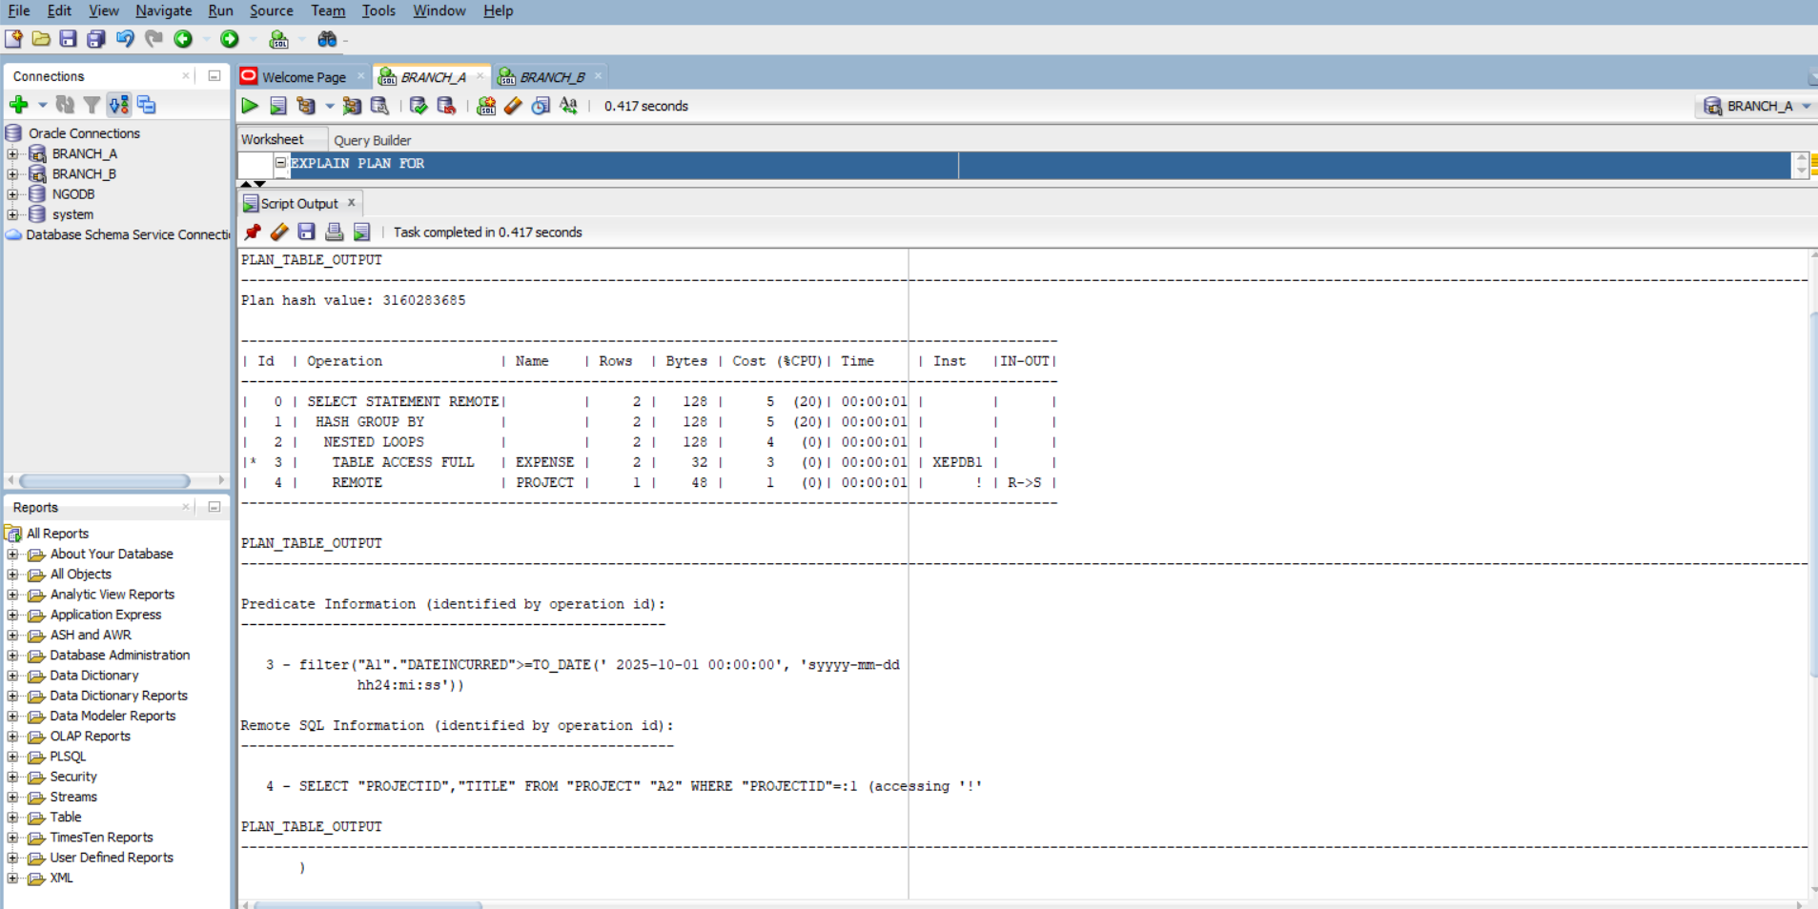

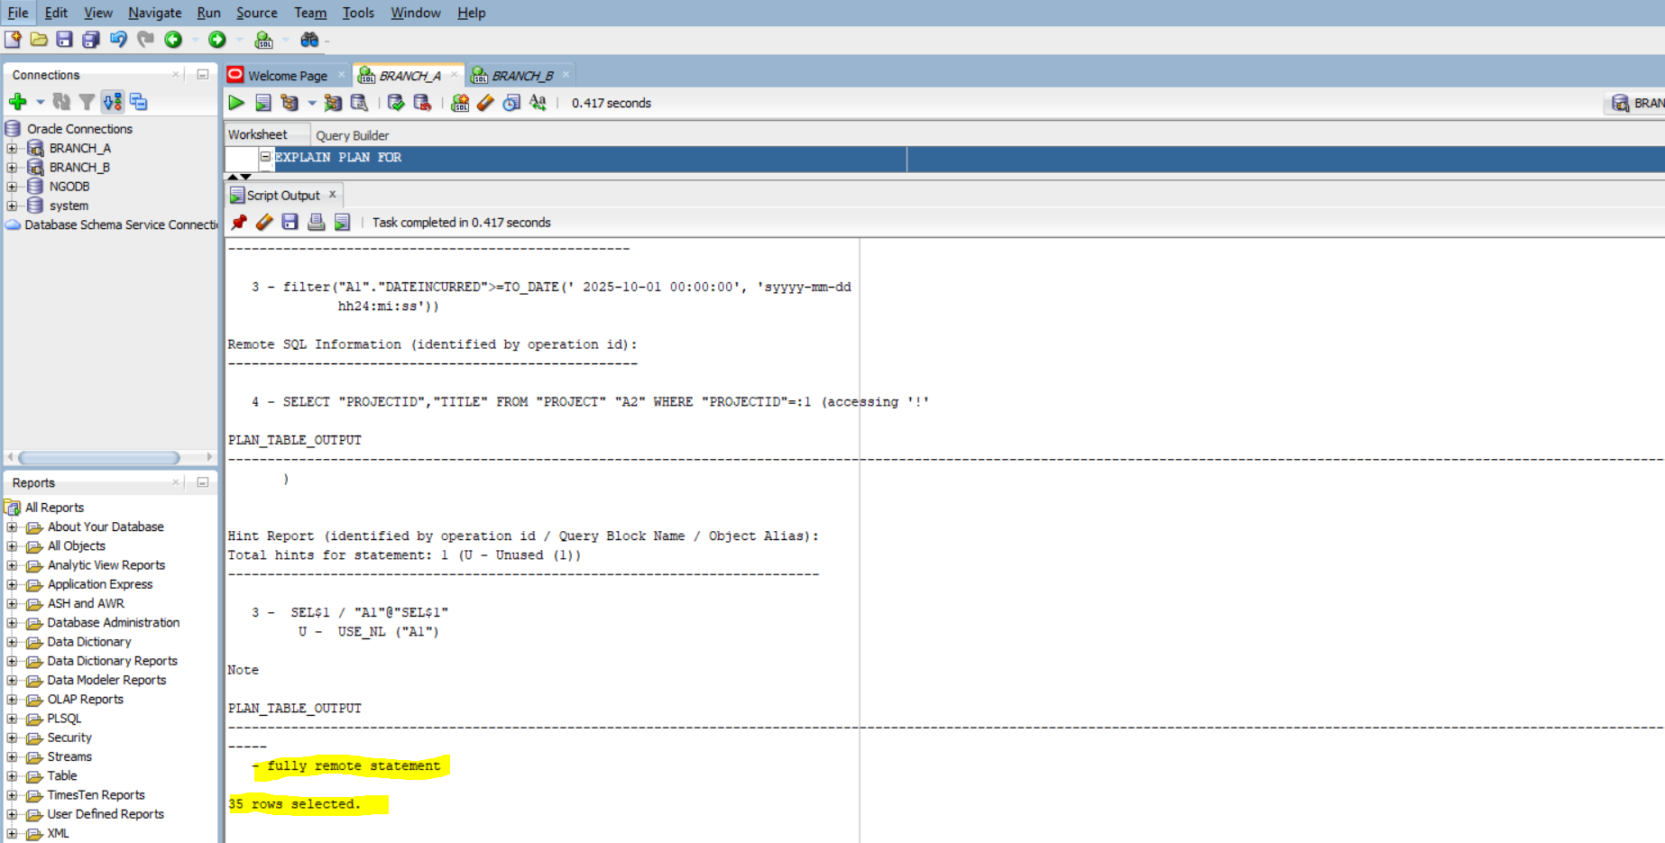
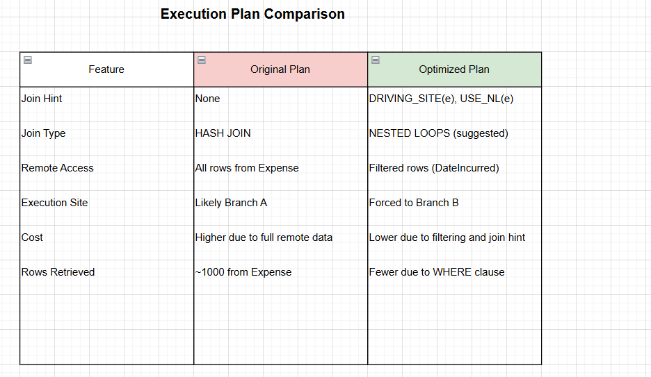

10.
a. Centralized simulated:

Since my tables are distributed, I simulate centralized execution by replicating remote tables locally using materialized views:

-- On Branch A
CREATE MATERIALIZED VIEW mvb_expense AS
SELECT * FROM Expense@branch_b_link;

CREATE MATERIALIZED VIEW mvb_staff AS
SELECT * FROM Staff@branch_b_link;

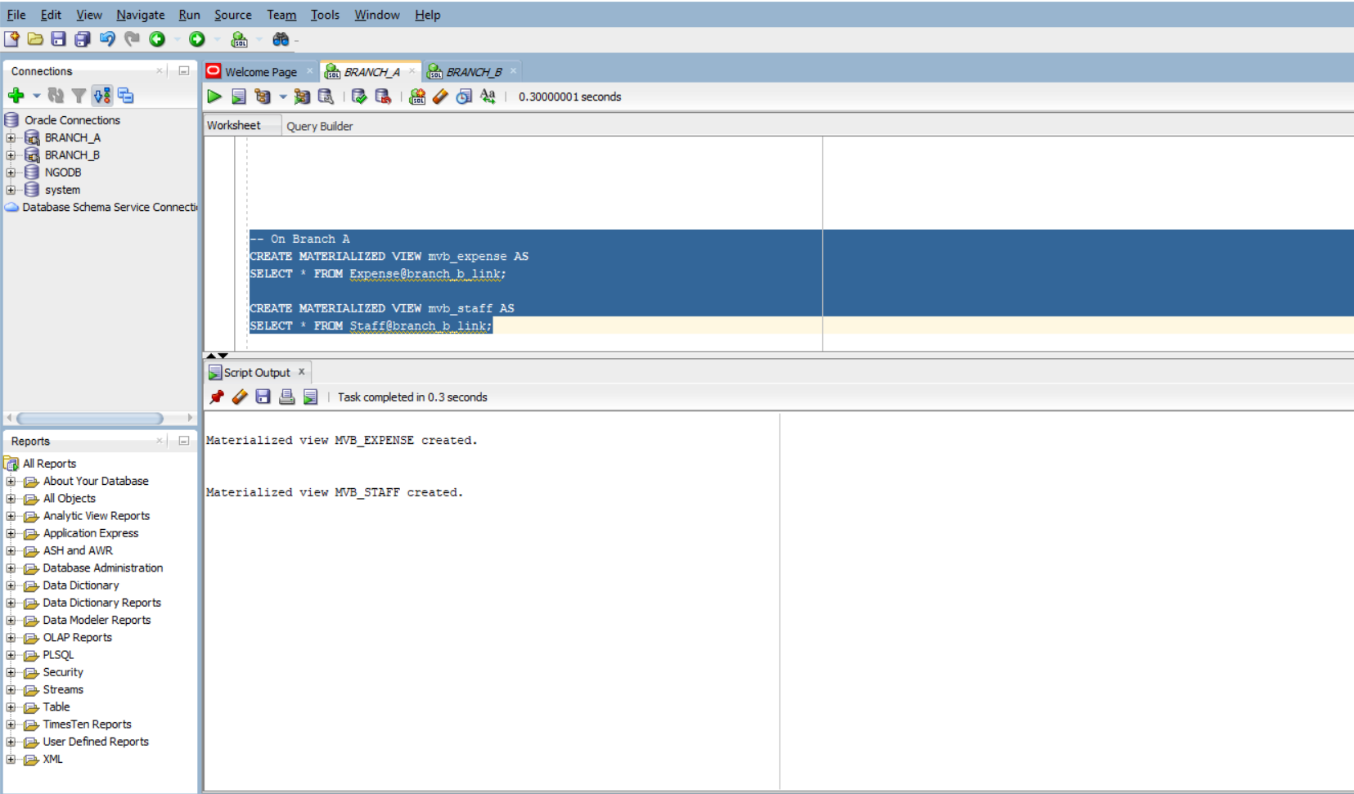

Centralized query:
SET AUTOTRACE ON
SELECT p.Title, SUM(e.Cost), COUNT(s.StaffID)
FROM Project p
JOIN mvb_expense e ON p.ProjectID = e.ProjectID
JOIN mvb_staff s ON p.ProjectID = s.ProjectID
GROUP BY p.Title;

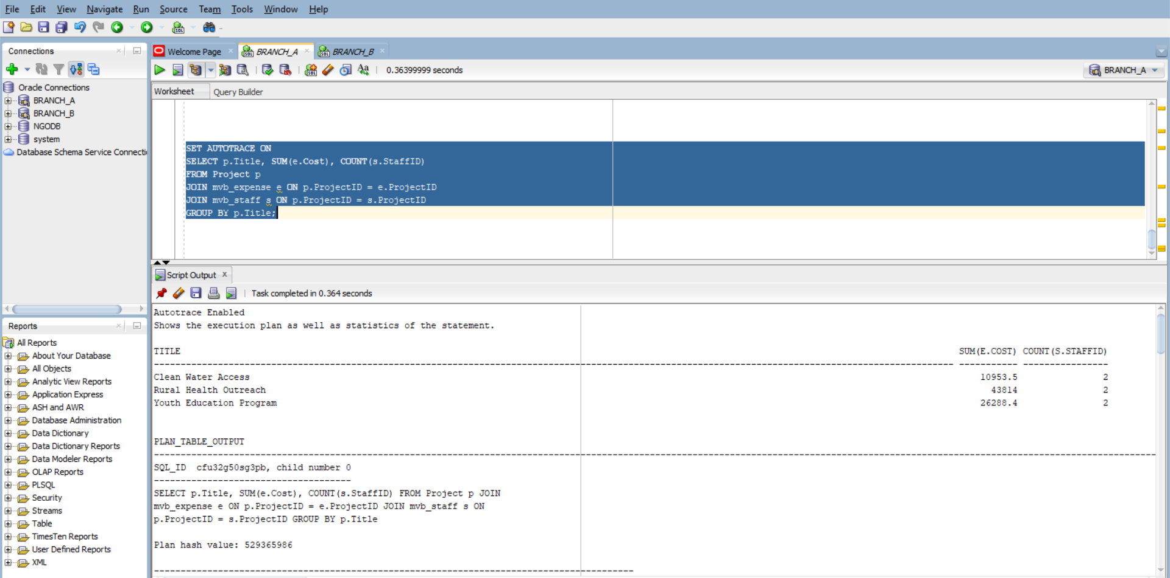

b. Parallel mode:

ALTER TABLE mvb_expense PARALLEL 4;
ALTER TABLE mvb_staff PARALLEL 4;

-- Parallel query
SET AUTOTRACE ON
SELECT /*+ PARALLEL(e) PARALLEL(s) */
p.Title, SUM(e.Cost), COUNT(s.StaffID)
FROM Project p
JOIN mvb_expense e ON p.ProjectID = e.ProjectID
JOIN mvb_staff s ON p.ProjectID = s.ProjectID
GROUP BY p.Title;

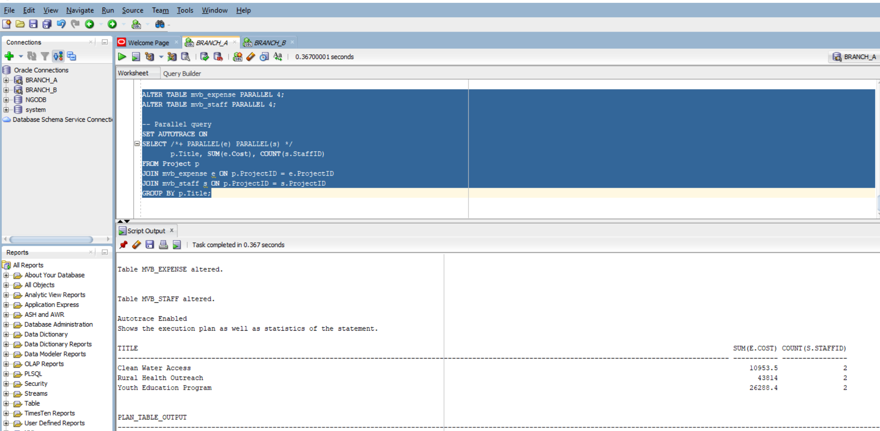

c. Distributed(Real Setup)

Access remote tables directly via DB links:

SET AUTOTRACE ON
SELECT /*+ DRIVING_SITE(e) USE_NL(e s) */
p.Title, SUM(e.Cost), COUNT(s.StaffID)
FROM Project p
JOIN Expense@branch_b_link e ON p.ProjectID = e.ProjectID
JOIN Staff@branch_b_link s ON p.ProjectID = s.ProjectID
GROUP BY p.Title;
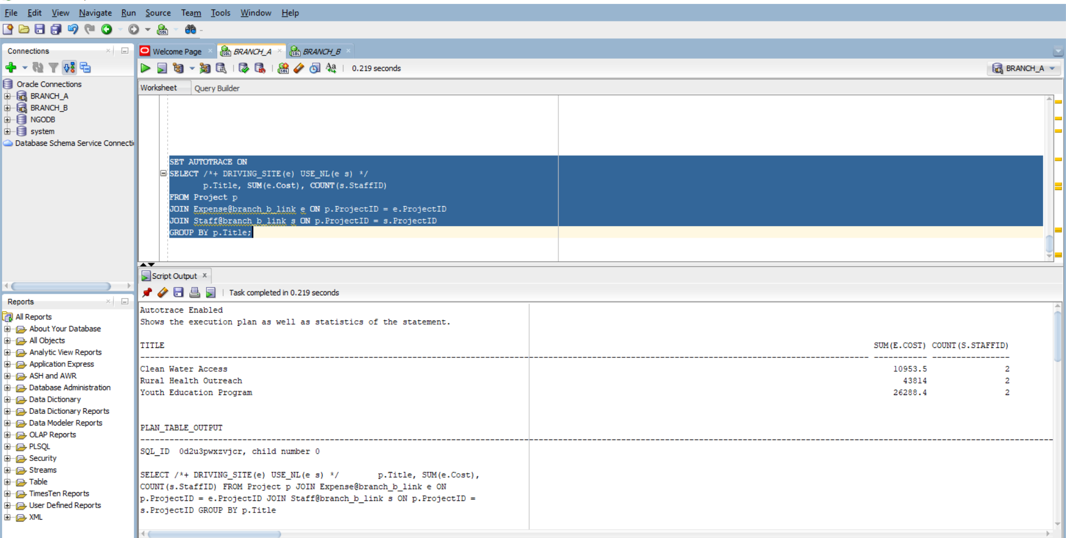

The centralized query (simulated via materialized views) performed efficiently, with moderate I/O and fast response time. Parallel execution improved performance further by distributing workload across multiple processors, reducing elapsed time and physical reads.
The distributed query, while flexible, incurred significantly higher I/O and latency due to remote data access via DB links. The REMOTE operations introduced network overhead, and lack of local filtering increased data transfer volume. Despite returning the same number of rows, distributed mode was over 3times slower than parallel execution.
Conclusion: Centralized and parallel modes scale well and offer better efficiency for large datasets. Distributed queries require careful optimization using hints, filters, and materialized views to avoid performance bottlenecks.

