🎯 What this research is for
Answer 1 of the working series
29 September 2026
Status: agreed aim, before the historical and pattern chapters
🔑 How to read this edition
The central idea of the chapter — bold, on a yellow marker.
An important sentence — blue and underlined, in the text itself.
A technical term — plum with a dotted line; its meaning is in “Words to know”.
💬 In plain words 🧭 The chapter as a map 📖 Words to know 🔁 Read it again

⭐ In one sentence
This research asks one question — how AI has changed microservice architecture — and answers it under five headings: design, boundaries, communication, operations, and tradeoffs.

💬 In plain words
Picture a city. A monolith is one department store: everything under one roof, one set of doors, one power supply. Microservices are a street of small shops, each with its own keys, its own till, and its own opening hours, trading with each other across the street. This research asks a precise question: now that AI helps design, build, and run those shops, did the layout of the street change — or only the tools in the builders’ hands?

📖 Words to know
microservice architecture | A way of building one application as many small, separately deployable programs (services), each owned by a small team and each with its own data.
design patterns | Named, reusable solutions to problems that keep recurring — a shared vocabulary, not a library.
baseline | The ‘before’ picture that later chapters compare AI’s influence against.
monolith | The opposite of microservices: one program, one deployment, one database.

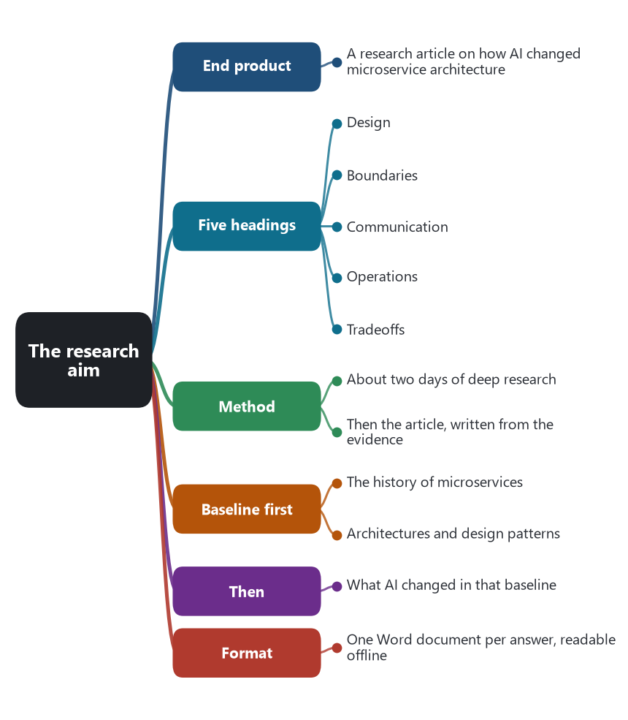
The chapter as a map: its sections and what each one holds.
The end product is a research article on how AI has changed microservice architecture: design, boundaries, communication, operations, and the tradeoffs that come with those changes.
The work is planned as about two days of deep research, followed by the article written from the evidence gathered. The history of microservices, and the architectures and design patterns of that style, are the baseline. Later chapters ask what AI changed in that baseline.
Each answer in the series is saved as its own Word document in this folder, so the draft can be read offline while the research continues.
🔁 Read it again: three things to carry away
1. The article asks one question — how AI changed microservice architecture — under five headings.
2. History and patterns come first, as the baseline; only then does the AI question get asked.
3. Each answer is its own document, so the draft can be read offline while the research continues.

