🕰️ The history of microservices
Answer 2 of the working series
29 September 2026
Baseline chapter. This is the architecture AI later meets.
🔑 How to read this edition
The central idea of the chapter — bold, on a yellow marker.
An important sentence — blue and underlined, in the text itself.
A technical term — plum with a dotted line; its meaning is in “Words to know”.
💬 In plain words 🧭 The chapter as a map 📖 Words to know 🔁 Read it again

⭐ In one sentence
Microservices were practiced for a decade before they were named in 2012 and described in 2014 — and that 2014 description is the ruler every later ‘AI changed it’ claim will be measured against.

💬 In plain words
Nobody invented microservices on a given day. The habit of small programs that do one thing and talk through simple channels is as old as Unix. Amazon and Netflix practiced it under other names because their single big applications stopped scaling; a group of architects gave it the name in 2012; Lewis and Fowler described it in 2014; and by 2015 the same people were warning about its price. The chapter’s job is to fix the 2014 description as the ruler.

📖 Words to know
monolith | One program, one deployment, one database — the shape microservices are contrasted with.
SOA | Service-oriented architecture: the 1990s–2000s idea of sharing logic and data through service interfaces; in enterprises it often arrived as SOAP and a central bus.
SOAP | An XML-based protocol for calling services, heavy on formal contracts and tooling.
enterprise service bus | A central piece of middleware that routed, transformed, and applied rules to messages between applications — the ‘smart pipe’ microservices rejected.
Conway | Melvin Conway’s 1968 observation, now ‘Conway’s law’: a system’s structure copies the communication structure of the organization that builds it.
two-tier | An application split only into a client and a database, with the logic in one or the other.
design for failure | Assuming remote calls will fail and building timeouts, circuit breakers, and fallbacks in from the start.
Docker | The tool that made containers ordinary: a packaged, isolated process with everything it needs, portable from laptop to server.
Kubernetes | Software that places, starts, restarts, and scales many containers across many machines (‘orchestration’).
Linkerd | The first service mesh (2016): a layer of proxies beside every service that handles retries, encryption, and routing.
modular monolith | One deployable unit whose internal boundaries are enforced in the code, so it could be split later.
Twelve-Factor App | Heroku’s 2011 rules for applications that run well on a platform: configuration in the environment, disposable processes, logs as streams.
CAP conjecture | Brewer’s 2000 statement that a distributed store cannot promise consistency, availability, and partition tolerance all at once.
REST | Fielding’s 2000 web style: resources with addresses, manipulated through a small set of verbs.

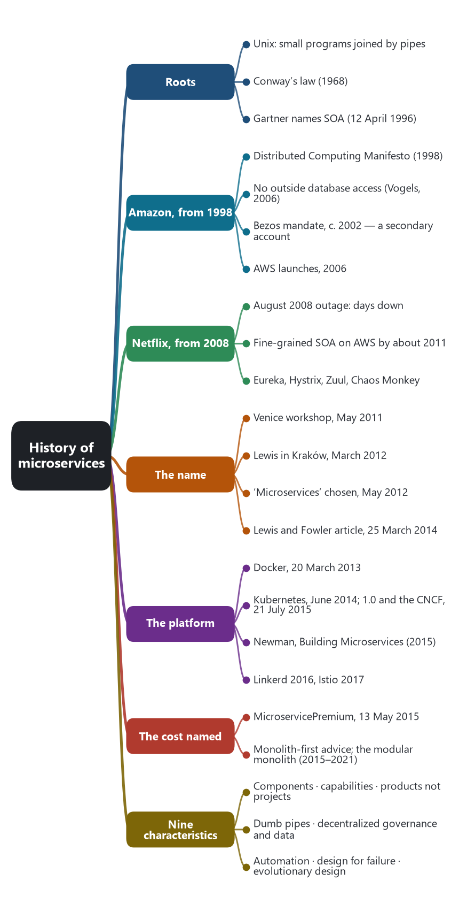
The chapter as a map: its sections and what each one holds.
Microservices were a running practice for more than a decade before the industry had a stable name for them. The word was argued over in 2011 and 2012 and fixed in public on 25 March 2014, when James Lewis and Martin Fowler published “Microservices” on martinfowler.com. That article is the baseline for the rest of this research: any claim that AI changed the architecture has to say which part of that 2014 style actually moved.

🧬 The style is older than the word
Fowler and Lewis said the roots go back at least to Unix: small programs, each doing one job, joined by simple pipes. Lewis’s March 2012 talk in Kraków was titled “Microservices — Java, the Unix Way.” The organizational idea is older still. Melvin Conway wrote in 1968 that a system copies the communication structure of the organization that designs it. That sentence later justified drawing service boundaries along business teams.

📜 Service orientation was named in 1996
On 12 April 1996, Gartner analysts Roy Schulte and Yefim Natis described a “service oriented” architecture: shared logic and data, reached through interfaces, so many applications could use the same capability. Through the 2000s that idea often arrived in enterprises as SOAP, central governance, and an enterprise service bus that routed, transformed, and applied rules. Lewis and Fowler wrote the 2014 article because “SOA” had come to mean too many incompatible things, and the systems they admired were a sharper variant: smart services, dull pipes.

🛒 Amazon was already doing it
In 1998, senior Amazon engineers wrote the Distributed Computing Manifesto. Werner Vogels published that memo in 2022. It separates presentation, business logic, and data, and it has clients reach data only through a service. In a 2006 interview for ACM Queue, Vogels said the two-tier monolith had stopped scaling around 2001. The rule they adopted was: encapsulate the data with the logic that uses it, allow no outside database access, and share no data between services.
A 2011 account by former Amazon engineer Steve Yegge describes a Jeff Bezos mandate, around 2002, that every team expose its data only through a network interface designed as if outsiders might call it. That memo is a retelling, so it is weaker evidence than Vogels. The public consequence is firmer: Amazon Web Services launched in 2006 by externalizing infrastructure Amazon had built for itself.

🎬 Netflix made the style famous at web scale
Adrian Cockcroft later described a 2008 data-center outage that took Netflix down for several days, as streaming load was arriving on top of the DVD business. The decision was to leave data-center operations and rebuild for the cloud. He called the result “fine-grained SOA.” The customer-facing product was running in AWS by about the end of 2011. The tools that leaked into the industry — Eureka, Hystrix, Zuul, and Chaos Monkey — are the public form of one 2014 characteristic: design for failure, because a remote call will fail.

🏷️ The name, then the platform
In May 2011 a workshop of architects near Venice found they had been building the same style under different labels. Lewis presented it in March 2012 at the 33rd Degree conference in Kraków. Fred George was speaking about the same ideas around the same time. In May 2012 that group chose “microservices.”
Docker was shown at PyCon and open-sourced on 20 March 2013, which made a service a portable deployable unit. Kubernetes’s first commit is 6 June 2014. Eric Brewer announced the project at DockerCon on 10 June 2014. Kubernetes 1.0 and the Cloud Native Computing Foundation were announced together on 21 July 2015. Sam Newman’s Building Microservices (2015) became the practice manual. Linkerd (2016) and Istio (2017) then added a traffic layer — discovery, retries, and routing — because operating hundreds of services had become its own problem.

💸 The same year as the boom, the cost was named
On 13 May 2015 Fowler published “MicroservicePremium”: distribution adds complexity and risk, and teams that take it on before they need it get into trouble. From 2015 through about 2021 the correction was monolith-first advice and the modular monolith. Many systems called microservices were one deployment unit sliced across the network, still sharing a database and a release train.

📌 What the 2014 article fixed as the style
Lewis and Fowler refused a formal definition. They listed characteristics they kept seeing in the field. Most systems called microservices showed most of these, and the list is what later writers argued with. These nine characteristics are the baseline this research will test against AI.
Characteristic | What it required
Services as components | Independently replaceable processes, reached by a remote call, rather than libraries linked into one executable.
Business capabilities | Boundaries follow the business, and teams are cross-functional. Conway’s Law (1968) is the cited reason.
Products, not projects | The team that builds a service keeps it. Amazon’s phrase was “you build it, you run it.”
Smart endpoints, dumb pipes | HTTP or a plain message bus. Routing and business rules stay in the service, away from an enterprise service bus.
Decentralized governance | Each service may choose its language and libraries. Shared tools are harvested from working code.
Decentralized data | Each service owns its data. Bounded contexts (Evans, 2003) and separate databases are the usual shape.
Infrastructure automation | Independent deployability only works with automated build and release.
Design for failure | Remote calls fail. Timeouts, circuit breakers, and isolation are part of the design.
Evolutionary design | Services can be split, replaced, or retired without a coordinated rewrite of the whole system.

Source: James Lewis and Martin Fowler, “Microservices,” martinfowler.com, 25 March 2014.

🕰️ Timeline
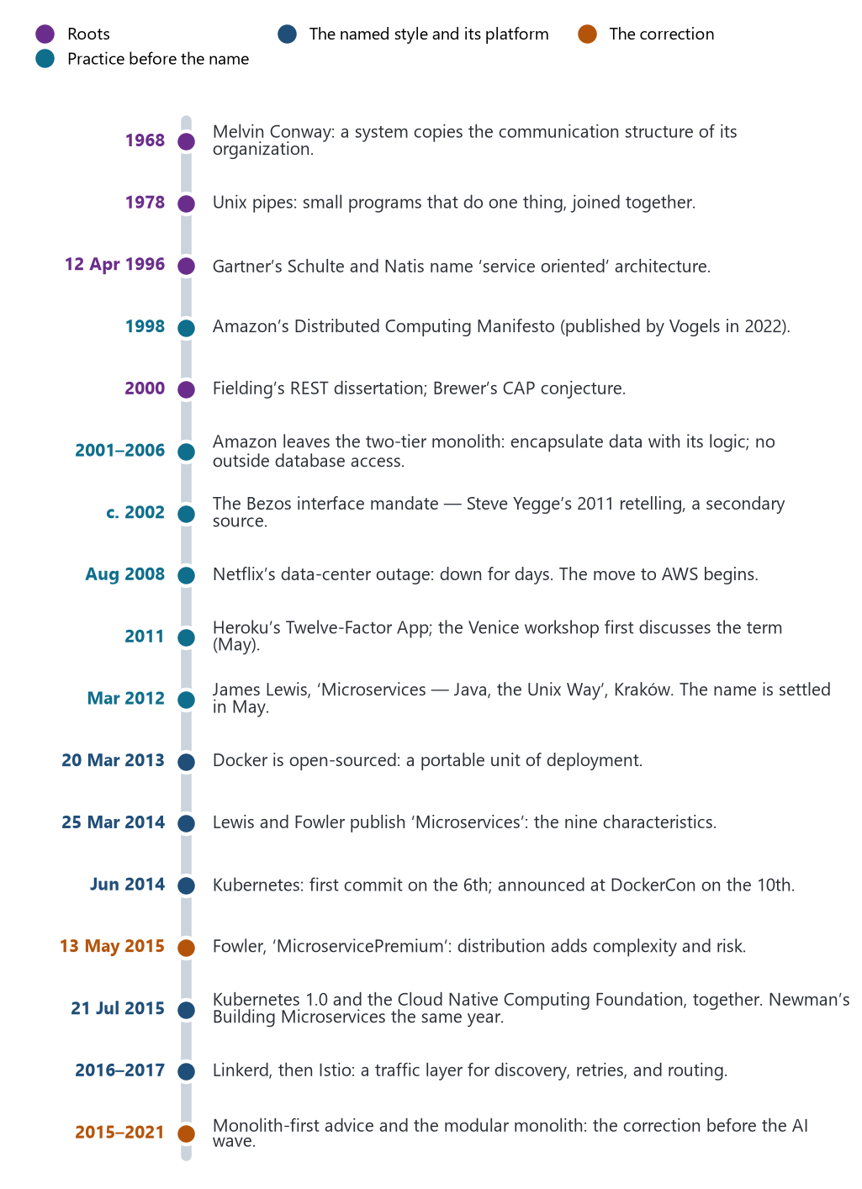
The road to the name and beyond, 1968–2021. Colors mark the four periods of the history chapter.
Years are publication or public-event dates. The Amazon mandate around 2002 is Steve Yegge’s later retelling, so it is marked as secondary. Werner Vogels’s own account is the stronger Amazon source.
Year | Event | Why it sits in this history
1968 | Melvin Conway, “How Do Committees Invent?” | Later used to justify aligning service boundaries with team boundaries.
1978 | Unix pipes and programs that do one thing | Lewis titled his 2012 talk “Microservices — Java, the Unix Way.” Fowler names Unix as a root.
1996 | Gartner, “Service Oriented Architectures,” Roy Schulte and Yefim Natis, 12 April | First widely cited naming of SOA: shared logic and data behind service interfaces.
1998 | Amazon, Distributed Computing Manifesto | Senior engineers propose separating presentation, business logic, and data, with clients reaching data only through a service. Vogels published the memo in 2022.
2000 | Fielding’s REST dissertation; Brewer’s CAP conjecture | The web’s resource style, and the distributed-systems limit that design-for-failure later assumes.
2001–2006 | Amazon moves off the two-tier monolith | Vogels (ACM Queue, 2006): encapsulate data with the logic that uses it; no outside database access; no shared data between services.
c. 2002 | Bezos interface mandate, via Steve Yegge (2011) | Secondary account: teams expose data only through network interfaces, designed as if outsiders might call them. AWS in 2006 is the public result.
August 2008 | Netflix data-center outage | Adrian Cockcroft: down for several days. That outage starts the leave-the-data-center decision. He later calls the result fine-grained SOA.
2011 | Heroku, The Twelve-Factor App; Venice workshop in May | An operations doctrine for apps on a platform, and the first recorded discussion of the microservice term.
March 2012 | Lewis at 33rd Degree, Kraków; Fred George around the same time | First public case-study talks. In May 2012 the Venice group settles on the name microservices.
March 2013 | Docker shown at PyCon; open-sourced 20 March | A portable unit of deployment. Independent services become ordinary to package.
25 March 2014 | Lewis and Fowler, “Microservices” | The article that gives the industry a shared description, written because SOA had become too vague.
June 2014 | Kubernetes: first commit 6 June; Eric Brewer announces it 10 June at DockerCon | Orchestration for many containers. The style now has an operations substrate.
2015 | Sam Newman, Building Microservices; Kubernetes 1.0 and the CNCF, 21 July | The practice manual, and the foundation that hosts the cloud-native toolchain.
13 May 2015 | Fowler, “MicroservicePremium” | The cost is named in the same year as the boom: distribution adds a premium in complexity and risk.
2016–2017 | Linkerd, then Istio | A dedicated layer for discovery, retries, and traffic between services. The mesh is operations catching up with the architecture.
2015–2021 | Monolith-first advice and the modular monolith | The correction before the AI wave: many teams had distributed a monolith and paid the premium without the independence.

Primary anchors: martinfowler.com (2014, 2015); Werner Vogels, ACM Queue (2006) and All Things Distributed (2022); Adrian Cockcroft’s account of the 2008 outage; the Kubernetes project blog and the 21 July 2015 Google Cloud post on version 1 and the Cloud Native Computing Foundation.

🌿 Two lineages that predate the name

🛒 Amazon, from 1998
A retail monolith that could not scale as a two-tier application. The remedy was service isolation: each capability owns its data and publishes an interface. By Vogels’s 2006 account, that move was already a decentralized services platform. Public AWS, from 2006, externalized infrastructure those teams had built for themselves.

🎬 Netflix, from 2008
A single Java application on Oracle, then a multi-day data-center failure as streaming load arrived. Cockcroft’s program was cloud-native decomposition, with the customer-facing product in AWS by about the end of 2011. Eureka, Hystrix, Zuul, and Chaos Monkey are the public tools of design for failure.

🎯 Baseline for the AI question
The style was a rejection of one central brain — the enterprise service bus — in favor of many smart services and dull pipes. Any claim that AI changed microservice architecture has to say which of the nine 2014 characteristics moved: boundaries, ownership, pipes, data, deployment, or failure design.
This chapter stops before the AI wave. The next chapter records the architectures and design patterns of the style as it stood.
🔁 Read it again: three things to carry away
1. The practice is decades older than the name: the name is from 2012, the description from 25 March 2014.
2. Amazon and Netflix reached it by necessity — a monolith that stopped scaling, an outage that lasted days.
3. The nine characteristics of 2014 are the ruler; the 2015 ‘premium’ is the warning that travels with it.

