🏛️ Architectures and design patterns of microservices
Answer 3 of the working series
29 September 2026
Baseline chapter. The pattern language is the before-state for the AI question.
🔑 How to read this edition
The central idea of the chapter — bold, on a yellow marker.
An important sentence — blue and underlined, in the text itself.
A technical term — plum with a dotted line; its meaning is in “Words to know”.
💬 In plain words 🧭 The chapter as a map 📖 Words to know 🔁 Read it again

⭐ In one sentence
Microservice architecture is one style; the patterns are the decisions inside it, arranged as the questions an architect meets in order — and any AI claim must name one of those decisions.

💬 In plain words
A pattern is a named, reusable answer to a recurring problem — ‘circuit breaker’, ‘saga’, ‘API gateway’. Richardson’s pattern language is a menu of such answers, arranged as the questions an architect meets in order: where to cut, who owns the data, how a multi-step action survives when one step fails, how services find and talk to each other, how the whole thing stays visible. Read the chapter as a checklist of decisions; the AI question later asks which decisions moved.

📖 Words to know
pattern language | A connected set of patterns arranged by the problems they solve, so one leads to the next.
saga | A multi-step business action done as a chain of local transactions, each with a compensating (undo) step.
compensations | Business-level undo steps for completed work — a refund, not a database rollback.
Choreography | Coordinating a saga by having each service react to the last event and publish the next.
Orchestration | Coordinating a saga with one coordinator that tells each participant what to do next.
CQRS | Command Query Responsibility Segregation: one model for writes, a separate pre-built view for reads.
API composition | Answering a query by calling each service that owns part of the data and joining the results in memory.
transactional outbox | Writing the outgoing message into your own database in the same transaction as the data, so a helper can publish it reliably later.
idempotent | Safe to do twice: the second time has no extra effect.
API gateway | A single front door for outside clients that routes, authenticates, and sometimes aggregates.
backend for frontend | One such front door per kind of client — web, iOS, Android — owned by that client’s team.
service registry | The address book of running service instances and their locations.
circuit breaker | A guard that stops calling a failing dependency for a while, then tries again.
bulkheads | Isolating threads or connections per dependency so one failure cannot drain everything.
sidecar | A helper process running beside a service, handling cross-cutting chores such as retries and discovery.
service mesh | Sidecars beside every service plus a control plane that configures them all.
strangler application | Growing a new system around an old one, route by route, until the old one can be retired.
anti-corruption layer | A translation layer that keeps a legacy system’s model from leaking into a new one.
event sourcing | Storing the sequence of changes as the record, and rebuilding current state by replaying them.
gRPC | Google’s remote-call framework: a schema, generated clients, and HTTP/2 underneath.
access token | A signed token carrying who is asking, passed from service to service.

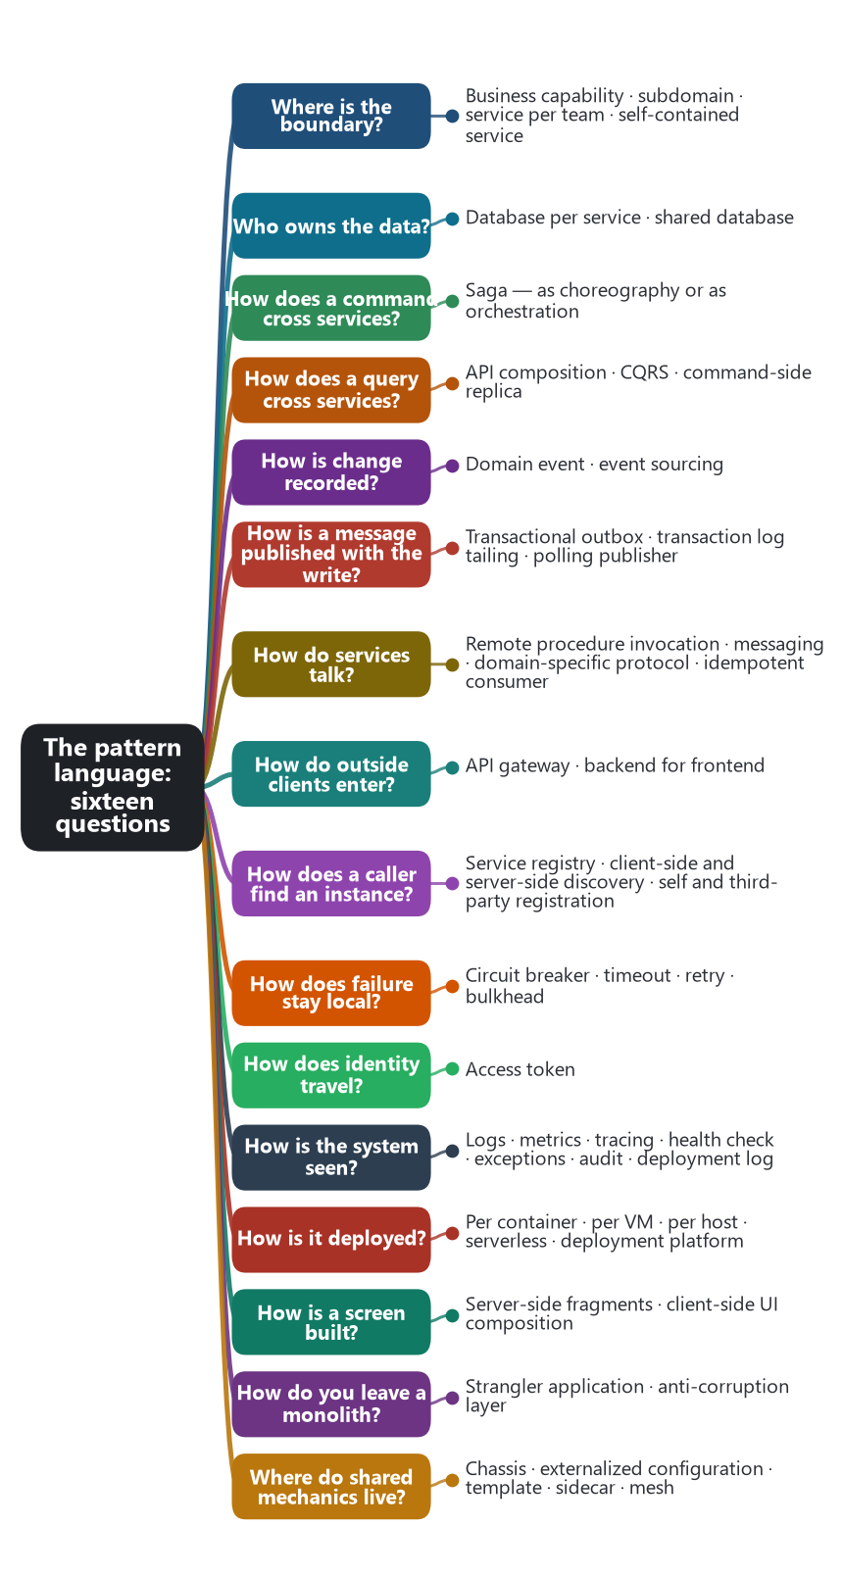
The chapter as a map: its sections and what each one holds.
Microservice architecture is one style. The patterns are the decisions inside that style. Chris Richardson’s pattern language at microservices.io is the catalog architects actually use. He dates it to 18 March 2014, a week before the Lewis and Fowler article, and published it as Microservices Patterns (Manning, 2018).

🏛️ The style
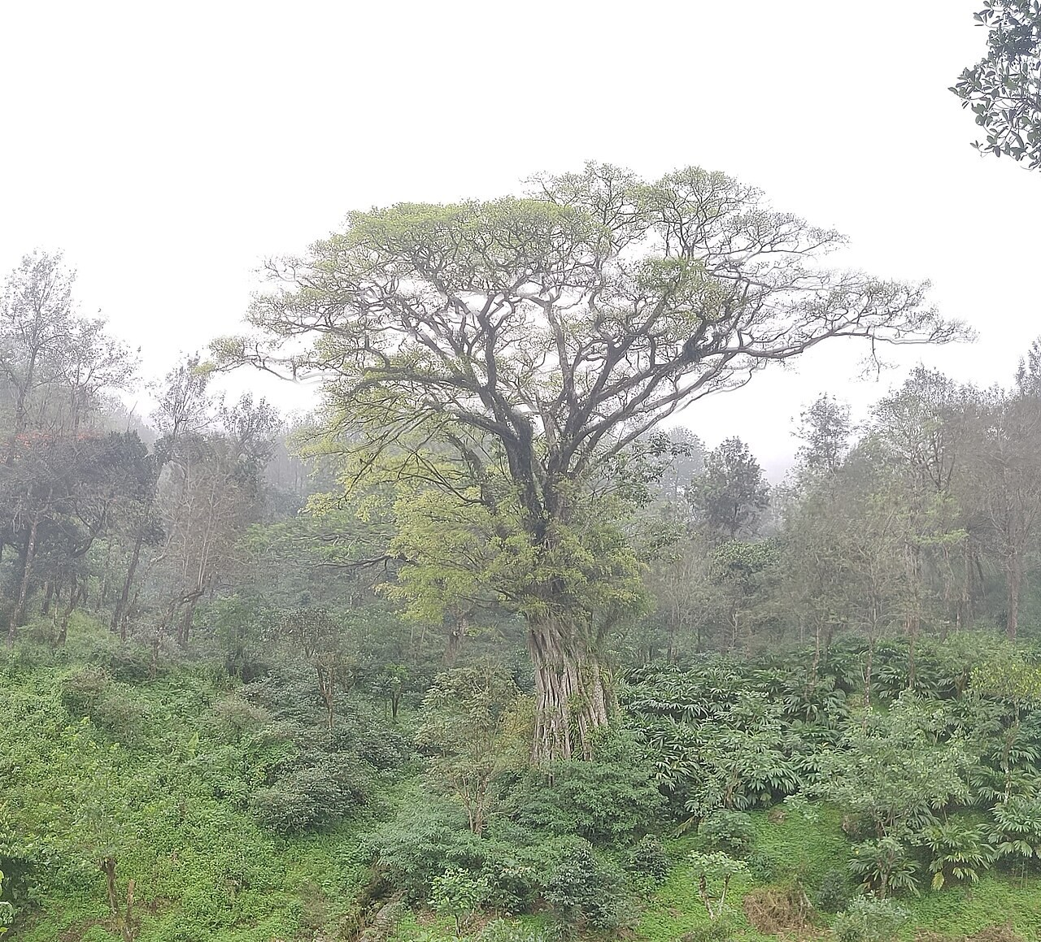
A strangler fig on its host tree in the Anamalai hills. The new grows around the old until the old can be removed — Martin Fowler’s metaphor for leaving a monolith. Photo: Shankar Raman, Wikimedia Commons, CC BY-SA 4.0.
An application is a set of services that can be deployed on their own and that stay loosely coupled. Richardson also keeps the monolith in the language, as the other style: one deployable unit. Moving from that unit to services is itself a design, usually the strangler application (Martin Fowler’s metaphor) plus an anti-corruption layer (Eric Evans, 2003) so the new model is translated at the edge of the old one.

✂️ Where the cut is made
Two decompositions carry the history already established. Decompose by business capability follows Lewis and Fowler. Decompose by subdomain follows Evans’s bounded contexts. Later additions are service per team, and the self-contained service: a service that answers a synchronous request without waiting on another service. Boundary size is the hard judgment. Forces that split a system — independent change, team autonomy, isolated failure — pull against forces that hold it together: data that must be consistent now, chatty calls, and operational cost.

🗄️ Who owns the data
Database per service is the data architecture that makes the rest necessary. Each service has a private database, so a schema change stays inside one team. A shared database is the other pattern in the language: one schema, and the services couple through it. Once data is private, one business action is no longer one database transaction.

🔗 How an action crosses services
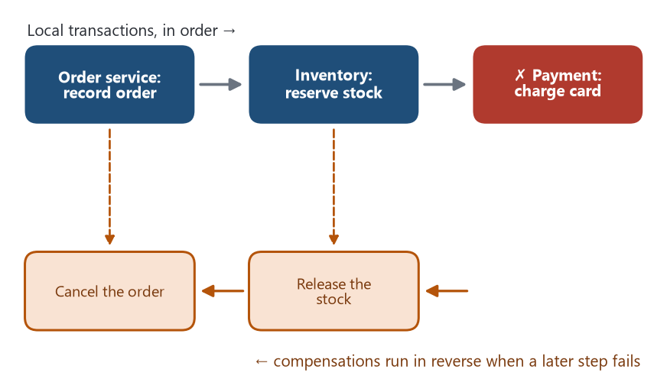
A saga: place an order as three local transactions. If the last step fails, the compensations for the earlier steps run in reverse.
A saga is a sequence of local transactions. If a later step fails, earlier steps run compensations. The idea is from Hector Garcia-Molina and Kenneth Salem (SIGMOD, 1987). Richardson applied it to services. It has two structures.
- Choreography. The order service records the order and publishes OrderPlaced. Inventory and payment subscribe and do their own local work, then publish their own events. No coordinator holds the whole story.
- Orchestration. One coordinator tells inventory to reserve, then payment to charge, and it runs the compensation if payment fails. The participants stay simpler. The coordinator holds the workflow.
Queries have their own patterns. API composition asks each owner and joins the answers in memory. CQRS keeps a separate read model so the query does not call every owner. A command-side replica gives the service that performs a command a local, read-only copy of data it does not own.
Publishing those events safely is its own group: transactional outbox, transaction log tailing, and polling publisher. The point of all three is that the database write and the message leave together.

🧭 Four ways an operation spans services
Once each service has its own database, one business action is no longer one database transaction. Richardson treats these four as the collaboration patterns.
Pattern | Kind of operation | Mechanism
Saga | Command | A sequence of local transactions. Choreography: each service emits an event and others react. Orchestration: one coordinator tells each participant the next step and runs compensations.
Command-side replica | Command that needs foreign data | The service that performs the command keeps a read-only copy of the data it must see, updated from events.
API composition | Query | The caller asks each owner and joins the answers in memory.
CQRS | Query | Commands update the service database. A separate query model is maintained as a view that can be read without calling every owner.

📡 How services talk, and how clients get in
Remote procedure invocation (HTTP APIs, gRPC) is the synchronous pipe. Messaging is the asynchronous one, and consumers are designed to be idempotent because a message can arrive twice. Domain events and event sourcing sit on the messaging side: either a service publishes that something changed, or it stores the aggregate as the sequence of events itself.
Outside clients usually meet an API gateway, one front door that routes, authenticates, and sometimes aggregates. A backend for frontend is a gateway per client experience — web, iOS, Android — owned by the team that ships that client. Phil Calçado used the name for the SoundCloud practice. Sam Newman wrote the pattern up. The rule that makes it work is one experience, one backend.

🔭 How the system stays up and can be seen
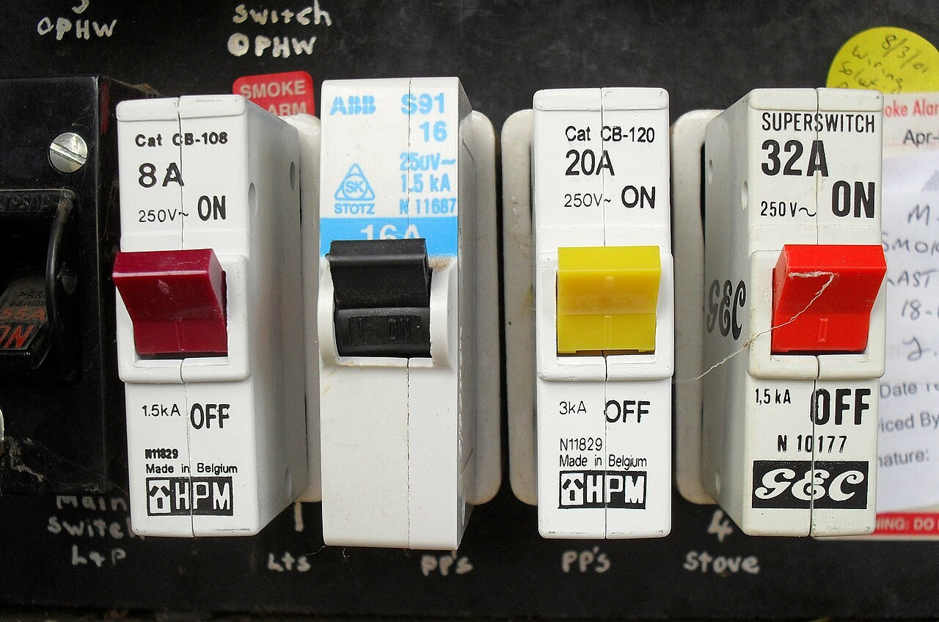
Household circuit breakers. Michael Nygard borrowed the name in Release It! (2007): the breaker trips to protect the wiring, and a software breaker stops calls to protect the caller. Photo: Bidgee, Wikimedia Commons, CC BY-SA 3.0.
Callers find instances through a service registry, either on the client side (the caller asks the registry, as with Netflix Eureka) or on the server side (a router asks). A circuit breaker, from Michael Nygard’s Release It! (2007), stops calling a dependency whose failures have crossed a threshold. Timeouts, retries, and bulkheads travel with it in practice. Identity travels as an access token. After the call, the system is understood through log aggregation, metrics, distributed tracing, and a health check API, because a single request is now a path across processes.

🚀 Where the patterns physically live
Deployment patterns choose the unit that starts and scales. One service instance per container became the ordinary choice after Docker and Kubernetes. Serverless is the other extreme in the language. Shared mechanics sit in a microservice chassis, a framework every service uses, or, from about 2016, in a sidecar and a service mesh, so retries, discovery, and traffic policy sit beside the service in a proxy.

🪜 The decision sequence
Richardson groups the language by the question an architect is answering. Names below are his, except sidecar and service mesh, which entered practice through the cloud-native toolchain and appear in the Azure microservices pattern set.
Question | Patterns | What the choice fixes
Where is the boundary? | Decompose by business capability; decompose by subdomain; service per team; self-contained service | Which team owns which capability, and whether a request can finish inside one service.
Who owns the data? | Database per service; shared database | Whether a schema change in one service can break another.
How does a command cross services? | Saga, as choreography or orchestration | Consistency without a distributed transaction. Each step is a local transaction, with a compensation if a later step fails.
How does a query cross services? | API composition; CQRS; command-side replica | Where the join lives: in the caller, in a maintained view, or in a local copy of someone else’s data.
How is change recorded? | Domain event; event sourcing | Whether the record is the current row, or the sequence of events that produced it.
How is a message published with the database write? | Transactional outbox; transaction log tailing; polling publisher | The write and the message either both happen, or the design accepts a gap.
How do services talk? | Remote procedure invocation; messaging; domain-specific protocol; idempotent consumer | Synchronous request-response, or asynchronous messages that must be safe to deliver twice.
How do outside clients enter? | API gateway; backend for frontend | One front door for every client, or one front door per client experience.
How does a caller find an instance? | Client-side discovery; server-side discovery; service registry; self registration; third-party registration | Whether the caller, or a router, asks a registry where the service is.
How does failure stay local? | Circuit breaker. Practitioners also use timeout, retry, and bulkhead | A sick dependency stops receiving calls instead of exhausting the caller.
How does identity travel? | Access token | The service that handles the request can tell who asked, without sharing a session database.
How is the system seen? | Log aggregation; application metrics; distributed tracing; health check API; exception tracking; audit logging; log deployments | A request that crosses services can be reconstructed after it fails.
How is it deployed? | Service instance per container; per VM; per host; multiple instances per host; serverless; service deployment platform | The unit that is started, stopped, and scaled. After 2015 the usual unit is one container on a platform.
How is a screen built from many services? | Server-side page fragment composition; client-side UI composition | Which tier assembles HTML or UI fragments that each service owns.
How do you leave a monolith? | Strangler application; anti-corruption layer | New behavior grows beside the old system, and the new model is translated at the boundary.
Where do shared mechanics live? | Microservice chassis; externalized configuration; service template; sidecar; service mesh | In a library every service copies, or in a proxy beside the service.

Source: microservices.io pattern index, Chris Richardson. Saga as a sequence of local transactions with compensations is Garcia-Molina and Salem, SIGMOD 1987, later applied to services. Circuit breaker and bulkhead are Michael Nygard, Release It! (2007). Strangler fig is Martin Fowler. Anti-corruption layer is Eric Evans, Domain-Driven Design (2003). Backend for frontend is the name Phil Calçado used for the SoundCloud practice; Sam Newman wrote the pattern up.

🎯 What this fixes for the AI chapter
These names are the before-state. A later claim that AI influenced microservice architecture has to name a decision in this sequence: where boundaries are drawn, how a saga is coordinated, whether the pipe stays dumb, or whether the sidecar and the mesh absorb the reliability patterns.
🔁 Read it again: three things to carry away
1. Patterns are decisions, arranged as the questions an architect meets in order.
2. Private data makes everything else necessary: sagas, composition, CQRS, and outboxes.
3. Any AI claim must name one decision in this sequence.

