🗂️ Microservice design patterns by the job they do
Answer 4 of the working series
29 September 2026
Full catalog, grouped by the type of problem each pattern serves.
🔑 How to read this edition
The central idea of the chapter — bold, on a yellow marker.
An important sentence — blue and underlined, in the text itself.
A technical term — plum with a dotted line; its meaning is in “Words to know”.
💬 In plain words 🧭 The chapter as a map 📖 Words to know 🔁 Read it again

⭐ In one sentence
Fifteen jobs, sixty-one named patterns, and a Record column that says where every name comes from — this is the row list the whole series refers back to.

💬 In plain words
The same menu as the previous chapter, laid out as a table: fifteen jobs, sixty-one named ways of doing them, with a note on where each name comes from — Richardson’s published index, a companion from an older book, or one of the two forms of the saga. It is the row list the rest of the series refers back to, and the maps below draw it in one picture so the shape of the language can be seen before the tables are read.

📖 Words to know
Index | The Record value for a name taken from Richardson’s published pattern index at microservices.io.
Pattern page | A page on microservices.io that the index listing does not show — sidecar and service mesh.
Companion | A pattern from Michael Nygard’s Release It! or the Azure Architecture Center that does the same job as an index entry.
sharding | Splitting one dataset across several databases by key — a general cloud pattern, left out here.
leader election | Agreeing which instance is in charge — general infrastructure, left out.
competing consumers | Several workers reading one queue — likewise a general pattern.
Domain event | An announcement that something meaningful happened inside a service.
Health check API | An endpoint a monitor calls to ask whether the instance can take work.
Externalized configuration | Settings kept outside the built package so one build runs everywhere.
Idempotent consumer | A message handler that can receive the same message twice and produce one effect.

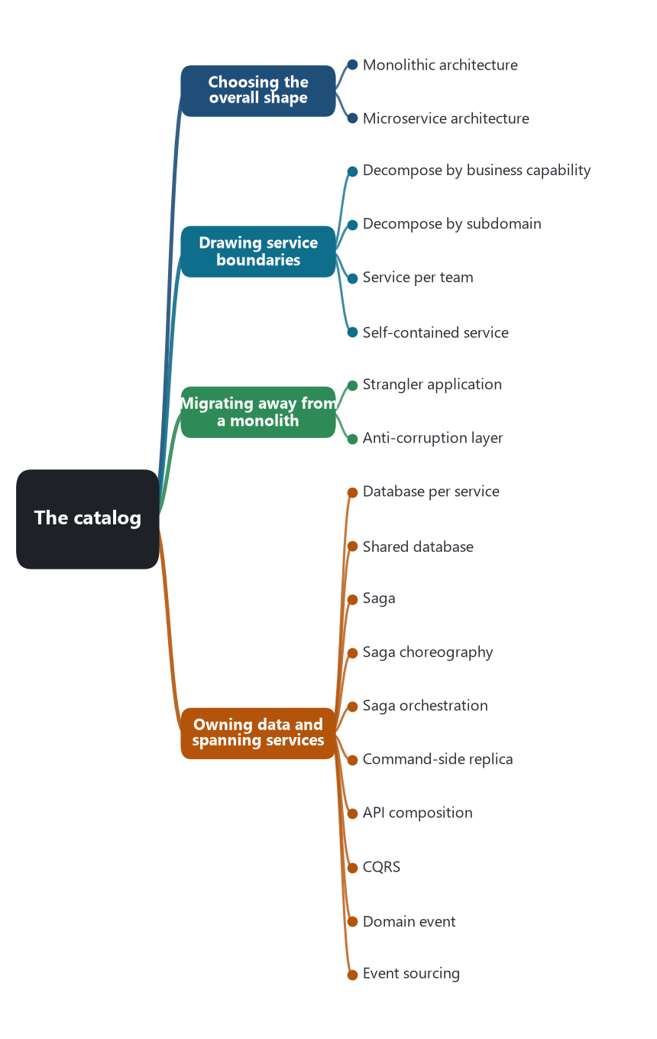
Map 1 of 4 — the catalog drawn as a tree: each job and the patterns that do it.
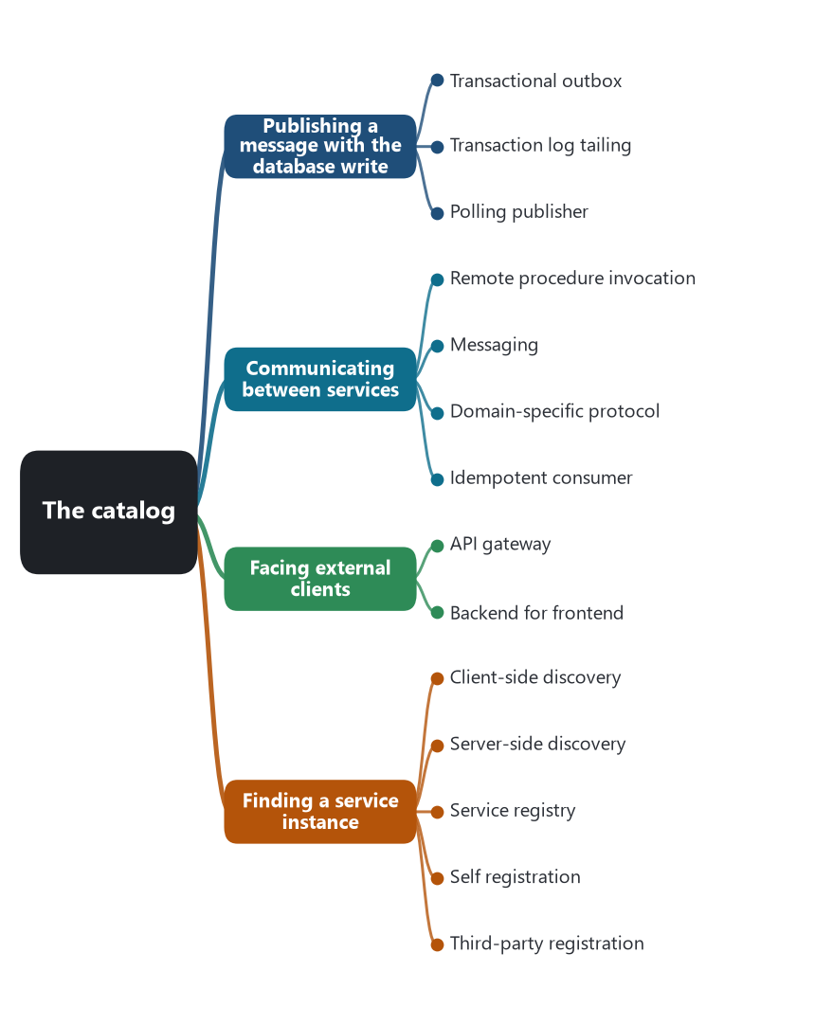
Map 2 of 4 — the catalog drawn as a tree: each job and the patterns that do it.
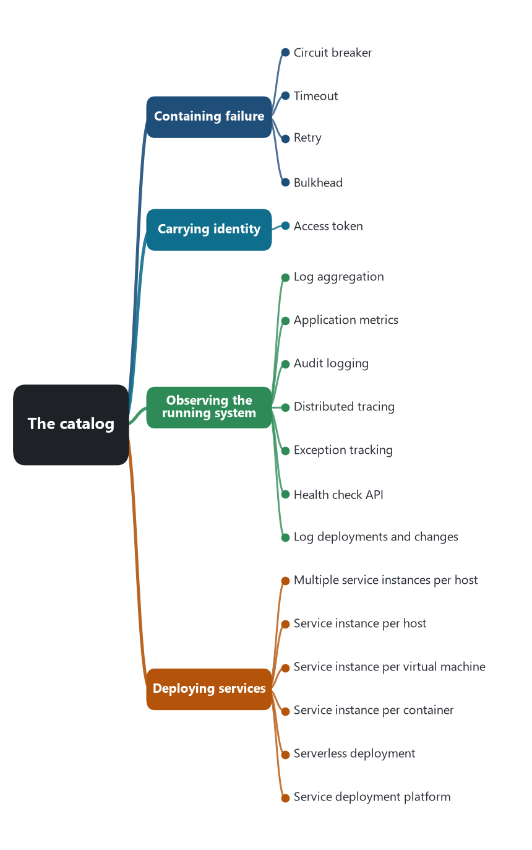
Map 3 of 4 — the catalog drawn as a tree: each job and the patterns that do it.
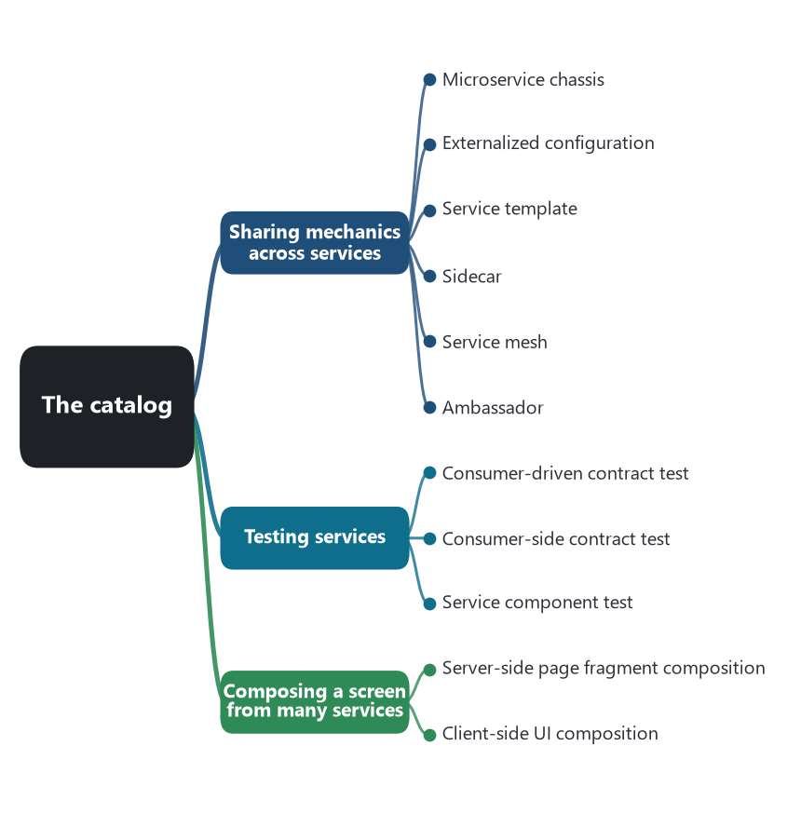
Map 4 of 4 — the catalog drawn as a tree: each job and the patterns that do it.
This is the working catalog for the research. It has 15 categories. 53 patterns are on Chris Richardson’s published index at microservices.io/patterns/index.html. Sidecar and service mesh have their own pattern pages on that site and are included here, which brings his named patterns to 55. Saga choreography and saga orchestration are the two forms of the saga, not extra index entries. Timeout, retry, bulkhead, and ambassador are companion patterns that teams use for the same jobs. They are marked so they are not mistaken for index entries.
The “Record” column says where the name comes from. Index means the published pattern-language index. Pattern page means a page on microservices.io that the index listing does not currently show. Form of saga means one of the two ways a saga is coordinated. Companion means a pattern from Michael Nygard’s Release It! (2007) or from the Azure Architecture Center that belongs in the same category.
General cloud patterns that are not part of this language — sharding, leader election, competing consumers, and the rest of the Azure cloud design catalog — are left out. They solve infrastructure problems that a microservice system may also have, and they are not the microservice pattern language.

🗂️ Categories
Category | The job | Patterns
Choosing the overall shape | Which architectural style the application uses. | 2
Drawing service boundaries | How the application is cut into services. | 4
Migrating away from a monolith | How a running system is replaced without a single cutover. | 2
Owning data and spanning services | How a command or a query is carried out when the data lives in more than one service. | 10
Publishing a message with the database write | How a service avoids writing to its database and then failing to publish the event. | 3
Communicating between services | The mechanism one service uses to talk to another, or to an external client. | 4
Facing external clients | How clients outside the system reach the services. | 2
Finding a service instance | How a caller learns the current network address of a service that may have many instances. | 5
Containing failure | How a failing or slow dependency is stopped from taking down its callers. | 4
Carrying identity | How the service that handles a request knows who asked. | 1
Observing the running system | How operators reconstruct what a request did after it has crossed several services. | 7
Deploying services | The unit that is started, stopped, and scaled. | 6
Sharing mechanics across services | Where logging, configuration, discovery, and traffic policy live, so each service does not rebuild them. | 6
Testing services | How a service is checked without standing up the whole system. | 3
Composing a screen from many services | How a page that needs data from several services is assembled. | 2

🏛️ Choosing the overall shape
Which architectural style the application uses.
Pattern | What it does | Record
Monolithic architecture | One deployable unit holds the user interface, the domain logic, and the database. | Index
Microservice architecture | The application is a set of independently deployable, loosely coupled services. | Index

✂️ Drawing service boundaries
How the application is cut into services.
Pattern | What it does | Record
Decompose by business capability | Each service corresponds to a business capability, such as order management or delivery. | Index
Decompose by subdomain | Each service corresponds to a domain-driven-design subdomain and its bounded context. | Index
Service per team | The service boundary follows the team that owns the capability. | Index
Self-contained service | A service handles a synchronous request without waiting for another service to respond. | Index

🌳 Migrating away from a monolith
How a running system is replaced without a single cutover.
Pattern | What it does | Record
Strangler application | New behavior is built beside the old system, and a facade routes each request to one or the other, until the old system can be retired. | Index
Anti-corruption layer | A translation layer keeps a new service’s model from being bent by the legacy system it still calls. | Index

🗄️ Owning data and spanning services
How a command or a query is carried out when the data lives in more than one service.
Pattern | What it does | Record
Database per service | Each service has a private database. Other services reach that data only through its API or its events. | Index
Shared database | Several services read and write the same database schema. | Index
Saga | A business action is a sequence of local transactions. If a later step fails, earlier steps run compensating actions. | Index
Saga choreography | A form of the saga. Each service publishes an event, and the next service reacts. No coordinator holds the whole workflow. | Form of saga
Saga orchestration | A form of the saga. One coordinator tells each participant the next step and runs compensations. | Form of saga
Command-side replica | The service that performs a command keeps a read-only copy of data it does not own, updated from events. | Index
API composition | A query calls the services that own the data and joins the answers in memory. | Index
CQRS | Commands update the service database. Queries read one or more materialized views maintained for that purpose. | Index
Domain event | A service publishes an event whenever its data changes, so other services can react. | Index
Event sourcing | The service stores an aggregate as the sequence of events that produced it, and rebuilds current state from that log. | Index

📤 Publishing a message with the database write
How a service avoids writing to its database and then failing to publish the event.
Pattern | What it does | Record
Transactional outbox | The service writes the business row and an outbox row in the same local transaction. A separate process publishes the outbox. | Index
Transaction log tailing | A process reads the database transaction log and publishes the changes it finds there. | Index
Polling publisher | A process polls a table of events or outbox rows and publishes any that have not yet been sent. | Index

📡 Communicating between services
The mechanism one service uses to talk to another, or to an external client.
Pattern | What it does | Record
Remote procedure invocation | A caller sends a request and waits for a response, typically over HTTP or gRPC. | Index
Messaging | Services exchange asynchronous messages through a broker. The sender does not have to be running at the same moment as the consumer. | Index
Domain-specific protocol | Services speak a protocol built for that domain, rather than a general HTTP or messaging API. | Index
Idempotent consumer | A message handler can safely receive the same message more than once and still produce one effect. | Index

🚪 Facing external clients
How clients outside the system reach the services.
Pattern | What it does | Record
API gateway | One entry service routes, and sometimes aggregates, calls so clients do not have to know the internal services. | Index
Backend for frontend | A separate API gateway for each kind of client, owned with that client. One experience, one backend. | Index

🧭 Finding a service instance
How a caller learns the current network address of a service that may have many instances.
Pattern | What it does | Record
Client-side discovery | The caller queries a registry and chooses an instance. | Index
Server-side discovery | The caller hits a router at a stable address. The router queries a registry and forwards the request. | Index
Service registry | A database of service instances and their locations. Callers or routers query it. | Index
Self registration | Each service instance registers and unregisters itself with the registry. | Index
Third-party registration | A registrar, such as the platform, registers and unregisters instances on their behalf. | Index

🧯 Containing failure
How a failing or slow dependency is stopped from taking down its callers.
Pattern | What it does | Record
Circuit breaker | A proxy fails calls immediately once the remote failure rate crosses a threshold, then allows a few trial calls later. | Index
Timeout | A caller stops waiting after a set time, so a slow dependency cannot hold its threads. | Companion
Retry | A caller repeats a failed call a limited number of times, usually only when the failure is safe to repeat. | Companion
Bulkhead | The caller isolates the threads, connections, or pool used for one dependency, so that dependency cannot exhaust the caller. | Companion

🎟️ Carrying identity
How the service that handles a request knows who asked.
Pattern | What it does | Record
Access token | A token that carries the caller’s identity travels with the request from service to service. | Index

🔭 Observing the running system
How operators reconstruct what a request did after it has crossed several services.
Pattern | What it does | Record
Log aggregation | Service logs are shipped to one store so they can be searched together. | Index
Application metrics | Each service records counts, timings, and other statistics about its operations. | Index
Audit logging | User actions are recorded in a durable store for later review. | Index
Distributed tracing | Each external request gets an identifier that is passed between services, and each hop records its start and end. | Index
Exception tracking | Exceptions are reported to a central tracker that groups them and notifies developers. | Index
Health check API | A service exposes an endpoint that a monitor can call to learn whether it can take work. | Index
Log deployments and changes | Deploys and configuration changes are recorded so they can be lined up with incidents. | Index

🚀 Deploying services
The unit that is started, stopped, and scaled.
Pattern | What it does | Record
Multiple service instances per host | Several service instances share one machine or one operating system. | Index
Service instance per host | Each service instance runs on its own host. | Index
Service instance per virtual machine | Each service instance is packaged as its own virtual machine. | Index
Service instance per container | Each service instance runs in its own container. This became the ordinary choice after Docker and Kubernetes. | Index
Serverless deployment | The platform runs the service on demand, and the team does not manage the host. | Index
Service deployment platform | An automated platform deploys services and presents them as a service abstraction, as Kubernetes does. | Index

🧰 Sharing mechanics across services
Where logging, configuration, discovery, and traffic policy live, so each service does not rebuild them.
Pattern | What it does | Record
Microservice chassis | A framework handles the cross-cutting concerns and leaves the team to write the domain logic. | Index
Externalized configuration | Database locations, credentials, and feature flags live outside the service package. | Index
Service template | A copyable starter service already contains the build and the standard cross-cutting concerns. | Index
Sidecar | Cross-cutting concerns run in a process or container beside the service instance. | Pattern page
Service mesh | A mesh mediates communication in and out of each service, and carries configuration, logs, health, metrics, and tracing. | Pattern page
Ambassador | An outbound proxy beside the service handles connectivity, retries, and monitoring for calls that service makes. | Companion

🧪 Testing services
How a service is checked without standing up the whole system.
Pattern | What it does | Record
Consumer-driven contract test | The team that calls a service writes a test suite that states the contract it depends on. | Index
Consumer-side contract test | A client verifies that it can still speak to the service it calls. | Index
Service component test | A service is tested in isolation, with test doubles standing in for the services it calls. | Index

🧩 Composing a screen from many services
How a page that needs data from several services is assembled.
Pattern | What it does | Record
Server-side page fragment composition | The server builds the page from HTML fragments, each generated by the service that owns that part of the business. | Index
Client-side UI composition | The client builds the screen from UI fragments, each rendered by a component tied to one business capability. | Index

Sources: Chris Richardson, pattern language index and pattern pages, microservices.io, consulted 29 September 2026. Saga: Hector Garcia-Molina and Kenneth Salem, “Sagas,” SIGMOD 1987; choreography and orchestration as described by Richardson, Azure Architecture Center, and AWS Prescriptive Guidance. Circuit breaker, timeout, retry, and bulkhead: Michael Nygard, Release It! (2007); circuit breaker is also the reliability pattern on the index. Ambassador: Azure Architecture Center. Strangler application: Martin Fowler. Anti-corruption layer: Eric Evans, Domain-Driven Design (2003). Backend for frontend: Phil Calçado’s name for the SoundCloud practice; Sam Newman’s pattern write-up.
🔁 Read it again: three things to carry away
1. Fifteen jobs, sixty-one patterns, and a Record column that says where each name comes from.
2. Companions — timeout, retry, bulkhead, ambassador — are marked so they are not mistaken for index entries.
3. General cloud patterns are deliberately left out; they are not the microservice pattern language.

