🧱 Implementing microservices, with domain-driven design as the model
Answer 5 of the working series
29 September 2026
Implementation methods. DDD draws the boundary and the model. Hexagonal architecture, CQRS, and events are how that model is built and connected.
🔑 How to read this edition
The central idea of the chapter — bold, on a yellow marker.
An important sentence — blue and underlined, in the text itself.
A technical term — plum with a dotted line; its meaning is in “Words to know”.
💬 In plain words 🧭 The chapter as a map 📖 Words to know 🔁 Read it again

⭐ In one sentence
A microservice is no smaller than an aggregate and no larger than a bounded context; domain-driven design finds both, and the inside of the service is built so that the business rule lives with the data it governs.

💬 In plain words
Domain-driven design (DDD) is a way of thinking about software that starts from the business’s own words. It asks: where does one meaning of ‘order’ or ‘delivery’ end and another begin (a bounded context)? Which cluster of objects must always be consistent together (an aggregate)? The chapter uses a drone-delivery example — a Delivery that a customer may cancel only until a drone has picked it up — and follows one request from the HTTP door to the message that leaves the service, so the reader sees where each rule lives.

📖 Words to know
Domain-driven design | Eric Evans’s approach (2003): model the software on the business’s own concepts and language, and cut it where meanings change.
bounded context | The boundary inside which one model and one vocabulary stay consistent; a candidate service.
ubiquitous language | The shared words the business, the code, and the API all use for the same thing.
subdomains | Parts of the business: core (what it competes on), supporting (what it needs), generic (what everyone has and can buy).
Aggregate | A cluster of objects saved together in one transaction, reached through one root object.
Entity | An object with an identity that persists over time — this Delivery, that Drone.
Value object | A value with no identity — an address, a weight, an amount of money.
Repository | The code that loads and saves an aggregate by its root’s identity.
Domain service | Business logic that belongs to no single entity, such as a Scheduler.
Application service | The use case: it opens the transaction, calls the domain, and returns a result — without containing the business rule.
Domain event | A meaningful change announced inside the service, such as DeliveryCompleted.
integration event | The version of an event that leaves the service on the message bus for other services.
Hexagonal architecture | Ports and adapters (Cockburn, 2005): business logic in the middle; HTTP, databases, and brokers plugged in at the edges through interfaces.
Transaction script | The simple interior: check a few fields, write a row, no domain model.
outbox | A table where outgoing events are saved in the same transaction as the data, to be published afterwards.
context map | Evans’s diagram of how bounded contexts relate: who supplies whom, who conforms, who translates.
MediatR | An in-process message dispatcher used in Microsoft’s eShop example to hand domain events to other handlers in the same service.
RabbitMQ | A message broker — the mailbox between services — used by eShop; Azure Service Bus is the alternative.
Anti-corruption layer | A translation layer that keeps a foreign or legacy model from leaking into your own.
Conformist | Accepting an upstream service’s model as it stands, without translation.

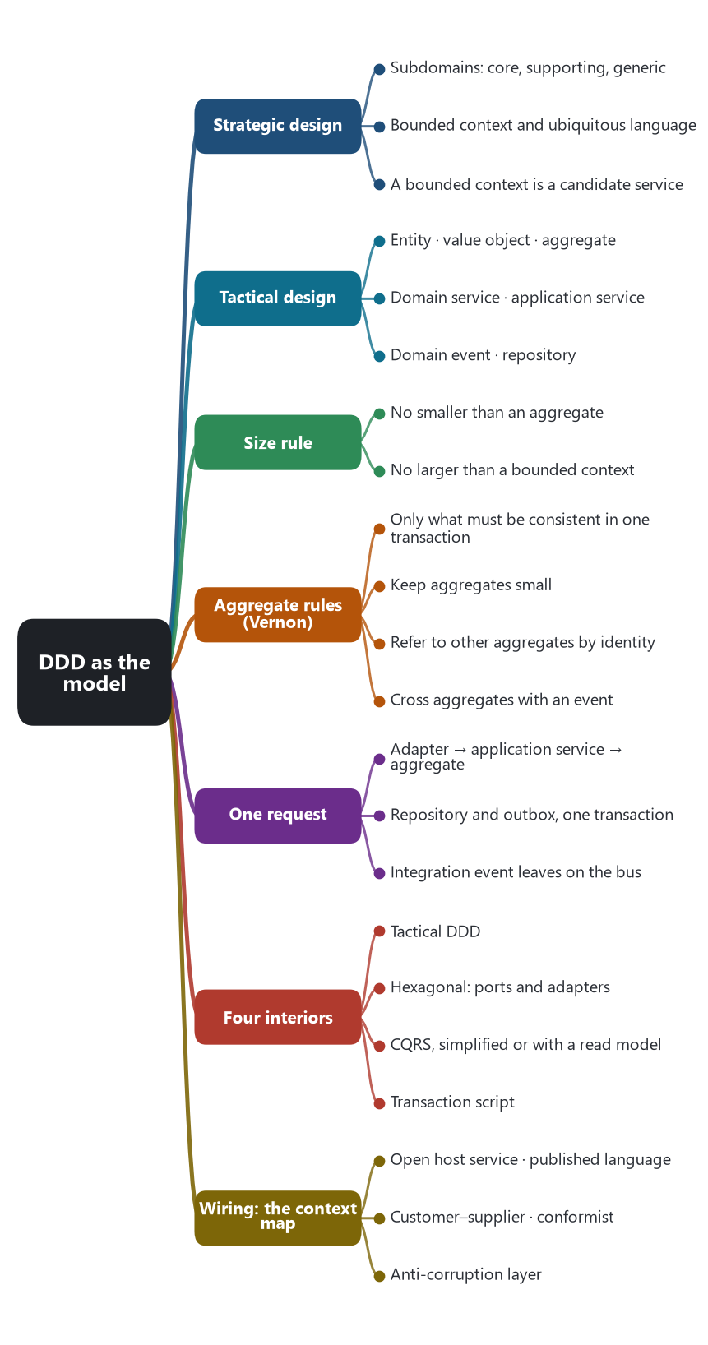
The chapter as a map: its sections and what each one holds.
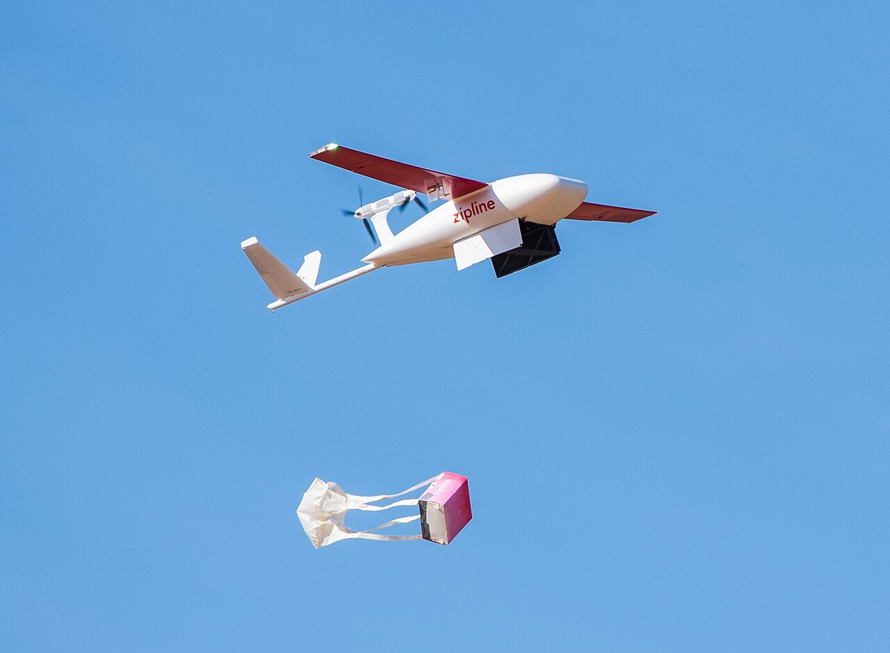
The running example of the series: a delivery drone dropping a package. A customer may cancel a delivery only until the drone has picked the package up — a rule that lives on the Delivery entity. Photo: Roksenhorn, Wikimedia Commons, CC BY-SA 4.0.
Domain-driven design is a way to implement a microservice, and a way to decide where one service ends. Microservice architecture describes the system of many services. DDD, hexagonal architecture, and CQRS describe the inside of one service, and the messages that pass between services. Eric Evans set out DDD in 2003. Vaughn Vernon’s Implementing Domain-Driven Design (2013) is the practical reference the microservice generation used. Microsoft’s Azure Architecture Center then wrote the size rule this research will keep: design a microservice to be no smaller than an aggregate, and no larger than a bounded context.

🗺️ Two passes: strategic, then tactical
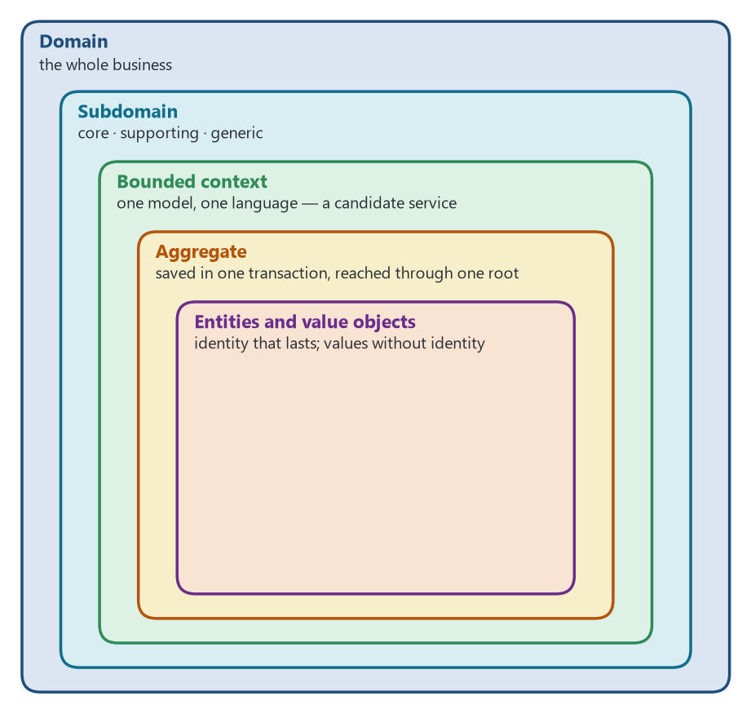
From the whole business down to the objects: the aggregate is the consistency boundary; the bounded context is the candidate service.
Strategic design divides the business. The domain is split into subdomains. A core subdomain is the part the business competes on, and it gets the careful model. A supporting subdomain is necessary and less differentiating. A generic subdomain is a solved problem, such as identity or notification, and is often bought or copied. Each piece of the model that must stay internally consistent is a bounded context, with its own ubiquitous language: the words the code, the API, and the team share. A bounded context is a candidate for a service. One context can become several services if scale demands it. Several small contexts can stay in one service if splitting them would only add operational cost.
Tactical design builds the model inside that context. These are the building blocks Evans defined, as Microsoft’s current guide applies them to a service.
Building block | What it is in the service
Entity | An object with a stable identity over time. Other services refer to it by that identity. Business rules live on the entity, so the model does not become a bag of data with the rules parked in a utility class.
Value object | An immutable value with no identity, such as a location, a weight, or an amount of money. Two value objects with the same attributes are interchangeable.
Aggregate | The consistency boundary. One entity is the root. Child objects are reached only through the root. Everything in the aggregate is saved in one local transaction.
Domain service | A stateless piece of business logic that belongs to no single entity. In the drone-delivery example, Scheduler coordinates drone, window, and route.
Application service | The use case. It opens the transaction, calls the domain, and returns a result. It does not contain the business rule.
Domain event | A meaningful change inside the context, such as DeliveryCompleted. A row insert is not a domain event.
Repository | The means of loading and saving an aggregate by the root’s identity.

Source: Eric Evans, Domain-Driven Design (2003). Azure Architecture Center, “Use tactical DDD to design microservices,” the drone-delivery worked example. The size rule is quoted from that guide.

📏 Rules that keep the service small enough
Vernon’s aggregate rules, from his 2011 essays and the 2013 book, are the ones microservice implementations follow.
- Include in the aggregate only what must be consistent in a single transaction.
- Keep aggregates small. Delivery, Package, Drone, and Account are separate aggregates because each has its own life cycle.
- Refer to another aggregate by identity. Delivery stores a DroneId and a PackageId. It does not hold the Drone object.
- When a business process crosses aggregates, publish an event and accept that the other side will catch up. That is the seam where a saga begins.
In the drone-delivery shipping context, Confirmation and Notification are children of Delivery, because they have no life of their own. Tag is a child of Package. Location, ETA, PackageWeight, and PackageSize are value objects. A customer can cancel a delivery only until a drone picks up the package, and that rule sits on the Delivery entity. Scheduler and Supervisor are domain services: one coordinates the steps, the other watches them for failure.

🏃 How one request runs
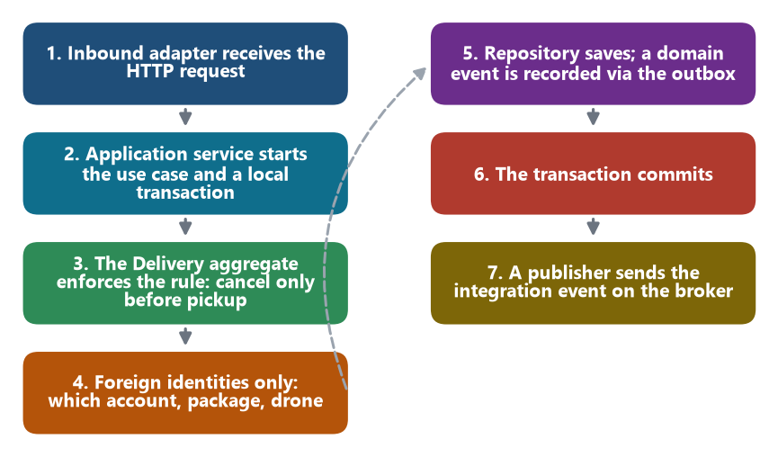
One request, from the HTTP door to the broker. Steps 1–6 happen inside one service and one transaction; step 7 is what other services see.
A customer schedules a delivery. The implementation steps are the same shape in the Azure example and in Microsoft’s eShop ordering service.
- An inbound adapter, the HTTP endpoint, receives the request.
- An application service starts the use case and a local database transaction.
- The domain enforces the rule. Delivery decides whether it can be scheduled or cancelled. The application service does not reimplement that decision.
- The aggregate stores foreign identities only: which account, which package, which drone.
- A repository saves the aggregate. A domain event such as DeliveryCreated is recorded in the same transaction, typically through an outbox.
- The transaction commits.
- A publisher then sends an integration event on the broker. The accounts context can consume DeliveryCompleted later and raise an invoice. The two contexts are not in one transaction.
Inside one service, an in-process domain event can notify another aggregate in the same model. eShop does this with MediatR. The event that leaves the service is a separate integration event, carried by RabbitMQ or Azure Service Bus in that reference application. Keeping those two events apart is the implementation of “smart endpoints and dumb pipes” at the level of one codebase.

🧱 Four ways to build the inside of a service
DDD is the right interior when the service holds real business rules. Other interiors are used beside it. eShop shows more than one interior in the same system: the ordering service is DDD and CQRS, while simpler capabilities stay closer to create-read-update-delete.
Implementation | What it builds | Where it is shown
Tactical DDD | The domain model: aggregates, entities, value objects, domain services, and domain events. | Evans (2003); Vernon (2013); Azure drone-delivery guide.
Hexagonal architecture, also called ports and adapters | The packaging. Business logic sits in the middle. Inbound adapters (HTTP, a message subscriber) call inbound ports. Outbound ports are interfaces the domain uses for a database or another service. Outbound adapters implement those interfaces. The domain does not import the web framework or the database driver. | Alistair Cockburn (2005). Chris Richardson uses this shape for each service, including the FTGO reference application.
CQRS, simplified | Commands go through aggregates and enforce rules. Queries are separate and can be plain SQL. Both can use the same database. This is enough for many services. | eShop ordering service: command side on the Order and Buyer aggregates; query side with Dapper.
CQRS with a read model | The command side publishes events. A separate view is maintained for queries, so a read does not call every owner and does not load the aggregate. | Richardson’s CQRS pattern. He uses a customer-credit replica in the order service as the worked case.
Transaction script | The endpoint checks a few fields and writes a row. There is no aggregate. Use this when the capability has thin rules, so a domain model would only add ceremony. | The simpler services in the eShop reference application, set beside the ordering service.

🔌 How services are wired to each other
Evans’s context map is the diagram of those relationships. Four of his relationship patterns become the integration style of a microservice system.
- Open host service and published language. The service offers a stable API and a stable event schema. Consumers depend on that published language.
- Customer–supplier. The downstream service needs a change, and the upstream service agrees to provide it. The teams negotiate.
- Conformist. The downstream service accepts the upstream model as it stands.
- Anti-corruption layer. The downstream service translates a foreign or legacy model into its own, so the foreign model does not leak inward.
A command that must cross services is implemented as a saga on top of these events. Choreography lets each service react. Orchestration puts a coordinator in front of the participants. The FTGO application, Richardson’s Java example, implements that coordination with sagas and transactional messaging through Eventuate. eShop implements the bus and the per-service models, and puts API gateways and backends-for-frontends on Envoy in front of the services.

🎯 What to take into the AI chapter
These are the implementation choices a later chapter can test. Did AI change how boundaries are found (bounded context and aggregate)? Did it change the interior of the service (domain model, hexagonal adapters, or a thin script)? Did it change the seam (domain event inside, integration event outside, saga across)? A tool that generates a controller and a database table has implemented the thin script. A tool that has implemented DDD has named the aggregates, kept foreign references as identities, and split the domain event from the integration event.
Sources: Eric Evans, Domain-Driven Design (2003). Vaughn Vernon, Implementing Domain-Driven Design (2013), and “Effective Aggregate Design” (2011). Azure Architecture Center, “Use tactical DDD to design microservices,” and “Microservice architecture style.” Microsoft eShopOnContainers reference application and the .NET microservices guide, “Applying CQRS and CQS approaches in a DDD microservice.” Chris Richardson, Microservices Patterns (2018), the hexagonal service shape, CQRS, and the FTGO example. Alistair Cockburn, hexagonal architecture (2005).
🔁 Read it again: three things to carry away
1. A service is no smaller than an aggregate and no larger than a bounded context.
2. Refer to other aggregates by identity; cross them with events, not joins.
3. Keep the in-process domain event apart from the integration event that leaves the service.

