🧭 Methods that sit beside domain-driven design
Answer 6 of the working series
29 September 2026
The neighbors of DDD: how a team discovers a domain, decides a service cut, builds the inside, connects services, and assigns ownership.
🔑 How to read this edition
The central idea of the chapter — bold, on a yellow marker.
An important sentence — blue and underlined, in the text itself.
A technical term — plum with a dotted line; its meaning is in “Words to know”.
💬 In plain words 🧭 The chapter as a map 📖 Words to know 🔁 Read it again

⭐ In one sentence
DDD has neighbors: workshops that find the domain, forces that decide the cut, drawings that shape the inside, a messaging vocabulary, and methods that assign ownership — and a later claim can name which one an AI tool imitates.

💬 In plain words
DDD has neighbours: workshops where business people and engineers map events on a wall (EventStorming), rules of thumb for deciding whether two things should be one service or two (Richardson’s dark energy and dark matter), other ways of drawing the inside of a service (onion, clean, functional core), a shared vocabulary for messages (Enterprise Integration Patterns), and ways of deciding which team owns what (Team Topologies, Data Mesh). None of them replaces DDD; each does a neighbouring job.

📖 Words to know
EventStorming | Brandolini’s workshop (2013): business and engineering write domain events on orange sticky notes along a timeline.
Domain Storytelling | Drawing the business as numbered picture-stories of actors, objects, and activities (Hofer and Schwentner, 2021).
Event Modeling | A storyboard of commands in, events stored, screens reading views — the workshop form of event sourcing (Dymitruk).
Behavior-driven development | Writing examples in the domain’s language — given, when, then — as specifications and tests (North, 2006).
Assemblage | Richardson’s 2023 process for defining a microservice architecture in five steps.
Dark energy | Richardson’s name for the five forces that push subdomains apart into separate services.
Dark matter | His name for the five forces that pull subdomains back together into one service.
Self-contained systems | INNOQ’s architecture: a team-owned vertical slice with its own UI, logic, and data.
scale cube | Three ways to grow: more copies (X), split by function (Y), partition data (Z).
Onion architecture | Palermo’s 2008 drawing: the domain in the center, frameworks and databases in the outer ring, dependencies pointing inward.
Clean architecture | Robert C. Martin’s concentric circles (2012; book 2017) with the same inward dependency rule.
functional core and an imperative shell | Pure decision logic inside; effects such as database and network calls in a thin outer layer (Bernhardt, 2012).
actor model | Isolated units that hold state and react to messages, never sharing memory (Hewitt, 1973; Erlang, Akka, Orleans).
Enterprise Integration Patterns | Hohpe and Woolf’s 2003 book of 65 named messaging patterns: channels, routers, translators, endpoints.
Reactive Manifesto | Responsive, resilient, elastic, message-driven: how a message-based system should behave (2014).
Team Topologies | Skelton and Pais (2019): four team types — stream-aligned, enabling, complicated-subsystem, platform — and three interaction modes.
cognitive load | How much a team must hold in its head; the limit on how many services one team can own.
Data Mesh | Dehghani (2019): domain teams own their analytical data as products, on a self-serve platform, under federated governance.
Micro-frontends | The same split applied to the user interface: each team ships its own fragment of the screen.

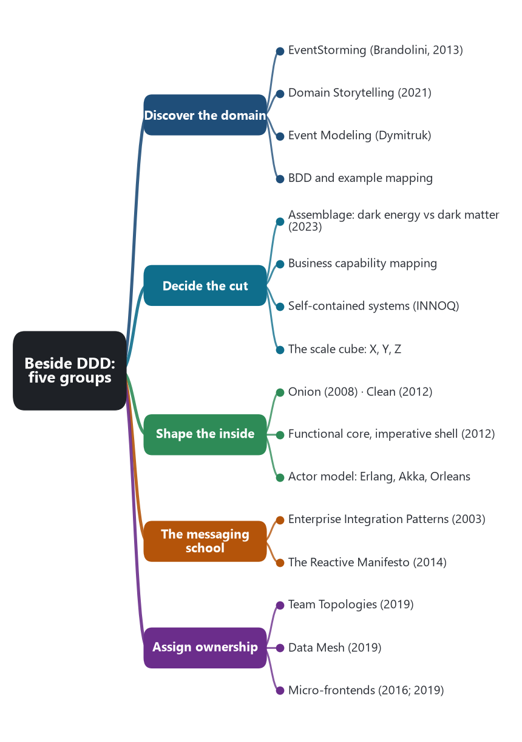
The chapter as a map: its sections and what each one holds.
Domain-driven design is one school. The previous chapter used it for boundaries and for the model inside a service, and it used hexagonal architecture, CQRS, a transaction script, context mapping, and sagas as the ways that model is built and connected. This chapter adds the methods that do neighboring jobs and that have not been set out yet. They fall into five groups.

🟠 Workshops that discover the domain
These happen before the code. Their output is the material strategic DDD then turns into bounded contexts and aggregates.
EventStorming was introduced by Alberto Brandolini. He described the workshop in November 2013, after trying it during Vaughn Vernon’s implementing-DDD tour. A long paper roll and orange sticky notes carry domain events, written as things that happened: OrderPlaced, DeliveryCompleted. People from the business and from engineering build the timeline together. Big-picture EventStorming finds where language and interests conflict, which is the clue to a bounded context. Design-level EventStorming then clusters events into aggregates. The book is Introducing EventStorming.
Domain Storytelling, by Stefan Hofer and Henning Schwentner, uses a pictorial sentence instead of a storm of events. Actors, work objects, and activities are drawn as a numbered story: a customer places an order, the kitchen prepares it, a rider delivers it. Repeating stories show the boundaries. Their book Domain Storytelling was published in 2021. The practice is a workshop for the same discovery DDD needs, drawn as stories rather than as a glossary.
Event Modeling, by Adam Dymitruk, lays one process on a horizontal storyboard. Commands go in, events are stored, and screens read a view of those events. It is the workshop form of event sourcing and CQRS: the board is already the shape of the system.
Behavior-driven development, which Dan North set out in 2006, writes examples in the language of the domain: given, when, then. It is the specification cousin of Evans’s ubiquitous language. Example mapping, from Matt Wynne, is the short workshop that turns a story into those examples before anyone writes a test.

✂️ Ways to decide the cut
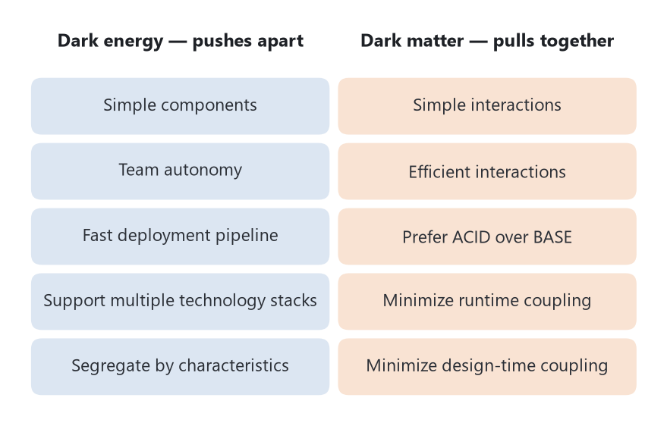
Richardson’s ten forces. Dark energy argues for a split; dark matter argues for staying together. The cut is the balance.
A bounded context is a candidate service. These methods decide whether that candidate stays whole, splits, or joins its neighbor.
Assemblage is Chris Richardson’s architecture-definition process, introduced in February 2023. It has five steps: discover system operations, define subdomains, design services and their collaborations, evaluate the architecture, and refactor it. The design step is driven by ten forces he names with an astronomy metaphor. Dark energy pushes subdomains apart into separate services. Dark matter pulls them back into one service.
Force | Direction | What it asks
Simple components | Apart | Is a smaller component easier to understand?
Team autonomy | Apart | Can this team ship without waiting for another team?
Fast deployment pipeline | Apart | Does a smaller component build and test faster?
Support multiple technology stacks | Apart | Does this subdomain need a different language or framework?
Segregate by characteristics | Apart | Does it need different scale, availability, or security?
Simple interactions | Together | Does splitting this turn one local operation into a distributed one?
Efficient interactions | Together | Would the split add round trips and large data transfers?
Prefer ACID over BASE | Together | Is a local transaction the honest implementation, where a saga would be a workaround?
Minimize runtime coupling | Together | Would the split make availability and latency depend on another service?
Minimize design-time coupling | Together | Would the two services have to change in lockstep?

Source: Chris Richardson, “About dark energy and dark matter,” microservices.io, 26 March 2023, and “Introducing Assemblage,” 9 February 2023.
Business capability mapping is the enterprise-architecture practice behind Lewis and Fowler’s phrase “organized around business capabilities.” A capability map names what the business does — take an order, dispatch a delivery — without naming the systems that do it today. Services are then lined up with those capabilities. DDD’s subdomain map and a capability map often describe the same business at two altitudes. The capability is the stable business fact. The bounded context is the model a team can keep consistent.
Self-contained systems are an architecture from INNOQ, published at scs-architecture.org, and taught by Stefan Tilkov and colleagues. An SCS is an autonomous web application owned by one team. It includes its own data, its own logic, and its own user interface. It shares no business code with its neighbors. It talks to them asynchronously wherever it can. An API is optional. The system of systems shares only a few macro decisions: the communication protocol, how user interfaces are composed, and how data is replicated. Everything else is a local decision. Where a typical microservice may be only an API, an SCS is a vertical slice a user can actually use.
The scale cube, from Martin Abbott and Michael Fisher’s The Art of Scalability, and explained by Richardson for services, names three ways to grow. The X axis runs more copies of the same thing. The Y axis splits by function, which is the microservice cut. The Z axis partitions data, so one service handles a subset of customers or regions. The cube stops a team from treating “make another service” as the only scaling move.

🧅 Ways to shape the inside of a service
Hexagonal architecture was the packaging in the previous chapter. Two older drawings state the same dependency rule, and two programming models are alternatives to a rich domain object.
Onion architecture, Jeffrey Palermo, 2008, puts the domain model at the center. Domain services wrap it, application services wrap those, and the database, the user interface, and the message broker sit in the outer ring. Source code in the center does not depend on the outer ring.
Clean architecture, Robert C. Martin, described in 2012 and as a book in 2017, draws the same rule as concentric circles: enterprise business rules, then application use cases, then interface adapters, then frameworks and drivers. Dependencies point inward. A use case knows the domain. The web framework knows the use case. The domain does not know HTTP.
A functional core and an imperative shell, from Gary Bernhardt’s 2012 talk “Boundaries,” is an alternative to Evans’s entities that carry behavior. The core is pure decisions: values in, values out, no database and no clock. The shell performs the effects: read the message, call the core, save the result, publish the event. Teams use it when they want the rules to be testable without a domain object graph.
The actor model, Carl Hewitt, 1973, and the style of Erlang, is the programming model Fowler pointed at in 2014 when he wrote that microservices resemble how Erlang programs are structured. An actor holds state and reacts to messages. It does not share memory with other actors. Akka, Orleans, and Elixir are later forms. A service can be one process in this style, or many actors inside one service. The isolation is the same idea as an aggregate boundary, enforced by the runtime rather than by a modeling rule.

✉️ The messaging school that services speak
Enterprise Integration Patterns, Gregor Hohpe and Bobby Woolf, 10 October 2003, is a language of 65 patterns for messages. Channels, routers, transformers, and endpoints are the vocabulary. Publish-subscribe, a dead-letter channel, a content-based router, and an idempotent receiver are in that book. Microservice messaging still uses those names. Fowler and Lewis’s “dumb pipes” keeps the smart routing in the services and in simple brokers, and the pattern names remain the ones Hohpe and Woolf drew.
The Reactive Manifesto, associated with Jonas Bonér and co-authors, in the 2014 second version, names four properties of a system built from messages: responsive, resilient, elastic, and message-driven. It is the operations-facing statement of the same idea as design-for-failure and as dumb pipes. It does not tell you where the bounded context is. It tells you how the system should behave once the services are separate.

👥 Ways to assign ownership
DDD says the model has a boundary. These methods say which team owns that boundary, including the data and the screen.
Team Topologies, Matthew Skelton and Manuel Pais, IT Revolution, 2019, limits a team’s cognitive load and gives four team types. A stream-aligned team owns a flow of work, which is the usual owner of a service or a bounded context. An enabling team helps other teams learn a skill and then leaves. A complicated-subsystem team owns a part that needs deep specialists. A platform team offers an internal product so stream-aligned teams do not build their own infrastructure. Three interaction modes govern how they meet: collaboration for a period of discovery, X-as-a-service when one team consumes another’s product, and facilitating when an enabling team coaches. Conway’s Law, which Fowler and Lewis cited in 2014, is the reason this book matters. The team diagram becomes the service diagram.
Data Mesh, Zhamak Dehghani, introduced in 2019 and set out as four principles, applies domain ownership to analytical data. The principles are domain-oriented ownership, data as a product, a self-serve data platform, and federated computational governance. The operational service owns its transactional database, which DDD already said. Data mesh says the same domain also owns the data product other teams analyze, and a platform team makes publishing that product cheap. A central data lake team is the data-world version of the shared database.
Micro-frontends apply the same split to the user interface. Thoughtworks put the term on its technology radar in 2016, and Cam Jackson wrote the widely cited account in 2019. Each team ships a fragment of the screen with its service. Server-side page fragment composition and client-side UI composition, already in the pattern catalog, are the two mechanisms. Self-contained systems take the stronger form: the fragment is a whole page the team owns, not a widget inside someone else’s shell.

🧭 How these sit with what is already written
Already in the series | Neighbor added here | The job they share
Bounded context and subdomain | EventStorming, Domain Storytelling, Event Modeling, capability maps | Finding the boundary from the business
Aggregate size rule | Assemblage, dark energy and dark matter, the scale cube | Deciding whether to split
Hexagonal architecture | Onion architecture, clean architecture, functional core, actors | Keeping the rules independent of HTTP and the database
Messaging, idempotent consumer, saga | Enterprise Integration Patterns, the Reactive Manifesto | How services talk once they are split
Products not projects, Conway’s Law | Team Topologies, Data Mesh, micro-frontends, self-contained systems | Who owns the service, the data product, and the screen

🎯 What this adds for the AI chapter
A later claim can now name which school an AI tool is imitating. Generating classes from a noun list is a thin echo of tactical DDD. Clustering orange events into aggregates is EventStorming. Recommending a split because two teams deploy independently, or refusing a split because the operation wants one transaction, is Assemblage’s pair of forces. Proposing a stream-aligned team and a platform team is Team Topologies. Publishing a dataset as a product of the domain is Data Mesh. The research can ask which of these the tools actually perform, and which they only name.
Sources: Alberto Brandolini, “Introducing Event Storming,” November 2013, and Introducing EventStorming. Stefan Hofer and Henning Schwentner, Domain Storytelling (2021). Adam Dymitruk, Event Modeling. Dan North, “Introducing BDD” (2006). Chris Richardson, Assemblage (9 February 2023) and dark energy / dark matter (26 March 2023). scs-architecture.org, INNOQ, self-contained systems. Jeffrey Palermo, onion architecture (2008). Robert C. Martin, clean architecture (2012; book 2017). Gary Bernhardt, “Boundaries” (2012). Gregor Hohpe and Bobby Woolf, Enterprise Integration Patterns (10 October 2003). The Reactive Manifesto (2014). Matthew Skelton and Manuel Pais, Team Topologies (2019). Zhamak Dehghani, data mesh principles, martinfowler.com. Cam Jackson, “Micro Frontends” (2019).
🔁 Read it again: three things to carry away
1. Workshops find the domain; forces decide the cut; drawings shape the inside; a messaging vocabulary connects; team methods assign ownership.
2. Dark energy pushes services apart; dark matter pulls them together — the cut is the balance.
3. Later, ask which school an AI tool imitates, and whether it performs the method or only names it.

