☁️ How microservices relate to cloud architecture
Answer 7 of the working series
29 September 2026
Cloud architecture is the platform. Microservice architecture is the cut of the application. Cloud native is the overlap.
🔑 How to read this edition
The central idea of the chapter — bold, on a yellow marker.
An important sentence — blue and underlined, in the text itself.
A technical term — plum with a dotted line; its meaning is in “Words to know”.
💬 In plain words 🧭 The chapter as a map 📖 Words to know 🔁 Read it again

⭐ In one sentence
Cloud architecture, cloud native, and microservices are three separate decisions; the cloud did not invent the service boundary — it made the boundary affordable.

💬 In plain words
Three different questions get mixed together under the word ‘cloud’. Where does the software run (cloud architecture)? Is it built to use an elastic platform (cloud native)? How is the application divided into services (microservices)? You can answer yes to any one without the others: a monolith can run in the cloud; a microservice suite can run in your own basement. The cloud’s real contribution is that it made many small deployable units affordable.

📖 Words to know
Cloud architecture | Deciding where software runs, how failure is contained across machines and sites, and which platform services teams may use.
Cloud native | Built to use an elastic platform: loosely coupled, automated, using containers, meshes, serverless, and declarative APIs.
Cloud Native Computing Foundation | The CNCF: home of Kubernetes and the cloud-native toolchain, and author of the cloud-native definition.
National Institute of Standards and Technology | NIST, the US standards body whose 2011 publication 800-145 defines cloud computing.
elasticity | Growing and shrinking capacity on demand.
Pooling | Many customers sharing one provider’s pool of compute, storage, and network.
Rehosting | Moving an application onto cloud machines unchanged — ‘lift and shift’.
Re-architecting | Redesigning the application to use the platform, for example by decomposing it into services.
availability zone | A data-center-scale failure domain inside a region.
region | A geography, often also a data-residency boundary.
blast-radius | How much is affected when something fails.
shared-responsibility | The line between what the provider runs and what the customer runs; it moves with the service model.
landing zone | The platform team’s prepared cloud environment: accounts, network, identity, guardrails.
paved road | The standard, supported path a new service is expected to take.
Well-architected | Amazon’s review framework with pillars such as reliability, cost, and operational excellence.
Twelve-Factor App | Heroku’s 2011 contract between an application and a platform.
Data mesh | Domain teams owning their analytical data as products, with a platform that makes publishing cheap.

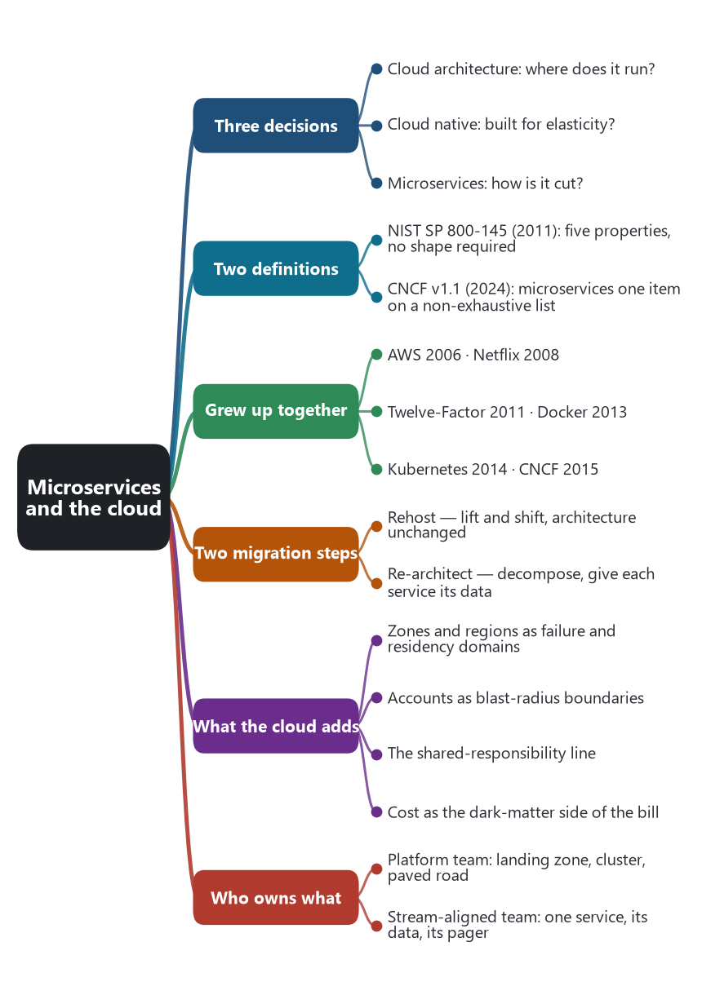
The chapter as a map: its sections and what each one holds.
A microservice system can run in a public cloud, a private cloud, or on a cluster in a company’s own data center. A cloud account can run a monolith, a three-tier application, or a single function with no service boundaries at all. The relationship is real, and it is a relationship between two decisions. Cloud architecture decides where the software runs, how failure is contained across machines and sites, and which platform services the teams may use. Microservice architecture decides how the application is divided, who owns the data, and how a business action crosses those divisions. Cloud native is the name for the overlap, where the application is built so that it can use the cloud’s elasticity, and where microservices are one of the forms that application takes.

🥞 Three layers, three decisions
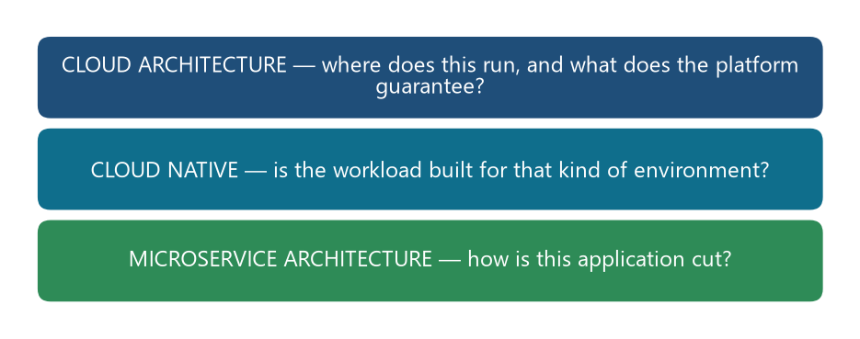
Three layers, three questions. A yes on one does not imply a yes on the others.
Layer | The question it answers | What a yes looks like
Cloud architecture | Where does this run, and what does the platform guarantee? | Accounts or subscriptions, networks, regions and availability zones, identity, and a measured pool of compute, storage, and messaging.
Cloud native | Is the workload built for that kind of environment? | Loosely coupled parts, automated change, and some combination of containers, a service mesh, microservices, immutable infrastructure, serverless, and declarative APIs.
Microservice architecture | How is this application cut? | Independently deployable services, each owning its data, collaborating by events, queries, or sagas.

The US National Institute of Standards and Technology fixed the cloud half of this in September 2011. A cloud, in that definition, offers on-demand self-service, broad network access, resource pooling, rapid elasticity, and measured service. Consumers draw on infrastructure, a platform, or software. Nothing in that definition requires the consumer’s application to be a set of microservices. Elasticity is what makes a microservice affordable to operate: one service can grow without growing its neighbors. Pooling is what a platform team offers to many service teams.
The Cloud Native Computing Foundation’s definition, version 1.1, approved on 26 February 2024, puts microservices in the other half. Cloud-native practice deploys workloads in public, private, or hybrid clouds in a programmatic and repeatable way. It is characterized by loosely coupled systems that interoperate in a manner that is secure, resilient, manageable, sustainable, and observable. The technologies it names are a combination, and the list is explicitly non-exhaustive: containers, service meshes, multi-tenancy, microservices, immutable infrastructure, serverless, and declarative APIs. Microservices are one item on that list. Serverless is another. A system can be cloud native and use only some of them.

🌱 Why the two grew up together
The history chapter already has the sequence. Amazon’s service interfaces became a public cloud in 2006, when infrastructure the company had built for itself was offered as services. Netflix’s 2008 data-center failure pushed a monolith toward Amazon Web Services and toward fine-grained services. Heroku’s Twelve-Factor App, in 2011, wrote the contract between an application and a platform: configuration in the environment, backing services treated as attached resources, processes that are stateless and disposable, logs as event streams. Docker in 2013 and Kubernetes in 2014 made the service instance a container the platform could place, restart, and scale. The CNCF, announced with Kubernetes 1.0 in July 2015, then hosted the projects that operate that style.
The cloud did not invent the service boundary. It made the boundary payable. Many processes, many databases, many deployable units, and many network calls are expensive on a fixed set of machines that the team must order months ahead. They are ordinary on a platform that starts a container in seconds and bills for what ran. Fowler’s microservice premium, named in 2015, is in part a cloud bill and an operations load: distribution has a cost even when the platform is elastic.

🚚 Moving to the cloud is a separate step from cutting services
Industry migration language keeps the two steps apart. Rehosting, often called lift and shift, moves an application onto cloud machines and leaves its architecture in place. A monolith on a virtual machine is a cloud deployment of a monolith. Re-architecting is the later step, in which the team decomposes the application, gives each service its own data store, and adopts the collaboration patterns. Amazon’s own prescriptive guidance on modernization treats decomposition, integration, and decentralized data as work done so the organization can draw on what the cloud offers, not as something the move itself performs. Self-contained systems and modular monoliths can also be cloud native. They use the platform and they keep a larger boundary.

🧰 What the platform supplies for each microservice decision
The pattern catalog named the decisions. A cloud platform is one place those decisions are implemented. The product names below are examples from Amazon Web Services, Microsoft Azure, and Google Cloud. The relationship is the capability, not the brand.
Microservice decision | Cloud capability | Examples
Service instance per container, virtual machine, or function | A place to run one deployable unit, and to run more copies when load rises | Virtual machines; Kubernetes and its managed forms (EKS, AKS, GKE); container services; Lambda, Azure Functions, Cloud Functions
Database per service | A data store the service can own, of a type that fits the model | A managed relational database, a document store, or a key-value store, provisioned for that service
API gateway and backend for frontend | A front door that authenticates, routes, and sometimes aggregates | A cloud API gateway, an ingress controller, or a proxy such as Envoy
Service registry, server-side discovery | A stable name that resolves to current instances | A Kubernetes Service; a cloud map; a load balancer that knows its targets
Messaging, domain events, outbox publication | A durable channel another service can consume | A queue, a topic, or a log: SQS and SNS, Azure Service Bus, Pub/Sub, a managed Kafka
Saga orchestration | A durable workflow that remembers the step and runs compensations | Application code, or a managed state machine such as Step Functions or Durable Functions
Circuit breaker, timeout, retry, mesh | A place for traffic policy that is not copied into every service | A service mesh on the cluster, or the equivalent offered by the cloud
Externalized configuration and access tokens | Secrets and identity kept out of the package | A secret store, a parameter store, and the cloud’s identity system issuing or checking tokens
Logs, metrics, traces, health checks | One place to reconstruct a request that crossed services and zones | Managed log and metric systems, a tracing service, probes the platform uses to restart an instance
Design for failure | Failure domains the service can be spread across | More than one availability zone; a second region when the business requires it; health checks that withdraw a bad instance

🌍 What cloud architecture asks that DDD does not
A bounded context does not name a region. Cloud architecture adds placement and blast radius. An availability zone is a data-center-scale failure domain. A region is a geography, and it is often a data-residency boundary. An account or subscription is an ownership and a blast-radius boundary: a team can be given its own account so that its permissions and its bill stay inside it. Network policy decides which services may call which. These cuts are orthogonal to the domain cut. A single bounded context can run in three zones. Two bounded contexts can be forbidden to share a database not only by DDD, but by the network.
The shared-responsibility line moves with the service model. On infrastructure as a service, the provider runs the machines’ host and the customer runs the operating system and the application. On a managed Kubernetes service, the provider runs the control plane and the customer runs the workloads. On a function service, the customer supplies the code and the provider runs the instance. Richardson’s deployment patterns — per virtual machine, per container, serverless — are choices of where that line sits. The domain model can be the same in all three. The operational model is not.
Cost and operability are the dark-matter side of the cloud. A saga is easier to host when a queue and a workflow engine are an API call away. It is still a distributed operation, with partial failure and with a bill made of requests, cross-zone traffic, idle sidecars, and many small databases. Well-architected reviews, such as Amazon’s, treat loosely coupled services as a reliability practice and treat cost and operational excellence as separate pillars. A design can satisfy the reliability pillar and fail the cost pillar. That is the microservice premium showing up in the platform.

👥 Who owns which layer
Team Topologies gives the usual split. A platform team owns the cloud landing zone, the cluster, the pipeline, and the paved road: identity, ingress, the mesh, the log stack, and the golden path for a new service. A stream-aligned team owns one service or one bounded context, its repository, its database, and its page in the on-call rotation. The platform is X-as-a-service toward the stream-aligned teams. Data mesh uses the same joint for analytical data: the domain owns the data product, and the platform makes publishing it cheap. Microservices without that platform team become a crowd of snowflake deployments. A platform without service boundaries is a cloud hosting a monolith, which is a legitimate architecture.

🎯 What this fixes for the AI chapter
An AI claim has to say which layer moved. Generating a service repository, a container file, and a database schema is help with the application cut and with the deployment unit. Choosing a region for data residency, an account boundary, a network policy, or a second failure domain is cloud architecture. Recommending a split because the platform can scale one container, or refusing a split because the operation wants one transaction, joins the two: that is Assemblage’s dark energy and dark matter, priced by the cloud. Tools that autoscale, restart, and trace are acting on the platform’s control loop. Tools that name aggregates are acting on the domain. The research should keep those effects in separate columns.
Sources: Peter Mell and Timothy Grance, The NIST Definition of Cloud Computing, Special Publication 800-145, September 2011. CNCF, Cloud Native Definition v1.1, approved by the TOC and Governing Board on 26 February 2024, github.com/cncf/toc DEFINITION.md. Adam Wiggins, The Twelve-Factor App (2011). The history of AWS, Netflix, Docker, Kubernetes, and the CNCF is the history chapter of this series. Chris Richardson, deployment and collaboration patterns, microservices.io. Amazon Web Services prescriptive guidance on decomposing monoliths. Matthew Skelton and Manuel Pais, Team Topologies (2019).
🔁 Read it again: three things to carry away
1. Cloud architecture, cloud native, and microservices are three decisions, not one.
2. The cloud made the service boundary payable; it did not invent it.
3. Zones, regions, accounts, and cost are cuts that domain-driven design does not name.

