☸️ Kubernetes from the point of view of microservices
Answer 8 of the working series
29 September 2026
Kubernetes keeps instances alive and addressable. The microservice architecture decides what those instances mean.
🔑 How to read this edition
The central idea of the chapter — bold, on a yellow marker.
An important sentence — blue and underlined, in the text itself.
A technical term — plum with a dotted line; its meaning is in “Words to know”.
💬 In plain words 🧭 The chapter as a map 📖 Words to know 🔁 Read it again

⭐ In one sentence
Kubernetes keeps instances alive and addressable; it is not a microservice architecture, and it will happily run a well-cut suite, a monolith, or a distributed monolith without telling them apart.

💬 In plain words
Kubernetes is the crew that keeps containers running, replaces them when they die, and gives each group of them a stable name. It knows nothing about orders, deliveries, or business rules. Think of two loops: the platform’s loop asks ‘are three copies running and reachable?’; the domain’s loop asks ‘may this delivery be cancelled?’. The first cannot fix a mistake in the second.

📖 Words to know
pod | The smallest unit Kubernetes runs: one or more containers scheduled together, sharing a network.
Deployment | The object that declares ‘N identical pods of this image’ and keeps that many running.
Service | A stable name and virtual address in front of whichever pods are ready (capitalized: the Kubernetes object).
control loop | Compare the declared desired state with reality, and act until they match.
liveness probe | A check whose failure restarts a wedged container.
readiness probe | A check whose failure withholds traffic from a pod without restarting it.
startup probe | A check that protects a slow-starting application from being killed too early.
StatefulSet | The exception for instances that need a stable identity and disk.
ConfigMaps | Configuration injected into pods as files or environment variables, kept out of the image; Secrets hold credentials the same way.
Ingress | The object (with the newer Gateway API) that routes traffic from outside the cluster to Services.
namespace | A grouping and access scope for objects — not a bounded context.
network policy | Rules for which pods may connect to which.
service account | Who a pod is allowed to be when it calls the platform API or a cloud service — workload identity.
rolling update | Replacing pods gradually with a new version.
horizontal pod autoscaler | Adds or removes copies of the same pod under load.
Borg | Google’s internal cluster manager, the ancestor of Kubernetes.
kubelet | The agent on each node that runs pods and reports their state.
disruption budget | A limit on how many pods may be taken down at once.
Twelve-Factor | Heroku’s rules; ‘disposability’ is the one the scheduler enforces.

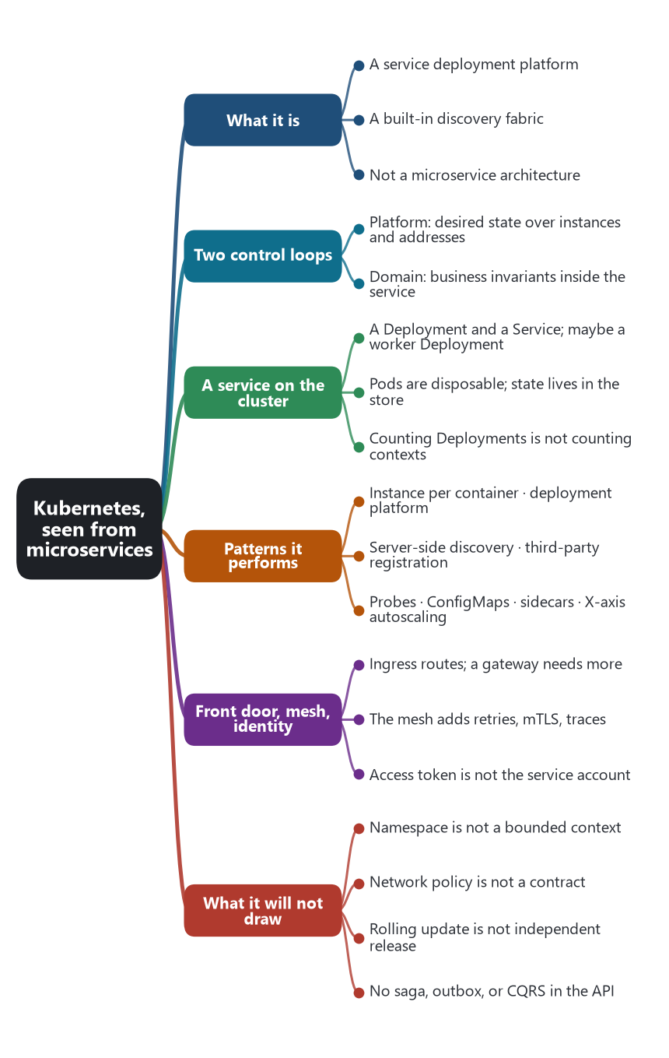
The chapter as a map: its sections and what each one holds.
From the point of view of microservices, Kubernetes is a service deployment platform and a built-in discovery fabric. It is the place a service instance runs, the thing that starts another copy when one dies, and the stable name other services call. It is not a microservice architecture. It does not know bounded contexts, aggregates, or sagas. A cluster can host a well-cut set of services, one monolith in a single pod, or a distributed monolith of twenty deployments that share a database and release together. The platform will dutifully keep all three running.
Kubernetes was designed from Google’s experience operating containers with Borg. Its first commit is 6 June 2014, Eric Brewer announced it at DockerCon on 10 June 2014, and version 1.0 was released with the Cloud Native Computing Foundation on 21 July 2015. In Richardson’s pattern language it is the usual implementation of two patterns at once: service instance per container, and service deployment platform. The rest of what teams attribute to Kubernetes is a set of older microservice patterns that the platform now performs so the service code does not have to.

🔄 Two control loops
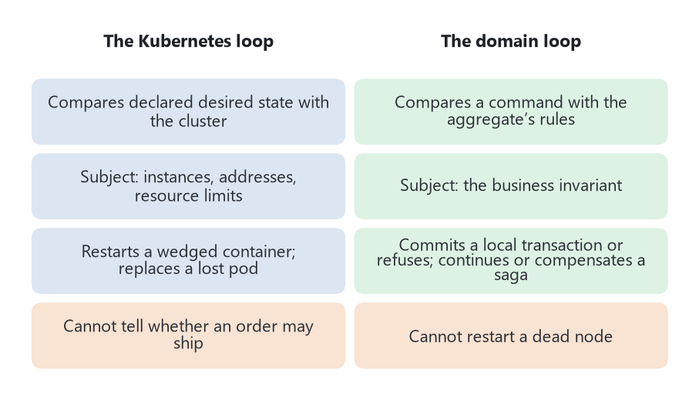
Two control loops that do not share a subject.
A useful way to see the split is to notice two control loops that do not share a subject.
The Kubernetes loop compares a declared desired state with the cluster. A Deployment says “three pods of this image.” If a node dies, the loop starts a pod somewhere else. If a process wedges, a liveness probe fails and the loop replaces the container. The subject of the loop is instances, addresses, and resource limits. The loop does not know whether an order is allowed to ship.
The domain loop lives inside the service. An aggregate compares a command with its rules and either commits a local transaction or refuses it. A saga compares a business process with the events that have arrived and either continues or compensates. The subject of that loop is the business invariant. Kubernetes can restart the process that runs the aggregate. It cannot repair a wrong model.

📦 What a microservice looks like on the cluster
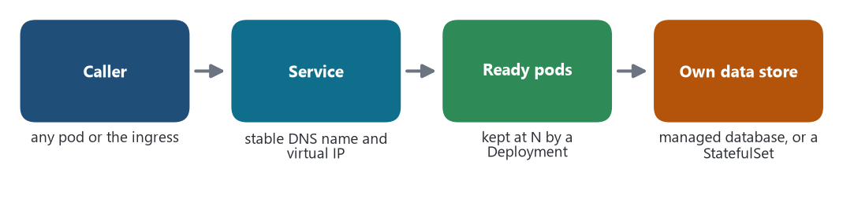
A microservice on the cluster: callers use one stable name; the platform forwards to a ready pod; the data lives in a store the service owns.
The smallest thing Kubernetes runs is a pod: one or more containers that share a network namespace and are scheduled together. The usual microservice is not “a pod.” It is a capability with its own repository, its own data, and its own release. On the cluster that capability is usually a Deployment, which keeps a set of identical pods, plus a Service, which is a durable name and a virtual address in front of whichever pods are ready. One business service can also be a Deployment for requests and another Deployment for a worker that consumes a queue, with the database outside the cluster. Counting Deployments does not count bounded contexts.
Pods are disposable. That is the Twelve-Factor rule of disposability, enforced by the scheduler. Any state the business must keep belongs in the service’s own data store, not in the container’s filesystem. A StatefulSet is the exception Kubernetes offers when an instance needs a stable identity and stable disk, which is how teams sometimes run a database inside the cluster. Many microservice systems leave that store to a managed cloud database and keep the Deployments stateless. Both placements can honor database-per-service. The platform does not choose the ownership. The team does, by giving that store to one service and not sharing its schema.

🤖 Patterns the platform performs
These are patterns from the catalog. Kubernetes does not rename them. It runs them.
Microservice pattern | What Kubernetes actually does
Service instance per container | Each pod runs the service’s image. A Deployment or ReplicaSet holds the desired number of copies.
Service deployment platform | You declare the desired state. Controllers reconcile the cluster until the running state matches. Replacing a pod is normal. Patching a running server is not the model.
Server-side discovery | Callers use one DNS name. The platform’s network layer forwards to a ready pod. The caller does not query a registry and pick an instance.
Service registry and third-party registration | The control plane records which pods match a Service’s selector. The application does not register itself on startup. The platform is the registrar Richardson called a third party.
Health check API | A liveness probe restarts a wedged process. A readiness probe removes a pod from the Service so it receives no traffic until it can work. A startup probe protects a slow start from being killed.
Externalized configuration | ConfigMaps and Secrets are mounted or injected. The image stays free of environment-specific addresses and credentials.
Sidecar | A pod may run a second container beside the application, sharing its network. That is the classic place for a proxy, a log shipper, or an adapter.
Design for failure, at the instance layer | A dead node loses its pods and the scheduler creates replacements. A disruption budget can refuse to evict too many pods at once. This is instance failure, not a failed business transaction.
Bulkhead, in a narrow sense | CPU and memory requests and limits stop one pod from consuming the node. They do not isolate the threads inside a process. That inner bulkhead remains application code, or a mesh policy.
Scale cube, X axis | A horizontal pod autoscaler adds or removes copies of the same pod. It does not split a service by function. Functional decomposition, the Y axis, is still an architecture decision made before the manifest is written.

🚪 The front door, the mesh, and identity

A motorcycle with a sidecar. The sidecar pattern is named for it: a helper container rides beside the application container in the same pod, sharing its network, and handles retries, encryption, and tracing. Photo: Infrogmation, Wikimedia Commons, CC BY-SA 4.0.
North-south traffic, from clients into the cluster, enters through an Ingress or through the Gateway API. That object can terminate TLS and route by host and path to Services. It is a routing front door. It becomes an API gateway or a backend for frontend only when a team adds authentication, aggregation, and a client-specific shape. Those are application responsibilities sitting behind, or inside, the route. The cluster’s ingress does not know that the mobile client needs a different payload from the web client.
East-west traffic, from service to service, is by default a Service name and a load-balanced connection. A service mesh adds the reliability patterns at that hop: retries, timeouts, mutual authentication, and traces. The first generation injected a sidecar proxy into the pod. Some meshes can now place that proxy at the node instead, so the pod contains only the application container and the traffic policy still belongs to the platform. Either way, the mesh is an optional layer on Kubernetes, not a feature of the Deployment. Circuit breaking a business dependency can live in that proxy or in the service’s own client. The platform does not notice that the dependency is the payment context.
Identity splits in two, and both are required. The access-token pattern still carries the user or the calling service inside the request, so the aggregate can decide whether this customer may cancel this delivery. A Kubernetes service account is a different identity: it is who the pod is allowed to be when it calls the platform API or a cloud service. Workload identity answers “may this process read this secret?” The token in the request answers “may this actor perform this business action?” Confusing the two leaves either the cluster open or the domain unchecked.

🚧 Boundaries Kubernetes will not draw
A namespace groups objects and is a scope for names and for role-based access. Teams often give a stream-aligned team a namespace, and a platform team the cluster. That is Conway’s Law used as an access boundary. It is not a bounded context. Two namespaces can share a database. One namespace can hold an entire monolith and its workers.
A network policy can refuse connections from one set of pods to another. That is a useful enforcement of “these services may not talk.” It is not the design of the talk they are allowed to have. The contract, the published language, and the anti-corruption layer remain in the repositories.
A rolling update can ship one Deployment while others stay on the old pods. That is the mechanical half of independent deployability. The other half is a contract that can evolve, a private schema, and a release train that is actually per service. Kubernetes will roll twenty Deployments in lockstep if the pipeline asks it to. The cluster cannot tell that those twenty are one distributed monolith.
Nothing in the API implements a saga, an outbox, API composition, or CQRS. A queue still lives in a broker. A workflow still lives in application code or in a workflow engine. A read model still has to be built. Operators sometimes point at a cluster full of small Deployments and call the result microservices. The architecture is in the data ownership and the collaboration, which are invisible to the scheduler.

☁️ Where this sits beside the cloud
Kubernetes is the portable form of the cloud platform from the previous chapter. A managed control plane — EKS, AKS, GKE, and their peers — moves the shared-responsibility line: the provider runs the control plane, and the customer runs the workloads, the node pools, and the application. The same manifests can run on a private cluster. Microservices do not become more real on the managed service. They become easier to place across zones, because the scheduler can spread pods, and easier to mistake for an architecture, because the objects are small and numerous.
The platform team from Team Topologies owns this layer: the cluster, the ingress, the policy, the mesh, the autoscaler, and the path by which a new service gets a Deployment, a Service, and a dashboard. The stream-aligned team owns the image, the probes, the resource requests, the schema, and the on-call for the business behavior. When those roles collapse into one, every service team invents its own cluster conventions. When they are honored, Kubernetes stays dull infrastructure under smart services, which is the arrangement Fowler and Lewis asked for from the pipes.

🎯 What this fixes for the AI chapter
Generating a Deployment, a Service, a container file, and a probe is help with the platform packaging. It can be correct and still wrap a shared database and a chatty call chain. An AI claim about microservices has to show a boundary, a private schema, and a collaboration pattern. An AI claim about Kubernetes has to show desired state that matches how the process fails, starts, and is found. The two outputs are often committed in one pull request. They are still two decisions, and the scheduler will not review the second one.
Sources: Kubernetes project history as in the history chapter of this series (first commit 6 June 2014, announcement 10 June 2014, version 1.0 and the CNCF on 21 July 2015). Brendan Burns, Brian Grant, David Oppenheimer, Eric Brewer, and John Wilkes, “Borg, Omega, and Kubernetes,” ACM Queue, 2016. Chris Richardson, service deployment platform, service instance per container, server-side discovery, third-party registration, and health check, microservices.io. Adam Wiggins, The Twelve-Factor App (2011), on disposability, config, and port binding. The pattern catalog and the cloud chapter of this series.
🔁 Read it again: three things to carry away
1. Kubernetes runs instances and keeps them addressable; it knows nothing about business rules.
2. Two control loops: the platform reconciles desired state; the domain enforces invariants.
3. Namespaces, network policies, and rolling updates are not bounded contexts, contracts, or independent releases.

