🏢 Requirements of a SaaS system
Answer 9 of the working series
29 September 2026
SaaS here is Software as a Service. The spelling SAS in the question is read as that cloud model, not as the SAS analytics product.
🔑 How to read this edition
The central idea of the chapter — bold, on a yellow marker.
An important sentence — blue and underlined, in the text itself.
A technical term — plum with a dotted line; its meaning is in “Words to know”.
💬 In plain words 🧭 The chapter as a map 📖 Words to know 🔁 Read it again

⭐ In one sentence
Software as a service means one product run by the provider for many tenants — so multi-tenancy is the architectural consequence, and every request, message, row, and log line must know its tenant.

💬 In plain words
Software as a service means one product, run by the provider, used by many customer organizations (tenants) at once. Multi-tenancy is the consequence: every request must carry which tenant it belongs to, every row must be attributable to a tenant, and the provider needs a control plane — the back office that onboards tenants, meters their use, and applies their tier. Microservices do not change these obligations; they multiply the places where each must be honored.

📖 Words to know
SaaS | Software as a service: the provider runs the application; customers use it through a browser or an API.
tenant | One customer organization inside a shared product.
Multi-tenancy | Many tenants served by one product, with their data and settings kept apart.
control plane | The provider’s back office: onboarding, the tenant record, identity into a tenant, tiers, metering, one place to operate the estate.
application plane | The product the tenants actually use, with a tenant context on every request.
Silo | A tenant gets dedicated resources, such as its own database or stack.
Pool | Tenants share resources; the tenant is enforced in the application and the data access.
Bridge | A mix: one service siloed, another pooled.
Noisy-neighbor | A tenant whose spike degrades the shared service for the others.
tier | A product level that may buy a silo, a higher quota, or a stricter recovery objective.
meters | Measures what each tenant consumed, for billing and fair throttling.
Offboarding | Exporting or deleting a tenant’s data and withdrawing its identity when it leaves.
tenant context | The tenant identifier carried on every request, message, log line, and query.
managed service | A per-customer install run by the provider — which fails NIST’s SaaS test.
Well-Architected SaaS Lens | Amazon’s review checklist for SaaS systems, with ten areas of concern.

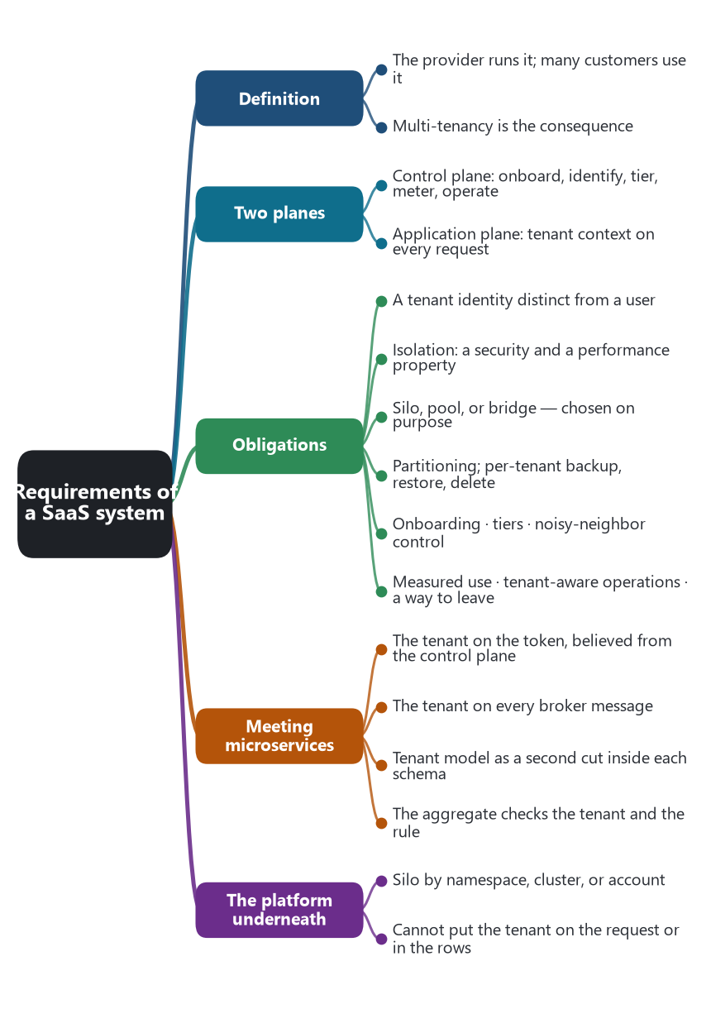
The chapter as a map: its sections and what each one holds.
A SaaS system is a software application the provider runs, and that many customers use, without those customers operating the servers, the database, or a private install. NIST’s cloud definition, Special Publication 800-145, September 2011, states the customer-facing bar. The application is reached through a browser or through a program interface. The customer does not manage the network, the servers, the operating system, the storage, or the individual application capabilities. The exception NIST allows is limited user-specific configuration. The five cloud properties still apply: the customer can sign up on demand, over the network, onto a pooled service that can grow, and the use of that service is measured.
Multi-tenancy is the architectural consequence. A tenant is one customer organization inside that shared product. A separate copy of the product, installed and operated per customer, can run in a cloud and still fail this test. Amazon’s SaaS guidance calls that a managed service. SaaS, even when a tenant is given some dedicated resources, still has one onboarding path, one identity experience, and one operational life for every tenant.

🎛️ Two planes
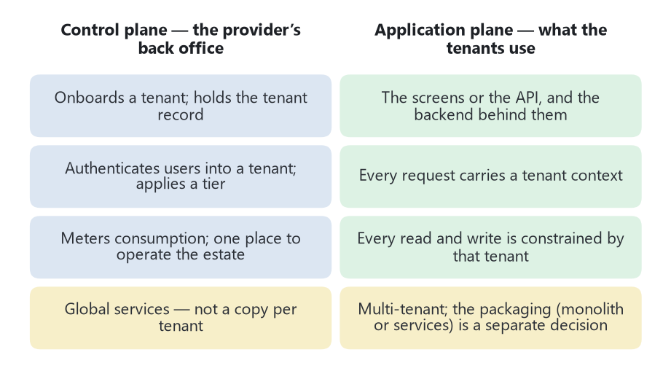
Two planes. Both are required; neither is the microservice architecture.
The SaaS Architecture Fundamentals whitepaper divides the system into a control plane and an application plane. Both are required. They are not two names for the microservice architecture.
The control plane is how the provider runs the tenants as one business. It onboards a tenant, holds the tenant record, authenticates users into a tenant, applies a tier, meters consumption, and gives the provider one place to operate the estate. Those services are global. They are not themselves a copy per tenant. If the control plane is missing, each tenant has become a private install, whatever the marketing says.
The application plane is the product the tenant actually uses: the screens or the API, and the backend that performs the business. This plane is multi-tenant. Every request carries a tenant context, and every read and write is constrained by it. The backend may be one modular application or a set of microservices. The packaging is a separate decision. The tenant context is not.

✅ What the system has to guarantee
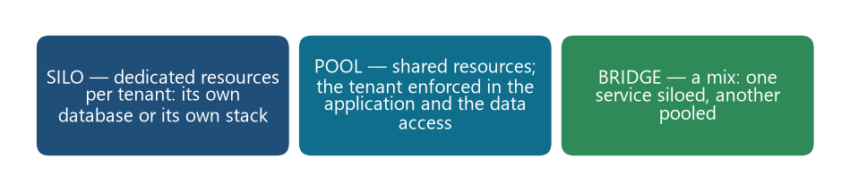
Three placement models. The system needs a chosen one, not an accident of how each team stored a tenant id.
The AWS Well-Architected SaaS Lens groups the extra concerns of this model into ten areas: tenant, silo pool and bridge, identity, tenant isolation, data partitioning, noisy neighbor, onboarding, tiers, activity and consumption, and tenant-aware operations. The requirements below are those concerns stated as obligations of the system.
Requirement | What the system must do
A tenant identity distinct from a user | Users belong to a tenant. The tenant is the unit of data, policy, billing, and offboarding. A user token that names only a person is not enough.
Tenant context on every request | The application plane receives the tenant on the way in and passes it through every service, query, and message. A log line, a trace, and a metric that cannot be tied to a tenant hide both abuse and cost.
Isolation | One tenant must not read or change another tenant’s data, exhaust another tenant’s capacity, or see another tenant’s configuration. Isolation is a security property and a performance property.
An explicit placement model | Silo gives a tenant dedicated resources, such as its own database or its own stack. Pool shares resources and enforces the tenant in the application and the data access. Bridge mixes them: one service siloed, another pooled. The system needs a chosen model, not an accident of how each team stored a tenant id.
Data partitioning that matches the model | Pooled tables carry a tenant key and refuse queries that lack it. Siloed stores are named and reached only for that tenant. A backup, a restore, and a deletion must be possible for one tenant.
Automated onboarding | A new tenant is created by the control plane: record, identity, configuration, and any dedicated resources, without an engineer performing a custom install.
Tiers | A tier is a product and a placement decision. A higher tier may buy a silo, a higher quota, or a stricter recovery objective. The application has to enforce the tier the control plane assigned.
Noisy-neighbor control | A pooled tenant with a spike must not take the shared service down for the others. Quotas, rate limits, and per-tenant resource limits are the bulkhead at tenant grain.
Measured use | The provider can say what a tenant consumed. Billing, fair throttling, and cost allocation all depend on that measurement. This is NIST’s measured service, scoped to the tenant.
Tenant-aware operations | Deploys, alarms, support, and capacity are run for a multi-tenant estate. An operator can find one tenant’s errors without dumping every tenant’s data into the ticket. A release updates the product the tenants share, including siloed resources the control plane still owns.
Limited configuration, not a fork | A tenant may set the options NIST called user-specific configuration, and may receive features its tier includes. The provider does not maintain a separate codebase per tenant.
A way to leave | Offboarding exports or deletes that tenant’s data and withdraws its identity. A pooled table that cannot name one tenant’s rows cannot do this.

🤝 How this meets microservices
SaaS does not require microservices. A single deployable application can meet every requirement above, and many SaaS products are built that way. Microservices change where the requirements have to be repeated.
The access-token pattern already carried the caller’s identity from service to service. SaaS adds the tenant to that token, and every service has to believe the control plane rather than a tenant id supplied by the client alone. A message on the broker needs the same tenant context, or the consumer will write an event into the wrong partition. Database-per-service still holds: each service owns its schema. Inside that schema the tenant model is a second cut. One service may pool all tenants in one database. Another, holding regulated data, may silo a database per tenant. That mix is the bridge model, and it is a legal microservice design. It is also easy to get wrong, because each team can pick a different convention and the control plane will not notice until a deletion or a restore.
The control plane behaves like the platform in Team Topologies. It is X-as-a-service toward the product teams: onboarding, tier, and metering are not reimplemented inside every bounded context. The stream-aligned team still owns the business rule and must apply the tenant constraint inside the aggregate. An aggregate that checks “may this delivery be cancelled?” and never checks “does this delivery belong to the tenant on the token?” has enforced the domain and missed the SaaS requirement.
Kubernetes and the cloud sit underneath both planes. They can silo a tenant by namespace, cluster, or account, and they can pool tenants on one Deployment. They do not put the tenant on the request, and they do not partition the rows. A network policy can separate siloed namespaces. It cannot separate two tenants that share a table. Noisy-neighbor limits on CPU are the pod bulkhead from the Kubernetes chapter. Tenant quotas are a further bulkhead inside the shared process.

🎯 What this fixes for the AI chapter
A generated service that stores orders and exposes an API can look complete and still be a single-tenant program. The SaaS obligations are visible in a few places: a tenant on the token, a tenant predicate on every query, a control-plane record that can create and delete that tenant, a meter, and a stated silo or pool choice. An AI claim about a SaaS system has to show those. An AI claim about microservices still has to show the bounded context and the private schema. A system can satisfy one and miss the other.
Sources: Peter Mell and Timothy Grance, The NIST Definition of Cloud Computing, Special Publication 800-145, September 2011, the Software as a Service model. NIST, Evaluation of Cloud Computing Services Based on NIST SP 800-145. Amazon Web Services, SaaS Architecture Fundamentals, “Control plane vs. application plane.” Amazon Web Services, Well-Architected SaaS Lens: tenant, silo, pool, and bridge, identity, isolation, data partitioning, noisy neighbor, onboarding, tiers, activity and consumption, and tenant-aware operations.
🔁 Read it again: three things to carry away
1. SaaS means one product for many tenants — with a control plane that onboards, tiers, and meters them.
2. Tenant context rides on every request, message, log line, and query.
3. Microservices repeat the tenant obligations in every service; the platform cannot supply them.

