🚀 PaaS from the point of view of microservices
Answer 10 of the working series
29 September 2026
PaaS here is Platform as a Service. The spelling Pass in the question is read as that cloud model.
🔑 How to read this edition
The central idea of the chapter — bold, on a yellow marker.
An important sentence — blue and underlined, in the text itself.
A technical term — plum with a dotted line; its meaning is in “Words to know”.
💬 In plain words 🧭 The chapter as a map 📖 Words to know 🔁 Read it again

⭐ In one sentence
A PaaS is the platform a service is pushed to: it runs, routes, restarts, and scales the process, and it neither knows nor cares whether that process is a microservice.

💬 In plain words
A PaaS is the platform you hand your code to: ‘here is my app, here are its process types, here is the database I want attached’. Heroku made this a git push. The platform runs, routes, restarts, and scales; it neither knows nor cares whether two apps share a database or whether a message carries a tenant. The service still has to mean something; the platform only keeps it running.

📖 Words to know
PaaS | Platform as a service: a place to deploy your application without managing servers or operating systems.
Infrastructure as a service | Raw machines, storage, and networks that the team manages itself (IaaS).
Heroku | The classic public PaaS: deploy by git push.
dyno | Heroku’s running copy of one process type — one command in a disposable container.
Procfile | The file that names an app’s process types, such as web and worker.
buildpack | The recipe that turns a repository into something runnable.
add-on | A database, cache, or queue attached to an app by name; the app reads its address from the environment (a ‘binding’).
Twelve-Factor App | Heroku’s 2011 rules for applications that run well on a platform.
router | The platform component that forwards requests to a live instance.
server-side discovery | The caller uses a stable name; the platform picks the instance.
Cloud Foundry | The open-source platform enterprises run themselves (2011).
OpenShift | Red Hat’s Kubernetes with a PaaS door in front.
Cloud Native Buildpacks | Buildpacks that emit ordinary container images.
distributed monolith | Many apps that share one schema and one release train — the costs of both styles.
stateless | Keeping no state between requests inside the process; state lives in an attached store.

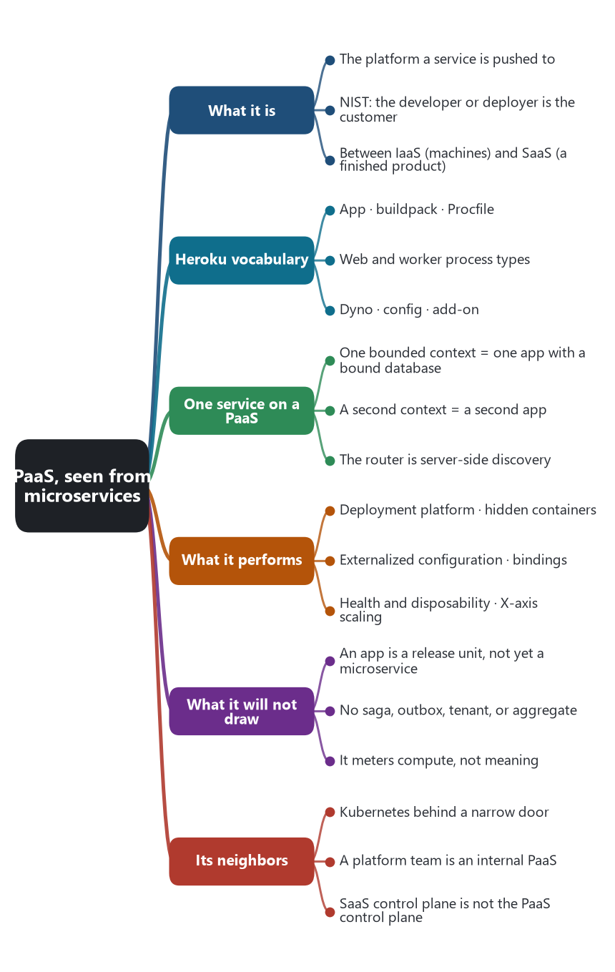
The chapter as a map: its sections and what each one holds.
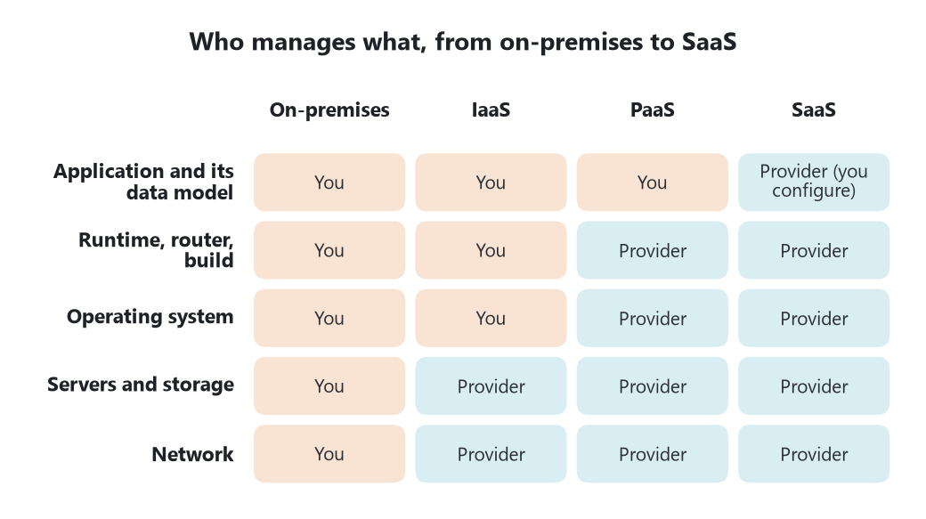
Who manages what. The responsibility line moves with the service model; the meaning of the application never moves to the provider.
From the point of view of microservices, a PaaS is the deployment platform a service is handed to. The team supplies the application, built with the languages and libraries the platform accepts, and the configuration of the hosting environment. The platform runs the processes, routes to them, restarts them, and attaches databases and queues. NIST Special Publication 800-145, September 2011, draws the line there. The consumer does not manage the network, the servers, the operating system, or the storage. The consumer does control the deployed applications and, possibly, settings of the application-hosting environment. NIST’s later evaluation guide is explicit about who that consumer is: the developer or deployer, not the end user of a finished product, and not the operator of virtual machines.
That places PaaS between the two models already in this series. Infrastructure as a service hands the team machines, and the team assembles the platform, or installs Kubernetes and operates it. Software as a service hands a tenant a finished product. Platform as a service hands a service team a place to run one service, and the next service, without handing them the machines. Heroku is the classic public example. Cloud Foundry, announced in 2011, is the classic private one. The Twelve-Factor App, written at Heroku in 2011, is the contract those platforms expect a service to keep.

📦 One microservice on a PaaS
On Heroku the unit is an app. A buildpack turns the repository into something runnable. A Procfile names process types. A web process receives HTTP. A worker process does not. It consumes a queue. Each running copy is a dyno: one command, in a container, disposable. Configuration sits in the environment. A database or a queue is an add-on, bound to the app, and the app reads its address from that binding. Cloud Foundry has the same shape under different names: push an application, bind a service from a broker, scale the instances.
From the architecture’s point of view, one bounded context is usually one such app, with its web process and its worker as two process types of that same service, not as two microservices. The database is a backing service attached to that app. A second bounded context is a second app, with its own repository, its own release, and its own binding. The platform will also allow both apps to be bound to one shared database. It will not object. Database-per-service remains a decision in the repositories and in the bindings the teams choose, not a rule of the dyno.
Service-to-service calls use a route the platform publishes, or a URL placed in configuration. The caller does not pick an instance. The platform’s router does. That is server-side discovery again, with the registrar hidden inside the platform. There is no pod manifest and no selector. The price of that simplicity is that the team also does not see the instance.

🤖 Patterns the platform performs
Microservice pattern | What a PaaS actually does
Service deployment platform | The team pushes a release. The platform builds it, starts the process types, and keeps the desired number of copies. Richardson’s pattern is the product.
Service instance per container, hidden | Each dyno or instance runs one command. The team scales a process type. The machine underneath is the provider’s concern.
Externalized configuration | Addresses, credentials, and feature flags are environment bindings. The build does not contain the production database name.
Backing services as attached resources | A database, a cache, or a queue is bound by name and can be replaced by rebinding. Twelve-factor stated this so a service would not assume a local disk or a fixed host.
Server-side discovery | Callers use the app’s route. The router forwards to a live instance.
Health and disposability | A failed instance is replaced. The filesystem is ephemeral. State belongs in the bound data store. Logs go to the platform’s stream, not to a file on the dyno.
Scale cube, X axis | Adding instances copies the same process. Splitting a capability into a new app is a separate release and a separate binding, which is the Y axis, decided by the team.
Third-party registration | The process does not announce itself to a registry. The platform that started it is the registrar.

Heroku’s own glossary is the concrete vocabulary: app, dyno, Procfile, web and worker process types, buildpack, config, add-on. Cloud Foundry’s service brokers are the same binding idea. Twelve-factor is Adam Wiggins, 2011.

🚧 What the platform will not draw
A PaaS app is a release unit. It becomes a microservice only if it owns its data and can be released without the apps next to it. Twenty apps that share one schema and one release train are a distributed monolith that happens to push cleanly. The router cannot see that.
Nothing in the push model implements a saga, an outbox, a tenant predicate, or an aggregate. A bound queue will carry whatever message the app publishes. If the message has no tenant, the SaaS requirement from the previous chapter is already lost, and the platform’s metering of dyno-hours will not catch it. If the message has no business identity, the saga has nothing to correlate. The platform meters compute. The service has to meter meaning.
The opinion of the platform is a real constraint. Buildpacks support a set of languages and runtimes. The process model wants a stateless command. Sidecars, a service mesh, and fine network policy are awkward on a classic PaaS, because those knobs were the thing the platform hid. Teams that need them either accept the paved road or step down to Kubernetes, where those objects are first-class and the team owns them. That step down is a change in the responsibility line, not a change in the bounded context.

☸️ Where Kubernetes sits
The previous chapter treated Kubernetes as the portable deployment platform the team still has to declare: pods, probes, Services, limits. A PaaS is that platform with the declaration narrowed to “here is the code, here are the process types, here are the bindings.” Many current platforms run on a cluster and show the team only the narrow door. OpenShift, Cloud Foundry on Kubernetes, and Heroku’s move to Cloud Native Buildpacks, which emit ordinary container images, are that arrangement. Cloud Run, App Service, and similar products are the same door on a public cloud. The cluster may still be there. The microservice team is not invited to operate it.
A platform team, in the Team Topologies sense, is an internal PaaS even when the substrate is Kubernetes. The paved path is a pipeline, a build, a bind, a route, and a dashboard. Stream-aligned teams push services. When that path is missing, every service team writes its own manifests and the organization has a cluster, not a platform. When the path is so narrow that a service cannot own a different data store or a different release, the platform has collapsed the architecture back into one application that merely has several processes.

🏢 Where SaaS sits
A company can build its SaaS product by placing each service on a PaaS. The PaaS control plane onboards applications, routes, and dynos. The SaaS control plane onboards tenants, tiers, and meters. They share a word and they do not share a job. Dynos are not tenants. Binding an add-on does not put a tenant key on a query. The application plane of the SaaS still has to carry the tenant through every app the PaaS is running. The provider of the SaaS is the consumer of the PaaS.

🎯 What this fixes for the AI chapter
Generating a Procfile, a manifest, and a set of environment bindings is help with the platform contract. It can be a correct twelve-factor app and still share a database, omit the tenant, and call five neighbors in one user request. An AI claim about PaaS has to show a stateless process, configuration outside the build, and backing services as bindings. An AI claim about microservices still has to show the boundary and the private data. Pushing to a platform discharges neither claim by itself.
Sources: Peter Mell and Timothy Grance, NIST Special Publication 800-145, September 2011, Platform as a Service. NIST Special Publication 500-322, Evaluation of Cloud Computing Services Based on NIST SP 800-145, on the developer or deployer as the PaaS consumer. Adam Wiggins, The Twelve-Factor App (2011). Heroku Dev Center glossary: app, dyno, Procfile, buildpack, add-on. Cloud Foundry’s application-push and service-binding model. The Kubernetes, SaaS, and pattern chapters of this series.
🔁 Read it again: three things to carry away
1. A PaaS runs the process you push; the meaning of the process is still yours.
2. A push-clean app can still share a database, omit the tenant, and call five neighbors per request.
3. Dynos are not tenants; the PaaS control plane and the SaaS control plane share a word, not a job.

