🧩 Types of software
Answer 11 of the working series
29 September 2026
Four cuts. A program can sit in one cell of each cut at the same time.
🔑 How to read this edition
The central idea of the chapter — bold, on a yellow marker.
An important sentence — blue and underlined, in the text itself.
A technical term — plum with a dotted line; its meaning is in “Words to know”.
💬 In plain words 🧭 The chapter as a map 📖 Words to know 🔁 Read it again

⭐ In one sentence
There is no single list of software types — four cuts answer four different questions, one program sits in one cell of each, and the research question lives on the structure cut.

💬 In plain words
Ask ‘what kind of software is this?’ and you get different answers depending on the question behind it: what job does it do beside the hardware; what problem does it solve; how does the customer receive it; how is it structured. A single program sits in one cell of each cut. Keeping the cuts apart stops the research from confusing an AI feature inside an application with an AI tool that redraws the architecture.

📖 Words to know
System software | Operates the machine for other programs: operating systems, runtimes, database engines, Kubernetes.
Middleware | Sits between system and application software, carrying messages, requests, and identity between programs.
Application software | Does a job a person or another business system asked for.
Development software | Builds, tests, and releases the other three kinds.
Pressman | Roger Pressman, author of the standard textbook Software Engineering: A Practitioner’s Approach, and of its seven categories.
Embedded software | Lives inside a device with fixed memory and real-time limits.
Product-line software | A family of related products built from one shared base.
on-premises | Installed and run on the customer’s own machines.
Infrastructure as a service | Machines, storage, and network from a provider; you install everything else.
Platform as a service | A place to run your application without managing the machines.
Software as a service | A finished product the provider runs and the customer logs into.
Modular monolith | One deployable unit with enforced internal boundaries.
Self-contained systems | Team-owned web applications, each with its own interface, data, and logic.
Serverless functions | Code the platform runs on demand; a function may be smaller than a bounded context.

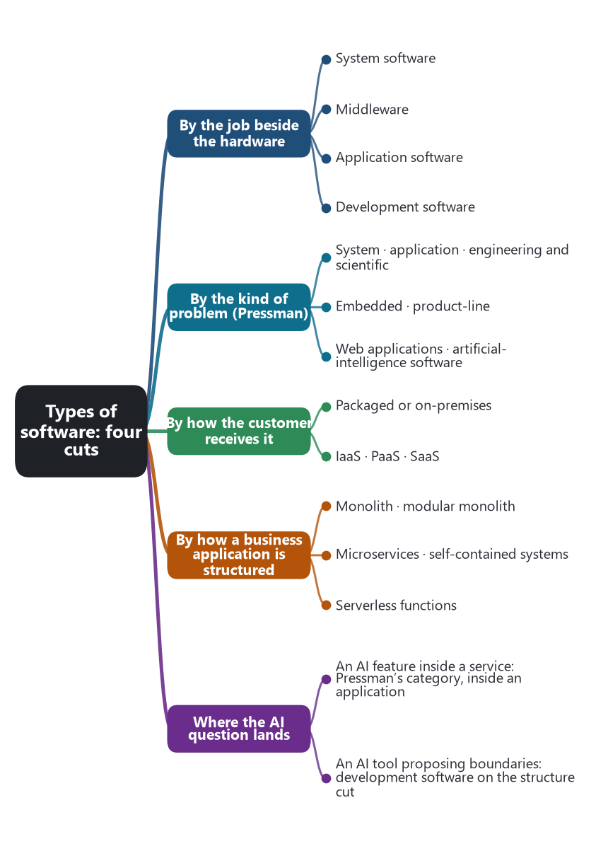
The chapter as a map: its sections and what each one holds.
There is no single list of software types. A useful classification says which question it is answering. Four questions cover the ground this research needs: what job the program does beside the hardware, what kind of problem it is built to solve, how a customer receives it, and how a business application is structured. One program occupies one place on each cut. Kubernetes is system software, delivered as a platform, and it is not itself a microservice. An order service is application software, often a web application, delivered on a PaaS or on infrastructure, and structured as one service in a suite.

🖥️ By the job beside the hardware
This is the everyday cut.
Type | The job | Examples in this series
System software | Operates the machine and makes it usable by other programs. It schedules processes, stores bytes, and moves packets. | An operating system. A container runtime. Kubernetes, as the deployment platform. A database engine.
Middleware | Sits between system software and the application, and carries messages, requests, and identity from one program to another. | A message broker. An API gateway. A service mesh. The PaaS router.
Application software | Does a job a person or another business system asked for. | The order service, the delivery service, the SaaS product the tenant uses.
Development software | Builds, tests, and releases the other three. | Compilers, buildpacks, pipelines, test runners, contract-test tools.

🧩 By the kind of problem
Roger Pressman’s software-engineering text groups programs by the problem they are written to solve. The list below is that grouping. Later editions place mobile applications with web applications. The categories overlap in practice: a web application can also be a product line, and an AI component can sit inside an application.
Pressman’s category | What is distinctive about it
System software | Heavy interaction with hardware, concurrency, sharing, and scheduling. Deterministic services other programs depend on.
Application software | A business or personal task. The emphasis is the user’s work: records, decisions, reports, workflows.
Engineering and scientific software | Numerical models. The result has to be accurate under a stated method, from simulation to analysis.
Embedded software | Lives inside a device and runs its functions, often with fixed memory and a real-time bound. A braking controller, a meter, a machine.
Product-line software | A family of related products from a shared base, configured for different customers rather than rewritten for each.
Web applications | Reached over the network through a browser or an HTTP API. They integrate data and business rules and are the usual face of the services in this series.
Artificial intelligence software | Non-numerical methods for problems that do not have a single direct calculation: recognition, search, learning, expert judgment.

Source: Roger S. Pressman, Software Engineering: A Practitioner’s Approach. The seven categories are the standard list from that book; mobile applications are grouped with web applications in later editions.

📦 By how the customer receives it
This is the cut NIST made for cloud computing, plus the older packaged form that NIST was distinguishing from the cloud. It answers a commercial and operational question, not a problem-domain question.
Delivery | What the customer holds | What the provider holds
Packaged or on-premises software | A copy they install and operate on machines they manage. | A release, and often a license. After installation, the customer’s operators run it.
Infrastructure as a service | Machines, and the software they themselves install, including a whole microservice suite. | The pool of compute, storage, and network.
Platform as a service | The application they wrote, its configuration, and its bindings. | The runtime, the router, the build, and the machines underneath.
Software as a service | A login, a configuration, and the tenant’s own data. | The entire product, its control plane, and the estate of tenants.

A SaaS product is still application software under the first cut, and usually a web application under Pressman’s cut. The delivery type does not change the problem type. It changes who patches the servers and who onboards the next customer. A PaaS is system software and middleware from the provider’s side, and a home for application software from the team’s side.

🏗️ By how a business application is structured
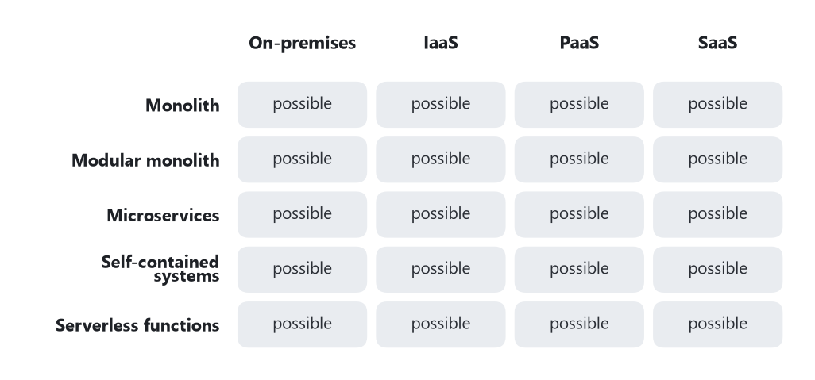
The two cuts that are easiest to confuse. Every cell is a real combination: a monolith can be SaaS; a microservice suite can be installed on your own machines.
This cut is the subject of the series so far. It applies mostly to application software and to web applications. It is not a fifth Pressman category.
Structure | The shape
Monolith | One deployable unit holds the interface, the rules, and the database access.
Modular monolith | One deployable unit, with internal boundaries that are enforced in the code and can later become services.
Microservices | A suite of independently deployable services, each owning its data and collaborating by calls, events, or sagas.
Self-contained systems | Each slice is a team-owned web application with its own interface, data, and logic.
Serverless functions | The platform runs a unit of code on demand. The function may be one service, or a fragment too small to be a bounded context.

These structures can be delivered in any of the ways in the previous table. A monolith can be SaaS. A microservice suite can be packaged and run on a company’s own machines. Kubernetes and a PaaS are system software used to run whichever structure the team chose. They are not themselves one of these structures.

🎯 Where the later AI question lands
Pressman’s artificial-intelligence category is software whose job is recognition, search, or learned judgment. The research question of this series is different and easy to blur with that category. It asks how AI changes the architecture of microservices, which are a structure of application software, usually web applications, usually delivered on a platform or as SaaS. An AI feature inside the order service is Pressman’s seventh category living inside an application. An AI tool that proposes service boundaries is development software acting on the structure cut. Naming which cut moved is the discipline of the later chapter.
The delivery cut follows Peter Mell and Timothy Grance, NIST Special Publication 800-145, September 2011. The structure cut follows the earlier chapters of this series: Lewis and Fowler, Richardson, the CNCF definition, and the SaaS and PaaS chapters.
🔁 Read it again: three things to carry away
1. Four cuts, four questions; one program sits in one cell of each.
2. Kubernetes and a PaaS are system software that hosts a structure; they are not a structure.
3. The research is about the structure cut — not about Pressman’s artificial-intelligence category.

