🏷️ What sits beside SaaS
Answer 12 of the working series
29 September 2026
NIST names three service models. PaaS and SaaS already have chapters. This chapter adds IaaS and the narrower names the industry hangs on the three.
🔑 How to read this edition
The central idea of the chapter — bold, on a yellow marker.
An important sentence — blue and underlined, in the text itself.
A technical term — plum with a dotted line; its meaning is in “Words to know”.
💬 In plain words 🧭 The chapter as a map 📖 Words to know 🔁 Read it again

⭐ In one sentence
There are exactly three official ‘as a service’ models — infrastructure, platform, software — sorted by who the customer is; every newer name lands under one of them.

💬 In plain words
There are exactly three official ‘as a service’ models — infrastructure, platform, software — sorted by who the customer is: an operator, a developer, or an end user. Every newer label (function-, container-, database-, identity-as-a-service, and so on) is a narrower product that still lands under one of the three. And ‘public, private, hybrid’ is a different question altogether: where the cloud runs.

📖 Words to know
NIST Special Publication 500-322 | The evaluation guide that sorts a cloud offering by what is provided and who the primary customer is.
Function as a service | FaaS: a unit of code run on demand and scaled to zero — Richardson’s serverless deployment.
Containers as a service | CaaS: a place to run containers, often a managed Kubernetes control plane.
Database as a service | DBaaS: a managed database engine — backups, patching, and scaling done by the provider.
Identity as a service | IDaaS: a directory, sign-in, and tokens, bought rather than built.
Integration platform as a service | iPaaS: hosted connectors, routing, and transformation between applications.
Backend as a service | BaaS: a ready-made backend — identity, data, push — for mobile and web clients.
Network as a service | NaaS: connectivity and network functions consumed as a service.
Security as a service | SECaaS: detection, protection, or compliance functions run by a provider.
DaaS | Desktop as a service — or data as a service; the abbreviation collides.
backing service | Any service an application consumes over the network: a database, a queue, a hosted model.
deployment models | NIST’s four: public, private, community, hybrid — where a cloud runs, not what kind of product it is.
data product | A dataset a domain publishes for others to analyze — the Data Mesh idea.
Managed Kubernetes | A cluster whose control plane the provider runs; the team runs the workloads.

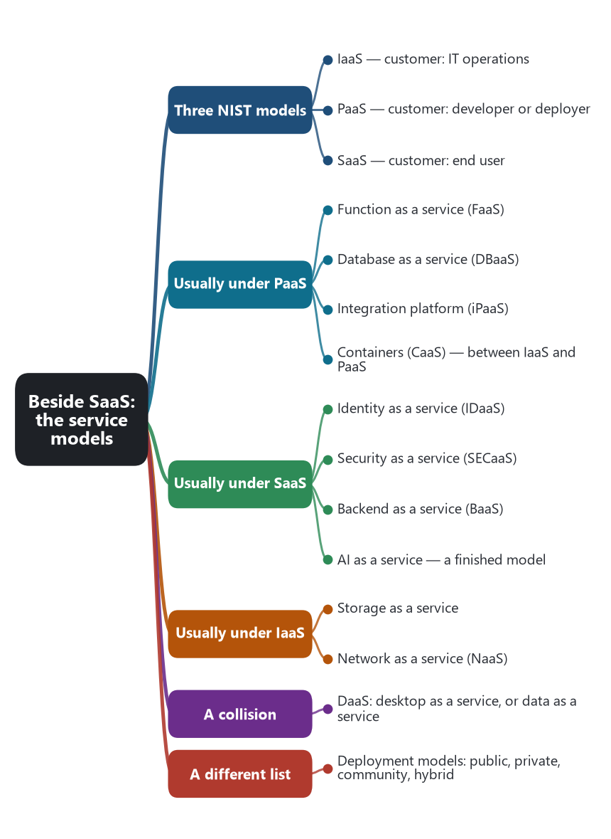
The chapter as a map: its sections and what each one holds.
The official set is three. In September 2011, NIST Special Publication 800-145 defined Software as a Service, Platform as a Service, and Infrastructure as a Service. The later evaluation guide, NIST Special Publication 500-322, sorts a cloud offering into one of those three by two facts: what is being provided, and who the primary customer is. An end user of a finished application is SaaS. A developer or deployer of an application is PaaS. An operator of systems, who needs machines and networks, is IaaS. A new “as a service” name does not create a fourth NIST model. It names a narrower product that still falls under one of the three, or under a mix.

3️⃣ The three models
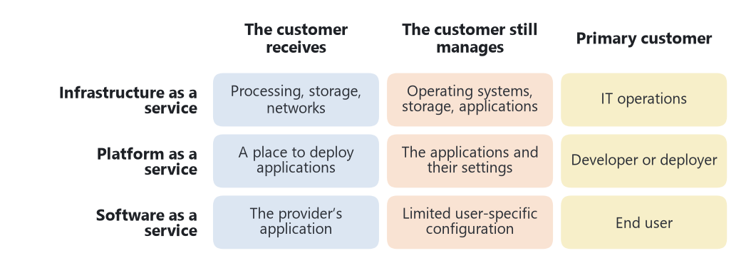
The NIST test: who is the customer, and what do they receive?
Model | The customer receives | The customer still manages | Primary customer
Infrastructure as a service | Processing, storage, and networks, on which they run any software, including operating systems. | Operating systems, storage they were given, and the applications. Limited control of some networking, such as host firewalls. | IT operations
Platform as a service | A place to deploy applications written with the provider’s languages and tools. | The applications, and possibly settings of the hosting environment. Not the network, servers, operating system, or storage. | Developer or deployer
Software as a service | The provider’s application, through a browser or a program interface. | Limited user-specific configuration. Not the infrastructure and not the application’s capabilities. | End user

PaaS and SaaS are already chapters of this series. IaaS is the one that had been named and not yet described. From the microservice point of view it is the raw pool. The team can install a cluster, a broker, and a database engine, and can run any service they can package. The provider runs the physical hosts and the virtualization. The team runs everything that makes those machines a platform. A virtual machine with a monolith on it is a completed IaaS deployment. A virtual machine with Kubernetes installed, and services scheduled on it, is a team-built platform sitting on IaaS. Managed Kubernetes moves part of that work back to the provider and lands between IaaS and PaaS, which is why the industry gave it a further name.

🏷️ Names that sit under the three
These are the narrower names that show up next to microservices. Each one is a product shape. The NIST row is where that shape usually lands, not a second official taxonomy.
Name | What is provided | Usual NIST home | What it means for a service
Function as a service (FaaS) | A unit of code run on demand. The provider starts the instance and scales it to zero. | PaaS, narrowed to a function | Richardson’s serverless deployment pattern. The function may be a whole service or a fragment smaller than a bounded context.
Containers as a service (CaaS) | A place to run containers, often a managed Kubernetes control plane. | Between IaaS and PaaS | The Kubernetes chapter. The team still brings the image, the probes, and the boundaries.
Database as a service (DBaaS) | A managed database engine: backups, patching, and often scaling. | PaaS, as a backing service | The usual way to give a service its own database without operating the engine.
Identity as a service (IDaaS) | A directory, sign-in, and tokens. | SaaS for the identity product | The access-token pattern, bought rather than built. The tenant still has to be on the token.
Integration platform as a service (iPaaS) | Hosted connectors, routing, and transformation between applications. | PaaS for integration | A hosted place for messaging and mapping. It can become the smart bus the 2014 article kept out of the middle.
Backend as a service (BaaS) | A ready-made backend for a client: identity, data, and push, aimed at mobile and web clients. | SaaS or PaaS, depending on how fixed the backend is | A shared backend behind client apps. Easy to start, and easy to become one database for every feature.
Storage as a service | Object, file, or block storage by API. | IaaS | A place for blobs and files. It is not the service’s system of record unless the service’s model says so.
Network as a service (NaaS) | Connectivity, delivery, and network functions consumed as a service. | IaaS | The routes and policies between services, without owning the wires.
Security as a service (SECaaS) | Detection, protection, or compliance functions run by a provider. | Usually SaaS | A control the platform team buys. It does not replace the tenant check inside the aggregate.
AI or machine learning as a service | A model or a training platform called by API. | SaaS for a finished model, PaaS for a training platform | Pressman’s AI category, consumed as a backing service. Calling it is not the same as changing the service boundaries.

Two names collide on the abbreviation DaaS. Desktop as a service provides a remote desktop and sits near SaaS or a virtual desktop on IaaS. Data as a service provides data through an API and sits near SaaS, and in this series it is the commercial form of a data product, the thing Data Mesh asks a domain to publish. The abbreviation alone does not say which one a document means.
Further marketing names — communications as a service, contact center as a service, business process as a service — follow the same pattern. Read them by the NIST test: if the customer is an end user of a finished application, it is SaaS; if the customer deploys their own application onto it, it is PaaS; if the customer operates systems on provided resources, it is IaaS.

⚠️ A different list that is easy to mix in
NIST also names four deployment models. They answer where the cloud runs, not what kind of product it is. A public cloud is owned by a provider and open to many customers. A private cloud is used by one organization. A community cloud is shared by a set of organizations with a common concern. A hybrid cloud binds two or more of those with technology that lets data and applications move. SaaS, PaaS, and IaaS can each be deployed in any of the four. A private cloud can host a SaaS product for one company’s own staff. A public cloud can host a single virtual machine. Deployment model and service model are two columns.

🎯 What this fixes for the AI chapter
An AI suggestion that says “use a service” has to name which model. Generating application code aimed at an end user is SaaS work only if tenancy, metering, and the control plane are in scope. Generating a container and a database binding is PaaS or CaaS work. Provisioning a network and a machine is IaaS work. Calling a hosted model is AI as a service, which is a backing service, not a new shape for the order aggregate. The three NIST rows are enough to place the suggestion. The longer list is how the suggestion will be branded.
Sources: Peter Mell and Timothy Grance, The NIST Definition of Cloud Computing, Special Publication 800-145, September 2011, service models and deployment models. NIST Special Publication 500-322, Evaluation of Cloud Computing Services Based on NIST SP 800-145, which sorts offerings by the capability provided and the primary customer. The PaaS, SaaS, Kubernetes, and software-type chapters of this series.
🔁 Read it again: three things to carry away
1. Three NIST models, sorted by who the customer is.
2. Every newer ‘-aaS’ name lands under one of the three.
3. A hosted model is AI as a service — a backing service, not a new aggregate.

