📏 Functional and non-functional requirements
Answer 13 of the working series
29 September 2026
Functional requirements are the behavior. Non-functional requirements are the qualities and constraints on that behavior.
🔑 How to read this edition
The central idea of the chapter — bold, on a yellow marker.
An important sentence — blue and underlined, in the text itself.
A technical term — plum with a dotted line; its meaning is in “Words to know”.
💬 In plain words 🧭 The chapter as a map 📖 Words to know 🔁 Read it again

⭐ In one sentence
Functional requirements say what the system does; non-functional requirements say how well and under what constraints — and services are usually split to satisfy the second kind.

💬 In plain words
A functional requirement says what the system does: ‘a customer can cancel a delivery before pickup’. A non-functional requirement says how well, and under what constraints: how fast, how available, how isolated between tenants, in which country the data may live. Both must be testable. Services are usually split to satisfy a non-functional requirement — and regretted when the non-functional cost of splitting was never written down.

📖 Words to know
functional requirement | What the system does in response to a situation.
non-functional requirement | A quality of that behavior, or a constraint on the system: speed, availability, security, changeability, placement.
Constraint | A fixed condition the design must obey, such as which region may hold the data.
ISO/IEC 25010:2023 | The international product-quality model with nine characteristics.
quality attribute | A measurable property of the system — performance, reliability, security — stated as a scenario that can fail a test.
given-when-then | The behavior-driven format for a testable functional example.
latency | How long a request takes.
availability | The share of time the system can do its job.
Maintainability | How easily a team can understand, change, and test one part.
Flexibility | How easily the system can be adapted, scaled, installed, or have a part replaced.
release unit | What is deployed together.
peak load | The highest traffic the system must handle at the stated quality.
Safety | Failing into a state that limits harm, and warning where harm is possible.
Interaction capability | The 2023 name for usability: can the intended user perceive, learn, and operate the interface?

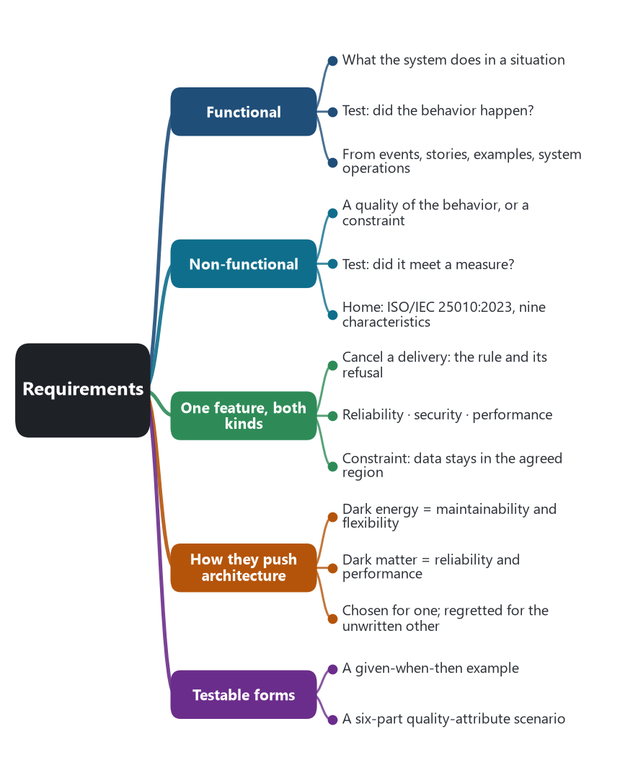
The chapter as a map: its sections and what each one holds.
A functional requirement states what the system does. It names a behavior in response to some situation: a customer can schedule a delivery, a tenant can be onboarded, an order that has not been paid cannot be dispatched. The test is whether the behavior happened. A non-functional requirement states a quality of that behavior, or a constraint on the system that provides it: how fast, how available, how isolated between tenants, how hard it is to change, which region may hold the data. The test is whether the behavior met a measure, or whether a constraint held. Both are requirements. A system can do the right thing and still be unfit, because it is too slow, leaks one tenant’s rows to another, or can only be released by redeploying every service at once.

🎭 The same feature, both kinds
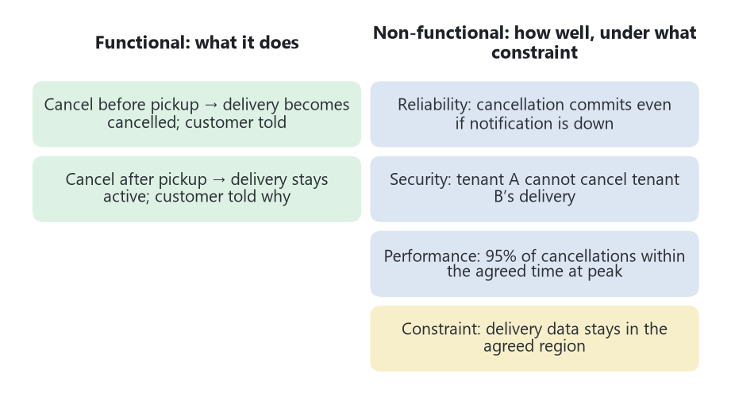
One feature — cancel a delivery — written as both kinds of requirement.
Cancel a delivery, from the drone-delivery example in the domain-driven design chapter.
Kind | A requirement that can be tested
Functional | When a customer cancels a delivery that a drone has not yet picked up, the delivery becomes cancelled and the customer is told.
Functional, the refusal | When a customer cancels a delivery that a drone has already picked up, the delivery stays active and the customer is told why.
Non-functional, reliability | If the notification service is down, the cancellation still commits, and the notification is sent when that service returns. The cancellation endpoint stays available while the notice is delayed.
Non-functional, security | A caller whose token names tenant A cannot cancel a delivery that belongs to tenant B.
Non-functional, performance | Under the stated peak load, 95 percent of cancellation requests complete within the agreed time.
Constraint | Delivery data for tenants in a given country remain in the region agreed for that country.

The first two rows are the business rule inside the Delivery aggregate. The next three are qualities of how that rule is offered. The last row is a constraint on placement. Architects sometimes file constraints with non-functional requirements, and sometimes keep them as their own list. Either filing is usable if the statement is testable. “The system shall be scalable” is not yet a requirement. It names a concern and gives no measure, no load, and no behavior.

🌱 Where each kind comes from
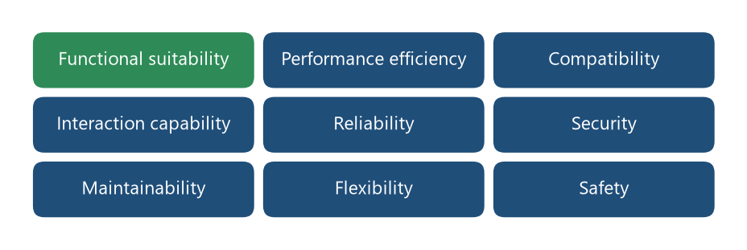
ISO/IEC 25010:2023 — the nine characteristics. Functional suitability is the quality of the functional side; the other eight are the usual home of non-functional requirements.
Functional requirements are gathered from the work: events on an EventStorming timeline, domain stories, given-when-then examples, and the system operations Assemblage starts from. They become commands, queries, and the rules on aggregates. They are the material of tactical domain-driven design.
Non-functional requirements are gathered from the conditions under which that work must succeed. ISO/IEC 25010:2023 is the current product-quality model. It has nine characteristics. Functional suitability — completeness, correctness, and appropriateness of the functions — is the quality of the functional side. The other eight are the usual home of non-functional requirements.
ISO/IEC 25010:2023 characteristic | The question it asks of this series
Functional suitability | Are the business functions complete, correct, and the ones the user actually needs?
Performance efficiency | Does the response stay within time and resource limits as load grows?
Compatibility | Can this service coexist with the others and exchange data with them on purpose?
Interaction capability | Can the intended user perceive, learn, and operate the interface, including people who need accessible interaction?
Reliability | Does it keep working, tolerate a failed dependency, stay available, and recover?
Security | Are confidentiality, integrity, authenticity, accountability, and resistance to attack holding, including between tenants?
Maintainability | Can a team understand, change, and test one service without a lockstep release of the suite?
Flexibility | Can it be adapted and scaled, installed into an environment, and have a part replaced?
Safety | When it fails, does it fail into a state that limits harm, and does it warn where harm is possible?

Source: ISO/IEC 25010:2023, Systems and software Quality Requirements and Evaluation (SQuaRE), product quality model. The 2023 edition replaced usability with interaction capability, replaced portability with flexibility, and added safety. The 2011 names still appear in older books.

🏗️ How they push the architecture
A functional requirement can be met inside one service or across several. “Schedule a delivery” can be one application service and one aggregate. “Schedule a delivery and invoice the account” crosses contexts, and then the functional requirement is what forces a saga, an API composition, or a replica. The existence of the function does not by itself force a new deployable unit.
Non-functional requirements are what make the cut expensive or necessary. Independent change and a fast pipeline are maintainability and flexibility, and they are Richardson’s dark-energy forces. A local transaction, a simple interaction, and a latency budget are reliability and performance, and they are the dark-matter forces that keep subdomains together. Fault isolation and a bulkhead are reliability. Tenant isolation is security. A region pin is a constraint that cloud architecture has to obey and that domain-driven design does not mention. Microservices are often chosen because a non-functional requirement cannot be met inside one release unit. They are often regretted because the non-functional cost of distribution — latency, partial failure, operability — was not written down as a requirement of its own.
The SaaS list in the earlier chapter splits the same way. Creating a tenant, applying a tier, and deleting that tenant’s data are functional requirements of the control plane. Isolation, noisy-neighbor limits, measured use, and tenant-aware operations are non-functional requirements, mostly security, performance, reliability, and maintainability. A PaaS or Kubernetes meets some of those qualities for instances: restart a dead process, scale copies, keep configuration out of the build. They do not meet the functional requirement, and they do not meet tenant isolation inside a shared table.

🧪 A form that an architect can test
Bass, Clements, and Kazman treat a quality attribute as a scenario with six parts: where the stimulus comes from, what the stimulus is, which part of the system it hits, the conditions at the time, the response, and the measure of that response. Written that way, a non-functional requirement can fail a test. “When the payment service returns errors for more than the agreed threshold, the order service stops calling it and still accepts the order as pending within the agreed time” is a circuit-breaker requirement. “The system shall be resilient” is a topic heading.
Functional requirements take the same discipline in given-when-then examples. The behavior-driven example and the quality-attribute scenario are the two test shapes. One checks the rule. The other checks the quality under stated conditions.

🎯 What this fixes for the AI chapter
A generated endpoint that cancels a delivery has addressed a functional requirement. It has not addressed isolation, latency, or what happens when notification is down unless those scenarios were in the request and show up in the design. A suggestion to split a service is an answer to a non-functional requirement, and it is only justified if that requirement was measured. Tools that emit code are practicing the functional side. Tools that choose a boundary, a region, a replica count, or a tenant placement are practicing the non-functional side. The research can grade them separately.
The scenario form follows Len Bass, Paul Clements, and Rick Kazman, Software Architecture in Practice, the quality-attribute scenario. The forces follow Chris Richardson’s dark energy and dark matter, already cited in this series. The delivery and tenancy examples follow the PaaS, SaaS, and domain chapters.
🔁 Read it again: three things to carry away
1. Functional: what it does. Non-functional: how well, under what constraints. Both must be testable.
2. Services are split to meet a non-functional requirement; the cost of splitting is also non-functional and must be written down.
3. Two test shapes: the given-when-then example, and the six-part quality-attribute scenario.

