🎓 Software engineering
Answer 15 of the working series
29 September 2026
The discipline. SWEBOK names the knowledge. ISO/IEC/IEEE 12207 names the life-cycle processes.
🔑 How to read this edition
The central idea of the chapter — bold, on a yellow marker.
An important sentence — blue and underlined, in the text itself.
A technical term — plum with a dotted line; its meaning is in “Words to know”.
💬 In plain words 🧭 The chapter as a map 📖 Words to know 🔁 Read it again

⭐ In one sentence
Software engineering is the discipline that produces every product in the series: eighteen knowledge areas, thirty life-cycle processes, and no prescribed life-cycle model — so a tool’s work can be named by the area it practices and what it still owes.

💬 In plain words
Software engineering is the discipline that produces every product in the earlier chapters. The SWEBOK Guide names its eighteen areas of knowledge; the ISO/IEC/IEEE 12207 standard names the thirty processes of a software life cycle, and refuses to choose a life-cycle model for you. Cancelling a delivery is walked through all fourteen technical processes so the reader can see the work each name stands for — and where a tool’s contribution can be graded.

📖 Words to know
SWEBOK | The Guide to the Software Engineering Body of Knowledge, published by the IEEE Computer Society.
knowledge areas | SWEBOK’s eighteen divisions of what a software engineer is expected to know.
ISO/IEC/IEEE 12207 | The international standard that lists the processes of a software life cycle.
life-cycle model | The overall shape of the work — waterfall, spiral, agile — which 12207 deliberately does not prescribe.
waterfall | A single sequential pass from requirements to delivery; Royce drew it in 1970 and warned against it in the same paper.
spiral model | Boehm’s 1986 model: cycles, each driven by the risk that cycle is there to reduce.
Agile Manifesto | The 2001 statement: working software, frequent delivery, changing requirements as a normal input.
Continuous Delivery | Humble and Farley (2010): making the path from commit to production an engineered, repeatable object.
DevOps | Carrying that path into operations — development and operations as one flow.
Verification | Checking that the built service meets the requirement that was specified.
Validation | Checking that the requirement, once met, serves the intended use.
configuration management | Knowing which versions and releases exist, and controlling change to them.
Corrective | Maintenance that repairs a discovered problem (with preventive, adaptive, additive, perfective, and emergency as the other categories).
enabling system | A system that supports the system of interest — the platform, in this series.
Stakeholder | Anyone with a stake in the outcome: customer, dispatcher, operator, regulator.
engineering economics | Choosing among the designs that would work by what each costs.
Annex H | The part of 12207:2017 that records agile as one way to apply the processes.

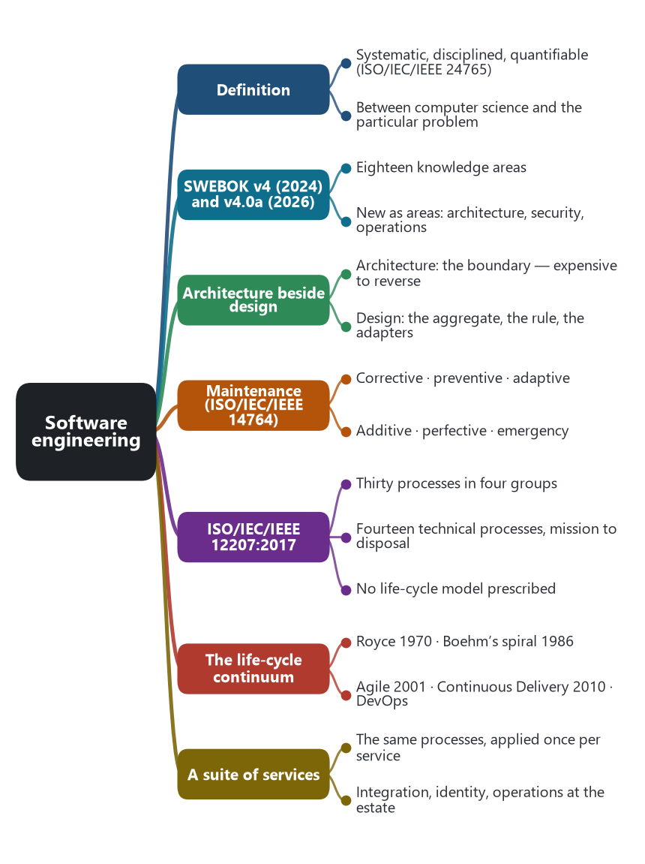
The chapter as a map: its sections and what each one holds.
Software engineering is the work of making software and of keeping it in service by an engineering method. The vocabulary that the SWEBOK Guide cites, ISO/IEC/IEEE 24765, defines software as computer programs, procedures, and possibly associated documentation and data pertaining to the operation of a computer system. It defines software engineering as the application of a systematic, disciplined, quantifiable approach to the development, operation, and maintenance of software; that is, the application of engineering to software. Version 4.0a of the Guide repeats that definition and places the discipline between two neighbors. Computer science, with the mathematical and physical disciplines, extends what is known about computation and machines. Software engineering applies that knowledge to a particular problem, under limits of cost, time, staff, and risk, and uses engineering economics to choose among the designs that would actually work. A peer review, a branching rule, a trace from a requirement to a test, and a judgment about the cost of a quality belong to the engineering. A result about what a language can express belongs to the science the engineering draws on.
The types chapter sorted programs by the problem they solve, by the job they do beside the hardware, by how a customer receives them, and by how a business application is structured. Those cuts name the product. This chapter names the work that produces any of them. An order service, a Kubernetes control plane, and a hosted model are three products from that earlier chapter. Each one is still specified, structured, built, tested, released, operated, and changed. Microservices are one structure on that cut. They are also a way of staffing this work, because many of the activities can be repeated once per service.

📚 Eighteen knowledge areas
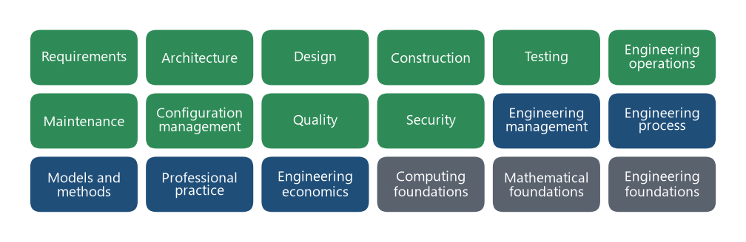
SWEBOK version 4: the eighteen knowledge areas. Green: the product and its care. Blue: how the work is conducted. Gray: foundations the other areas borrow.
Version 4.0 of the Guide to the Software Engineering Body of Knowledge was released by the IEEE Computer Society on 15 October 2024. Version 4.0a, edited by Hironori Washizaki, is the minor revision released in August 2026. It organizes the generally accepted portion of the literature into eighteen knowledge areas. Three of them are areas of their own for the first time, relative to the 2014 Guide: software architecture, software security, and software engineering operations. Agile practice and DevOps are written into the areas. The Guide points at the literature. The project still chooses a life-cycle model, and the pattern books already cited in this series still carry the microservice decisions.
The first ten areas describe the product and its care. The next five describe how the work is conducted. The last three are the foundations the Guide says the other areas borrow. The right-hand column says where this series already stands, so a later claim can point at an area that has a chapter and at an area that so far only has a name.
Knowledge area | The question it asks | Where this series stands
Software requirements | What behavior, quality, and constraint must hold? | The requirements chapter, and the given-when-then examples in the domain chapters.
Software architecture | Which decisions are significant, and which structures carry them? | The history, the pattern catalog, cloud, Kubernetes, SaaS, PaaS, and the service models.
Software design | How is a part structured once those decisions are made? | Domain-driven design, the hexagonal interior and its neighbors, and the messaging school.
Software construction | How is the code written so a later change can still be understood? | Touched inside the domain chapter. Not yet its own chapter.
Software testing | How are faults found before a user finds them? | Contract tests and health checks appear in the pattern chapters. Testing as a discipline is not yet its own chapter.
Software engineering operations | How is the running service installed, released, observed, and restored? | The Kubernetes chapter, the PaaS chapter, and the reliability patterns.
Software maintenance | How is the service changed after delivery? | Implied by independent deployability. The categories are set out below.
Software configuration management | Which versions and releases exist, and how is a change controlled? | The image tag and the pipeline, so far unnamed as this area.
Software quality | Do the product and the work meet stated criteria? | ISO/IEC 25010:2023 in the requirements chapter.
Software security | How does the service resist attack, including between tenants? | The tenant predicate and the token, so far filed under SaaS and requirements.
Software engineering management | How is the work scoped, planned, tracked, and closed? | Team boundaries in the neighbors chapter. Management is not its own chapter.
Software engineering process | Which life cycle is in force, and how is it improved? | The life-cycle section of this chapter.
Software engineering models and methods | Which models and methods does the team use across phases? | EventStorming, domain-driven design, Assemblage, and the agile methods below.
Software engineering professional practice | What standards of conduct apply to the engineer? | Outside the scope of this series.
Software engineering economics | Which feasible design is worth the cost? | Richardson's dark energy and dark matter are a local form of this judgment.
Computing foundations | What computing do the other areas assume? | Assumed.
Mathematical foundations | What mathematics do the other areas assume? | Assumed.
Engineering foundations | What general engineering practice do the other areas assume? | Assumed.

Source: Guide to the Software Engineering Body of Knowledge, Version 4.0a, IEEE Computer Society, editor Hironori Washizaki, August 2026. Version 4.0 was released on 15 October 2024. The definition of software engineering is the one Version 4.0a quotes from ISO/IEC/IEEE 24765, Systems and software engineering — Vocabulary.

🏛️ Architecture beside design
Version 4 gives architecture its own knowledge area, beside design. Architecture deals with stakeholders and their concerns, with views of the system, with styles and reference architectures, and with the evaluation of decisions that are expensive to reverse. Design continues from there: high-level and detailed design, persistence, distribution, errors, integration, and the pattern applied inside a part. In the delivery estate the architectural decision is that delivery is its own service, owns its rows, and collaborates with order and notification through a published language. The design decision is the Delivery aggregate, the rule that a picked-up delivery stays active, and the adapters that speak HTTP and the broker. A drawing of classes that never names the service boundary has recorded a design. The boundary is the architecture, and it is the decision the pattern chapters have been writing down.

🔧 Maintenance after delivery
Maintenance is the work done on software after delivery. The Guide, following ISO/IEC/IEEE 14764, classifies a maintenance request into five categories, and adds emergency maintenance as a sixth for an unscheduled temporary repair. ISO/IEC/IEEE 14764 also regroups the five as corrections or enhancements. The distinction matters once a tool can open a change, because a repair, a new feature, and a cleanup have different requirements and different tests.
Category | What the change does | A delivery example
Corrective | Repairs a discovered problem after delivery. | A cancellation that committed and then failed to tell the customer, fixed in the notification path.
Preventive | Corrects a latent fault before it occurs in the live system. | Closing a race that would let two cancellations both win, found by review before it is reported.
Adaptive | Keeps the product usable in a changed environment. | The broker client changes because the platform upgraded the broker.
Additive | Adds a function or feature after delivery. | A cancellation fee, which is a new business rule and a new requirement.
Perfective | Improves performance, maintainability, documentation, or other attributes, for the user or for the next change. | Rewriting the cancellation method so the next rule is cheaper to add, with the same observable behavior.
Emergency | An unscheduled modification to keep the system operational, pending corrective maintenance. | A temporary guard deployed during an incident, with a corrective change still owed.

Source: SWEBOK Guide Version 4.0a, Software Maintenance knowledge area, citing ISO/IEC/IEEE 14764. Additive maintenance is the category that adds functionality. Perfective maintenance improves attributes of software that already has its functions.

🔄 A life cycle is a set of processes
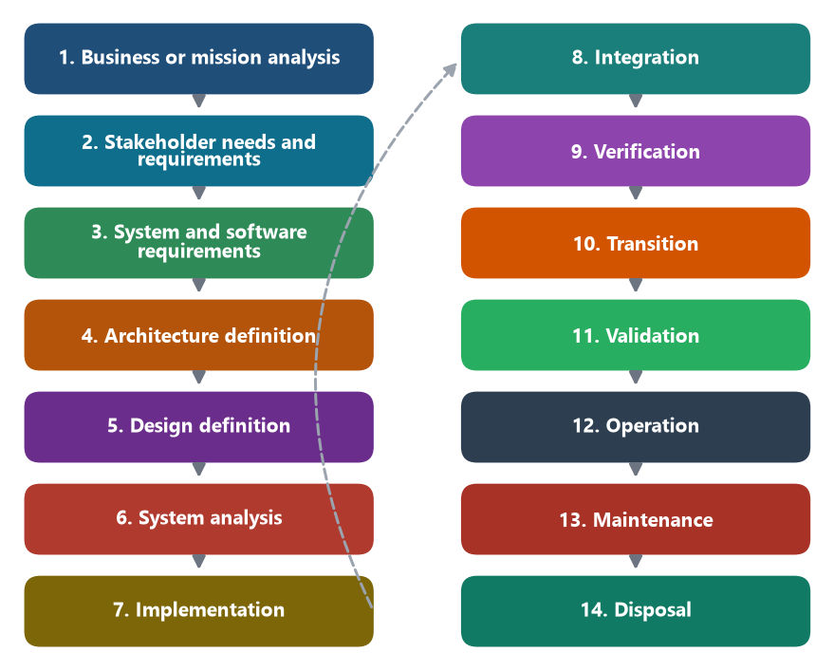
The fourteen technical processes of ISO/IEC/IEEE 12207:2017, from the mission to disposal. Several can be open in the same week.
ISO/IEC/IEEE 12207:2017 is the process standard for the software life cycle. Its introduction describes software engineering as an interdisciplinary approach whose aim is a successful software system: stakeholder needs and required functionality understood early, requirements documented, design synthesis and validation carried through, and both the business need and the technical need considered, from the conception of the idea to the retirement of the system. The standard is equally plain about the choice it leaves open. It prescribes neither a life-cycle model, nor a development methodology, nor a modeling technique. The project selects a model and maps these processes onto it. The same processes may be applied concurrently, iteratively, and recursively, to a software system and to its elements. A revision, ISO/IEC/IEEE 12207:2026, has since been issued. The names below are the 2017 edition, which is the text this chapter uses.
The 2017 edition groups thirty processes into four groups. Agreement processes cover the contract between an acquirer and a supplier. Organizational project-enabling processes give the organization its life-cycle model, its infrastructure, its portfolio, its people, its quality management, and its knowledge. Technical management processes plan, assess, decide, handle risk, control configuration, manage information, measure, and assure quality. Technical processes are the fourteen that take a need through to retirement.
Group | Processes | In this series
Agreement | Acquisition. Supply. | The team buying a database service, a buildpack, or a hosted model. The team is the acquirer. The provider is the supplier.
Organizational project-enabling | Life-cycle model management. Infrastructure. Portfolio. Human resources. Quality. Knowledge. | The platform team, the decision to run on a PaaS, and the stream-aligned team that owns a service.
Technical management | Planning. Assessment and control. Decision management. Risk. Configuration. Information. Measurement. Quality assurance. | The backlog, the risk in a proposed split, the image baseline, and an error budget.
Technical | The fourteen processes in the next table. | The feature itself, from the mission down to disposal.

Cancel a delivery, walked once through the technical processes. Each row is a process with a purpose. Several rows can be open in the same week. The table is the list, applied to one rule, so the names stay attached to work a team can point at.
Technical process | What it produces here
Business or mission analysis | Drone delivery is the business. Letting a customer cancel before pickup is part of that mission.
Stakeholder needs and requirements | The customer, the dispatcher, the tenant administrator, and the operator each have a stake in the cancellation.
System and software requirements | The testable functional and quality statements already written in the requirements chapter.
Architecture definition | Delivery is its own service and owns its rows. Notification is a collaborator, not a table inside delivery.
Design definition | The Delivery aggregate, the pickup rule, and the ports to HTTP and the broker.
System analysis | The tradeoff, using Richardson's forces, on whether notification stays inside the delivery service.
Implementation | The code of the delivery service.
Integration | Order, delivery, and notification joined at the agreed seam.
Verification | A check that the built service meets the written rule: a picked-up delivery stays active.
Transition | The release into the cluster or the PaaS.
Validation | A customer cancels in the product, and the result serves the use the stakeholder actually has.
Operation | Probes, logs, and the response when the service is in use.
Maintenance | A later change to the rule, classified as one of the categories above.
Disposal | Removal of a tenant's deliveries, or retirement of the service.

Verification and validation are both checks, and they answer different questions. Verification asks whether the service meets the requirement that was specified. Validation asks whether that requirement, once met, serves the intended use. A suite can pass every cancellation test and still fail validation, if customers needed to cancel after pickup and the mission analysis had set that case aside. The requirements chapter's two test shapes line up with this pair. A given-when-then example and a quality-attribute scenario are the specified behavior verification checks. A stakeholder accepting the running product is validation.
Source: ISO/IEC/IEEE 12207:2017, Systems and software engineering — Software life cycle processes. The limitation on life-cycle models is clause 1.4. Concurrent, iterative, and recursive application is clause 1.3. The four groups and the fourteen technical processes are clauses 6.1 through 6.4.

🐝 What a suite of services changes
The eighteen areas and the thirty processes stay the same list when the structure becomes a suite of services. What changes is the element a process is applied to. The 2017 standard already allows a process to be applied recursively to system elements. A microservice organization uses that permission. Requirements, the architecture inside one boundary, design, construction, a large part of testing, configuration, and release can belong to one service and one team. Integration, a shared quality bar, identity, and a good part of operations belong to the estate. A monolith runs the product areas once, on one release unit. A suite runs many of them once per service, and runs integration across services. The platform, in the Kubernetes and PaaS chapters, is the enabling system the standard distinguishes from the software system of interest. It supplies infrastructure and a share of operations. The delivery service still has its own requirements process, and the platform does not perform it.
The life-cycle model is a decision inside the process knowledge area. Winston Royce's 1970 paper drew the sequential pass that later teaching called the waterfall, and argued in the same paper that a single pass is risky and that the work has to iterate. Barry Boehm's spiral model, published in IEEE Computer in May 1986, drives each cycle by the risk that cycle is there to reduce. The Agile Manifesto, 2001, states the short cycle as working software, frequent delivery, and changing requirements taken as a normal input. Annex H of ISO/IEC/IEEE 12207:2017 records agile as one way to apply the processes. Jez Humble and David Farley's Continuous Delivery, 2010, makes the path from commit to production an engineering object. DevOps carries that path into the operations area, which is one reason Version 4 of the Guide gave operations a knowledge area of its own.
A microservice architecture assumes a point on this continuum: one service can be verified, released, and operated without a lockstep release of its neighbors. That assumption is a process decision, and it is the maintainability and flexibility scenario from the requirements chapter. Twelve services drawn on a diagram, released only as a single batch, are a suite with a monolith's life cycle. The drawing and the process are two decisions. The history chapter's move from a product owned by one team to independently deployable services was a change in both.

🎯 What this fixes for the AI chapter
An AI system enters this map in two places, and the types chapter already separated them. A model that recognizes a damaged package is Pressman's artificial-intelligence software, and that product still has requirements, a design, tests, an operation, and a maintenance category. A tool that proposes a change to the delivery service is development software acting on one or more knowledge areas. The same vendor can sell both. They are different rows when the research grades a claim.
What the tool does | The area it is practicing | What is still owed
Writes a given-when-then example for cancellation | Requirements specification | The example is testable, and someone accepts it as the requirement.
Proposes that delivery and notification are separate services | Architecture synthesis | The proposal is evaluated against the forces. Generation alone is not the evaluation.
Emits the aggregate, the port, and the controller | Design and construction | The rule lives in the service that owns the fact.
Generates a unit test that a picked-up delivery stays active | Verification, at unit level | The test encodes the specified rule.
Watches an error rate and restarts a pod | Operations | The signal and the response are defined. The restart leaves the business rule alone.
Opens a change that adds a cancellation fee | Additive maintenance, which then requires the earlier processes | The fee is a new requirement, then a design, then a release.
Rewrites a method so the next change is cheaper, with the same behavior | Perfective maintenance | The existing tests still pass. No new stakeholder-visible function was added.
Patches a live fault as a temporary measure | Emergency maintenance | A corrective change is still owed.
Calls a hosted model from notification | Acquisition of a backing service | The call is an agreement with a supplier. It is not a new knowledge area, and it does not move the service boundary.

A claim that AI does software engineering can be graded once the area is named. A tool that emits a controller has practiced construction. A tool that also opens the merge request has touched configuration management. A tool that splits a service has practiced architecture when the decision is evaluated and recorded. A tool that edits three services and merges them has not validated the result until a stakeholder, or a test that stands for that stakeholder's acceptance, has accepted it. The human checkpoint in the AI-pattern chapter is one way validation and authorization stay in the process when a model proposes the change. The checkpoint is a process control. The service boundary remains an architectural decision, made in the architecture area and held by the owning service.
Sources: ISO/IEC/IEEE 24765, Systems and software engineering — Vocabulary, for the definition quoted in SWEBOK. Guide to the Software Engineering Body of Knowledge, Version 4.0a, IEEE Computer Society, editor Hironori Washizaki, August 2026, including the eighteen knowledge areas and the maintenance categories. ISO/IEC/IEEE 12207:2017, Software life cycle processes. Winston W. Royce, "Managing the Development of Large Software Systems," Proceedings of IEEE WESCON, 1970. Barry W. Boehm, "A Spiral Model of Software Development and Enhancement," IEEE Computer, May 1986. The Agile Manifesto, 2001. Jez Humble and David Farley, Continuous Delivery, 2010. The types, requirements, domain, and AI-pattern chapters of this series.
🔁 Read it again: three things to carry away
1. Eighteen knowledge areas; thirty processes; no life-cycle model prescribed.
2. Verification checks the requirement; validation checks the use.
3. A tool’s work is graded by the area it practices and by what it still owes.

