🏙️ The patterns in popular software
Answer 16 of the working series
29 September 2026
61 chapters, one per pattern in the working catalog of Answer 4, in the same 15 parts. Each chapter names the problem, the pattern, the software that shows it, and the cost.
🔑 How to read this edition
The central idea of the chapter — bold, on a yellow marker.
An important sentence — blue and underlined, in the text itself.
A technical term — plum with a dotted line; its meaning is in “Words to know”.
💬 In plain words 🧭 The chapter as a map 📖 Words to know 🔁 Read it again

⭐ In one sentence
Every pattern in the catalog, shown in software people know — chosen on one rule, that the company wrote the decision down — with the problem, the pattern, the named cases, and the cost.

💬 In plain words
Every pattern in the catalog, told through software people know: Amazon’s product page, Netflix’s move to the cloud, Uber’s 2,200 services, Airbnb’s migration, Shopify’s decision to stay a monolith, Stripe’s idempotency keys, LinkedIn’s Kafka. Each mini-chapter has the same four beats — the problem, the pattern, the named examples, the cost — so the patterns become stories with a bill attached. Under every chapter heading this edition adds one line in plain words.

📖 Words to know
eShopOnContainers | Microsoft’s .NET reference application: Catalog, Basket, Ordering, and Identity as separate services.
FTGO | Chris Richardson’s worked example in Microservices Patterns: a food-to-go ordering system.
Netflix OSS | The tools Netflix released — Eureka, Hystrix, Zuul, Ribbon, Archaius — that became reference implementations.
Envoy | Lyft’s proxy (2016), built to be a sidecar; the data plane of Istio.
Kafka | LinkedIn’s partitioned, replicated log (2010) that became the event backbone of large systems.
Cassandra | A distributed database Netflix and Monzo use, in which each service owns a keyspace.

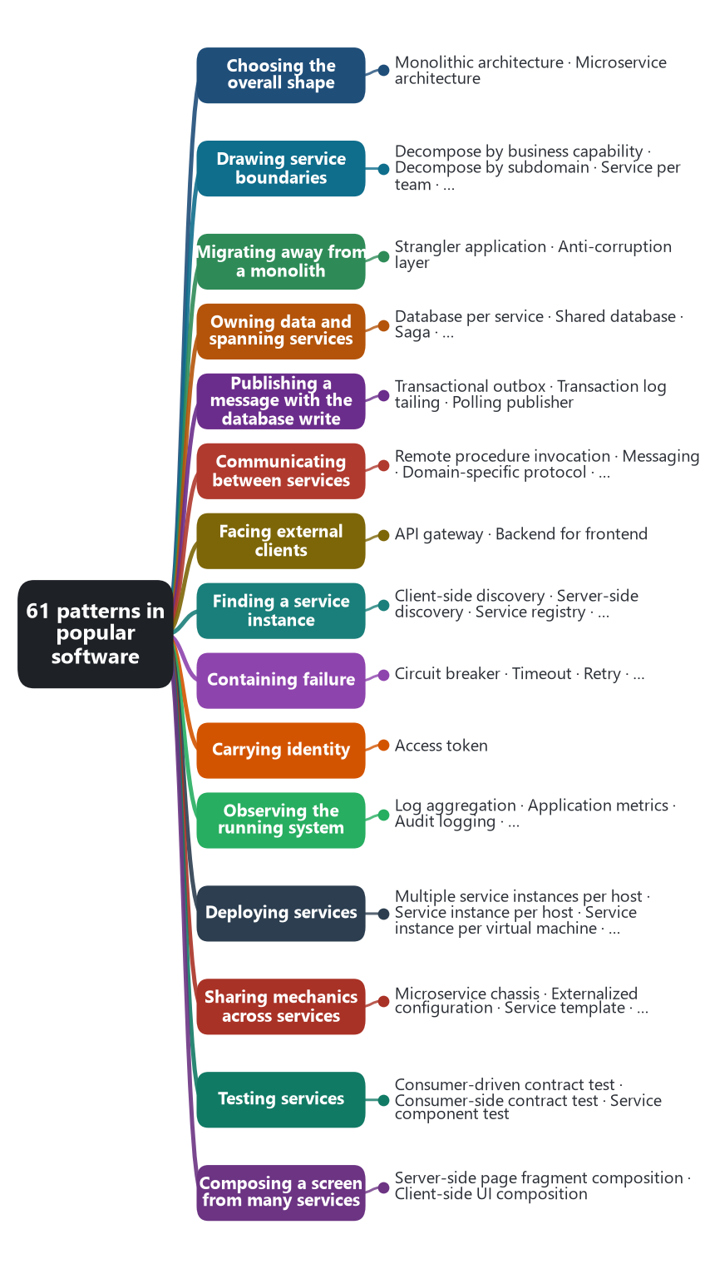
The chapter as a map: its sections and what each one holds.
Answer 3 set out the pattern language and Answer 4 listed its catalog. This answer takes each pattern in turn and explains it through software that many people have used or read about: Amazon, Netflix, Uber, Airbnb, Shopify, Stripe, LinkedIn, Twitter, Google, Facebook, Spotify, Monzo, Zalando, Microsoft’s eShopOnContainers reference application, and the open-source platforms — Kubernetes, Kafka, Envoy, Istio, Prometheus — that grew out of those companies’ needs.
The examples are chosen on one rule: the company or project wrote the decision down, in an engineering blog, a paper, a conference talk, or an open-source repository, so the claim can be checked. Dates are the year the practice was published, not the year it began. Companies change; each example describes the system as it was described at the time, and several chapters include a case where a company later moved the other way.
Every chapter has the same four parts. The problem: what goes wrong without the pattern. The pattern: what it prescribes, in Richardson’s terms. One or more named examples. The cost: what the pattern charges, because a pattern with no cost is a slogan. A source line closes each chapter.

📋 Contents
Ch. | Pattern | Software used in the chapter
1 | Monolithic architecture | Shopify, Stack Overflow, Basecamp, Amazon Prime Video, Segment
2 | Microservice architecture | Amazon, Netflix, Uber, Monzo
3 | Decompose by business capability | Amazon, Netflix, Microsoft eShop
4 | Decompose by subdomain | Uber (DOMA), Microsoft eShop
5 | Service per team | Amazon two-pizza teams, Spotify squads, Netflix full-cycle developers
6 | Self-contained service | Netflix personalization, Richardson’s FTGO
7 | Strangler application | Netflix (2009–2016), Airbnb, GitHub Scientist, Twitter Diffy
8 | Anti-corruption layer | Airbnb data services, Amazon’s Oracle exit, payment adapters
9 | Database per service | Amazon, Netflix, Monzo, Microsoft eShop
10 | Shared database | Airbnb Monorail, Shopify pods, Segment
11 | Saga | Microsoft eShop ordering, Uber trips, Netflix content workflows
12 | Saga choreography | Microsoft eShop, LinkedIn and Kafka
13 | Saga orchestration | Netflix Conductor, Uber Cadence and Temporal, AWS Step Functions
14 | Command-side replica | Microsoft eShop basket prices, Netflix EVCache
15 | API composition | Amazon product page, Netflix API and GraphQL Federation
16 | CQRS | Twitter timelines, Microsoft eShop, Airbnb derived data
17 | Domain event | Stripe events, Shopify webhooks, Zalando Nakadi
18 | Event sourcing | LMAX, Netflix Downloads, Kafka as a log
19 | Transactional outbox | Microsoft eShop IntegrationEventLog, Debezium outbox router
20 | Transaction log tailing | LinkedIn Databus, Debezium, Airbnb SpinalTap, Netflix DBLog, Facebook Wormhole
21 | Polling publisher | Eventuate Tram, Stripe webhook delivery, database-backed job queues
22 | Remote procedure invocation | Google gRPC, Facebook Thrift, Twitter Finagle
23 | Messaging | LinkedIn Kafka, Amazon SQS, Netflix Keystone, RabbitMQ
24 | Domain-specific protocol | Facebook Messenger (MQTT), WhatsApp (XMPP), Discord Gateway
25 | Idempotent consumer | Stripe idempotency keys, Kafka exactly-once, SQS FIFO
26 | API gateway | Netflix Zuul, Amazon API Gateway, Kong, Uber’s edge gateway
27 | Backend for frontend | SoundCloud, REA Group, Netflix device endpoints, Microsoft eShop
28 | Client-side discovery | Netflix Eureka and Ribbon, gRPC xDS
29 | Server-side discovery | AWS ELB, Kubernetes Service, Airbnb SmartStack
30 | Service registry | Netflix Eureka, ZooKeeper, HashiCorp Consul, etcd in Kubernetes
31 | Self registration | Eureka clients, Consul agents, Finagle ServerSets
32 | Third-party registration | Kubernetes EndpointSlices, Netflix Prana, Airbnb Nerve, Registrator
33 | Circuit breaker | Netflix Hystrix, Polly, Envoy outlier detection
34 | Timeout | Hystrix, gRPC deadlines, Envoy
35 | Retry | AWS SDKs, gRPC, Envoy retry budgets, Google SRE
36 | Bulkhead | Hystrix thread pools, Shopify Semian, AWS cells
37 | Access token | OAuth 2.0 and JWT, Netflix Passport, Microsoft eShop Identity, SPIFFE
38 | Log aggregation | ELK (Elasticsearch, Logstash, Kibana), Splunk, Fluentd, Grafana Loki
39 | Application metrics | Etsy StatsD and Graphite, Prometheus (SoundCloud), Netflix Atlas, Uber M3
40 | Audit logging | AWS CloudTrail, Kubernetes audit logs, GitHub and Slack audit logs, Stripe events
41 | Distributed tracing | Google Dapper, Twitter Zipkin, Uber Jaeger, OpenTelemetry, Netflix Edgar
42 | Exception tracking | Sentry, Airbrake, Rollbar, Bugsnag, Crashlytics
43 | Health check API | Kubernetes probes, Spring Boot Actuator, Dropwizard, Consul checks
44 | Log deployments and changes | Etsy Deployinator, Grafana annotations, Netflix Spinnaker, Kubernetes rollout history
45 | Multiple service instances per host | Java application servers, IIS application pools
46 | Service instance per host | Google search clusters (2003), Stack Overflow
47 | Service instance per virtual machine | Netflix Aminator and Asgard, HashiCorp Packer
48 | Service instance per container | Docker, Kubernetes, Google Borg, Netflix Titus, Spotify Helios
49 | Serverless deployment | AWS Lambda, Netflix early Lambda use, Amazon Prime Video (2023), Cloudflare Workers
50 | Service deployment platform | Heroku, Google App Engine, Cloud Foundry, Kubernetes, Netflix Spinnaker and Titus
51 | Microservice chassis | Dropwizard, Spring Boot and Spring Cloud Netflix, Twitter Finagle, Monzo Typhon
52 | Externalized configuration | Twelve-Factor App, Netflix Archaius, Spring Cloud Config, Kubernetes ConfigMaps and Secrets, HashiCorp Vault
53 | Service template | Spotify Backstage, Spring Initializr, dotnet templates, Monzo’s generator
54 | Sidecar | Netflix Prana, Lyft Envoy, Istio injection, Kubernetes pods, Dapr
55 | Service mesh | Linkerd (Buoyant), Istio, Envoy, Consul Connect, Monzo, Airbnb SmartStack
56 | Ambassador | Kubernetes ambassador containers, Google Cloud SQL Auth Proxy, Airbnb Synapse, Envoy egress
57 | Consumer-driven contract test | Pact (REA Group and DiUS), Spring Cloud Contract, Atlassian
58 | Consumer-side contract test | Pact consumer tests, Spring Cloud Contract stubs, WireMock
59 | Service component test | Testcontainers, WireMock, Shopify Toxiproxy, Google hermetic servers
60 | Server-side page fragment composition | Facebook BigPipe, Zalando Mosaic and Tailor, Amazon product page, Edge Side Includes
61 | Client-side UI composition | Spotify desktop client, micro-frontends (ThoughtWorks, IKEA), single-spa, webpack Module Federation

🏛️ Part 1. Choosing the overall shape
The first decision is whether the application is one deployable unit or many. Both are patterns in Richardson’s language, and well-known software has moved in both directions. The examples here are chosen because the companies wrote up the decision and the reasons.
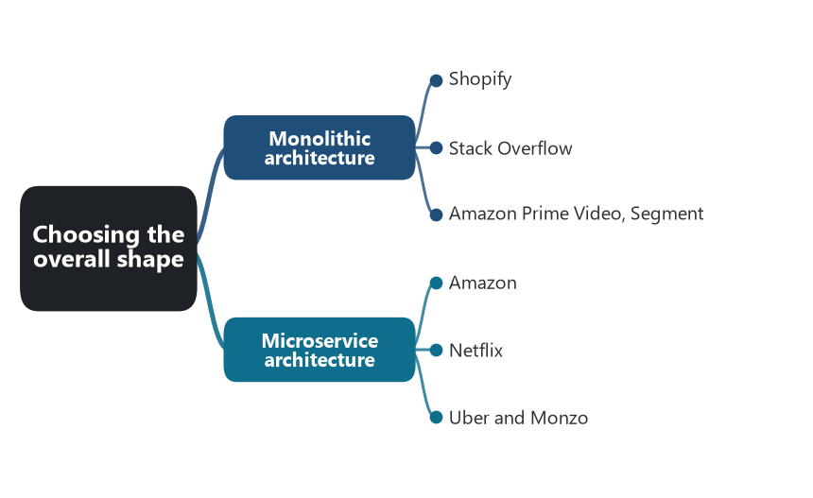
Part map — Choosing the overall shape: the patterns of this part and the software that shows each one.
📖 Words to know in this part
Deployable unit | What is built, shipped, and started as one thing.
Load balancer | A component that spreads incoming requests across identical copies.
Modular monolith | One deployable unit whose internal boundaries are enforced in the code.
Pod (Shopify sense) | A complete copy of the application with its own database; a shop lives in exactly one. Not the Kubernetes pod.
Blast radius | How much is affected when one thing fails.

🧱 Chapter 1. Monolithic architecture
💬 In plain words: One program, one deploy, one database. The simplest thing that can work — and often the right thing.

❓ The problem. A team has to ship a product, and every distributed boundary is a cost before it is a benefit. Network calls, partial failure, and per-service pipelines are paid for on day one; the benefits arrive only when the organization is large enough to need independent releases.
💡 The pattern. The user interface, the domain logic, and the data access are one deployable unit: one build, one process image, one database. Scaling is by running more identical copies behind a load balancer. Structure inside the unit is a matter of code organization, not of deployment.
Shopify. Shopify runs one of the largest Ruby on Rails codebases in existence and has kept it a monolith. In “Deconstructing the Monolith” (2019), Kirsten Westeinde describes the choice not to split into services but to reorganize the code into components with enforced boundaries — the modular monolith — with a tool, later open-sourced as Packwerk (2020), that fails the build when one component reaches into another’s internals. Horizontal scale comes from “pods”: each pod is a complete copy of the application with its own MySQL, and a shop lives in exactly one pod.
Stack Overflow. Nick Craver’s 2016 architecture write-ups show the Q&A sites served by a single .NET application on nine web servers with a SQL Server pair, handling hundreds of millions of page views a month. Basecamp’s David Heinemeier Hansson argued the same position in “The Majestic Monolith” (2016): for a small team, one well-organized codebase is the faster path.
Amazon Prime Video, Segment. Two documented returns. In 2023 the Prime Video audio/video quality monitoring team moved a pipeline built from Step Functions, Lambda, and S3 into a single ECS process and reported roughly a 90 percent drop in infrastructure cost, because the orchestration and the object-store traffic between steps dominated the bill. In 2018 Segment consolidated about 140 per-destination services back into one, because shared libraries drifted across the services and testing and deploying them separately had become the work.
⚠️ The cost. One release train, one runtime, and one blast radius. A bad deploy affects every feature. Internal boundaries hold only as long as the team enforces them, which is why Shopify built a tool to do it.
Source: Westeinde, Shopify Engineering, 2019; Packwerk, 2020. Craver, “Stack Overflow: The Architecture” series, 2016. Hansson, “The Majestic Monolith,” 2016. Kolny, Prime Video Tech, 2023. Noonan, “Goodbye Microservices,” Segment, 2018.

🐝 Chapter 2. Microservice architecture
💬 In plain words: Many small programs, each owned by a small team, each with its own data, talking over the network.

❓ The problem. One codebase and one release train stop scaling with the organization. Many teams wait on one deploy. One failure takes the whole product down. One technology has to fit every job.
💡 The pattern. The application is a set of services, each independently deployable and loosely coupled, each owned by a small team, each with its own data. Lewis and Fowler’s 2014 article named the characteristics: organized around business capabilities, decentralized data management, smart endpoints and dumb pipes, products not projects.
Amazon. Around 2002 Jeff Bezos issued the mandate that Steve Yegge later summarized: all teams expose their data and functionality through service interfaces; teams communicate only through those interfaces; no direct database reads, no shared memory; every interface is designed as if it could be exposed to the outside. Werner Vogels described the result in 2006: the team that builds a service runs it, and a single product page draws on more than a hundred services. Amazon Web Services grew out of that service-team culture.
Netflix. In August 2008 a database corruption stopped DVD shipments for three days. From 2009 Netflix moved its streaming system to AWS and rebuilt its monolithic Java application as hundreds of services. The last data center closed in January 2016. The pieces Netflix built along the way — Eureka, Hystrix, Zuul, Ribbon, Archaius — were released as Netflix OSS and became the reference implementations for a generation.
Uber and Monzo. Uber grew from a Python monolith to about 2,200 critical microservices by 2020, when it had to introduce a domain layer above them. Monzo, a bank founded in 2015, was built on microservices in Go from the start and had about 1,500 services by 2019.
⚠️ The cost. Distributed-systems problems become everyday problems: partial failure, latency, data consistency across owners, and the operational tooling to see any of it. The remaining chapters of this document are the bill for this decision.
Source: Yegge’s 2011 account of the Bezos mandate. Vogels, “A Conversation with Werner Vogels,” ACM Queue, 2006. Izrailevsky, “Completing the Netflix Cloud Migration,” 2016. Gluck, “Introducing Domain-Oriented Microservice Architecture,” Uber, 2020. Kleeman, Monzo, 2019. Lewis and Fowler, “Microservices,” 2014.

✂️ Part 2. Drawing service boundaries
Where the cut is made decides what the rest of the system has to compensate for. Four patterns give four rules for the cut, and the same companies show more than one of them.
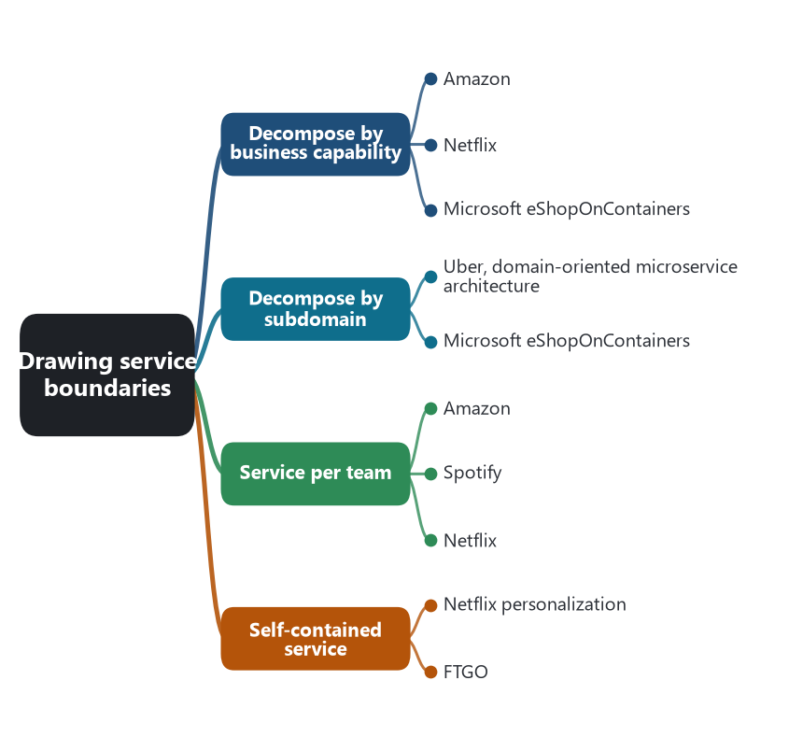
Part map — Drawing service boundaries: the patterns of this part and the software that shows each one.
📖 Words to know in this part
Bounded context | The boundary inside which one model and one vocabulary stay consistent.
Conway’s law | A system copies the communication structure of the organization that builds it.
DOMA | Uber’s domain-oriented microservice architecture: services grouped into domains with one gateway each.
Stream-aligned team | Team Topologies’ name for a team that owns one flow of work end to end.
Cognitive load | How much a team must hold in its head — the limit on what it can own.
Replica / EVCache | A local copy of data owned elsewhere; Netflix’s replicated in-memory store.

🏬 Chapter 3. Decompose by business capability
💬 In plain words: Cut along what the business does: ordering, billing, delivery.

❓ The problem. The team needs a rule for what a service is, and the rule has to stay stable while the implementation changes.
💡 The pattern. A business capability is something the business does to produce value: take orders, manage inventory, deliver, bill. Each service corresponds to a capability. Capabilities change slowly; the code that implements them changes constantly, which is what makes them a good place for a boundary.
Amazon. The service teams that followed the Bezos mandate were organized around what the retail business does — cataloguing, ordering, paying, fulfilling — with each team owning the service and its operation. Vogels’s “you build it, you run it” was a statement about capability ownership as much as about operations.
Netflix. Netflix’s services follow the capabilities of a streaming business: membership and billing, playback licensing, encoding, personalization, and the device-facing API. Each is a group of services owned by a team whose name is the capability.
Microsoft eShopOnContainers. Microsoft’s .NET reference application shows the same cut at small scale. Catalog, Basket, Ordering, and Identity are four capabilities of an online shop, each a separate service with its own store.
⚠️ The cost. Capabilities are business-level names, and a business-level name can still hide a very large service. Ordering at Amazon is not one process. The pattern gives the first cut, and the subdomain pattern refines it.
Source: Lewis and Fowler, “organized around business capabilities,” 2014. Vogels, ACM Queue, 2006. Microsoft, .NET Microservices: Architecture for Containerized .NET Applications, and the eShopOnContainers repository.

🗺️ Chapter 4. Decompose by subdomain
💬 In plain words: Cut along the business’s own vocabulary; where a word changes meaning, a boundary is hiding.

❓ The problem. A capability is too coarse, or two capabilities use the same word to mean different things, and the model inside one service is being bent to serve another.
💡 The pattern. Domain-driven design divides the domain into subdomains — core, supporting, generic — and gives each its own bounded context with its own language. Each bounded context is a candidate service. The same real-world thing may be a different concept in each context.
Uber, domain-oriented microservice architecture. By 2020 Uber had about 2,200 critical microservices and the dependency graph had become the problem. DOMA groups related services into domains, gives each domain one gateway as its single entry point, arranges domains into layers (infrastructure, business, product, presentation) so that dependencies point downward, and adds an extension mechanism so a product team can extend a domain without editing its code. It is subdomain decomposition applied after the fact, to a system that had been cut by team and feature.
Microsoft eShopOnContainers. The Ordering service is a bounded context with its own language: Order, Buyer, OrderItem, PaymentMethod. The Catalog service has CatalogItem. A product is a different concept in each context. Ordering copies the name and price into the order at the moment of purchase and never joins back to the catalog table.
⚠️ The cost. The bounded contexts exist first in a model, so a team without a model will cut by database table or by screen. Finding the contexts takes domain time that a feature deadline does not budget for.
Source: Evans, Domain-Driven Design, 2003. Gluck, Uber Engineering, 2020. Microsoft, eShopOnContainers and the .NET microservices guide, the Ordering bounded context.

👥 Chapter 5. Service per team
💬 In plain words: Draw the boundary around the people who will answer the pager.

❓ The problem. A service owned by nobody, or by everybody, is not maintained. A service owned by three teams needs a committee to change.
💡 The pattern. The service boundary follows the team. A small team owns one or a few services end to end, including operation. This is Conway’s law used deliberately: the communication structure of the organization becomes the structure of the system.
Amazon. The “two-pizza team” — small enough to be fed by two pizzas — is the unit of ownership that the 2002 mandate assumed. A team owns a service, its interface, its data, and its pager.
Spotify. Henrik Kniberg and Anders Ivarsson’s 2012 paper “Scaling Agile @ Spotify” described squads: small teams that own a feature area and the services behind it end to end, grouped into tribes. The paper became the most copied organizational diagram of the decade, and Spotify itself later said the structure was a snapshot, not a model.
Netflix. Netflix’s 2018 “Full Cycle Developers” post states the rule directly: the team that designs and builds a service also deploys, operates, and supports it. Skelton and Pais generalized the pattern as the stream-aligned team in Team Topologies (2019), with team cognitive load as the limit on how many services one team can own.
⚠️ The cost. Reorganizations orphan services. Service count grows with headcount rather than with the domain. A boundary drawn around a team is only as good as the team boundary was.
Source: Vogels, 2006. Kniberg and Ivarsson, “Scaling Agile @ Spotify,” 2012. Fisher-Ogden et al., “Full Cycle Developers at Netflix,” 2018. Skelton and Pais, Team Topologies, 2019.

🎒 Chapter 6. Self-contained service
💬 In plain words: Answer the request from what you already hold; fetch nothing live from your neighbors.

❓ The problem. A request that fans out to five services synchronously has the latency of the slowest and the availability of the product of all five. Every hop is a place to time out.
💡 The pattern. Design the service so it can answer a synchronous request without synchronously calling another service. Data it needs from others arrives ahead of time through events and is kept locally (a CQRS view or a command-side replica). Work that must involve others is finished asynchronously through a saga.
Netflix personalization. Netflix’s 2013 description of its recommendation architecture has three layers. Offline computation runs on Hadoop over the full history. Nearline computation runs when an event arrives and stores results. Online computation runs at request time under a strict latency budget and reads mostly precomputed rows from EVCache and Cassandra. The homepage request is answered from data already at hand; if the online step cannot finish in time it falls back to the precomputed result. The service that serves the page is self-contained at request time because the expensive collaboration happened before the request.
FTGO. Chris Richardson’s worked example is the Delivery service, which keeps a replica of the restaurant and order data it needs to schedule a courier, so scheduling never waits on the Order service.
⚠️ The cost. Replication and eventual consistency. The service answers with data that may be seconds or minutes old, and it has to be designed to say so.
Source: Amatriain and Basilico, “System Architectures for Personalization and Recommendation,” Netflix Tech Blog, 2013. Richardson, microservices.io, “Self-contained service,” and Microservices Patterns, 2018.

🌳 Part 3. Migrating away from a monolith
Almost every microservice system in this document was a monolith first. Two patterns govern the years in which both exist.
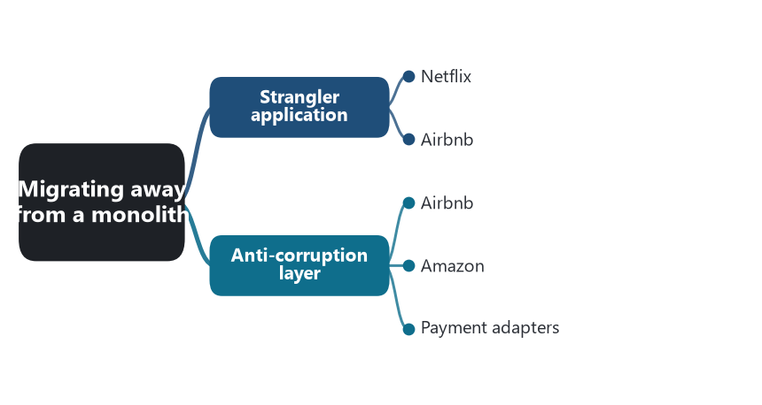
Part map — Migrating away from a monolith: the patterns of this part and the software that shows each one.
📖 Words to know in this part
Facade | A front component that receives every request and routes it to the old or the new system.
Strangler fig | A tree that grows around its host until the host is gone — Fowler’s metaphor.
Thrift IDL | An interface definition language: one file that describes a service’s calls, from which clients are generated.
Side-by-side comparison | Running the old and the new path on the same traffic and diffing the results (GitHub Scientist, Twitter Diffy).

🌳 Chapter 7. Strangler application
💬 In plain words: Grow the new system around the old one, route by route, until the old one can be switched off.


A strangler fig on its host in the Anamalai hills. Netflix took from 2009 to January 2016 to strangle its data center; Airbnb began strangling Monorail in 2018. Photo: Shankar Raman, Wikimedia Commons, CC BY-SA 4.0.
❓ The problem. A rewrite that runs for two years and cuts over on one night has almost never worked. The old system keeps changing while the new one is built, and the cutover is the biggest release the company has ever done.
💡 The pattern. Martin Fowler’s strangler fig (2004): the new system grows around the old one. A facade routes each request to either the old or the new implementation. Function by function, traffic moves. The old system shrinks until it can be switched off.
Netflix. The move to AWS took from 2009 to January 2016. Netflix moved non-member-facing systems first — encoding, then internal tools — then customer-facing pieces, and billing last, because billing had the most rules and the least tolerance for a mistake. For years the DVD business stayed in the data center while streaming ran in the cloud. Each moved piece was routed to the new implementation while the rest stayed where it was.
Airbnb. Airbnb’s Rails monolith, “Monorail,” was strangled from 2018. Jessica Tai described the sequence: freeze new development in the monolith, extract reads before writes, move one endpoint at a time, and run the old and the new path side by side, comparing results, before switching traffic. The comparison step has its own tools: GitHub’s Scientist (2016) runs a new code path beside the old one and reports mismatches without changing the result users see, and Twitter’s Diffy (2015) replays production traffic against old and new services and diffs the responses.
⚠️ The cost. Two systems for years, with data that has to stay in step across both. The facade is a permanent seam if the strangling stops halfway, which it often does when the visible features have moved and only the unglamorous ones remain.
Source: Fowler, “StranglerFigApplication,” 2004. Izrailevsky, Netflix, 2016. Tai, “Airbnb’s Great Migration: From Monolith to Service-Oriented,” QCon, 2018. GitHub Scientist, 2016. Twitter Diffy, 2015.

🛡️ Chapter 8. Anti-corruption layer
💬 In plain words: A translator at the border, so the old system’s vocabulary never leaks into the new model.

❓ The problem. A new service that reads the old system’s tables or speaks its API starts to think in the old system’s terms. Its model is bent to match the legacy schema, and the migration produces a second copy of the first system’s mistakes.
💡 The pattern. Eric Evans’s anti-corruption layer (2003): a translation layer between the new model and the foreign one. On one side it speaks the legacy system’s language; on the other it speaks the new bounded context’s. The new model never imports a legacy type.
Airbnb. In the Monorail migration, new services were not allowed to read the monolith’s MySQL tables. A layer of data services wrapped the tables behind Thrift interfaces and owned all reads and writes to them. Domain services above depended on the Thrift interface, not on the Rails schema, so a later change of storage under a data service did not reach the callers.
Amazon. By October 2019 Amazon’s consumer business had turned off its last Oracle database: about 7,500 databases and 75 petabytes moved to DynamoDB, Aurora, RDS, and Redshift, team by team. It was possible because, since the mandate, consumers reached a team’s data only through the team’s service interface. The interface was the layer that kept each team’s storage decision from reaching anyone else.
Payment adapters. Every payment service that talks to Stripe, Adyen, or PayPal through an adapter is running an anti-corruption layer. The domain has its own Payment and its own state machine; the adapter translates to each provider’s objects and events.
⚠️ The cost. Another codebase to maintain, and translation cost on every call. The layer is worth it when the foreign model is large or is going to change; for a small stable dependency, a conformist mapping is cheaper.
Source: Evans, Domain-Driven Design, 2003. Tai, QCon 2018. Barr, “Migration Complete – Amazon’s Consumer Business Just Turned off its Final Oracle Database,” AWS News Blog, 2019.

🗄️ Part 4. Owning data and spanning services
Once each service owns its data, one business action is no longer one database transaction. This part has the most patterns because it has the hardest problem.
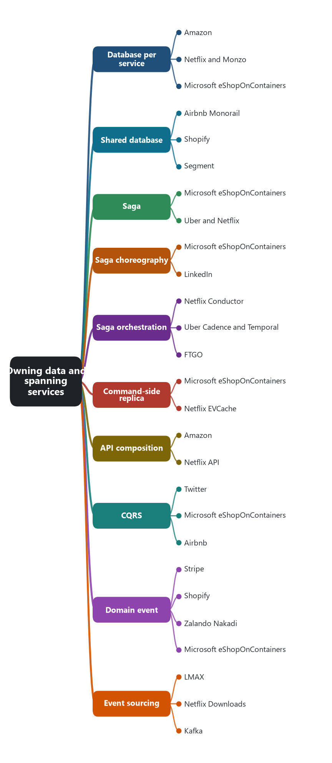
Part map — Owning data and spanning services: the patterns of this part and the software that shows each one.
📖 Words to know in this part
Two-phase commit | A protocol for one transaction across several databases — slow and usually unavailable across services.
Local transaction | A transaction inside one service’s own database.
Compensation | The business-level undo for a completed step: a refund, not a rollback.
Keyspace | Cassandra’s equivalent of a database schema.
Fan-out on write | Pushing a new item into every follower’s list at write time, so reads are one fetch.
Snapshot | A saved point-in-time state so replaying events can start late.
Schema registry | A service that stores and enforces the shape of events.
Event store | A database that keeps the sequence of events as the record.

🔐 Chapter 9. Database per service
💬 In plain words: Your data is yours; others ask through your API or listen to your events.

❓ The problem. If two services write the same tables, a schema change by one breaks the other, the two teams have to coordinate releases, and the database is the shared bottleneck for scale.
💡 The pattern. Each service has a private database. Other services reach that data only through the owner’s API or its events. The store can be a separate server, a separate schema, or a separate set of tables that no one else is allowed to touch; the rule is the ownership, not the physical separation.
Amazon. The 2002 mandate’s sharpest clause was “no direct database reads.” Seventeen years later that clause let Amazon move off Oracle team by team, with each team choosing what Vogels calls a purpose-built database: DynamoDB for key-value at scale, Aurora for relational, ElastiCache for in-memory, Redshift for analytics.
Netflix and Monzo. Netflix services own their data in Cassandra and EVCache and expose it through APIs; there is no shared relational schema across the streaming system. Monzo runs a shared Cassandra cluster in which each service owns its own keyspace, and no service reads another service’s tables.
Microsoft eShopOnContainers. Catalog and Ordering each have their own SQL Server database, Basket uses Redis, and Identity has its own store. Each store is a separate container. The reference application shows polyglot persistence at the smallest useful scale.
⚠️ The cost. No joins across services and no distributed transactions. Queries that used to be one SQL statement become API composition or a CQRS view. Commands that used to be one transaction become a saga. More database engines to operate.
Source: Yegge, 2011. Barr, AWS, 2019. Vogels, on purpose-built databases, re:Invent talks 2018–2019. Monzo engineering talks by Matt Heath, 2016–2018. Microsoft, eShopOnContainers.

🤝 Chapter 10. Shared database
💬 In plain words: Several services write the same tables. Fast to start; the coupling arrives later.

❓ The problem. Not every system is ready for private data. Early on, or when two services are tightly related, a shared schema is faster, and it keeps transactions and joins.
💡 The pattern. Several services read and write the same database schema. Richardson keeps it in the language as a real choice with real costs: it is the starting point for most migrations and the correct end point for some small systems.
Airbnb Monorail. Before the SOA migration, one Rails application and one MySQL database held everything. As the first services were extracted, several of them read the same tables, and the coupling that produced is why Airbnb introduced data services as sole owners of each table group.
Shopify. The legitimate form. Shopify’s modular monolith runs as several kinds of process — web servers, job workers — that share the shard’s MySQL. It is one codebase deployed as many processes, and the boundaries are enforced in code by Packwerk, not in the database. That is a monolith with a shared database, and it is a deliberate design.
Segment. When Segment folded 140 destination services back into one in 2018, the services had already shared a queue and libraries. The consolidation accepted one codebase and one store rather than pretend the services were independent.
⚠️ The cost. Schema coupling. One team’s migration breaks another team’s queries. Scaling the database is everyone’s problem. Services that share a database and deploy separately are the “distributed monolith,” which has the costs of both styles.
Source: Tai, QCon 2018. Westeinde, Shopify, 2019. Noonan, Segment, 2018. Richardson, microservices.io, “Shared database.”

🔗 Chapter 11. Saga
💬 In plain words: A long action done as a chain of small local steps, each with an undo step ready.

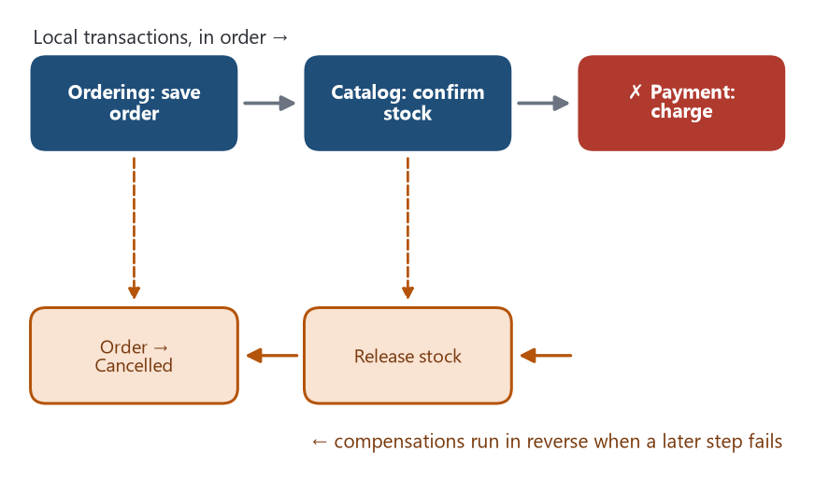
The saga in one picture: local transactions forward, compensations in reverse. eShop’s order saga cancels the order; Uber’s trip and Netflix’s title-launch run for hours or days.
❓ The problem. Place an order: reserve stock, charge the card, confirm. Each step is in a different service with a different database. There is no transaction that spans them, and a two-phase commit across services is unavailable or unwanted.
💡 The pattern. Hector Garcia-Molina and Kenneth Salem defined the saga in 1987 for long-lived database transactions: a sequence of local transactions, each with a compensating transaction that semantically undoes it. If step four fails, compensations for steps three, two, and one run. Richardson applied the idea to services. A saga is coordinated in one of two ways, choreography or orchestration, treated in the next two chapters.
Microsoft eShopOnContainers. Placing an order is a saga across Ordering, Basket, Catalog, and Payment. The steps are local transactions in each service; if stock is rejected or payment fails, Ordering’s compensation is to move the order to Cancelled, and nothing else has to be undone because the earlier steps were designed to be reversible by that one change.
Uber and Netflix. An Uber trip — request, match, ride, fare, charge, payout — is a long-running sequence across services with failure at every step; Uber built Cadence to run such sequences durably. A Netflix title going live — ingest, encode, quality-check, publish — is a saga across media services, and Netflix built Conductor to coordinate it.
⚠️ The cost. Compensations are business logic and have to be designed: a refund is not a rollback. Sagas lack isolation, so another saga can read data a saga is about to compensate. Richardson lists the countermeasures — semantic lock, commutative updates, pessimistic view, re-read value — and each is more code.
Source: Garcia-Molina and Salem, “Sagas,” SIGMOD 1987. Richardson, Microservices Patterns, chapter 4. Microsoft, eShopOnContainers. Uber Cadence, 2017. Netflix Conductor, 2016.

💃 Chapter 12. Saga choreography
💬 In plain words: No conductor: each service reacts to the last event and publishes the next.

❓ The problem. The saga needs coordination, and the team does not want a coordinator that every service depends on.
💡 The pattern. Each service does its local transaction and publishes an event. The next service subscribes to that event and reacts. No one holds the whole workflow; it exists only as the sum of the subscriptions.
Microsoft eShopOnContainers. The order saga is documented event by event. Ordering saves the order and publishes OrderStartedIntegrationEvent; Basket deletes the buyer’s basket. Ordering publishes OrderStatusChangedToAwaitingValidationIntegrationEvent; Catalog checks stock and publishes OrderStockConfirmedIntegrationEvent or OrderStockRejectedIntegrationEvent; Ordering moves the order to StockConfirmed or Cancelled. Ordering publishes OrderStatusChangedToStockConfirmedIntegrationEvent; Payment charges and publishes OrderPaymentSucceededIntegrationEvent or OrderPaymentFailedIntegrationEvent; Ordering marks the order Paid or Cancelled, and on Paid, Catalog decrements stock. Every arrow is a subscription. There is no service called OrderProcess.
LinkedIn. Kafka was built at LinkedIn in 2010 to carry exactly this style at company scale. A member edits a profile; the change is published once; search indexing, the news feed, and the Hadoop pipeline each consume it and react independently. Jay Kreps’s 2013 essay “The Log” is the argument for the event log as the coordination medium.
⚠️ The cost. The workflow is nowhere to read. To know where an order is, an engineer follows a correlation ID through six services’ logs. Cyclic subscriptions appear by accident. Adding a step means changing which events are consumed in several services.
Source: Microsoft, .NET microservices guide, “Implementing event-based communication between microservices,” and the eShopOnContainers integration events. Kreps, “The Log: What every software engineer should know about real-time data’s unifying abstraction,” 2013.

🎼 Chapter 13. Saga orchestration
💬 In plain words: One conductor tells each service what to do, and runs the undo steps when something fails.

❓ The problem. The saga has many steps, branches, and compensations, and the team needs to see the workflow as one thing and know exactly where each instance is.
💡 The pattern. One orchestrator holds the workflow. It tells each participant what to do next, waits for the reply, and on failure runs the compensations in reverse order. Participants stay simple; the orchestrator holds the state.
Netflix Conductor. Open-sourced in December 2016 to run Netflix’s content ingestion and media processing workflows. A workflow is a JSON definition of tasks with fork, join, decision, and sub-workflow; worker services poll for their task type, do the work, and report back; the server tracks state, retries, and timeouts, and a failed workflow can be restarted from the failed task. Netflix stepped back from the project in 2023 and the community continued it as Conductor OSS and Orkes.
Uber Cadence and Temporal. Cadence (2017) took a different shape: the orchestrator is ordinary code — a “workflow function” in Go or Java — and the platform makes it durable by recording every decision as an event and replaying the history to recover state after a crash. A workflow can sleep for thirty days and wake up. Its creators, Maxim Fateev and Samar Abbas, forked it as Temporal in 2019. AWS Step Functions (2016) is the managed version of the same idea with a state-machine definition.
FTGO. Richardson’s CreateOrderSaga is the small worked case: the orchestrator sends commands to Consumer, Kitchen, and Accounting services and runs RejectTicket and other compensations when a step replies with failure.
⚠️ The cost. The orchestrator can become the place where all business logic ends up — the smart pipe that the 2014 article warned against — and a single point that every participant depends on. In exchange, the workflow is explicit, its state is queryable, and the compensation order is written down.
Source: Netflix Conductor, 2016, and the 2023 transition note. Uber Engineering on Cadence, 2017–2020; Temporal, 2019. AWS Step Functions, 2016. Richardson, Microservices Patterns, chapter 4.

🪞 Chapter 14. Command-side replica
💬 In plain words: Keep a local copy of the other team’s facts, refreshed by their events, so you never call them mid-action.

❓ The problem. A command in one service needs data another service owns — the price of an item, a customer’s credit limit — and the team does not want a synchronous call on the command path.
💡 The pattern. The service that performs the command keeps a read-only replica of the data it must see, updated by subscribing to the owner’s events. The command reads the local copy.
Microsoft eShopOnContainers. Catalog owns prices. When a price changes, Catalog publishes ProductPriceChangedIntegrationEvent. Basket subscribes and updates the price of that product in every stored basket in Redis. When the customer adds an item or checks out, Basket uses the price it holds and never calls Catalog. The basket is a command-side replica of catalog prices, maintained by events.
Netflix EVCache. Netflix keeps member, entitlement, and personalization data in EVCache, a replicated in-memory store built on memcached, near the services that need it, and since 2016 replicates writes across AWS regions so that a service in any region reads its copy locally. Playback and homepage services read the replica instead of calling the owning service on every request.
⚠️ The cost. Staleness — the replica can lag the owner by the event delay. The replicating service depends on the owner’s event schema. Data is stored twice, and the replica has to be rebuilt if events were missed.
Source: Microsoft, eShopOnContainers, Basket service and the ProductPriceChangedIntegrationEvent handler. Netflix Tech Blog, “Announcing EVCache,” 2013, and “Caching for a Global Netflix,” 2016. Richardson, microservices.io, “Command-side replica.”

🧮 Chapter 15. API composition
💬 In plain words: Ask everyone who owns a piece of the answer, then join the pieces in memory.

❓ The problem. A query needs data from several services — the order, the customer, the delivery status — and there is no database to join them in.
💡 The pattern. A composer calls each service that owns part of the answer and joins the results in memory. The composer can be the client, an API gateway, or a dedicated service.
Amazon. Vogels’s 2006 description of a product page: a request draws on more than a hundred services — pricing, availability, reviews, recommendations, images — and the page is composed from their answers. The page renderer is the composer.
Netflix API. Daniel Jacobson’s 2012–2013 posts describe the Netflix API tier: a device request fans out to dozens of backend services and is composed into one response shaped for that device. Hystrix was born in this tier, because a composer that calls forty services meets every one of their failures. In 2020 Netflix moved the composition to GraphQL Federation: each team runs a Domain Graph Service that owns part of the schema, and a federated gateway plans the query, calls the services, and joins the results. The composer became a query planner.
⚠️ The cost. In-memory joins over large results do not scale. The composer is on the critical path of every downstream failure and needs timeouts and fallbacks. Fan-out latency is the slowest call, not the average.
Source: Vogels, ACM Queue, 2006. Jacobson, “Embracing the Differences: Inside the Netflix API Redesign,” 2012. Netflix Tech Blog, “How Netflix Scales its API with GraphQL Federation,” 2020.

🔀 Chapter 16. CQRS
💬 In plain words: One model for changing things; a separate, pre-shaped view for reading them.

❓ The problem. The read shape and the write shape are different. Writes need the aggregate and its rules; reads need a flat view, often across several owners, and they happen a hundred times more often.
💡 The pattern. Command Query Responsibility Segregation. Commands go through the domain model and update the service’s database. A separate query model — one or more views — is maintained from the events that commands produce, and queries read the view. The two models can share a database or be separate stores.
Twitter. Raffi Krikorian’s 2012 “Timelines at Scale” is the industrial case. The write path takes a tweet and fans it out into the Redis timeline list of every follower — fanout on write. The read path for a home timeline is one Redis fetch of that list plus hydration of the tweets. The list is a read model maintained by the fanout service; the tweet store is the write model. Users with millions of followers were handled differently, because fanning out to millions of lists for one tweet does not pay.
Microsoft eShopOnContainers. The simplified form. Ordering’s commands go through the Order aggregate with Entity Framework Core; its queries are plain SQL through Dapper against the same database, returning view models directly. No second store, but two models.
Airbnb. In the SOA migration, “derived data services” were read models: they combined data from several data services, kept their own storage, and were updated from change events captured by SpinalTap.
⚠️ The cost. The view lags the write. A user who posts and immediately reads may not see their own write unless the design handles it. Views have to be rebuilt when their shape changes, which means replaying events.
Source: Krikorian, “Timelines at Scale,” QCon SF 2012. Microsoft, .NET microservices guide, “Applying CQRS and CQS approaches in a DDD microservice.” Tai, QCon 2018. Airbnb, “Capturing Data Evolution in a Service-Oriented Architecture,” 2018.

📣 Chapter 17. Domain event
💬 In plain words: Announce what happened; let whoever cares react.

❓ The problem. Something meaningful happened inside a service — an order was paid, a delivery was completed — and other services need to know, without the owner knowing who they are.
💡 The pattern. The service publishes an event whenever its data changes in a way the business names. The event carries the identity of the aggregate and what happened. Subscribers react; the publisher does not wait for them.
Stripe. Every change to a Stripe object produces an Event: charge.succeeded, invoice.paid, customer.subscription.deleted. Events are stored, listed through the Events API, and delivered to customers’ endpoints by webhooks. It is a domain-event feed exposed as a product, and it is why an integrator can build a whole billing workflow without polling.
Shopify. Shopify webhook topics — orders/create, products/update, app/uninstalled — are the same shape, and the app ecosystem is built on them.
Zalando Nakadi. Inside a company the same idea needs a bus. Zalando’s Nakadi (2016) is an event broker with a RESTful API and a schema registry: a team registers an event type with a JSON schema, publishes events that are validated against it, and other teams subscribe. The schema enforcement is what makes the event a contract rather than a log line.
Microsoft eShopOnContainers. The distinction that matters inside one service: OrderStartedDomainEvent is handled in-process through MediatR by other aggregates in the same model; OrderStartedIntegrationEvent is the version that leaves the service on the bus. Two events, two audiences.
⚠️ The cost. The event schema is a public contract and has to be versioned like an API. The publisher acquires consumers it does not know about, and removing a field becomes a negotiation.
Source: Stripe API reference, Events and Webhooks. Shopify Admin API, webhook topics. Zalando Nakadi, 2016. Microsoft, eShopOnContainers, domain events versus integration events.

📼 Chapter 18. Event sourcing
💬 In plain words: Store the history of changes, not just the latest state, and rebuild state by replaying it.

❓ The problem. The current row says what the balance is. It does not say how it got there, and the business or the regulator wants to know. Audit, replay, and temporal queries are afterthoughts in a state-based store.
💡 The pattern. The service stores an aggregate as the sequence of events that produced it, appended to an event store, and rebuilds current state by replaying them. Snapshots shorten the replay. The event log is the source of truth; every other representation is derived.
LMAX. Martin Fowler’s 2011 description of the LMAX exchange: the business logic processor is a single-threaded in-memory Java object. Every input event is journaled to disk before it is processed, replicas process the same journal, and after a restart the processor is rebuilt from a snapshot plus the events since. The journal is the database. The design allowed six million orders per second on one thread with the Disruptor ring buffer feeding it.
Netflix Downloads. Netflix’s 2017 “Scaling Event Sourcing for Netflix Downloads” describes the license service for offline viewing. Every license event — granted, renewed, released — is appended to Cassandra; the aggregate is rebuilt in memory from its events; snapshots are taken to bound replay time. The posts are candid about the costs: evolving event schemas, and testing that old events still replay correctly against new code.
Kafka. LinkedIn’s Kafka is a durable, replayable log, and Kreps’s “The Log” argues that the whole company’s state can be treated as derived from it. Kafka is not an event store for aggregates, but it made replayable logs an ordinary component.
⚠️ The cost. Event schema evolution is permanent: an event written in 2017 must still replay in 2026. Queries need projections, so event sourcing almost always brings CQRS. The mental model is unfamiliar to most teams.
Source: Fowler, “The LMAX Architecture,” 2011. Avery and Reta, “Scaling Event Sourcing for Netflix Downloads,” Netflix Tech Blog, 2017. Kreps, “The Log,” 2013. Greg Young on CQRS and event sourcing, 2010–2012.

📤 Part 5. Publishing a message with the database write
A service writes an order and then publishes OrderPlaced. If it crashes between the two, the order exists and no one knows. Three patterns close the gap.
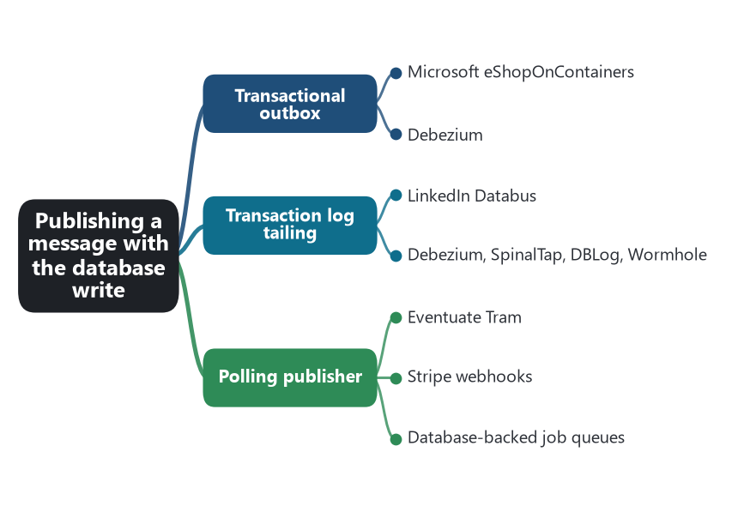
Part map — Publishing a message with the database write: the patterns of this part and the software that shows each one.
📖 Words to know in this part
At-least-once delivery | A message may arrive more than once, never zero times.
Change data capture (CDC) | Reading a database’s own change log and publishing the changes.
Binlog / write-ahead log | MySQL’s and Postgres’s durable records of every change.
Polling | Asking again and again on a timer.

📮 Chapter 19. Transactional outbox
💬 In plain words: Write the outgoing message into your own database with the data; a helper delivers it later, so nothing is lost.

❓ The problem. The database write commits and the publish to the broker fails, or the reverse. There is no transaction that spans a database and a message broker, and two-phase commit is not on offer from Kafka or RabbitMQ.
💡 The pattern. The service writes the business row and a row in an outbox table in the same local transaction. A separate publisher reads the outbox and sends the messages. Because both rows commit or neither does, the message can never be lost, only delayed or duplicated.
Microsoft eShopOnContainers. The IntegrationEventLogEF library is an outbox. When Ordering saves an order, it also inserts an IntegrationEventLogEntry into an event log table in the same database, inside the same Entity Framework transaction. After commit, the integration event service publishes the pending entries to RabbitMQ or Azure Service Bus and marks each Published; a failed publish leaves the entry marked for retry. The guide explains the reason in one sentence: the update and the event must succeed or fail together.
Debezium. Gunnar Morling’s 2019 outbox event router made the pattern infrastructure. The service writes the outbox row in its transaction; Debezium tails the database log, picks up the outbox insert, and routes it to a Kafka topic named in the row; the service can delete the outbox row immediately, because Debezium has already read the insert from the log. The publisher in the pattern is replaced by change data capture.
⚠️ The cost. At-least-once delivery, so every consumer has to be idempotent. The outbox table grows and needs cleanup. There is a delay between commit and publish equal to the publisher’s polling or tailing interval.
Source: Microsoft, .NET microservices guide, “Designing atomicity and resiliency when publishing to the event bus,” and the IntegrationEventLogEF project. Morling, “Reliable Microservices Data Exchange With the Outbox Pattern,” Debezium blog, 2019. Richardson, microservices.io, “Transactional outbox.”

📜 Chapter 20. Transaction log tailing
💬 In plain words: Read the database’s own change log and turn each change into a message.

❓ The problem. The team wants every committed change published without touching application code, and without a polling query hammering the outbox table.
💡 The pattern. A process reads the database’s own transaction log — MySQL’s binlog, Postgres’s write-ahead log, the Oracle redo log — and publishes each change it finds. The database already recorded the change durably; the tailer turns that record into a message.
LinkedIn Databus. Databus (published 2012, open-sourced 2013) captured changes from LinkedIn’s Oracle and MySQL databases and fed them, in commit order, to search indexes, the social graph, and caches. It is the direct ancestor of every change-data-capture system in this chapter.
Debezium, SpinalTap, DBLog, Wormhole. Debezium (Red Hat, 2016) reads MySQL, Postgres, MongoDB, SQL Server, and Oracle logs into Kafka and is the open-source default. Airbnb’s SpinalTap (2018) reads MySQL binlogs and DynamoDB streams into Kafka and drives search indexing, cache invalidation, and derived data. Netflix’s DBLog (2019) adds a way to take a consistent full snapshot while the log keeps flowing, so a new consumer can bootstrap. Facebook’s Wormhole (2015) is the same mechanic over the MySQL binlog at Facebook scale, feeding caches and indexes across regions.
⚠️ The cost. Coupled to one database engine’s log format. A row change is not a domain event: “orders.status changed from 2 to 3” has to be turned into OrderPaid somewhere, which is why the outbox and CDC are usually combined. Snapshot and ordering semantics need care.
Source: Das et al., “All Aboard the Databus!,” SoCC 2012. Debezium, 2016. Airbnb, “Capturing Data Evolution in a Service-Oriented Architecture,” 2018. Andreakis and Papapanagiotou, “DBLog: A Generic Change-Data-Capture Framework,” Netflix, 2019. Sharma et al., “Wormhole,” NSDI 2015.

⏱️ Chapter 21. Polling publisher
💬 In plain words: A loop that checks for unsent rows and sends them. Plain, a little slow, works anywhere.

❓ The problem. The team has an outbox or an event table and needs the simplest possible thing that publishes it.
💡 The pattern. A process polls the table for rows not yet published, publishes them, and marks them sent. No log access, no broker transaction, no special database features.
Eventuate Tram. Richardson’s framework for the FTGO example publishes the outbox either by polling or by tailing the log, and polling is the default when the database does not expose its log. The polling loop is a SELECT of unpublished rows, a publish, and an UPDATE.
Stripe webhooks. Stripe stores every event and delivers it to each subscribed endpoint. A failed delivery is retried with exponential backoff for up to three days in live mode. The delivery system is a publisher working through a stored table of pending deliveries; the event store is the outbox, and the retry schedule is the polling interval.
Database-backed job queues. Rails’ Delayed Job and Solid Queue, and Sidekiq’s Postgres-backed cousins, are polled tables of work. Used to carry publish jobs, they are polling publishers by another name, and many teams have one without calling it that.
⚠️ The cost. Polling adds load and a latency floor equal to the interval. Concurrent publishers need row locking or partitioning. In return it runs anywhere.
Source: Richardson, Eventuate Tram documentation and microservices.io, “Polling publisher.” Stripe documentation, webhook delivery and retry behavior.

📡 Part 6. Communicating between services
The 2014 article asked for smart endpoints and dumb pipes. The pipes in popular software are two: request-response, and messages through a broker. Two smaller patterns cover protocols built for a domain and what happens when a message arrives twice.
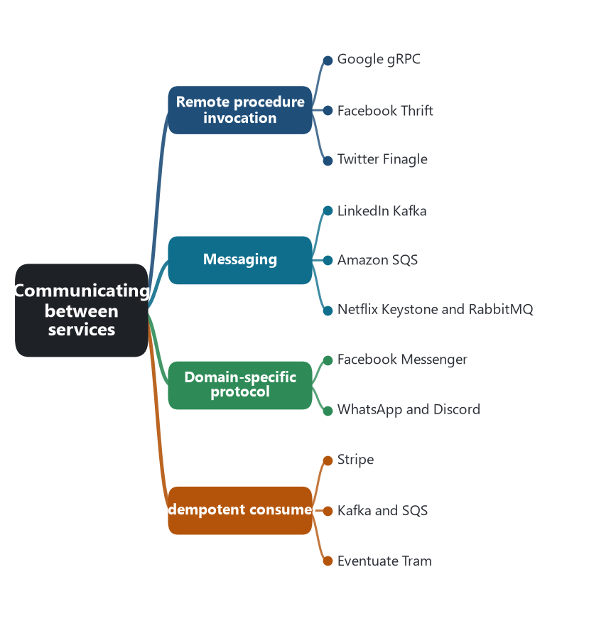
Part map — Communicating between services: the patterns of this part and the software that shows each one.
📖 Words to know in this part
IDL / schema | A formal description of calls or messages from which code is generated.
HTTP/2 | The newer web protocol gRPC rides on: multiplexed, binary, efficient.
Broker | The middleman that stores and forwards messages (Kafka, RabbitMQ, SQS).
Publish-subscribe | One publishes; any number subscribe and receive.
MQTT / XMPP | Lightweight publish-subscribe and chat protocols older than smartphones.
Idempotency key | A client-chosen identifier that makes a retried request safe.

📞 Chapter 22. Remote procedure invocation
💬 In plain words: Call and wait for the answer — a phone call between services.

❓ The problem. One service needs an answer from another now: is this item in stock, what is this customer’s address.
💡 The pattern. The caller sends a request and blocks for the response. The interface is defined in a schema or an IDL, and clients are generated. HTTP with JSON, gRPC, and Thrift are the common forms.
Google gRPC. Google’s internal RPC system, Stubby, connected every service in the company for a decade before Google released gRPC in 2015 (1.0 in 2016): HTTP/2 transport, Protocol Buffers as the schema, generated clients in a dozen languages, and deadlines and cancellation built into every call. It became the default for service-to-service calls in the Kubernetes ecosystem.
Facebook Thrift. Facebook built Thrift in 2007 so services written in PHP, C++, Java, and Python could call each other through one IDL; it went to Apache. Airbnb chose Thrift IDL for its SOA in 2018 for the same reason: one definition, generated clients in Ruby and Java.
Twitter Finagle. Finagle (2011) is an RPC system where a service is a function from request to future response; load balancing, retries, timeouts, and Zipkin tracing are composable filters around that function. It carried Twitter’s traffic and is the ancestor of Linkerd.
⚠️ The cost. Temporal coupling: both services must be up at the same moment. Failure cascades along the call chain, which is why discovery, breakers, and timeouts follow in later parts.
Source: gRPC, 2015–2016. Slee, Agarwal, and Kwiatkowski, “Thrift: Scalable Cross-Language Services Implementation,” Facebook, 2007. Eriksen, “Your Server as a Function,” PLOS 2013. Tai, QCon 2018.

✉️ Chapter 23. Messaging
💬 In plain words: Leave a message in a mailbox; the receiver reads it when ready.

❓ The problem. The sender should not have to wait for, or even know about, the receiver. Work should survive a receiver being down. Load should be smoothed rather than propagated.
💡 The pattern. Services exchange messages through a broker. Point-to-point channels carry commands; publish-subscribe channels carry events. The broker stores the message until a consumer takes it.
LinkedIn Kafka. Kafka was built at LinkedIn in 2010 to replace a tangle of point-to-point feeds with one partitioned, replicated log that many consumers read at their own pace. It was open-sourced in 2011 and became the event backbone of most large microservice systems, including Netflix, Uber, and Airbnb.
Amazon SQS. Simple Queue Service was the first AWS service released to the public, in beta in 2004 and generally available in 2006, before EC2. Amazon shipped a queue before it shipped a computer, which says what it thought the hard part of a distributed system was.
Netflix Keystone and RabbitMQ. Netflix’s Keystone pipeline carried hundreds of billions of events a day through Kafka by 2016. At the small end, eShopOnContainers uses RabbitMQ as its default event bus, with Azure Service Bus as the alternative implementation behind the same interface.
⚠️ The cost. At-least-once delivery, out-of-order arrival, and a broker to operate. Debugging an asynchronous flow needs correlation IDs and tracing. The broker invites logic into the pipe — routing rules, transformations — which the 2014 article said belongs in the endpoints.
Source: Kreps, Narkhede, and Rao, “Kafka: a Distributed Messaging System for Log Processing,” 2011. Amazon Web Services announcements, 2004 and 2006. Netflix Tech Blog, “Evolution of the Netflix Data Pipeline,” 2016. Microsoft, eShopOnContainers event bus.

🗣️ Chapter 24. Domain-specific protocol
💬 In plain words: When HTTP is the wrong shape, speak a language built for the job: chat, telephony, devices.

❓ The problem. HTTP request-response fits ordering a book. It fits badly when the connection must stay open, messages are tiny and frequent, and the client is a phone on a weak network.
💡 The pattern. Services and clients speak a protocol built for the domain instead of a general HTTP or messaging API. Email has SMTP, telephony has SIP, databases have wire protocols. Chat, presence, and telemetry get protocols of their own.
Facebook Messenger. Facebook’s 2011 engineering note on building Messenger explains that HTTP’s overhead made low-latency mobile messaging impractical, so the phone client speaks MQTT — a 1999 publish-subscribe protocol designed at IBM for constrained devices — over a persistent connection to Facebook’s servers.
WhatsApp and Discord. WhatsApp’s clients speak a modified, compressed XMPP, the chat protocol standardized in the early 2000s, to an Erlang backend. Discord’s clients hold a WebSocket to the Gateway and exchange framed messages with opcodes for heartbeat, identify, and event dispatch; REST is used only for actions that fit it.
⚠️ The cost. Bespoke tooling. Generic gateways, tracers, and load balancers understand HTTP and gRPC; a domain protocol needs its own.
Source: Zhang, “Building Facebook Messenger,” Facebook Engineering, 2011. MQTT, Stanford-Clark and Nipper, 1999. WhatsApp engineering talks by Rick Reed, 2012–2014. Discord developer documentation, Gateway.

🔁 Chapter 25. Idempotent consumer
💬 In plain words: Getting the same message twice must have the same effect as getting it once.

❓ The problem. Brokers and retries deliver at least once. A payment handler that receives ChargeCard twice charges twice.
💡 The pattern. A handler can receive the same message more than once and produce exactly one effect. Either the operation is naturally idempotent (set status to Paid), or the handler records the message ID it has processed, in the same transaction as the business change, and ignores repeats.
Stripe. Brandur Leach’s 2017 post on Stripe’s idempotency keys is the reference design. A client puts an Idempotency-Key header on a POST; Stripe stores the key with the outcome of the first request for 24 hours and returns that stored result to any retry, so a network failure after the charge does not produce a second charge. The client library retries freely because the key makes the retry safe.
Kafka and SQS. Kafka 0.11 (2017) added the idempotent producer — a producer ID and sequence number let the broker discard duplicates from a retried send — and transactions across partitions. Amazon SQS FIFO queues (2016) deduplicate on a MessageDeduplicationId within a five-minute window. Both make the pipe help, and neither removes the need for the handler to be safe on its own.
Eventuate Tram. Richardson’s framework keeps a received_messages table; the handler inserts the message ID in the same transaction as its business update, and a duplicate fails the insert and is skipped.
⚠️ The cost. Storage for processed IDs and a policy for how long to keep them. Choosing what the key is — the request, the business action, the message — is a design decision the team has to make on purpose.
Source: Leach, “Designing robust and predictable APIs with idempotency,” Stripe, 2017. KIP-98, Apache Kafka 0.11, 2017. Amazon SQS FIFO, 2016. Richardson, microservices.io, “Idempotent consumer.”

🚪 Part 7. Facing external clients
A phone should not know that there are four hundred services. Two patterns put a front door in place.
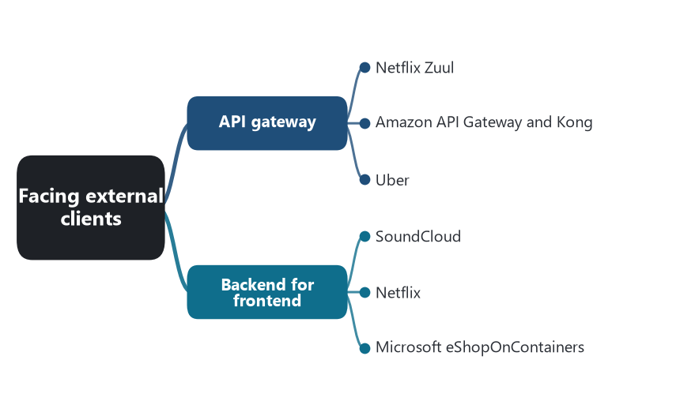
Part map — Facing external clients: the patterns of this part and the software that shows each one.
📖 Words to know in this part
TLS termination | Decrypting incoming HTTPS at the edge.
Rate limiting | Refusing requests beyond an agreed pace.
Aggregation | Combining several backend calls into one response.
Non-blocking I/O | Handling many connections without a thread waiting on each.

🚪 Chapter 26. API gateway
💬 In plain words: One front door that knows the way to every room.

❓ The problem. Clients would otherwise call many services directly, know their addresses, handle each one’s authentication, and make a dozen round trips over a mobile network for one screen.
💡 The pattern. One entry service receives all external requests. It routes to internal services, authenticates, rate-limits, and often aggregates several calls into one response. Internal topology is hidden behind it.
Netflix Zuul. Zuul (open-sourced 2013) fronts all Netflix device traffic. Filters written in Groovy run at request time for authentication, routing, canary release, and load shedding, and can be changed without redeploying the gateway. Zuul 2 (2018) rebuilt it on Netty for asynchronous, non-blocking I/O to handle connection spikes when millions of devices reconnect at once.
Amazon API Gateway and Kong. Amazon API Gateway (2015) is the managed form: routes, throttling, keys, and authorizers in front of Lambda functions and services. Kong (2015) is the open-source form on NGINX and OpenResty with plugins for the same jobs.
Uber. Uber’s 2020 description of its API gateway: the edge layer terminates TLS, authenticates, translates protocols, applies rate limits, and exposes thousands of endpoints defined in configuration, so product teams publish an endpoint without writing gateway code.
⚠️ The cost. One more hop, a component every request depends on, and a team that owns it. A gateway attracts business logic and becomes the smart pipe; the backend-for-frontend pattern is one answer to that.
Source: Netflix Tech Blog, “Announcing Zuul,” 2013, and “Open Sourcing Zuul 2,” 2018. Amazon API Gateway, 2015. Kong, 2015. Thangavelu et al., “The Architecture of Uber’s API Gateway,” 2020.

📱 Chapter 27. Backend for frontend
💬 In plain words: A front door per kind of client, owned by that client’s team.

❓ The problem. One gateway serving web, iOS, Android, and TV becomes a bottleneck: every client team files changes against it, and the response shape is a compromise that fits none of them.
💡 The pattern. A separate backend per client experience, owned by the team that ships that client. Each composes and shapes responses for its own screens. One experience, one backend.
SoundCloud. Phil Calçado described the practice at SoundCloud, where the single public API shared by all clients had become the place every team waited on. Each client team got its own backend, deployed on its own schedule, that called the internal services and returned exactly what its screens needed. Sam Newman wrote the pattern up in 2015, adding REA Group as a second case.
Netflix. Netflix reached the same shape from inside its API tier. In 2013 Jacobson described the “client adapter layer”: device teams wrote Groovy scripts, deployed into the API service without an API-team release, that shaped the generic response for their device. The scripts were backends for frontends living inside one process.
Microsoft eShopOnContainers. The reference application has a web shopping aggregator and a mobile shopping aggregator behind Envoy, each composing Catalog, Basket, and Ordering calls for its client.
⚠️ The cost. Duplication across the backends and more deployables. The pattern works only while the rule holds: one experience, one backend. A backend shared by two clients is a gateway again.
Source: Newman, “Pattern: Backends For Frontends,” 2015, citing Calçado’s SoundCloud work. Jacobson, “The Netflix Dynamic Scripting Platform,” 2013. Microsoft, eShopOnContainers aggregators.

🧭 Part 8. Finding a service instance
Instances start, stop, and move. A caller needs a current address. Five patterns split the work between the caller, a router, a registry, and whoever fills the registry.
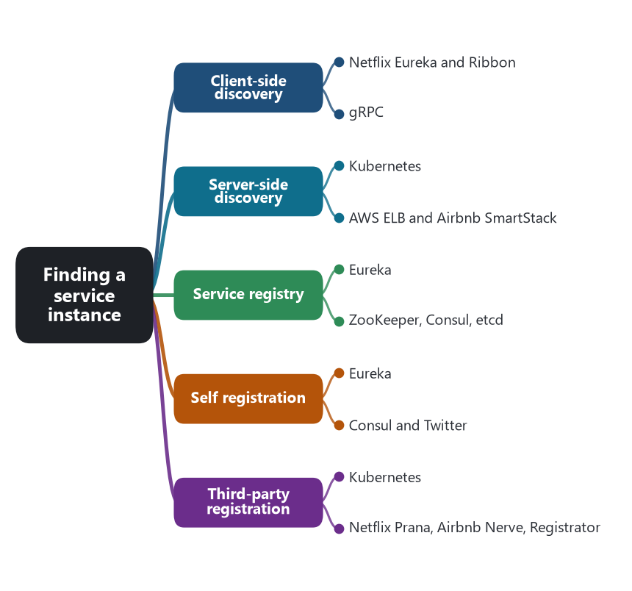
Part map — Finding a service instance: the patterns of this part and the software that shows each one.
📖 Words to know in this part
Heartbeat / lease | A periodic ‘still alive’ signal; the registry evicts an entry whose lease expires.
DNS | The name-to-address system; a stable name in front of moving instances.
EndpointSlice | Kubernetes’ list of the ready pod addresses behind a Service.
iptables / IPVS | Kernel rules that forward a virtual address to a real one.
Availability vs consistency | Keep answering with possibly stale data, or refuse to answer rather than be wrong.

🔎 Chapter 28. Client-side discovery
💬 In plain words: The caller opens the address book and picks an instance itself.

❓ The problem. A load balancer in front of every service is another hop, another component, and another team’s configuration change for every new service.
💡 The pattern. The caller asks a service registry for the instances of the service it wants, chooses one with its own load-balancing logic, and calls it directly.
Netflix Eureka and Ribbon. Eureka (2012) is the registry; Ribbon is the client. A Netflix service fetches the registry, caches it, and load-balances across instances itself, preferring instances in its own availability zone. Because the client holds a cached copy, a Eureka outage does not stop calls — the cache goes stale but keeps working, a deliberate choice for availability over consistency. Spring Cloud Netflix (2015) brought the pair to the wider JVM world.
gRPC. gRPC clients can load-balance across a list of addresses supplied by a resolver, and with the xDS protocol from the Envoy project can receive that list from a control plane — client-side discovery with a mesh-style source of truth.
⚠️ The cost. Discovery and load-balancing logic in every language the company uses. Netflix could do it because it was a JVM shop; Prana was built for everyone else.
Source: Netflix Tech Blog, “Netflix Shares Cloud Load Balancing and Failover Tool: Eureka!,” 2012. Spring Cloud Netflix, 2015. gRPC xDS support, 2020.

🛣️ Chapter 29. Server-side discovery
💬 In plain words: The caller sends to one stable name; a router picks the instance.

❓ The problem. The team wants discovery out of the application code and the same for every language.
💡 The pattern. The caller sends to a stable address — a load balancer or a virtual IP. The router queries the registry and forwards to a healthy instance. The caller knows only the name.
Kubernetes. A Service is a stable DNS name and cluster IP. kube-proxy programs iptables or IPVS rules on every node so that traffic to the cluster IP is forwarded to one of the ready pods listed in the Service’s EndpointSlices. The calling pod resolves a name and connects; it never sees a pod IP change.
AWS ELB and Airbnb SmartStack. Elastic Load Balancing (2009) with Auto Scaling groups was the cloud’s first version of the pattern, and it is how Netflix exposed services to the edge. Airbnb’s SmartStack (2013) put the router on each host: Synapse configures a local HAProxy with one port per dependency, and the application connects to localhost. The registry is ZooKeeper, filled by Nerve.
⚠️ The cost. One more hop, and a router that is itself a critical component to scale and secure. In Kubernetes the hop is a kernel rule; in a hardware balancer it is a device.
Source: Kubernetes documentation, Services and kube-proxy. AWS Elastic Load Balancing, 2009. Serebryany, “SmartStack: Service Discovery in the Cloud,” Airbnb, 2013.

📒 Chapter 30. Service registry
💬 In plain words: The address book: who is running where, and whether they are healthy.

❓ The problem. Someone has to hold the current list of instances and their health, and stay available while instances churn.
💡 The pattern. A database of service instances and their network locations. Instances or a registrar write to it; clients or routers read from it. It is the one component in this part that everyone depends on.
Eureka. A peer-replicated registry that chose availability over consistency: each Eureka server holds the full registry, replicates to peers, and keeps serving from its copy if peers are unreachable. Instances that stop heart-beating are evicted after a lease expires.
ZooKeeper, Consul, etcd. Yahoo’s ZooKeeper (2008) was the consistent coordination store that Airbnb’s SmartStack and Twitter’s Finagle ServerSets used as a registry, and that Kafka used until KRaft. HashiCorp Consul (2014) combined a registry, health checks, a key-value store, and a DNS interface, so any client that can resolve a name can discover. Kubernetes stores its Services and EndpointSlices in etcd (2013), which makes etcd the registry for every Kubernetes cluster without anyone calling it that.
⚠️ The cost. The registry’s consistency choice becomes the system’s. Eureka may hand out a dead address for up to ninety seconds; ZooKeeper may refuse to answer during a partition. Both are correct for someone.
Source: Netflix Eureka wiki. Hunt et al., “ZooKeeper: Wait-free coordination for Internet-scale systems,” USENIX ATC 2010. HashiCorp Consul, 2014. etcd, CoreOS, 2013; Kubernetes architecture documentation.

✍️ Chapter 31. Self registration
💬 In plain words: Each instance writes itself into the address book when it starts.

❓ The problem. The registry is empty until something fills it.
💡 The pattern. Each service instance registers itself on startup, sends heartbeats while it runs, and deregisters on shutdown. The service knows best when it is ready.
Eureka. A Eureka client registers on start, renews its lease every thirty seconds, and is evicted if no renewal arrives for ninety seconds. A Spring Boot application with the Eureka client on its classpath does all of this with one annotation; the registration code is in the library, not the service.
Consul and Twitter. A Consul agent runs on each host and the service registers with the local agent, which reports to the cluster and runs the health checks. Twitter’s Finagle services announced themselves into ZooKeeper ServerSets, and clients resolved a service name to the current set.
⚠️ The cost. Registration code in every service or every chassis. A process that crashes without deregistering leaves a stale entry until the lease expires, so callers must tolerate a dead address.
Source: Netflix Eureka wiki, client configuration. HashiCorp Consul, service registration. Twitter Finagle, ServerSets and Zookeeper.

📇 Chapter 32. Third-party registration
💬 In plain words: Someone else — usually the platform — writes the instance into the address book.

❓ The problem. The service is written in a language without a registry client, or the team wants the platform to own registration so the service does not have to.
💡 The pattern. A registrar registers and deregisters instances on their behalf, by watching the platform or by probing the process. The service is unaware of the registry.
Kubernetes. A pod does nothing to be discovered. The kubelet reports the pod’s readiness; the EndpointSlice controller in the control plane watches pods that match a Service’s selector and writes their IPs into the Service’s EndpointSlices when they are ready, and removes them when they are not. Registration is a side effect of scheduling.
Netflix Prana, Airbnb Nerve, Registrator. Prana (2014) is a sidecar that registers a non-JVM process with Eureka and heartbeats for it. Airbnb’s Nerve runs on each host, health-checks each local service, and writes its presence into ZooKeeper. Glider Labs’ Registrator (2014) watches Docker container start and stop events and registers them with Consul or etcd. Each is a registrar standing beside a service that never heard of the registry.
⚠️ The cost. The registrar has to know whether the service is healthy, which is why third-party registration and the health check API arrive together.
Source: Kubernetes documentation, EndpointSlices and readiness. Netflix Tech Blog, “Prana: A Sidecar for your Netflix PaaS based Applications and Services,” 2014. Serebryany, Airbnb, 2013. Glider Labs Registrator, 2014.

🧯 Part 9. Containing failure
In a monolith a slow function slows the process. In a service system a slow dependency exhausts the caller’s threads, then the caller’s callers. Michael Nygard named the defenses in Release It! (2007), and Netflix turned them into a library.
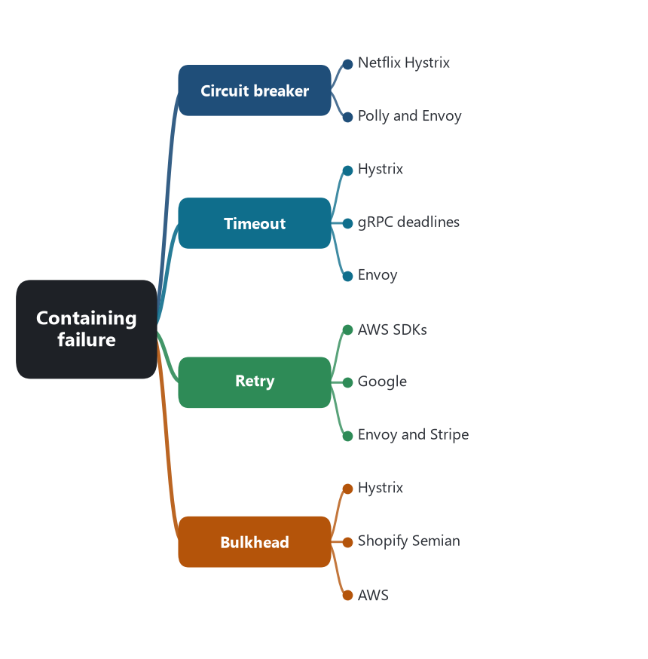
Part map — Containing failure: the patterns of this part and the software that shows each one.
📖 Words to know in this part
Thread pool | A fixed set of workers; exhaust it and every caller waits.
Half-open | The breaker’s trial state: let one call through to see if the dependency recovered.
Deadline propagation | Passing ‘how much time is left’ down the call chain.
Jitter | Random spread added to retry delays so a fleet does not retry in lockstep.
Retry budget | A cap on retries as a share of requests, so retries cannot cause an outage.
Cell | A complete copy of a service serving a slice of customers, so a failure is bounded.

⚡ Chapter 33. Circuit breaker
💬 In plain words: After too many failures, stop calling for a while; test the water before resuming.

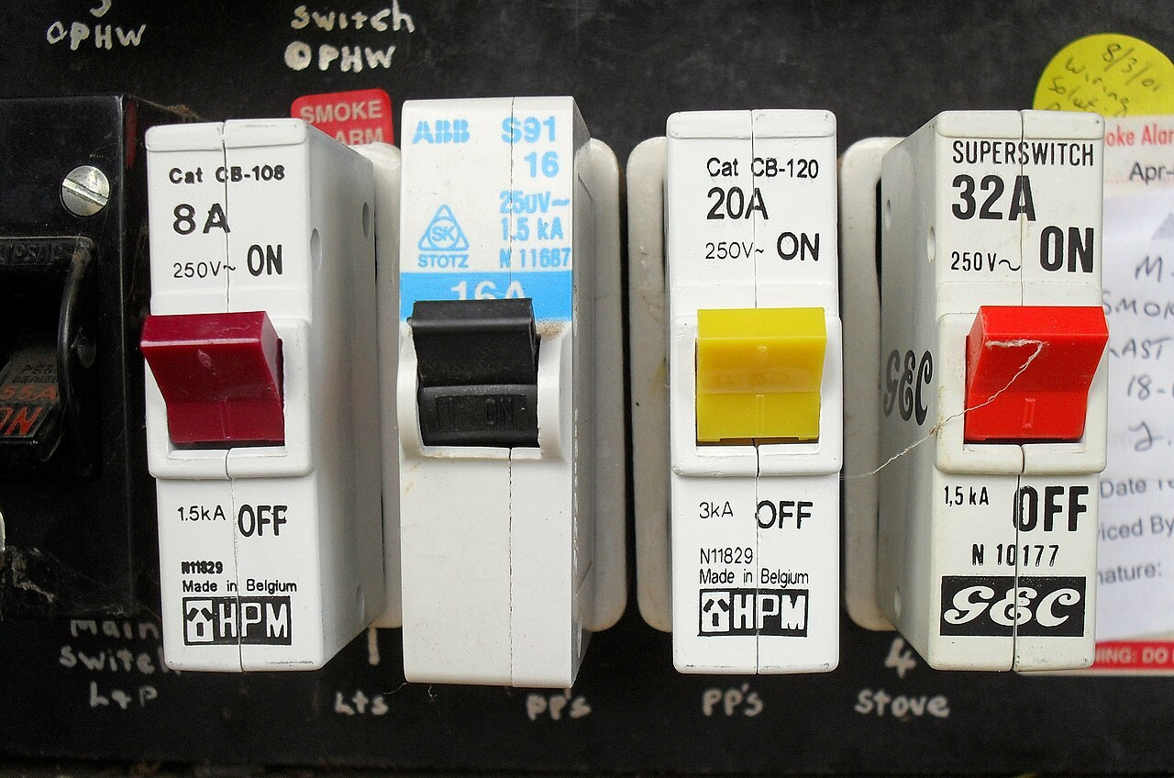
Household circuit breakers: they trip to protect the wiring. Hystrix opened its circuit at a 50 percent failure rate over ten seconds and let one trial call through after five. Photo: Bidgee, Wikimedia Commons, CC BY-SA 3.0.
❓ The problem. A dependency is failing. Every call to it still takes the full timeout, still holds a thread, and still fails. The caller spends its capacity waiting for a service that cannot answer.
💡 The pattern. A proxy counts failures. When the failure rate over a window crosses a threshold, the circuit opens and calls fail immediately without being attempted. After a pause the circuit goes half-open and lets a trial call through; success closes it. Nygard’s metaphor is the electrical breaker: it trips to protect the wiring.
Netflix Hystrix. Hystrix (2012) wraps each dependency call in a command. With default settings, the circuit opens when at least 20 requests in a rolling ten-second window have a failure rate above 50 percent, stays open for five seconds, and then tries one request. Each command has a fallback — a cached value, a default, an empty list — so the Netflix API tier degraded a row of the homepage rather than the page. Netflix reported tens of billions of thread-isolated calls a day through Hystrix. It entered maintenance in 2018, with Resilience4j recommended in its place, and its dashboard of open and closed circuits is still the mental image most engineers have of the pattern.
Polly and Envoy. eShopOnContainers uses Polly, the .NET resilience library, to put a breaker around each HttpClient. Envoy’s outlier detection does the same job in the proxy: hosts that return consecutive 5xx responses are ejected from the load-balancing pool for a period and then readmitted, and Istio exposes it as a DestinationRule. The breaker moved from a library in the service to a sidecar beside it.
⚠️ The cost. Thresholds have to be tuned per dependency; under low traffic the sample is too small and the breaker flaps. A fallback is business logic — what does the page show when recommendations are down — and has to be designed.
Source: Nygard, Release It!, 2007. Netflix Tech Blog, “Introducing Hystrix for Resilience Engineering,” 2012; Hystrix wiki, configuration defaults; maintenance announcement, 2018. Polly. Envoy documentation, outlier detection.

⏳ Chapter 34. Timeout
💬 In plain words: Decide in advance how long you will wait; then stop waiting.

❓ The problem. A call that never returns holds a thread, a connection, and a database cursor forever. A dependency that is slow, not down, is worse than one that is down, because the breaker never sees a failure.
💡 The pattern. The caller stops waiting after a set time and treats the call as failed. Timeouts propagate: a caller with 800 milliseconds left should not give its dependency a two-second budget.
Hystrix. Every Hystrix command has an execution timeout, one second by default, after which the call is abandoned and the fallback runs. The timeout is what turns a slow dependency into a counted failure that can open the circuit.
gRPC deadlines. gRPC calls carry a deadline rather than a timeout: an absolute point in time, propagated to every downstream call made while serving the request. If the edge gives a request 500 milliseconds, the third service in the chain sees how much of that remains and can refuse work it cannot finish. Google’s 2016 post on deadlines describes the alternative: a chain of services each waiting on the next long after the client has given up.
Envoy. Envoy applies a route timeout, 15 seconds by default, and a per-try timeout for each retry attempt, so the timeout is configured once in the sidecar and applies to every language.
⚠️ The cost. Too short, and healthy slow calls fail. Too long, and the timeout protects nothing. The right value is a budget for the whole request, divided among the hops, and few teams write that budget down.
Source: Hystrix wiki, execution.isolation.thread.timeoutInMilliseconds. Sheerin, “gRPC and Deadlines,” 2016. Envoy documentation, route timeouts.

🔄 Chapter 35. Retry
💬 In plain words: Try again a few times, with growing random pauses, and only when it is safe to repeat.

❓ The problem. Many failures are transient — a dropped connection, a node restarting. Failing the user for a blip is wrong. Retrying a whole fleet at once is worse.
💡 The pattern. The caller repeats a failed call a limited number of times, only for failures that are safe to repeat, with a growing and randomized delay between attempts.
AWS SDKs. Marc Brooker’s 2015 post “Exponential Backoff And Jitter” showed with simulation that plain exponential backoff still produces synchronized retry waves, and that “full jitter” — a random delay between zero and the exponential cap — spreads the load and finishes sooner. AWS SDKs implement it, and the post is cited by every retry library since.
Google. The SRE book’s chapter on overload gives the budgets Google uses: a request is retried at most three times, and a client stops retrying when retries exceed ten percent of its requests, because a retry storm against an overloaded service is a self-inflicted outage. gRPC lets a service publish its retry policy — which status codes are retryable, how many attempts — so every client behaves the same.
Envoy and Stripe. Envoy retry budgets cap concurrent retries as a percentage of active requests. Stripe’s client libraries retry automatically, and can, because they send the same idempotency key on every attempt.
⚠️ The cost. Retries multiply load exactly when the dependency can least take it. They are safe only for idempotent operations, which is why the idempotent-consumer chapter exists.
Source: Brooker, “Exponential Backoff And Jitter,” AWS Architecture Blog, 2015. Beyer et al., Site Reliability Engineering, chapter 21, “Handling Overload,” 2016. gRPC retry design. Envoy documentation, retry budgets. Stripe API reference.

🚢 Chapter 36. Bulkhead
💬 In plain words: Compartments: one flooding dependency cannot sink the whole ship.

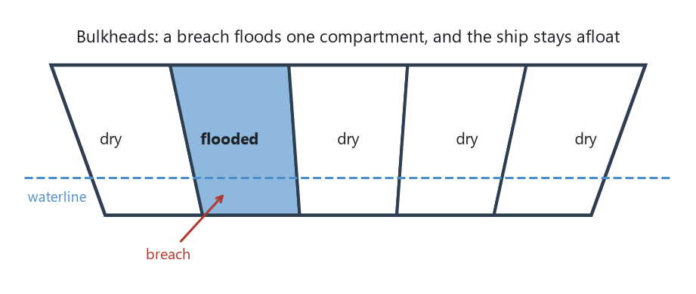
Nygard’s metaphor drawn: watertight compartments in a hull. Hystrix thread pools, Shopify’s Semian tickets, and AWS cells are the same idea at three sizes.
❓ The problem. One slow dependency consumes every thread in the caller’s pool, and calls to healthy dependencies queue behind it. One tenant or one region takes down all of them.
💡 The pattern. Isolate the resources used for one dependency, one tenant, or one partition, so exhaustion stays inside the compartment. Nygard took the name from a ship’s hull: a breach floods one section.
Hystrix. Each Hystrix command group runs on its own thread pool, ten threads by default. If the recommendations service hangs, its ten threads fill and further calls are rejected immediately with the fallback, while the threads for the catalog service are untouched. Semaphore isolation is the lighter alternative for in-process calls.
Shopify Semian. Semian (2015) is Shopify’s resiliency library for Ruby. Its bulkhead is a ticket count per resource — MySQL, Redis, an HTTP host: only so many worker processes may hold a connection to that resource at once, so a slow shard cannot absorb every worker on the host. Circuit breakers sit beside the bulkheads in the same library.
AWS. At infrastructure scale the bulkhead is the cell. Peter Vosshall’s 2018 talk on minimizing blast radius describes services partitioned into cells, each a complete copy serving a slice of customers, so a failure is bounded to one cell; availability zones and Route 53’s shuffle sharding are the same idea at other layers.
⚠️ The cost. Capacity is fragmented: ten pools of ten are less flexible than one pool of a hundred. Pool sizes have to be tuned, and the wrong size is either a bottleneck or no protection.
Source: Nygard, Release It!, 2007. Hystrix wiki, thread pool isolation. Shopify Semian, 2015. Vosshall, “How AWS Minimizes the Blast Radius of Failures,” re:Invent 2018. MacCárthaigh on shuffle sharding, AWS Architecture Blog.

🎟️ Part 10. Carrying identity
In a monolith the session knows who the user is. In a service system the fourth service in the chain has to know too, without calling back to a session store on every hop.
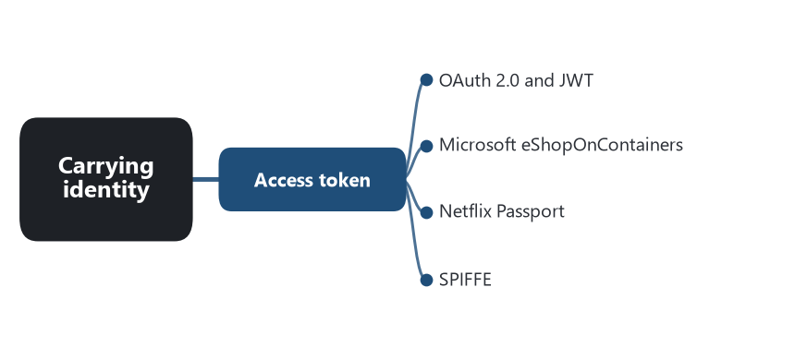
Part map — Carrying identity: the patterns of this part and the software that shows each one.
📖 Words to know in this part
OAuth 2.0 | The standard for how a client obtains a token.
JWT | JSON Web Token: a signed token a service can verify without a network call.
Claim | A statement inside a token, such as the user’s identifier.
Mutual TLS / SPIFFE | Both ends prove their identity with certificates; SPIFFE names workloads.
Confused deputy | A service misusing the authority of the token it was handed.

🎟️ Chapter 37. Access token
💬 In plain words: The caller’s identity travels with the request, signed, so every service can check it locally.

❓ The problem. The service that handles a request has to know who asked and what they may do. A shared session database puts every service on one store; asking the identity service on every hop puts it on every path.
💡 The pattern. A token carrying the caller’s identity and claims travels with the request from service to service. Each service verifies the token’s signature locally and reads the claims. The identity service is called once, when the token is issued.
OAuth 2.0 and JWT. OAuth 2.0 (RFC 6749, 2012) standardized how a client obtains a token; JSON Web Token (RFC 7519, 2015) standardized a signed, self-describing token that a service can verify without a network call. Together they are the identity layer of most public microservice APIs.
Microsoft eShopOnContainers. The Identity service issues JWTs. Ordering and Basket validate the signature against the issuer’s keys and take the user identifier from a claim. No service holds a session, and no service calls Identity on a request path.
Netflix Passport. Netflix’s 2021 post on edge authentication describes the problem at scale: devices authenticate in many ways — cookies, device tokens, partner tokens — and every service used to parse them. Zuul now terminates all of them and mints a Passport, a short-lived signed identity token, that travels with the request to every downstream service. Services read one format, and a change in a device’s authentication method is a change in Zuul alone.
SPIFFE. Service identity is the other half. In Istio, each workload gets an X.509 certificate with a SPIFFE identity and calls are mutually authenticated over TLS; that certificate says which service is calling, while the access token says on whose behalf.
⚠️ The cost. Tokens expire and have to be refreshed; keys rotate; a leaked long-lived token is a credential. A service that forwards a token it received can act with the caller’s full authority, which is the confused-deputy problem the pattern does not solve by itself.
Source: RFC 6749, 2012; RFC 7519, 2015. Microsoft, eShopOnContainers Identity service. Casella et al., “Edge Authentication and Token-Agnostic Identity Propagation,” Netflix Tech Blog, 2021. SPIFFE and Istio security documentation.

🔭 Part 11. Observing the running system
A request is now a path across processes. Seven patterns make that path visible after the fact. Most of the tools in this part were built by the companies in the earlier parts because nothing else existed.
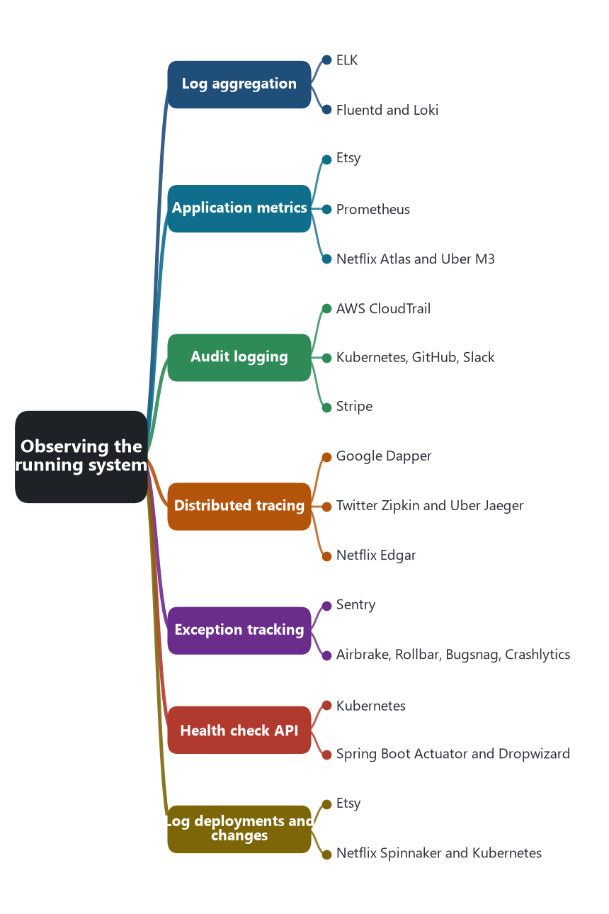
Part map — Observing the running system: the patterns of this part and the software that shows each one.
📖 Words to know in this part
Correlation ID | One identifier stamped on every log line of one request.
Time series | Numbers recorded against time.
Cardinality | How many distinct label values a metric has; too many and it becomes a log.
Span / trace | One hop’s timing record; the tree of spans for one request.
Percentile | ‘95 percent of requests finished within…’ — a measure that ignores the average.
Append-only | A store that can be added to but never edited.

🗃️ Chapter 38. Log aggregation
💬 In plain words: Ship every service’s logs to one searchable place, tied together by a request ID.

❓ The problem. A request touched twelve services on twelve hosts. The logs are in twelve files, and the host that wrote one of them has already been replaced.
💡 The pattern. Every service writes structured logs; an agent ships them to one searchable store; a correlation ID in every line ties the twelve together.
ELK. Elasticsearch (2010), Logstash (2009), and Kibana (2011) were three separate open-source projects that became one stack because operators kept combining them: Logstash to collect and parse, Elasticsearch to index, Kibana to search. For most of the 2010s “ELK” was the name for the pattern. Splunk (2003) is the commercial version that preceded it.
Fluentd and Loki. Fluentd (2011, later a CNCF project) and its lighter sibling Fluent Bit became the shipping agents in Kubernetes, running as a DaemonSet on every node and reading container stdout. Grafana Loki (2018) made the opposite indexing choice from Elasticsearch — index only labels, not the text — because at container scale full-text indexing of logs was the largest line item.
⚠️ The cost. Volume and cost, which is why Loki exists. Aggregation only pays if the logs are structured and carry the correlation ID, and that discipline has to be enforced in the chassis or the template.
Source: Elastic, project histories. Fluentd, CNCF. Grafana Labs, Loki announcement, 2018.

📈 Chapter 39. Application metrics
💬 In plain words: Counts and timings over time, so health can be seen at a glance.

❓ The problem. Is the system healthy right now, and was it healthy at 3 a.m.? Logs answer that slowly and expensively. Operators need numbers over time.
💡 The pattern. Each service records counters, timers, and gauges about its operations — requests, errors, latency percentiles — and a collector stores them as time series for dashboards and alerts.
Etsy. Ian Malpass’s 2011 post “Measure Anything, Measure Everything” released StatsD, a tiny daemon that takes UDP packets from application code and forwards aggregated metrics to Graphite, the time-series store Orbitz had open-sourced in 2008. The message was cultural: make emitting a metric one line of code so engineers measure everything.
Prometheus. Built at SoundCloud from 2012 by engineers who had used Google’s Borgmon, released in 2015, and the second project accepted by the CNCF in 2016. Prometheus pulls metrics from an HTTP endpoint on each instance, stores them with labels, and its query language made the “four golden signals” — latency, traffic, errors, saturation — a dashboard convention. It is the default metrics system of Kubernetes.
Netflix Atlas and Uber M3. Netflix released Atlas (2014) as a dimensional time-series store for its fleet, and Uber released M3 (2018) as a Prometheus-compatible store built for the cardinality of thousands of services.
⚠️ The cost. Cardinality: a label per user or per request turns a metric into a log. Alert fatigue when every metric has a threshold. The numbers say that something is wrong, not what; tracing says what.
Source: Malpass, “Measure Anything, Measure Everything,” Etsy Code as Craft, 2011. Prometheus project history; CNCF, 2016. Beyer et al., Site Reliability Engineering, chapter 6, 2016. Netflix Atlas, 2014. Uber M3, 2018.

🧾 Chapter 40. Audit logging
💬 In plain words: A permanent record of who did what, when — kept for the regulator.

❓ The problem. Who changed this setting, deleted this record, or granted this permission, and when? Application logs rotate; a regulator or a security team needs a record that does not.
💡 The pattern. User and administrative actions are recorded — who, what, when, from where — in a durable, append-only store that is kept for as long as policy requires and cannot be edited by the systems it records.
AWS CloudTrail. CloudTrail (2013) records every API call made in an AWS account, by which principal, from which address, with what parameters, and delivers the log to S3. It is the record that incident response and compliance in the cloud start from, and a model for what a service’s audit log should contain.
Kubernetes, GitHub, Slack. The Kubernetes API server writes an audit log, governed by a policy that says which requests to record and at what detail. GitHub’s and Slack’s enterprise audit logs expose the same kind of record — who invited whom, who changed a setting — to customers through an API, because the customers’ own compliance depends on it.
Stripe. Stripe’s stored event history is a domain-event feed and an audit log at once: every state change is recorded with its time and its cause, and the events are retrievable later.
⚠️ The cost. Retention and storage, immutability that the application itself cannot bypass, and personal data in the record that privacy law then governs.
Source: AWS CloudTrail, 2013. Kubernetes documentation, auditing. GitHub and Slack audit log APIs. Stripe API reference, Events.

🧵 Chapter 41. Distributed tracing
💬 In plain words: Follow one request across every service it touched, hop by hop.

❓ The problem. A request was slow. Which of the nine services it passed through was slow, and was it slow because of the tenth service that one of them called?
💡 The pattern. The edge assigns each request a trace ID. Every hop records a span — start, end, service, operation — tagged with that ID and the parent span, and passes the IDs on in headers. A collector assembles the spans into a tree.
Google Dapper. The 2010 Dapper paper described the system Google had run since 2005: trace and span IDs propagated through Stubby RPCs, sampling to keep overhead negligible, and a central store. Nearly every tracer since is a Dapper implementation.
Twitter Zipkin and Uber Jaeger. Twitter open-sourced Zipkin in 2012 as Dapper for Finagle. Uber built Jaeger in 2015 when Zipkin did not fit its scale and polyglot services, open-sourced it in 2017, and gave it to the CNCF. OpenTracing (2016) and OpenCensus (2018) then merged into OpenTelemetry (2019) so that instrumentation is written once, and the W3C Trace Context header (2020) fixed the format of the IDs on the wire so any proxy can propagate them.
Netflix Edgar. Netflix’s 2020 post on Edgar shows the pattern used for support rather than performance: for a given customer’s stream session, Edgar assembles the trace, the logs, and the metadata from every service involved so an engineer can see why one playback failed.
⚠️ The cost. Every hop has to propagate the headers, including queues and asynchronous work, or the trace breaks. Sampling trades completeness for storage; Netflix chose to keep more because the missing trace is always the one support needs.
Source: Sigelman et al., “Dapper, a Large-Scale Distributed Systems Tracing Infrastructure,” Google, 2010. Twitter, Zipkin, 2012. Uber Engineering, Jaeger, 2017. OpenTelemetry, 2019. W3C Trace Context, 2020. Netflix Tech Blog, “Edgar: Solving Mysteries Faster with Observability,” 2020.

🐞 Chapter 42. Exception tracking
💬 In plain words: Errors reported to one place that groups them and tells the owner.

❓ The problem. An exception was logged somewhere in four hundred services. Nobody read the log line, or a thousand identical lines hid the one that mattered.
💡 The pattern. Exceptions are reported to a central tracker that groups identical errors, counts occurrences, attaches the release and the request context, and notifies the owning team of new and regressed errors.
Sentry. Sentry began in 2008 as David Cramer’s Django plugin that stored exceptions in a database instead of a log file, became a standalone open-source server in 2010, and became the default of the category. Its fingerprinting groups an exception by stack trace and message, its release tracking says which deploy introduced an error, and its SDKs attach the user, the request, and the breadcrumbs that led to the failure.
Airbrake, Rollbar, Bugsnag, Crashlytics. Airbrake (as Hoptoad, 2008) did the same for Rails applications; Rollbar (2012) and Bugsnag (2013) followed for services; Crashlytics (2011) did it for mobile clients and became part of Firebase. Together they made “an exception with no ticket” a thing a team could notice.
⚠️ The cost. Noise if every handled exception is reported. Stack traces and request bodies carry personal data into a third-party store, which has to be scrubbed.
Source: Sentry project history. Airbrake, Rollbar, Bugsnag, Crashlytics.

🩺 Chapter 43. Health check API
💬 In plain words: An endpoint that says ‘alive’, ‘ready’, or ‘not now’.

❓ The problem. The registry, the load balancer, and the orchestrator all need to know whether an instance can take traffic, and a process that is running is not the same as a process that is working.
💡 The pattern. The service exposes an endpoint that reports its health, and a monitor calls it. The best versions distinguish “I am alive” from “I am ready to serve” from “my dependencies are reachable.”
Kubernetes. Kubernetes made the distinction a platform primitive. A liveness probe failing restarts the container. A readiness probe failing removes the pod from the Service’s endpoints without restarting it — the pod is alive, but not to be sent traffic. A startup probe (stable since 1.20) holds the other two off while a slow application boots. The probes are how third-party registration knows what to register.
Spring Boot Actuator and Dropwizard. Dropwizard (2011) shipped a health-check registry in its first release, and Spring Boot Actuator’s /health endpoint (2014) aggregates indicators for the database, disk, and message broker into one status. Consul and Eureka poll such endpoints; AWS load balancers call one before routing to a target.
⚠️ The cost. A shallow check says nothing; a deep check that calls every dependency turns a dependency’s outage into the caller being marked unhealthy and removed, which is a cascade. The design of the check is a design of what failure should do.
Source: Kubernetes documentation, liveness, readiness, and startup probes. Dropwizard, 2011. Spring Boot Actuator, 2014. HashiCorp Consul, health checks.

📌 Chapter 44. Log deployments and changes
💬 In plain words: Record every change, so an outage can be lined up with what changed just before it.

❓ The problem. The error rate went up at 14:07. Something changed at 14:06, and the team spends an hour finding out what. The SRE book’s estimate is that roughly seventy percent of outages follow a change to a live system.
💡 The pattern. Every deployment and configuration change is recorded — what, who, when, which version — in a place that can be laid over the metrics, so an incident can be lined up with the change that preceded it.
Etsy. Etsy’s Deployinator (2010) pushed a marker into Graphite on every deploy, and every Etsy graph showed deploys as vertical lines. An engineer looking at a latency graph saw the line and the jump together. Erik Kastner’s “Quantum of Deployment” made the deploy line a convention, and Grafana annotations are its descendant.
Netflix Spinnaker and Kubernetes. Spinnaker (2015) keeps the execution history of every pipeline: which image, which cluster, who triggered it, and what happened. Kubernetes records a Deployment’s revision history, and kubectl rollout history with a change-cause annotation gives the operator the list of what changed, and rollout undo to reverse it.
⚠️ The cost. Only code deploys get recorded unless the team also records feature-flag flips, configuration pushes, and infrastructure changes, and those are the changes that are hardest to see.
Source: Kastner, “Quantum of Deployment,” Etsy Code as Craft, 2010. Beyer et al., Site Reliability Engineering, 2016, on the share of outages caused by change. Netflix Spinnaker, 2015. Kubernetes documentation, Deployments.

🚀 Part 12. Deploying services
The unit that starts, stops, and scales has changed three times in twenty years: from many processes on a server, to one image per virtual machine, to one container per pod, and to the function. The pattern language keeps all of them.
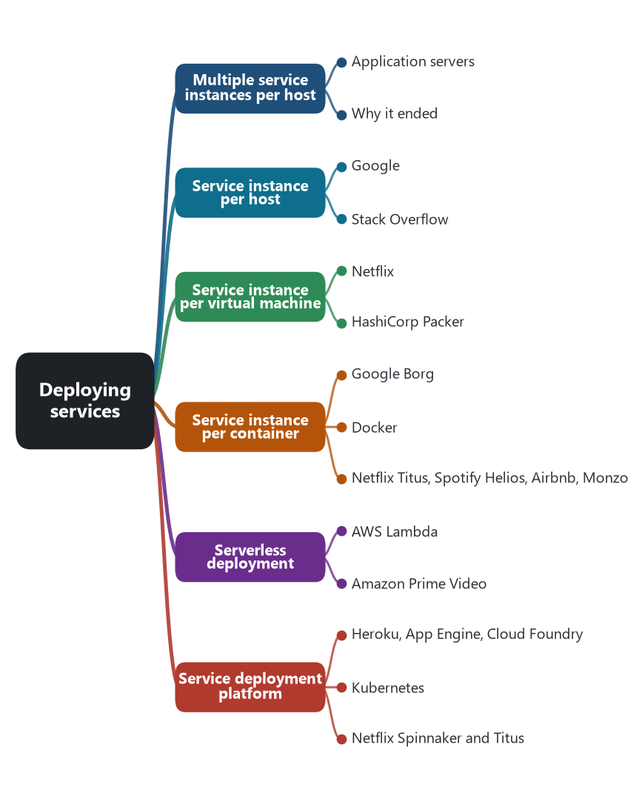
Part map — Deploying services: the patterns of this part and the software that shows each one.
📖 Words to know in this part
cgroups / namespaces | Linux kernel features that isolate a process’s resources and view of the system — the substance of a container.
Image | The packaged, immutable artifact a container or VM starts from.
Auto Scaling group | A set of identical VMs kept at a target count.
Red/black deploy | Launch the new fleet, switch traffic, terminate the old.
Cold start | The delay before an idle serverless function can answer.
Scale to zero | Running no instances at all while idle.

🏘️ Chapter 45. Multiple service instances per host
💬 In plain words: Several services share one machine. Cheap, and they trip over each other.

❓ The problem. Machines are expensive and mostly idle. Several services on one machine use it better.
💡 The pattern. Several service instances share one host and one operating system, as separate processes or as modules inside one process. This was the default before virtualization made machines cheap to create.
Application servers. WebLogic, WebSphere, JBoss, and Tomcat were built for this: one JVM hosting many deployed applications, each a WAR or EAR file, sharing the heap, the thread pools, and the process lifecycle. Microsoft’s IIS hosted many sites and application pools on one server in the same way. Most of the services extracted from monoliths in 2010–2014 first ran like this, several to a host, managed by the operations team’s scripts.
Why it ended. One application’s memory leak took down its neighbors; two applications needed different library versions; nobody could say which service used the CPU. The container pattern below is this pattern with the isolation added back.
⚠️ The cost. No isolation of resources or failures. Dependency conflicts. Per-service resource use is invisible. Deploying one service risks the others in the process.
Source: Richardson, microservices.io, “Multiple service instances per host.” Vendor documentation for the application servers named.

🏠 Chapter 46. Service instance per host
💬 In plain words: One service per machine. Isolated, and wasteful.

❓ The problem. Isolation. A service that has a machine to itself cannot be starved or crashed by a neighbor, and its resource use is the machine’s.
💡 The pattern. Each service instance runs on its own host, physical or virtual. The next two chapters are the virtual and container forms; this one is the general case and its physical origin.
Google. Barroso, Dean, and Hölzle’s 2003 paper on Google’s search cluster describes machines dedicated by role: index servers, document servers, and web servers, each machine running one role, with thousands of cheap commodity machines instead of a few large ones. One role per host is how Google reasoned about capacity before Borg packed roles onto shared machines inside containers.
Stack Overflow. Craver’s 2016 inventory is one role per physical server: web servers, SQL Server, Redis, the tag engine, Elasticsearch, HAProxy, each on its own dedicated hardware. It is the pattern applied to a monolith’s tiers rather than to microservices, and it shows the pattern is about isolation, not about service count.
⚠️ The cost. Utilization is low and provisioning is slow when the host is physical. The virtual machine fixed the second problem and the container fixed the first.
Source: Barroso, Dean, and Hölzle, “Web Search for a Planet: The Google Cluster Architecture,” IEEE Micro, 2003. Craver, 2016.

💽 Chapter 47. Service instance per virtual machine
💬 In plain words: Bake the service into a machine image; deploy by launching copies; never patch, replace.

❓ The problem. The team wants one service per host, provisioned in minutes, replaced rather than patched, and scaled by count.
💡 The pattern. Each service is packaged as a virtual machine image. Deploying means launching instances of the image; scaling means launching more; a new version is a new image, and old instances are terminated rather than updated.
Netflix. From 2011 Netflix baked every service into its own Amazon Machine Image — “Building with Legos,” as the 2011 post called it — with a tool later open-sourced as Aminator, and launched it into an Auto Scaling group with Asgard (2012). A deploy was a red/black switch: launch the new group, move traffic, terminate the old. Nothing was ever changed on a running instance; the image was the release. Spinnaker (2015) generalized the pipeline across clouds.
HashiCorp Packer. Packer (2013) made image baking a general tool: one template builds the same image for AWS, VMware, and later Docker, and the immutable-server practice spread beyond Netflix.
⚠️ The cost. Minutes to boot, gigabytes per image, and a whole operating system per service. The container kept the immutability and removed most of the weight.
Source: Ciancutti, “Building with Legos,” Netflix Tech Blog, 2011. Netflix Asgard, 2012; Aminator, 2013. HashiCorp Packer, 2013. Netflix Spinnaker, 2015.

📦 Chapter 48. Service instance per container
💬 In plain words: The isolation of a virtual machine at a fraction of the weight; an orchestrator places them.

❓ The problem. One service per virtual machine is isolated but heavy. Teams want the isolation and the immutable image without a kernel per service.
💡 The pattern. Each service instance runs in its own container: an image with the service and its dependencies, isolated by kernel namespaces and cgroups, sharing the host kernel. An orchestrator schedules containers onto hosts.
Google Borg. Google had run every task in a cgroups-based container on shared machines for a decade before the 2015 Borg paper described it; Google contributed cgroups to Linux in 2006–2007 for this. Kubernetes (2014, 1.0 in 2015) is Borg’s lessons rewritten for everyone else.
Docker. Docker (2013) made the container image portable and the developer experience simple, and it is the reason the pattern is called container rather than cgroup. eShopOnContainers is named for it: one Dockerfile per service, composed for local development with docker-compose and deployed to Kubernetes.
Netflix Titus, Spotify Helios, Airbnb, Monzo. Netflix built Titus (in production from about 2015, open-sourced 2018) to run containers on its existing VM fleet and scheduling. Spotify open-sourced Helios (2014) to run Docker before Kubernetes existed. Airbnb moved its services to Kubernetes in 2018 and Monzo has run on it since 2016.
⚠️ The cost. An image supply chain to secure and an orchestrator to operate. The isolation is weaker than a VM’s, which matters for multi-tenant platforms.
Source: Verma et al., “Large-scale cluster management at Google with Borg,” EuroSys 2015. Docker, 2013. Kubernetes, 2014–2015. Netflix Titus, 2018. Spotify Helios, 2014. Cebula, Airbnb, KubeCon 2018. Monzo engineering talks.

☁️ Chapter 49. Serverless deployment
💬 In plain words: Upload code; the platform runs it on demand and bills per run.

❓ The problem. The team wants to deploy code, not instances. Idle capacity should cost nothing; a burst should be absorbed without a scaling policy.
💡 The pattern. The platform runs the service’s code on demand in response to an event or a request, scales the number of running copies itself, including to zero, and bills per invocation. The team manages no host, virtual machine, or container.
AWS Lambda. Lambda (announced 2014) defined the category: upload a function, connect it to an event source — an S3 upload, a queue message, an HTTP request through API Gateway — and the platform runs it. Netflix was an early public case, using Lambda for encoding triggers, backup validation, and security checks that fired on events rather than running as services. Google Cloud Functions and Azure Functions followed in 2016; Cloudflare Workers (2017) ran functions at the edge; Knative (2018) brought scale-to-zero to Kubernetes.
Amazon Prime Video. The 2023 monitoring-service case is the boundary of the pattern. A high-throughput pipeline built from Step Functions and Lambda, passing video frames through S3 between steps, cost more in orchestration and storage transfers than the compute; moved into one long-running ECS process, it cost about a tenth. Serverless suits event-driven and bursty work; it suits a steady stream less well.
⚠️ The cost. Cold starts, execution time limits, and a vendor’s event model. At high steady throughput, per-invocation billing exceeds a reserved instance, which is what Prime Video measured.
Source: AWS Lambda, 2014. Netflix presentations at re:Invent, 2014–2015. Kolny, Prime Video Tech, 2023. Cloudflare Workers, 2017. Knative, 2018. Richardson, microservices.io, “Serverless deployment.”

🏗️ Chapter 50. Service deployment platform
💬 In plain words: Say ‘run three copies behind this name’; the platform makes it so.

❓ The problem. A team should be able to say “run three copies of this behind this name” and have it happen, without owning the machines, the placement, the restarts, or the load balancer configuration.
💡 The pattern. An automated platform takes a packaged service and provides deployment, scaling, placement, health management, and a service abstraction — a stable name that routes to whatever instances currently exist.
Heroku, App Engine, Cloud Foundry. Heroku (2007) made the platform a git push: the buildpack builds the application, dynos run it, the router gives it a name. Google App Engine (2008) offered the same shape with Google’s runtimes. Cloud Foundry (2011) was the open-source platform enterprises ran themselves. Each one is the platform-as-a-service chapter of this series applied to one service.
Kubernetes. Kubernetes is the platform most microservice systems now sit on. A Deployment declares the image and replica count and performs rolling updates; the scheduler places pods; the kubelet restarts them; a Service gives them a name. The platform owns everything the deployment patterns above used to leave to scripts.
Netflix Spinnaker and Titus. Netflix built its platform in two parts: Spinnaker (2015) for the delivery pipeline — bake, deploy, canary analysis, red/black — and Titus for container scheduling. Together they are a service deployment platform assembled by one company for one fleet, which is what most large companies did before Kubernetes made it a commodity.
⚠️ The cost. A platform team, and abstractions that leak when a service needs something the platform did not foresee: a GPU, a privileged port, a stateful volume.
Source: Heroku, 2007. Google App Engine, 2008. Cloud Foundry, 2011. Kubernetes documentation, Deployments and Services. Netflix Spinnaker, 2015; Titus, 2018. The PaaS and Kubernetes chapters of this series.

🧰 Part 13. Sharing mechanics across services
Every service needs logging, configuration, discovery, retries, and metrics. The question is whether those live in a library every service compiles in, or in a process beside the service. The industry answered library first, then proxy.
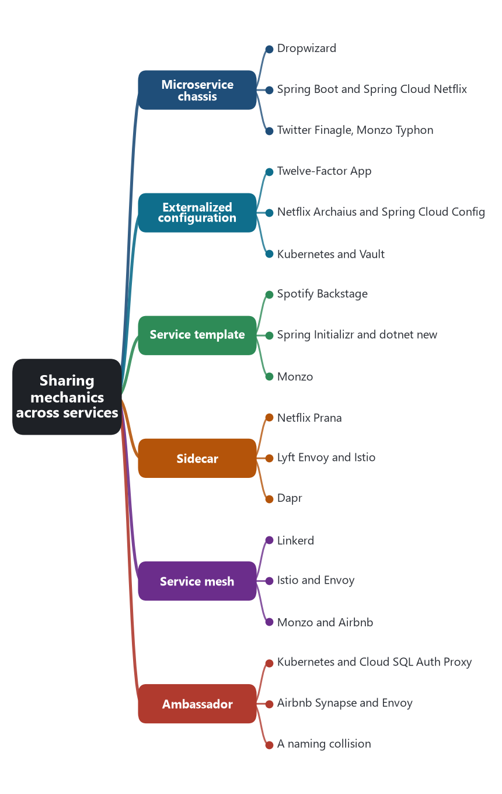
Part map — Sharing mechanics across services: the patterns of this part and the software that shows each one.
📖 Words to know in this part
Cross-cutting concern | A need every service shares: logging, configuration, discovery, retries.
Dynamic property | A setting that can change at runtime without a restart.
Secret leasing | A credential issued for a time and revoked afterwards.
Golden path | The paved, expected way to build and run a service.
Control plane / data plane | What configures the proxies; the proxies that carry traffic.

🧰 Chapter 51. Microservice chassis
💬 In plain words: A shared framework, so the fortieth service does not rebuild logging and health checks.

❓ The problem. The fortieth service should not reimplement health checks, metrics, configuration loading, and the discovery client. Forty copies of that code will be forty slightly different copies.
💡 The pattern. A framework handles the cross-cutting concerns and leaves the team to write domain logic. Starting a service means depending on the chassis and adding handlers.
Dropwizard. Coda Hale released Dropwizard at Yammer in 2011: Jetty, Jersey, Jackson, Metrics, and health checks assembled into one opinionated bundle so that a production-ready HTTP service was a main method and a resource class. It was the first widely used chassis, and Metrics — its instrumentation library — outlived it.
Spring Boot and Spring Cloud Netflix. Spring Boot (2014) made the Java service a self-contained jar with an embedded server and auto-configuration. Spring Cloud Netflix (2015) wrapped Eureka, Ribbon, Hystrix, and Archaius as starters, so a Spring Boot application registered, discovered, and broke circuits by adding dependencies. For several years this pair was the default chassis of enterprise microservices.
Twitter Finagle, Monzo Typhon. Finagle is a chassis for RPC: tracing, load balancing, retries, and metrics are filters composed around every server and client. Monzo’s Go services share Typhon, an RPC library with common middleware, so that every one of its 1,500 services speaks and observes the same way.
⚠️ The cost. Language lock-in: the chassis exists for one runtime, and a company with four languages needs four. Upgrading the chassis across hundreds of services is a project of its own, which is the reason the sidecar and the mesh appeared.
Source: Hale, Dropwizard, 2011. Spring Boot 1.0, 2014. Spring Cloud Netflix, 2015. Twitter Finagle. Monzo Typhon. Richardson, microservices.io, “Microservice chassis.”

⚙️ Chapter 52. Externalized configuration
💬 In plain words: Settings and secrets live outside the build, so one image runs everywhere.

❓ The problem. The same image must run in test, staging, and production with different database addresses, credentials, and limits, and a configuration change should not require a build.
💡 The pattern. Configuration lives outside the service package — environment variables, a configuration service, mounted files — and is read at startup or refreshed at runtime. Secrets are configuration with stricter handling.
Twelve-Factor App. Adam Wiggins’s 2011 manifesto from Heroku made it a rule: factor III, store config in the environment, because config varies between deploys and code does not. The test it proposes is whether the codebase could be open-sourced without leaking a credential.
Netflix Archaius and Spring Cloud Config. Archaius (2012) gave Netflix services dynamic properties: values polled from a source and changed at runtime without restart, which is how Hystrix thresholds were tuned during incidents. Spring Cloud Config (2015) served configuration from a Git repository so that a configuration change was a commit with history.
Kubernetes and Vault. Kubernetes made ConfigMaps and Secrets first-class objects mounted into pods as files or environment variables, separating the image from its settings by construction. HashiCorp Vault (2015) added secrets that are issued dynamically, leased, and revoked, so a database credential is minted for one service instance and expires with it.
⚠️ The cost. Configuration drift between environments, and a configuration change that is not versioned and reviewed is a production change nobody can trace. Secrets in environment variables leak into logs and process lists.
Source: Wiggins, The Twelve-Factor App, 2011. Netflix Archaius, 2012. Spring Cloud Config, 2015. Kubernetes documentation, ConfigMaps and Secrets. HashiCorp Vault, 2015.

📐 Chapter 53. Service template
💬 In plain words: A ready-made starter service to copy: build, pipeline, and metrics already wired.

❓ The problem. A new service takes a day to set up — build, CI, Dockerfile, metrics, health endpoint, ownership metadata — and each team sets it up differently.
💡 The pattern. A copyable starter service already contains the build, the chassis, and the standard cross-cutting concerns. A new service is generated from it and the team fills in the domain.
Spotify Backstage. Backstage (open-sourced 2020, later a CNCF project) is Spotify’s developer portal, and its Software Templates are the pattern as a product: a template scaffolds a repository with the CI pipeline, the Dockerfile, the observability hooks, and the catalog entry that records who owns it. Spotify calls the result a “golden path” — the paved road that a team is expected to take unless it has a reason not to.
Spring Initializr and dotnet new. start.spring.io generates a Spring Boot project with the chosen starters wired; dotnet new generates a .NET web API with the standard layout. Both are service templates without the company-specific parts, which each company then adds.
Monzo. Monzo’s engineers describe generating a new service from a standard skeleton so that the shared libraries, the RPC layer, and the metrics are present before any domain code is written; that is how a small company came to have 1,500 services that look alike.
⚠️ The cost. A template is copied, not linked. When the template improves, the services generated from it last year do not, which is the argument for putting as much as possible in the chassis and as little as possible in the template.
Source: Spotify Backstage, 2020, Software Templates. Spring Initializr. .NET SDK templates. Monzo engineering blog and talks, 2018–2019.

🏍️ Chapter 54. Sidecar
💬 In plain words: A helper process riding beside the service, handling the plumbing in any language.


A motorcycle with a sidecar. Prana rode beside non-JVM services at Netflix; Envoy rides beside every pod under Istio. Photo: Infrogmation, Wikimedia Commons, CC BY-SA 4.0.
❓ The problem. The chassis solved cross-cutting concerns for one language. The Python service and the Node service are still on their own, and upgrading the chassis still means redeploying every service.
💡 The pattern. The cross-cutting concerns run in a separate process or container beside the service instance, sharing its host or pod, and handle traffic, configuration, or logs on its behalf. The service stays language-agnostic and small.
Netflix Prana. Prana (2014) is the earliest well-known sidecar: a Java process deployed beside a non-JVM service that registers it with Eureka, gives it Ribbon-style client-side load balancing, and serves Archaius configuration over a local HTTP port. The Python service got the Netflix stack without a line of Java.
Lyft Envoy and Istio. Envoy (open-sourced 2016) is a proxy written to be a sidecar: it handles every inbound and outbound connection for the service next to it, adding TLS, retries, timeouts, breakers, and tracing headers. Istio (2017) injects an Envoy container into every pod automatically, so the service developer does not know it is there. Brendan Burns and David Oppenheimer’s 2016 paper named sidecar, ambassador, and adapter as the container patterns; the Kubernetes pod — containers sharing a network namespace — is what made the sidecar cheap to deploy, and Kubernetes 1.28 (2023) added native sidecar containers with their own lifecycle.
Dapr. Microsoft’s Dapr (2019) puts service invocation, pub/sub, and state stores behind a sidecar’s local HTTP and gRPC API, so the application calls localhost and the sidecar talks to Redis, Kafka, or Service Bus.
⚠️ The cost. A second process per instance — memory and CPU multiplied by the number of pods — and a latency hop on every call. In exchange, upgrading the sidecar fleet is one rollout instead of hundreds.
Source: Netflix Tech Blog, Prana, 2014. Klein, Envoy, Lyft, 2016. Istio, 2017. Burns and Oppenheimer, “Design patterns for container-based distributed systems,” HotCloud 2016. Kubernetes 1.28 release notes. Dapr, 2019.

🕸️ Chapter 55. Service mesh
💬 In plain words: Sidecars everywhere, plus a control tower that configures them all.

❓ The problem. A sidecar beside every service still needs to be told where services are, what the retry policy is, and which certificates to use. Configuring a thousand sidecars by hand is the chassis problem again.
💡 The pattern. A data plane of sidecar proxies mediates all service-to-service communication, and a control plane configures them: discovery, load balancing, mutual TLS, retries, timeouts, breakers, and telemetry, applied by policy rather than by code in each service.
Linkerd. Buoyant, founded by former Twitter engineers, released Linkerd in February 2016, built on Finagle; William Morgan gave the category its name. Linkerd 2 (2018) rewrote the data plane as a small Rust proxy for Kubernetes.
Istio and Envoy. Istio (May 2017, from Google, IBM, and Lyft) paired Envoy as the data plane with a control plane that distributes routing, security, and telemetry policy to every sidecar. It brought the discovery, breaker, retry, and tracing patterns of the earlier parts out of the Netflix libraries and into the platform. Consul Connect (2018) and AWS App Mesh (2018) followed with the same shape.
Monzo and Airbnb. Monzo ran Linkerd early and later moved its data plane to Envoy, and its 2019 network-isolation work — policy for which of 1,500 services may call which — is the kind of rule a mesh exists to enforce. Airbnb’s SmartStack (2013), with a registrar and a per-host HAProxy on every machine, was a service mesh before the term, missing only the central control plane.
⚠️ The cost. A control plane to operate and understand, a proxy hop per call, and a category of failures — sidecar injection, certificate rotation, policy misconfiguration — that did not exist before. The mesh moves the reliability patterns; it does not touch the data patterns. A saga is still a saga.
Source: Buoyant, Linkerd, 2016; Morgan, “What’s a service mesh? And why do I need one?,” 2017. Istio, 2017. Klein, Envoy, 2016. HashiCorp Consul Connect, 2018. Kleeman, Monzo, 2019; Monzo engineering talks. Serebryany, Airbnb, 2013.

🤵 Chapter 56. Ambassador
💬 In plain words: A sidecar for outbound calls only: the app talks to localhost; the ambassador finds and secures the destination.

❓ The problem. A service makes outbound calls that need connectivity logic — discovery, TLS, retries, connection pooling — and the team wants that logic out of the application and the same across languages.
💡 The pattern. An outbound proxy beside the service handles connections the service makes. The service connects to localhost; the ambassador finds the destination, secures the connection, and applies retry and monitoring. It is the sidecar pattern restricted to outbound traffic.
Kubernetes and Cloud SQL Auth Proxy. Burns and Oppenheimer’s 2016 paper uses an ambassador container for exactly this: the application talks to localhost and the ambassador handles sharding or discovery. Google’s Cloud SQL Auth Proxy is the production case — a sidecar that opens an authenticated, encrypted connection to a Cloud SQL instance and exposes it on a local port, so the application sees a plain database on localhost and never handles certificates.
Airbnb Synapse and Envoy. Airbnb’s Synapse (2013) configured a local HAProxy with one port per dependency; a service connecting to localhost:3000 reached whichever healthy instances of the dependency existed. Envoy in egress mode does the same for HTTP and gRPC calls leaving a pod.
A naming collision. Datawire’s Ambassador (2017) is an Envoy-based API gateway for Kubernetes ingress, an edge component, not this pattern. The name is shared; the job is not.
⚠️ The cost. A hop and a process per instance, as with any sidecar. The name is ambiguous enough that a design document should say which one it means.
Source: Burns and Oppenheimer, HotCloud 2016. Google Cloud SQL Auth Proxy documentation. Serebryany, Airbnb, 2013. Envoy documentation. Azure Architecture Center, “Ambassador pattern.”

🧪 Part 14. Testing services
A monolith is tested by running it. Four hundred services cannot be stood up on a laptop, and the interesting bugs are between them. Three patterns test a service without the rest.
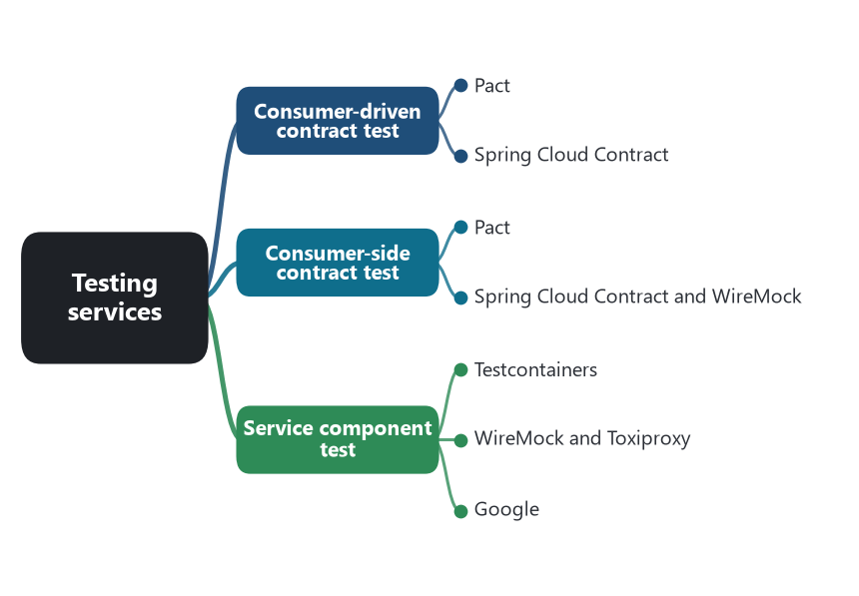
Part map — Testing services: the patterns of this part and the software that shows each one.
📖 Words to know in this part
Contract | A written, executable statement of what a consumer expects from a provider.
Test double (stub, mock) | A stand-in for a real dependency in a test.
Pact Broker | Where contracts and verification results are stored; answers ‘can I deploy?’.
Hermetic | Sealed: a test that needs no shared environment.

📝 Chapter 57. Consumer-driven contract test
💬 In plain words: Callers write down what they depend on; the provider’s build checks it before release.

❓ The problem. The Orders team changes a field name. The three services that call Orders break in production, because nobody knew they depended on that field, and an end-to-end test environment that would have caught it takes a day to stand up and is always broken.
💡 The pattern. Each consumer writes down the interactions it depends on — this request, this response shape — as an executable contract. The provider runs every consumer’s contracts in its own build. A provider change that breaks a consumer fails the provider’s build, before deployment. Ian Robinson named the idea in 2006.
Pact. Pact was written in 2013 by engineers at DiUS working with REA Group, the Australian property site, whose Ruby services kept breaking each other. The consumer’s test runs against a mock provider and records a pact file; the provider’s build replays the pact against the real provider. The Pact Broker stores pacts and verification results, and its can-i-deploy check answers whether this version of a service is compatible with everything currently deployed. Atlassian adopted Pact across its Jira and Bitbucket teams and spoke about it publicly, which is how it reached the enterprise.
Spring Cloud Contract. Marcin Grzejszczak’s Spring Cloud Contract (2016) puts the contract on the provider side in Groovy or YAML, generates the provider’s tests from it, and publishes WireMock stubs that consumers test against — the same guarantee, with the artifact flowing the other way.
⚠️ The cost. Contracts to maintain as the API evolves, and a broker to run. The pattern fits known internal consumers; a public API with unknown consumers cannot collect their contracts.
Source: Robinson, “Consumer-Driven Contracts: A Service Evolution Pattern,” 2006. Pact, 2013; Pact Broker. Atlassian talks on Pact adoption, 2017–2018. Spring Cloud Contract, 2016.

✅ Chapter 58. Consumer-side contract test
💬 In plain words: The caller tests its own client against a stand-in built from the agreed contract.

❓ The problem. The consumer’s client code — the class that calls Orders and parses the reply — has to be tested, and the real Orders service is not available in the consumer’s unit test.
💡 The pattern. The consumer tests its client against a stub of the provider that is derived from the contract, so the test proves the client can speak the agreed protocol without the provider running.
Pact. The consumer half of a Pact test is a consumer-side contract test: the client is exercised against Pact’s mock provider, which is configured with the expected interactions and fails the test if the client sends anything else. The pact file that results is the contract the provider will later verify.
Spring Cloud Contract and WireMock. Spring Cloud Contract publishes WireMock stubs built from the provider’s contracts as a versioned artifact; the consumer’s tests start the stub runner and call it as if it were the provider. WireMock (2011) on its own is the general tool — a programmable HTTP stub — and is what most consumer-side tests use when there is no contract framework.
⚠️ The cost. A stub that is not derived from the provider’s verified contract drifts, and the consumer passes tests against a provider that no longer exists. The pattern is only as good as the link to the provider’s verification.
Source: Pact documentation, consumer tests. Spring Cloud Contract, stub runner. WireMock, 2011.

🧪 Chapter 59. Service component test
💬 In plain words: Test one whole service alone, with a real database and fake neighbors.

❓ The problem. Unit tests pass and the service fails on start because the real database rejects the schema, or because the message serialization differs from what the broker delivers. The team wants to test the whole service, alone.
💡 The pattern. The service is run as a black box with its real infrastructure dependencies — database, broker — as throwaway instances, and the other services it calls replaced by test doubles. Tests drive its API and observe its outputs.
Testcontainers. Richard North’s Testcontainers (2015) starts a real Postgres, Kafka, or Redis in Docker for the duration of a test and tears it down after. It replaced the in-memory database that behaved differently from production, and it is now the standard way a JVM, .NET, Go, or Node service is component-tested.
WireMock and Toxiproxy. WireMock stands in for the services the component calls. Shopify’s Toxiproxy (2014) sits between the component and its dependencies as a TCP proxy and injects latency, dropped connections, and bandwidth limits on command, so the test can ask what the service does when Redis is slow, not only when it is absent.
Google. Google’s testing blog described “hermetic servers” in 2012: a server under test started with all its dependencies faked or local, so the test is repeatable and needs no shared environment. eShopOnContainers does the small version with ASP.NET Core’s TestServer hosting a service in-process with test doubles.
⚠️ The cost. Slower and heavier than unit tests, and the doubles can drift from the real services unless contract tests keep them honest — which is why the three testing patterns are used together.
Source: North, Testcontainers, 2015. WireMock, 2011. Shopify Toxiproxy, 2014. Google Testing Blog, “Hermetic Servers,” 2012. Microsoft, eShopOnContainers functional tests.

🧩 Part 15. Composing a screen from many services
The page shows the product, its price, the reviews, and the recommendations, and four teams own those. Two patterns decide which tier puts the page together.
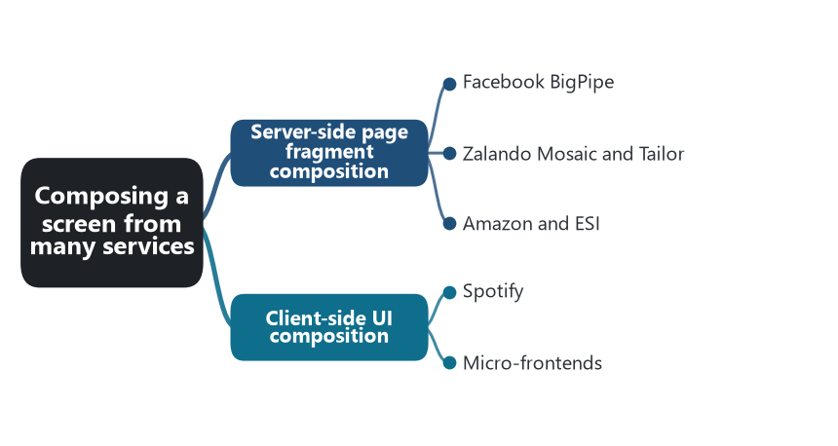
Part map — Composing a screen from many services: the patterns of this part and the software that shows each one.
📖 Words to know in this part
Fragment / pagelet | A piece of a page produced by one team’s service.
ESI | Edge Side Includes: assembling a page from fragments in a cache or CDN.
iframe | A browser element that embeds one page inside another.
Module Federation | Letting one built application load code from another at runtime.
Shell | The thin host application that loads the fragments.

🧩 Chapter 60. Server-side page fragment composition
💬 In plain words: The server stitches a page from fragments each team produced.

❓ The problem. A page needs HTML from several services, and it should render as one page, quickly, with each fragment owned by the team that owns the data.
💡 The pattern. The server assembles the page from HTML fragments, each generated by the service that owns that part of the business. A layout service or template names the fragments; a composer fetches them and streams the page.
Facebook BigPipe. Changhao Jiang’s 2010 post described BigPipe: a page is split into “pagelets” — the news feed, the chat list, the ads — each generated by its own server-side path, and the page is flushed to the browser in chunks as each pagelet is ready, so the first pagelet renders while the slowest is still being built.
Zalando Mosaic and Tailor. Zalando’s Mosaic (2016) is BigPipe for a company of many teams: Tailor is a Node service that takes a template naming fragments, fetches each fragment from the team’s service over HTTP, and streams the assembled page; Skipper routes requests to the right template. Each team deploys its fragment service on its own schedule.
Amazon and ESI. Amazon’s product page is composed on the server from more than a hundred services’ output. Edge Side Includes (2001, from Akamai and Oracle) did the composition in the cache: a page with <esi:include> tags is assembled by Varnish or a CDN from fragments with different cache lifetimes, so the price fragment can be fresh while the description is cached for a day.
⚠️ The cost. The page is as slow as its slowest fragment unless it streams. Fragments from different teams have to share styling and layout without sharing a codebase, and someone owns the template.
Source: Jiang, “BigPipe: Pipelining web pages for high performance,” Facebook Engineering, 2010. Zalando Tech, Mosaic and Tailor, 2016. Vogels, 2006. W3C Note, Edge Side Includes, 2001.

🖼️ Chapter 61. Client-side UI composition
💬 In plain words: The browser assembles the screen from pieces each team ships independently.

❓ The problem. The application is a single-page app, and one frontend codebase owned by every team has become the frontend monolith: one build, one release, one framework version for everyone.
💡 The pattern. The client assembles the screen from UI fragments, each built and deployed by the team that owns the business capability behind it. A shell loads the fragments at runtime; each fragment talks to its own backend.
Spotify. Spotify’s desktop client of the early 2010s was built from independent web views, each hosted in its own iframe and shipped by its own squad, communicating through a shared bridge. It was the client-side version of the squad structure: a team owned a screen and could release it without a client release.
Micro-frontends. ThoughtWorks put “micro frontends” on its Technology Radar in 2016 and Cam Jackson’s 2019 article on martinfowler.com described the practice with IKEA, whose web presence was composed from fragments owned by different teams, among the cases. single-spa (2015) is a shell framework that mounts and unmounts independently built applications by route; webpack 5’s Module Federation (2020) lets one build load code from another build at runtime, which removed the iframe.
⚠️ The cost. Duplicate framework code in the browser unless dependencies are shared carefully, shared state and navigation that no single fragment owns, and a design system to keep ten teams’ fragments looking like one product.
Source: Spotify engineering talks on the desktop client architecture, 2012–2014. ThoughtWorks Technology Radar, November 2016. Jackson, “Micro Frontends,” martinfowler.com, 2019. single-spa, 2015. webpack 5 Module Federation, 2020.

🎯 What this fixes for the AI chapter
Each chapter now has a named case: the software in which the pattern became ordinary, and the reason that company gave. A later claim that AI has changed a pattern can be tested against that case. Did a generated service include an outbox, or a controller that publishes after commit and hopes? Did a suggested boundary follow a capability, a subdomain, or a table? Did a generated saga choose choreography or orchestration, and did it write the compensations? Did the reliability patterns land in the code, in a chassis, or in a sidecar the tool did not know was there? The examples in these chapters are the standard the answers will be held to.
Three observations from the chapters travel forward. First, the data patterns — saga, outbox, replica, CQRS — were designed by hand in every case here, with the business rule and the compensation written by someone who knew the domain. Second, the reliability and discovery patterns have already moved once, from Netflix’s libraries into Envoy and the mesh, so “where does the pattern live” is a question with precedent. Third, several companies moved back — Segment, Prime Video, Shopify’s choice never to leave — and each gave a cost as the reason. Any account of AI’s influence has to say which of these three it touched.
Sources are given at the end of each chapter. The pattern names and groupings follow Chris Richardson, microservices.io and Microservices Patterns (2018), with the companions noted in Answer 4. Lewis and Fowler, “Microservices,” 2014, for the characteristics. Nygard, Release It!, 2007, for the stability patterns. Evans, Domain-Driven Design, 2003, for the subdomain and anti-corruption layer.
🔁 Read it again: three things to carry away
1. Each pattern has a named case and a documented cost.
2. Data patterns were hand-designed everywhere; reliability patterns have already moved once — from libraries into the mesh.
3. Several companies moved back — Segment, Prime Video, Shopify never left — and each gave a cost as the reason.

