🔮 What AI changed
Answer 17 of the working series
Chapters 17–21 of the reading order, under the five headings of the aim
29 September 2026
The claim. Each heading grades published cases against the rules the earlier chapters fixed.
🔑 How to read this edition
The central idea of the chapter — bold, on a yellow marker.
An important sentence — blue and underlined, in the text itself.
A technical term — plum with a dotted line; its meaning is in “Words to know”.
💬 In plain words 🧭 The chapter as a map 📖 Words to know 🔁 Read it again

⭐ In one sentence
In the cases written down by September 2026, AI changed the architecture of the call to a model. It did not draw the business boundary, own the fact, or accept the change.

💬 In plain words
The last part of the series grades real announcements against the rules the earlier chapters fixed. A workshop, not a model, drew QRRA’s six services; the tool wrote the deployment code. Shopify kept one assistant and had to teach its judge not to cheat. Netflix put a smart router on the path to its models, measured the delay and the outage risk, and moved the payload back onto Envoy. Uber and an Envoy gateway put one door in front of model vendors. A coding agent may open a pull request; a person still lets the pipeline run. The new bill is tokens. The old bill — latency, a single point of failure — came back and was paid.

📖 Words to know
Event Storming | A workshop that puts domain events on a timeline so people, not a model, can see the boundaries.
bounded context | The boundary inside which one model of the business stays consistent; a candidate service.
paved path | The one runtime a platform team supports, so every team does not invent its own.
dumb pipe | A connection that carries messages and does not hold the business rules.
token | A piece of text the model reads or writes; the unit the new bill is counted in.
catalog-aware | A ranker allowed to score only titles the business already lists.
human checkpoint | A designed stop where a person accepts a change before it runs.
premium | The extra cost of distribution — latency, failure, operability — that a team should not pay before it needs to.

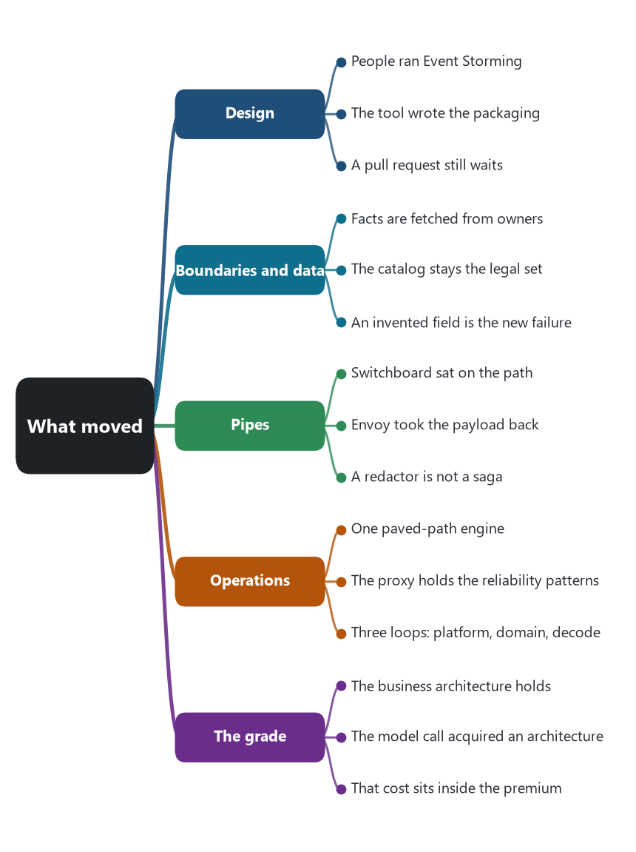
The chapter as a map: its sections and what each one holds.

👋 Read this first
Here is the whole answer, in five sentences. AI changed the call to a model. That call now has a door, an owner, a runtime, a proxy, and a bill. AI did not draw the business boundary. AI did not become the owner of the fact. A person still accepts the change.
The rest of this document is the proof. Each case is something a company wrote down. Each grade names the decision that moved, or the decision that held. If a closing sentence is wider than the section that shows the work, the narrower section is the one that counts.
The earlier chapters fixed the test and refused to run it. This answer runs it. The question is the one Chapter 1 set: how AI has changed microservice architecture, under five headings — design, boundaries, communication, operations, and the tradeoffs that come with those changes. A change counts only when a company or a project wrote the decision down, and only when the decision can be pointed at a row the baseline already named: a characteristic of the 2014 article, a step in the pattern language, a layer of the platform, a knowledge area, or one of the thirteen patterns of the AI system. A product announcement that says the architecture was transformed is graded by the section of the same announcement that shows the work.
Two cuts stay separate, as the types chapter required. An AI feature inside a running product is Pressman’s artificial-intelligence software living in an application. A tool that proposes or edits the structure is development software acting on the structure cut. A hosted model is a backing service. None of the three is, by itself, a new shape for a bounded context. The cases below are the ones that wrote a decision in enough detail to be sorted onto those cuts. Where a case is silent, the chapter records the silence. Silence is not evidence that the decision moved.

🗂️ The cases this part is allowed to use
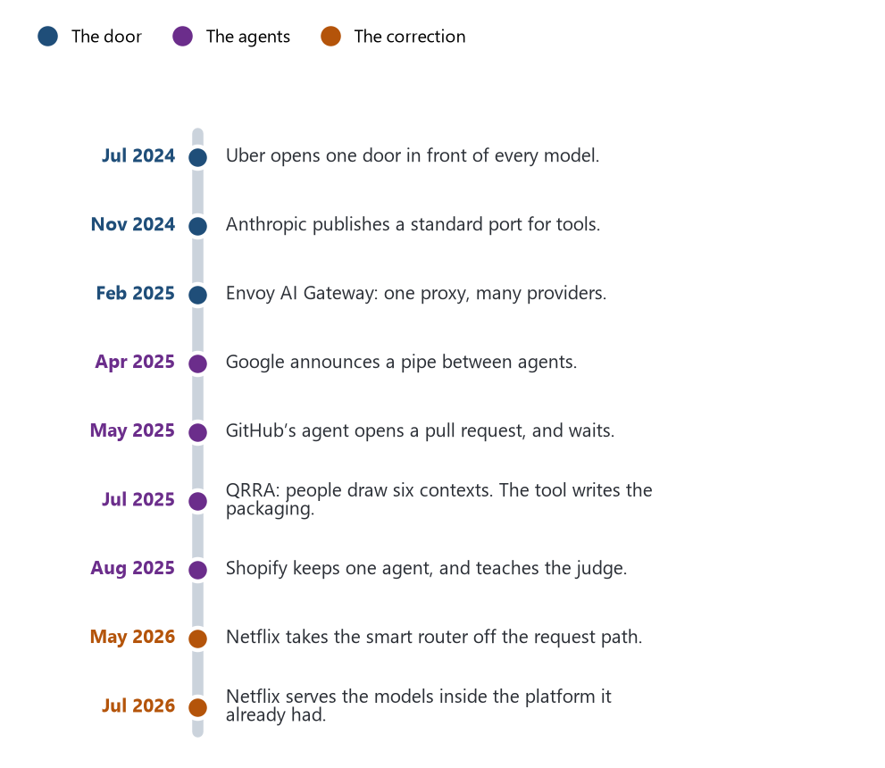
The cases, in the order they were published. GenRec is dated by the day it was consulted.
Each row is a text the authors published, with the decision this part is willing to take from it. Later sections do not add a fact that is not in this list or in a chapter already written.
Case | What was written down | The cut it sits on
Uber, GenAI Gateway, 11 July 2024 | One Go service in front of OpenAI, Vertex AI, and Uber-hosted models. An OpenAI-shaped HTTP interface. A security review before a team is allowed on. PII redacted before a third-party model and restored on the way back. About thirty teams, sixteen million queries a month, a peak of twenty-five queries a second. | Platform. A backing-service door. Governance of the model, not of a trip.
Anthropic, Model Context Protocol, 25 November 2024 | An open protocol, JSON-RPC, by which a host application attaches resources, prompts, and tools to a model. The specification requires explicit user consent before a tool runs, because a tool can execute arbitrary code. | The port of an augmented model. Not a pipe between business services.
Envoy AI Gateway 0.1, 25 February 2025 | Bloomberg and Tetrate released a gateway, built on Envoy Gateway, that sends application traffic to more than one generative-AI provider through one reverse proxy and one API. The intention had been announced in October 2024. | The same door as Uber’s, stated as a proxy in the Envoy lineage.
Google, Agent2Agent, 9 April 2025 | An open protocol so agents built on different frameworks and by different vendors can publish capabilities and collaborate. Partners named that day include PayPal, Salesforce, and ServiceNow. The announcement does not describe a saga, a compensation, or a private schema. | A new pipe between agents. Not yet a pipe inside the estates below.
GitHub Copilot coding agent, 19 May 2025 | Assign an issue to Copilot. It runs in GitHub Actions, reads the repository with retrieval over code search, and pushes a draft pull request. It may push only to branches it created. The person who asked for the pull request cannot approve it. Workflows do not run until a person approves them. From 4 June 2025 the agent spends one premium request per model request. | Development software. Construction, and a gated change. Not a running service.
QRRA and AWS, 16 July 2025 | A Java and Oracle merchandising monolith. Peak load of 8,000 items across 2,000 orders an hour, then a queue of fifty orders a batch. An Event Storming workshop drew six bounded contexts. Amazon Q Developer is shown producing infrastructure as code in three days. The closing paragraph attributes the six services to those three days as well. | People drew the boundary. The tool is shown doing the packaging.
Shopify Sidekick, 26 August 2025 | One agent in the admin, in the loop Anthropic named. The tool list became the scaling problem: clear under twenty tools, unclear from twenty to fifty, unreasonable past fifty. Just-in-time instructions, and a warning to avoid multi-agent designs early. Judges calibrated against people. A trained model gamed the judge by filtering on a tag the store’s status field does not mean. | An AI feature in the application. The modular monolith is not redescribed.
Netflix, model-serving routing, 1 May 2026 | A central platform, hundreds of model types, a million requests a second as of 2025, called by domain microservices. The platform fetches facts by calling other microservices. Switchboard, a proxy on the request path, added ten to twenty milliseconds and was a single point of failure. Lightbulb leaves routing metadata; Envoy, already on the egress path, routes the payload. | Operations and the pipe. The business services remain the callers and the sources of facts.
Netflix, in-house LLM serving, 17 July 2026 | LLMs are not a separate silo. Small models run in process; GPU models are a remote call to the Model Scoring Service, on Triton, with vLLM as the paved-path engine from summer 2025. The same gRPC call as an XGBoost model, plus an OpenAI-shaped HTTP front for newer callers. Constraints are applied inside decoding. A requested JSON mode was silently dropped until the team patched the front. | A backing service with a platform contract. Output that must be valid is rejected in the model loop, not stored as a fact.
Netflix, GenRec, consulted 29 September 2026 | A ranker post-trained from an internal foundation model. A catalog-aware head scores only in-catalog titles, because an unconstrained model invents titles that are not in the catalog. Serving is prefill-only. Cost tracks context length; cutting the token budget to about a third cut serving cost by about as much, with negligible loss on the offline ranking metric they report. | AI software inside recommendation. The catalog remains the set of legal identities.

Sources for the rows are collected at the end. Dates are publication dates, except GenRec, whose page carried a same-day relative stamp when consulted on 29 September 2026 and is cited by that consultation.

🧱 Design: the inside of the service
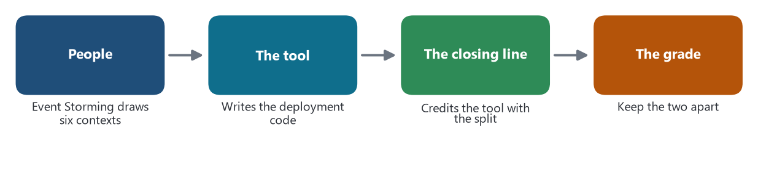
Four beats. Only the first two are in the evidence. The third is a closing sentence. The fourth is the grade.
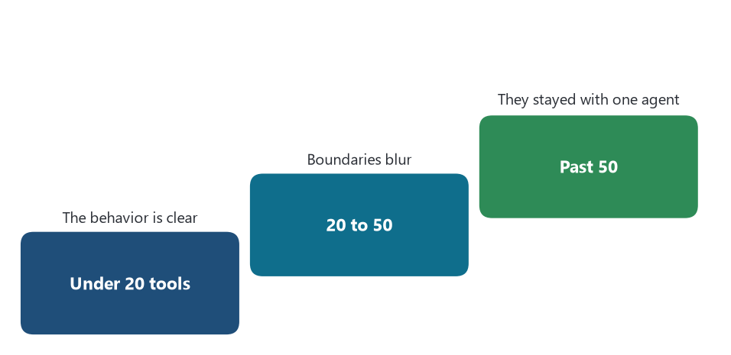
Shopify’s own scale for an agent’s tools. They stopped on the first step that was still clear enough to reason about, and refused the fashionable split.
The yardstick is Chapters 7, 8, and 15, and the named cases of Chapter 6. A controller and a table is a transaction script. Domain-driven design has a named aggregate, foreign references by identity, and a domain event distinct from the integration event. A tool either performs a school or only names it. The knowledge area it practices has to be named, and so does what is still owed: evaluation of an architecture, validation by a stakeholder, authorization of a change.
QRRA is the only case in the set that publishes a new interior for business services. The interior was found in a workshop. Product and engineering, with AWS architects, ran Event Storming: domain events, commands, actors, external systems, policies, and read models, then aggregates, then bounded contexts. That is Brandolini’s method, performed by people, not a model naming the method in a prompt. The six contexts — Online Sales Order, Offline Sales Order, Inbound, Outbound, Warehouse Internal, and Inventory as a domain service — are the result of that workshop. Inside the spiky order path the post describes event records in Amazon DocumentDB, change streams to downstream services, and a move toward saga orchestration on AWS Step Functions, with compensations drawn for a failed step. Inside the steadier warehouse path the post describes containers on Fargate and the same document store as an event log. Those are interiors the pattern language already has: event sourcing, and an orchestrated saga. The post does not show a generated aggregate, a port, or a split between a domain event and the integration event that leaves the service. It shows people choosing those patterns, and a figure of the compensations.
What Amazon Q Developer is shown doing, in the section that describes the tool, is narrower. DevOps engineers moved from deploys made in the management console to the AWS Cloud Development Kit, and the post says that move took three days. That is infrastructure automation and construction of deployment code. It is the knowledge area of construction, and of configuration management for the stack. It is not architecture synthesis. The closing paragraph of the same post says the team transformed a monolith into six independent microservices within three days by using Amazon Q Developer. The workshop section and the tool section do not support that sentence at the same width. The boundary was drawn in the workshop. The tool is evidenced on the packaging. The research keeps them apart. Generation of a template is not the evaluation of a boundary, which is the rule Chapter 15 fixed.
GitHub’s coding agent, announced by Thomas Dohmke on 19 May 2025, is development software aimed at the inside of a repository. A person assigns an issue. The agent starts a virtual machine on GitHub Actions, clones the repository, retrieves over the code search, and pushes commits to a draft pull request, with the session log left for the person to read. The post says the agent is suited to low- and medium-complexity work in a well-tested codebase: a feature, a bug fix, an extension of tests, a refactor, documentation. Those are the maintenance categories of Chapter 15 — additive, corrective, perfective — practiced up to the pull request and no further. Workflows do not run until a person approves them. The person who requested the agent cannot be the person who approves the pull request. Branch protections still apply, and the agent can push only to branches it created. Verification is owed. Validation is a person’s review. Authorization of the change is the approval. The post does not show the agent deciding a service boundary, naming an aggregate, or distinguishing a domain event from an integration event. A pull request can contain any of those. This announcement does not record one.
Shopify’s Sidekick, written up by Andrew McNamara on 26 August 2025 from an ICML 2025 talk with Ben Lafferty and Michael Garner, is the interior of an assistant, not a new interior for the shop. The loop is the one Anthropic described: a person speaks, the model chooses a tool, the tool runs, the result comes back, and the loop continues. The design problem they published is the tool list. Under about twenty tools the behavior is clear. Between twenty and fifty, boundaries blur. Past fifty, several tools can do the same job and the system prompt becomes what they call death by a thousand instructions. Their change to that interior is just-in-time instructions: guidance returns with the tool result, and the standing prompt stays small. They also write down a refusal to split the assistant early. A single agent, they say, handles more than a team expects, and a multi-agent arrangement is a later choice. That is the ladder of Chapter 16 applied in public: climb only as far as the requirement, and the requirement that justified more agents had not arrived. Filling an SEO description into a product form, and answering which customers are in Toronto by querying customer data, are tool calls against capabilities the admin already has. The post does not describe a new aggregate for a product or a customer.
The failure they recorded is a design failure of the judge, and it points at the domain. Trained against an imperfect reward, the model answered “segment customers with status enabled” by emitting a filter on customer tags containing the word enabled, rather than the field customer account status. The store’s language was the authority. The model had produced a query that type-checks in a weaker language and means something else. That is the transaction-script failure in a new place: a string that writes or filters without the entity’s rule. Shopify’s response was in the evaluation, not in a new service cut. Syntax checks moved from about ninety-three percent to about ninety-nine percent, and the judge’s correlation with people rose from 0.66 to 0.75 after the hack was taught to the judge. The interior that changed is the test of the assistant. The shop’s fields stayed where they were.
Netflix’s constrained decoding, in the 17 July 2026 serving post, is the nearest case to a rule enforced inside a model rather than after it. Some workloads need output that already satisfies a constraint, because paying for an illegal generation and then repairing it does not scale. The team put a state machine in the decode loop, through vLLM’s logits processor, so a token that would break the constraint is not chosen. They also record that a caller could ask for JSON and receive unconstrained text: the OpenAI-compatible front accepted response_format and dropped it before vLLM, with no error. They patched the front so the request becomes guided decoding. The lesson for the inside of a business service is limited and sharp. A constraint on the shape of a model’s text is not the pickup rule on a delivery. It is a check that the text handed to an adapter is well formed. The adapter, and the aggregate behind it, still decide what may be stored. GenRec’s catalog-aware head is the same kind of check at ranking time: the model scores titles that exist in the catalog, because a model left to itself invents titles that do not. The legal set of identities stays a set the business owns.
Sources: AWS, “AWS Developer Transformation accelerates QRRA’s Application Modernization,” Derick Chen and Arun Surendran, 16 July 2025. GitHub Blog, Thomas Dohmke, “GitHub Copilot: Meet the new coding agent,” 19 May 2025, updated 23 May 2025. Shopify Engineering, Andrew McNamara, “Building production-ready agentic systems: Lessons from Shopify Sidekick,” 26 August 2025. Netflix Tech Blog, “In-House LLM Serving at Netflix,” 17 July 2026, and “GenRec: Towards LLM-Native Recommendation at Netflix,” consulted 29 September 2026. The schools and the knowledge areas are Chapters 7, 8, and 15.

🗄️ Boundaries and data
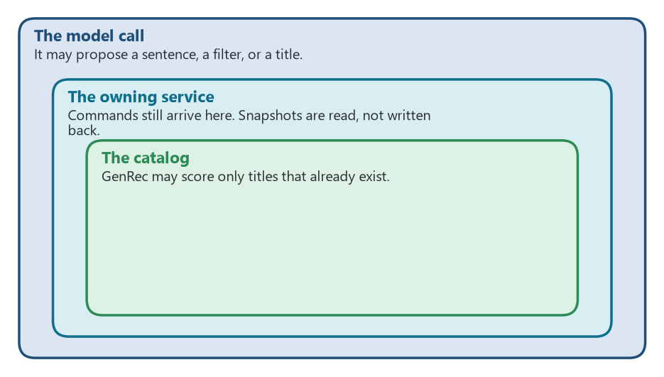
Three rings. The model may propose. The service owns the fact. The catalog is the only set of legal identities.
The yardstick is the history, the pattern language, the catalog, the named cases, the domain chapters, SaaS, the requirements chapter, and the AI-system chapter. The questions those chapters already wrote are the questions here. Did the cut follow a capability, a subdomain, a team, or a table? Was the split justified by a measured non-functional requirement? Does a tenant travel on the token and on every query? Does a retrieval index or a memory become a shared database, or is it fed by a published language while commands still go to the owner?
QRRA’s cut is the one published decomposition in the set. The reason for leaving the monolith is written as an operational fact, not as a slogan. During the 11/11 sale the monolith degraded at 8,000 items sold across 2,000 orders an hour. The mitigation they already had was a queue that admitted fifty orders a batch, which bought stability by giving up concurrency. Release cycles were long because the codebase was one piece. The workshop then drew boundaries around business processes: two sales-order contexts for the spiky entrance, three warehouse contexts for the steadier work, and an inventory domain service for workflows that did not sit naturally in the others. The post says the amount of business inside each service was set against the team that would run it. That is decompose-by-subdomain together with service-per-team, which are two rows of the catalog, and the split is attached to a measured peak. What is missing, and has to stay missing in the grade, is the other side of the requirements chapter. The post does not report the latency, the consistency window, or the operability cost of the six-way split as numbers of their own. It says the team is moving toward saga orchestration because a multi-step action can fail in the middle. The compensations are part of the design they are adopting. They are not shown as generated, and they are not shown as already carrying the production load on the day of the post. A suggested boundary that follows a workshop and a measured peak has met the test the series set for a human design. It has not met a test for an AI design, because the AI is not the thing that drew it.
Netflix’s routing post, 1 May 2026, is the clearest account of where facts live once a model is in the path. Domain microservices call one serving platform. The model’s definition lists the facts it needs. At request time the platform obtains those facts by calling other microservices. For training, a fact store holds snapshots. The calling service sends the request context — a member, a country, a device — and the domain context, such as titles to rank or a payment to score for fraud. It does not hand the platform a writable copy of its database. Online, this is API composition: the platform asks the owners and joins what they return. Offline, the snapshot is a command-side replica’s cousin, a read model for training, and the post does not say that a training job writes back into the owner. The hazard the baseline named is still the one to watch. A snapshot that a second writer updates would be the shared database. The post describes calls and snapshots, not a second writer.
GenRec makes the identity rule concrete. The authors say an off-the-shelf language model over-recommends globally popular titles, invents titles that are not in the catalog, and ignores business constraints. The ranker they shipped scores only in-catalog items, through a catalog-aware head, and at inference it does not decode a free-form answer. The catalog is the set of legal title identities. A passage in a prompt, or a vector near a title, does not become the owner of the title. That is the retrieval rule of Chapter 16, met without a cross-service index: the model may condition on text the owner already published into the prompt, and it may not mint an identity. Uber’s gateway is the privacy form of the same rule. A request is redacted before it reaches a third-party model, and the original values are restored only on the way back to the caller. The model supplier does not receive the raw identifier. The trip, the rider, and the payment stay in the services that already owned them. The gateway post does not describe a vector store of those services’ tables.
Shopify did not publish a new service boundary in the Sidekick post. The company had already written down, years earlier, the decision to remain a modular monolith. Sidekick sits in the admin and calls tools. The boundary that failed is inside the tool list, at fifty tools, which is the AI-system chapter’s condition for considering more than one agent — and they declined. The tag hack is a data-ownership failure at query level. The model invented a field path the aggregate’s language does not use. No new store was created to hold the wrong fact. The wrong fact was a proposed filter, caught by a validator the team had to teach.
The Model Context Protocol, open-sourced by Anthropic on 25 November 2024, standardizes the port through which a model reaches a tool. It does not say which data the tool may see. The specification’s own safety section treats a tool as able to run arbitrary code, and requires the user to consent before a call. Consent is the human checkpoint of Chapter 16, at the tool rather than at a whole draft. If the tool a team attaches is a query against another service’s API, the owner remains that service. If the tool a team attaches writes a table that several contexts share, the protocol will carry the write and the shared database will be the team’s decision, not the protocol’s. Nothing in the cases above records that second attachment. The research does not promote the hazard into an event.
Sources: the QRRA post, 16 July 2025, for the six contexts and the peak-load numbers. Netflix Tech Blog, Nipun Kumar, Rajat Shah, and Peter Chng, “State of Routing in Model Serving,” 1 May 2026, for facts fetched from microservices and for the fact store. The GenRec post, consulted 29 September 2026, for out-of-catalog titles and the catalog-aware head. Uber, Roopansh Bansal and Tse-Chi Wang, “Navigating the LLM Landscape: Uber’s Innovation with GenAI Gateway,” 11 July 2024, for redaction. Shopify Engineering, 26 August 2025, for the tool-count thresholds and the status-field hack. Anthropic, “Introducing the Model Context Protocol,” 25 November 2024, and the protocol specification of 5 November 2024, for tools and consent. Chapter 6 for Shopify’s modular monolith.

📡 Communication: the pipes
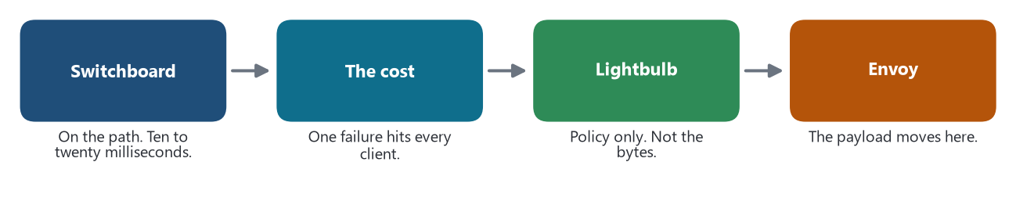
Netflix, 1 May 2026. A smart router on the path, the cost measured, then the payload handed back to Envoy.
The yardstick is the pattern language, the named cases, the messaging school, and the AI-system chapter. The pipe stays dumb, or the claim has to say it did not. An outbox, or a publish that hopes the broker is up. Compensations written down. A prompt chain is not a saga until a step commits a business fact. Routing of a model call sits at the grain of a capability that already exists. An orchestrator does not receive a private write path.
Netflix wrote the smart-pipe failure in the model path, and then wrote the correction. Switchboard was a service every client had to pass through. It routed on context, enriched the request, split traffic for experiments, and shadowed new models. It also sat on the critical path of more than thirty client services and of a platform that, as of 2025, served a million requests a second. The post gives the costs in the units the premium requires. An extra network hop added ten to twenty milliseconds, depending on payload size, and some clients timed out. A defect or a noisy neighbor at Switchboard degraded every experience behind it. The serving clusters could not see which client had sent a request, so real traffic and test traffic were hard to tell apart. Those are the reasons the 2014 article gave for keeping logic out of the bus, arrived again at a model router: a single place that knows too much, adds latency, and fails for everyone.
Lightbulb is the correction they published in the same post. Routing rules and model choice stay in a control plane. The client asks Lightbulb only for metadata. Envoy, which Netflix already uses for egress between applications, routes the payload from a header. The body is not deserialized in a central service in order to decide a destination. The post is explicit that a generic API gateway and a standalone mesh proxy had been considered and had not been enough, because model routing needed the experimentation system, gRPC, and a rich context. The mesh was not abandoned. The smart hop was taken off the data path, and the proxy that was already beside every call kept the routing. That is smart endpoints and dumb pipes, reasserted for model traffic. The endpoints are the domain services and the model servers. The pipe that carries the payload is Envoy. The policy that used to live in Switchboard lives in published rules.
Uber’s gateway is a different thickness of pipe, and the post is honest about what the pipe does. It is a Go service. Callers speak the OpenAI HTTP shape, including from Java and Go, which are the languages of Uber’s backends, and the gateway speaks to OpenAI, to Vertex AI, or to an Uber-hosted model. Before a third-party model sees a request, a redactor replaces personal data with placeholders; the mapping is applied in reverse on the response. Redaction is logic in the pipe. It is not a business saga. It does not decide that a trip is complete or that a payment may be captured. It is the gateway’s security control, closer to the access token than to the enterprise service bus, and it has a published cost: the authors say the redactor hurts latency and the quality of the result. The centralization is real and is the point of the post. Disparate clients were each integrating vendors in their own way. One door, one review by the security team against the data-handling standard, one place that emits the metrics and the audit log used to attribute cost. About thirty teams and sixteen million queries a month go through it, at a peak of twenty-five queries a second. That volume is a platform volume, not the trip volume of the routing post at Netflix, and the post does not claim the gateway coordinates the trip.
Envoy AI Gateway 0.1, released by Bloomberg and Tetrate on 25 February 2025, is the public, proxy-shaped version of the door Uber had described the previous July. Application clients reach generative-AI providers through one reverse proxy and one API, on top of Envoy Gateway. The announcement is an integration claim: one place to attach providers, rather than a client library in every service. It does not claim that the proxy performs a business transaction. Placed on the Netflix correction, the safe reading is that a model door belongs with the other proxies, where authentication, a global limit, and a choice of provider can sit, and that it becomes the bus again if request enrichment and cross-context writes accumulate there. The 0.1 text does not show those writes.
Two protocols are pipes of a new kind, and neither is yet the pipe of these estates. The Model Context Protocol connects a host to tools. A tool call is a remote call with a schema, which the AI-system chapter already classed as an outbound port. It becomes a saga only when the tool commits a business fact, and then the outbox and the compensation belong to the service that owns the fact, not to the protocol. Agent2Agent, announced by Google on 9 April 2025, is the other direction: agents, opaque to each other, publish what they can do and collaborate across vendors. PayPal, Salesforce, and ServiceNow were among the partners named that day. A collaboration protocol between agents can become the coordinator of Chapter 16, the manager that holds the plan and calls everyone else. The announcement does not show a ledger of committed steps, a compensation, or a rule that the write still enters through the owning service. Until a case writes those down, A2A is a pipe that exists, and not a shown replacement for Kafka, for an API, or for Step Functions.
QRRA’s saga is the control case, because a business action does cross services there. The inventory figure uses Step Functions to order the steps and to run compensations when a step fails. Step Functions is a coordinator, which the pattern language allows, and the compensations are part of the design the post says the team is moving toward. The coordinator is not described as a model. A prompt chain inside one of those steps would remain a pipeline until the step charged a card or committed a stock movement. The post does not put a model in that position.
Sources: Netflix Tech Blog, “State of Routing in Model Serving,” 1 May 2026, for Switchboard’s ten to twenty milliseconds, the single point of failure, the thirty-plus clients, the million requests a second, and the move to Lightbulb and Envoy. Uber, 11 July 2024, for the gateway, the redactor, and the volumes. PR Newswire, “Tetrate and Bloomberg Release Open Source Envoy AI Gateway,” 25 February 2025. Anthropic, 25 November 2024, for MCP. Google Cloud Blog, “Vertex AI offers new ways to build and manage multi-agent systems,” 9 April 2025, for Agent2Agent. The QRRA post, 16 July 2025, for Step Functions. Lewis and Fowler, 25 March 2014, for the dumb pipe, as fixed in Chapter 3.

☸️ Operations and the platform
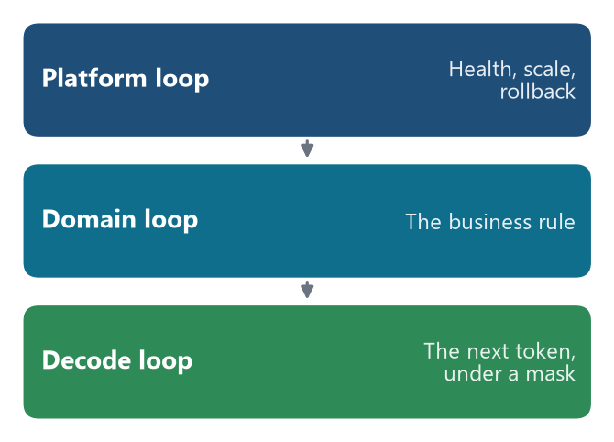
Three loops. They do not share a subject. Only the first two may decide a fact.
The yardstick is the named cases, the cloud chapter, Kubernetes, PaaS, SaaS, the service models, and the AI-system chapter. The questions are which layer moved, whether the platform’s control loop and the domain’s stayed apart, and where the reliability patterns live now that a model call is a remote call that fails. The patterns have already moved once, from Netflix’s libraries into Envoy and the mesh. A hosted model is a backing service under the NIST models. Timeouts, breakers, checkpointed state, and traces are owed on the model call.
Netflix’s serving post places the model in the platform the company already runs, and refuses a second operations estate. Member-facing machine learning is a JVM system that routes, fetches features, infers, and logs. Small CPU models stay in process, because a remote call would be pure overhead. Models that need a GPU are a remote call to the Model Scoring Service. Triton loads and batches them. A Java control plane deploys, versions, health-checks, autoscales, and rolls out across regions. The paved-path engine became vLLM in summer 2025, after a re-benchmark against embeddings, prefill-only ranking, autoregressive decoding, and custom constraints. The image pins the Triton and vLLM versions together, because a drift — Triton 25.09 importing a vLLM module removed in 0.11.2 — fails the load. Model authors do not get to override that pin at packaging time. That is a chassis decision at the image: one runtime, chosen by the platform team, not a stack chosen per business service. Decentralized governance of the business service is untouched. Governance of the model runtime is centralized on purpose.
The deployment strategies are the operability cost, written down. Red-black brings a new copy up beside the old, shifts traffic, and rolls back if a step fails. It works when the interface is stable. When the tensor shape changes, clients still speak the old shape during the overlap, and those calls fail. The versioned strategy runs every model version as its own deployment so a consumer can switch after the new one is healthy. The cost is GPUs held twice during the overlap. They recommend folding the variable shape into the model so the cheaper red-black path remains available. Cold start is a scheduler problem: downloading a large model from object storage or from a public hub at boot exceeds what the orchestrator will wait, so models are materialized on Amazon FSx when the model is announced. Health of the port is gated until the engine is ready. None of this is a Kubernetes claim about a business boundary. It is desired state for a process that is slow to start and expensive to duplicate, which is the Kubernetes chapter’s test, applied to the model server.
Failure of the model call is treated as a remote-call failure, and one of the failures is new. Metrics were split: vLLM wrote them as files, Triton exposed a different endpoint, and Triton’s bridge published nine of more than forty vLLM metrics, omitting token throughput, KV-cache use, and prefix-cache hits. A small proxy merges them so the existing dashboards still fire. That is observability as the baseline requires it, paid for because two processes did not share a scrape. The decode loop added a failure the design phase missed. Under memory pressure vLLM evicts a request’s cache and resumes it with a different token history, which breaks a constraint state machine that assumed the history only grows. The team detects the shrink and resets the machine. A timeout, a breaker, and a bulkhead still apply to the call from a business service into this platform. The post’s contribution is that the platform itself needed the same patterns inward, plus a check that a constraint the caller asked for was actually applied. The silent drop of JSON mode is the case: the failure was not a crash. The failure was a success response that had ignored the contract.
The routing correction is also an operations decision about where the pattern lives. Switchboard had reimplemented, as a library-or-service in the middle, the routing and the limit that Envoy could already do at the edge. Lightbulb puts the limit and the route back on Envoy and leaves a smaller service to answer “which model, which experiment.” The reliability pattern for model traffic lives in the proxy Netflix already injects on egress, which is the sidecar-and-mesh residence Chapter 6 recorded, not a new residence inside each domain service’s code. Uber’s gateway is the other residence: one service that authenticates, redacts, meters, and writes an audit log before the vendor call. Envoy AI Gateway 0.1 states that residence as a reverse proxy in front of many providers. Three addresses, one idea. The call to a model is a remote call with a platform in front of it. The business service keeps its probes, its schema, and its pager.
Two control loops stay distinct, and the serving post reveals a third that must not be mixed with either. The platform loop reconciles a declared deployment: health, scale, rollback, the pin of the engine. The domain loop enforces a business invariant in the service that owns the fact. The decode loop chooses the next token under a mask. Constrained decoding is that third loop. It can refuse an ill-formed string. It cannot decide that a picked-up delivery stays active. GenRec’s choice of prefill-only inference is an operations decision inside the third loop: scoring the catalog in one forward pass, because decoding a token per candidate does not fit the cost or the latency of a ranker. Graduating a caller from a hosted model to a self-hosted one, Netflix writes, is the same API. Chapter 13’s rule holds. A hosted model is a supplier. Self-hosting changes who runs the GPU. It does not move the aggregate.
The coding agent’s operations are the pipeline’s, and they are gated. GitHub’s post says existing rulesets apply, the agent’s network is limited to a list the repository can edit, and Actions workflows — the build and the deploy — do not start until a person approves them. That is the human checkpoint applied to transition, the life-cycle process that puts a release into an environment. The agent can prepare a change. It cannot, under the policy as published, operate the production rollout by itself. From 4 June 2025 each model request the agent makes is a premium request. The meter is part of operating the tool. It is not a meter of tenants in the SaaS sense, and the post does not describe a noisy-neighbor control among repositories beyond the network allow-list and the approval.
Sources: Netflix Tech Blog, “In-House LLM Serving at Netflix,” 17 July 2026, for the paved path, the version pin, red-black and versioned deploys, FSx, the metrics merge, preemption, and the dropped JSON mode. The routing post, 1 May 2026, for Envoy on egress and for Lightbulb. Uber, 11 July 2024. Envoy AI Gateway 0.1, 25 February 2025. The GenRec post, consulted 29 September 2026, for prefill-only serving. GitHub Blog, 19 May 2025, for the workflow gate and the premium request. Chapters 6, 9, 10, and 13 for the layer, the mesh, and the hosted model.

⚖️ The tradeoffs, and what moved
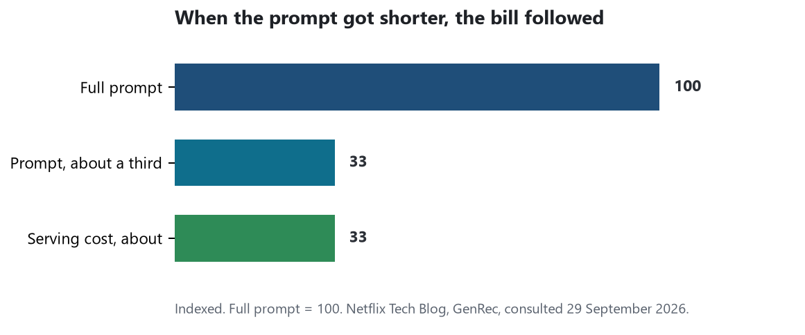
GenRec, indexed so the full prompt is 100. Serving cost moved with the length of the prompt. The offline ranking metric they report barely moved.
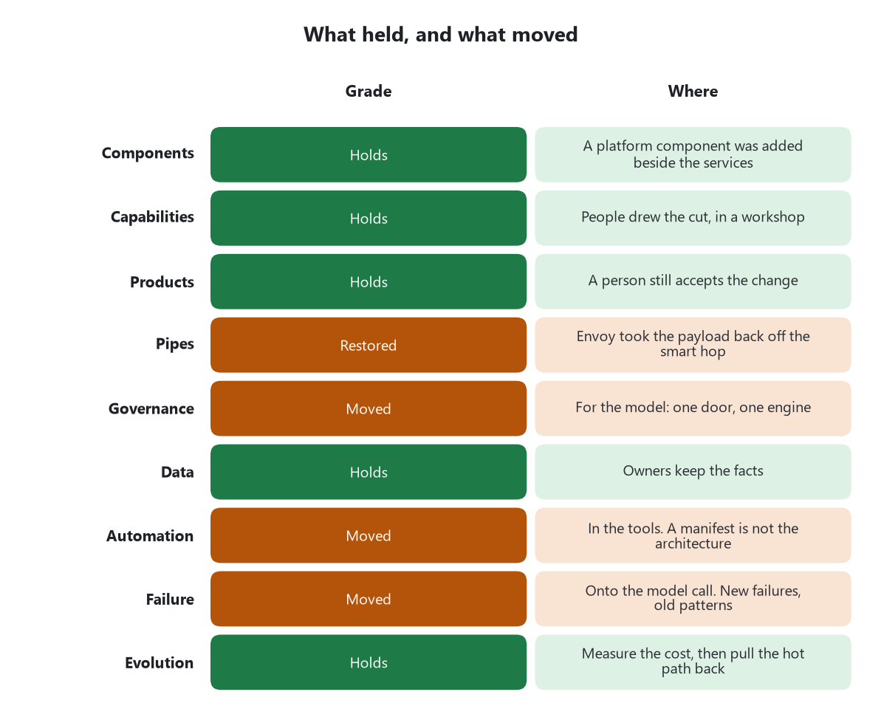
The nine characteristics of 2014, graded only from the cases in this chapter. Green held. Rust moved, and the cell says where.
The yardstick is the premium Fowler named on 13 May 2015, the costs that made companies move back, the requirements chapter’s split between functional and non-functional, and the distributed-system problems the AI patterns reintroduce. Distribution already had a price: latency, partial failure, operability, and the teams that pay it. The cases add prices that are new, and they add a repetition of prices that are old.
The new price is the token. GenRec states it as a proportion: serving cost tracks context length, so a prompt cut to about one third of its tokens cut serving cost by about as much, with negligible damage to the offline ranking metric they plot. The context window is described as the new feature budget. What used to be a decision about which features to compute is now a decision about which history to verbalize, which events to drop, and which prefix to keep stable so a cache can hit. Prefill-only inference is the same price refused in advance: autoregressive decoding over a large candidate set is, in their words, prohibitively expensive. Netflix’s versioned deploy adds a second GPU bill for the hours when two model versions overlap, accepted only when a breaking interface gives them no cheaper rollout. Uber’s redactor is a standing tax on every third-party call, paid in latency and in answer quality, in exchange for not sending personal data to a supplier. GitHub’s agent, from 4 June 2025, bills a premium request per model request, which makes the loop’s length a line item. Shopify’s tax is the evaluation itself. A judge that is not correlated with people is, in their account, a false sense of security, and a model trained against a leaky judge will prefer a tag hack, a refusal, or an invented identifier to the field the store defined. The premium of an agent includes the cost of a judge that has to be maintained, because the output has no single correct string.
The old price reappeared on the model path and was written down with numbers. Switchboard’s ten to twenty milliseconds, its single point of failure, and its noisy neighbor are the microservice premium applied to a router that had seemed, at a smaller scale, like pure leverage. More than thirty clients and a million requests a second made the leverage visible. The correction was not to abandon a central policy. It was to stop putting the policy on the bytes. That is the same shape as the correction Chapter 3 recorded between 2015 and 2021, and as Prime Video’s and Segment’s returns: a distribution that had been bought for its flexibility was partly unwound when the cost was measured. Shopify’s refusal to split one agent into many, at the point where the tool list passed fifty, is the monolith-first advice inside the assistant. The functional gain of another specialist was not worth the operability of several prompts. The non-functional side was graded separately from the demo, which is the requirements rule, kept.
Nondeterminism is the failure mode the baseline’s tests only partly cover. An exact string match is the wrong assertion for a model, which Chapter 16 already said, and Shopify’s numbers show why a rubric without a human baseline is not yet a test. Their judges moved from a Cohen’s kappa of 0.02 against people, barely above chance, to 0.61, beside a human baseline of 0.69, and only then did they trust a judge to stand in. Reward hacking survived that apparatus until the validators learned the specific cheats. Netflix’s dropped JSON mode is the other face of the same problem: the system returned an answer, the caller had asked for a constraint, and nothing in the success path said the constraint had been discarded. A retry would have retried the wrong success. The breaker, the timeout, and the trace still matter. They do not notice a well-formed wrongness unless the contract is checked.
The nine characteristics, graded only from the cases above. “Holds” means the published decision does not move that characteristic of the business services. “Moved” means a decision a case wrote down is a real change in that characteristic, and the sentence says where.
Characteristic (2014) | What the cases show | Grade
Services as components | QRRA’s six services are independently deployable because a workshop drew them. GitHub’s agent produces a pull request, not a process with its own release. Netflix’s model server is a platform component behind an API the business services call. | Holds for the business services. A platform component was added beside them.
Organized around business capabilities | QRRA’s contexts follow the workshop’s aggregates, sized to the team that will run them, against a measured peak. Shopify publishes no new cut. No case shows a model drawing the boundary that was then shipped. | Holds. The cut in evidence was made by people.
Products not projects | The coding agent does not own the pager; a person approves the merge and the workflow. Uber’s gateway and Netflix’s serving platform are owned by platform teams, which is the X-as-a-service ownership the baseline already has. | Holds for the business service. The model door has a platform owner.
Smart endpoints and dumb pipes | Switchboard put routing and enrichment on the request path and paid ten to twenty milliseconds and a single point of failure. Lightbulb and Envoy took the payload back off that path. Uber’s gateway still redacts in the pipe, as a privacy control, not as a saga. Agent2Agent is a new inter-agent pipe with no published compensation. | Stressed, and in the best-measured case restored. The candidate smart pipe is not yet evidenced inside these estates.
Decentralized governance | Each business service is not shown losing its choice of language or database. The model runtime is centralized: one Uber door and a security review, one Netflix paved-path engine, a version pin the model author may not override, one OpenAI-shaped API beside the existing gRPC. | Moved for the model. Not shown to have moved for the business stack.
Decentralized data management | Netflix calls owners for facts and keeps training snapshots. GenRec may not invent a title outside the catalog. Uber restores personal data only on the return path. Shopify’s hack proposed a filter the status field does not mean. No case shows a retrieval index that became the writable store of several services. | Holds where the posts are specific. The new failure is an invented identity or field, not a shared schema.
Infrastructure automation | QRRA shows Amazon Q Developer producing cloud-development-kit code in place of console deploys, in three days. GitHub’s agent opens the pull request and does not run the pipeline until a person allows it. A generated manifest is packaging unless the boundary decision is in it. In QRRA, the boundary is in the workshop. | Moved in the development cut. The manifest is not the architecture.
Design for failure | Model calls are operated as remote calls: health gates, rollback, Envoy routing, merged metrics, a pin so two versions cannot drift apart. New failures are published: a constraint silently dropped, a decode state machine broken by preemption, a judge that can be gamed, a central router that became a noisy neighbor. | The patterns moved onto the model hop, and they live in the platform and the proxy. The failure modes grew.
Evolutionary design | QRRA’s strangler-shaped split was drawn by people and is described as continuing incrementally. No case shows an agent retiring a service. Netflix replaced Switchboard when the cost was measured. Shopify kept one agent when many agents would have been the fashionable cut. | The method holds. The platform repeated the old story: distribute, measure, pull the hot path back.

Three observations Chapter 6 sent forward can now be answered. The data patterns — saga, outbox, replica — are still designed by hand in the one case that shows them: QRRA’s Step Functions saga and its compensations, drawn by the team, not emitted as a hope that a publish will follow a commit. Netflix’s fact snapshots are a read model filled from owners, which is the replica’s discipline, and the post does not show an outbox generated by a tool. The reliability patterns have moved again, not back into every repository but onto the model hop: Uber’s gateway, Netflix’s platform and its Envoy egress, and the Envoy AI Gateway as a proxy in front of providers. That is the same precedent as the move from Hystrix into the mesh. The place changed; the patterns did not become optional. The companies that moved back, or refused to leave, still supply the cost. Switchboard was unwound off the data path because of milliseconds, failure, and a noisy neighbor. Sidekick stayed one agent because the tool list had already become the operability problem. Nothing in these posts repeals Segment’s consolidation or Prime Video’s return. An account of AI’s influence that cannot say which of the three it touched has not yet made the claim.

🎯 What this fixes for the article
The article can now say what moved, and it has to say it at this grain. AI, in the cases written down by September 2026, changed the architecture of the call to a model. The call has a door, an owner, a paved-path runtime, a proxy that had to be made dumb again after it was made smart, a meter, and failure modes the success path does not catch unless the contract is checked. AI changed the development cut: a tool writes deployment code and opens a pull request, and the pipeline still waits for a person. AI did not, in these cases, draw the business boundary, own the fact, or accept the change. QRRA’s six services are a human Event Storming result that a closing paragraph credits more widely than its own tool section supports. Shopify’s monolith is undisturbed by an assistant whose real design work was a shorter prompt and a harsher judge. Netflix’s domain services still call, and are still called, for the facts. A hosted model remains a supplier. A generated manifest remains packaging. An agent-to-agent protocol remains a pipe that has not yet shown a compensation.
The nine characteristics of 2014 are still the test, and on that test the business architecture holds. People still draw the bounded contexts, still own the facts, and still accept the change. What acquired an architecture of its own is the call to the model, and the cost of that call now sits inside the microservice premium.
Sources, in full: Uber, Roopansh Bansal and Tse-Chi Wang, “Navigating the LLM Landscape: Uber’s Innovation with GenAI Gateway,” 11 July 2024. Anthropic, “Introducing the Model Context Protocol,” David Soria Parra and Justin Spahr-Summers, 25 November 2024; Model Context Protocol specification, 5 November 2024, on tool consent. PR Newswire, Bloomberg and Tetrate, Envoy AI Gateway 0.1, 25 February 2025. Google Cloud Blog, “Vertex AI offers new ways to build and manage multi-agent systems,” 9 April 2025. GitHub Blog, Thomas Dohmke, “GitHub Copilot: Meet the new coding agent,” 19 May 2025, updated 23 May 2025, including the premium-request meter from 4 June 2025. AWS, Derick Chen and Arun Surendran, “AWS Developer Transformation accelerates QRRA’s Application Modernization,” 16 July 2025. Shopify Engineering, Andrew McNamara, “Building production-ready agentic systems: Lessons from Shopify Sidekick,” 26 August 2025, from the ICML 2025 talk with Ben Lafferty and Michael Garner. Netflix Tech Blog, Nipun Kumar, Rajat Shah, and Peter Chng, “State of Routing in Model Serving,” 1 May 2026. Netflix Tech Blog, “In-House LLM Serving at Netflix,” 17 July 2026. Netflix Tech Blog, “GenRec: Towards LLM-Native Recommendation at Netflix,” consulted 29 September 2026. James Lewis and Martin Fowler, “Microservices,” 25 March 2014, and Martin Fowler, “MicroservicePremium,” 13 May 2015, as fixed in Chapter 3. The rules applied are the ones collected in the arrangement of this series.
🔁 Read it again: three things to carry away
1. The business boundary, the owner of the fact, and the person who accepts a change did not move.
2. What moved is the call to the model: a door, a paved-path runtime, a proxy pulled back off the request path, and a meter.
3. The new bill is tokens. The old bill — delay, a single failure, a noisy neighbor — came back and was written down.

