Module 1 - Mini-Project Document
Objective: -
Based on earlier payment transactions, get sales forecast for coming months and take inventory status to achieve the sales target.
A) Exploratory phase:
Below queries are used to prepare the required data from sakila_master.db and exported to excel
- Monthly sales per category

SELECT
SUM (amount) AS sumtotal, name ,
STRFTIME ('%m',STRFTIME('%Y-%m-%d',payment_date)) AS month
FROM payment AS p
INNER JOIN rental AS r ON p.rental_id = r.rental_id
INNER JOIN inventory AS i ON r.inventory_id= i.inventory_id
INNER JOIN film_category AS fc ON i.film_id = fc.film_id
INNER JOIN category AS c ON fc.category_id = c.category_id
GROUP BY name , STRFTIME ('%m',STRFTIME('%Y-%m-%d',payment_date))
ORDER BY name

- Sales_by category

SELECT
Category,
total_sales,
RANK() OVER (ORDER BY total_sales DESC ) AS Sales_Rank
FROM sales_by_film_category
ORDER BY total_sales DESC

- Inventory by category

SELECT
name ,
Inventory_count ,
DENSE_RANK () OVER (ORDER BY Inventory_Count DESC) AS InvRank
FROM
(
SELECT name , count(inventory_id) as Inventory_Count FROM film_category AS fc
INNER JOIN inventory AS i ON fc.film_id = i.film_id
INNER JOIN category AS c ON fc.category_id = c.category_id
GROUP BY name
ORDER BY Inventory_Count DESC
) AS A

- Analysis and visualization
Sales amount per month is extracted and forecast chart constructed to get sales prediction for September and October

Please refer attachment for data and chart

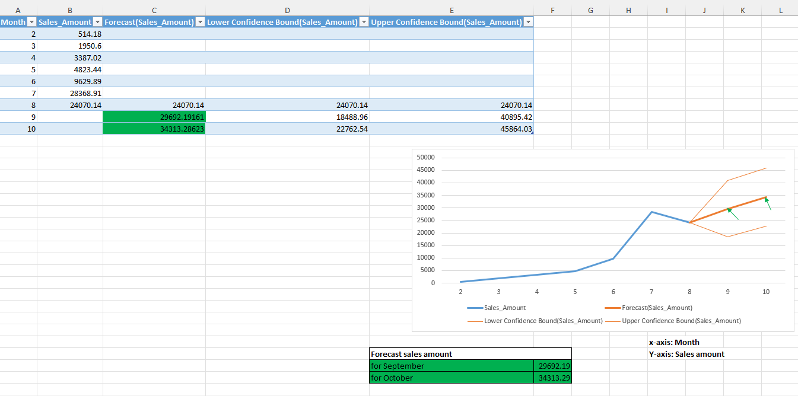

To achieve above sales , it is important to prepare the corresponding inventory of movie titles as per category to meet the customer demands in future

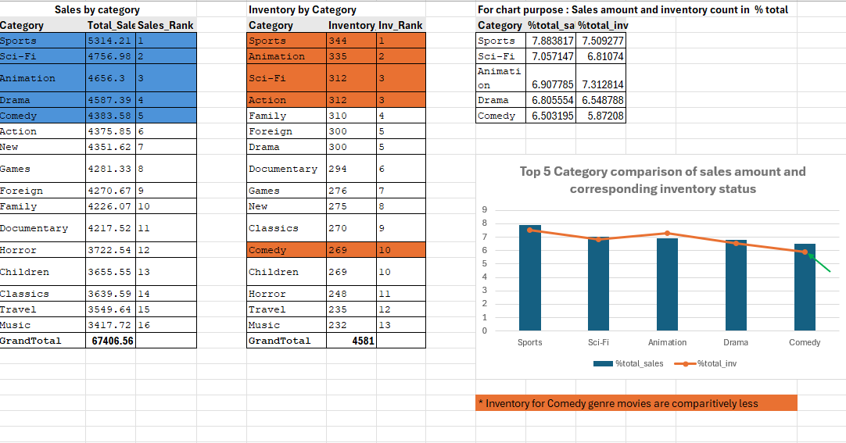

- Insights and learnings
- From above charts, Out of top 5 genre of movies, Comedy movie title inventory count is very less compare to other 4 genres considered for the analysis

- So, it is suggested to add in more comedy movie titles to inventory, to support the sales growth in coming months

