**COSC60220131JavaFX**

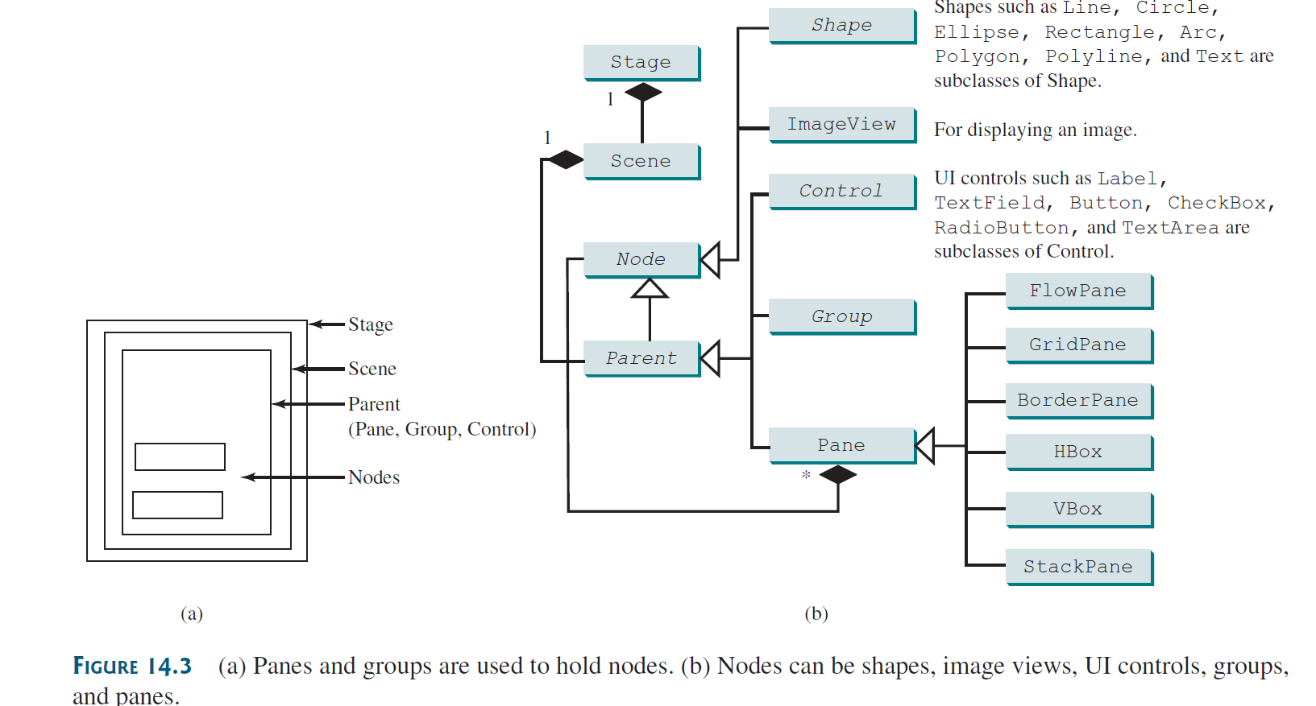

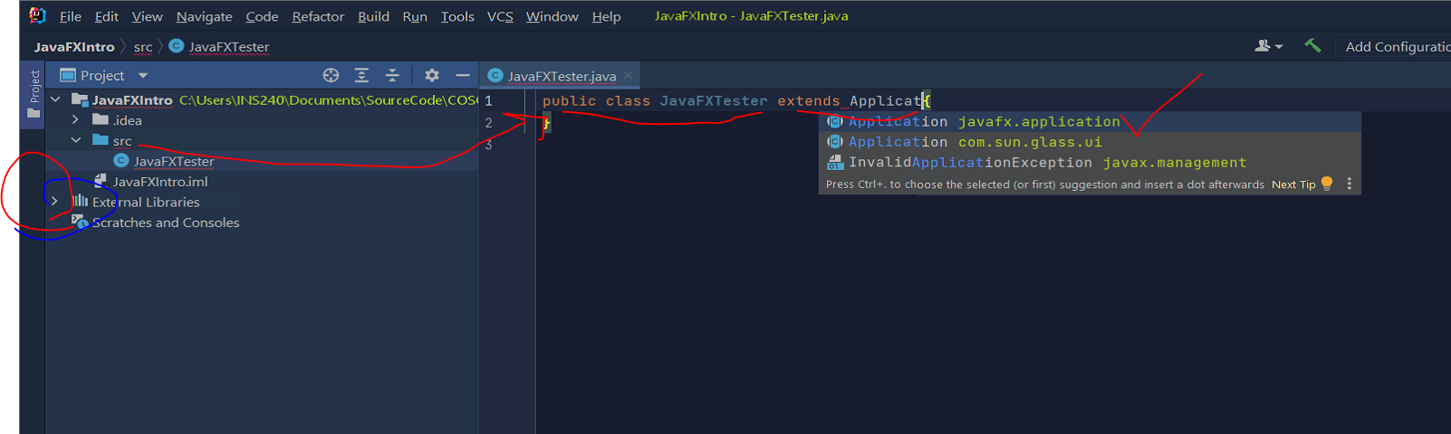

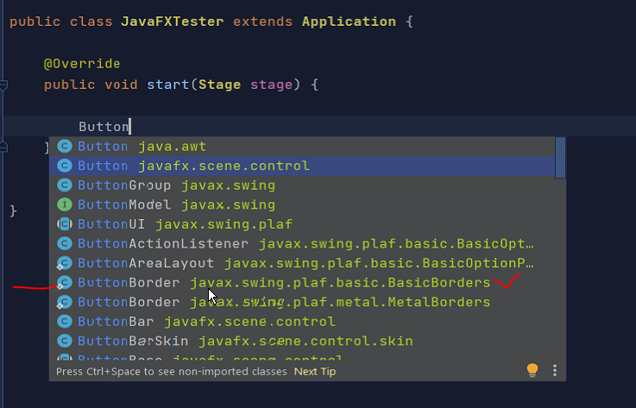

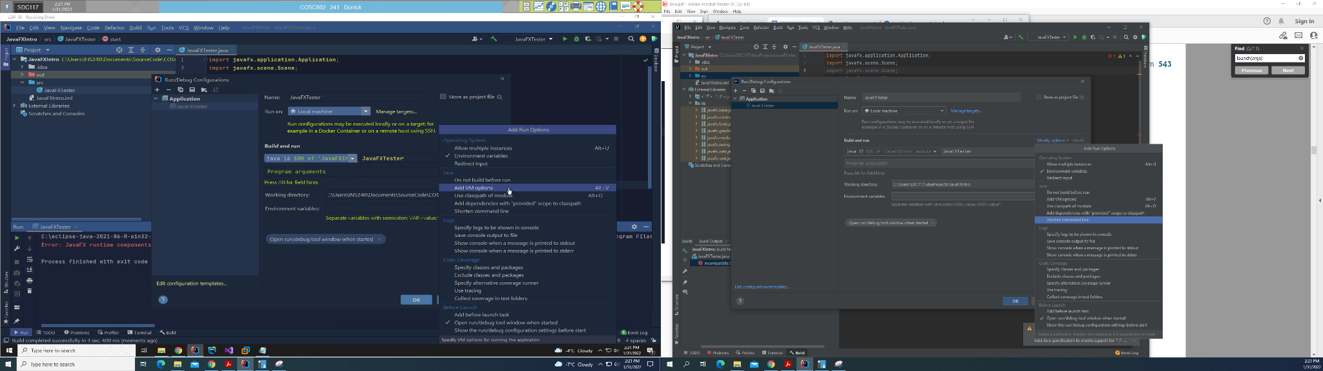

<https://intellij-support.jetbrains.com/hc/en-us/community/posts/360005624699-How-to-link-javafx-dependency-from-maven-to-Run-Configuration-VM-options->

<https://intellij-support.jetbrains.com/hc/en-us/articles/206544869-Configuring-JVM-options-and-platform-properties>

--module-path C:\Users\SDC117\Documents\javafx-sdk-17.0.2\lib --add-modules=javafx.controls

--module-path /Users/mojahan/Documents/javafx/lib --add-modules=javafx.controls

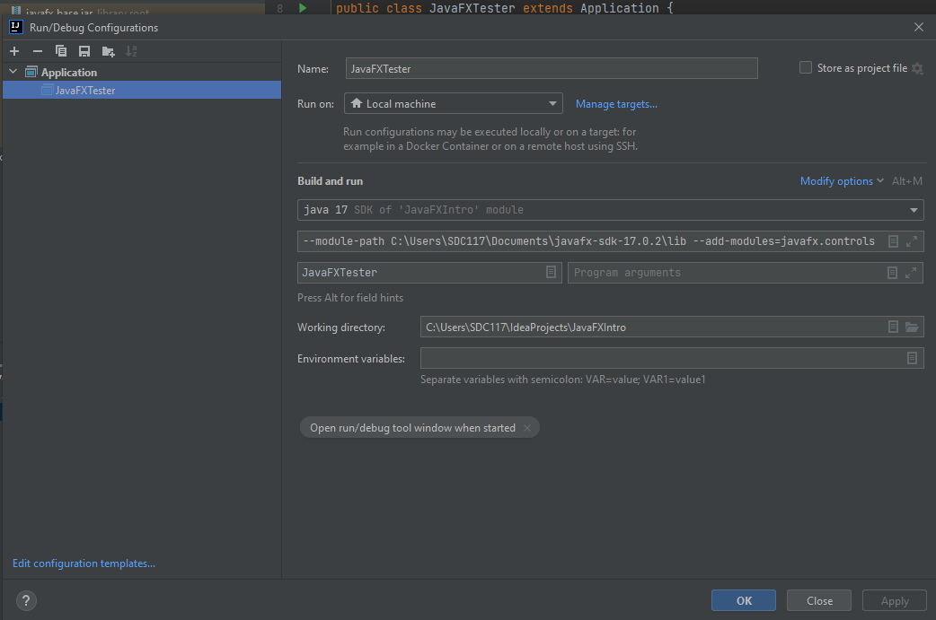

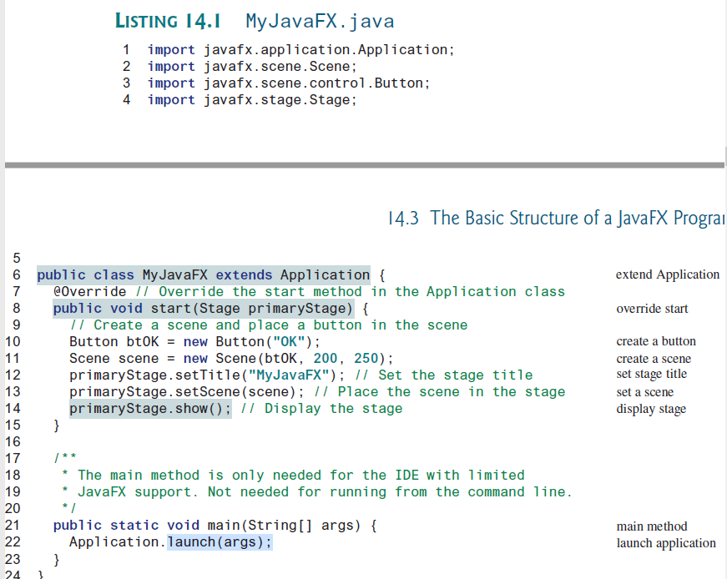The launch method (line 22) is a static method defined in the Application class for

launching a stand-alone JavaFX application. The main method (lines 21–23) is not needed

if you run the program from the command line. It may be needed to launch a JavaFX program

from an IDE with a limited JavaFX support. When you run a JavaFX application without a

main method, JVM automatically invokes the launch method to run the application.

The main class overrides the start method defined in javafx.application

.Application (line 8). After a JavaFX application is launched, the JVM constructs an instance

of the class using its no-arg constructor and invokes its start method. The start method

normally places UI controls in a scene and displays the scene in a stage, as shown in Figure 14.2a.

Line 10 creates a Button object and places it in a Scene object (line 11). A Scene object

can be created using the constructor Scene(node, width, height). This constructor

specifies the width and height of the scene and places the node in the scene.

A Stage object is a window. A Stage object called primary stage is automatically created

by the JVM when the application is launched. Line 13 sets the scene to the primary stage and

line 14 displays the primary stage. JavaFX names the Stage and Scene classes using the

analogy from the theater. You may think of stage as the platform to support scenes, and nodes

as actors to perform in the scenes