**COSC60220202JavaFX**

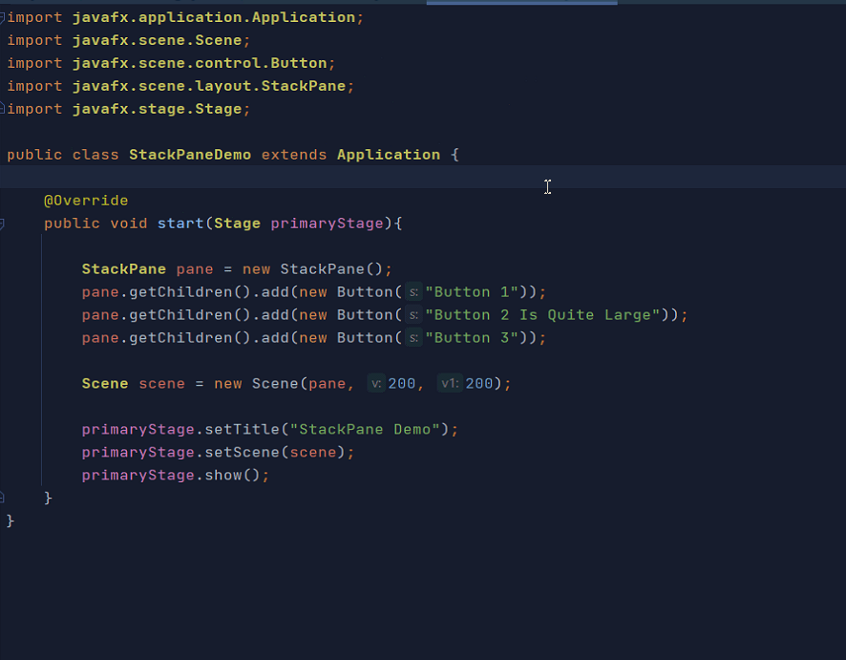

**Insert Lable and test nest to each others**

**package COSC60220220204JavaFX;**

**import javafx.application.Application;**

**import javafx.scene.Scene;**

**import javafx.scene.control.Button;**

**import javafx.scene.layout.StackPane;**

**import javafx.stage.Stage;**

**import java.awt.*;**

**public class StackPaneDemo extends Application {**

**@Override**

**public void start(Stage primaryStage) {**

**StackPane pane = new StackPane();**

**pane.getChildren().add(new Button("Button 1"));**

**pane.getChildren().add(new Button("Button 2 Is Quite Large"));**

**pane.getChildren().add(new Button("Button 3"));**

**Scene scene= new Scene(pane, 200 , 200);**

**primaryStage.setTitle("Stack Pane Demo");**

**primaryStage.setScene(scene);**

**primaryStage.show();**

**}**

**}**

**Listing 14.12 ShowBorderPane.java**

**Add border to pane add**

**class CustomPane extends StackPane {**

**public CustomPane(String title) {**

**getChildren().add(new Label(title));**

**setStyle("-fx-border-color: red");**

**setPadding(new Insets(11.5, 12.5, 13.5, 14.5));**

**}**

**}**

**ALL CODE**

**package COSC60220220204JavaFX;**

**import javafx.application.Application;**

**import javafx.geometry.Insets;**

**import javafx.scene.Scene;**

**import javafx.scene.control.Label;**

**import javafx.scene.layout.BorderPane;**

**import javafx.scene.layout.StackPane;**

**import javafx.stage.Stage;**

**public class BorderPaneDemo extends Application {**

**@Override // Override the start method in the Application class**

**public void start(Stage startStage) {**

**// Create a border pane**

**BorderPane pane = new BorderPane();**

**// Place nodes in the pane**

**pane.setTop(new CustomPane("Top"));**

**pane.setRight(new CustomPane("Right"));**

**pane.setBottom(new CustomPane("Bottom"));**

**pane.setLeft(new CustomPane("Left"));**

**pane.setCenter(new CustomPane("Center"));**

**// Create a scene and place it in the stage**

**Scene scene = new Scene(pane);**

**startStage.setTitle("ShowBorderPane"); // Set the stage title**

**startStage.setScene(scene); // Place the scene in the stage**

**startStage.show(); // Display the stage**

**}**

**}**

**// Define a custom pane to hold a label in the center of the pane**

**class CustomPane extends StackPane {**

**public CustomPane(String title) {**

**getChildren().add(new Label(title));**

**setStyle("-fx-border-color: red");**

**setPadding(new Insets(50));**

**}**

**}**

**___________________________________________________________**

**GRID PANE page 562**

**package COSC60220220204JavaFX;**

**import javafx.application.Application;**

**import javafx.geometry.HPos;**

**import javafx.geometry.Insets;**

**import javafx.geometry.Pos;**

**import javafx.scene.Scene;**

**import javafx.scene.control.Button;**

**import javafx.scene.control.Label;**

**import javafx.scene.control.TextField;**

**import javafx.scene.layout.GridPane;**

**import javafx.stage.Stage;**

**public class GridPaneDemo extends Application {**

**@Override // Override the start method in the Application class**

**public void start(Stage aStage) {**

**// CREATE GRID PANE**

**// Create a pane and set its properties**

**GridPane pane = new GridPane();**

**// Place nodes in the pane**

**// This menu we want to create**

**// lable1 textbox1**

**// lable2 textbox2**

**// lable3 textbook3**

**// Botton**

**////////////////// lable1 textbox1**

**pane.add(new Label("First Name:"), 0, 0);**

**pane.add(new TextField(), 1, 0);**

**////////////////// lable2 textbox2**

**pane.add(new Label("MI:"), 0, 1);**

**pane.add(new TextField(), 1, 1);**

**////////////////// lable3 textbox3**

**pane.add(new Label("Last Name:"), 0, 2);**

**pane.add(new TextField(), 1, 2);**

**// Botton**

**Button btnAdd = new Button("Add Name");**

**pane.add(btnAdd, 1, 3);**

**//Align staff as template**

**pane.setAlignment(Pos.*CENTER*);**

**pane.setPadding(new Insets(11.5, 12.5, 13.5, 14.5));**

**pane.setHgap(5);**

**pane.setVgap(15);**

**// SET button horizontal position RIGHT**

**GridPane.*setHalignment*(btnAdd, HPos.*RIGHT*);**

**///////////////////////////////////////////////////////////**

**// Create a scene and place it in the stage**

**Scene scene = new Scene(pane,500,300 );**

**aStage.setTitle("GridPane Demo"); // Set the stage title**

**aStage.setScene(scene); // Place the scene in the stage**

**aStage.show(); // Display the stage**

**}**

**}**

**Add New Lable and text field:**

**pane.addRow(4, new Label("Password: "), new TextField());**

**pane.addRow(4, new Label("Password: "), new TextField(), new Label("Some Text to show result change and fit add stuff"));**

**_________________________________________________________________**