Kali Linux Exercise: Introduction to Docker and Exploring Vulnerabilities

Objective
This lab introduces you to Docker, a powerful tool for creating and managing lightweight, isolated environments called containers. Containers allow you to simulate real-world systems without the need for additional physical resources. As cybersecurity professionals, understanding Docker is crucial because it enables you to test, develop, and deploy applications securely and efficiently.

Part 1: Understanding Docker and Basic Setup
1. What is Docker?
Docker is an open-source platform for creating, deploying, and managing containers. Containers bundle software, libraries, and dependencies together, ensuring the application runs the same way regardless of the environment. Unlike virtual machines, containers are lightweight and share the host operating system's kernel, making them faster and more resource-efficient.
Task: Install Docker and Docker Compose on your Kali Linux instance and verify the installation by checking their versions.

Screenshots
Provide screenshots of the Docker and Docker Compose version outputs below.
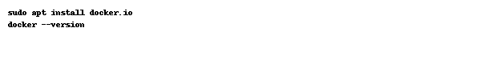

Part 2: Creating and Managing Docker Networks
3. Setting Up a Custom Network: Create a Docker network named 'vulnet' with a subnet to allow isolated communication for containers. Use the command:
docker network create vulnet --subnet=192.168.100.0/24
Provide the output of the network inspection command.

