**Histograms of Various Days for Amazon**

Day 1: 3rd December 2014

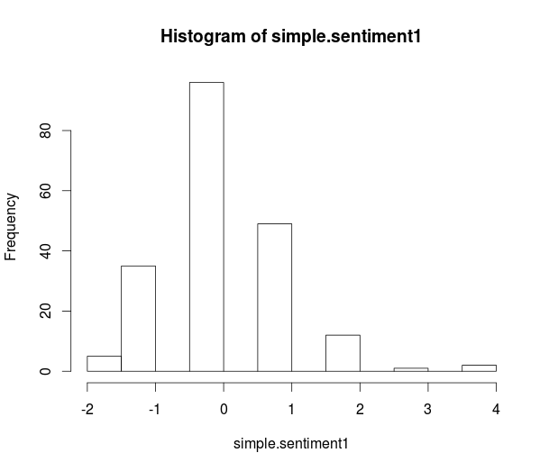

Day 2: 4th December 2014

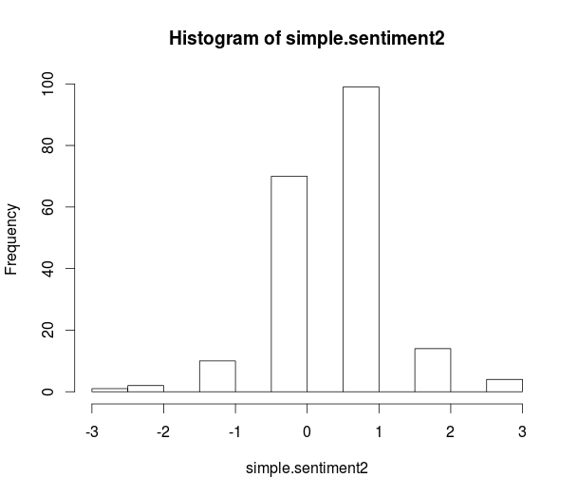

Day 3: 5th December 2014

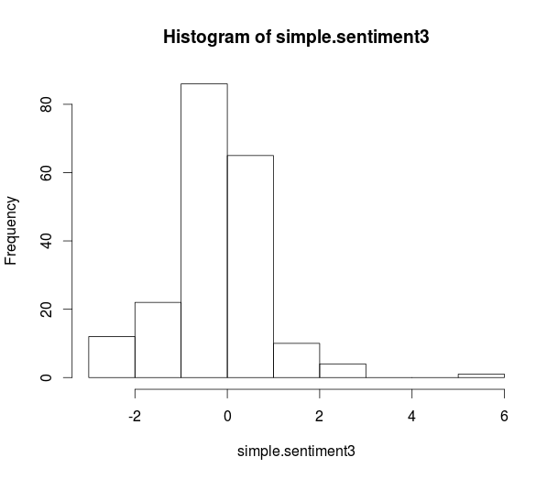

Day 4: 8th December 2014

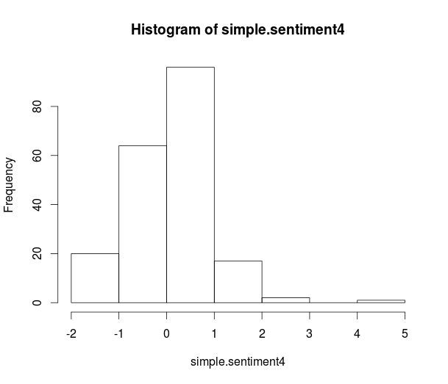

Day 5: 9th December 2014

