BFS WITH 100X100 GRID SIZE AND START POINT AT (0,0) AND ENDING GOAL AT (90,90)
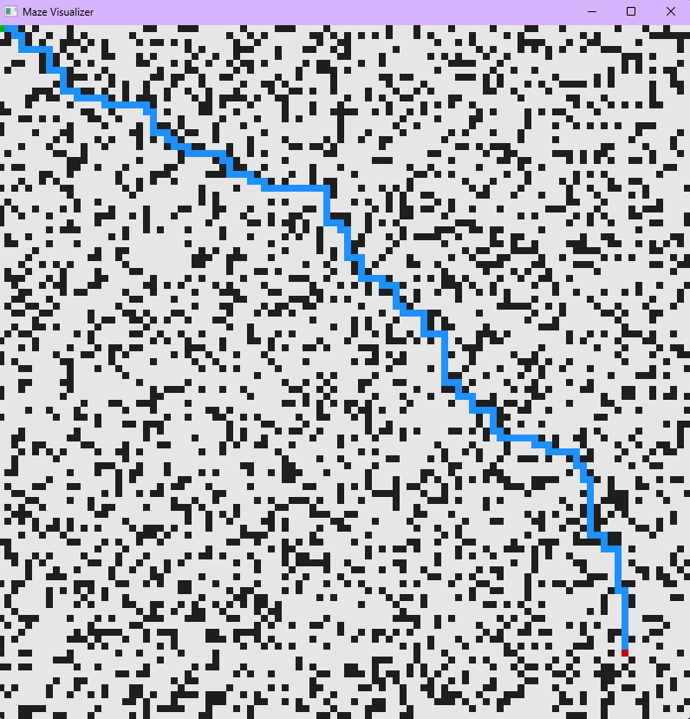
DFS WITH 100X100 GRID SIZE AND START POINT AT (0,0) AND ENDING GOAL AT (90,90)
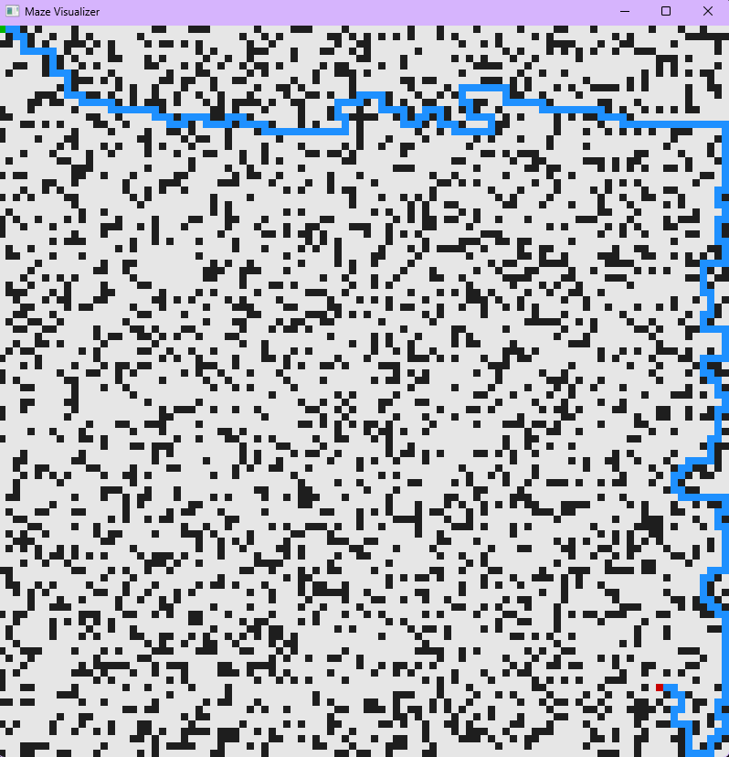
A* WITH 100X100 GRID SIZE AND START POINT AT (0,0) AND ENDING GOAL AT (90,90)
