Customer Logon:
ID: custest@gmail.com
Password: zxczxc

Admin:
D: admintest@gmail.com
Password: 123456
URl: http://www.pemasarankys.my/admin_area/login.php

Front Page
- Home
> Product list, Search option
- About Us
- Contact Us
- Logon
> Forgot Password 1)
> New Registration

Customers Panel
- Main Menu
> Logout
> Received Quotations 2)
> View Order 3)
> View Favorites 4)
> View Tell a Friend 5)
> All Products

- My Profile
> My Account
> Edit/ Update Account 6)
> Change Password
> Delete Account
> Send Feedback 7)
> Logout

Control Panel
- View RFQ 8)
- View Order 9)
- Insert New Product
- View all product
- Insert new category
- View all category
- Create Customer 10)
- View customers 11)
- Send Greeting/ invitation 12)
- Logout

Example of product view after logon
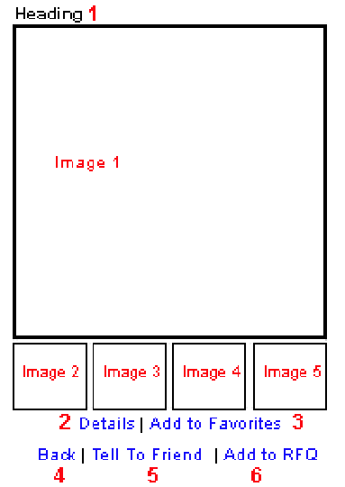

- Heading
- Details
- Add to Favorites
- Back
- Tell To Friend - > show email entering box and the click Submit option
- Add to RFQ – Appear box to key in quantity then continue shopping, once finished Submit for Quotation

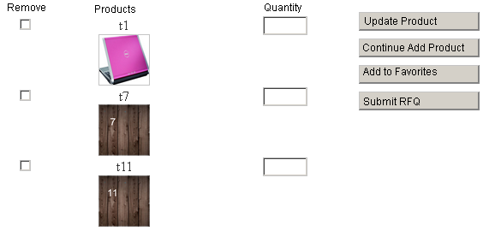

Notes:
1) New registration must avoid duplicate registration

2) Delete Account (Customer page) – Send the delete account to “disable account list” in Admin control panel –Notify by email both admin and customers

3) Send Feedback to Seller/admin – Customer just need to fill “Feedback” box other info pick from user profile. Image No 7

4) Must have search option and load page by page for products, View RFQ, View Order, View all category and View customers

1) Forgot Password
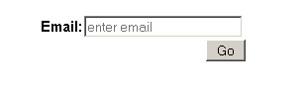
2) Received Quotations
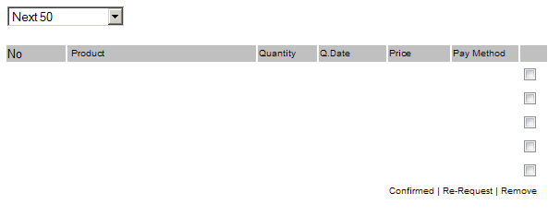

3) View Order

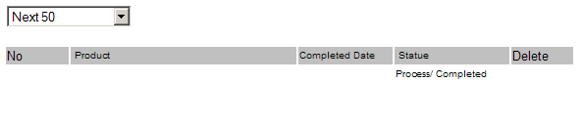

4) View Favorites
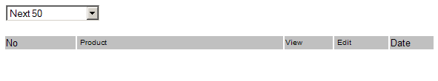
5) View Tell a Friend
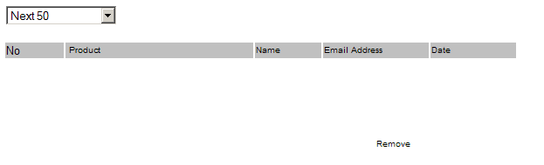
6) Edit/ Update Account

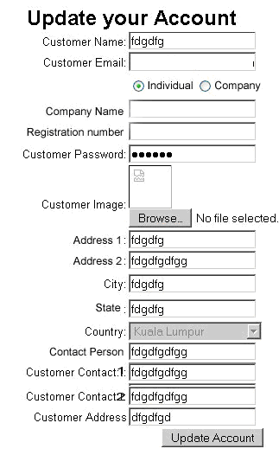
7) Send Feedback
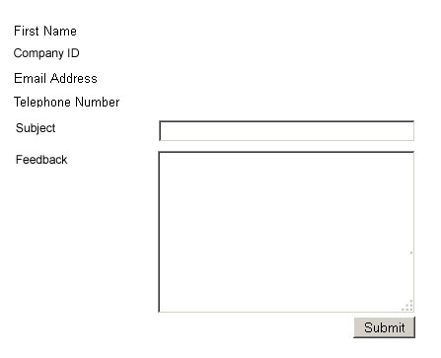
- View RFQ
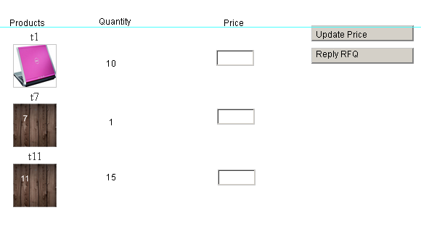
- View Order

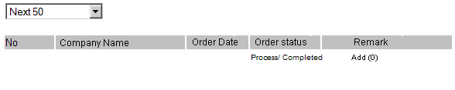

- Create Customer
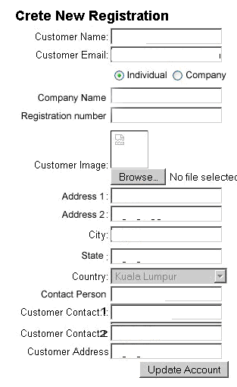

- View customers
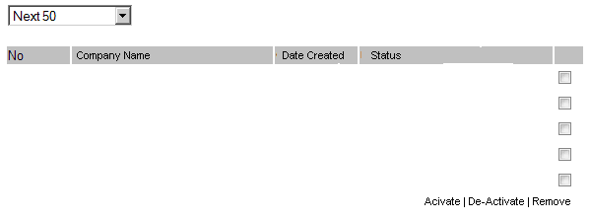

- Send Greeting/ invitation
