CHAPTER 1
INTRODUCTION

1.1. PROBLEM DEFINITION
The modern academic landscape presents students with a unique set of challenges that hinder effective learning and knowledge retention. The core problem is threefold: information overload, ineffective study methodologies, and a disconnect between theoretical knowledge and practical application.
1. Information Overload & Passive Learning: Students are inundated with vast amounts of information from textbooks, lecture slides, and research papers. Processing this volume of data manually is time-consuming and often leads to cognitive fatigue. Furthermore, the default study method for many students is passive learning—re-reading notes or highlighting text. Research in cognitive psychology consistently demonstrates that these passive techniques are significantly less effective for long-term retention compared to active recall and spaced repetition. Students spend hours studying but often fail to retain the information beyond the immediate exam period.
2. The Engagement Gap: Traditional study materials are static and often unengaging. The lack of interactivity can lead to boredom and procrastination, especially in an era where digital distractions are ubiquitous. Maintaining focus for "Deep Work" sessions is increasingly difficult for digital-native students.
3. The Theory-Practice Gap: Academic curricula often focus heavily on theoretical concepts and definitions. However, students frequently struggle to bridge the gap between understanding a concept in the abstract and applying it to solve real-world problems. This lack of application-based practice limits their critical thinking and problem-solving skills.
NoteWise AI is designed to directly address these problems. It automates the conversion of passive study materials into active learning tools (flashcards, quizzes), gamifies the learning process to boost engagement, and provides practical "Arena Challenges" to bridge the gap between theory and practice.

1.2. OBJECTIVES
The primary objectives of the NoteWise AI project are to design, develop, and deploy a comprehensive web-based learning platform that leverages artificial intelligence to optimize student study habits. Specifically, the project aims to:
- Develop a Full-Stack Architecture: Build a robust, scalable web application using a modern tech stack comprising a React.js frontend for a dynamic user interface and a Python/FastAPI backend for high-performance logic processing.
- Automate Content Creation: Implement an AI-driven engine using the Google Gemini API capable of parsing user-uploaded PDF documents and automatically generating high-quality, context-aware flashcards and quiz questions. This eliminates the manual labor of creating study aids.
- Implement Intelligent Scheduling: Design and integrate a "Unified Mastery Model" algorithm. This custom algorithm will combine Spaced Repetition Systems (SRS) (similar to SM-2) with a topic-level Mastery Score to create a personalized, adaptive review schedule for each user, ensuring efficient long-term retention.
- Foster Deep Work: Integrate productivity tools directly into the learning environment, specifically a "Deep Work" Pomodoro timer, to help users structure their study sessions and minimize distractions.
- Bridge Theory and Practice: Create an "Application Arena" module where users are presented with AI-generated real-world scenarios that require the application of theoretical concepts, thereby testing and improving higher-order thinking skills.
- Ensure Security and Personalization: Implement a secure authentication system using JWT (JSON Web Tokens) and password hashing to protect user data and provide a personalized experience where study sets and progress are privately managed.

1.3. METHODOLOGY TO BE FOLLOWED
The development of NoteWise AI follows a structured, agile methodology tailored for a collaborative two-person team. This approach, termed "Concurrent Layers with Role Swapping," ensures efficiency and comprehensive skill acquisition.
1. Parallel Development Streams: To maximize productivity, development tasks are split horizontally across the technology stack. For any given feature (e.g., User Authentication), one partner assumes the role of Backend Lead, developing the API endpoints, database models, and business logic. Simultaneously, the other partner acts as the Frontend Lead, designing the user interface, managing state, and implementing the API calls. This allows both layers of the application to progress securely in parallel.
2. Strict API Contracts: The success of parallel development relies on clear communication. Before a single line of code is written for a new feature, the team defines a strict "API Contract." This document specifies:
- Endpoint URL: (e.g., POST /api/generate)
- Request Body Structure: The exact JSON keys and data types the frontend must send.
- Response Structure: The exact JSON format the backend will return, including success data and error messages. This contract acts as the "blueprint," allowing the frontend developer to build components using mock data that will seamlessly integrate with the real backend once it is complete.
3. Version Control & Feature Branching: All code is managed using Git and hosted on GitHub. The team employs a Feature Branch Workflow:
- Main Branch: Contains only stable, production-ready code.
- Feature Branches: Every new feature (e.g., feature/auth-setup, feature/pdf-parsing) is built on its own isolated branch.
- Pull Requests (PRs): Code is never pushed directly to main. Instead, a Pull Request is opened. This triggers a mandatory Code Review phase where the other partner reviews the code for logic errors, style consistency, and potential bugs before merging it.
4. Role Swapping: To ensure both partners become proficient Full-Stack Developers, roles are swapped after the completion of each major module. The partner who built the backend for Phase 1 will build the frontend for Phase 2, and vice-versa. This prevents knowledge silos and ensures both members understand the entire system architecture.

1.4. EXPECTED OUTCOMES
The successful execution of this project will result in the following tangible and intangible outcomes:
- A Functional Web Application: A deployed, live URL for NoteWise AI that allows users to register, upload PDFs, and interact with generated study materials.
- Intelligent Content Engine: A verified backend system that can ingest PDF text and reliably output structured, relevant educational content using Generative AI.
- Personalized Learning System: A working database implementation that tracks individual user progress, remembering which cards a user finds difficult and scheduling them accordingly.
- Technical Proficiency: A demonstration of advanced skills in:
  - Backend Engineering: API design, database modeling with SQLAlchemy, authentication flows.
  - Frontend Engineering: React component design, state management, asynchronous data fetching.
  - AI Integration: Prompt engineering, handling LLM responses, and integrating third-party AI services.
- Documentation: A comprehensive project report and code documentation that serves as a guide for future maintenance or expansion of the platform.

1.5. HARDWARE AND SOFTWARE REQUIREMENTS
Hardware Requirements:
- Processor: Intel Core i5/i7 (5th Gen or later) or AMD Ryzen 5/7, or Apple Silicon M1/M2.
- RAM: Minimum 8GB (16GB recommended) to comfortably run the React development server, Python backend, and database services simultaneously.
- Storage: 256GB SSD or higher for project files and dependencies.
- Network: Stable broadband internet connection is critical for:
  - Downloading packages (npm, pip).
  - Pushing/pulling code from GitHub.
  - Communicating with the cloud-based Google Gemini API (the AI engine resides in the cloud, not on the local machine).
Software Requirements:
- Operating System: Windows 10/11, macOS (Ventura or later), or a Linux distribution (Ubuntu 20.04+).
- Code Editor: Visual Studio Code (VS Code) is the chosen IDE due to its robust ecosystem of extensions for Python, React, and Git.
- Backend Environment:
  - Python 3.10+: The core programming language.
  - FastAPI: The web framework for building the API.
  - Uvicorn: An ASGI web server implementation to run the FastAPI app.
  - Virtual Environment (venv): For isolating project dependencies.
- Frontend Environment:
  - Node.js (v18 LTS): The runtime environment for executing JavaScript code outside the browser.
  - npm: Package manager for installing React libraries.
  - React.js (via Vite): The frontend library and build tool.
- Database:
  - PostgreSQL 14+: An open-source object-relational database system.
  - pgAdmin 4: A management tool for PostgreSQL.
- Version Control: Git (for local version control) and GitHub (for remote repository hosting).
- API Testing: Swagger UI (built-in to FastAPI) for documenting and testing API endpoints.

CHAPTER 2
FUNDAMENTALS OF PYTHON

2.1. INTRODUCTION TO PYTHON
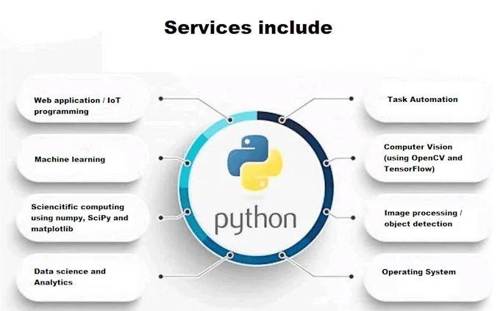
Python is a high-level, interpreted, general-purpose programming language. Created by Guido van Rossum and first released in 1991, Python's design philosophy emphasizes code readability with its notable use of significant indentation. It provides constructs that enable clear programming on both small and large scales.
Python is dynamically typed and garbage-collected. It supports multiple programming paradigms, including structured (particularly, procedural), object-oriented, and functional programming. It is often described as a "batteries included" language due to its comprehensive standard library.
In the context of NoteWise AI, Python serves as the backbone of our server-side operations. Its simplicity allows for rapid development, while its powerful libraries for web handling (FastAPI) and data processing make it the ideal choice for building complex, data-driven applications.

2.2. ADVANTAGES OF PYTHON
Python's popularity in modern software development, particularly in web development and AI, stems from several key advantages:
- Readability and Maintainability: Python's syntax mirrors the English language. It uses indentation to define code blocks instead of curly braces or keywords, which forces a clean, uniform layout. This makes the code easy to read and understand, significantly reducing the cost of program maintenance.
- Extensive Standard Library: Python comes with a vast library that supports many common programming tasks, such as connecting to web servers, reading and modifying files, and working with data. This "batteries included" approach means developers can do more with less code.
- Rich Ecosystem of Third-Party Modules: The Python Package Index (PyPI) hosts thousands of third-party modules. For our project, we leverage powerful libraries like SQLAlchemy for database ORM, Pydantic for data validation, and google-generativeai for AI integration.
- Cross-Platform Compatibility: Python is an interpreted language. Code written on a Windows machine can run seamlessly on macOS or Linux servers without recompilation, ensuring our backend is portable.
- Integration Capabilities: Python integrates easily with C, C++, and Java, making it a powerful glue language. It allows us to interface with high-performance libraries and systems easily.
- Strong Support for Asynchronous Programming: With the introduction of async and await keywords, Python (via frameworks like FastAPI) can handle thousands of concurrent connections efficiently, which is crucial for a responsive web application.

2.3. DATA TYPES
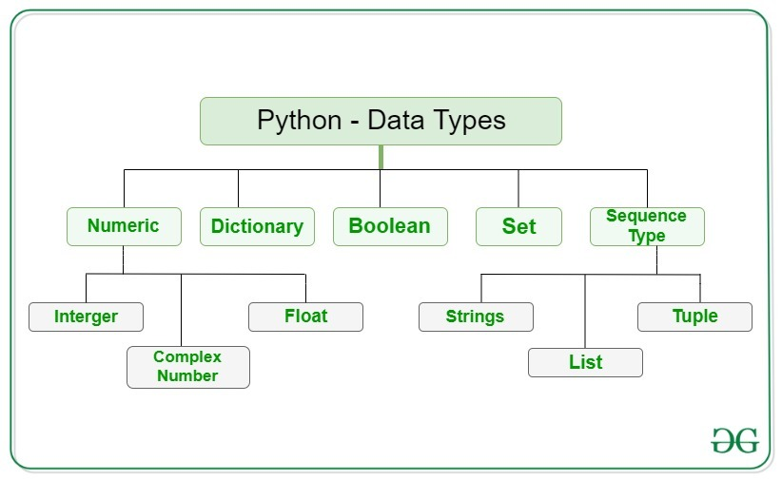
In Python, every value has a datatype. Since everything is an object in Python programming, data types are actually classes and variables are instances (objects) of these classes. The standard data types in Python include:
- Numeric Types: int, float, complex
- Sequence Types: str, list, tuple
- Mapping Type: dict
- Set Types: set, frozenset
- Boolean Type: bool
- Binary Types: bytes, bytearray, memoryview
Understanding these types is fundamental to data manipulation in our backend logic, such as parsing user inputs or formatting data for the database.

2.4. PYTHON NUMBERS
Python supports three main types of numbers:
- Integers (int): These are whole numbers, positive or negative, without decimals, of unlimited length.
  - Example: user_id = 105, score = -5.
  - In our project, int is used for primary keys (id), counting repetitions, and tracking study time.
- Floating Point Numbers (float): These are numbers containing one or more decimals.
  - Example: mastery_score = 85.5, interval = 2.5.
  - We use floats to store precision metrics like the "Ease Factor" in our Spaced Repetition Algorithm.
- Complex Numbers (complex): Complex numbers are written with a "j" as the imaginary part.
  - Example: x = 3+5j.
  - While rarely used in web development, they are powerful for scientific computing.

2.5. PYTHON STRINGS
A string is a sequence of characters. In Python, strings are enclosed in single quotes ('...') or double quotes ("...").
- Immutability: Python strings are immutable, meaning they cannot be changed after they are created. Operations that "modify" a string actually create a new string object.
- Indexing and Slicing: Strings can be indexed (e.g., text[0]) and sliced (e.g., text[1:5]) to access specific substrings.
- Methods: Python provides powerful string methods like .strip(), .lower(), .replace(), and .split().
  - Application: In NoteWise AI, extensive string manipulation is used to clean the text extracted from PDF files before sending it to the AI, and to parse the JSON string returned by the AI.

2.6. PYTHON LISTS
Lists are one of the most versatile data types in Python. A list is an ordered, mutable collection of items.
- Syntax: Defined by square brackets []. Example: topics = ["SQL", "Python", "React"].
- Heterogeneous: Lists can contain items of different data types (e.g., [1, "Hello", 3.14]).
- Mutable: You can add, remove, or change items after the list is created using methods like .append(), .remove(), and .pop().
- Application: We use lists to store collections of objects, such as the list of Flashcard objects generated by the AI or the list of StudySet items belonging to a user.

2.7. PYTHON TUPLES
A tuple is similar to a list in that it is an ordered collection of items. However, the key difference is that tuples are immutable.
- Syntax: Defined by parentheses (). Example: coordinates = (10, 20).
- Immutability: Once a tuple is created, you cannot change its values. This makes tuples faster and safer for write-protected data.
- Application: Tuples are often used to return multiple values from a function or to store data that should not be modified, such as database configuration constants (HOST, PORT).

2.8. PYTHON SETS
A set is an unordered, unindexed collection of unique items.
- Syntax: Defined by curly braces {}. Example: unique_tags = {"Biology", "Chemistry"}.
- Uniqueness: Sets automatically remove duplicate entries. If you add "Biology" twice, it will only appear once.
- Operations: Sets support mathematical operations like union (|), intersection (&), and difference (-).
- Application: Sets are incredibly useful for tasks like finding all unique tags used across a user's study library, or filtering out duplicate words from a text analysis.

2.9. PYTHON DICTIONARIES
Dictionaries are unordered collections of key-value pairs. They are optimized for retrieving data when you know the key.
- Syntax: Defined by curly braces {} with key-value pairs. Example: user = {"name": "John", "email": "john@example.com"}.
- Access: Values are accessed by their key: user["email"].
- Mutable: You can add new keys or change the value of existing keys.
- Application: Dictionaries are the fundamental data structure for JSON handling. When our API receives data from the frontend or sends data to the database, it is almost always processed as a dictionary (or a list of dictionaries).

2.10. FUNCTIONS IN PYTHON
A function is a block of organized, reusable code that is used to perform a single, related action.
- Definition: Defined using the def keyword.
- Parameters: Functions can accept input values called arguments.
- Return Values: Functions can return data to the caller using the return statement.
- Modularity: Functions allow us to break our complex application into smaller, manageable pieces.
  - Example: We have separate functions for hash_password(password), create_access_token(data), and extract_text_from_pdf(file). This modularity makes our code clean, readable, and easy to test.

CHAPTER 3
FUNDAMENTALS OF DBMS

3.1. INTRODUCTION
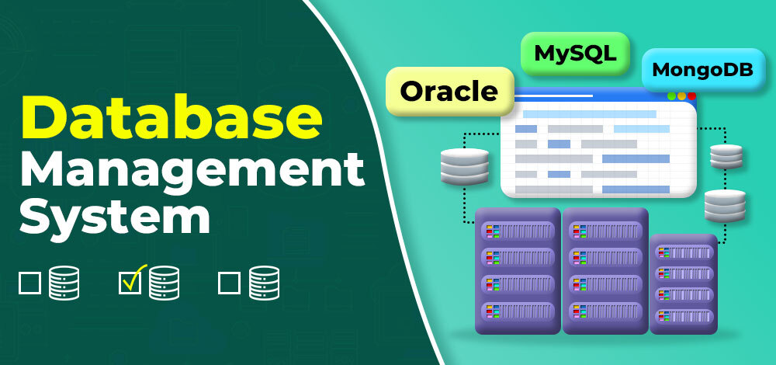
A Database Management System (DBMS) is system software for creating and managing databases. A database is an organized collection of structured information, or data, typically stored electronically in a computer system. The DBMS provides users and programmers with a systematic way to create, retrieve, update, and manage data. It serves as an interface between the database and its end-users or application programs, ensuring that data is consistently organized and remains easily accessible.
For NoteWise AI, we utilize PostgreSQL, a powerful, open-source object-relational database system. It serves as the persistent storage layer for our application, ensuring that user accounts, study sets, and learning progress are safely stored and retrieved efficiently.

3.2. CHARACTERISTICS OF A DBMS
A modern DBMS like PostgreSQL exhibits several key characteristics that distinguish it from a simple file-processing system:
- Real-world Entity Representation: A DBMS creates a realistic picture of real-world entities. For example, a User entity in our database directly models a real student using our app, with attributes like email and password.
- Relation-based Tables: Data is stored in tables that are related to each other. This allows for complex data relationships, such as linking a Flashcard to a specific StudySet.
- Data Independence: The database structure (schema) is separated from the application programs. We can change the database storage method without rewriting the application code.
- Concurrency Control: The DBMS allows multiple users to access and modify data at the same time without conflicts. It manages "transactions" to ensure data integrity.
- ACID Properties: It follows the concepts of Atomicity, Consistency, Isolation, and Durability, which are crucial for reliable data processing.
- Security: It offers robust features to control access, ensuring only authorized users (via our authentication system) can view or modify specific data.

3.3. DATA MODEL
A data model is an abstract model that organizes elements of data and standardizes how they relate to one another and to the properties of real-world entities.
- Relational Model: This is the most common model and the one used in our project. It organizes data into tables (relations) consisting of rows (tuples) and columns (attributes). Each row represents a unique record, and each column represents a field of data.
- Entity-Relationship (ER) Model: This is a high-level conceptual data model used for database design. It represents the logical structure of the database using diagrams that show Entities, Attributes, and Relationships.
- Object-Relational Model: PostgreSQL is an object-relational database, meaning it supports features of both the relational model (tables, keys) and the object-oriented model (inheritance, custom types).

3.4. THREE-SCHEMA ARCHITECTURE
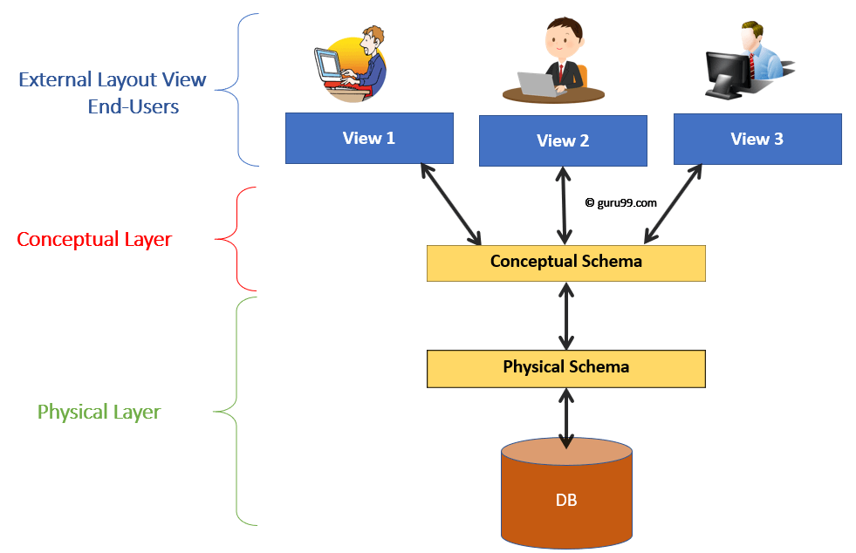
The primary goal of the three-schema architecture is to separate the user applications from the physical database.
- Internal Level (Physical Schema): This is the lowest level. It describes how the data is actually stored on the storage medium (disk drives). It deals with data compression, encryption, and indexing techniques for performance optimization.
- Conceptual Level (Logical Schema): This level describes what data is stored in the database and the relationships among the data. It represents the entire database in terms of tables, columns, and constraints. This is the level where we define our User and StudySet tables using SQL or SQLAlchemy.
- External Level (View Schema): This is the highest level, closest to the user. It describes only the part of the database that a particular user group is interested in. For example, a user viewing their dashboard only sees their own study sets, hiding the data of other users and sensitive fields like password hashes.

3.5. DBMS COMPONENT MODULES
A DBMS is a complex software system composed of several functional modules:
- Query Processor:
  - DDL Interpreter: Interprets DDL statements (like CREATE TABLE) and records them in the data dictionary.
  - DML Compiler: Translates DML statements (like SELECT, INSERT) into low-level instructions (query plan) that the query evaluation engine can execute.
- Storage Manager:
  - Authorization Manager: Checks if the user has permission to perform the requested operation.
  - Transaction Manager: Ensures that the database remains in a consistent state despite system failures or concurrent transaction executions.
  - File Manager: Manages the allocation of space on disk storage and the data structures used to represent information.
  - Buffer Manager: Fetches data from disk storage into main memory (RAM) and decides what data to cache for faster access.

3.6. ENTITY-RELATIONSHIP (ER) MODEL
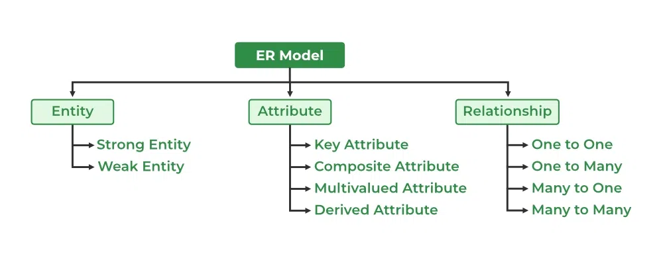
The ER model is the conceptual blueprint for our database.
- Entities:
  - User: Represents a registered student.
  - StudySet: Represents a collection of learning materials derived from a single PDF.
  - Flashcard: Represents a single question-answer pair.
  - Quiz Question: Represents a multiple-choice question.
  - Arena Challenge: Represents a higher-order thinking scenario.
- Attributes:
  - User: id (PK), email, hashed_password.
  - StudySet: id (PK), title, mastery_score.
  - Flashcard: id (PK), question, answer, next_review_date.
- Relationships:
  - User - StudySet: One-to-Many (One user can have multiple study sets).
  - StudySet - Flashcard: One-to-Many (One study set contains many flashcards).
  - StudySet – Quiz Question: One-to-Many.

3.7. RELATIONAL SCHEMA
The Relational Schema translates the ER model into the actual tables used by PostgreSQL.
- Table: Users
  - id (Integer, Primary Key)
  - email (Varchar, Unique)
  - hashed_password (Varchar)
  - is_active (Boolean)
- Table: StudySets
  - id (Integer, Primary Key)
  - user_id (Integer, Foreign Key references Users.id)
  - title (Varchar)
  - mastery_score (Float)
- Table: Flashcards
  - id (Integer, Primary Key)
  - set_id (Integer, Foreign Key references StudySets.id)
  - question (Text)
  - answer (Text)
  - interval (Float)
  - next_review_date (Date)
This schema ensures referential integrity (e.g., you cannot create a flashcard for a study set that doesn't exist) and optimized data retrieval.

CHAPTER 4
FUNDAMENTALS OF SQL

4.1. INTRODUCTION
Structured Query Language (SQL) is the standard language for dealing with Relational Databases. It allows users to create, read, update, and delete data within a database. In NoteWise AI, while we use an Object-Relational Mapper (SQLAlchemy) to interact with the database using Python code, SQLAlchemy ultimately translates our Python commands into raw SQL queries that are executed by PostgreSQL. Understanding SQL is essential for debugging and optimizing these database interactions.

4.2. SQL COMMANDS
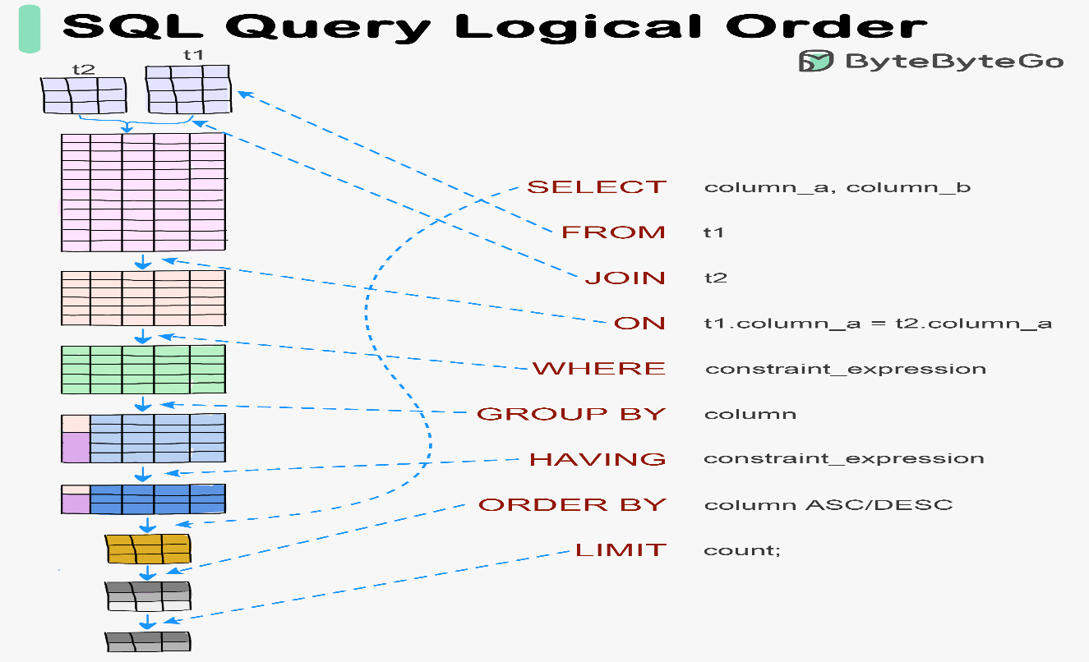
SQL commands are instructions to the database. They are broadly categorized into five types based on their function: DDL, DML, DCL, TCL, and DQL.

4.3. DATA DEFINITION LANGUAGE (DDL)
DDL commands define the structure or schema of the database. These changes are auto-committed (saved permanently) immediately.
- CREATE: Creates a new database or table.
  - Project Usage: Used to create the users table with columns for id, email, and password.
  - Example: CREATE TABLE users (id SERIAL PRIMARY KEY, email VARCHAR(255));
- DROP: Deletes a table or database entirely.
  - Project Usage: Used during development to reset the database if the schema changes drastically.
- ALTER: Modifies an existing table structure, such as adding a new column.
  - Project Usage: Adding the is_active column to the existing users table.
- TRUNCATE: Removes all records from a table but keeps the structure. It is faster than DELETE for clearing data.

4.4. DATA MANIPULATION LANGUAGE (DML)
DML commands manipulate the actual data stored within the tables. These are the commands our application runs most frequently.
- INSERT: Adds new rows of data.
  - Project Usage: When a user registers, an INSERT command adds their details to the users table.
- UPDATE: Modifies existing data.
  - Project Usage: When a user reviews a flashcard, an UPDATE command changes the next_review_date and interval for that specific card.
- DELETE: Removes specific rows.
  - Project Usage: When a user deletes a study set, a DELETE command removes that set and (via cascading) all its associated flashcards.

4.5. DATA CONTROL LANGUAGE (DCL)
DCL commands handle rights, permissions, and security of the database system.
- GRANT: Gives users access privileges to the database.
- REVOKE: Withdraws access privileges.
  - Project Usage: In our PostgreSQL setup, we create a specific database user and GRANT them privileges only on the notewise_db, ensuring they cannot access other system databases.

4.6. TRANSACTION CONTROL LANGUAGE (TCL)
TCL commands manage transactions in the database. A transaction is a sequence of operations performed as a single logical unit of work.
- COMMIT: Saves all the changes made during the current transaction.
  - Project Usage: In FastAPI, db. commit () is called only after all operations (e.g., creating a user AND hashing their password) succeed.
- ROLLBACK: Reverts the database to the state before the transaction began.
  - Project Usage: If an error occurs during study set creation (e.g., PDF parsing fails), db. rollback () ensures that a partial, empty study set is not saved to the database.
- SAVEPOINT: Sets a point within a transaction to which you can later roll back.

4.7. DATA QUERY LANGUAGE (DQL)
DQL is used to fetch data from the database. It consists of only one command: SELECT.
- SELECT: Retrieves data from one or more tables.
  - Project Usage: This is the most used command.
  - Login: SELECT * FROM users WHERE email = 'test@example.com' finds the user to verify their password.
  - Dashboard: SELECT * FROM study_sets WHERE user_id = 5 retrieves all study sets for the logged-in user.
  - Review: SELECT * FROM flashcards WHERE next_review_date <= CURRENT_DATE fetches only the cards that are due for review today.

CHAPTER 5
DESIGN

CHAPTER 6
IMPLEMENTATION

CHAPTER 7
RESULTS

CHAPTER 8
CONCLUSION

REFERENCES

