2025-02-07 1744 dogs smart off trail scents sounds.odt

Dogs know wheree to go tothe side of the path

walking in fort rock.

People walk on the path.

dogs go the same direction but they zigzag all across and around the path as they go.

dogs know what’s up.

they know where it’s at.

dogs know what’s interesting and important.

cool stuff like scents and sounds and chipmunks and birds and squirrels and rabbits and anything else.

-

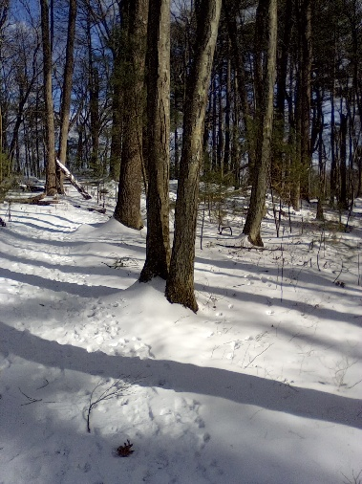

-

Related:

#0083 - Dogs Doing Jiu-Jitsu | https://lemonmama.com/lemonmama/2025/2025%20February%20Blog%20Posts.html#0083