Global spectral manifold complexity predicts neural-surrogate learning difficulty in nanophotonics
MOHAMMAD H. JAVANI,1,* [COAUTHORS]
1Department of Cyber-Physical Systems, Clark Atlanta University, Atlanta, Georgia 30314, USA
[Additional affiliations]
*Corresponding author: [email]

Abstract
Generating electromagnetic training data is often the main cost of developing neural surrogates for nanophotonics. We examined whether response-manifold geometry could predict relative training-data burden across nine datasets under a fixed multilayer-perceptron protocol. PCA99 dimension was strongly associated with learning difficulty (Pearson r = 0.894; Spearman rho = 0.900) and gave the best leave-one-case-out calibration (Q² = 0.580), whereas local TwoNN dimension was not associated with difficulty. The PCA99/TwoNN ratio gave the strongest rank ordering (rho = 0.983) and remained stable when each case was removed in turn, although its numerical calibration was weaker. Global spectral complexity may therefore help estimate sample burden before full-scale training, although broader validation is needed.
Keywords: nanophotonics; neural surrogate; response manifold; intrinsic dimension; principal-component analysis; learning curves; sample efficiency

1. Introduction
Neural forward models can replace repeated calls to an electromagnetic solver and can also be used inside inverse-design loops. This approach has been applied to multilayer nanoparticles, plasmonic structures, metasurfaces, gratings, and integrated photonic components [1–4]. The speedup, however, comes only after a sufficiently representative simulation library has been generated. That initial library can be expensive, and its required size is usually chosen empirically for each device class. A reliable way to estimate the needed sample count before large-scale simulation would therefore be useful.
Although a spectrum may contain hundreds of sampled coordinates, resonance shifts, line-shape changes, and interference features make those coordinates strongly dependent. Autoencoders, principal-component analysis, metric learning, and design-space mapping have all been used to compress or interpret such responses [5–7]. In this setting, however, the word "dimension" can refer to two different properties. Local intrinsic-dimension estimators measure the number of coordinates needed in a neighborhood of the data manifold [8,9]. Covariance-based measures instead count the linear directions required to represent the data cloud as a whole. A curved or folded manifold may consequently have modest local dimension while requiring many global components.
The distinction may also matter for learning. Local dimension measures the degrees of freedom seen by a nearest-neighbor estimator. Global linear complexity measures how many spectral directions a surrogate must coordinate across the entire design distribution. Effective manifold dimension can govern regression complexity in statistical learning theory [11], but its usefulness as an empirical cross-architecture diagnostic has not been established for nanophotonic neural surrogates. The number of design variables is unlikely to be sufficient by itself: equal-sized parameter spaces can generate very different resonance families and spectral correlations.
We examine seven SiO₂/TiO₂ multilayer datasets, one 2×2 metasurface dataset, and one grating dataset under the same analysis and training protocol. Response resolution and geometry-analysis sample size are held constant across cases. The learning and capacity curves use identical budgets, metrics, and three fixed seeds, while exact permutation tests and leave-one-case-out analyses separate rank association from calibrated prediction.
The comparison points to different roles for the two geometric scales. PCA-based global complexity is the best calibrated single predictor of learning difficulty, whereas the global-to-local ratio gives the most stable rank ordering. Neither local intrinsic dimension alone nor the number of design variables transfers reliably across the sampled architectures.

2. Results

2.1 Global and local spectral complexity diverge with multilayer depth
The seven multilayer datasets provide a structural series in which the number of independently variable layers increases from 8 to 20; each spectrum contains 200 coordinates. All three global measures (PCA99 dimension, participation ratio, and effective rank) increased monotonically with layer count. PCA99 rose from 9 components for 8 layers to 53 for 20 layers. TwoNN local intrinsic dimension also increased, from 5.58 to 12.22, so the earlier interpretation that it is independent of layer count is not supported. The difference lies in the rate of growth: PCA99 increased much faster, and the PCA99/TwoNN ratio rose from 1.61 to 4.34 (Fig. 1). A linear fit of this ratio against layer count gave R² = 0.9970.
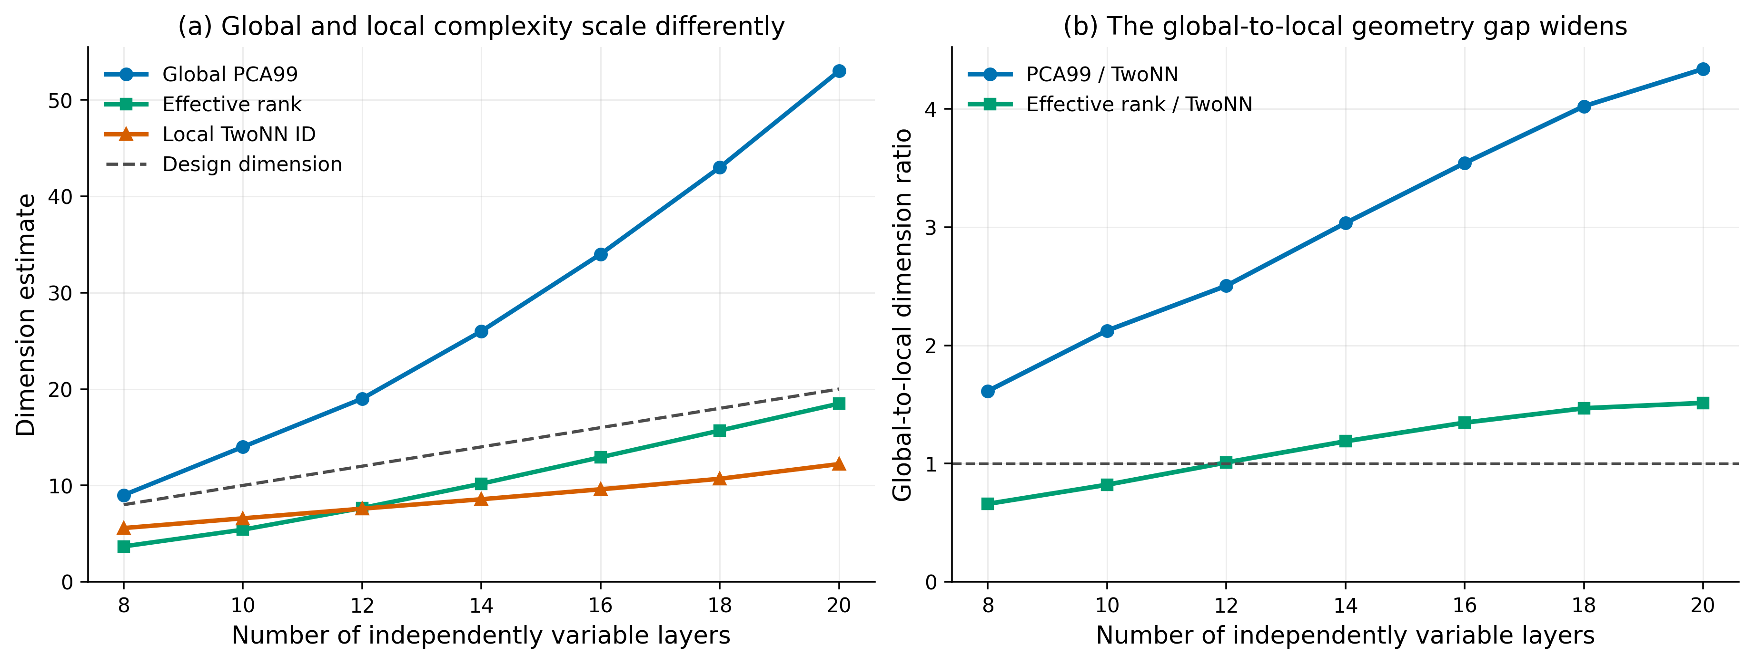
Fig. 1. Multilayer scaling separates global from local spectral geometry. (a) Common-grid PCA99, effective rank, and TwoNN intrinsic dimension all increase with the number of independently variable layers, but the global measures rise faster. The dashed line shows design dimension. (b) Ratios of PCA99 and effective rank to TwoNN dimension widen monotonically. TwoNN values are means over five 5,000-sample repeats; the shaded uncertainty is smaller than most markers.

2.2 Cross-architecture comparison exposes the weakness of design dimension
After linear resampling to 200 points on each dataset's normalized spectral coordinate, the 2×2 case had PCA99 = 74 and TwoNN = 7.80; the corresponding values for the grating were 27 and 2.47. Their PCA99/TwoNN ratios were 9.49 and 10.94, both above the multilayer range, even though the design spaces contained only 9 and 4 variables. Input dimension alone therefore does not account for the number of global spectral directions. With only one 2×2 and one grating dataset, and with different physical spectral intervals, these cases cannot establish a general ordering of device families. They nevertheless show how far global response complexity can depart from both design dimension and local intrinsic dimension (Fig. 2 and Table 1).
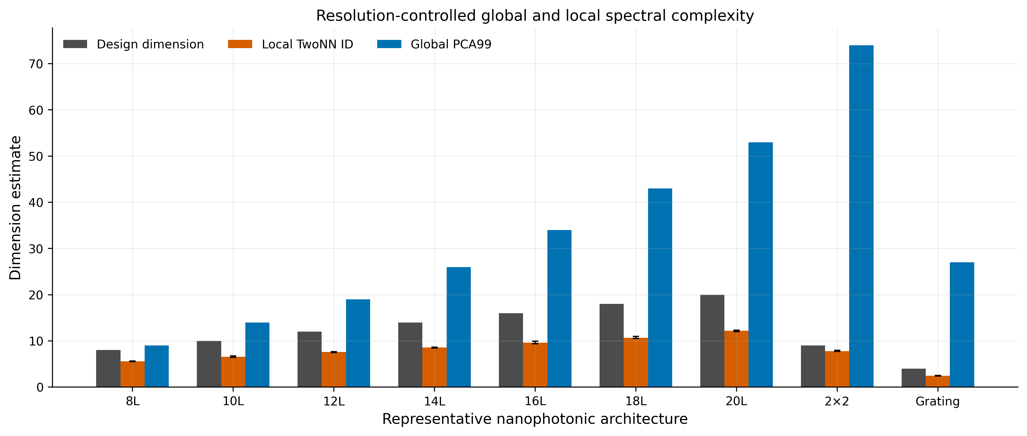
Fig. 2. Resolution-controlled comparison across nine representative datasets. The bars show design dimension, local TwoNN intrinsic dimension, and global PCA99 dimension after all response vectors were represented with 200 normalized spectral coordinates. Error bars show the empirical 95% interval across five TwoNN repeats.
Table 1. Dataset inventory and primary geometry metrics.
Case | Design  dim. | Samples | Native  response | Effective  rank | PCA99 | TwoNN | PCA99 /  TwoNN
8-layer | 8 | 50,000 | 200 | 3.68 | 9 | 5.58 | 1.61
10-layer | 10 | 50,000 | 200 | 5.41 | 14 | 6.59 | 2.12
12-layer | 12 | 50,000 | 200 | 7.66 | 19 | 7.59 | 2.50
14-layer | 14 | 50,000 | 200 | 10.18 | 26 | 8.57 | 3.03
16-layer | 16 | 50,000 | 200 | 12.92 | 34 | 9.60 | 3.54
18-layer | 18 | 50,000 | 200 | 15.69 | 43 | 10.69 | 4.02
20-layer | 20 | 200,000 | 200 | 18.49 | 53 | 12.22 | 4.34
2×2 | 9 | 6,000 | 551 | 21.56 | 74 | 7.80 | 9.49
Grating | 4 | 12,000 | 400 | 7.49 | 27 | 2.47 | 10.94

2.3 Local-dimension estimates are stable at the analysis scale
We recomputed TwoNN at 1,000, 2,500, and 5,000 samples using five deterministic repeats. The multilayer ordering did not change with sample size, and the 20-layer, 2×2, and grating estimates approached distinct plateaus (Fig. 3). At 5,000 samples, the between-repeat standard deviations ranged from 0.034 to 0.212. A synthetic five-dimensional Gaussian test returned TwoNN = 5.010 and Levina-Bickel k = 20 harmonic dimension = 4.749, consistent with the expected dimension. We also examined mild Savitzky-Golay smoothing as a sensitivity test; the primary estimates reported here use the unsmoothed spectra.
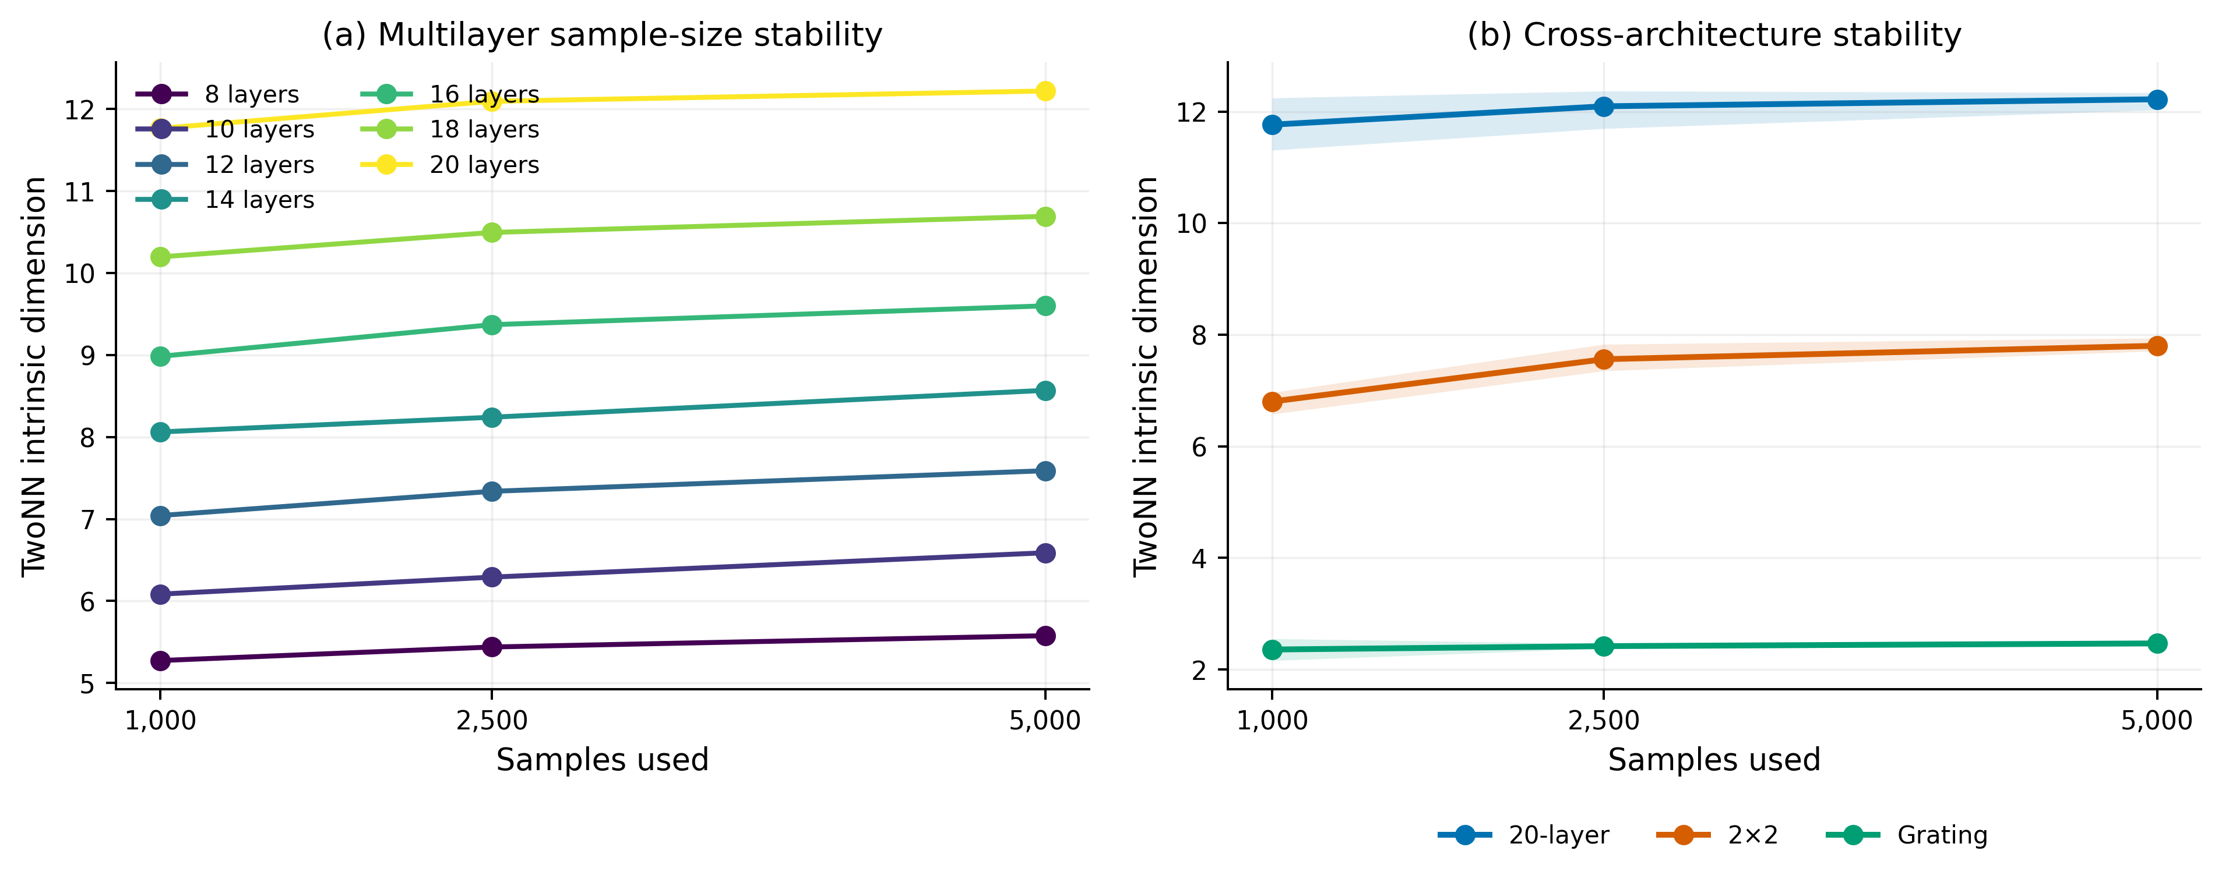
Fig. 3. Stability of TwoNN intrinsic-dimension estimates with analysis sample size. (a) Every multilayer case retains its ordering from 1,000 to 5,000 spectra. (b) The 20-layer, 2×2, and grating estimates approach distinct stable values; shading shows empirical 95% intervals across five repeats.

2.4 Controlled learning curves reveal a broad difficulty gradient
For the learning curves, we used an MLP with four hidden layers of width 512. Each case was trained on six nested sample sizes from 500 to 4,800, with three fixed seeds and separate validation and test sets of 600 samples each. At 4,800 training samples, test R² exceeded 0.998 for the 8-, 10-, and 12-layer cases. Performance declined as the spectral responses became more complex: the 20-layer, grating, and 2×2 cases reached 0.945, 0.940, and 0.881, respectively (Fig. 4 and Table 2). Variation among seeds was small compared with the separation between curves.
Only four cases reached R² ≥ 0.99 within the tested training range: the 8-, 10-, 12-, and 14-layer cases first crossed the threshold at 500, 1,000, 2,000, and 4,000 samples, respectively. The other five cases remained right-censored above 4,800 samples, making this threshold unsuitable as the primary outcome. We instead defined learning difficulty as one minus the trapezoidal area under test R² versus log training-sample size. This measure uses all six points and ranged from 0.00056 for the 8-layer case to 0.24805 for the 2×2 case.
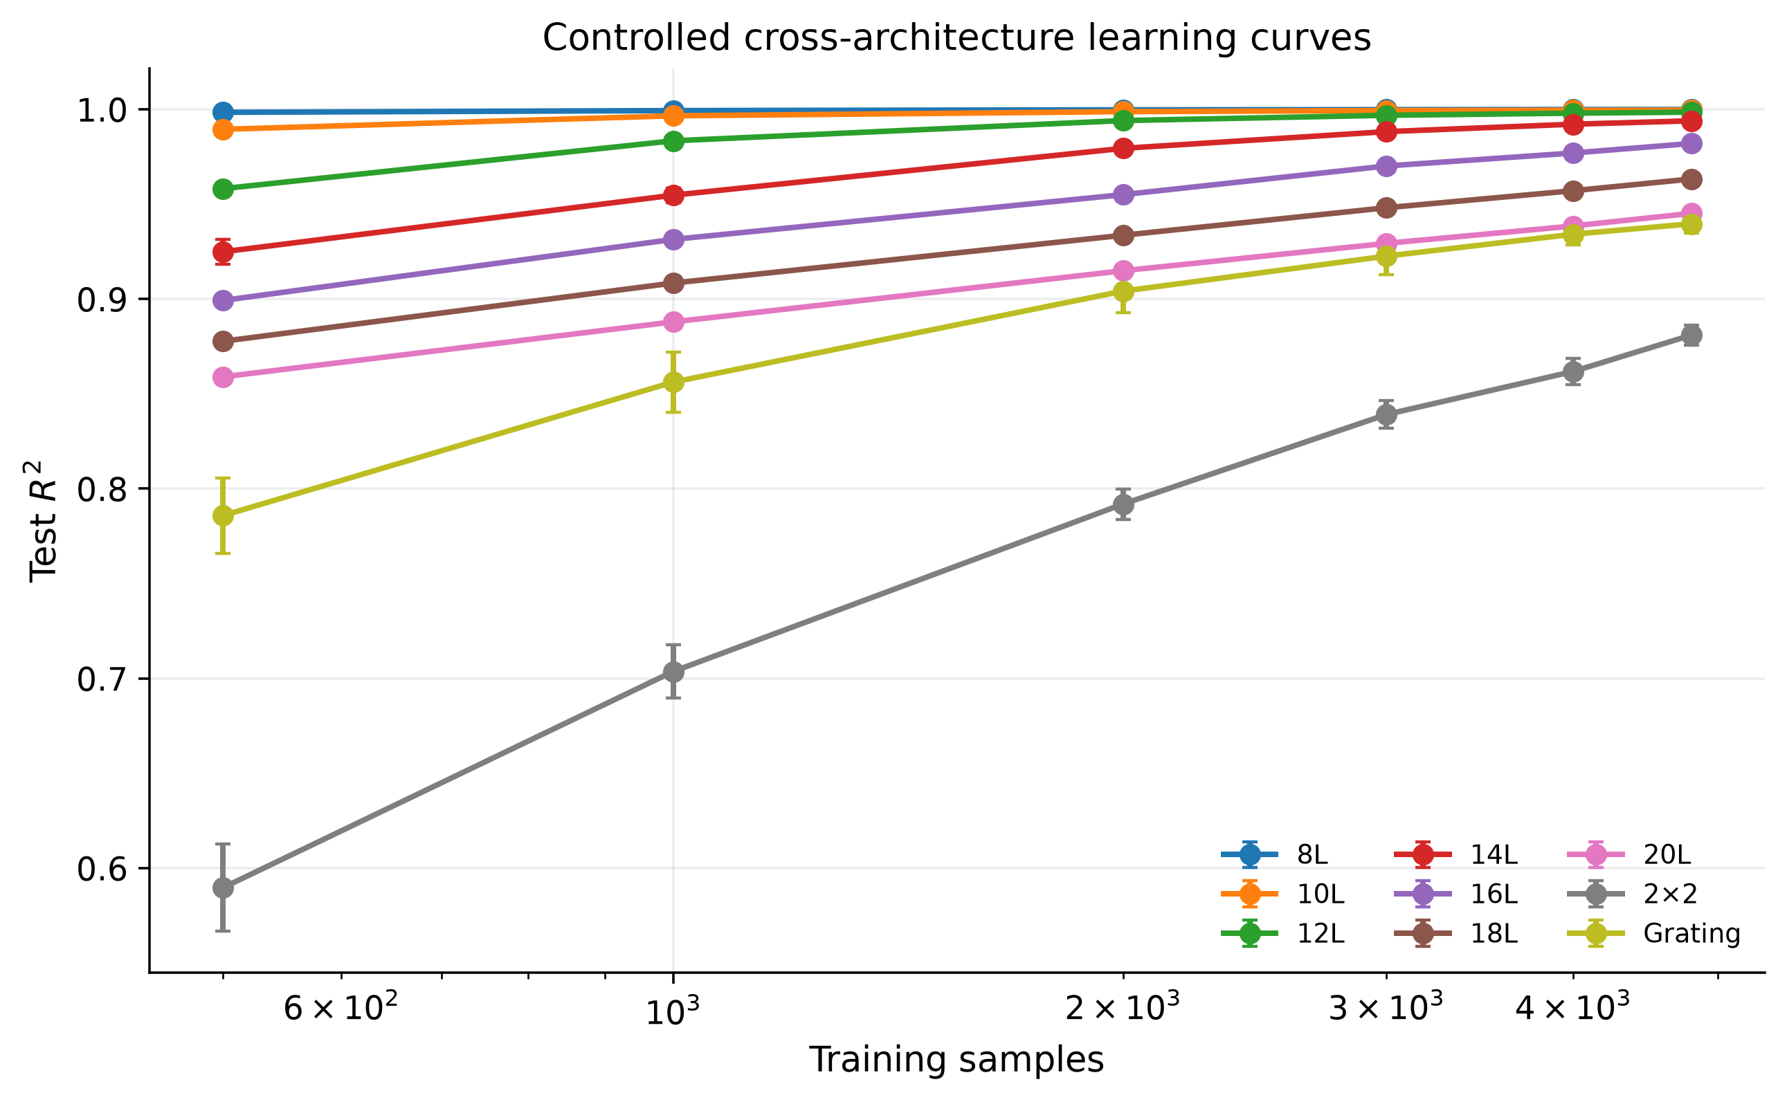
Fig. 4. Controlled neural-surrogate learning curves. Mean global test R² is plotted against training-sample size for a four-hidden-layer, width-512 MLP. Error bars are standard deviations across seeds 1-3. All cases used the same 200-point output representation, 600 validation samples, and 600 test samples.
Table 2. Learning-curve endpoints and continuous difficulty outcome.
Case | Test R² at  N = 500 | Test R² at  N = 4,800 | Learning  difficulty | R² >= 0.99  threshold
8-layer | 0.9984 ± 0.0006 | 0.9999 ± 0.0001 | 0.00056 | 500
10-layer | 0.9894 ± 0.0009 | 0.9995 ± 0.0001 | 0.00314 | 1,000
12-layer | 0.9582 ± 0.0026 | 0.9985 ± 0.0003 | 0.01370 | 2,000
14-layer | 0.9249 ± 0.0067 | 0.9939 ± 0.0009 | 0.03325 | 4,000
16-layer | 0.8992 ± 0.0029 | 0.9820 ± 0.0012 | 0.05508 | >4800
18-layer | 0.8777 ± 0.0014 | 0.9633 ± 0.0010 | 0.07683 | >4800
20-layer | 0.8590 ± 0.0022 | 0.9452 ± 0.0010 | 0.09605 | >4800
2×2 | 0.5897 ± 0.0230 | 0.8810 ± 0.0052 | 0.24805 | >4800
Grating | 0.7858 ± 0.0198 | 0.9396 ± 0.0047 | 0.12131 | >4800

2.5 Global complexity predicts difficulty; local dimension alone does not
Across the nine cases, common-grid PCA99 was strongly associated with learning difficulty (Pearson r = 0.894, p = 0.00115; Spearman rho = 0.900, exact two-sided permutation p = 0.00203). TwoNN local intrinsic dimension showed no comparable marginal association (r = 0.029, p = 0.942; rho = 0.300, exact p = 0.437), nor did design dimension (r = -0.131, p = 0.737; rho = 0.083, exact p = 0.843). Rank-based sensitivity analyses and residualization against design dimension gave the same qualitative result.
The PCA99/TwoNN and effective-rank/TwoNN ratios each reached Spearman rho = 0.983, with exact p = 4.96 × 10⁻⁵ and Benjamini-Hochberg q = 1.74 × 10⁻⁴ across the seven prespecified predictors. After removal of any single case, rho remained between 0.976 and 1.000; the rank association was therefore not driven by either cross-family endpoint. The ratio was less successful as a numerical cost model. In one-predictor leave-one-case-out regression, PCA99 gave RMSE = 0.0479 and Q² = 0.580, compared with RMSE = 0.0750 and Q² = -0.032 for PCA99/TwoNN. The ratio preserves the case ordering but overpredicts the grating difficulty and underpredicts the 2×2 difficulty (Fig. 5 and Table 3).
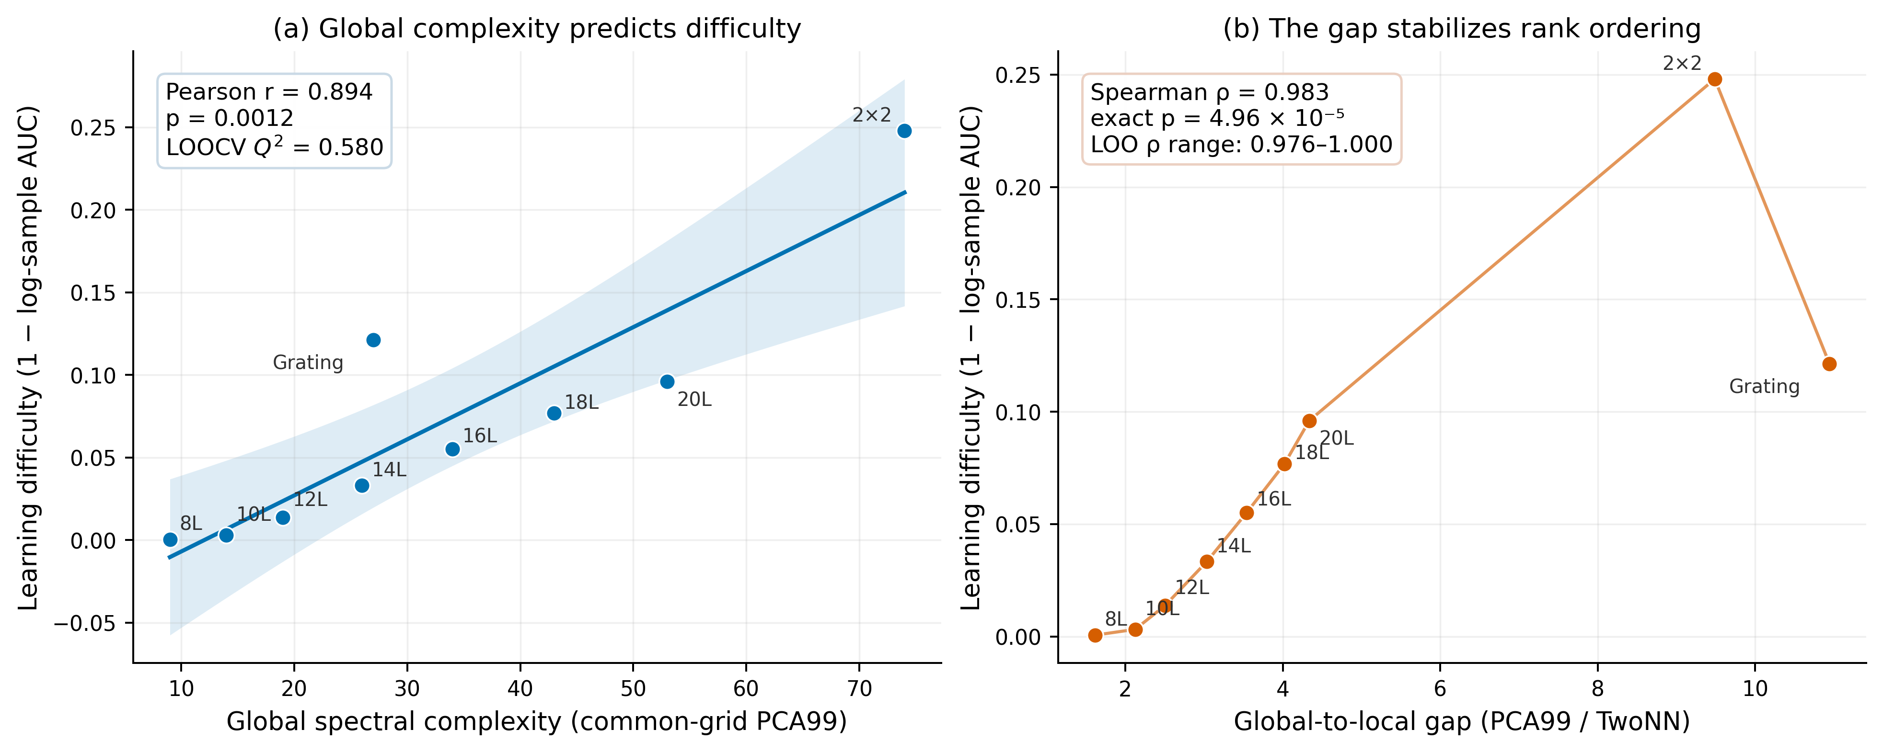
Fig. 5. Geometry-learning association with robustness statistics. (a) Common-grid PCA99 provides the strongest calibrated one-predictor leave-one-case-out model of continuous learning difficulty; the line and band show the ordinary least-squares fit and 95% mean-response interval. (b) The PCA99/TwoNN ratio provides the strongest rank ordering. The connecting line is a visual ordering guide, not a fitted cost model. Exact p values enumerate all 9! outcome permutations.
Table 3. Geometry predictors of continuous learning difficulty across nine cases.
Predictor | Pearson  r | p | Spearman  rho | Exact p | BH q | LOOCV  RMSE | Q²
PCA99 dimension | 0.894 | 0.0012 | 0.900 | 0.0020 | 0.0047 | 0.0479 | 0.580
Participation ratio | 0.801 | 0.0094 | 0.833 | 0.0083 | 0.0145 | 0.0632 | 0.267
Effective rank | 0.779 | 0.0134 | 0.750 | 0.0255 | 0.0357 | 0.0660 | 0.202
PCA99 / TwoNN | 0.844 | 0.0042 | 0.983 | 4.96e-05 | 0.0002 | 0.0750 | -0.032
Effective-rank / TwoNN | 0.865 | 0.0026 | 0.983 | 4.96e-05 | 0.0002 | 0.0672 | 0.171
TwoNN local ID | 0.029 | 0.9417 | 0.300 | 0.4366 | 0.5094 | 0.0914 | -0.534
Design dimension | -0.131 | 0.7366 | 0.083 | 0.8432 | 0.8432 | 0.0897 | -0.477

Note: Exact p values are two-sided permutation tests over all 9! assignments. BH q values correct the seven prespecified Spearman tests. LOOCV statistics come from separate one-predictor linear regressions trained on eight cases and evaluated on the ninth.

2.6 Capacity curves do not support a monotonic parameter-threshold claim
The capacity experiments used 4,800 training samples and hidden widths from 32 to 512. The easier multilayer cases reached R² ≥ 0.99 with relatively few parameters, whereas several difficult cases had nonmonotonic test curves (Fig. 6). For the 20-layer and 2×2 cases, for example, width 128 performed better than width 512. Only four cases crossed the R² ≥ 0.99 threshold within the tested range. Parameter count is therefore confounded by optimization and generalization in this experiment, and we do not interpret the curves as monotonic capacity thresholds. They mainly limit the scope of the geometry result: spectral geometry predicts fixed-protocol sample difficulty more clearly than it predicts the best finite-width network.
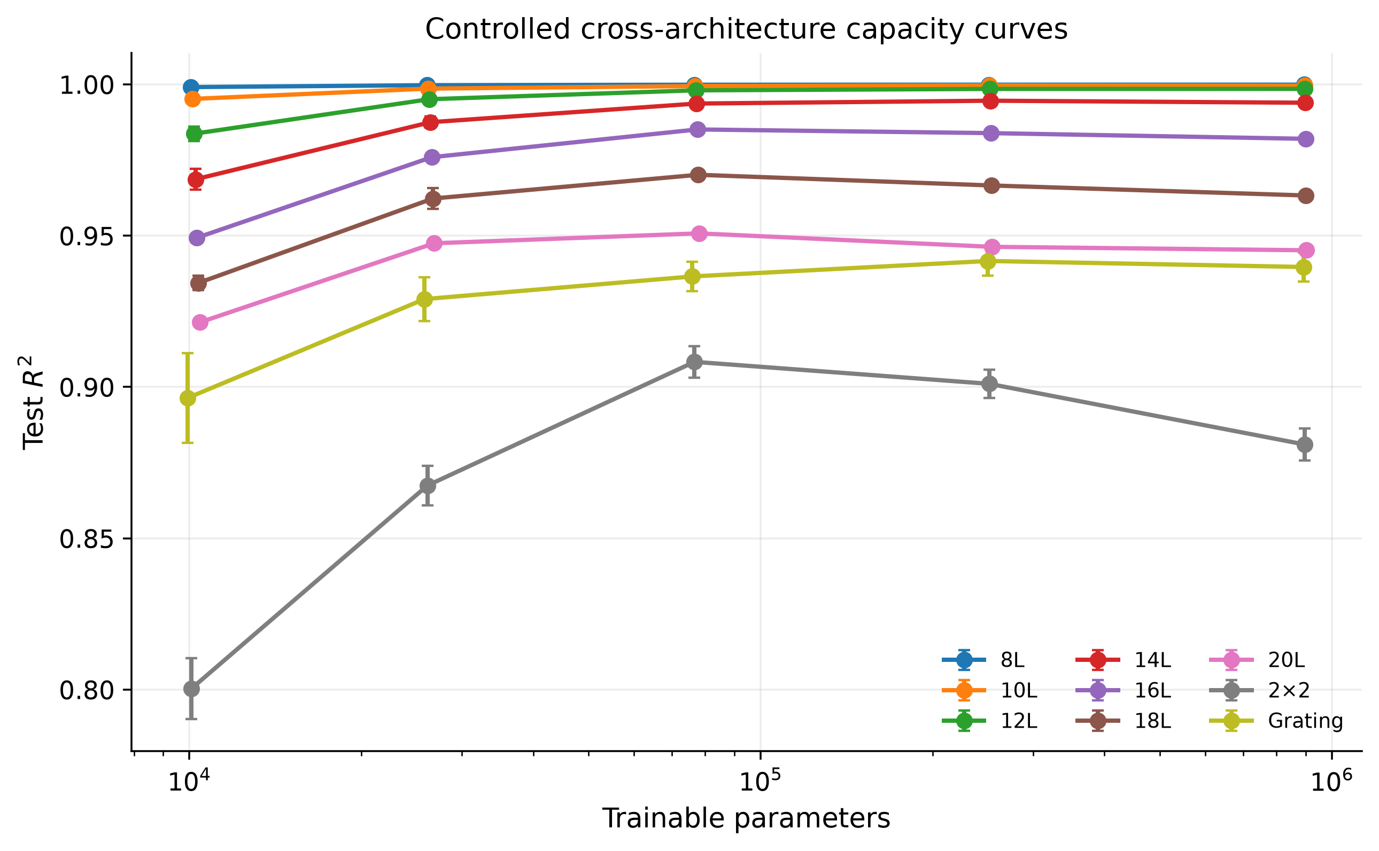
Fig. 6. Controlled capacity curves at 4,800 training samples. Mean global test R² is plotted against trainable parameter count for four-hidden-layer MLPs with widths 32, 64, 128, 256, and 512. Error bars are standard deviations across three seeds. Nonmonotonic curves for several difficult cases preclude a simple minimum-capacity interpretation.

3. Discussion
The results distinguish local from global spectral geometry. Local intrinsic dimension increased with multilayer depth and clearly contains structural information, but it did not predict neural-surrogate learning difficulty across the 2×2 and grating cases. PCA99 did. One interpretation is that a fixed MLP must learn not only the local degrees of freedom but also the spectral directions occupied across the full design distribution. If tangent directions rotate across a manifold, or if separated regions emphasize different resonances, a response set may be locally low-dimensional and still require many global components.
The global-to-local ratio makes this contrast more explicit. Its near-perfect rank association, together with its leave-one-out stability, shows that the excess of global over local dimension is useful for ordering these nine datasets. The numerical predictions were less accurate. The grating and 2×2 cases have the two largest ratios but appear in the opposite order when ranked by learning difficulty. Thus, the ratio describes manifold organization, whereas the absolute global span measured by PCA99 better estimates the magnitude of the fixed-protocol burden.
Within the multilayer series, design dimension appears predictive because layer count, global complexity, local dimension, and learning difficulty rise together. That relationship breaks when the 2×2 and grating cases are added. A correlation within one device family is therefore not enough to establish a transferable complexity measure. Although the cross-family sample is small, it is sufficient to rule out design dimension as the sole explanation and supports examining response geometry before committing to a large simulation library.
In practice, one could begin with a pilot library of roughly 5,000 spectra, map the responses to a common analysis representation, and compute PCA99, participation ratio, effective rank, and TwoNN before searching over surrogate models. PCA99 offers the most useful first estimate of relative sample burden. The global/local ratio can then flag response sets that occupy many global directions despite having few local degrees of freedom. This screening cannot replace an actual learning curve, but it can help set pilot budgets and discourage direct transfer of a sample count from a geometrically simpler device.
The evidence remains limited to nine architecture-level observations, with seven multilayers and only one example from each of the other two families. This 7/1/1 imbalance does not support universal comparisons between device families. In addition, normalized-axis resampling equalizes output dimension without aligning physical wavelength or frequency. The measured global complexity therefore depends on the spectral interval used for each dataset.
The learning result is also conditional on one MLP family, loss function, optimizer, and train/validation/test protocol. Correlation alone does not show that curvature or folding causes the observed learning difficulty, and the capacity curves indicate that optimization and generalization can outweigh nominal parameter count. The available archive contains aggregate three-seed summaries but not the raw per-seed DNN tables or run metadata. Those files should be included in any public reproducibility release.
A stronger test will require more architectures rather than more descriptors of the same nine datasets. This should include several gratings, several metasurface or 2×2 variants, and additional spectral intervals generated under matched simulation conditions. Repeating the analysis with convolutional, residual, Fourier, and operator-learning models would show whether global spectral complexity predicts data requirements across surrogate classes or mainly for fully connected MLPs. A prospective experiment could estimate geometry from a pilot set, specify the expected sample requirement in advance, and test it on held-out device families.

4. Methods

4.1 Datasets and electromagnetic responses
Nine paired design-response datasets were analyzed. Seven multilayer datasets contained independently variable SiO₂/TiO₂ layer thicknesses di in the range 30-70 nm. The 8-, 10-, 12-, 14-, 16-, and 18-layer cases contained 50,000 samples each, and the 20-layer case contained 200,000 samples. Each response contained 200 transmission values over the thesis-documented 300-750 nm wavelength interval and was generated by a custom Python implementation of the transfer-matrix method [18].
The 2×2 dataset contained 6,000 designs for a periodic unit cell comprising four elliptical HfO₂ pillars on a SiO₂ substrate. Its nine design variables were the unit-cell period (500-900 nm) and the x- and y-directed radii of each pillar (45-200 nm). The stored response was a 551-point reflection spectrum over 300-750 nm, calculated at normal incidence by the finite-difference time-domain method in Ansys Lumerical FDTD [18].
The grating dataset contained 12,000 designs and 400-point reflection spectra over 700-1200 nm, calculated in Ansys Lumerical FDTD under broadband TM-polarized illumination [18]. The physical family was a TiO₂ relief grating on a SiO₂ substrate. The dissertation describes substrate thickness, period, two groove depths, and duty cycle as five physical quantities, with H1 and H2 sampled from 250-275 nm subject to H2 < H1, period from 450-650 nm, substrate thickness from 50-300 nm, and groove width from 50-395 nm subject to l < P. The archived design matrix used in the present analysis has four columns and contains no coordinate labels. We therefore analyze its four supplied coordinates without assigning an unverified one-to-one mapping to the five dissertation quantities.
The dissertation establishes the solver, materials, incidence, response type, spectral interval, and design ranges reported above, but it does not preserve the exact wavelength vectors, mesh settings, boundary conditions, material-dispersion database versions, or Lumerical project files. These simulator internals were not reconstructed for this response-manifold study, which uses the previously generated spectral arrays as its starting data.
Input audits verified matching sample counts for every design-response pair, finite nonnegative values, and no duplicates in the controlled duplicate checks. A learnability-based pairing test on the repaired 2×2 data yielded test R² = 0.725 for the supplied pairing and R² = -0.028 after response permutation. One of the 3,306,000 stored 2×2 response values was 1.03293 (spectral row 348, sample 5450). It was retained as generated, and no output clipping was applied, because the archived material did not provide a physical or numerical basis for altering that isolated value.

4.2 Common response representation
For cross-architecture geometry and DNN experiments, every response was represented by 200 points. Native 200-point multilayer spectra were unchanged. The 551-point 2×2 and 400-point grating responses were linearly resampled along a normalized coordinate u in [0,1]. This operation controls the number of output coordinates and prevents grid size alone from determining PCA rank or network size. It does not align physical wavelength or frequency ranges and should not be interpreted as a common physical spectral axis.

4.3 Global linear and effective spectral complexity
For a centered samples-by-spectral-coordinate matrix X, the covariance eigenvalues lambda_i were sorted in descending order and normalized as p_i = lambda_i / sum_j lambda_j. PCA99 was the smallest integer k satisfying sum_(i=1)^k p_i >= 0.99. Participation ratio was defined as d_PR = 1 / sum_i p_i^2. Effective rank was d_ER = exp[-sum_i p_i log(p_i)], following Roy and Vetterli [10]. Full-data global metrics were supplemented by 30 equal-sample repeats using 5,000 spectra per case to check sensitivity to unequal source-dataset sizes.

4.4 Local nonlinear intrinsic dimension
Local distances were computed after an orthogonal PCA projection retaining 99.99% of variance, which reduced neighbor-search cost while preserving the retained Euclidean geometry. Exact brute-force nearest neighbors were then calculated. For each point, TwoNN uses the ratio mu = r2/r1 between second- and first-neighbor distances. Under a locally uniform approximation, the maximum-likelihood estimate is d_TwoNN = n / sum_i log(mu_i) [8]. A complementary slope estimate used the lower 90% of the empirical transformed cumulative distribution. Levina-Bickel maximum-likelihood estimates were computed at k = 10, 20, and 30 [9], and local PCA dimensions were evaluated in 100-neighbor neighborhoods for 200 randomly selected points.
Primary local estimates used 5,000 spectra, five deterministic repeats, and base seed 240819. Sample-size sensitivity used 1,000 and 2,500 spectra with the same number of repeats. Empirical 95% intervals are the 2.5th and 97.5th percentiles across repeats. A synthetic five-dimensional Gaussian test and a Savitzky-Golay smoothing sensitivity analysis were run as implementation controls [17]. Reported primary values use unsmoothed spectra.

4.5 Controlled neural-surrogate experiments
Each forward surrogate was a fully connected MLP with four hidden layers, SiLU activations, and a linear 200-output layer. Input variables and each output coordinate were standardized using training-set means and standard deviations only. The learning-curve experiment fixed hidden width at 512 and used nested training sizes of 500, 1,000, 2,000, 3,000, 4,000, and 4,800. The capacity experiment fixed training size at 4,800 and used widths of 32, 64, 128, 256, and 512.
For seeds 1, 2, and 3, data were independently permuted using split seeds 991001, 991002, and 991003. The first 600 examples were held out for testing, the next 600 for validation, and nested training subsets were taken from the remaining pool. Models were optimized with AdamW [12] using mean-squared error, learning rate 1 × 10⁻³, weight decay 1 × 10⁻⁶, batch size 256, at most 600 epochs, and early stopping after 50 epochs without validation improvement greater than 1 × 10⁻⁵. Deterministic algorithms were requested in PyTorch where available [13]. The checkpoint with minimum validation MSE was evaluated on the unscaled test responses.

4.6 Evaluation outcomes
The primary performance statistic was global test R² computed from the total sum of squared errors across all test samples and spectral coordinates. Secondary metrics were the mean coordinate-wise R², RMSE, RMSE normalized by the global test-response standard deviation, MAE, mean spectral angle, and the 95th percentile across samples of the maximum absolute spectral error. Seed summaries report the mean and sample standard deviation.
For each case, the learning-curve area was integrated by the trapezoidal rule against log training-sample size and normalized by the log-size interval. Learning difficulty was D = 1 - AUC_logN. A threshold at R² ≥ 0.99 was tabulated but treated as secondary because five cases remained right-censored above 4,800 samples. Capacity thresholds were likewise secondary because test performance was not monotonic in width.

4.7 Statistical analysis
We summarized associations between D and seven prespecified predictors using Pearson correlation and Spearman rank correlation. With only nine cases, the two-sided Spearman p values were calculated exactly by enumerating all 9! permutations of the outcome ranks. Benjamini-Hochberg q values controlled the false-discovery rate across the seven rank tests. Robustness checks included the multilayer-only subset, separate exclusion of each cross-family case, leave-one-case-out ranges, and partial Pearson and rank correlations after residualizing predictor and outcome against design dimension.
For calibrated prediction, we fitted separate one-predictor ordinary least-squares models. Each case was predicted from a model trained on the other eight. We report leave-one-case-out MAE, RMSE, and Q² = 1 - SSE/SST, with SST calculated around the full-sample mean. Descriptive 95% bootstrap intervals for the two global/local rank correlations used 50,000 nonparametric case-resampling replicates. Because the nine cases are neither numerous nor independent draws from a balanced population of device families, these inferential results are treated as exploratory. Analyses used NumPy, SciPy, scikit-learn, pandas, and Matplotlib [14-16].

5. Conclusions
Across these nine datasets and the fixed MLP protocol, PCA99 tracked learning difficulty more reliably than local intrinsic dimension or the number of design variables. The PCA99/TwoNN ratio gave the most stable rank ordering, but PCA99 gave the better numerical prediction. Global and local measures therefore provide different information: their ratio is useful for comparing manifold organization, whereas absolute global span is more useful for estimating sample burden. A pilot geometry analysis may help plan simulation budgets, but broader prospective tests are needed before this relationship can be treated as a general sample-complexity law.

Data Availability
The data underlying the results presented in this paper are available from the corresponding author upon reasonable request. The accompanying reproducibility package contains the aggregate three-seed tables, analysis code, robustness outputs, and figure-generation scripts used for this manuscript. Raw per-seed training logs, run metadata, and Lumerical project files were not present in the supplied archives.

Author Contributions
Mohammad H. Javani: Conceptualization, methodology, software, validation, formal analysis, investigation, data curation, visualization, and writing.

Funding
[Funding information will be entered in Prism before submission.]

Disclosures
The authors declare no conflicts of interest.

References
- J. Peurifoy, Y. Shen, L. Jing, et al., "Nanophotonic particle simulation and inverse design using artificial neural networks," Sci. Adv. 4, eaar4206 (2018), https://doi.org/10.1126/sciadv.aar4206.
- I. Malkiel, M. Mrejen, A. Nagler, et al., "Plasmonic nanostructure design and characterization via deep learning," Light Sci. Appl. 7, 60 (2018), https://doi.org/10.1038/s41377-018-0060-7.
- D. Liu, Y. Tan, E. Khoram, et al., "Training deep neural networks for the inverse design of nanophotonic structures," ACS Photon. 5, 1365-1369 (2018), https://doi.org/10.1021/acsphotonics.7b01377.
- S. An, B. Zheng, H. Tang, et al., "A deep learning approach for objective-driven all-dielectric metasurface design," ACS Photon. 6, 3196-3207 (2019), https://doi.org/10.1021/acsphotonics.9b00966.
- Y. Kiarashinejad, S. Abdollahramezani, and A. Adibi, "Deep learning approach based on dimensionality reduction for designing electromagnetic nanostructures," npj Comput. Mater. 6, 12 (2020), https://doi.org/10.1038/s41524-020-0276-y.
- D. Melati, Y. Grinberg, M. Kamandar Dezfouli, et al., "Mapping the global design space of nanophotonic components using machine learning pattern recognition," Nat. Commun. 10, 4775 (2019), https://doi.org/10.1038/s41467-019-12698-1.
- M. Zandehshahvar, Y. Kiarashinejad, and A. Adibi, "Metric learning: harnessing the power of machine learning in nanophotonics," ACS Photon. 10, 900-909 (2023), https://doi.org/10.1021/acsphotonics.2c01331.
- E. Facco, M. d'Errico, A. Rodriguez, et al., "Estimating the intrinsic dimension of datasets by a minimal neighborhood information," Sci. Rep. 7, 12140 (2017), https://doi.org/10.1038/s41598-017-11873-y.
- E. Levina and P. J. Bickel, "Maximum likelihood estimation of intrinsic dimension," in Advances in Neural Information Processing Systems 17 (MIT Press, 2004), pp. 777-784.
- O. Roy and M. Vetterli, "The effective rank: a measure of effective dimensionality," in 15th European Signal Processing Conference (IEEE, 2007), pp. 606-610.
- A. McRae, J. Romberg, and M. Davenport, "Sample complexity and effective dimension for regression on manifolds," in Advances in Neural Information Processing Systems 33 (Curran Associates, 2020).
- I. Loshchilov and F. Hutter, "Decoupled weight decay regularization," in International Conference on Learning Representations (2019).
- A. Paszke, S. Gross, F. Massa, et al., "PyTorch: an imperative style, high-performance deep learning library," in Advances in Neural Information Processing Systems 32 (Curran Associates, 2019), pp. 8024-8035.
- F. Pedregosa, G. Varoquaux, A. Gramfort, et al., "Scikit-learn: machine learning in Python," J. Mach. Learn. Res. 12, 2825-2830 (2011).
- P. Virtanen, R. Gommers, T. E. Oliphant, et al., "SciPy 1.0: fundamental algorithms for scientific computing in Python," Nat. Methods 17, 261-272 (2020), https://doi.org/10.1038/s41592-019-0686-2.
- C. R. Harris, K. J. Millman, S. J. van der Walt, et al., "Array programming with NumPy," Nature 585, 357-362 (2020), https://doi.org/10.1038/s41586-020-2649-2.
- A. Savitzky and M. J. E. Golay, "Smoothing and differentiation of data by simplified least squares procedures," Anal. Chem. 36, 1627-1639 (1964), https://doi.org/10.1021/ac60214a047.
- M. H. Javani, "Machine learning approaches for knowledge discovery in nanophotonic structures," Ph.D. dissertation (Georgia Institute of Technology, 2024).

Supplementary information

Supplementary robustness analysis
Figure S1 compares calibration and rank stability. In panel (a), PCA99 has the lowest leave-one-case-out RMSE for continuous learning difficulty. Panel (b) shows how the Spearman correlation changes when each architecture is removed in turn; the two global/local ratios retain the highest and narrowest ranges. We therefore report PCA99 as the primary calibrated predictor and the ratio as a secondary rank descriptor.
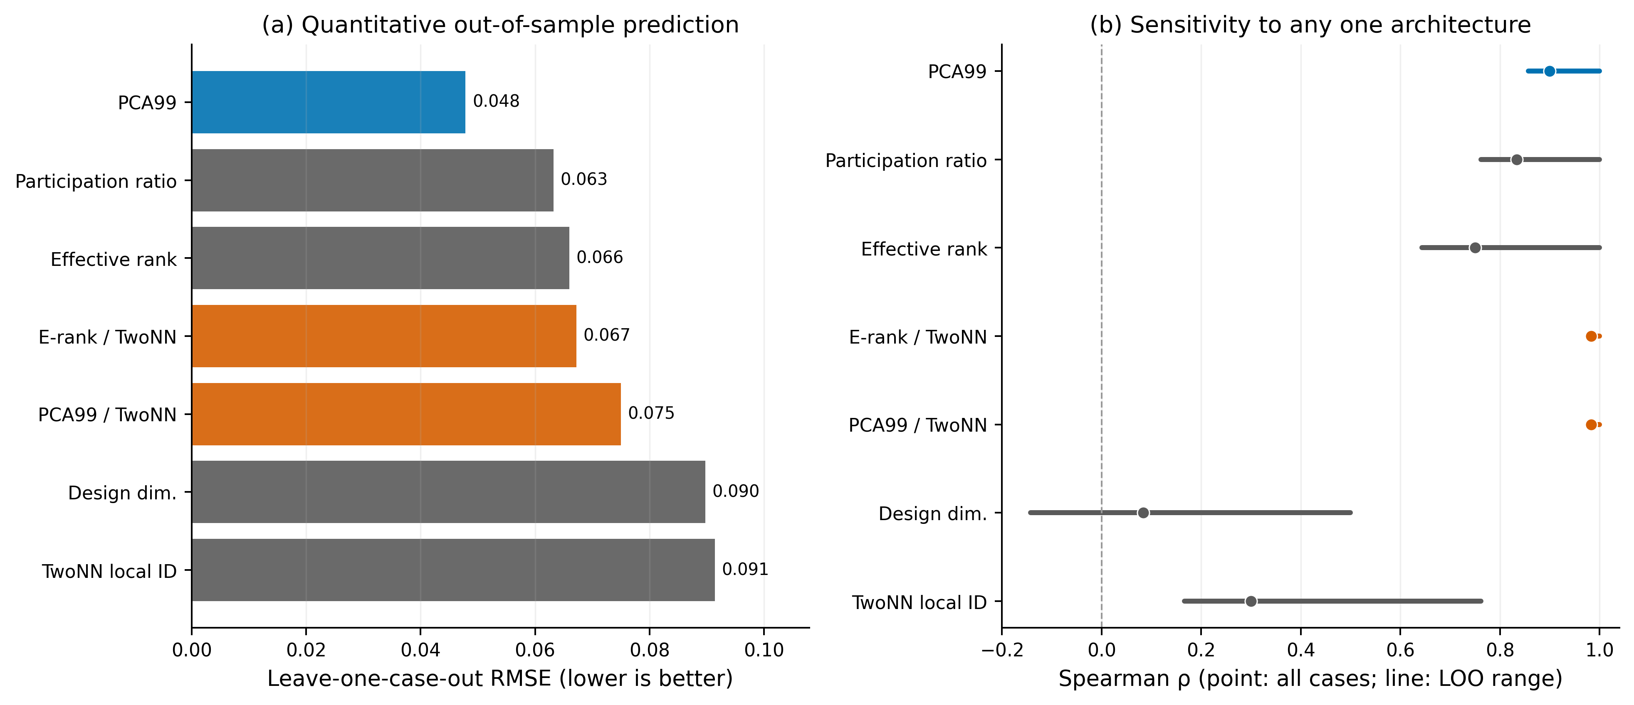
Fig. S1. Predictor robustness. (a) Leave-one-case-out RMSE for univariate linear models of learning difficulty. (b) Full-sample Spearman rho (point) and the range after dropping each case in turn (line). Blue marks the best calibrated predictor; orange marks global/local ratios.

