Intrinsic Response-Manifold Dimensionality Predicts Learning Resources for Nanophotonic Surrogate Models
Mohammad H. Javani, [coauthors]
Department of Cyber-Physical Systems, Clark Atlanta University, Atlanta, Georgia, United States
[Additional affiliations]
*Corresponding author: [email]

ABSTRACT
Machine-learning surrogates can substantially reduce the cost of nanophotonic design, but their network capacity and training-set size are still usually chosen by empirical tuning rather than from properties of the photonic system itself. Here, we examine whether the intrinsic dimensionality of the optical-response manifold can provide a quantitative pre-training indicator of both resources. We analyze alternating SiO2/TiO2 multilayers with 8–20 independently variable layers and 200-point optical spectra. Participation ratio, principal-component analysis (PCA), and nonlinear autoencoder (AE) reconstruction all show that response complexity increases with structural complexity. The PCA dimension required for 99% explained variance rises from 9 to 53, while the AE latent dimension required for reconstruction R² ≥ 0.99 rises from 5 to 30. In controlled forward-surrogate experiments, the minimum tested training-set size needed for mean test R² ≥ 0.99 increases from ≤1,000 to 30,000 samples. AE dimension is strongly correlated with this data requirement (Pearson r = 0.992, p = 1.1 × 10⁻5; Spearman ρ = 0.991, p = 1.5 × 10⁻5). For structures with resolved capacity thresholds, AE dimension is also correlated with minimum tested model capacity (Pearson r = 0.955, p = 0.00295; r = 0.981 for log parameter count). In the 20-layer system, an extended 200,000-sample experiment shows that increasing the accuracy target from R² = 0.99 to 0.999 shifts the first observed training threshold from 30,000 to 150,000 samples. The results link response-manifold complexity to the practical resources needed for neural surrogate modeling and suggest a way to estimate data and model requirements before full-scale training.
KEYWORDS: nanophotonics, artificial intelligence, surrogate modeling, intrinsic dimensionality, manifold learning, autoencoder, sample complexity, multilayer optics

INTRODUCTION
Data-driven surrogate models are now widely used in computational nanophotonics because they replace repeated electromagnetic evaluations with fast learned mappings between device parameters and optical responses. Neural surrogates have been demonstrated for nanoparticles, multilayers, metasurfaces, and integrated photonic devices, and they are increasingly incorporated into inverse-design and optimization workflows.1–8 Once a surrogate is introduced, however, two practical questions remain: how much training data should be generated, and how large should the network be?
These choices are usually made empirically. Dataset sizes are often inherited from earlier studies or set by the available simulation budget, while network width and depth are adjusted until the validation error is acceptable. That approach is workable, but it offers little physical guidance and can lead to unnecessary computation. It also does not explain why photonic problems with similar nominal design dimensionality can require very different amounts of data or model capacity.
A more relevant quantity may be the complexity of the physically realizable response set. Broadband spectra live in a high-dimensional ambient space, but Maxwell-constrained responses can occupy a much smaller structured manifold. Manifold learning has already been used to identify compact representations of nanophotonic response spaces and to support inverse design.9 In our earlier pruning study, we found that dense nanophotonic surrogates can contain substantial redundant capacity.10 Taken together, these observations suggest that learning difficulty may depend less on the raw number of geometric variables or spectral samples than on the intrinsic complexity of the response manifold.
This view is also consistent with results from the broader machine-learning literature. When data are concentrated near a low-dimensional manifold, approximation and regression behavior can depend on intrinsic rather than ambient dimension.11,12 Intrinsic dimensionality has likewise been associated with representation quality and generalization in neural networks.13,14 What has not been tested systematically in photonics is whether a measurable response-manifold dimension can predict the resources needed by a separate surrogate-learning task.
We test that question using a controlled family of alternating SiO2/TiO2 multilayers with 8–20 independently variable layers and a fixed 200-point spectral representation. Response complexity is quantified using participation ratio, PCA, and nonlinear AE reconstruction. We then measure two separate resource endpoints: the minimum tested neural-network capacity and the minimum tested training-set size required to reach mean test R² ≥ 0.99. Across the multilayer family, increasing structural complexity is accompanied by higher response-manifold dimensionality and greater learning-resource demand. The nonlinear AE dimension is particularly informative, with r = 0.992 for the observed training-data threshold and r = 0.955 for resolved model-capacity thresholds. Our aim is therefore not to introduce another forward model, but to test whether response-manifold complexity can serve as a practical pre-training diagnostic for surrogate design.

METHODS

Photonic structures and data generation
We considered seven one-dimensional alternating SiO2/TiO2 multilayer classes with 8, 10, 12, 14, 16, 18, and 20 independently variable layer thicknesses. Each thickness was sampled over 30–70 nm. For every design, the optical response was evaluated at 200 uniformly sampled frequency points from 350 to 750 THz using the transfer-matrix method (TMM). The resulting forward problem maps an L-dimensional design vector to a 200-dimensional response vector.
For the primary analysis, each layer count was represented by 50,000 randomly generated design-response pairs. We also generated a separate 200,000-sample dataset for the 20-layer structure to examine the high-complexity regime at stricter accuracy targets. Quality-control checks confirmed the expected array dimensions, finite values, and the absence of exact duplicate designs or responses in the datasets used here.
AUTHOR ACTION REQUIRED BEFORE SUBMISSION: insert the exact stored optical-response quantity, material-dispersion model, polarization/incidence conditions, substrate/superstrate assumptions, and TMM boundary-condition implementation from the original simulation code.

Intrinsic response-manifold dimensionality
For each 50,000-sample dataset, 80% of the samples were assigned to training, 10% to validation, and 10% to testing. PCA was fitted only to the training spectra. If λi denotes the variance associated with principal component i, the participation ratio was calculated as DPR = (Σi λi)²/(Σi λi²). We also recorded the minimum number of principal components needed to explain 95%, 99%, 99.5%, and 99.9% of the total response variance.
Nonlinear dimensionality was estimated with fully connected autoencoders using a 200–128–64–z encoder and a symmetric z–64–128–200 decoder. Hidden layers used ReLU activations; the bottleneck and output layers were linear. The latent dimension z was swept over 1, 2, 3, 4, 5, 6, 7, 8, 9, 10, 12, 14, 16, 20, 24, 30, and 40. Models were trained with Adam (learning rate 10⁻3), mean-squared reconstruction loss, batch size 512, a maximum of 200 epochs, validation-based early stopping with patience 15, and three random seeds. We defined DAE operationally as the smallest tested latent dimension for which the mean held-out reconstruction R² reached 0.99.

Forward-surrogate capacity analysis
Fully connected forward surrogates mapped the L design variables to the 200-point optical response. We first evaluated progressively larger dense networks and then used targeted high-capacity diagnostics for the more complex structures. Models were trained with Adam and mean-squared error, with early stopping based on validation loss. The capacity endpoint was the minimum tested trainable parameter count for which mean test R² reached 0.99. The resolved values were 17,736, 17,864, 60,488, 77,256, 253,128, and 701,768 parameters for the 8-, 10-, 12-, 14-, 16-, and 18-layer systems, respectively. The 20-layer threshold was not resolved in the fixed-50,000-sample sweep and was treated as right-censored.

Controlled learning curves
To separate data limitation from model under-capacity, we assigned one fixed, capacity-appropriate four-hidden-layer network to each structure and kept that architecture unchanged throughout its learning curve. Hidden widths were 64, 64, 128, 128, 256, 448, and 896 for the 8-, 10-, 12-, 14-, 16-, 18-, and 20-layer systems, respectively. For every structure, 5,000 samples were reserved for validation and 5,000 for testing. Training subsets were nested within seed-specific random permutations. Inputs and outputs were standardized using statistics computed only from the current training subset.
The common training grid contained 5,000, 10,000, 15,000, 20,000, 25,000, 30,000, 35,000, and 40,000 samples. For the 8–14 layer structures, we added a low-sample refinement at 1,000, 2,000, 3,000, 4,000, and 5,000 samples. Networks used GELU activations, Adam with an initial learning rate of 10⁻3, ReduceLROnPlateau scheduling, a maximum of 1,200 epochs, and early stopping with patience 100. Three random seeds were used. The primary endpoint was the minimum tested training-set size at which mean test R² reached 0.99.

Extended 20-layer learning curve
The 20-layer structure was also evaluated using the 200,000-sample dataset and a fixed four-hidden-layer network of width 896, corresponding to 2,609,352 trainable parameters. Training sizes were 10,000, 20,000, 30,000, 50,000, 75,000, 100,000, 150,000, and 180,000 samples, with 10,000 samples each reserved for validation and testing.

Statistical analysis
Associations between intrinsic-complexity measures and learning-resource endpoints were quantified using Pearson product-moment and Spearman rank correlations. The 8- and 10-layer R² = 0.99 sample thresholds are left-censored because both systems already exceeded the target at the smallest tested size of 1,000 samples; these values are therefore reported as ≤1,000. To assess the effect of this censoring, we reassigned both thresholds to 250, 500, 750, and 1,000 samples and repeated the correlation analysis. The right-censored 20-layer capacity point was excluded from the capacity correlations. All statistical tests were two-sided.

RESULTS AND DISCUSSION

Structural complexity produces a higher-dimensional response manifold
Each response-complexity measure increased monotonically with layer count. The participation ratio rose from 2.36 for the 8-layer system to 9.28 for the 20-layer system. Over the same range, the PCA dimension required for 99% explained variance increased from 9 to 53, and the nonlinear AE dimension required for reconstruction R² ≥ 0.99 increased from 5 to 30 (Figure 1). The consistent ordering across linear and nonlinear measures indicates that the observed increase in complexity is not specific to a single dimensionality estimator.
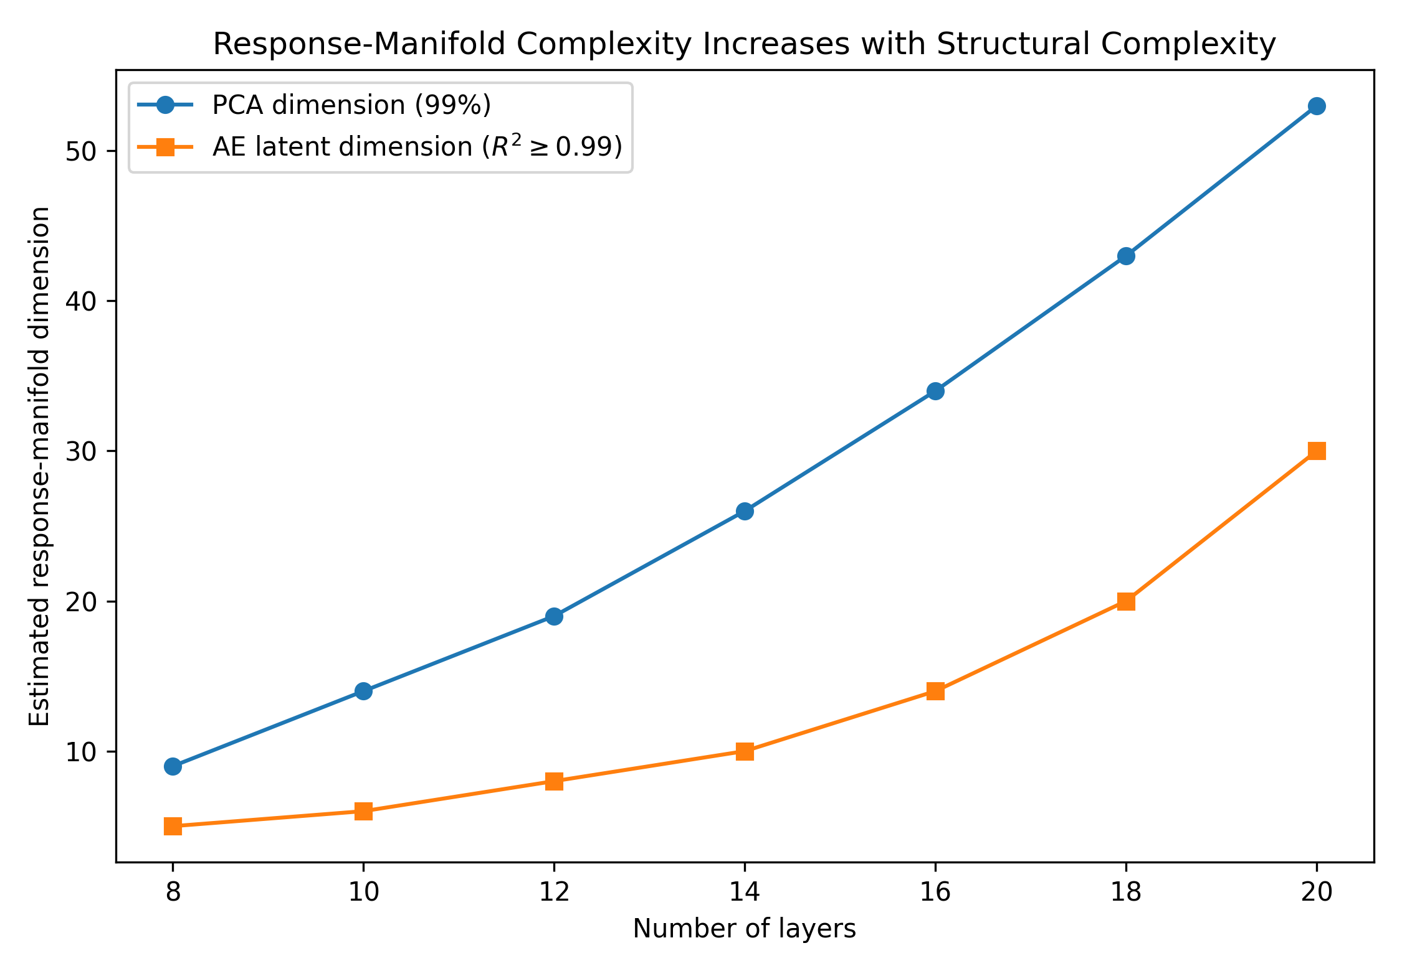
Figure 1. Response-manifold dimensionality increases with multilayer structural complexity. PCA reports the number of components needed for 99% explained variance; AE reports the smallest tested latent dimension with mean held-out reconstruction R² ≥ 0.99.
The AE representation was consistently more compact than the corresponding PCA subspace. For the 16-layer system, PCA required 34 dimensions to retain 99% of the variance, whereas the AE reached R² ≥ 0.99 with 14 latent coordinates. For 20 layers, the corresponding values were 53 and 30. This separation suggests that the physically realizable spectra occupy a structured nonlinear manifold rather than simply a higher-rank linear subspace.

Response-manifold dimensionality predicts model capacity
The minimum tested model capacity needed for test R² ≥ 0.99 increased from approximately 1.8 × 10⁴ parameters for the 8- and 10-layer systems to 7.0 × 10⁵ for 18 layers. Among the six structures with resolved thresholds, AE dimension was strongly correlated with the minimum tested parameter count (Pearson r = 0.955, p = 0.00295; Spearman ρ = 1.000). The correlation was stronger after log-transforming parameter count (Pearson r = 0.981, p = 5.40 × 10⁻4; Figure 2).
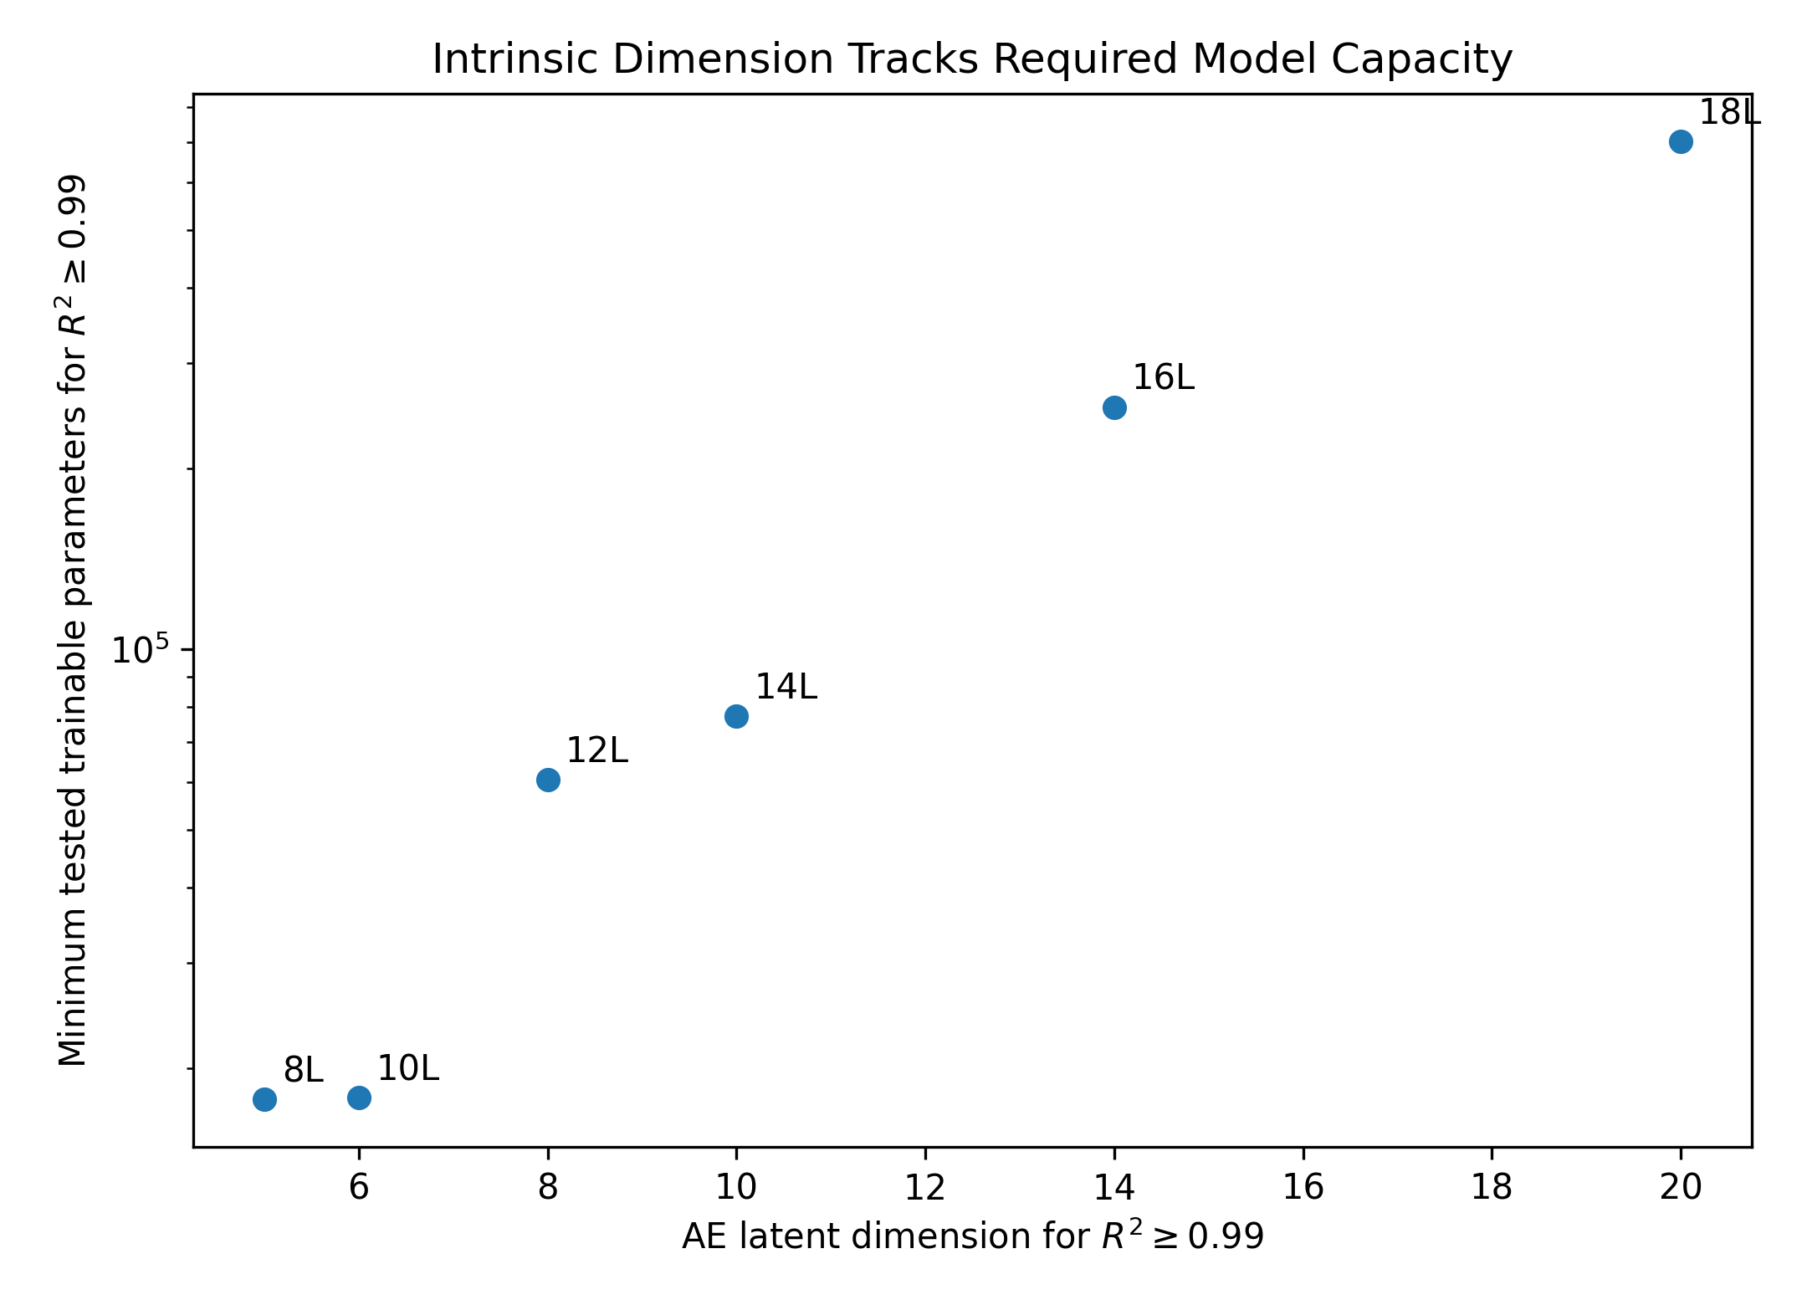
Figure 2. Nonlinear response-manifold dimension tracks the minimum tested forward-model capacity required for mean test R² ≥ 0.99. The right-censored 20-layer capacity threshold is excluded.
This capacity trend is consistent with our earlier pruning results. Pruning begins with an oversized network and identifies removable redundancy after training;10 here, we ask the complementary question of whether response complexity can indicate a reasonable capacity scale beforehand. The monotonic relationship suggests that manifold characterization may be useful when selecting an initial architecture, before any later compression or fine tuning.

Response-manifold dimensionality predicts training-data demand
The learning curves show a similarly clear increase in data requirement. The 8- and 10-layer systems already exceeded mean test R² = 0.99 with 1,000 training samples. The first tested sizes that reached the same target were 2,000 samples for 12 layers, 4,000 for 14 layers, 10,000 for 16 layers, 15,000 for 18 layers, and 30,000 for 20 layers (Table 1 and Figure 3).
Layers | Participation ratio | PCA 99% | AE dim. | Min. tested samples | Min. tested parameters
8 | 2.36 | 9 | 5 | ≤1,000 | 17,736
10 | 3.15 | 14 | 6 | ≤1,000 | 17,864
12 | 4.20 | 19 | 8 | 2,000 | 60,488
14 | 5.36 | 26 | 10 | 4,000 | 77,256
16 | 6.62 | 34 | 14 | 10,000 | 253,128
18 | 7.93 | 43 | 20 | 15,000 | 701,768
20 | 9.28 | 53 | 30 | 30,000 | —
Table 1. Response-manifold complexity and learning-resource thresholds. The 8- and 10-layer sample thresholds are left-censored at 1,000 samples; the 20-layer fixed-50k capacity threshold is right-censored.
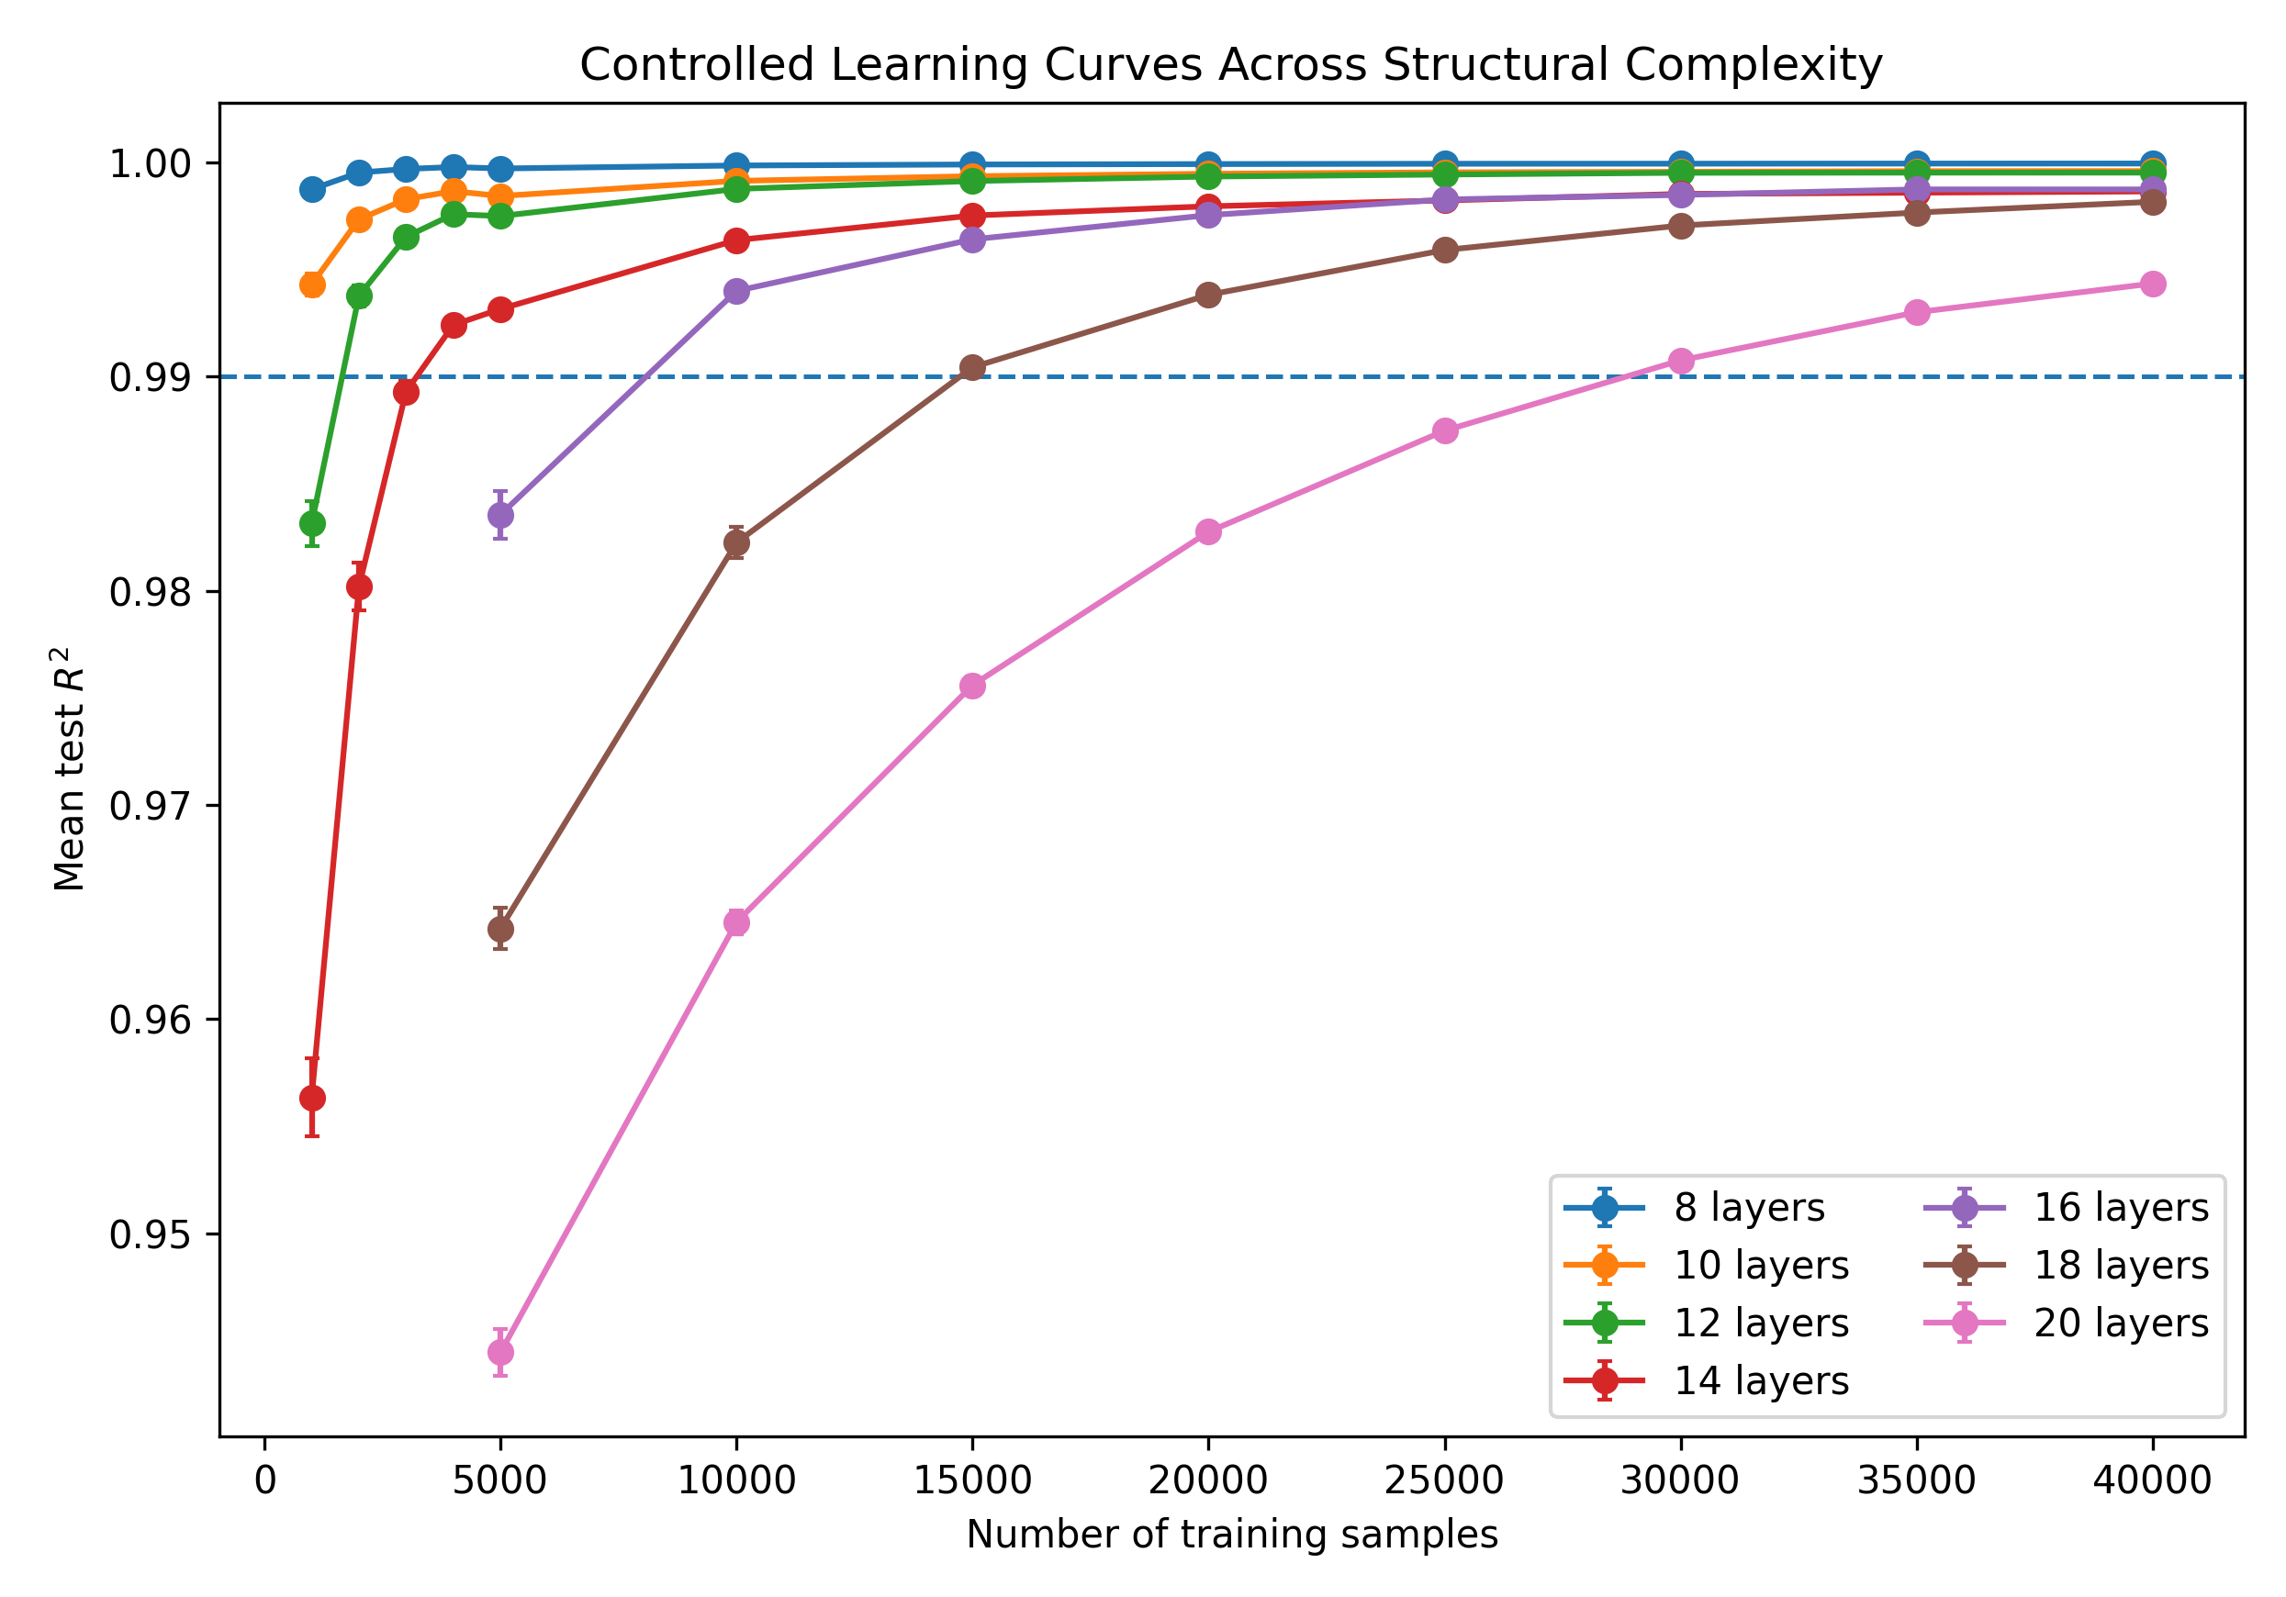
Figure 3. Controlled learning curves across the seven multilayer systems. Each structure uses a fixed capacity-appropriate architecture; the horizontal line denotes mean test R² = 0.99.
Using these minimum tested thresholds, AE dimension was strongly correlated with training-data requirement (Pearson r = 0.992, p = 1.1 × 10⁻5; Spearman ρ = 0.991, p = 1.5 × 10⁻5). Participation ratio and PCA-based dimensions followed the same ordering. The relationship is therefore not unique to the AE definition of complexity.
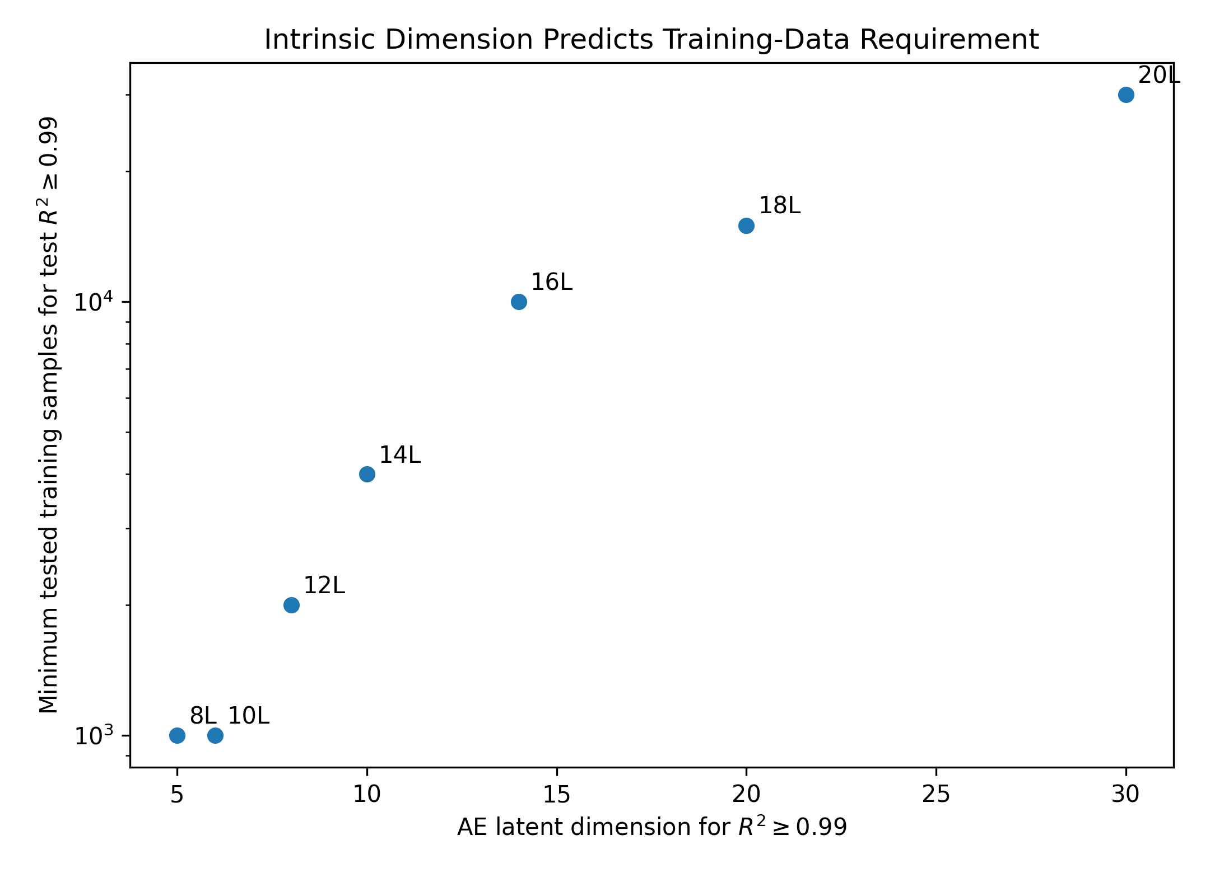
Figure 4. AE response-manifold dimension versus minimum tested training-set size required for mean test R² ≥ 0.99. The training-size axis is logarithmic.

Censoring sensitivity and stricter accuracy targets
Because the true R² = 0.99 thresholds for the 8- and 10-layer systems lie below 1,000 samples, we checked whether assigning both values to the boundary of 1,000 samples was driving the correlation. It was not. Reassigning the censored thresholds to 250, 500, 750, or 1,000 samples left the relationship significant. Even with the 250-sample assumption, the correlation between AE dimension and log10 sample requirement was r = 0.873 (p = 0.0104); with 1,000 samples, r = 0.942 (p = 0.00152). Spearman ρ remained 0.991 (p = 1.5 × 10⁻5) throughout.
The extended 20-layer experiment also shows how strongly the data requirement depends on the desired fidelity. Mean test R² increased from 0.9645 at 10,000 training samples to 0.9907 at 30,000, 0.9961 at 50,000, 0.9989 at 100,000, and 0.99958 at 180,000 samples. The first tested sizes exceeding R² = 0.99, 0.995, and 0.999 were 30,000, 50,000, and 150,000 samples, respectively (Figure 5). Over the same range, the train-test generalization gap decreased from approximately 0.026 to 0.00030.
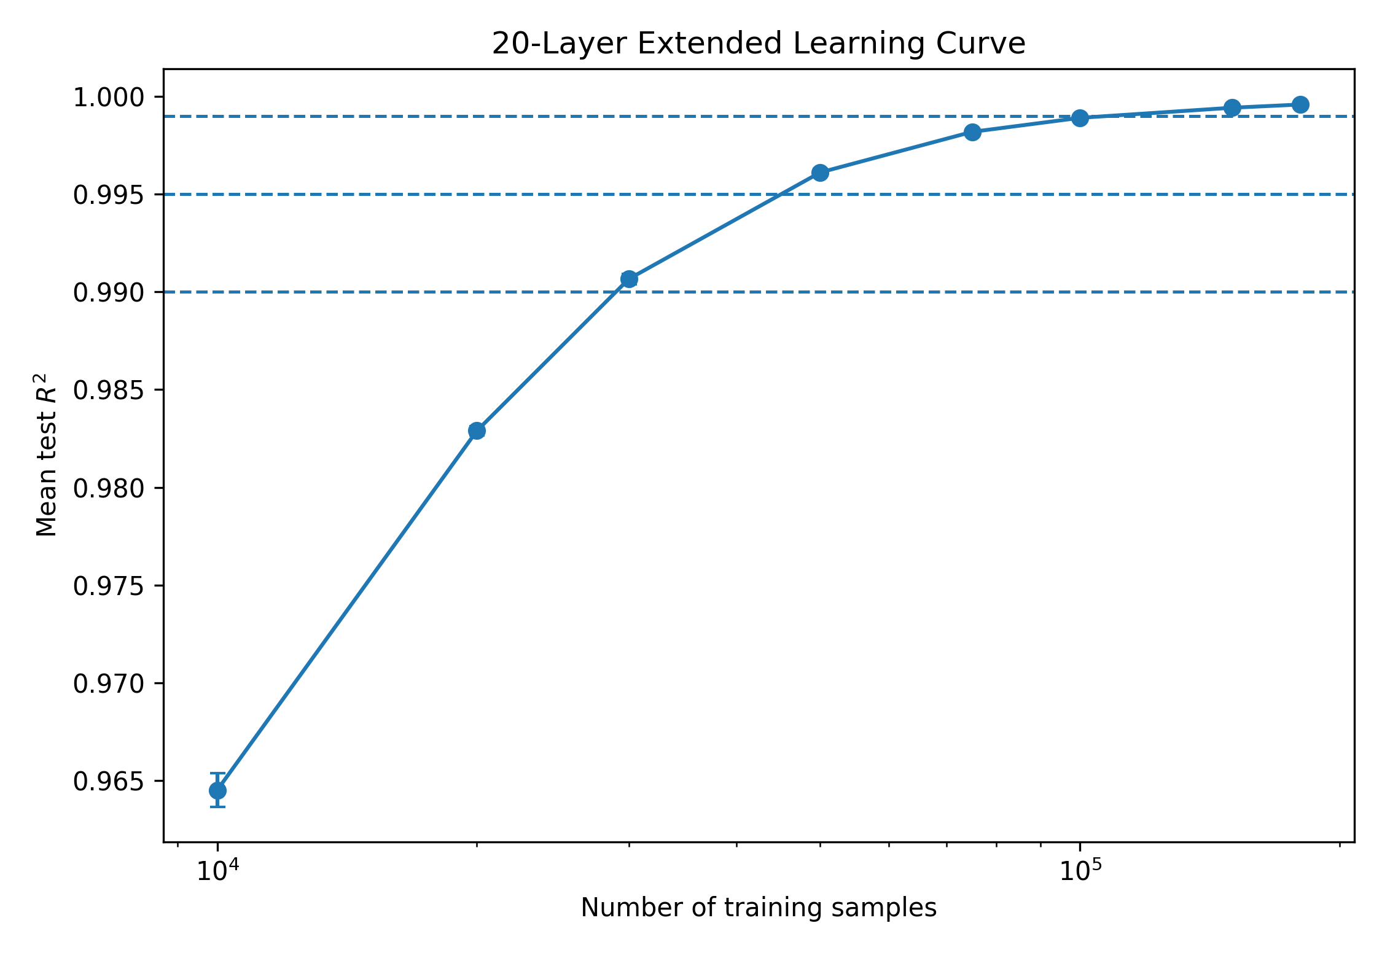
Figure 5. Extended 20-layer learning curve using the 200,000-sample dataset. Increasingly stringent surrogate-accuracy targets require substantially larger training sets.

Practical implications and limitations
These results suggest a practical change in how surrogate-model resources are selected. Rather than generating a large dataset first and tuning network size afterward, one can use a pilot dataset to estimate response-manifold complexity and use that estimate to choose an initial data budget and model scale. This is particularly relevant in photonics, where electromagnetic data generation can dominate the offline cost of a machine-learning workflow.
The reported relationships should not be read as universal scaling laws. The thresholds depend on the network architecture, optimizer, sampling distribution, response noise, and chosen accuracy criterion. They are also minimum tested values on discrete grids rather than exact mathematical complexities. Within those limits, however, the same ordering is recovered by independent dimensionality estimators and by two different resource endpoints, and the sample relationship remains significant under the censoring sensitivity analysis.
The present study is deliberately restricted to one physical family. That controlled setting makes the layer-count comparison easier to interpret, but the numerical thresholds should not be transferred directly to metasurfaces, gratings, resonators, or experimental data. A useful next test is therefore cross-family generalization: whether a normalized response-manifold descriptor predicts learning resources across qualitatively different photonic systems.

CONCLUSIONS
The intrinsic dimensionality of the optical-response manifold provides a quantitative link between structural complexity and the resources needed for neural surrogate learning. In the SiO2/TiO2 multilayers studied here, increasing the layer count from 8 to 20 systematically increased participation ratio, PCA dimension, and nonlinear AE dimension. The same progression was accompanied by higher minimum tested model capacity and larger training sets at a fixed accuracy target. AE dimension correlated with the observed sample threshold at r = 0.992 and with resolved model-capacity thresholds at r = 0.955. These results support a practical workflow in which response-manifold complexity is estimated from pilot simulations and then used to guide data generation and initial model sizing before full-scale training.

ASSOCIATED CONTENT
Supporting Information. Detailed architecture tables, hyperparameters, threshold definitions, censoring sensitivity analysis, and additional PCA/AE dimensionality results can be provided as Supporting Information. The public reproducibility repository contains the analysis scripts and frozen result tables.

DATA AND CODE AVAILABILITY
Code and frozen analysis outputs are included in the accompanying GitHub reproducibility package. Because the raw simulation datasets are large, they will be deposited in a DOI-bearing data repository and linked from the GitHub README before submission. [INSERT GITHUB URL AND DATA DOI].

AUTHOR INFORMATION
Corresponding Author: Mohammad H. Javani — [email]
Author Contributions: M.H.J.: Conceptualization, methodology, software, formal analysis, investigation, visualization, writing—original draft, and supervision. [Add finalized contributions for all coauthors.]
Notes: The authors declare no competing financial interest.

ACKNOWLEDGMENTS
[Insert funding sources, institutional support, computational resources, and collaborator acknowledgments.]

REFERENCES
1. Molesky, S.; Lin, Z.; Piggott, A. Y.; Jin, W.; Vucković, J.; Rodriguez, A. W. Inverse Design in Nanophotonics. Nat. Photonics 2018, 12, 659–670.
2. Jensen, J. S.; Sigmund, O. Topology Optimization for Nano-Photonics. Laser Photonics Rev. 2011, 5, 308–321.
3. Peurifoy, J.; et al. Nanophotonic Particle Simulation and Inverse Design Using Artificial Neural Networks. Sci. Adv. 2018, 4, eaar4206.
4. Malkiel, I.; et al. Plasmonic Nanostructure Design and Characterization via Deep Learning. Light Sci. Appl. 2018, 7, 60.
5. Liu, D.; Tan, Y.; Khoram, E.; Yu, Z. Training Deep Neural Networks for the Inverse Design of Nanophotonic Structures. ACS Photonics 2018, 5, 1365–1369.
6. Wiecha, P. R.; Arbouet, A.; Girard, C.; Muskens, O. L. Deep Learning in Nano-Photonics: Inverse Design and Beyond. Photonics Res. 2021, 9, B182–B200.
7. So, S.; Badloe, T.; Noh, J.; Bravo-Abad, J.; Rho, J. Deep Learning Enabled Inverse Design in Nanophotonics. Nanophotonics 2020, 9, 1041–1057.
8. Ma, W.; et al. Deep Learning for the Design of Photonic Structures. Nat. Photonics 2021, 15, 77–90.
9. Kiarashinejad, Y.; et al. Manifold Learning for Knowledge Discovery and Intelligent Inverse Design of Photonic Nanostructures: Breaking the Geometric Complexity. ACS Photonics 2022.
10. Javani, M. H.; Zandehshahvar, M.; Adibi, A. Reducing Computation Complexity in Optimization of Nanophotonic Structures Using Pruning. IEEE Photonics Technol. Lett. 2024, 36.
11. McRae, A.; Romberg, J.; Davenport, M. Sample Complexity and Effective Dimension for Regression on Manifolds. Adv. Neural Inf. Process. Syst. 2020, 33.
12. Sharma, U.; Kaplan, J. Scaling Laws from the Data Manifold Dimension. J. Mach. Learn. Res. 2022, 23, 1–34.
13. Ansuini, A.; Laio, A.; Macke, J. H.; Zoccolan, D. Intrinsic Dimension of Data Representations in Deep Neural Networks. Adv. Neural Inf. Process. Syst. 2019, 32.
14. Kienitz, D.; Komendantskaya, E.; Lones, M. The Effect of Manifold Entanglement and Intrinsic Dimensionality on Learning. Proc. AAAI Conf. Artif. Intell. 2022, 36, 7160–7167.
15. Jolliffe, I. T. Principal Component Analysis, 2nd ed.; Springer: New York, 2002.
16. Hinton, G. E.; Salakhutdinov, R. R. Reducing the Dimensionality of Data with Neural Networks. Science 2006, 313, 504–507.
17. Kingma, D. P.; Ba, J. Adam: A Method for Stochastic Optimization. ICLR 2015.
18. Yeh, P. Optical Waves in Layered Media; Wiley: Hoboken, NJ, 2005.

FOR TABLE OF CONTENTS USE ONLY
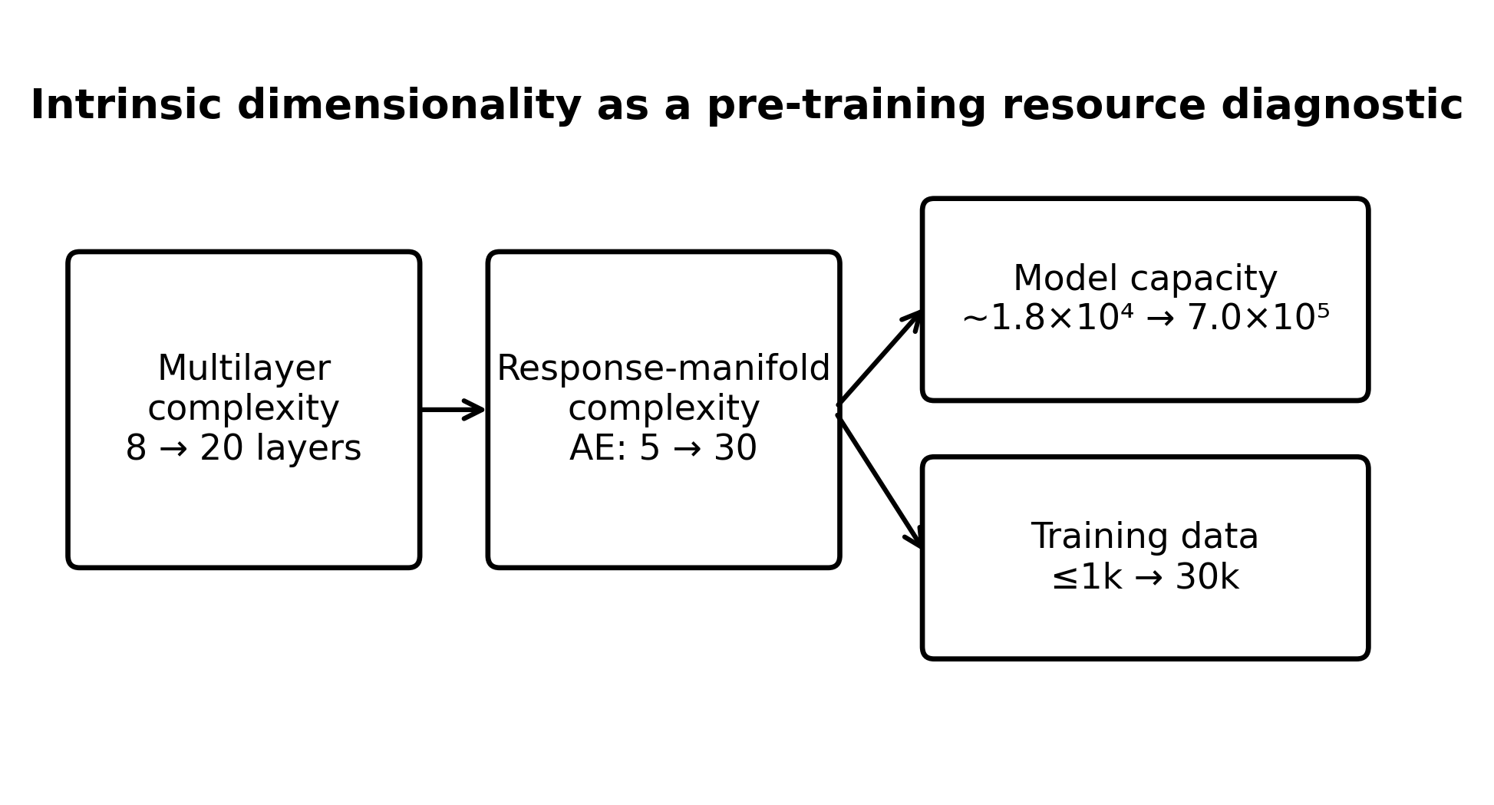
Intrinsic response-manifold dimensionality provides a pre-training indicator of the neural-network capacity and training data required to learn nanophotonic systems.

