Crossover Test Project

Virtual Exposition System

Design Document

# Specification

Objective is to architect, design and implement from the ground up a virtual exposition application, it will allow companies to book their place in virtual expositions in different exposition events.

Companies will choose from available events the one they want to take place in, then they will choose their stand within the exposition hall from a map and finally they will receive a report about the users who visited their stand on the event after it is over.

# Requirements

Create the web application with the following requirements:

1. The home screen displays a map with different event places highlighted on it.
2. Selecting an event on the map displays the event details (name, location, event dates) right below the map and the “Book your place” button become active.
3. Clicking “Book your place” will take the user to the exposition hall map, it is a virtual map for the exposition hall with different stands which he can navigate through it and book his stand.
4. Booked stands is highlighted as booked, the logo of the booking company will be displayed on top of the stand, below it the marketing documents (could be downloaded) and the contact details.
5. Free stands is highlighted as free, and on top of it the price.
6. The user can select any empty stand to book, clicking on an empty stand shows a popup with details of the stand, a real image of it and a “Reserve” button.
7. Clicking on reserve takes the user to the registration page where he supposed to provide: contact details, upload marketing documents, company admin and company logo.
8. Clicking on “Confirm Reservation” reserves the stand for the user, takes him to the exposition hall screen viewing the booked stand with the user’s company details on it.
9. Finally the company admin receives a report by mail about the users of the stand after the event is over.

# ERD

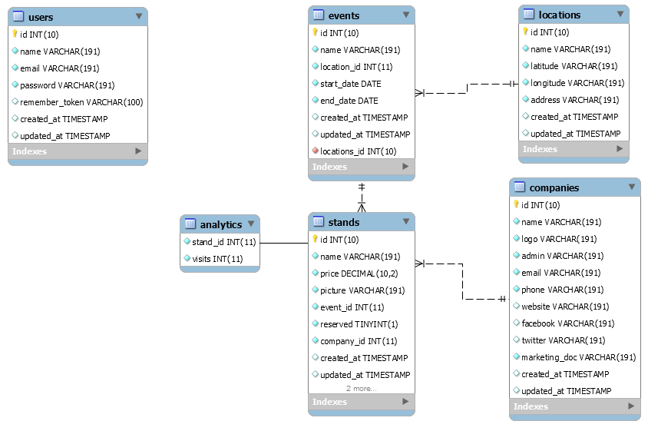

# Technology

System has been developed using

* PHP 7
* Laravel 5.5
* AngularJS 1.6
* Twitter Bootstrap 4
* Google Maps API
* SVG
* D3.js
* PHPUnit
* Laravel Dusk
* MySQL Database

# Implementation

All the requirements specified above are implanted including:

* Show events on maps
* There are three options for events available in top menu
  + Upcoming events – where companies can book stand
  + Current events – where visitors can visit stands and their visits will be tracked
  + Expired events – these are past events
* To reserve user has to be logged in
* Once event is finished emails can be sent using custom artisan command
  + php artisan email:send
* Above command can be scheduled in cron to run daily midnight

# Classes

Following model classes have been used

* Analytic
* Company
* Event
* Location
* Stand
* User

Following controller classes have been used

* EventController
* HomeController
* ReservationController
* StandController

# Unit Tests

Unit tests are implemented using PHPUnit as well as Laravel dusk. To run all unit tests run following commands from project directory.

* vendor/bin/phpunit
* php artisan dusk

# Feedback

There are few things that can be done to enhance the system and make it complete. Plus, there were few things that were not implemented. All these stuff is mentioned below.

* File upload extension verification/restriction
* API security
* Reservation Form Validation
* Admin panel to manage events and stands
* Approval system
* Email on reservation
* File download security
* Hall map – Currently this is implemented as tabular form. This can be done using svg image file with clickable poinst.
* Cron schedules – Currently we have to run the stats email sending command which is implemented in the system. This can be scheduled on cron to run daily at midnight.
* Logging for debugging and monitoring purposes
* Using Factories for unit testing

In addition to that design document could be enhanced to add few more details.