**Self Organizing Neural Network (SONN)**

Self Organizing Neural Network (SONN) is an unsupervised learning model in Artificial Neural Network termed as Self-Organizing Feature Maps or Kohonen Maps. These feature maps are the generated two-dimensional discretized form of an input space during the model training (based on competitive learning).

This phenomenon is very similar to biological systems. In the human cortex, sensory input spaces (e.g., auditory, motor, tactile, visual, somatosensory, etc.) of multi-dimension are represented by two-dimensional maps. Such projection of higher dimensional inputs to reduced dimensional maps is termed as topology conserving. And this topology-conserving mapping can be achieved by the Self Organizing Networks.

**Why SONN is required?**

These Self-Organizing Maps are used for classification and visualization of higher-dimensional data in lower-dimension.

**SONN Architecture:**

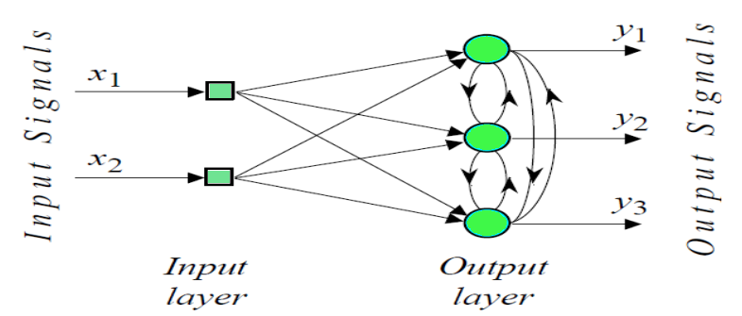

**Layers**

Layer is a general term that applies to a collection of 'nodes' operating together at a specific depth within a neural network. The input layer is contains your raw data (you can think of each variable as a 'node'). The hidden layer(s) are where the black magic happens in neural networks.

Self organizing maps have two layers, the first one is the input layer and the second one is the output layer or the feature map.

Unlike other ANN types, SOM doesn’t have activation function in neurons, we directly pass weights to output layer without doing anything.

Each neuron in a SOM is assigned a weight vector with the same dimensionality d as the input space.

**INTER-LAYER CONNECTIONS**

The purest form of a SONN has three layers:

1. The input layer

2. The hidden layer

3. The output layer

As the names suggest, each of these layers has a specific purpose. These layers are made up of nodes. There can be multiple hidden layers in a neural network according to the requirements.

The input layer picks up the input signals and transfers them to the next layer. It gathers the data from the outside world.

The hidden layer performs all the back-end tasks of calculation. A network can even have zero hidden layers. However, a neural network has at least one hidden layer.

The output layer transmits the final result of the hidden layer’s calculation.

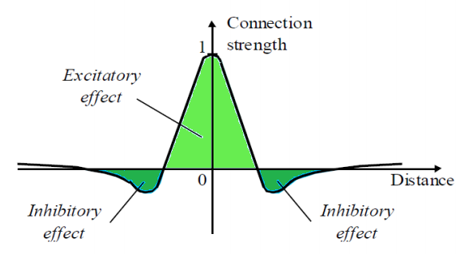

• This is accomplished by the utilization of a Mexican hat function which depicts the synaptic weights between the neurons in the Kohonen layer.

**Phases of SONN:**

**1. Learning phase:** Construction of maps; the network is designed with a competitive process using the training samples.

**2. Prediction phase:** Classification of new data; for the new data samples, a specific location is provided on the converged map.

**Kohonen Self-Organizing feature map (SOM)** refers to a neural network, which is trained using competitive learning. Basic competitive learning implies that the competition process takes place before the cycle of learning. The competition process suggests that some criteria select a winning processing element.

The Self-Organizing Map (SOM) is one of the most frequently used architectures for unsupervised artificial neural networks. Introduced by Teuvo Kohonen in the 1980s, SOMs have been developed as a very powerful method for visualization and unsupervised classification tasks by an active and innovative community of interna­ tional researchers. A number of extensions and modifications have been developed during the last two decades. The reason is surely not that the original algorithm was imperfect or inad­ equate. It is rather the universal applicability and easy handling of the SOM. Com­ pared to many other network paradigms, only a few parameters need to be arranged and thus also for a beginner the network leads to useful and reliable results. Never­ theless there is scope for improvements and sophisticated new developments as this book impressively demonstrates. The number of published applications utilizing the SOM appears to be unending. As the title of this book indicates, the reader will benefit from some of the latest the­ oretical developments and will become acquainted with a number of challenging real-world applications. Our aim in producing this book has been to provide an up­ to-date treatment of the field of self-organizing neural networks, which will be ac­ cessible to researchers, practitioners and graduated students from diverse disciplines in academics and industry.

# Implementation of Self Organizing Neural Network (SONN) from Scratch

# To implement a SONN, here are some essential consideration:

1. Construct a Self Organizing Neural Network (SONN) or Kohonen Network with **100 neurons** arranged in a 2-dimensional matrix with **10 rows** and **10 columns**
2. Train the network with **1500** 2-dimensional input vectors randomly generated in the interval between **-1 and +1**
3. Select initial synaptic weights randomly in the same interval **-1 and +1**
4. Assign learning rate parameter  is equal to**0.1**
5. Objective is to classify 2-dimensional input vectors such that each neuron in the network should respond only to the input vectors occurring in its region
6. Test the performance of the self organizing neurons using the following Input vectors:

In the Self Organizing Neural Network (SONN), learning is performed by shifting the weights from inactive connections to active ones. The neurons which were won are selected to learn along with their neighborhood neurons. If a neuron does not respond for a specific input pattern, then learning will not be performed in that particular neuron

**UNIVERITY OF NIGERIA NSUKKA**

**FACULTY OF PHYSICAL SCIENCES**

**DEPARTMENT OF COMPUTER SCIENCE**

**AN ASSIGNMENT SUBMITTED IN PARTIAL FULFILLMENT FOR THE REQUIREMENT OF THE COURSE COS 337(ARTIFICIAL INTELLIGENCE)BY**

**KALU MARY-JANE OGORI**

**REG NO: 2018/250793**

**TOPIC: SELF NEURAL ORGANIZING NETWORK**

**LECTURER: MR NZEH ROYRANSOM CHIEMELA**