A model for the future: Ecosystem services provided by the aquaculture activities of Veta la Palma, Southern Spain.

Walton M.E.M.1*, Vilas C. 2,  Cañavate J.P. 2, Gonzalez-Ortegon, E. 1, Prieto A. 2, van Bergeijk S.A. 2, Green A.J. 3, Librero, M.4, Mazuelos, N.4,  Le Vay L1.

1Centre for Applied Marine Sciences, College of Natural Sciences, Bangor University, Menai Bridge, Anglesey, Wales LL59 5EY, UK

2IFAPA Centro El Toruño, Ctra. N. IV Km. 654a. Camino de Tiro Pico, El Puerto de Santa María, Cadiz 11500, Spain

3Estación Biológica de Doñana CSIC, c/ Americo Vespucio, s/n, Isla de la Cartuja, 41092 Sevilla, Spain

4Veta la Palma, Pesquerías Isla Mayor, S.A., Real 34, 41920 San Juan de Aznalfarache, Sevilla, Spain

* [email: m.walton@bangor.ac.uk](mailto:*m.walton@bangor.ac.uk) Tel: +44 1248 382888

Abstract

The lack of space and opportunity for development have been identified as key reasons behind the stagnation of the European aquaculture industry. With the historical loss and degradation of current European wetlands there is an opportunity for harnessing the commercial investment of the aquaculture industry in construction of dual purpose wetlands that incorporate both conservation and extensive aquaculture activities. These wetlands can be used to expand the area available to suitable aquaculture into ecologically sensitive areas, such as Natura 2000 sites. Veta la Palma (VLP) situated in the Doñana Natural Park (and a Natura 2000 site) is an example of such an aquaculture development and a possible model for future opportunities. In the current study some of the important ecosystem services that are provided by VLP are assessed. The provisioning services of VLP were the economic rationale for the investment and more than 820 tonnes yr-1 of fish and shrimp is produced, through a mixture of semi-extensive and extensive aquaculture. The regulating services include nutrient absorption, and the flow of river water through VLP and high primary production results in the absorption of 377 tonnes of dissolved inorganic nitrogen yr-1, and 516 tonnes of C yr-1. Supporting services include the provision of habitat for more than 94 bird and 21 fish species. The primary production that supports the birds, extensive and semi-extensive aquaculture production was also estimated to be 167,000 t, 50,000 t and 133,000 t yr-1, respectively. The losses to birds are substantial and these estimates indicate that almost half of the primary production supports the wetland birds which directly consume 249 tonnes of fish and 2578 tonnes of invertebrates per annum. However it is the ecological credentials of the farm that enable premium prices and hence ensure the economic viability of the farm. The study demonstrates the possibility of using aquaculture to mitigate the historical loss of wetlands, provide significant ecosystem services and contribute to achievement of the European environmental legislative goals, and furthers the opportunity for the expansion of aquaculture into sensitive but impacted habitats.

Keywords: Extensive aquaculture, ecosystem services, reconstructed wetlands, wetland birds, nutrient absorption, bird predation.

1. Introduction

Global aquaculture production continues to increase, playing an ever more important role in world food production, reaching 70.5 million tonnes in 2012 (FAO, 2014). However, in the European Union, aquaculture growth has been stagnant over the last decade (FAO, 2014) and there is a growing gap between seafood consumption and production. In an effort to redress this, the European Commission is promoting environmentally, socially and economically sustainable aquaculture, including recommendations that member states work towards removing some of the barriers to aquaculture growth, including reducing administrative burdens and improving access to space and water (EC, 2013). To this end, member states have been encouraged to identify suitable areas for development of aquaculture production that is compatible with environmental legislation such as the Birds and Habitats Directives (Natura 2000 sites), the Marine Strategy Framework Directive (MSFD) and the Water Framework Directive (WFD). These directives can significantly constrain approval of new sites and hence the total space available for development. More than 3000 km2 of European coastline are currently occupied by Natura 2000 sites and the possible integration of complementary aquaculture activities represents a significant increase in area available to appropriate aquaculture (EEA, 2010b). Recently, the European Commission has provided guidance on how aquaculture activities can be integrated within Natura 2000 sites, including a number of examples of how biodiversity can be enhanced by aquaculture farms (EC, 2012). The current paper proposes that appropriately designed dual-purpose farms can not only enhance regulating and supporting ecosystem services through increasing biodiversity and improving water quality but also improve provisioning services and cultural services. As a contribution to meeting the environmental targets under the WFD (2015) and MSFD (2020), this type of aquaculture provides an excellent model to revitalise degraded wetlands. This is especially true where previous conversion to less sustainable uses has resulted in the loss of ecosystem services through drainage or siltation, or where abandoned fish farms or salt pans have resulted in net losses in biodiversity.

More than 80 % of European wetlands have been lost (Mitsch and Gosselink, 2000) and with them the ecosystem services such as water purification and nutrient recycling that are vitally important in ensuring the good water quality needed for coastal aquaculture activities. In southern Spain, wetland management and potential restoration are in conflict with pressure from coastal development and diversion of upstream freshwater for irrigation and human consumption and several studies have reported the degradation of ecosystem services within national parks such as the Doñana National Park as a result of the increasing development of agriculture in the surrounding areas (e.g. Martin-Lopez, et al., 2011; Palomo, et al., 2014; Zorrilla-Miras, et al., 2014). The current study is set within the boundary of the Doñana Natural Park (also a Natura 2000 site) which has lost more than half of its natural wetlands and 90% of its shallow lakes (EEA, 2010a). The present study assesses a range of ecosystem services that may be provided with appropriate dual-purpose design for both aquaculture and conservation. It demonstrates how aquaculture can be used as the economic driver to reconstruct wetlands and reinstate the hydrology needed to redress the loss of these wetlands, while also producing aquaculture products that have added value due to their high quality and ecological sustainability credentials. With the understanding that any wetland aquaculture development will require site-specific design, the Veta la Palma development is presented here as a model for best practice in aquaculture pond design that can help to inform similar eco-aquaculture developments.

1. Methods
   1. Site description

The study site at Veta La Palma (VLP), in Southern Spain, is located within Doñana Natural Park, adjoining the Doñana National Park (also a UNESCO World Heritage Site) to the west and the Guadalquivir estuary to the east and south (Fig. 1). In the 1990s, from agricultural land created by the drainage and siltation of wetlands, almost 3000 ha of wetlands were reconstructed as 40 large (70 ha each) shallow (0.5 m) brackish-water dual-purpose lagoons, complete with bird shelter/nesting islands and a deeper (1 m) peripheral canal with vegetated banks. In the lagoons, extensive culture of naturally-recruited shrimp (Palaemonidae) and fish occurs with production entirely supported by natural productivity. Some of these lagoons have greater water exchange as they receive the water from semi-extensive seabass (*Dicentrarchus labrax*) production that occurs in a row of small (0.1-0.9 ha) culture ponds where fish are maintained at 2-4 kg m-2 and nutrition comes from both inflowing natural production and formulated feeds supplied by demand feeders. Others are not connected to semi-extensive seabass production, have less water exchange, generally higher salinity and focus on extensive shrimp with some diverse natural fish production. Across the whole farm, water is recirculated during the winter, but once salinity in the Guadalquivir estuary rises above 10 psu, typically between February and November, the sluice gates are opened and a mix of 70:30 estuarine/lagoon water is circulated through the lagoons.



Figure 1: Satellite image of the sampled lagoons of Veta la Palma, part of the Doñana Natural Park and the boundary (dashed line) that separates it from Doñana National Park. Inserted are the geographic location of Veta La Palma and diagrammatic representation of the semi-extensive ponds and extensive lagoons (not to scale).

* 1. Assessment of ecosystem services

Ecosystem services are defined in the MEA (2005) as the benefits obtained from the ecosystem and are classified into four types, most recently by TEEB (2010) as follows: Provisioning services (including food provision), Regulating services (including water purification and carbon sequestration), Cultural services (including ecotourism and scientific knowledge) and Supporting services (Primary productivity, life cycle maintenance, species and genetic diversity)

* + 1. Food Production

The primary function of this wetland, and the economic justification for the investment in its construction and operation, is the provision of aquaculture products. Lagoons are harvested periodically every 3 to 5 years by lowering the water level to concentrate the fish which are then collected by netting. In addition 100-120 fyke nets are deployed daily around the farm for the continuous harvest of shrimp, with mullet and other fish also regularly caught as bycatch. Semi-extensively cultured fish are harvested three years after stocking. Annual farm gate sales figures were used to assess the average production (t wet weight yr-1) over the ten year period between 2003 and 2012.

* + 1. Nutrient absorption

The nutrient absorption function was examined by looking at the change in nutrient concentrations as water passed through the lagoons. Over one year between May 2011 and May 2012, water samples were taken at 5cm below the surface from incoming estuarine water at the farm intake valve, and at the outlet of mixed and extensive lagoons. The sample was then vacuum filtered through GF/F filters (Whatman) and stored frozen until nutrient analysis using a 5 channel LACHAT Instruments Quick-Chem 8000 autoanalyzer for total dissolved inorganic nitrogen (TDIN) and phosphate. Annual N removal (N yr-1) was calculated as:

N yr-1 = ∑ (concentration of N in monthly sample of inflowing water × monthly volume of inflowing estuarine water) – (mean concentration of N in monthly sample of water exiting lagoons × monthly volume of outflowing water released to estuary).

Water flow rates were provided by VLP management and based on the volume of water pumped versus that entering the farm from the estuary. Water exiting lagoons was estimated as the new water entering the farm minus the water recirculated and water losses due to evaporation and based on mean evaporation rates estimated for the nearby Doñana National Park using the Thorthwaite method (EBD, 2013).

However the total N absorbed by this wetlands also includes the nitrogen excreted by the semi-extensively cultured fish. The amount of nitrogen excreted from the fish in semi-extensive culture was calculated following Peres and Oliva-Teles (2005) assuming a three year production cycle in steady state, where the N excreted by the total fish stock in one year should be the same as the lifetime value for harvested fish (as smaller size classes equivalent to Years 1 and 2 of growth of harvested fish are present in the stock biomass).

Annual N excreted = (1-N retention) * (fish biomass gain/PER)/protein: nitrogen ratio.

Where N retention = N retained in biomass/N ingested = 0.35, PER = fish biomass gain /N ingested =1.67 and protein: nitrogen ratio =6.25 (from Peres and Oliva-Teles, 2005).

* + 1. Life cycle maintenance and biodiversity

The diversity and biomass of wetland birds supported by the reconstructed lagoons of VLP were estimated using the monthly bird census conducted by the staff at the Estación Biológica de Doñana (Equipo de Seguimiento de Procesos Naturales-ICTS Reserva Biológica de Doñana (EBD-CSIC)) between 2004 and 2012. Water bird biomass present on these lagoons over each month was obtained by multiplying mean weight of each species (extracted from Tacutu, et al., 2013) and their mean monthly counts on the aquaculture lagoons of VLP.

* + 1. Primary productivity

Underpinning the above services is the ability of this ecosystem to capture the sun´s energy. Benthic and water column primary production was assessed using light and dark benthic chambers and bottles following the methods of Opalinski, et al. (2010). Water column primary production was estimated using 250 ml dark and light bottles set 5 cm below the water surface in the 6 different lagoons. Lagoon water was 100 µm filtered prior to incubation in the water column. Open-bottomed benthic chambers covering 0.0188 m2 were very gently pushed into the sediment in the shallow central platform. Incubation times varied between 1 and 8 h depending on the time of year. This was supported by monthly chlorophyll epiflourescence readings using a multiparameter sonde (YSI 600 OMS VZ, Ohio, USA)

* + 1. Assimilation of primary productivity by wetland birds and cultured species

As part of a parallel study all primary producers and fauna in six lagoons in VLP was sampled seasonally 4 times a year, and the isotopic signatures obtained (see Walton et al, this issue for details of sampling and analysis). Trophic position of harvested species was estimated using the difference between the δ15N value of the consumer and the mean δ15N value of primary producers, and calculated using discrimination factors of 2.2 ‰ for the trophic step and 2.9 ‰ for each subsequent step (McCutchan, et al., 2003). The amount of primary production consumed (PPC) in the food web supporting each harvested species was estimated using an assumed average trophic efficiency (TEF) of 10% (Pauly and Christensen, 1995), the isotopic trophic level above primary producers (TL) and the harvested biomass (HWt). Where: ∑ PPC = HWt species1/TEF TL species1 + HWt species2 /TEFTL species2 + ……

Prior to calculating PPC for the semi-extensively cultured bass, the proportion of biomass derived from foraged food was estimated using the Bayesian isotopic mixing model mixSIAR using the δ15N and δ13C signatures of the bass (muscle tissue), pelleted diet and likely prey items that enter the pond. A TEF of 10% was applied (as above) to give an estimate of the wet weight of the foraged prey ingested and hence PPC, calculated as above.

To estimate the consumption by birds during their residence in VLP, the energy requirements of each bird species were used to determine daily ingestion rates, allowing for 80% assimilation efficiency (Meire, et al., 1994; Scheiffarth and Nehls, 1997).

The daily energy expenditure (DEE) = 3×BMR×CF×H

where W = weight in kg obtained from (Tacutu, et al., 2013), and CF = Conversion factor from watt to kJ d-1 (86.4), and where BMR = Basal Metabolic Rate (Watts). For waders including Suborders: Charadrii, Chionidi, Scolopaci and Thinocori BMR = 5.06W 0.729 (Kersten and Piersma, 1987), for Anseriformes (ducks) BMR = 4.8 × W0.672 (Brunckhorst & Hûppop, in Scheiffarth and Nehls (1997)) and for all other species BMR = 3.56 ×W 0.734 (Aschoff & Pohl, 1970 in Scheiffarth and Nehls (1997)).

Consumption = (D×DEE×Pi×(1/Q)/Ei)

+(D×DEE×Pf×(1/Q)/Ef)

+(D×DEE×Pm×(1/Q)/Em)

Where E = Energy density of diet items is estimated using the relationship between percentage dry weight of sampled organisms and energy density for invertebrates (i) (James, et al., 2012) and for fish (f) (Hartman and Brandt, 1995) and literature values for macrophytes (m) (Ballard, et al., 2004), D = number of bird days month-1 (mean monthly counts 2004-2011 × 30 days), P = proportion of diet type (i, f, m) and Q = assimilation efficiency (80%). Diet type proportions were extracted from the (BirdLife_International, 2014) data base. For birds with mixed diets, the proportion of dietary components was assumed to be equal in terms of biomass, except where the database descriptor included relative specialisation. A diet component with a descriptor such as “predominantly” was assigned a 0.8 proportion, whereas those with descriptors such as “mostly” were assigned a proportion of 0.7. The amount of fish, invertebrates and primary productivity were then corrected for trophic level to estimate the amount of primary production that supports the bird population using the same calculation above. In the winter many ducks (*Anas* spp.) are known to feed almost exclusively in rice fields in Spain and Portugal (e.g. Navedo, et al., 2015) and unpublished data collected by researchers at Estación Biológica de Doñana CSIC indicate that, with the exception of *Anas clypeata*, ducks are obtaining almost all their nutrition from the rice fields around VLP between October and February. Hence during this time, these ducks are omitted from the estimations of consumption.

1. Results and Discussion
   1. Provisioning services

The combination of semi-extensive (stocked and fed) and extensive (natural recruitment and no feeding) culture systems results in a mean annual production of 820 tonnes of which extensive production accounted for just over 25% (Figure 2). Bass (*D. labrax*) is the main semi-extensively cultured species plus some gilthead seabream (*Sparus aurata*) harvested after a three year growout period. Shrimp (*Palaemon varians* and *Palaemon macrodactylus*) and mullet (*Lisa aurata*, *Lisa ramada* and *Mugil cephalus*) are the dominant extensive species accounting for 182.6 tonnes yr-1. Eel is no longer harvested (since 2011). Smaller fish species that are not commercially exploited are also present, including *Fundulus heteroclitus*, *Gambusia affinis*, *Alosa* spp., *Atherina boyeri*, *Engraulis encrasicolus*, *Pomatoschistus* spp., and *Gobius paganellusi*.

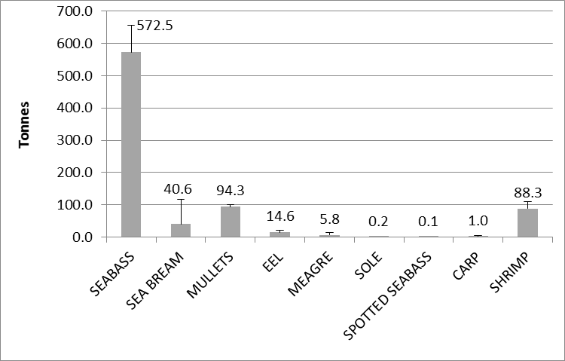

Figure 2: Average annual harvests from both semi-extensive and extensive culture systems (tonnes) in Veta la Palma between 2003 and 2012. Numbers indicate the tonnes harvested of each species.

While primary production in the VLP lagoons is relatively high, driven by the influx of nutrient rich water and only apparently limited by phosphorus availability (see below), the extensive aquaculture production of 69 kg ha-1 yr-1 falls in the middle of the range of European extensive aquaculture sites. In the valliculture ponds of Northern Italy, operated by private enterprises, fish production averages 53 kg ha-1 yr-1 (FAO, 1999) with increasing numbers of piscivorous birds reducing harvests by 30% in the last 10 years (Anras, et al., 2010). Other areas where extensive aquaculture of fish occurs in Europe, includes more than 70 Greek lagoons run by cooperatives, where barrier nets separate areas of the lagoon and support average fish yields of 47.2 kg ha-1 yr-1 (Ananiadis, 1984), but it is unclear whether this is true extensive culture or fisheries. In the Vassova and Eratino lagoons of Northern Greece, aquaculture production of bass and sea bream have fallen to 3kg ha-1 yr-1 due to environmental problems and high winter mortality rates (Theocharis, et al., 1998). In contrast the “esteros” of Cadiz province in southern Spain, where fish production occurs in the large water reservoirs used for flooding the salt pans, average harvests result in a production of 267 kg ha-1 yr-1 (Yufera and Arias, 2010). In the last 90 years, production has increased dramatically from 40 kg ha-1 yr-1 to the present levels, mainly driven by a refocusing of the esteros to extensive fish production with accompanied improvements in water exchange management and a better understanding of natural fry recruitment and farming methods (Yufera and Arias, 2010).

As a result of the provisioning services provided by VLP, over a hundred local people are directly employed on the farm, and many more indirectly (UNEP, 2012), promoting conservation of the Doñana area compatible with the economic development of the zone.

* 1. Regulating services
     1. Nutrient absorption

Inflowing nutrient concentrations varied throughout the year with TDIN concentration peaking in the summer at 325 µM N and declining to 133 µM N in spring, phosphate concentrations were much lower varying from 1.6 to 3.2 µM P with no seasonal correlations. The N:P ratio in the inflow varied from 76:1 to 156:1. Nitrogen retention varied with both water inflow rate and primary productivity; greatest retention was in July and August when 24kg N ha-1 month-1 was retained in the farm with no retention in December and January when the water was only recirculating. The amount of nitrogen excreted from an annual production of 611 tonnes of fish under semi-extensive culture is estimated to be 38.1 tonnes per annum.

Table 1: Total monthly N (kg month-1) entering and exiting the Veta La Palma aquaculture system.

|  |  |  |  |
| --- | --- | --- | --- |
| Month | N entering (kg N) | N exiting (Kg N) | N Retained (Kg N) |
| Jan | 0.0 | 0.0 | 0.0 |
| Feb | 6543.5 | 494.6 | 6048.9 |
| Mar | 14706.4 | 721.4 | 13985.0 |
| Apr | 33936.5 | 1399.1 | 32537.4 |
| May | 44517.2 | 2105.6 | 42411.6 |
| Jun | 53648.2 | 1232.4 | 52415.8 |
| Jul | 65725.8 | 1097.7 | 64628.1 |
| Aug | 66145.8 | 1451.0 | 64694.8 |
| Sep | 52076.7 | 2412.9 | 49663.8 |
| Oct | 49346.8 | 2061.7 | 47285.2 |
| Nov | 3454.6 | 53.2 | 3401.4 |
| Dec | 0.0 | 0.0 | 0.0 |
|  | 390101.4 | 13029.6 | 377071.8 |

Dissolved inorganic nitrogen absorption by the VLP wetlands, including that excreted by the cultured fish, is estimated to be 415 tonnes yr-1 or 15.5g m-2 yr-1 year (1.1 mol m-2 yr-1 ) with an average removal efficiency of greater than 90% (Table 1). A recent review of the nutrient absorption capabilities of various types of constructed wetlands suggested that although the efficiencies were considerably lower in removal of total nitrogen 44-66 % compared with VLP, the absorption rates per unit area were much higher removing between 250 and 630 g N m-2 yr-1 (Zhang, et al., 2014). The estimated rate of N absorption is supported by the measured net carbon retained by the lagoon phytoplankton of 1.6 mol m-2 yr-1 which combined with the estimated macrophyte sequestration sums to 11.2 mol m-2 yr-1 (see section 3.2.2 and Morris, et al., 2013). According to the Redfield ratio of 106C:16N:1P the expected molar ratio of carbon sequestration to nitrogen absorption is 6.6, however recently a review of Redfield ratios from different habitats suggested that there was considerable variation and freshwater and coastal C:N ratios were 10 and 8.6 (Sterner, et al., 2008). The ratio of C:N absorption in the current study of 10.2:1 is close to predicted ratios, however both dissolved organic nitrogen and carbon can occur in substantial amounts which can significantly alter the ratio (Sterner, et al., 2008). Similarly the low concentration of phosphorus and the ratio of N:P of 76-156:1 both indicate production in VLP is likely to be limited by P given the deviation from the Redfield ratio of 16:1, although the rate of N retention suggests P cycling in this system is efficient.

Several EU directives address eutrophication, with the Water Framework Directive and Marine Strategy Framework Directive calling for the restoration of the good ecological condition of receiving water bodies, whereas the Habitats and Birds Directive seek to limit the adverse effects of eutrophication especially in Natura 2000 sites and others such as the Nitrates Directive (EU Council Directive 91/676/EEC) propose concentration guidelines. As such there is growing pressure for governments to reduce the amount of nitrogen in the environment (Sutton, et al., 2011) either by reducing the nitrogen emissions or through water treatment. This is of local relevance as biannual monitoring (2001-2003) showed nitrate levels in the Guadalquivir routinely exceed the local government critical levels of 100 μmol l-1 (Mendiguchía, et al., 2007). Recently there have been various studies suggesting that catchment-based nutrient trading schemes could be used in Europe (Ferreira, et al., 2009; Lindahl, et al., 2005) similar to those that have been used to improve coastal water in the USA (Newell, 2004). Nitrogen retained by VLP (from the Guadalquivir River) is the equivalent produced by 114,300 people or population equivalent (PEQ) yr-1. To remove this much N would incur treatment costs of €3,428,000 yr-1 using a conversion factor of 30 € PEQ-1 yr-1 (Lindahl, et al., 2005; Nunes, et al., 2011).

* + 1. Carbon sequestration.

The role of these wetlands in carbon sequestration and storage was examined in a study by Morris et al (2013). Aerial fluxes were calculated using repeated measurements of alkalinity, pH and other physiochemical parameters in a variety of water bodies in the Donaña National Park (including one permanently flooded aquaculture lagoon in VLP in the Natural Park). Results suggested that the permanently flooded extensive aquaculture lagoons act as weak carbon sinks (-1.6 mol C m-2 y-1), and although the seasonally inundated freshwater natural ponds elsewhere in the park were strong C sources, the authors suggested that C fixation by vascular plants was more than six times as important as that that of phytoplankton, which meant that overall the Donaña wetland was a net carbon sink.

* 1. Habitat or supporting services
     1. Primary production

Maximum primary productivity occurred during July with oxygen consumption suggesting that carbon being fixed peaked at a rate of 22.8 g C m-2 d-1 in the water column and 3.9g C m-2 d-1 in benthic algae but by November no discernible fixation was occurring. This is supported by fluorescence readings that also peak in the June /July and fall in the winter (Walton, et al., In Press). In agreement with Morris, et al. (2013), the current dual isotope aquatic food web studies focusing on the sources of carbon in the diets of higher consumers indicate that in fact only 51% of the carbon in high consumers originates from phytoplankton (water column and benthic microalgae) with vascular plants (both reeds and widgeon grass) being almost as important sources of carbon. Harding (1997) reviewed the daily phytoplankton primary productivity in 26 warm freshwater systems from around the world which varied between 0.1 to 30.9 g C m-2 d-1. Extrapolating from the current studies daily estimates of carbon fixation result in annual phytoplankton (benthic and water column) primary production estimates of 408 g C m-2 yr-1 which is within the range of primary productivity for coastal systems given by Herman, et al. (1999) that range from 60 to 670 g C m-2 yr-1. The difference between the carbon retained and the carbon fixed suggests that about only about 5 % of the carbon fixed is sequestered, with the rest respired and released back in to the atmosphere. In a review, Keddy (2010) reported that more than 90% of primary production in wetlands is eventually re-released as CO2 due to direct consumption of phytoplankton and indirectly via the benthos.

* + 1. Habitats for species

Ninety four water bird species are surveyed every month. Numbers varied according to the season, peaking in November when more than 120,000 birds were present, but with different groups of birds utilizing the VLP lagoons at different times (Figure 3). No complete picture of the number of individual birds that use the wetland is available, but the lowest estimate of usage is calculated by summing the highest average monthly count of each bird species which indicates that at least 173,655 different individuals use the wetland over the course of a year.

Ducks use VLP in the autumn and winter months when biomass surpasses 50 tonnes in November (Figure 3) with three omnivorous duck species being particularly dominant: the mallard (*Anas platyrhynchos*), northern shoveller (*A. clypeata*) and northern pintail (*Anas acuta*). Waders (shorebirds) are less important in terms of biomass but increasingly use the lagoons during the winter months when black tailed godwits (*Limosa limosa*) and pied avocets (*Recurvirostra avosetta*) swell the biomass to more than 7 tonnes (Figure 3). Bird species other than waders and ducks (“other” in Figure 2) use the VLP ponds more during the summer when the biomass exceeds 55 tonnes, dominated (66-81%) by greater flamingos (*Phoenicopterus roseus*) and crested coots (*Fulica atra*), with more than 3 tonnes of biomass for great cormorants (*Phalacrocorax carbo*) resident during the winter months. The creation of the VLP lagoons has attracted grey herons *Ardea cinerea* and spoonbills *Platalea leucorodia*, and led to a redistribution of these increasing species across Doñana (Ramo et al. 2013). The biodiversity supported by this wetland is immediately noticeable by the vast flocks of birds feeding in lagoons, however the macroinvertebrate community, although numerous with average monthly biomass of 283.5 g dry weight m-2, is not especially rich with only 31 species present (Rodriguez Perez, 2006). Similarly fish diversity was also poor with only 18 species recorded during sampling in the current study. This is not unsurprising as the supply population in Guadalquivir estuary only contains 21 species and is one of the least diverse fish populations reported in nine European estuaries surveyed (Pihl, et al., 2008). More recently a 12 year study sampled the nektonic fish and crustaceans at three points in the estuary (Gonzalez-Ortegon, et al., 2012), in 2011 at the sampling point outside the farm gate 39 fish species were caught, but eight of these were rare with only 1 individual caught. The permanently inundated lagoons at VLP provide a vital refuge for ducks and other waterbirds during the dry season until winter rains re-flood the Doñana marshes within the National Park area (Kloskowski, et al., 2009). The survey data suggests that at least 173,655 individual birds from 94 species utilize this habitat (EBD-CSIC), however other reports suggest that more than 250,000 birds use VLP and more than 250 bird species have been reported (UNEP, 2012). These lagoons are also particularly important feeding grounds for great cormorants (*Phalacrocorax carbo*), greater flamingos (*Phoenicopterus roseus*), black winged stilts (*Himantopus himantopus*) and pied avocets (*Recurvirostra avosetta*) (Rendon, et al., 2008), and feeding by flamingos, coots and ducks have been shown to have a significant influence on the biomass of both macrophytes and invertebrate populations (Rodriguez-Perez and Green, 2006; Rodriguez-Perez and Green, 2012).

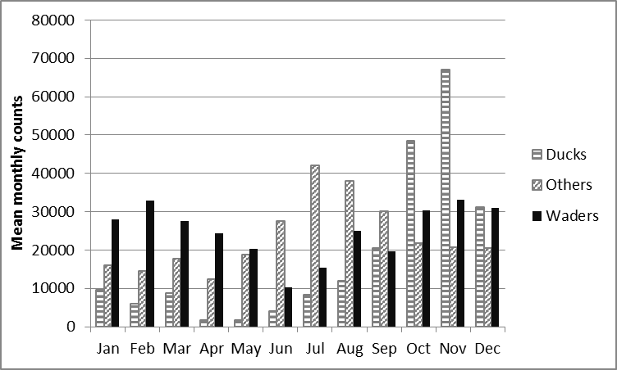

Figure 3: Mean monthly counts of birds utilizing the extensive aquaculture lagoons in Veta la Palma between 2004 and 2012.

* + 1. Maintenance of biodiversity.

Recent cessation of the fishing of the IUCN red listed critically endangered European eel, *Anguila anguila*, means that in addition to the unknown quantity of mature eels that make it through the 5cm wide mesh on the outlets of the extensive lagoons, there is now an estimated 14.6 tonnes of eel that is no longer being harvested and can form part of the adult silver eel population that undergoes the migration to the Sargasso Sea.

In addition the lagoons provide habitat for other Red-listed birds, including the globally threatened white-headed duck (*Oxyura leucocephala*) and marbled teal (*Marmaronetta angustirostris*), as well as the near-threatened ferruginous duck (*Aythya nyroca*) and the Eurasian curlew (*Numenius arquata*).

Previous studies have shown that this recently constructed wetland has been colonized by more than eight non-native faunal species and one non-native plant (*Spartina densiflora*) as a result of its exchange of water with the Guadalquivir river estuary, an international shipping channel (e.g. Frisch, et al., 2006; Rodriguez-Perez and Green, 2012; Rodriguez-Perez, et al., 2009)

The waterbirds supported by the VLP lagoons themselves provide a broad set of ecosystem services (Green and Elmberg, 2014). For example, the migratory populations of Doñana provide a major service as vectors of plants and invertebrates dispersed along their flyways across Europe and North Africa (Brochet, et al., 2009; Figuerola, et al., 2003). Many species also provide a provisioning service as hunting quarry along their migration route.

Some bird species such as the black-tailed godwit have increased in numbers as a direct consequence of the creation of the VLP lagoons (Marquez-Ferrando, et al., 2014). The greater flamingos breeding in Fuente de Piedra in Malaga (the largest colony in the Iberian Peninsula) are strongly dependent on the aquaculture lagoons as feeding grounds (Rendon, et al., 2008) However, it is important to recognize that while these lagoons add to the overall diversity, some bird species are strongly dependent on the natural marshes inside the UNESCO World Heritage Site, (Rendon, et al., 2008).

* + 1. Assimilation of primary productivity by wetland birds and aquaculture species

To estimate the PPC in support of the semi-extensive bass, the amount of natural prey consumed by the bass needs to be calculated using the isotopic signatures of consumer and diet. The relative enrichment of δ15N signature of the semi-extensively cultured bass compared with the pelleted diet suggests that the bass are feeding on 15N enriched natural prey items that are entering the pond (Figure 4). The mixing model mixSIAR indicates that a mean of between 69 and 78% of the diet is pelleted feed with mysids (*Mesopodopsis slabberi*) accounting for the majority of the rest. During the summer months when metabolic demand is highest, there is greater reliance on the pelleted diet as it is likely that natural food supply is outstripped by demand. Although the overlapping Bayesian credibility intervals that spread between 7 and10% each side of the mean indicate that seasonal variation may not be significant. In total the natural prey consumed by the semi-extensive bass require 115,000 tonnes primary production to support them as estimated using the trophic level of the prey (Table 2a).

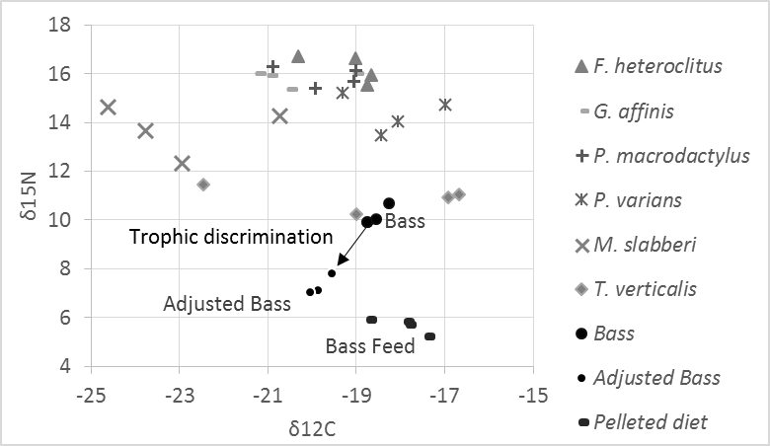

Figure 4: Isotopic δ15N and δ12C signatures of the semi-extensively cultured bass, pelleted diet and likely prey items that enter the ponds. Adjusted *D. labrax* is the isotopic signature of the bass without the isotopic discrimination that occurs during assimilation of the diet into the consumer tissue.

The amount of primary productivity supporting the production of extensive fish and shrimp estimated directly using trophic efficiency is almost 47000 tonnes of primary productivity with the majority ( 57%) due to shrimp and mullet, despite these species having amongst the lowest trophic levels and hence being more energetically efficient compared to top predators like bass and meagre (Table 2b).

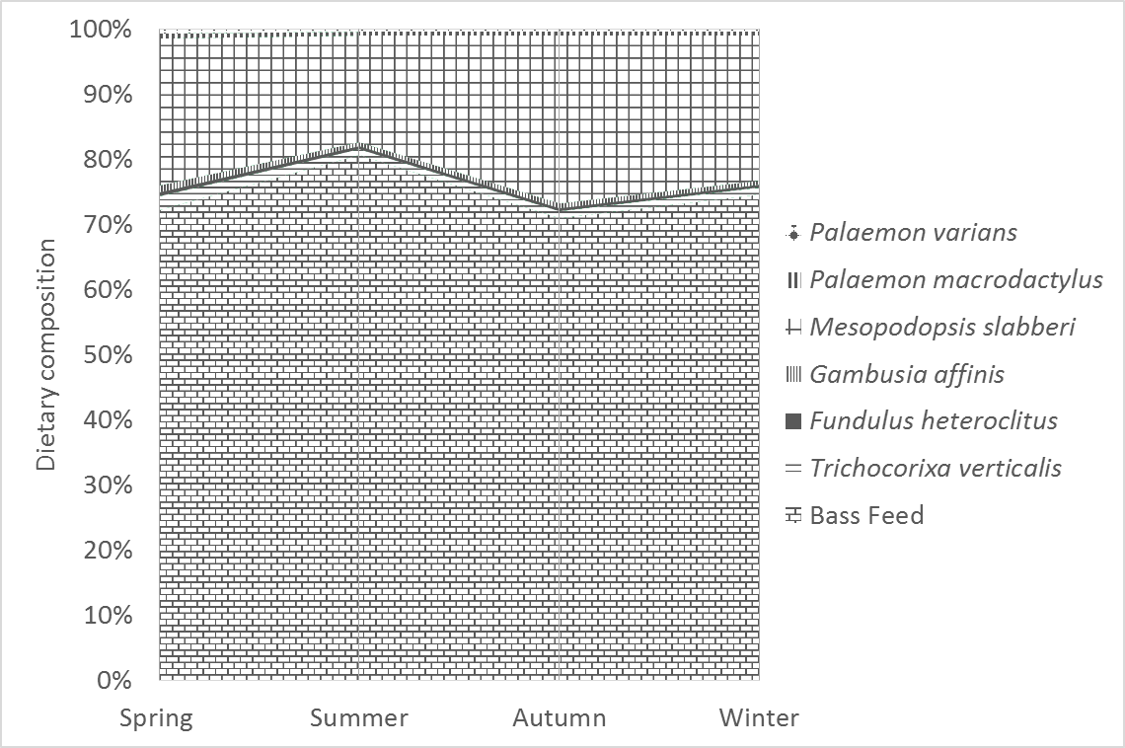

Figure 5: Seasonal variation in the contribution of wild food to diet of semi-extensively cultured bass as indicated by the mixSIAR isotopic mixing model.

The calculated amount of primary productivity supporting the bird life, diet consumed was estimated using the bird’s energy requirements and dietary energy values, and correcting for trophic efficiency. Greater flamingos, having the largest biomass, also consume the largest amount of macrophytes (22% of total) and invertebrates (44% of total). Cormorants, gulls, herons and egrets are responsible for approximately half the 249 tonnes (WW) of fish losses in VLP (Figure 6).

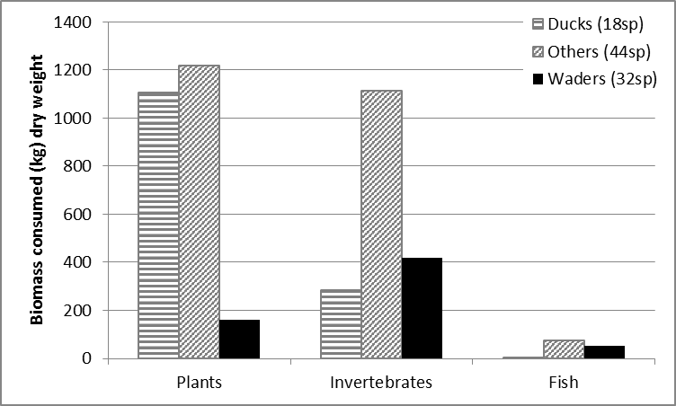

Figure 6: Annual biomass consumption (kg dwt d-1) by the birds in the lagoons of VLP

Plant biomass is the largest component consumed by birds, and is especially important for the ducks that utilise the ponds. Dividing the annual consumption by the area of water surface (2686 ha) this represents 2.48 t wet wt ha-1 yr-1 of macrophytes, 0.96 t ha-1 yr-1 of invertebrates and 0.09t ha-1 yr-1 of fish. Correcting for trophic level, birds in Veta la Palma consume 167000 tonnes (wet wt) of primary productivity (Table 2c). This suggests that the primary production footprint of the water birds counted on the aquaculture lagoons of VLP is almost as great as that which supports the extensive and semi-extensive fish and shrimp harvests.

Assuming the primary productivity which supports food webs for water birds is divided in the same ratio as stable isotopes suggested for the extensively cultured species, then 52% of the supporting primary productivity comes from benthic and water column phytoplankton with 48% coming from vascular macrophytes (reeds and widgeon grass). Applying the wet weight to carbon conversion of Sherr and Sherr (1984), 107 g C m-2 yr-1 of primary production supports bird consumption and aquaculture production. This represents only about a quarter of estimated phytoplankton primary production in this study (408 g C m-2 yr-1). The remaining production is either exported or recycled through detrital food webs within in the VLP lagoons.

Table 2: Primary production (wet weight tonnes) utilized in the production of

1. The semi-extensively cultured bass (*Dicentrarchus labrax*).

|  |  |  |  |  |
| --- | --- | --- | --- | --- |
| Species consumed by semi-extensively cultured bass | TEF | Trophic levels | Estimated prey consumption by bass (t) | PP consumed (t) |
| *Fundulus heteroclitus* | 0.1 | 2.56 | 62.82 | 22,594.88 |
| *Gambusia affinis* | 0.1 | 2.41 | 79.95 | 20,753.45 |
| *Mesopodopsis slabberi* | 0.1 | 1.70 | 1,250.61 | 63,124.72 |
| *Palaemon macrodactylus* | 0.1 | 2.44 | 74.24 | 20,613.28 |
| *Palaemon varians* | 0.1 | 1.92 | 57.11 | 4,799.20 |
| *Trichocorixa verticalis* | 0.1 | 1.00 | 137.05 | 1,370.54 |
| Sum |  |  | 1,661.78 | 133,256.08 |

1. The extensively cultured species

|  |  |  |  |  |
| --- | --- | --- | --- | --- |
| Extensively cultured species | TEF | Trophic levels | Harvest weight of species (t) | PP  consumed (t) |
| *Dicentrarchus labrax* | 0.1 | 3.26 | 1.42 | 2,584.39 |
| *Sparus aurata* | 0.1 | 3.22 | 0.35 | 580.20 |
| Mugilidae | 0.1 | 2.24 | 94.30 | 16,297.31 |
| *Anguilla anguilla* | 0.1 | 2.66 | 14.60 | 6,652.43 |
| *Argyrosomus regius* | 0.1 | 3.24 | 5.76 | 9,964.05 |
| *Solea senagalensis* | 0.1 | 2.68 | 0.21 | 101.83 |
| *Dicentrarchus punctatus* | 0.1 | 3.26 | 0.13 | 242.03 |
| *Cyprinus carpio* | 0.1 | 2.12 | 1.04 | 136.38 |
| *Palaemon* sp. | 0.1 | 2.07 | 88.33 | 10,435.74 |
| Sum |  |  | 206.15 | 46,994.36 |

1. The water birds that occupy Veta la Palma.

|  |  |  |  |  |
| --- | --- | --- | --- | --- |
| Bird diet | TEF | Trophic levels | Estimated consumption (t) | PP  consumed (t) |
| Macrophytes | 0.1 | 0 | 6,666.69 | 6,666.69 |
| Invertebrtates | 0.1 | 1.5 | 2,578.89 | 81,551.52 |
| Fish | 0.1 | 2.5 | 249.16 | 78,791.24 |
| Sum |  |  |  | 167,009.45 |

The current study used the energy demands of different bird species relative to the energy content of the prey items to estimate the biomass consumed by these bird populations. Energy values for diets obtained from sampled fish and invertebrates of 21.3 kJ g-1 and 22.3 kJ g-1 dry weight (DW) respectively, were very close to those reported elsewhere in the literature of 22.4-23.7 kJ g-1 AFDW for invertebrates in both Alaska and at lower latitudes (Wacasey and Atkinson, 1987). Fish energy densities were reported by (Wanless, et al., 2005) to range between 14.3 and 28.3 kJ g-1 DW in two separate studies. The current study suggested that bird predation was responsible for the annual removal of 34 g DW m-2 macrophytes, 25 g DW m-2 invertebrates and 2 g DW m-2 of fish. In the Wadden Sea bird predation of invertebrate communities results in similar annual rates that range from 4.85 to 27.4 g DW m-2 depending on the habitat (Scheiffarth and Nehls, 1997) and elsewhere along the East Atlantic Flyway annual invertebrate consumption ranges from 3 to 39 g DW m-2 (Moreira, 1997). It is noteworthy that fish losses due to bird predation is more than double the total extensive fish production although the majority of these losses will be small non-commercial species such as *G. affinis*, *F. heteroclitus* and *Pomatoschistus* spp. Other extensive farms report smaller losses to bird predation in the esteros of Cadiz losses were estimated to be 15-30% (Yufera and Arias, 2010) and in the valliculture systems of Northern Italy 30% (Anras, et al., 2010). It is remarkable that with the losses sustained to predation that aquaculture production at VLP remains economically viable. Profitability is due to the mixed cultivation system of semi-intensive ponds, where the fish are protected by nets during juvenile stages, together with the production from the extensive lagoons in addition the high values of the environmentally sustainably reared fish and shrimp.

* 1. Cultural services, Ecotourism and Scientific knowledge

Tourism activities are now restricted to groups that have prior permission to visit in order to limit the stress on bird populations and for biosecurity reasons. A well laid out visitors’ centre is also available to visiting groups. In addition the management at VLP is extremely supportive of scientific studies, and so far more than thirty peer-reviewed studies have been published that use data from the farm.

4. Implications for the expansion of wetland aquaculture

While in Europe the use of aquaculture as either a driver of wetland construction or wetland conservation is relatively unknown and has not entered mainstream thinking or policy, in tropical climates the integration of aquaculture into sensitive habitats such as mangroves have long been practiced with numerous examples from Africa, South East Asia and China (Binh, et al., 1997; Folke and Kautsky, 1992; Huang, et al., 1997; Primavera, et al., 2010). The VLP example presented here, provides one method of how this can be achieved in a more temperate setting.

A recent review of status of semi-intensive and extensive aquaculture in France, Italy, Greece, Portugal and Spain examined the reasons for stagnation in the industry and suggested that many of the potential aquaculture areas are under some sort of protected status which limits development (Anras, et al., 2010). The twin pillars of the EU nature conservation policy are the Habitats Directive 92/43/EEC and the Birds Directive 2009/147/EC. These aim to protect rare and endangered species and the core areas that they inhabit together with around 230 habitat types that are of European importance (EC, 2012). These goals are realised in the form of the Natura 2000 Network which seeks to achieve a favourable conservation status for these endangered species and important habitats. Each site has its own conservation objectives but does not exclude sustainable development (EC, 2012). The current study demonstrates how the integration of the appropriate type of aquaculture (the VLP model) into a Natura 2000 Network site can be used to facilitate this objective of favourable conservation status. VLP provides feeding grounds for the large wetland bird population during the months when the main wetlands in the Doňana National Park are dry (Figuerola and Green, 2004; Kloskowski, et al., 2009), and the existence of these reconstructed wetlands complements the natural wetlands and enables a larger and more diverse waterbird community to persist (Kloskowski, et al., 2009).

The results presented here for VLP parallel recent work on integrating fish farming and bird conservation in eastern European freshwater wetlands (Birdlife International, 2010). There is considerable scope for increasing the area of such mixed semi-extensive and extensive marine species aquaculture in coastal wetlands in the Atlantic region of Europe. For example, at a stakeholder meeting in Seville, Spain entitled “The potential for wetland aquaculture; balancing economic development and conservation benefits” scientists, NGOs, regional government officials and aquaculture farmers identified over 20,000 ha of degraded wetlands on the SW Atlantic coast of Spain and Portugal that could be improved using this dual purpose wetland aquaculture model, with further potential areas reported in estuaries on the western coast of Portugal (30th October 2013, [www.seafareproject.eu/index.php/media-centre/](http://www.seafareproject.eu/index.php/media-centre/)). Coastal aquaculture in France and Greece both suffer from water quality problems caused by agricultural runoff (Anras, et al., 2010). Schemes like VLP that has demonstrated how hydraulic restoration of wetland can improve water quality through the absorption of high levels of nutrients, could be part of the management to improve coastal water quality.

In response to rising sea levels, UK shoreline management plans now include a managed realignment (MR) option i.e. a managed movement of the shoreline inland and now there are at least 29 sites where MR has been initiated with various objectives, the most common of which is the creation of intertidal habitat followed by improvement of flood defences and reduction of flood defence cost (Esteves, 2012). Most of these MR schemes in UK are small, less than 20 ha, despite studies that have shown that ecosystem services are only significantly improved when the areas involved are greater than 100 ha. Aquaculture may also be used to defray some of the costs of reconstructing these wetlands in return for the option to operate integrated wetland aquaculture schemes that can mitigate for the loss of wetland habitat elsewhere to due to coastal development as required by the EU Habitats Directive. In this cooler northern European setting, the aquaculture models may be different from the VLP case study, for example fish production in intensive recirculation systems with downstream nutrient remediation in wetlands (Webb, et al., 2012) and shellfish production using primary production entrained from wetland ponds (eg www.morecambebayoysters.co.uk). The use of compensatory mitigation or biodiversity offsets, where habitats that are lost due to development are offset by the restoration or recreation of new habitat, are commonly used around the world (McKenney and Kiesecker, 2010).

5. Summary

In summary this study demonstrates the feasibility of using aquaculture as the economic driver for the construction of dual purpose wetlands with an integrated aquaculture function that can provide multiple ecosystem services, compensate for wetland that has been lost elsewhere, improve downstream water quality in coastal areas thereby increasing the area available for shellfish cultivation, and provide livelihoods. The scale of the ecosystem services offered in this study should provide persuasive evidence for policy makers of what is achievable with this model of aquaculture. The study also indicates that the large areas of degraded Mediterranean wetlands presented by Anras, et al. (2010) and those in the Atlantic area identified in the stakeholders meeting mentioned in the final “Implications” section represent potential sites where this type of dual purpose aquaculture or a locally adapted model could provide significant ecosystem services through the rehabilitation of impacted wetlands.

Acknowledgements

This research was funded by the European Union Atlantic Area Transnational Programme (2007-2013) through the SEAFARE project, grant no 2009-1/123.

References

Ananiadis, C., 1984. Aspects of coastal lagoon and pond fishery management problems in Greece. General Fisheries Council for the Mediterranean. Studies and Reviews (61). 2, 477-519.

Anras, L., Boglione, C., Cataudella, S., Dinis, M.T., Livi, S., Makridis, P., Marino, G., Ramalho, A., Yúfera, M., 2010. The current status of extensive and semi-intensive aquaculture practices in Southern Europe. Aquaculture Europe. 35: 2, 12-16.

Ballard, B.M., Thompson, J.E., Petrie, M.J., Chekett, M., Hewitt, D.G., 2004. Diet and nutrition of northern pintails wintering along the southern coast of Texas. Journal of Wildlife Management. 68: 2, 371-382, 10.2193/0022-541x(2004)068[0371:danonp]2.0.co;2.

Binh, C.T., Phillips, M.J., Demaine, H., 1997. Integrated shrimp-mangrove farming systems in the Mekong delta of Vietnam. Aquaculture Research. 28: 8, 599-610, 10.1111/j.1365-2109.1997.tb01080.x.

BirdLife International, 2014. IUCN Red List for birds.

Brochet, A.-L., Guillemain, M., Fritz, H., Gauthier-Clerc, M., Green, A.J., 2009. The role of migratory ducks in the long-distance dispersal of native plants and the spread of exotic plants in Europe. Ecography. 32: 6, 919-928, 10.1111/j.1600-0587.2009.05757.x.

EBD, 2013. Resumen Estatistico: ETP Calculada por Thornthwaite. Estación Biológica de Doñana, Consejo Superior de Investigaciones Científicas, CSIC, Seville, Spain. <http://www-rbd.ebd.csic.es/mediofisico/parametrosmeteorologicos/palaciomanual/resumen.htm>.

EC, 2012. Guidance document on aquaculture activities in the context of the Natura 2000 Network. Europena Commission, pp. 89.

EC, 2013. Strategic Guidelines for the sustainable development of EU aquaculture: Communication from the Commission to the European Parliament, the Council, the European Economic and Social Committee and the Committee of the Regions. in: Fisheries (Ed.). European Commision, Brussels, pp. 12.

EEA, 2010a. Ecosystem accounting and the cost of biodiversity losses. The case of coastal Mediterranean wetlands, EEA Technical Report. European Environment Agency, pp. 93.

EEA, 2010b. 10 messages for 2010: Coastal ecosystems. European Environment Agency, Luxembourg, pp. 18.

Esteves, L.S., 2012. Climate change adaptation in England: is managed realignment a sustainable strategy? Regions. 288: 4, 16-18.

FAO, 1999. Consultation on the application of Article 9 of the FAO code of conduct for responsible fisheries in the Mediterranean region: Synthesis of the National Reports (TEMP/RER/908/MUL). FAO, Rome.

FAO, 2014. The State of World Fisheries and Aquaculture 2014, Rome, pp. 223.

Ferreira, J.G., Sequeira, A., Hawkins, A.J.S., Newton, A., Nickell, T.D., Pastres, R., Forte, J., Bodoy, A., Bricker, S.B., 2009. Analysis of coastal and offshore aquaculture: Application of the FARM model to multiple systems and shellfish species. Aquaculture. 289: 1–2, 32-41, <http://dx.doi.org/10.1016/j.aquaculture.2008.12.017>.

Figuerola, J., Green, A.J., 2004. Effects of seed ingestion and herbivory by waterfowl on seedling establishment: a field experiment with wigeongrass *Ruppia maritima* in Donana, south-west Spain. Plant Ecology. 173: 1, 33-38.

Figuerola, J., Green, A.J., Santamaria, L., 2003. Passive internal transport of aquatic organisms by waterfowl in Donana, south-west Spain. Global Ecology and Biogeography. 12: 5, 427-436.

Folke, C., Kautsky, N., 1992. Aquaculture With Its Environment - Prospects for sustainability. Ocean & Coastal Management. 17: 1, 5-24, 10.1016/0964-5691(92)90059-t.

Frisch, D., Rodriguez-Perez, H., Green, A.J., 2006. Invasion of artificial ponds in Donana Natural Park, southwest Spain, by an exotic estuarine copepod. Aquatic Conservation-Marine and Freshwater Ecosystems. 16: 5, 483-492, 10.1002/aqc.718.

Gonzalez-Ortegon, E., Subida, M.D., Arias, A.M., Baldo, F., Cuesta, J.A., Fernandez-Delgado, C., Vilas, C., Drake, P., 2012. Nekton response to freshwater inputs in a temperate European Estuary with regulated riverine inflow. Science of the Total Environment. 440, 261-271, 10.1016/j.scitotenv.2012.06.061.

Green, A.J., Elmberg, J., 2014. Ecosystem services provided by waterbirds. Biological Reviews. 89: 1, 105-122, 10.1111/brv.12045.

Harding, W.R., 1997. Phytoplankton primary production in a shallow, well-mixed, hypertrophic South African lake. Hydrobiologia. 344, 87-102.

Hartman, K.J., Brandt, S.B., 1995. Estimating Energy Density of Fish. Transactions of the American Fisheries Society. 124: 3, 347-355, 10.1577/1548-8659(1995)124<0347:eedof>2.3.co;2.

Herman, P.M.J., Middelburg, J.J., Van de Koppel, J., Heip, C.H.R., 1999. Ecology of estuarine macrobenthos. in: Nedwell, D.B., Raffaelli, D.G. (Eds.), Advances in Ecological Research, Vol 29: Estuaries, pp. 195-240.

Huang, W.D., Kanninen, M., Xu, Q.F., Huang, B.L., 1997. Agroforestry in China: Present state and future potential. Ambio. 26: 6, 394-398.

James, D.A., Csargo, I.J., Von Eschen, A., Thul, M.D., Baker, J.M., Hayer, C.-A., Howell, J., Krause, J., Letvin, A., Chipps, S.R., 2012. A generalized model for estimating the energy density of invertebrates. Freshwater Science. 31: 1, 69-77, 10.1899/11-057.1.

Keddy, P.A., 2010. Wetland Ecology: Principles and Conservation. Cambridge Univeristy Press, Cambridge, 516 pp.

Kersten, M., Piersma, T., 1987. High-levels of energy-expenditure in shorebirds - metabolic adaptations to an energetically expensive way of life. Ardea. 75: 2, 175-187.

Kloskowski, J., Green, A.J., Polak, M., Bustamante, J., Krogulec, J., 2009. Complementary use of natural and artificial wetlands by waterbirds wintering in Donana, south-west Spain. Aquatic Conservation. 19: 7, 815-826, :10.1002/aqc.1027.

Lindahl, O., Hart, R., Hernroth, B., Kollberg, S., Loo, L.O., Olrog, L., Rehnstam-Holm, A.S., Svensson, J., Svensson, S., Syversen, U., 2005. Improving marine water quality by mussel farming: A profitable solution for Swedish society. Ambio. 34: 2, 131-138, 10.1639/0044-7447(2005)034[0131:imwqbm]2.0.co;2.

Marquez-Ferrando, R., Figuerola, J., Hooijmeijer, J.C.E.W., Piersma, T., 2014. Recently created man-made habitats in Donana provide alternative wintering space for the threatened Continental European black-tailed godwit population. Biological Conservation. 171, 127-135, 10.1016/j.biocon.2014.01.022.

Martin-Lopez, B., Garcia-Llorente, M., Palomo, I., Montes, C., 2011. The conservation against development paradigm in protected areas: Valuation of ecosystem services in the Donana social-ecological system (southwestern Spain). Ecological Economics. 70: 8, 1481-1491, 10.1016/j.ecolecon.2011.03.009.

McCutchan, J.H., Lewis, W.M., Kendall, C., McGrath, C.C., 2003. Variation in trophic shift for stable isotope ratios of carbon, nitrogen, and sulfur. Oikos. 102: 2, 378-390.

McKenney, B.A., Kiesecker, J.M., 2010. Policy Development for Biodiversity Offsets: A Review of Offset Frameworks. Environmental Management. 45: 1, 165-176, 10.1007/s00267-009-9396-3.

MEA, 2005. Millennium Ecosystem Assessment: Ecosystems and Human Well-being: Biodiversity Synthesis. World Resources Institute, Washington, DC, pp. 86.

Meire, P.M., Schekkerman, H., Meininger, P.L., 1994. Consumption of benthic invertebrates by waterbirds in the Oosterschelde estuary, SW Netherlands. Hydrobiologia. 282-283: 0, 525-546.

Mendiguchía, C., Moreno, C., García-Vargas, M., 2007. Evaluation of natural and anthropogenic influences on the Guadalquivir River (Spain) by dissolved heavy metals and nutrients. Chemosphere. 69: 10, 1509-1517, <http://dx.doi.org/10.1016/j.chemosphere.2007.05.082>.

Mitsch, W.J., Gosselink, J.G., 2000. Wetlands (3rd edition). John Wiley & Sons, Inc., New York, USA.

Moreira, F., 1997. The importance of shorebirds to energy fluxes in a food web of a South European estuary. Estuarine Coastal and Shelf Science. 44: 1, 67-78, 10.1006/ecss.1996.0112.

Morris, E.P., Flecha, S., Figuerola, J., Costas, E., Navarro, G., Ruiz, J., Rodriguez, P., Huertas, E., 2013. Contribution of Donana Wetlands to Carbon Sequestration. Plos One. 8: 8, e71456

10.1371/journal.pone.0071456.

Navedo, J.G., Hahn, S., Parejo, M., Abad-Gómez, J.M., Gutiérrez, J.S., Villegas, A., Sánchez-Guzmán, J.M., Masero, J.A., 2015. Unravelling trophic subsidies of agroecosystems for biodiversity conservation: Food consumption and nutrient recycling by waterbirds in Mediterranean rice fields. Science of The Total Environment. 511: 0, 288-297, <http://dx.doi.org/10.1016/j.scitotenv.2014.12.068>.

Newell, R.I.E., 2004. Ecosystem influences of natural and cultivated populations of suspension-feeding bivalve molluscs: A review. Journal of Shellfish Research. 23: 1, 51-61.

Nunes, J.P., Ferreira, J.G., Bricker, S.B., O'Loan, B., Dabrowski, T., Dallaghan, B., Hawkins, A.J.S., O'Connor, B., O'Carroll, T., 2011. Towards an ecosystem approach to aquaculture: Assessment of sustainable shellfish cultivation at different scales of space, time and complexity. Aquaculture. 315: 3–4, 369-383, <http://dx.doi.org/10.1016/j.aquaculture.2011.02.048>.

Opalinski, K.W., Maciejewska, K., Urban-Malinga, B., Weslawski, J.M., 2010. The oxygen fluxes of sandy littoral areas: Quantifying primary and secondary producers in the Baltic Sea. Marine Pollution Bulletin. 61: 4-6, 211-214, 10.1016/j.marpolbul.2010.02.016.

Palomo, I., Martin-Lopez, B., Zorrilla-Miras, P., Garcia Del Amo, D., Montes, C., 2014. Deliberative mapping of ecosystem services within and around Donana National Park (SW Spain) in relation to land use change. Regional Environmental Change. 14: 1, 237-251, 10.1007/s10113-013-0488-5.

Pauly, D., Christensen, V., 1995. Primary production required to sustain global fisheries. Nature. 374: 6519, 255-257.

Peres, H., Oliva-Teles, A., 2005. Protein and energy metabolism of European seabass (Dicentrarchus labrax) juveniles and estimation of maintenance requirements. Fish Physiology and Biochemistry. 31: 1, 23-31, 10.1007/s10695-005-4586-2.

Pihl, L., Cattrijsse, A., Codling, I., Mathieson, S., McLusky, D.S., Roberts, C., 2008. Habitat use by fish in estuaries and other brackish areas. in: Elliot, M., Hemingway, K.L. (Eds.), Fishes in estuaries. Balckwell Science Ltd., London, pp. 10-53.

Primavera, J.H., Binas, J.B., Samonte-Tan, G.P.B., Lebata, M.J.J., Alava, V.R., Walton, M., LeVay, L., 2010. Mud crab pen culture: replacement of fish feed requirement and impacts on mangrove community structure. Aquaculture Research. 41: 8, 1211-1220, 10.1111/j.1365-2109.2009.02408.x.

Rendon, M.A., Green, A.J., Aquilera, E., Almaraz, P., 2008. Status, distribution and long-term changes in the waterbird community wintering in Donana, south-west Spain. Biological Conservation. 141: 5, 1371-1388, 10.1016/j.biocon.2008.03.006.

Rodriguez-Perez, H., Green, A.J., 2006. Waterbird impacts on widgeongrass Ruppia maritima in a Mediterranean wetland: comparing bird groups and seasonal effects. Oikos. 112: 3, 525-534, 10.1111/j.0030-1299.2006.14307.x.

Rodriguez-Perez, H., Green, A.J., 2012. Strong seasonal effects of waterbirds on benthic communities in shallow lakes. Freshwater Science. 31: 4, 1273-1288, 10.1899/11-129.1.

Rodriguez-Perez, H., Florencio, M., Gomez-Rodriguez, C., Green, A.J., Diaz-Paniagua, C., Serrano, L., 2009. Monitoring the invasion of the aquatic bug *Trichocorixa verticalis verticalis* (Hemiptera: Corixidae) in the wetlands of Donaña National Park (SW Spain). Hydrobiologia. 634: 1, 209-217, 10.1007/s10750-009-9901-y.

Rodriguez Perez, H., 2006. The effects of aquatic birds on the macrophites and invertebrates of the Donana marshes., PhD Thesis. Science Faculty. Autonomous University of Madrid, Madrid, pp. 151.

Scheiffarth, G., Nehls, G., 1997. Consumption of benthic fauna by carnivorous birds in the Wadden Sea. Helgolander Meeresuntersuchungen. 51: 3, 373-387.

Sherr, B.F., Sherr, E.B., 1984. Role of heterotrophic Protozoa in carbon and energy flow in aquatic ecosystems, 412-423 pp.

Sterner, R.W., Andersen, T., Elser, J.J., Hessen, D.O., Hood, J.M., McCauley, E., Urabe, J., 2008. Scale-dependent carbon : nitrogen : phosphorus seston stoichiometry in marine and freshwaters. Limnology and Oceanography. 53: 3, 1169-1180, 10.4319/lo.2008.53.3.1169.

Sutton, M.A., Oenema, O., Erisman, J.W., Leip, A., van Grinsven, H., Winiwarter, W., 2011. Too much of a good thing. Nature. 472: 7342, 159-161.

Tacutu, R., Craig, T., Budovsky, A., Wuttke, D., Lehmann, G., Taranukha, D., Costa, J., Fraifeld, V.E., de Magalhaes, J.P., 2013. Human Ageing Genomic Resources: Integrated databases and tools for the biology and genetics of ageing. Nucleic Acids Research. 41: D1, D1027-D1033, 10.1093/nar/gks1155.

TEEB, 2010. The Economics of Ecosystems and Biodiversity: Ecological and Economic Foundations. Earthscan, London and Washington, 456 pp.

Theocharis, V.S., Sylaios, G., Stamatis, N., Ragias, V., 1998. Influence of environmental conditions on extensive aquaculture in two coastal lagoons of the Nestos river delta, Northern Greece. Rapport Commision International pour l'exploration scientifique de la Mer Mediterranee, Monaco. 35, 586-587.

UNEP, 2012. Ecosystem approach to aquaculture management and biodiversity conservation in a Mediterranean coastal wetland: case study of Doñana marshes (Andalucia, Spain). Regional Activity Centre for Specially Protected Areas (RAC/SPA), Tunis.

Wacasey, J.W., Atkinson, E.G., 1987. Energy values of marine benthic invertebrates from the Canadian Artic. Marine Ecology Progress Series. 39: 3, 243-250, 10.3354/meps039243.

Walton, M.E.M., Vilas, C., Coccia, C., Green, A.J., Cañavate, J.P., Prieto, A., van Bergeijk, S.A., Medialdea, J.M., Kennedy, H., King, J., Le Vay, L., In Press. The effect of water management on extensive aquaculture food webs in the reconstructed wetlands of the Doñana Natural Park. . Aquaculture.

Wanless, S., Harris, M.P., Redman, P., Speakman, J.R., 2005. Low energy values of fish as a probable cause of a major seabird breeding failure in the North Sea. Marine Ecology Progress Series. 294, 1-8, 10.3354/meps294001.

Webb, J.M., Quinta, R., Papadimitriou, S., Norman, L., Rigby, M., Thomas, D.N., Le Vay, L., 2012. Halophyte filter beds for treatment of saline wastewater from aquaculture. Water Research. 46: 16, 5102-5114, 10.1016/j.watres.2012.06.034.

Yufera, M., Arias, A.M., 2010. Traditional polyculture in “Esteros” in the Bay of Cádiz (Spain). Aquaculture Europe. 25: 3, 22-25.

Zhang, D.Q., Jinadasa, K.B.S.N., Gersberg, R.M., Liu, Y., Ng, W.J., Tan, S.K., 2014. Application of constructed wetlands for wastewater treatment in developing countries - A review of recent developments (2000-2013). Journal of Environmental Management. 141, 116-131, 10.1016/j.jenvman.2014.03.015.

Zorrilla-Miras, P., Palomo, I., Gomez-Baggethun, E., Martin-Lopez, B., Lomas, P.L., Montes, C., 2014. Effects of land-use change on wetland ecosystem services: A case study in the Donana marshes (SW Spain). Landscape and Urban Planning. 122, 160-174, 10.1016/j.landurbplan.2013.09.013.