NSDUH Output

Matthew Beattie (beat0000)

December 4, 2016

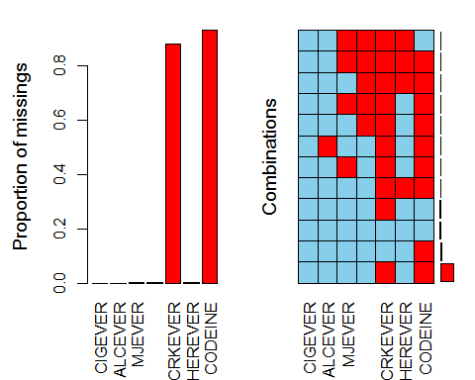

##   
## Missings per variable:   
## Variable Count  
## CIGEVER 0  
## ALCEVER 12  
## MJEVER 27  
## COCEVER 23  
## CRKEVER 48641  
## HEREVER 33  
## CODEINE 51326  
##   
## Missings in combinations of variables:   
## Combinations Count Percent  
## 0:0:0:0:0:0:0 2164 3.915253931  
## 0:0:0:0:0:0:1 4466 8.080186716  
## 0:0:0:0:1:0:0 1780 3.220495377  
## 0:0:0:0:1:0:1 46785 84.646559679  
## 0:0:0:0:1:1:1 24 0.043422410  
## 0:0:0:1:1:0:1 9 0.016283404  
## 0:0:0:1:1:1:1 4 0.007237068  
## 0:0:1:0:1:0:1 17 0.030757540  
## 0:0:1:1:1:0:1 5 0.009046335  
## 0:0:1:1:1:1:0 1 0.001809267  
## 0:0:1:1:1:1:1 4 0.007237068  
## 0:1:0:0:1:0:1 12 0.021711205

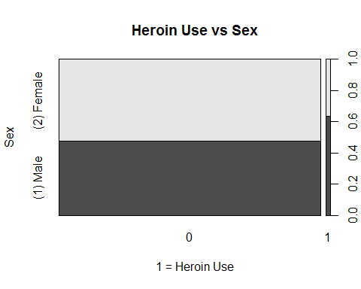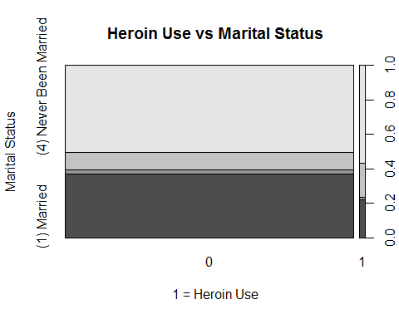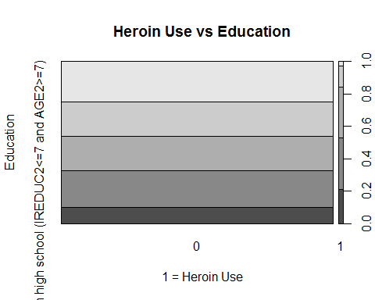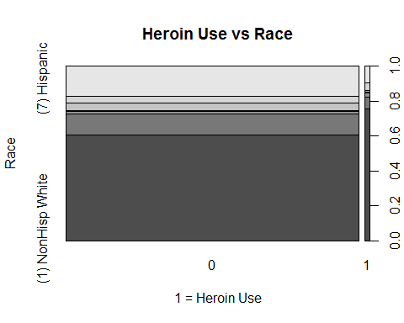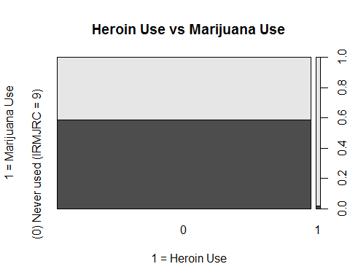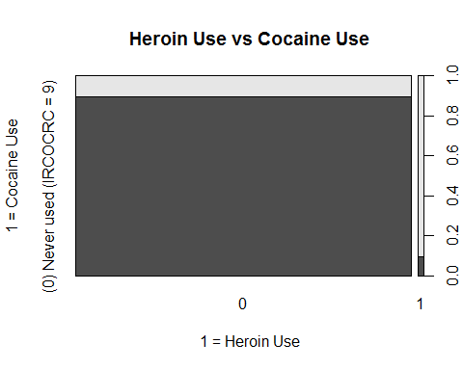

## Call:  
## rpart(formula = HERFLAG ~ ., data = dfV1.train, parms = list(split = "information"))  
## n= 11054   
##   
## CP nsplit rel error xerror xstd  
## 1 0.03590426 0 1.0000000 1.0000000 0.07230964  
## 2 0.01773050 4 0.8563830 0.9361702 0.07000246  
## 3 0.01595745 7 0.8031915 1.0212766 0.07306139  
## 4 0.01196809 9 0.7712766 1.0106383 0.07268656  
## 5 0.01063830 14 0.6914894 1.0691489 0.07472318  
## 6 0.01000000 17 0.6542553 1.0691489 0.07472318  
##   
## Variable importance  
## COCFLAG FUCOC21 LSDFLAG CRKFLAG FUCOC18 HALFLAG PERCTYL2 OXYCODP2   
## 23 14 7 7 6 6 5 5   
## VICOLOR2 OTHANL HYDCODOP OXYFLAG MORPHIN2 PCPFLAG FUCRK21 IREDUC2   
## 2 2 2 2 2 1 1 1   
## FUPCP21 ALCMDAYS TXILALEV PSYYFU2 IEMYFU TRAMADL2 FUCRK18 FUPCP18   
## 1 1 1 1 1 1 1 1   
## BINGEHVY MRJMDAYS   
## 1 1   
##   
## Node number 1: 11054 observations, complexity param=0.03590426  
## predicted class=0 expected loss=0.01700742 P(node) =1  
## class counts: 10866 188  
## probabilities: 0.983 0.017   
## left son=2 (9727 obs) right son=3 (1327 obs)  
## Primary splits:  
## COCFLAG splits as LR, improve=291.9977, (0 missing)  
## OXYCODP2 splits as LR, improve=252.8786, (0 missing)  
## PERCTYL2 splits as LR, improve=249.5773, (0 missing)  
## HALFLAG splits as LR, improve=247.0055, (0 missing)  
## IEMFLAG splits as LR, improve=235.5111, (0 missing)  
## Surrogate splits:  
## FUCOC21 splits as RL, agree=0.950, adj=0.584, (0 split)  
## LSDFLAG splits as LR, agree=0.915, adj=0.290, (0 split)  
## FUCOC18 splits as RL, agree=0.912, adj=0.271, (0 split)  
## HALFLAG splits as LR, agree=0.910, adj=0.249, (0 split)  
## CRKFLAG splits as LR, agree=0.910, adj=0.246, (0 split)  
##   
## Node number 2: 9727 observations  
## predicted class=0 expected loss=0.002364552 P(node) =0.879953  
## class counts: 9704 23  
## probabilities: 0.998 0.002   
##   
## Node number 3: 1327 observations, complexity param=0.03590426  
## predicted class=0 expected loss=0.1243406 P(node) =0.120047  
## class counts: 1162 165  
## probabilities: 0.876 0.124   
## left son=6 (936 obs) right son=7 (391 obs)  
## Primary splits:  
## PERCTYL2 splits as LR, improve=66.28215, (0 missing)  
## OXYCODP2 splits as LR, improve=63.88384, (0 missing)  
## MORPHIN2 splits as LR, improve=62.43694, (0 missing)  
## OTHANL splits as LR, improve=55.35324, (0 missing)  
## TXILALEV splits as LR, improve=54.53266, (0 missing)  
## Surrogate splits:  
## OXYCODP2 splits as LR, agree=0.962, adj=0.870, (0 split)  
## VICOLOR2 splits as LR, agree=0.827, adj=0.414, (0 split)  
## OTHANL splits as LR, agree=0.827, adj=0.412, (0 split)  
## OXYFLAG splits as LR, agree=0.819, adj=0.386, (0 split)  
## HYDCODOP splits as LR, agree=0.819, adj=0.386, (0 split)  
##   
## Node number 6: 936 observations, complexity param=0.01595745  
## predicted class=0 expected loss=0.0534188 P(node) =0.08467523  
## class counts: 886 50  
## probabilities: 0.947 0.053   
## left son=12 (851 obs) right son=13 (85 obs)  
## Primary splits:  
## PCPFLAG splits as LR, improve=14.86315, (0 missing)  
## TXILALEV splits as LR, improve=13.41458, (0 missing)  
## FUHAL21 splits as RL, improve=13.29633, (0 missing)  
## FUPCP21 splits as RL, improve=12.82491, (0 missing)  
## CRKFLAG splits as LR, improve=12.63731, (0 missing)  
## Surrogate splits:  
## FUPCP21 splits as RL, agree=0.971, adj=0.682, (0 split)  
## FUPCP18 splits as RL, agree=0.954, adj=0.494, (0 split)  
## PCPYR splits as LR, agree=0.915, adj=0.059, (0 split)  
## TUINAL2 splits as LR, agree=0.913, adj=0.047, (0 split)  
## PCPMON splits as LR, agree=0.911, adj=0.024, (0 split)  
##   
## Node number 7: 391 observations, complexity param=0.03590426  
## predicted class=0 expected loss=0.2941176 P(node) =0.03537181  
## class counts: 276 115  
## probabilities: 0.706 0.294   
## left son=14 (284 obs) right son=15 (107 obs)  
## Primary splits:  
## MORPHIN2 splits as LR, improve=20.68792, (0 missing)  
## TXILALEV splits as LR, improve=19.33926, (0 missing)  
## CRKFLAG splits as LR, improve=18.83484, (0 missing)  
## DILAUD2 splits as LR, improve=14.83821, (0 missing)  
## PCPFLAG splits as LR, improve=13.11606, (0 missing)  
## Surrogate splits:  
## METHDON2 splits as LR, agree=0.788, adj=0.224, (0 split)  
## DILAUD2 splits as LR, agree=0.785, adj=0.215, (0 split)  
## TRAMADP splits as LR, agree=0.770, adj=0.159, (0 split)  
## DEMEROL2 splits as LR, agree=0.765, adj=0.140, (0 split)  
## TRAMADL2 splits as LR, agree=0.760, adj=0.121, (0 split)  
##   
## Node number 12: 851 observations  
## predicted class=0 expected loss=0.03760282 P(node) =0.07698571  
## class counts: 819 32  
## probabilities: 0.962 0.038   
##   
## Node number 13: 85 observations, complexity param=0.01595745  
## predicted class=0 expected loss=0.2117647 P(node) =0.007689524  
## class counts: 67 18  
## probabilities: 0.788 0.212   
## left son=26 (73 obs) right son=27 (12 obs)  
## Primary splits:  
## FUCRK21 splits as RL, improve=9.876237, (0 missing)  
## CIGPDAY splits as LRRL-L, improve=9.630924, (0 missing)  
## FUCRK18 splits as RL, improve=7.526250, (0 missing)  
## MRJMDAYS splits as RLLRL, improve=6.364805, (0 missing)  
## MRJYDAYS splits as LLRRRL, improve=6.105985, (0 missing)  
## Surrogate splits:  
## FUCRK18 splits as RL, agree=0.941, adj=0.583, (0 split)  
## FUOXY21 splits as RL, agree=0.906, adj=0.333, (0 split)  
## CRKYR splits as LR, agree=0.894, adj=0.250, (0 split)  
## CRKMON splits as LR, agree=0.894, adj=0.250, (0 split)  
## HALMON splits as LR, agree=0.894, adj=0.250, (0 split)  
##   
## Node number 14: 284 observations, complexity param=0.01196809  
## predicted class=0 expected loss=0.2007042 P(node) =0.02569206  
## class counts: 227 57  
## probabilities: 0.799 0.201   
## left son=28 (187 obs) right son=29 (97 obs)  
## Primary splits:  
## CRKFLAG splits as LR, improve=11.230280, (0 missing)  
## ILORALC splits as RL, improve= 8.790041, (0 missing)  
## PCPFLAG splits as LR, improve= 6.471008, (0 missing)  
## ILALMON splits as RL, improve= 6.113814, (0 missing)  
## NILALMON splits as LR, improve= 6.113814, (0 missing)  
## Surrogate splits:  
## FUCRK21 splits as RL, agree=0.799, adj=0.412, (0 split)  
## MTHFLAG splits as LR, agree=0.711, adj=0.155, (0 split)  
## METHDES2 splits as LR, agree=0.711, adj=0.155, (0 split)  
## FUCRK18 splits as RL, agree=0.711, adj=0.155, (0 split)  
## CPNMTHFG splits as LR, agree=0.701, adj=0.124, (0 split)  
##   
## Node number 15: 107 observations, complexity param=0.03590426  
## predicted class=1 expected loss=0.4579439 P(node) =0.009679754  
## class counts: 49 58  
## probabilities: 0.458 0.542   
## left son=30 (42 obs) right son=31 (65 obs)  
## Primary splits:  
## TXILALEV splits as LR, improve=9.387146, (0 missing)  
## ANYBARB splits as LR, improve=4.594700, (0 missing)  
## TXPCAID2 splits as LR, improve=4.493079, (0 missing)  
## ILLPCAID splits as LR, improve=4.493079, (0 missing)  
## METHDON2 splits as LR, improve=4.386414, (0 missing)  
## Surrogate splits:  
## IEMYFU < 2003.5 to the right, agree=0.720, adj=0.286, (0 split)  
## SUMYFU < 2003.5 to the right, agree=0.710, adj=0.262, (0 split)  
## PSYYFU2 < 2005.5 to the right, agree=0.701, adj=0.238, (0 split)  
## MRJYDAYS splits as RLRRLR, agree=0.682, adj=0.190, (0 split)  
## MRJMDAYS splits as LRRLR, agree=0.682, adj=0.190, (0 split)  
##   
## Node number 26: 73 observations  
## predicted class=0 expected loss=0.1232877 P(node) =0.006603944  
## class counts: 64 9  
## probabilities: 0.877 0.123   
##   
## Node number 27: 12 observations  
## predicted class=1 expected loss=0.25 P(node) =0.00108558  
## class counts: 3 9  
## probabilities: 0.250 0.750   
##   
## Node number 28: 187 observations  
## predicted class=0 expected loss=0.1176471 P(node) =0.01691695  
## class counts: 165 22  
## probabilities: 0.882 0.118   
##   
## Node number 29: 97 observations, complexity param=0.01196809  
## predicted class=0 expected loss=0.3608247 P(node) =0.008775104  
## class counts: 62 35  
## probabilities: 0.639 0.361   
## left son=58 (25 obs) right son=59 (72 obs)  
## Primary splits:  
## ALCMDAYS splits as LLRRR, improve=6.801910, (0 missing)  
## BINGEHVY splits as RLLR, improve=4.863114, (0 missing)  
## TRAMADL2 splits as RL, improve=4.795300, (0 missing)  
## ALCAVGM < 7 to the left, improve=4.432819, (40 missing)  
## SUMAGE < 9.5 to the right, improve=3.988651, (0 missing)  
## Surrogate splits:  
## BINGEHVY splits as RRLR, agree=0.825, adj=0.32, (0 split)  
## PSYYFU2 < 2006.5 to the right, agree=0.784, adj=0.16, (0 split)  
## ALCYDAYS splits as RLRRRR, agree=0.773, adj=0.12, (0 split)  
## IREDUC2 splits as RRRRRRLRLRR, agree=0.773, adj=0.12, (0 split)  
## IEMYFU < 2007.5 to the right, agree=0.763, adj=0.08, (0 split)  
##   
## Node number 30: 42 observations  
## predicted class=0 expected loss=0.2857143 P(node) =0.00379953  
## class counts: 30 12  
## probabilities: 0.714 0.286   
##   
## Node number 31: 65 observations, complexity param=0.0177305  
## predicted class=1 expected loss=0.2923077 P(node) =0.005880224  
## class counts: 19 46  
## probabilities: 0.292 0.708   
## left son=62 (52 obs) right son=63 (13 obs)  
## Primary splits:  
## MRJMDAYS splits as RRRLL, improve=5.137744, (0 missing)  
## IREDUC2 splits as ---RLLLLRRR, improve=5.029909, (0 missing)  
## CATAG6 splits as LRLLRR, improve=4.570728, (0 missing)  
## EDUCCAT2 splits as LLRRL, improve=4.570728, (0 missing)  
## INCOME splits as RLLL, improve=3.990941, (0 missing)  
## Surrogate splits:  
## MRJYDAYS splits as LLLRLL, agree=0.846, adj=0.231, (0 split)  
## SEDYR splits as LR, agree=0.831, adj=0.154, (0 split)  
## MJOMON2 splits as LR, agree=0.831, adj=0.154, (0 split)  
## STMYDAYS splits as LLRL-L, agree=0.831, adj=0.154, (0 split)  
## MRJMON splits as LR, agree=0.815, adj=0.077, (0 split)  
##   
## Node number 58: 25 observations  
## predicted class=0 expected loss=0.08 P(node) =0.002261625  
## class counts: 23 2  
## probabilities: 0.920 0.080   
##   
## Node number 59: 72 observations, complexity param=0.01196809  
## predicted class=0 expected loss=0.4583333 P(node) =0.006513479  
## class counts: 39 33  
## probabilities: 0.542 0.458   
## left son=118 (8 obs) right son=119 (64 obs)  
## Primary splits:  
## TRAMADL2 splits as RL, improve=5.326142, (0 missing)  
## IREDUC2 splits as RLLRLLLLRLL, improve=4.199500, (0 missing)  
## PSYYFU2 < 2003.5 to the left, improve=3.886110, (0 missing)  
## IEMYFU < 2003.5 to the left, improve=3.554723, (0 missing)  
## TRAMADP splits as RL, improve=2.856482, (0 missing)  
## Surrogate splits:  
## SANOREX2 splits as RL, agree=0.917, adj=0.250, (0 split)  
## MAZINDOL splits as RL, agree=0.917, adj=0.250, (0 split)  
## TALACEN2 splits as RL, agree=0.903, adj=0.125, (0 split)  
## LIBRIUM2 splits as RL, agree=0.903, adj=0.125, (0 split)  
## TRANXEN2 splits as RL, agree=0.903, adj=0.125, (0 split)  
##   
## Node number 62: 52 observations, complexity param=0.0177305  
## predicted class=1 expected loss=0.3653846 P(node) =0.004704179  
## class counts: 19 33  
## probabilities: 0.365 0.635   
## left son=124 (21 obs) right son=125 (31 obs)  
## Primary splits:  
## BINGEHVY splits as LRLR, improve=4.949335, (0 missing)  
## IREDUC2 splits as ---RLLLLRRR, improve=4.883461, (0 missing)  
## CATAG6 splits as LRLLRR, improve=4.289601, (0 missing)  
## EDUCCAT2 splits as LLRRL, improve=4.289601, (0 missing)  
## ALCMDAYS splits as LLRLR, improve=4.284307, (0 missing)  
## Surrogate splits:  
## HVYDRK2 splits as RL, agree=0.846, adj=0.619, (0 split)  
## ALCMDAYS splits as RLLLR, agree=0.846, adj=0.619, (0 split)  
## ALCMON splits as RL, agree=0.827, adj=0.571, (0 split)  
## CIGALCMO splits as LRLR, agree=0.827, adj=0.571, (0 split)  
## ALCYDAYS splits as RRLLLR, agree=0.769, adj=0.429, (0 split)  
##   
## Node number 63: 13 observations  
## predicted class=1 expected loss=0 P(node) =0.001176045  
## class counts: 0 13  
## probabilities: 0.000 1.000   
##   
## Node number 118: 8 observations  
## predicted class=0 expected loss=0 P(node) =0.0007237199  
## class counts: 8 0  
## probabilities: 1.000 0.000   
##   
## Node number 119: 64 observations, complexity param=0.01196809  
## predicted class=1 expected loss=0.484375 P(node) =0.005789759  
## class counts: 31 33  
## probabilities: 0.484 0.516   
## left son=238 (55 obs) right son=239 (9 obs)  
## Primary splits:  
## IREDUC2 splits as RLLRLLRLRLL, improve=6.653735, (0 missing)  
## IEMYFU < 2003.5 to the left, improve=3.983410, (0 missing)  
## PSYYFU2 < 2003.5 to the left, improve=3.880371, (0 missing)  
## INCOME splits as LRLL, improve=2.437720, (0 missing)  
## CIGPDAY splits as RLRR-R, improve=2.380872, (0 missing)  
## Surrogate splits:  
## K6SCMON < 21.5 to the left, agree=0.891, adj=0.222, (0 split)  
## DEPNDMRJ splits as LR, agree=0.875, adj=0.111, (0 split)  
##   
## Node number 124: 21 observations, complexity param=0.0177305  
## predicted class=0 expected loss=0.3809524 P(node) =0.001899765  
## class counts: 13 8  
## probabilities: 0.619 0.381   
## left son=248 (14 obs) right son=249 (7 obs)  
## Primary splits:  
## DIETPIL2 splits as LR, improve=5.342655, (0 missing)  
## IREDUC2 splits as ---RLLLLRRR, improve=5.342655, (0 missing)  
## K6SCMON < 7.5 to the left, improve=5.008220, (1 missing)  
## K6SCMAX < 7 to the left, improve=4.100761, (1 missing)  
## EMPSTATY splits as LRLR, improve=3.493968, (0 missing)  
## Surrogate splits:  
## OTHSED splits as LR, agree=0.905, adj=0.714, (0 split)  
## IREDUC2 splits as ---RLLLLRRR, agree=0.905, adj=0.714, (0 split)  
## CIGMON splits as RL, agree=0.857, adj=0.571, (0 split)  
## CDCGMO splits as RL, agree=0.857, adj=0.571, (0 split)  
## CDNOCGMO splits as LR, agree=0.857, adj=0.571, (0 split)  
##   
## Node number 125: 31 observations  
## predicted class=1 expected loss=0.1935484 P(node) =0.002804415  
## class counts: 6 25  
## probabilities: 0.194 0.806   
##   
## Node number 238: 55 observations, complexity param=0.01196809  
## predicted class=0 expected loss=0.4363636 P(node) =0.004975574  
## class counts: 31 24  
## probabilities: 0.564 0.436   
## left son=476 (45 obs) right son=477 (10 obs)  
## Primary splits:  
## PSYYFU2 < 2003.5 to the left, improve=3.385592, (0 missing)  
## IEMYFU < 2003.5 to the left, improve=3.050580, (0 missing)  
## LSDFLAG splits as LR, improve=2.114385, (0 missing)  
## FUHAL21 splits as RL, improve=2.114385, (0 missing)  
## K6SCMAX < 13.5 to the right, improve=2.114385, (0 missing)  
## Surrogate splits:  
## IEMYFU < 2003.5 to the left, agree=0.945, adj=0.7, (0 split)  
## SUMYFU < 2001 to the left, agree=0.909, adj=0.5, (0 split)  
## CATAG6 splits as -RLLL-, agree=0.909, adj=0.5, (0 split)  
## PREGAGE2 splits as -RLL, agree=0.909, adj=0.5, (0 split)  
## SEXAGE splits as --RRL, agree=0.909, adj=0.5, (0 split)  
##   
## Node number 239: 9 observations  
## predicted class=1 expected loss=0 P(node) =0.0008141849  
## class counts: 0 9  
## probabilities: 0.000 1.000   
##   
## Node number 248: 14 observations  
## predicted class=0 expected loss=0.1428571 P(node) =0.00126651  
## class counts: 12 2  
## probabilities: 0.857 0.143   
##   
## Node number 249: 7 observations  
## predicted class=1 expected loss=0.1428571 P(node) =0.0006332549  
## class counts: 1 6  
## probabilities: 0.143 0.857   
##   
## Node number 476: 45 observations, complexity param=0.0106383  
## predicted class=0 expected loss=0.3555556 P(node) =0.004070925  
## class counts: 29 16  
## probabilities: 0.644 0.356   
## left son=952 (15 obs) right son=953 (30 obs)  
## Primary splits:  
## HEALTH2 splits as LLRR, improve=2.668997, (0 missing)  
## ALCYDAYS splits as RLLRLR, improve=2.134200, (0 missing)  
## FUANL21 splits as LR, improve=2.098037, (0 missing)  
## LSDFLAG splits as LR, improve=1.775559, (0 missing)  
## OTHSTM splits as RL, improve=1.696367, (0 missing)  
## Surrogate splits:  
## PROCODNP splits as LR, agree=0.822, adj=0.467, (0 split)  
## RITMPHE2 splits as RL, agree=0.800, adj=0.400, (0 split)  
## METHDEXM splits as RL, agree=0.800, adj=0.400, (0 split)  
## CATAG6 splits as -LLRR-, agree=0.778, adj=0.333, (0 split)  
## IEMYFU < 1995 to the right, agree=0.756, adj=0.267, (0 split)  
##   
## Node number 477: 10 observations  
## predicted class=1 expected loss=0.2 P(node) =0.0009046499  
## class counts: 2 8  
## probabilities: 0.200 0.800   
##   
## Node number 952: 15 observations  
## predicted class=0 expected loss=0.1333333 P(node) =0.001356975  
## class counts: 13 2  
## probabilities: 0.867 0.133   
##   
## Node number 953: 30 observations, complexity param=0.0106383  
## predicted class=0 expected loss=0.4666667 P(node) =0.00271395  
## class counts: 16 14  
## probabilities: 0.533 0.467   
## left son=1906 (8 obs) right son=1907 (22 obs)  
## Primary splits:  
## ALCYDAYS splits as RLLRLR, improve=2.829967, (0 missing)  
## CIGMDAYS splits as LRLRLR, improve=1.951205, (0 missing)  
## INCOME splits as LRRL, improve=1.670123, (0 missing)  
## HYDROCD2 splits as RL, improve=1.665725, (0 missing)  
## ECSFLAG splits as LR, improve=1.632274, (0 missing)  
## Surrogate splits:  
## HALFLAG splits as LR, agree=0.833, adj=0.375, (0 split)  
## K6SCMON < 19.5 to the right, agree=0.833, adj=0.375, (0 split)  
## K6SCMAX < 17.5 to the right, agree=0.833, adj=0.375, (0 split)  
## MRJYDAYS splits as RR-RLR, agree=0.800, adj=0.250, (0 split)  
## ABODILAL splits as RL, agree=0.800, adj=0.250, (0 split)  
##   
## Node number 1906: 8 observations  
## predicted class=0 expected loss=0.125 P(node) =0.0007237199  
## class counts: 7 1  
## probabilities: 0.875 0.125   
##   
## Node number 1907: 22 observations, complexity param=0.0106383  
## predicted class=1 expected loss=0.4090909 P(node) =0.00199023  
## class counts: 9 13  
## probabilities: 0.409 0.591   
## left son=3814 (11 obs) right son=3815 (11 obs)  
## Primary splits:  
## PSYYFU2 < 1981.5 to the left, improve=2.457739, (0 missing)  
## FUANL21 splits as LR, improve=2.308696, (0 missing)  
## PSYAGE2 < 21 to the left, improve=1.648907, (0 missing)  
## FUPSY21 splits as LR, improve=1.648907, (0 missing)  
## CIGMDAYS splits as LR-LLR, improve=1.215291, (0 missing)  
## Surrogate splits:  
## SUMYFU < 1979 to the left, agree=0.909, adj=0.818, (0 split)  
## IEMYFU < 1979.5 to the left, agree=0.909, adj=0.818, (0 split)  
## PSYAGE2 < 21 to the left, agree=0.818, adj=0.636, (0 split)  
## FUPSY21 splits as LR, agree=0.818, adj=0.636, (0 split)  
## SUMAGE < 14.5 to the left, agree=0.773, adj=0.545, (0 split)  
##   
## Node number 3814: 11 observations  
## predicted class=0 expected loss=0.3636364 P(node) =0.0009951149  
## class counts: 7 4  
## probabilities: 0.636 0.364   
##   
## Node number 3815: 11 observations  
## predicted class=1 expected loss=0.1818182 P(node) =0.0009951149  
## class counts: 2 9  
## probabilities: 0.182 0.818

## Overall  
## ALCAVGM 4.432819  
## ALCMDAYS 11.086217  
## ALCYDAYS 4.964167  
## ANYBARB 4.594700  
## BINGEHVY 9.812449  
## CATAG6 8.860330  
## CIGMDAYS 3.166496  
## CIGPDAY 12.011796  
## COCFLAG 291.997719  
## CRKFLAG 42.702429  
## DIETPIL2 5.342655  
## DILAUD2 14.838211  
## ECSFLAG 1.632274  
## EDUCCAT2 8.860330  
## EMPSTATY 3.493968  
## FUANL21 4.406734  
## FUCRK18 7.526250  
## FUCRK21 9.876237  
## FUHAL21 15.410715  
## FUPCP21 12.824914  
## FUPSY21 1.648907  
## HALFLAG 247.005510  
## HEALTH2 2.668997  
## HYDROCD2 1.665725  
## IEMFLAG 235.511061  
## IEMYFU 10.588713  
## ILALMON 6.113814  
## ILLPCAID 4.493079  
## ILORALC 8.790041  
## INCOME 8.098784  
## IREDUC2 26.109259  
## K6SCMAX 6.215146  
## K6SCMON 5.008220  
## LSDFLAG 3.889945  
## METHDON2 4.386414  
## MORPHIN2 83.124858  
## MRJMDAYS 11.502550  
## MRJYDAYS 6.105985  
## NILALMON 6.113814  
## OTHANL 55.353244  
## OTHSTM 1.696367  
## OXYCODP2 316.762426  
## PCPFLAG 34.450216  
## PERCTYL2 315.859491  
## PSYAGE2 1.648907  
## PSYYFU2 13.609813  
## SUMAGE 3.988651  
## TRAMADL2 10.121442  
## TRAMADP 2.856482  
## TXILALEV 96.673646  
## TXPCAID2 4.493079  
## CIGFLAG 0.000000  
## CIGYR 0.000000  
## CIGMON 0.000000  
## CGRFLAG 0.000000  
## CGRYR 0.000000  
## CGRMON 0.000000  
## PIPFLAG 0.000000  
## PIPMON 0.000000  
## SMKFLAG 0.000000  
## SMKYR 0.000000  
## SMKMON 0.000000  
## CHWFLAG 0.000000  
## CHWYR 0.000000  
## CHWMON 0.000000  
## SNFFLAG 0.000000  
## SNFYR 0.000000  
## SNFMON 0.000000  
## TOBFLAG 0.000000  
## TOBYR 0.000000  
## TOBMON 0.000000  
## ALCFLAG 0.000000  
## ALCYR 0.000000  
## ALCMON 0.000000  
## MRJFLAG 0.000000  
## MRJYR 0.000000  
## MRJMON 0.000000  
## COCYR 0.000000  
## COCMON 0.000000  
## CRKYR 0.000000  
## CRKMON 0.000000  
## HALYR 0.000000  
## HALMON 0.000000  
## LSDYR 0.000000  
## LSDMON 0.000000  
## PCPYR 0.000000  
## PCPMON 0.000000  
## ECSYR 0.000000  
## ECSMON 0.000000  
## INHFLAG 0.000000  
## INHYR 0.000000  
## INHMON 0.000000  
## ANLFLAG 0.000000  
## ANLYR 0.000000  
## ANLMON 0.000000  
## OXYFLAG 0.000000  
## OXYYR 0.000000  
## OXYMON 0.000000  
## TRQFLAG 0.000000  
## TRQYR 0.000000  
## TRQMON 0.000000  
## STMFLAG 0.000000  
## STMYR 0.000000  
## STMMON 0.000000  
## CPNSTMFG 0.000000  
## CPNSTMYR 0.000000  
## CPNSTMMN 0.000000  
## MTHFLAG 0.000000  
## MTHYR 0.000000  
## MTHMON 0.000000  
## CPNMTHFG 0.000000  
## CPNMTHYR 0.000000  
## CPNMTHMN 0.000000  
## SEDFLAG 0.000000  
## SEDYR 0.000000  
## SEDMON 0.000000  
## PSYFLAG2 0.000000  
## PSYYR2 0.000000  
## PSYMON2 0.000000  
## CPNPSYFG 0.000000  
## CPNPSYYR 0.000000  
## CPNPSYMN 0.000000  
## SUMFLAG 0.000000  
## SUMYR 0.000000  
## SUMMON 0.000000  
## SUMYFU 0.000000  
## MJOFLAG 0.000000  
## MJOYR2 0.000000  
## MJOMON2 0.000000  
## IEMYR 0.000000  
## IEMMON 0.000000  
## IEMAGE 0.000000  
## CDUFLAG 0.000000  
## DCIGMON 0.000000  
## CDCGMO 0.000000  
## CDNOCGMO 0.000000  
## CIGALCMO 0.000000  
## BINGEDRK 0.000000  
## HVYDRK2 0.000000  
## ILTOALMN 0.000000  
## TOBALCMN 0.000000  
## ILANDALC 0.000000  
## PEYOTE2 0.000000  
## MESC2 0.000000  
## PSILCY2 0.000000  
## AMYLNIT2 0.000000  
## CLEFLU2 0.000000  
## GAS2 0.000000  
## GLUE2 0.000000  
## ETHER2 0.000000  
## SOLVENT2 0.000000  
## LGAS2 0.000000  
## NITOXID2 0.000000  
## SPPAINT2 0.000000  
## AEROS2 0.000000  
## DARVTYL2 0.000000  
## VICOLOR2 0.000000  
## CODEINE2 0.000000  
## DEMEROL2 0.000000  
## FIORICT2 0.000000  
## FIORINL2 0.000000  
## PHENCOD2 0.000000  
## PROPOXY2 0.000000  
## SK65A2 0.000000  
## STADOL2 0.000000  
## TALACEN2 0.000000  
## TALWIN2 0.000000  
## TALWINX2 0.000000  
## ULTRAM2 0.000000  
## PROCODNP 0.000000  
## HYDCODOP 0.000000  
## KLONOPI2 0.000000  
## XNAXATV2 0.000000  
## VALMDIA2 0.000000  
## ATARAX2 0.000000  
## BUSPAR2 0.000000  
## EQUANIL2 0.000000  
## FLEXERL2 0.000000  
## LIBRIUM2 0.000000  
## LIMBTRL2 0.000000  
## MEPROB2 0.000000  
## MILTOWN2 0.000000  
## ROHYPNL2 0.000000  
## SERAX2 0.000000  
## SOMA2 0.000000  
## TRANXEN2 0.000000  
## VISTAR2 0.000000  
## OTHTRN 0.000000  
## BENZOS 0.000000  
## MEPROBPD 0.000000  
## MUSCRELX 0.000000  
## METHDES2 0.000000  
## RITMPHE2 0.000000  
## CYLERT2 0.000000  
## DEXED2 0.000000  
## DETAMP2 0.000000  
## DIDREX2 0.000000  
## ESKAT2 0.000000  
## IONAMIN2 0.000000  
## MAZANOR2 0.000000  
## OBLA2 0.000000  
## PLEGINE2 0.000000  
## PRELUDN2 0.000000  
## SANOREX2 0.000000  
## TENUATE2 0.000000  
## AMDXPHEN 0.000000  
## MAZINDOL 0.000000  
## METHDEXM 0.000000  
## METHAQ2 0.000000  
## NEMBBAR2 0.000000  
## RESTTMA2 0.000000  
## AMYTAL2 0.000000  
## BUTISOL2 0.000000  
## CHHYD2 0.000000  
## DALMANE2 0.000000  
## HALCION2 0.000000  
## PHENOBR2 0.000000  
## PLACIDY2 0.000000  
## TUINAL2 0.000000  
## OTHSED 0.000000  
## RTDALHAL 0.000000  
## CIGAFU 0.000000  
## DCIGAFU 0.000000  
## ALCAFU 0.000000  
## MJAFU 0.000000  
## COCYDAYS 0.000000  
## HALYDAYS 0.000000  
## INHYDAYS 0.000000  
## STMYDAYS 0.000000  
## COCMDAYS 0.000000  
## HALMDAYS 0.000000  
## INHMDAYS 0.000000  
## CIG1PACK 0.000000  
## CIGAVGD 0.000000  
## CIGAVGM 0.000000  
## FUCIG18 0.000000  
## FUCIG21 0.000000  
## FUCD218 0.000000  
## FUCD221 0.000000  
## FUCGR18 0.000000  
## FUCGR21 0.000000  
## FUSLT18 0.000000  
## FUSLT21 0.000000  
## FUALC18 0.000000  
## FUALC21 0.000000  
## FUMJ18 0.000000  
## FUMJ21 0.000000  
## FUCOC18 0.000000  
## FUCOC21 0.000000  
## FUHAL18 0.000000  
## FULSD18 0.000000  
## FULSD21 0.000000  
## FUPCP18 0.000000  
## FUECS18 0.000000  
## FUECS21 0.000000  
## FUINH18 0.000000  
## FUINH21 0.000000  
## FUANL18 0.000000  
## FUOXY18 0.000000  
## FUOXY21 0.000000  
## FUTRN18 0.000000  
## FUTRN21 0.000000  
## FUSTM18 0.000000  
## FUSTM21 0.000000  
## FUMTH18 0.000000  
## FUMTH21 0.000000  
## FUSED18 0.000000  
## FUSED21 0.000000  
## FUPSY18 0.000000  
## FUSUM18 0.000000  
## FUSUM21 0.000000  
## FUIEM18 0.000000  
## FUIEM21 0.000000  
## NDSSDNSP 0.000000  
## FTNDDNSP 0.000000  
## DNICNSP 0.000000  
## DEPNDALC 0.000000  
## DEPNDANL 0.000000  
## DEPNDCOC 0.000000  
## DEPNDHAL 0.000000  
## DEPNDINH 0.000000  
## DEPNDMRJ 0.000000  
## DEPNDSED 0.000000  
## DEPNDSTM 0.000000  
## DEPNDTRN 0.000000  
## DEPNDPSY 0.000000  
## DPILLALC 0.000000  
## DPILANAL 0.000000  
## ABUSEALC 0.000000  
## ABUSEANL 0.000000  
## ABUSECOC 0.000000  
## ABUSEHAL 0.000000  
## ABUSEINH 0.000000  
## ABUSEMRJ 0.000000  
## ABUSESED 0.000000  
## ABUSESTM 0.000000  
## ABUSETRN 0.000000  
## ABUSEILL 0.000000  
## ABUSEIEM 0.000000  
## ABUSEXMJ 0.000000  
## ABUSEPSY 0.000000  
## ABILLALC 0.000000  
## ABILANAL 0.000000  
## ABODALC 0.000000  
## ABODANL 0.000000  
## ABODCOC 0.000000  
## ABODHAL 0.000000  
## ABODINH 0.000000  
## ABODMRJ 0.000000  
## ABODSED 0.000000  
## ABODSTM 0.000000  
## ABODTRN 0.000000  
## ABODILL 0.000000  
## ABODPSY 0.000000  
## ABODILAL 0.000000  
## ABDILAAL 0.000000  
## ALCTRMT 0.000000  
## ILLTRMT 0.000000  
## TXALNOIL 0.000000  
## TXILNOAL 0.000000  
## TXILLALC 0.000000  
## TXILANAL 0.000000  
## TXLTALC2 0.000000  
## TXLTMJ2 0.000000  
## TXLTCOC2 0.000000  
## TXLTHAL2 0.000000  
## TXLTINH2 0.000000  
## TXLTANL2 0.000000  
## TXLTTRN2 0.000000  
## TXLTSTM2 0.000000  
## TXLTSED2 0.000000  
## TXLTILL2 0.000000  
## TXPINS2 0.000000  
## TXPCARE2 0.000000  
## TXPPUBP2 0.000000  
## TXPSAVE2 0.000000  
## TXPFMLY2 0.000000  
## TXPCORT2 0.000000  
## TXPMILC2 0.000000  
## TXPEMPL2 0.000000  
## ALCPINS 0.000000  
## ALCPCARE 0.000000  
## ALCPCAID 0.000000  
## ALCPPUBP 0.000000  
## ALCPSAVE 0.000000  
## ALCPFMLY 0.000000  
## ALCPCORT 0.000000  
## ALCPMILC 0.000000  
## ALCPEMPL 0.000000  
## ILLPINS 0.000000  
## ILLPCARE 0.000000  
## ILLPPUBP 0.000000  
## ILLPSAVE 0.000000  
## ILLPFMLY 0.000000  
## ILLPCORT 0.000000  
## ILLPMILC 0.000000  
## ILLPEMPL 0.000000  
## SPECTALC 0.000000  
## SPECTILL 0.000000  
## AMHINP2 0.000000  
## AMHOUTP3 0.000000  
## AMHRX2 0.000000  
## AMHTXRC3 0.000000  
## SPDMON 0.000000  
## K6SCYR 0.000000  
## SPDYR 0.000000  
## MHSUITHK 0.000000  
## MHSUTK_U 0.000000  
## MHSUIPLN 0.000000  
## MHSUITRY 0.000000  
## GOVTPROG 0.000000  
## POVERTY2 0.000000  
## HLCALLFG 0.000000  
## HLCALL99 0.000000  
## ANYHLTI2 0.000000  
## IRINSUR4 0.000000  
## IIINSUR4 0.000000  
## OTHINS 0.000000  
## IRSEX 0.000000  
## IRMARIT 0.000000  
## IIMARIT 0.000000  
## IIEDUC2 0.000000  
## PREGAGE2 0.000000  
## SEXAGE 0.000000  
## NEWRACE2 0.000000  
## SEXRACE 0.000000

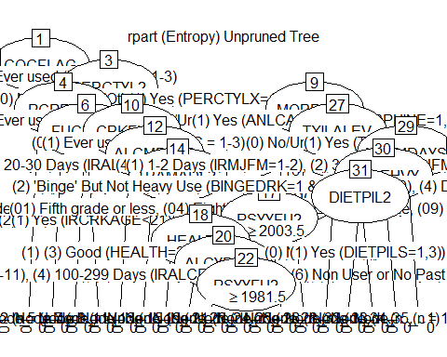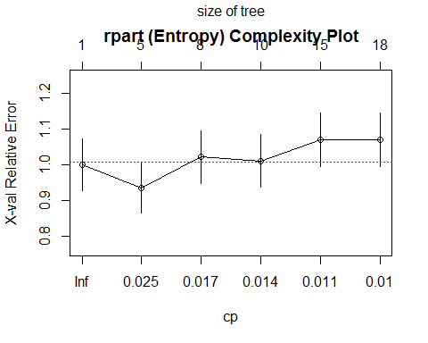

##   
## Model formula:  
## HERFLAG ~ CIGFLAG + CIGYR + CIGMON + CGRFLAG + CGRYR + CGRMON +   
## PIPFLAG + PIPMON + SMKFLAG + SMKYR + SMKMON + CHWFLAG + CHWYR +   
## CHWMON + SNFFLAG + SNFYR + SNFMON + TOBFLAG + TOBYR + TOBMON +   
## ALCFLAG + ALCYR + ALCMON + MRJFLAG + MRJYR + MRJMON + COCFLAG +   
## COCYR + COCMON + CRKFLAG + CRKYR + CRKMON + HALFLAG + HALYR +   
## HALMON + LSDFLAG + LSDYR + LSDMON + PCPFLAG + PCPYR + PCPMON +   
## ECSFLAG + ECSYR + ECSMON + INHFLAG + INHYR + INHMON + ANLFLAG +   
## ANLYR + ANLMON + OXYFLAG + OXYYR + OXYMON + TRQFLAG + TRQYR +   
## TRQMON + STMFLAG + STMYR + STMMON + CPNSTMFG + CPNSTMYR +   
## CPNSTMMN + MTHFLAG + MTHYR + MTHMON + CPNMTHFG + CPNMTHYR +   
## CPNMTHMN + SEDFLAG + SEDYR + SEDMON + PSYFLAG2 + PSYYR2 +   
## PSYMON2 + PSYAGE2 + PSYYFU2 + CPNPSYFG + CPNPSYYR + CPNPSYMN +   
## SUMFLAG + SUMYR + SUMMON + SUMAGE + SUMYFU + MJOFLAG + MJOYR2 +   
## MJOMON2 + IEMFLAG + IEMYR + IEMMON + IEMAGE + IEMYFU + CDUFLAG +   
## DCIGMON + CDCGMO + CDNOCGMO + CIGALCMO + BINGEDRK + HVYDRK2 +   
## BINGEHVY + ILTOALMN + ILALMON + TOBALCMN + NILALMON + ILANDALC +   
## ILORALC + PEYOTE2 + MESC2 + PSILCY2 + AMYLNIT2 + CLEFLU2 +   
## GAS2 + GLUE2 + ETHER2 + SOLVENT2 + LGAS2 + NITOXID2 + SPPAINT2 +   
## AEROS2 + DARVTYL2 + PERCTYL2 + VICOLOR2 + CODEINE2 + DEMEROL2 +   
## DILAUD2 + FIORICT2 + FIORINL2 + HYDROCD2 + METHDON2 + MORPHIN2 +   
## PHENCOD2 + PROPOXY2 + SK65A2 + STADOL2 + TALACEN2 + TALWIN2 +   
## TALWINX2 + TRAMADL2 + ULTRAM2 + OTHANL + PROCODNP + OXYCODP2 +   
## HYDCODOP + TRAMADP + KLONOPI2 + XNAXATV2 + VALMDIA2 + ATARAX2 +   
## BUSPAR2 + EQUANIL2 + FLEXERL2 + LIBRIUM2 + LIMBTRL2 + MEPROB2 +   
## MILTOWN2 + ROHYPNL2 + SERAX2 + SOMA2 + TRANXEN2 + VISTAR2 +   
## OTHTRN + BENZOS + MEPROBPD + MUSCRELX + METHDES2 + DIETPIL2 +   
## RITMPHE2 + CYLERT2 + DEXED2 + DETAMP2 + DIDREX2 + ESKAT2 +   
## IONAMIN2 + MAZANOR2 + OBLA2 + PLEGINE2 + PRELUDN2 + SANOREX2 +   
## TENUATE2 + OTHSTM + AMDXPHEN + MAZINDOL + METHDEXM + METHAQ2 +   
## NEMBBAR2 + RESTTMA2 + AMYTAL2 + BUTISOL2 + CHHYD2 + DALMANE2 +   
## HALCION2 + PHENOBR2 + PLACIDY2 + TUINAL2 + OTHSED + RTDALHAL +   
## ANYBARB + CIGAFU + DCIGAFU + ALCAFU + MJAFU + ALCYDAYS +   
## MRJYDAYS + COCYDAYS + HALYDAYS + INHYDAYS + STMYDAYS + CIGMDAYS +   
## ALCMDAYS + MRJMDAYS + COCMDAYS + HALMDAYS + INHMDAYS + CIGPDAY +   
## CIG1PACK + CIGAVGD + CIGAVGM + ALCAVGM + FUCIG18 + FUCIG21 +   
## FUCD218 + FUCD221 + FUCGR18 + FUCGR21 + FUSLT18 + FUSLT21 +   
## FUALC18 + FUALC21 + FUMJ18 + FUMJ21 + FUCOC18 + FUCOC21 +   
## FUCRK18 + FUCRK21 + FUHAL18 + FUHAL21 + FULSD18 + FULSD21 +   
## FUPCP18 + FUPCP21 + FUECS18 + FUECS21 + FUINH18 + FUINH21 +   
## FUANL18 + FUANL21 + FUOXY18 + FUOXY21 + FUTRN18 + FUTRN21 +   
## FUSTM18 + FUSTM21 + FUMTH18 + FUMTH21 + FUSED18 + FUSED21 +   
## FUPSY18 + FUPSY21 + FUSUM18 + FUSUM21 + FUIEM18 + FUIEM21 +   
## NDSSDNSP + FTNDDNSP + DNICNSP + DEPNDALC + DEPNDANL + DEPNDCOC +   
## DEPNDHAL + DEPNDINH + DEPNDMRJ + DEPNDSED + DEPNDSTM + DEPNDTRN +   
## DEPNDPSY + DPILLALC + DPILANAL + ABUSEALC + ABUSEANL + ABUSECOC +   
## ABUSEHAL + ABUSEINH + ABUSEMRJ + ABUSESED + ABUSESTM + ABUSETRN +   
## ABUSEILL + ABUSEIEM + ABUSEXMJ + ABUSEPSY + ABILLALC + ABILANAL +   
## ABODALC + ABODANL + ABODCOC + ABODHAL + ABODINH + ABODMRJ +   
## ABODSED + ABODSTM + ABODTRN + ABODILL + ABODPSY + ABODILAL +   
## ABDILAAL + TXILALEV + ALCTRMT + ILLTRMT + TXALNOIL + TXILNOAL +   
## TXILLALC + TXILANAL + TXLTALC2 + TXLTMJ2 + TXLTCOC2 + TXLTHAL2 +   
## TXLTINH2 + TXLTANL2 + TXLTTRN2 + TXLTSTM2 + TXLTSED2 + TXLTILL2 +   
## TXPINS2 + TXPCARE2 + TXPCAID2 + TXPPUBP2 + TXPSAVE2 + TXPFMLY2 +   
## TXPCORT2 + TXPMILC2 + TXPEMPL2 + ALCPINS + ALCPCARE + ALCPCAID +   
## ALCPPUBP + ALCPSAVE + ALCPFMLY + ALCPCORT + ALCPMILC + ALCPEMPL +   
## ILLPINS + ILLPCARE + ILLPCAID + ILLPPUBP + ILLPSAVE + ILLPFMLY +   
## ILLPCORT + ILLPMILC + ILLPEMPL + SPECTALC + SPECTILL + AMHINP2 +   
## AMHOUTP3 + AMHRX2 + AMHTXRC3 + K6SCMON + SPDMON + K6SCYR +   
## K6SCMAX + SPDYR + MHSUITHK + MHSUTK_U + MHSUIPLN + MHSUITRY +   
## GOVTPROG + INCOME + POVERTY2 + HLCALLFG + HLCALL99 + ANYHLTI2 +   
## IRINSUR4 + IIINSUR4 + OTHINS + IRSEX + IRMARIT + IIMARIT +   
## IREDUC2 + IIEDUC2 + CATAG6 + PREGAGE2 + SEXAGE + NEWRACE2 +   
## SEXRACE + EDUCCAT2 + HEALTH2 + EMPSTATY  
##   
## Fitted party:  
## [1] root  
## | [2] COCFLAG in (0) Never used (IRCOCRC = 9): 0 (n = 9727, err = 0.2%)  
## | [3] COCFLAG in (1) Ever used (IRCOCRC = 1-3)  
## | | [4] PERCTYL2 in (0) No/Unknown (Otherwise): 0 (n = 936, err = 5.3%)  
## | | [5] PERCTYL2 in (1) Yes (PERCTYLX=1,3)  
## | | | [6] MORPHIN2 in (0) No/Unknown (Otherwise): 0 (n = 284, err = 20.1%)  
## | | | [7] MORPHIN2 in (1) Yes (ANLCARD and MORPHINE=1,3)  
## | | | | [8] TXILALEV in (0) No/Unknown (Otherwise): 0 (n = 42, err = 28.6%)  
## | | | | [9] TXILALEV in (1) Yes (TXEVER=1): 1 (n = 65, err = 29.2%)  
##   
## Number of inner nodes: 4  
## Number of terminal nodes: 5

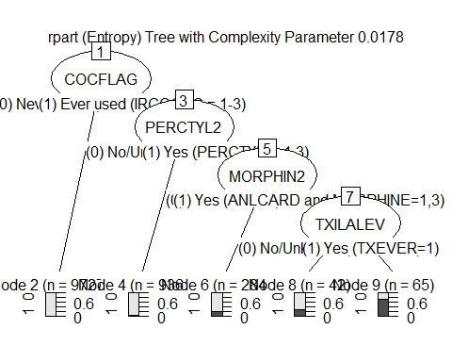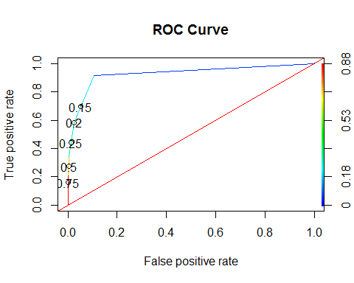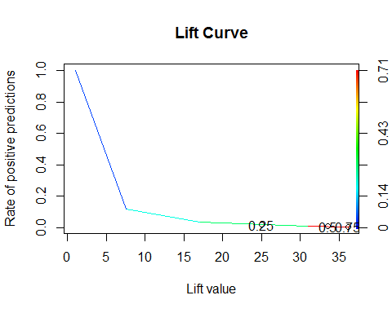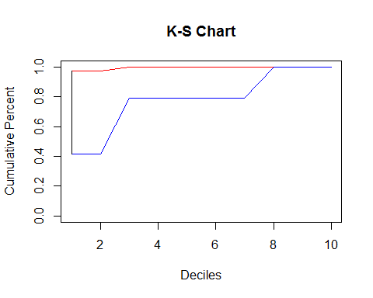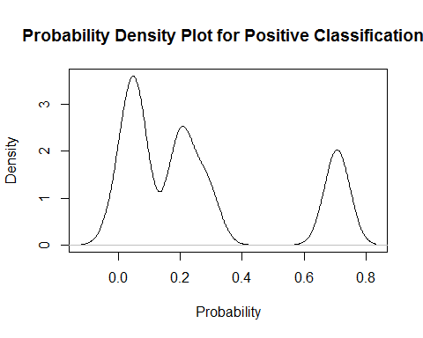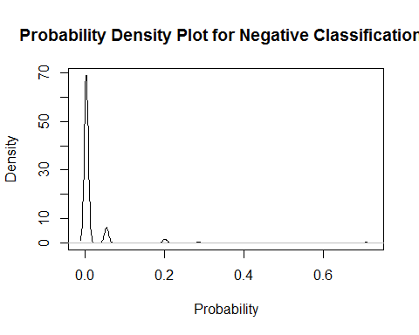

## $AUC  
## $AUC[[1]]  
## [1] 0.9262817  
##   
##   
## $`D Statistic`  
## [1] 0.2399654  
##   
## $`KS Statistic`  
## Group CumPct0 CumPct1 Dif  
## 1 1 0.9752433 0.4164456 0.5587977  
## 2 2 0.9752433 0.4164456 0.5587977  
##   
## $`Confusion Matrix`  
## Confusion Matrix and Statistics  
##   
## Reference  
## Prediction 0 1  
## 0 43233 230  
## 1 498 256  
##   
## Accuracy : 0.9835   
## 95% CI : (0.9823, 0.9847)  
## No Information Rate : 0.989   
## P-Value [Acc > NIR] : 1   
##   
## Kappa : 0.4049   
## Mcnemar's Test P-Value : <2e-16   
##   
## Sensitivity : 0.9886   
## Specificity : 0.5267   
## Pos Pred Value : 0.9947   
## Neg Pred Value : 0.3395   
## Prevalence : 0.9890   
## Detection Rate : 0.9777   
## Detection Prevalence : 0.9829   
## Balanced Accuracy : 0.7577   
##   
## 'Positive' Class : 0   
##

##   
## Call:  
## C5.0.formula(formula = HERFLAG ~ ., data = dfV1.train, trials = 5, rules  
## = FALSE)  
##   
##   
## C5.0 [Release 2.07 GPL Edition] Sun Dec 04 21:47:37 2016  
## -------------------------------  
##   
## Class specified by attribute `outcome'  
##   
## Read 11054 cases (385 attributes) from undefined.data  
##   
## ----- Trial 0: -----  
##   
## Decision tree:  
##   
## PCPMON = (1) Used within the past month (IRPCPRC = 1): 1 (3)  
## PCPMON = (0) Did not use in the past month (IRPCPRC = 2-3,9):  
## :...DILAUD2 = (1) Yes (ANLCARD and DILAUD=1,3):  
## :...TXILALEV = (1) Yes (TXEVER=1): 1 (52/18)  
## : TXILALEV = (0) No/Unknown (Otherwise):  
## : :...FUCRK21 = (1) Yes (IRCRKAGE<21): 1 (6/1)  
## : FUCRK21 = (2) No (IRCRKAGE>=21): 0 (29/5)  
## DILAUD2 = (0) No/Unknown (Otherwise):  
## :...DEPNDCOC = (1) Yes (See comment above DEPNDALC):  
## :...METHDON2 = (0) No/Unknown (Otherwise): 0 (9/1)  
## : METHDON2 = (1) Yes (ANLCARD and METHDON=1,3): 1 (5)  
## DEPNDCOC = (0) No/Unknown (Otherwise):  
## :...FUCRK18 = (1) Yes (IRCRKAGE<18):  
## :...PCPFLAG = (0) Never used (IRPCPRC = 9): 0 (42/9)  
## : PCPFLAG = (1) Ever used (IRPCPRC = 1-3):  
## : :...SPDMON = (0) No (K6SCMON<13): 1 (8.8)  
## : SPDMON = (1) Yes (K6SCMON>=13): 0 (2.2/0.2)  
## FUCRK18 = (2) No (IRCRKAGE>=18):  
## :...PHENOBR2 = (1) Yes (SEDCARD and PHENOBAR=1,3):  
## :...PEYOTE2 = (0) No/Unknown (Otherwise): 0 (13)  
## : PEYOTE2 = (1) Yes (PEYOTE=1,3): 1 (8/1)  
## PHENOBR2 = (0) No/Unknown (Otherwise):  
## :...TXILNOAL = (0) No/Unknown (Otherwise): 0 (10837/100)  
## TXILNOAL = (1) Yes (TXYRADG=2): [S1]  
##   
## SubTree [S1]  
##   
## IEMMON = (0) Never used drug/used only marijuana past month: 0 (30/3)  
## IEMMON = (1) Illicit drug except for marijuana used past month: 1 (9/2)  
##   
## ----- Trial 1: -----  
##   
## Decision tree:  
##   
## COCFLAG = (0) Never used (IRCOCRC = 9):  
## :...TXLTTRN2 = (1) Yes (TXLTYTRN=1,3): 1 (43.5/2.3)  
## : TXLTTRN2 = (0) No/Unknown (Otherwise):  
## : :...FUMTH21 = (1) Yes (IRMTHAGE<21): 1 (121.6/39.2)  
## : FUMTH21 = (2) No (IRMTHAGE>=21): 0 (7590/244.4)  
## COCFLAG = (1) Ever used (IRCOCRC = 1-3):  
## :...STMYDAYS in {(2) 12-49 Days (IRSTMFY=12-49),  
## : (5) 300-365 Days (IRSTMFY=300-365)}: 0 (81.8/1.5)  
## STMYDAYS in {(1) 1-11 Days (IRSTMFY=1-11),(3) 50-99 Days (IRSTMFY=50-99),  
## : (4) 100-299 Days (IRSTMFY=100-299),  
## : (6) Non User or No Past Year Use (IRSTMFY=991,993)}:  
## :...MRJFLAG = (0) Never used (IRMJRC = 9): 0 (22.6)  
## MRJFLAG = (1) Ever used (IRMJRC = 1-3):  
## :...AMYTAL2 = (1) Yes (SEDCARD and AMYTAL=1,3): 0 (45/2.3)  
## AMYTAL2 = (0) No/Unknown (Otherwise):  
## :...NEWRACE2 in {(3) NonHisp Native Am/AK Native,  
## : (4) NonHisp Native HI/Other Pac Isl}: 0 (26.4)  
## NEWRACE2 in {(1) NonHisp White,(2) NonHisp Black/Afr Am,  
## : (5) NonHisp Asian,(6) NonHisp more than one race,  
## : (7) Hispanic}: [S1]  
##   
## SubTree [S1]  
##   
## CHWMON = (1) Used within the past month (IRCHWRC = 1): 0 (23.3/2.3)  
## CHWMON = (0) Did not use in the past month (IRCHWRC = 2-4,9):  
## :...DILAUD2 = (1) Yes (ANLCARD and DILAUD=1,3): 0 (381.7/105.8)  
## DILAUD2 = (0) No/Unknown (Otherwise):  
## :...IEMYFU > 2011: 0 (35.4)  
## IEMYFU <= 2011: [S2]  
##   
## SubTree [S2]  
##   
## SEXRACE in {(1) Male, White, Not Hisp (IRSEX=1 and NEWRACE2=1),  
## : (2) Female, White, Not Hisp (IRSEX=2 and NEWRACE2=1),  
## : (3) Male, Black, Not Hisp (IRSEX=1 and NEWRACE2=2),  
## : (4) Female, Black, Not Hisp (IRSEX=2 and NEWRACE2=2),  
## : (5) Male, Hispanic (IRSEX=1 and NEWRACE2=7),  
## : (7) Male or Female, Other Races (Otherwise)}: 1 (2621.7/680.9)  
## SEXRACE = (6) Female, Hispanic (IRSEX=2 and NEWRACE2=7): 0 (60.9/20.2)  
##   
## ----- Trial 2: -----  
##   
## Decision tree:  
##   
## MILTOWN2 = (1) Yes (TRNCARD and MILTOWN=1,3): 1 (22.2)  
## MILTOWN2 = (0) No/Unknown (Otherwise):  
## :...IEMFLAG = (0) Never used drug/used only marijuana: 0 (4584.8)  
## IEMFLAG = (1) Illicit drug except for marijuana are ever used:  
## :...IEMYFU > 2011: 0 (360/0.6)  
## IEMYFU <= 2011:  
## :...DEPNDTRN = (1) Yes (See comment above DEPNDALC): 1 (64.2/9.4)  
## DEPNDTRN = (0) No/Unknown (Otherwise): [S1]  
##   
## SubTree [S1]  
##   
## SEXAGE in {(1) Males Aged 12-17 (IRSEX=1 and CATAGE=1),  
## : (2) Females Aged 12-17 (IRSEX=2 and CATAGE=1)}: 0 (129.9/1.2)  
## SEXAGE in {(3) Males Aged 18-25 (IRSEX=1 and CATAGE=2),  
## : (4) Females Aged 18-25 (IRSEX=2 and CATAGE=2),(5) Otherwise}:  
## :...ILLPSAVE = (1) Yes (TXLTILL2=1 and TXPSAVE2=1): 1 (156.5/43.3)  
## ILLPSAVE = (0) No/Unknown (TXLTILL2=0 or TXPSAVE2=0):  
## :...AMYTAL2 = (1) Yes (SEDCARD and AMYTAL=1,3): 0 (37.3/2.9)  
## AMYTAL2 = (0) No/Unknown (Otherwise):  
## :...HALCION2 = (1) Yes (SEDCARD and HALCION=1,3): 1 (60.1/4.1)  
## HALCION2 = (0) No/Unknown (Otherwise):  
## :...PRELUDN2 = (1) Yes (STMCARD and PRELUDIN=1,3): 1 (38.5/4.1)  
## PRELUDN2 = (0) No/Unknown (Otherwise):  
## :...SUMYFU <= 1967: 1 (299.6/87.8)  
## SUMYFU > 1967:  
## :...PERCTYL2 = (0) No/Unknown (Otherwise): [S2]  
## PERCTYL2 = (1) Yes (PERCTYLX=1,3):  
## :...MRJFLAG = (0) Never used (IRMJRC = 9): 0 (24)  
## MRJFLAG = (1) Ever used (IRMJRC = 1-3): [S3]  
##   
## SubTree [S2]  
##   
## ALCPCARE = (1) Yes (TXLTALC2=1 and TXPCARE2=1): 1 (15.7)  
## ALCPCARE = (0) No/Unknown (TXLTALC2=0 or TXPCARE2=0):  
## :...DEPNDSTM = (1) Yes (See comment above): 1 (42.6/11.1)  
## DEPNDSTM = (0) No/Unknown (Otherwise):  
## :...TXLTANL2 = (1) Yes (TXLTYANL=1,3): 1 (17.5/1.8)  
## TXLTANL2 = (0) No/Unknown (Otherwise):  
## :...K6SCMON > 21: 1 (45.8/7.6)  
## K6SCMON <= 21:  
## :...CRKMON = (1) Used within the past month (IRCRKRC = 1): 1 (22.2/5.9)  
## CRKMON = (0) Did not use in the past month (IRCRKRC = 2-3,9):  
## :...VISTAR2 = (0) No/Unknown (Otherwise): 0 (3216.5/524.7)  
## VISTAR2 = (1) Yes (TRNCARD and VISTAR=1,3): 1 (24.5/8.8)  
##   
## SubTree [S3]  
##   
## STADOL2 = (1) Yes (ANLCARD and STADOL=1,3): 0 (15.7)  
## STADOL2 = (0) No/Unknown (Otherwise):  
## :...INHMDAYS in {(3) 6-19 Days (IRINHFM=6-19),  
## : (4) 20-30 Days (IRINHFM=20-30)}: 1 (0)  
## INHMDAYS = (2) 3-5 Days (IRINHFM=3-5): 0 (16.3)  
## INHMDAYS in {(1) 1-2 Days (IRINHFM=1-2),  
## : (5) Non User or No Past Month Use (IRINHFM=91,93)}:  
## :...CRKMON = (1) Used within the past month (IRCRKRC = 1): 0 (25.1/0.6)  
## CRKMON = (0) Did not use in the past month (IRCRKRC = 2-3,9):  
## :...DEPNDSTM = (1) Yes (See comment above): 0 (7)  
## DEPNDSTM = (0) No/Unknown (Otherwise):  
## :...TXLTMJ2 = (1) Yes (TXLTYMJ=1,3): 0 (44.4/2.9)  
## TXLTMJ2 = (0) No/Unknown (Otherwise):  
## :...AMHINP2 = (1) Yes (AUINPYR=1): 0 (47.3/3.5)  
## AMHINP2 = (2) No (AUINPYR=2):  
## :...FIORINL2 = (1) Yes (ANLCARD and FIORINAL=1,3): 1 (18.7)  
## FIORINL2 = (0) No/Unknown (Otherwise): [S4]  
##   
## SubTree [S4]  
##   
## CHWMON = (1) Used within the past month (IRCHWRC = 1): 0 (10)  
## CHWMON = (0) Did not use in the past month (IRCHWRC = 2-4,9):  
## :...PSYYFU2 > 2011: 0 (27.4)  
## PSYYFU2 <= 2011:  
## :...INHMON = (1) Used within the past month (IRINHRC = 1): 1 (15.7)  
## INHMON = (0) Did not use in the past month (IRINHRC = 2-3,9):  
## :...ALCPCORT = (1) Yes (TXLTALC2=1 and TXPCORT2=1): 1 (15.7)  
## ALCPCORT = (0) No/Unknown (TXLTALC2=0 or TXPCORT2=0):  
## :...ALCFLAG = (0) Never used (IRALCRC = 9): 1 (19.2/0.6)  
## ALCFLAG = (1) Ever used (IRALCRC = 1-3):  
## :...VISTAR2 = (1) Yes (TRNCARD and VISTAR=1,3): 1 (19.2/0.6)  
## VISTAR2 = (0) No/Unknown (Otherwise):  
## :...TXPFMLY2 = (1) Yes (TXPYFMLY=1,3): 0 (14.6)  
## TXPFMLY2 = (0) No/Unknown (Otherwise):  
## :...K6SCMAX > 19: 0 (68.5/5.9)  
## K6SCMAX <= 19:  
## :...K6SCMON > 17: 1 (34.4)  
## K6SCMON <= 17:  
## :...FUALC21 = (2) No (IRALCAGE>=21): 0 (14)  
## FUALC21 = (1) Yes (IRALCAGE<21):  
## :...ETHER2 = (1) Yes (ETHER=1,3): 1 (34.1/1.2)  
## ETHER2 = (0) No/Unknown (Otherwise): [S5]  
##   
## SubTree [S5]  
##   
## PIPMON = (1) Used within the past month (IRPIPMN = 1): 0 (12.9)  
## PIPMON = (0) Did not use in the past month (IRPIPMN = 2,9):  
## :...MTHMON = (1) Used within the past month (IRMTHRC = 1): 1 (16.3/0.6)  
## MTHMON = (0) Did not use in the past month (IRMTHRC = 2-3,9): [S6]  
##   
## SubTree [S6]  
##   
## SEXRACE in {(3) Male, Black, Not Hisp (IRSEX=1 and NEWRACE2=2),  
## : (6) Female, Hispanic (IRSEX=2 and NEWRACE2=7)}: 0 (44.5)  
## SEXRACE in {(1) Male, White, Not Hisp (IRSEX=1 and NEWRACE2=1),  
## : (2) Female, White, Not Hisp (IRSEX=2 and NEWRACE2=1),  
## : (4) Female, Black, Not Hisp (IRSEX=2 and NEWRACE2=2),  
## : (5) Male, Hispanic (IRSEX=1 and NEWRACE2=7),  
## : (7) Male or Female, Other Races (Otherwise)}:  
## :...INHYR = (1) Used within the past year (IRINHRC = 1,2): 0 (9.4)  
## INHYR = (0) Did not use in the past year (IRINHRC = 3,9):  
## :...DEPNDANL = (1) Yes (See comment above DEPNDALC): 1 (120.7/12.9)  
## DEPNDANL = (0) No/Unknown (Otherwise): [S7]  
##   
## SubTree [S7]  
##   
## ABUSEALC = (1) Yes (Any one of above criteria and DEPNDALC=0): 0 (60.9/1.2)  
## ABUSEALC = (0) No/Unknown (Otherwise):  
## :...TXPSAVE2 = (0) No/Unknown (Otherwise): 1 (1171.3/506.5)  
## TXPSAVE2 = (1) Yes (TXPYSAVE=1,3): 0 (8.8)  
##   
## ----- Trial 3: -----  
##   
## Decision tree:  
##   
## MILTOWN2 = (1) Yes (TRNCARD and MILTOWN=1,3): 1 (17.5)  
## MILTOWN2 = (0) No/Unknown (Otherwise):  
## :...TXLTSED2 = (1) Yes (TXLTYSED=1,3): 1 (19.8/2.8)  
## TXLTSED2 = (0) No/Unknown (Otherwise):  
## :...CRKFLAG = (0) Never used (IRCRKRC = 9):  
## :...TUINAL2 = (1) Yes (SEDCARD and TUINAL=1,3): 1 (31/7.8)  
## : TUINAL2 = (0) No/Unknown (Otherwise):  
## : :...FIORINL2 = (1) Yes (ANLCARD and FIORINAL=1,3): 1 (19.8/5.1)  
## : FIORINL2 = (0) No/Unknown (Otherwise):  
## : :...HALCION2 = (1) Yes (SEDCARD and HALCION=1,3): 1 (42.2/15.1)  
## : HALCION2 = (0) No/Unknown (Otherwise):  
## : :...TXILALEV = (0) No/Unknown (Otherwise): 0 (7721.6/412.4)  
## : TXILALEV = (1) Yes (TXEVER=1): [S1]  
## CRKFLAG = (1) Ever used (IRCRKRC = 1-3):  
## :...NEWRACE2 in {(4) NonHisp Native HI/Other Pac Isl,  
## : (5) NonHisp Asian}: 1 (48.6)  
## NEWRACE2 in {(1) NonHisp White,(2) NonHisp Black/Afr Am,  
## : (3) NonHisp Native Am/AK Native,  
## : (6) NonHisp more than one race,(7) Hispanic}:  
## :...FIORINL2 = (1) Yes (ANLCARD and FIORINAL=1,3): 0 (27.1)  
## FIORINL2 = (0) No/Unknown (Otherwise):  
## :...AMYTAL2 = (1) Yes (SEDCARD and AMYTAL=1,3): 0 (25.7)  
## AMYTAL2 = (0) No/Unknown (Otherwise):  
## :...TXLTSTM2 = (1) Yes (TXLTYSTM=1,3): 0 (52.3/2.3)  
## TXLTSTM2 = (0) No/Unknown (Otherwise): [S2]  
##   
## SubTree [S1]  
##   
## OXYMON = (1) Used within the past month (IROXYRC = 1): 1 (27.1)  
## OXYMON = (0) Did not use in the past month (IROXYRC = 2-3,9):  
## :...GLUE2 = (1) Yes (GLUE=1,3): 1 (63.2/6)  
## GLUE2 = (0) No/Unknown (Otherwise):  
## :...COCMDAYS = (3) 6-19 Days (IRCOCFM=6-19): 1 (6.1)  
## COCMDAYS in {(1) 1-2 Days (IRCOCFM=1-2),(2) 3-5 Days (IRCOCFM=3-5),  
## : (4) 20-30 Days (IRCOCFM=20-30),  
## : (5) Non User or No Past Month Use (IRCOCFM=91,93)}:  
## :...LSDMON = (1) Used within the past month (IRLSDRC = 1): 1 (19.4/0.9)  
## LSDMON = (0) Did not use in the past month (IRLSDRC = 2-3,9):  
## :...DEMEROL2 = (0) No/Unknown (Otherwise): 0 (1259.7/306.1)  
## DEMEROL2 = (1) Yes (ANLCARD and DEMEROL=1,3): 1 (38.8/10.8)  
##   
## SubTree [S2]  
##   
## DEPNDTRN = (1) Yes (See comment above DEPNDALC): 1 (30.4)  
## DEPNDTRN = (0) No/Unknown (Otherwise):  
## :...ABODHAL = (1) Yes (ABUSEHAL=1 or DEPNDHAL=1): 1 (20.7)  
## ABODHAL = (0) No/Unknown (ABUSEHAL=0 and DEPNDHAL=0):  
## :...ABUSEMRJ = (1) Yes (Any one of above criteria and DEPNDMRJ=0): 0 (16.3)  
## ABUSEMRJ = (0) No/Unknown (Otherwise): [S3]  
##   
## SubTree [S3]  
##   
## ABUSEANL = (1) Yes (Any one of above criteria and DEPNDANL=0): 1 (27.1)  
## ABUSEANL = (0) No/Unknown (Otherwise):  
## :...OXYMON = (1) Used within the past month (IROXYRC = 1): 0 (23.2)  
## OXYMON = (0) Did not use in the past month (IROXYRC = 2-3,9):  
## :...ABILANAL = (1) Yes (ABUSEILL=1 & ABUSEALC=1 & DPILLALC=0): 1 (12.4)  
## ABILANAL = (0) No/Unknown (Otherwise):  
## :...COCMDAYS in {(2) 3-5 Days (IRCOCFM=3-5),  
## : (3) 6-19 Days (IRCOCFM=6-19),  
## : (4) 20-30 Days (IRCOCFM=20-30)}: 0 (37.7/0.9)  
## COCMDAYS in {(1) 1-2 Days (IRCOCFM=1-2),  
## : (5) Non User or No Past Month Use (IRCOCFM=91,93)}:  
## :...LIBRIUM2 = (1) Yes (TRNCARD and LIBRIUM=1,3): 1 (8.9)  
## LIBRIUM2 = (0) No/Unknown (Otherwise):  
## :...ROHYPNL2 = (1) Yes (TRNCARD and ROHYPNOL=1,3): 0 (19.2)  
## ROHYPNL2 = (0) No/Unknown (Otherwise):  
## :...PROPOXY2 = (1) Yes (ANLCARD and PROPOXY=1,3): 1 (14.7)  
## PROPOXY2 = (0) No/Unknown (Otherwise):  
## :...RESTTMA2 = (1) Yes (RESTTMAZ=1,3): 0 (33.9)  
## RESTTMA2 = (0) No/Unknown (Otherwise):  
## :...LGAS2 = (1) Yes (LGAS=1,3): 1 (59.9/4.6)  
## LGAS2 = (0) No/Unknown (Otherwise): [S4]  
##   
## SubTree [S4]  
##   
## DEXED2 = (1) Yes (STMCARD and DEXED=1,3): 0 (64.2/0.5)  
## DEXED2 = (0) No/Unknown (Otherwise): [S5]  
##   
## SubTree [S5]  
##   
## IREDUC2 in {(01) Fifth grade or less,(02) Sixth grade,(03) Seventh grade,  
## : (06) Tenth grade}: 0 (66.8)  
## IREDUC2 in {(04) Eighth grade,(05) Ninth grade,(07) Eleventh grade,  
## (08) Twelfth grade,(09) Freshman/13th year,  
## (10) Sophomore/14th year or Junior/15th year,  
## (11) Senior/16th year or Grad/Prof School (or higher)}: 1 (1191.4/513.1)  
##   
## ----- Trial 4: -----  
##   
## Decision tree:  
##   
## PCPMON = (1) Used within the past month (IRPCPRC = 1): 1 (27.6)  
## PCPMON = (0) Did not use in the past month (IRPCPRC = 2-3,9):  
## :...MILTOWN2 = (1) Yes (TRNCARD and MILTOWN=1,3): 1 (14)  
## MILTOWN2 = (0) No/Unknown (Otherwise):  
## :...SERAX2 = (1) Yes (TRNCARD and SERAX=1,3): 1 (32.3/7.2)  
## SERAX2 = (0) No/Unknown (Otherwise):  
## :...INHMDAYS = (1) 1-2 Days (IRINHFM=1-2): 1 (47.8/14.1)  
## INHMDAYS in {(2) 3-5 Days (IRINHFM=3-5),  
## : (3) 6-19 Days (IRINHFM=6-19),  
## : (4) 20-30 Days (IRINHFM=20-30),  
## : (5) Non User or No Past Month Use (IRINHFM=91,93)}: [S1]  
##   
## SubTree [S1]  
##   
## ABUSEANL = (1) Yes (Any one of above criteria and DEPNDANL=0): 1 (90.8/35.2)  
## ABUSEANL = (0) No/Unknown (Otherwise):  
## :...SEDMON = (1) Used within the past month (IRSEDRC = 1): 1 (15.5/5.2)  
## SEDMON = (0) Did not use in the past month (IRSEDRC = 2-3,9):  
## :...IEMFLAG = (0) Never used drug/used only marijuana: 0 (2902.9)  
## IEMFLAG = (1) Illicit drug except for marijuana are ever used:  
## :...COCYDAYS = (4) 100-299 Days (IRCOCFY=100-299): 1 (63.8/16.8)  
## COCYDAYS in {(1) 1-11 Days (IRCOCFY=1-11),  
## : (2) 12-49 Days (IRCOCFY=12-49),  
## : (3) 50-99 Days (IRCOCFY=50-99),  
## : (5) 300-365 Days (IRCOCFY=300-365),  
## : (6) Non User or No Past Year Use (IRCOCFY=991,993)}:  
## :...FUMTH18 = (1) Yes (IRMTHAGE<18): 0 (883.2/384.4)  
## FUMTH18 = (2) No (IRMTHAGE>=18):  
## :...DEPNDTRN = (1) Yes (See comment above DEPNDALC): 1 (31.8/8.3)  
## DEPNDTRN = (0) No/Unknown (Otherwise):  
## :...TXALNOIL = (1) Yes (TXYRADG=1): 1 (118.8/51.3)  
## TXALNOIL = (0) No/Unknown (Otherwise): [S2]  
##   
## SubTree [S2]  
##   
## MTHMON = (1) Used within the past month (IRMTHRC = 1): 1 (45.8/16.7)  
## MTHMON = (0) Did not use in the past month (IRMTHRC = 2-3,9):  
## :...ABUSEHAL = (1) Yes (Any one of above criteria and DEPNDHAL=0): 1 (10.1/3.3)  
## ABUSEHAL = (0) No/Unknown (Otherwise):  
## :...TXLTHAL2 = (1) Yes (TXLTYHAL=1,3): 1 (52.8/22.2)  
## TXLTHAL2 = (0) No/Unknown (Otherwise):  
## :...ALCPSAVE = (1) Yes (TXLTALC2=1 and TXPSAVE2=1): 1 (110.5/52.9)  
## ALCPSAVE = (0) No/Unknown (TXLTALC2=0 or TXPSAVE2=0):  
## :...ETHER2 = (1) Yes (ETHER=1,3): 0 (124/39.2)  
## ETHER2 = (0) No/Unknown (Otherwise):  
## :...TXILALEV = (0) No/Unknown (Otherwise): 0 (4516.6/322.4)  
## TXILALEV = (1) Yes (TXEVER=1):  
## :...IEMYFU <= 1968: 1 (113/21.9)  
## IEMYFU > 1968: [S3]  
##   
## SubTree [S3]  
##   
## COCMDAYS in {(1) 1-2 Days (IRCOCFM=1-2),  
## : (3) 6-19 Days (IRCOCFM=6-19)}: 1 (41.4/2.2)  
## COCMDAYS in {(2) 3-5 Days (IRCOCFM=3-5),(4) 20-30 Days (IRCOCFM=20-30),  
## (5) Non User or No Past Month Use (IRCOCFM=91,93)}: 0 (1775.2/419.2)  
##   
##   
## Evaluation on training data (11054 cases):  
##   
## Trial Decision Tree   
## ----- ----------------   
## Size Errors   
##   
## 0 14 140( 1.3%)  
## 1 12 1019( 9.2%)  
## 2 44 407( 3.7%)  
## 3 31 250( 2.3%)  
## 4 20 250( 2.3%)  
## boost 101( 0.9%) <<  
##   
##   
## (a) (b) <-classified as  
## ---- ----  
## 10835 31 (a): class 0  
## 70 118 (b): class 1  
##   
##   
## Attribute usage:  
##   
## 100.00% COCFLAG  
## 100.00% PCPMON  
## 100.00% DILAUD2  
## 100.00% MILTOWN2  
## 99.96% IEMFLAG  
## 99.96% TXLTSED2  
## 99.94% SERAX2  
## 99.92% CRKFLAG  
## 99.91% INHMDAYS  
## 99.84% FIORINL2  
## 99.73% ABUSEANL  
## 99.68% HALCION2  
## 99.51% SEDMON  
## 99.30% TXILALEV  
## 99.19% DEPNDCOC  
## 99.06% FUCRK18  
## 98.58% PHENOBR2  
## 98.39% TXILNOAL  
## 97.00% TUINAL2  
## 88.00% TXLTTRN2  
## 87.94% FUMTH21  
## 29.17% IEMYFU  
## 28.93% DEPNDTRN  
## 28.62% COCYDAYS  
## 28.51% FUMTH18  
## 27.20% MTHMON  
## 27.04% TXALNOIL  
## 26.96% ETHER2  
## 26.68% ABUSEHAL  
## 26.62% TXLTHAL2  
## 26.56% ALCPSAVE  
## 24.20% SEXAGE  
## 23.54% AMYTAL2  
## 22.95% ILLPSAVE  
## 22.47% PRELUDN2  
## 22.42% SUMYFU  
## 21.74% PERCTYL2  
## 21.32% DEPNDSTM  
## 21.15% CRKMON  
## 20.62% VISTAR2  
## 20.38% K6SCMON  
## 16.86% ALCPCARE  
## 16.77% TXLTANL2  
## 13.67% MRJFLAG  
## 12.64% CHWMON  
## 12.00% STMYDAYS  
## 11.56% NEWRACE2  
## 11.28% SEXRACE  
## 6.81% COCMDAYS  
## 6.80% OXYMON  
## 4.54% STADOL2  
## 4.43% TXLTMJ2  
## 4.36% AMHINP2  
## 4.19% GLUE2  
## 4.14% PSYYFU2  
## 4.09% LSDMON  
## 4.06% INHMON  
## 4.05% DEMEROL2  
## 4.05% ALCPCORT  
## 4.04% ALCFLAG  
## 3.99% TXPFMLY2  
## 3.94% K6SCMAX  
## 3.62% FUALC21  
## 3.43% PIPMON  
## 3.07% INHYR  
## 3.03% DEPNDANL  
## 2.89% ABUSEALC  
## 2.82% TXLTSTM2  
## 2.70% ABODHAL  
## 2.67% ABUSEMRJ  
## 2.60% TXPSAVE2  
## 2.56% ABILANAL  
## 2.47% LIBRIUM2  
## 2.44% ROHYPNL2  
## 2.41% PROPOXY2  
## 2.39% RESTTMA2  
## 2.33% LGAS2  
## 2.27% DEXED2  
## 2.18% IREDUC2  
## 0.48% PCPFLAG  
## 0.35% IEMMON  
## 0.32% FUCRK21  
## 0.19% PEYOTE2  
## 0.13% METHDON2  
## 0.09% SPDMON  
##   
##   
## Time: 3.4 secs

## Overall  
## COCFLAG 100.00  
## PCPMON 100.00  
## DILAUD2 100.00  
## MILTOWN2 100.00  
## IEMFLAG 99.96  
## TXLTSED2 99.96  
## SERAX2 99.94  
## CRKFLAG 99.92  
## INHMDAYS 99.91  
## FIORINL2 99.84  
## ABUSEANL 99.73  
## HALCION2 99.68  
## SEDMON 99.51  
## TXILALEV 99.30  
## DEPNDCOC 99.19  
## FUCRK18 99.06  
## PHENOBR2 98.58  
## TXILNOAL 98.39  
## TUINAL2 97.00  
## TXLTTRN2 88.00  
## FUMTH21 87.94  
## IEMYFU 29.17  
## DEPNDTRN 28.93  
## COCYDAYS 28.62  
## FUMTH18 28.51  
## MTHMON 27.20  
## TXALNOIL 27.04  
## ETHER2 26.96  
## ABUSEHAL 26.68  
## TXLTHAL2 26.62  
## ALCPSAVE 26.56  
## SEXAGE 24.20  
## AMYTAL2 23.54  
## ILLPSAVE 22.95  
## PRELUDN2 22.47  
## SUMYFU 22.42  
## PERCTYL2 21.74  
## DEPNDSTM 21.32  
## CRKMON 21.15  
## VISTAR2 20.62  
## K6SCMON 20.38  
## ALCPCARE 16.86  
## TXLTANL2 16.77  
## MRJFLAG 13.67  
## CHWMON 12.64  
## STMYDAYS 12.00  
## NEWRACE2 11.56  
## SEXRACE 11.28  
## COCMDAYS 6.81  
## OXYMON 6.80  
## STADOL2 4.54  
## TXLTMJ2 4.43  
## AMHINP2 4.36  
## GLUE2 4.19  
## PSYYFU2 4.14  
## LSDMON 4.09  
## INHMON 4.06  
## DEMEROL2 4.05  
## ALCPCORT 4.05  
## ALCFLAG 4.04  
## TXPFMLY2 3.99  
## K6SCMAX 3.94  
## FUALC21 3.62  
## PIPMON 3.43  
## INHYR 3.07  
## DEPNDANL 3.03  
## ABUSEALC 2.89  
## TXLTSTM2 2.82  
## ABODHAL 2.70  
## ABUSEMRJ 2.67  
## TXPSAVE2 2.60  
## ABILANAL 2.56  
## LIBRIUM2 2.47  
## ROHYPNL2 2.44  
## PROPOXY2 2.41  
## RESTTMA2 2.39  
## LGAS2 2.33  
## DEXED2 2.27  
## IREDUC2 2.18  
## PCPFLAG 0.48  
## IEMMON 0.35  
## FUCRK21 0.32  
## PEYOTE2 0.19  
## METHDON2 0.13  
## SPDMON 0.09  
## CIGFLAG 0.00  
## CIGYR 0.00  
## CIGMON 0.00  
## CGRFLAG 0.00  
## CGRYR 0.00  
## CGRMON 0.00  
## PIPFLAG 0.00  
## SMKFLAG 0.00  
## SMKYR 0.00  
## SMKMON 0.00  
## CHWFLAG 0.00  
## CHWYR 0.00  
## SNFFLAG 0.00  
## SNFYR 0.00  
## SNFMON 0.00  
## TOBFLAG 0.00  
## TOBYR 0.00  
## TOBMON 0.00  
## ALCYR 0.00  
## ALCMON 0.00  
## MRJYR 0.00  
## MRJMON 0.00  
## COCYR 0.00  
## COCMON 0.00  
## CRKYR 0.00  
## HALFLAG 0.00  
## HALYR 0.00  
## HALMON 0.00  
## LSDFLAG 0.00  
## LSDYR 0.00  
## PCPYR 0.00  
## ECSFLAG 0.00  
## ECSYR 0.00  
## ECSMON 0.00  
## INHFLAG 0.00  
## ANLFLAG 0.00  
## ANLYR 0.00  
## ANLMON 0.00  
## OXYFLAG 0.00  
## OXYYR 0.00  
## TRQFLAG 0.00  
## TRQYR 0.00  
## TRQMON 0.00  
## STMFLAG 0.00  
## STMYR 0.00  
## STMMON 0.00  
## CPNSTMFG 0.00  
## CPNSTMYR 0.00  
## CPNSTMMN 0.00  
## MTHFLAG 0.00  
## MTHYR 0.00  
## CPNMTHFG 0.00  
## CPNMTHYR 0.00  
## CPNMTHMN 0.00  
## SEDFLAG 0.00  
## SEDYR 0.00  
## PSYFLAG2 0.00  
## PSYYR2 0.00  
## PSYMON2 0.00  
## PSYAGE2 0.00  
## CPNPSYFG 0.00  
## CPNPSYYR 0.00  
## CPNPSYMN 0.00  
## SUMFLAG 0.00  
## SUMYR 0.00  
## SUMMON 0.00  
## SUMAGE 0.00  
## MJOFLAG 0.00  
## MJOYR2 0.00  
## MJOMON2 0.00  
## IEMYR 0.00  
## IEMAGE 0.00  
## CDUFLAG 0.00  
## DCIGMON 0.00  
## CDCGMO 0.00  
## CDNOCGMO 0.00  
## CIGALCMO 0.00  
## BINGEDRK 0.00  
## HVYDRK2 0.00  
## BINGEHVY 0.00  
## ILTOALMN 0.00  
## ILALMON 0.00  
## TOBALCMN 0.00  
## NILALMON 0.00  
## ILANDALC 0.00  
## ILORALC 0.00  
## MESC2 0.00  
## PSILCY2 0.00  
## AMYLNIT2 0.00  
## CLEFLU2 0.00  
## GAS2 0.00  
## SOLVENT2 0.00  
## NITOXID2 0.00  
## SPPAINT2 0.00  
## AEROS2 0.00  
## DARVTYL2 0.00  
## VICOLOR2 0.00  
## CODEINE2 0.00  
## FIORICT2 0.00  
## HYDROCD2 0.00  
## MORPHIN2 0.00  
## PHENCOD2 0.00  
## SK65A2 0.00  
## TALACEN2 0.00  
## TALWIN2 0.00  
## TALWINX2 0.00  
## TRAMADL2 0.00  
## ULTRAM2 0.00  
## OTHANL 0.00  
## PROCODNP 0.00  
## OXYCODP2 0.00  
## HYDCODOP 0.00  
## TRAMADP 0.00  
## KLONOPI2 0.00  
## XNAXATV2 0.00  
## VALMDIA2 0.00  
## ATARAX2 0.00  
## BUSPAR2 0.00  
## EQUANIL2 0.00  
## FLEXERL2 0.00  
## LIMBTRL2 0.00  
## MEPROB2 0.00  
## SOMA2 0.00  
## TRANXEN2 0.00  
## OTHTRN 0.00  
## BENZOS 0.00  
## MEPROBPD 0.00  
## MUSCRELX 0.00  
## METHDES2 0.00  
## DIETPIL2 0.00  
## RITMPHE2 0.00  
## CYLERT2 0.00  
## DETAMP2 0.00  
## DIDREX2 0.00  
## ESKAT2 0.00  
## IONAMIN2 0.00  
## MAZANOR2 0.00  
## OBLA2 0.00  
## PLEGINE2 0.00  
## SANOREX2 0.00  
## TENUATE2 0.00  
## OTHSTM 0.00  
## AMDXPHEN 0.00  
## MAZINDOL 0.00  
## METHDEXM 0.00  
## METHAQ2 0.00  
## NEMBBAR2 0.00  
## BUTISOL2 0.00  
## CHHYD2 0.00  
## DALMANE2 0.00  
## PLACIDY2 0.00  
## OTHSED 0.00  
## RTDALHAL 0.00  
## ANYBARB 0.00  
## CIGAFU 0.00  
## DCIGAFU 0.00  
## ALCAFU 0.00  
## MJAFU 0.00  
## ALCYDAYS 0.00  
## MRJYDAYS 0.00  
## HALYDAYS 0.00  
## INHYDAYS 0.00  
## CIGMDAYS 0.00  
## ALCMDAYS 0.00  
## MRJMDAYS 0.00  
## HALMDAYS 0.00  
## CIGPDAY 0.00  
## CIG1PACK 0.00  
## CIGAVGD 0.00  
## CIGAVGM 0.00  
## ALCAVGM 0.00  
## FUCIG18 0.00  
## FUCIG21 0.00  
## FUCD218 0.00  
## FUCD221 0.00  
## FUCGR18 0.00  
## FUCGR21 0.00  
## FUSLT18 0.00  
## FUSLT21 0.00  
## FUALC18 0.00  
## FUMJ18 0.00  
## FUMJ21 0.00  
## FUCOC18 0.00  
## FUCOC21 0.00  
## FUHAL18 0.00  
## FUHAL21 0.00  
## FULSD18 0.00  
## FULSD21 0.00  
## FUPCP18 0.00  
## FUPCP21 0.00  
## FUECS18 0.00  
## FUECS21 0.00  
## FUINH18 0.00  
## FUINH21 0.00  
## FUANL18 0.00  
## FUANL21 0.00  
## FUOXY18 0.00  
## FUOXY21 0.00  
## FUTRN18 0.00  
## FUTRN21 0.00  
## FUSTM18 0.00  
## FUSTM21 0.00  
## FUSED18 0.00  
## FUSED21 0.00  
## FUPSY18 0.00  
## FUPSY21 0.00  
## FUSUM18 0.00  
## FUSUM21 0.00  
## FUIEM18 0.00  
## FUIEM21 0.00  
## NDSSDNSP 0.00  
## FTNDDNSP 0.00  
## DNICNSP 0.00  
## DEPNDALC 0.00  
## DEPNDHAL 0.00  
## DEPNDINH 0.00  
## DEPNDMRJ 0.00  
## DEPNDSED 0.00  
## DEPNDPSY 0.00  
## DPILLALC 0.00  
## DPILANAL 0.00  
## ABUSECOC 0.00  
## ABUSEINH 0.00  
## ABUSESED 0.00  
## ABUSESTM 0.00  
## ABUSETRN 0.00  
## ABUSEILL 0.00  
## ABUSEIEM 0.00  
## ABUSEXMJ 0.00  
## ABUSEPSY 0.00  
## ABILLALC 0.00  
## ABODALC 0.00  
## ABODANL 0.00  
## ABODCOC 0.00  
## ABODINH 0.00  
## ABODMRJ 0.00  
## ABODSED 0.00  
## ABODSTM 0.00  
## ABODTRN 0.00  
## ABODILL 0.00  
## ABODPSY 0.00  
## ABODILAL 0.00  
## ABDILAAL 0.00  
## ALCTRMT 0.00  
## ILLTRMT 0.00  
## TXILLALC 0.00  
## TXILANAL 0.00  
## TXLTALC2 0.00  
## TXLTCOC2 0.00  
## TXLTINH2 0.00  
## TXLTILL2 0.00  
## TXPINS2 0.00  
## TXPCARE2 0.00  
## TXPCAID2 0.00  
## TXPPUBP2 0.00  
## TXPCORT2 0.00  
## TXPMILC2 0.00  
## TXPEMPL2 0.00  
## ALCPINS 0.00  
## ALCPCAID 0.00  
## ALCPPUBP 0.00  
## ALCPFMLY 0.00  
## ALCPMILC 0.00  
## ALCPEMPL 0.00  
## ILLPINS 0.00  
## ILLPCARE 0.00  
## ILLPCAID 0.00  
## ILLPPUBP 0.00  
## ILLPFMLY 0.00  
## ILLPCORT 0.00  
## ILLPMILC 0.00  
## ILLPEMPL 0.00  
## SPECTALC 0.00  
## SPECTILL 0.00  
## AMHOUTP3 0.00  
## AMHRX2 0.00  
## AMHTXRC3 0.00  
## K6SCYR 0.00  
## SPDYR 0.00  
## MHSUITHK 0.00  
## MHSUTK_U 0.00  
## MHSUIPLN 0.00  
## MHSUITRY 0.00  
## GOVTPROG 0.00  
## INCOME 0.00  
## POVERTY2 0.00  
## ANYHLTI2 0.00  
## IRINSUR4 0.00  
## IIINSUR4 0.00  
## OTHINS 0.00  
## IRSEX 0.00  
## IRMARIT 0.00  
## IIMARIT 0.00  
## IIEDUC2 0.00  
## CATAG6 0.00  
## PREGAGE2 0.00  
## EDUCCAT2 0.00  
## HEALTH2 0.00  
## EMPSTATY 0.00

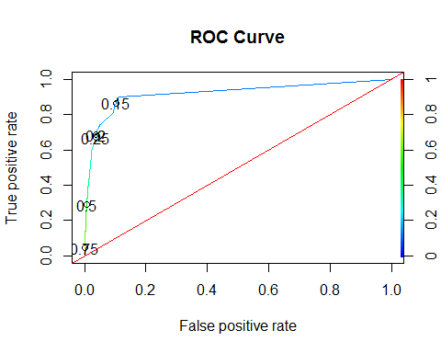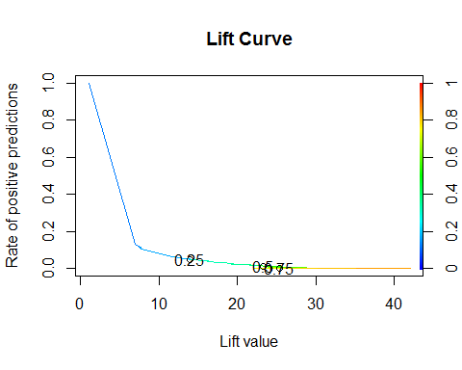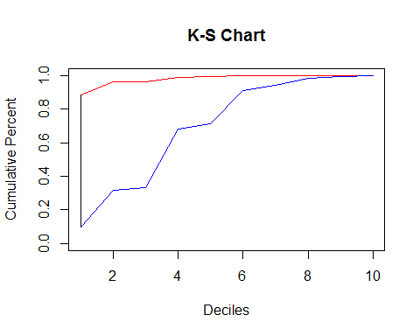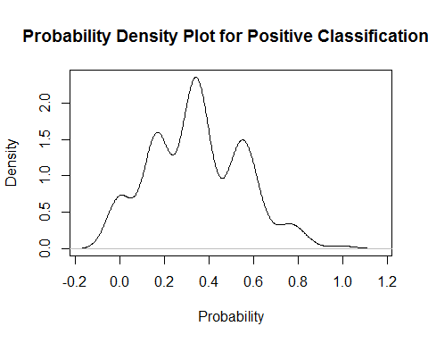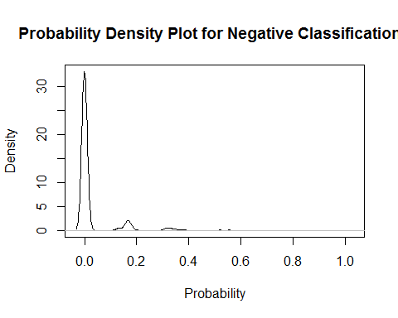

## $AUC  
## $AUC[[1]]  
## [1] 0.919985  
##   
##   
## $`D Statistic`  
## [1] 0.3211795  
##   
## $`KS Statistic`  
## Group CumPct0 CumPct1 Dif  
## 1 1 0.8837156 0.09898477 0.7847308  
##   
## $`Confusion Matrix`  
## Confusion Matrix and Statistics  
##   
## Reference  
## Prediction 0 1  
## 0 21399 315  
## 1 222 172  
##   
## Accuracy : 0.9757   
## 95% CI : (0.9736, 0.9777)  
## No Information Rate : 0.978   
## P-Value [Acc > NIR] : 0.9888   
##   
## Kappa : 0.3782   
## Mcnemar's Test P-Value : 7.184e-05   
##   
## Sensitivity : 0.9897   
## Specificity : 0.3532   
## Pos Pred Value : 0.9855   
## Neg Pred Value : 0.4365   
## Prevalence : 0.9780   
## Detection Rate : 0.9679   
## Detection Prevalence : 0.9822   
## Balanced Accuracy : 0.6715   
##   
## 'Positive' Class : 0   
##

## Call:  
## ada(HERFLAG ~ ., data = dfV3.train, iter = 10)  
##   
## Loss: exponential Method: discrete Iteration: 10   
##   
## Final Confusion Matrix for Data:  
## Final Prediction  
## True value 0 1  
## 0 16281 13  
## 1 165 122  
##   
## Train Error: 0.011   
##   
## Out-Of-Bag Error: 0.012 iteration= 10   
##   
## Additional Estimates of number of iterations:  
##   
## train.err1 train.kap1   
## 9 10

## Call:  
## ada(HERFLAG ~ ., data = dfV3.train, iter = 10)  
##   
## Loss: exponential Method: discrete Iteration: 10   
##   
## Training Results  
##   
## Accuracy: 0.989 Kappa: 0.573

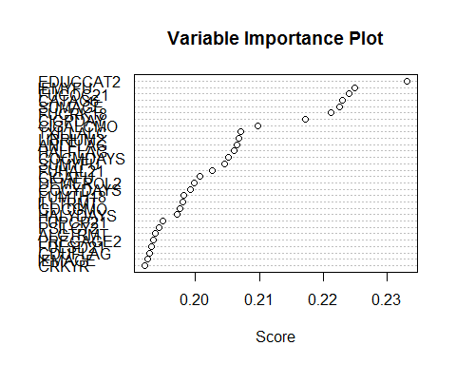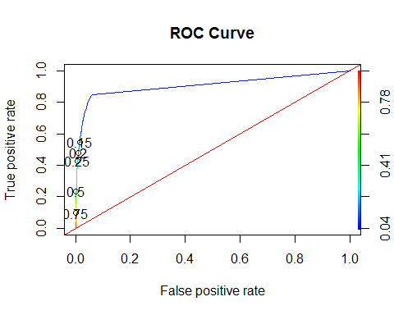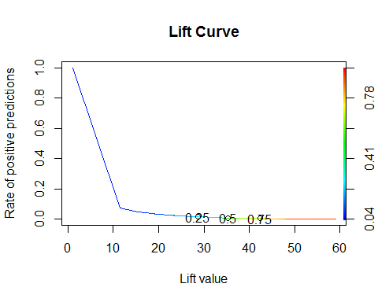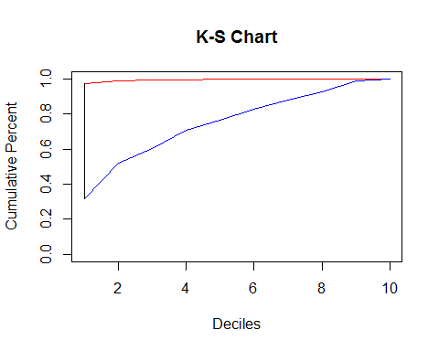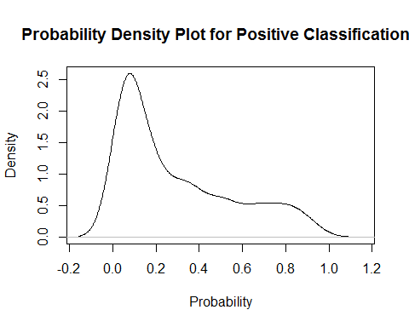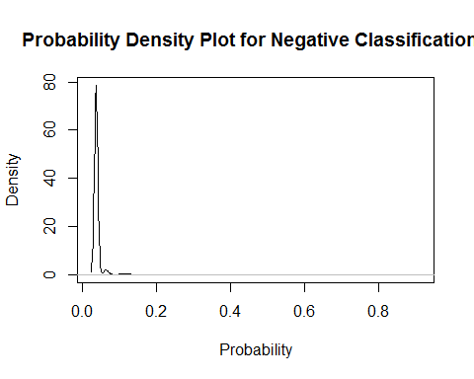

## $AUC  
## $AUC[[1]]  
## [1] 0.9084735  
##   
##   
## $`D Statistic`  
## [1] 0.2507476  
##   
## $`KS Statistic`  
## Group CumPct0 CumPct1 Dif  
## 1 1 0.9730248 0.3160305 0.6569943  
##   
## $`Confusion Matrix`  
## Confusion Matrix and Statistics  
##   
## Reference  
## Prediction 0 1  
## 0 37483 552  
## 1 298 357  
##   
## Accuracy : 0.978   
## 95% CI : (0.9765, 0.9795)  
## No Information Rate : 0.9765   
## P-Value [Acc > NIR] : 0.02389   
##   
## Kappa : 0.4456   
## Mcnemar's Test P-Value : < 2e-16   
##   
## Sensitivity : 0.9921   
## Specificity : 0.3927   
## Pos Pred Value : 0.9855   
## Neg Pred Value : 0.5450   
## Prevalence : 0.9765   
## Detection Rate : 0.9688   
## Detection Prevalence : 0.9831   
## Balanced Accuracy : 0.6924   
##   
## 'Positive' Class : 0   
##

##   
## Call:  
## glm(formula = HERFLAG ~ ., family = "binomial", data = dfImp.train)  
##   
## Deviance Residuals:   
## Min 1Q Median 3Q Max   
## -2.3970 -0.0952 0.0000 0.0000 3.5841   
##   
## Coefficients:  
## Estimate Std. Error z value  
## (Intercept) -22.6301 306.5130 -0.074  
## EDUCCAT2(2) Less than high school 1.7907 0.5076 3.528  
## EDUCCAT2(3) High school graduate 1.5543 0.4983 3.119  
## EDUCCAT2(4) Some college 1.6278 0.4996 3.258  
## EDUCCAT2(5) College graduate 1.3788 0.5195 2.654  
## SUMAGE(2) Under 18 15.8577 306.5128 0.052  
## SUMAGE(3) 18-25 15.3783 306.5129 0.050  
## SUMAGE(4) 26-34 16.1577 306.5133 0.053  
## SUMAGE(5) 35-49 -0.9174 2449.1966 0.000  
## SUMAGE(6) 50-64 -0.8336 6095.1701 0.000  
## SUMAGE(7) 65-99 -1.1358 9506.5148 0.000  
## FUCRK181 0.4691 0.2083 2.252  
## CIGPDAY(2) Fewer than 6 0.4740 0.2997 1.582  
## CIGPDAY(3) 6-15 0.6087 0.2339 2.602  
## CIGPDAY(4) 26 or More 0.9671 0.3537 2.734  
## CIGPDAY(5) Not Reported 0.8576 0.2354 3.644  
## CIGALCMO(2) Past Mon Use of Cig & Alc -0.4230 0.2472 -1.711  
## CIGALCMO(3) Past Mon Use of Cig & No Alc -0.1438 0.2885 -0.499  
## CIGALCMO(4) Past Mon Use of Alc & No Cig -0.5482 0.2373 -2.311  
## FUCOC211 1.0973 0.1573 6.974  
## TXILLALC1 1.2883 0.1875 6.870  
## LIBRIUM21 1.8509 0.5285 3.502  
## ANLFLAG1 1.2383 0.1623 7.630  
## HALFLAG1 1.6239 0.1930 8.414  
## Pr(>|z|)   
## (Intercept) 0.941145   
## EDUCCAT2(2) Less than high school 0.000419 ***  
## EDUCCAT2(3) High school graduate 0.001815 **   
## EDUCCAT2(4) Some college 0.001120 **   
## EDUCCAT2(5) College graduate 0.007958 **   
## SUMAGE(2) Under 18 0.958739   
## SUMAGE(3) 18-25 0.959985   
## SUMAGE(4) 26-34 0.957959   
## SUMAGE(5) 35-49 0.999701   
## SUMAGE(6) 50-64 0.999891   
## SUMAGE(7) 65-99 0.999905   
## FUCRK181 0.024316 *   
## CIGPDAY(2) Fewer than 6 0.113681   
## CIGPDAY(3) 6-15 0.009256 **   
## CIGPDAY(4) 26 or More 0.006254 **   
## CIGPDAY(5) Not Reported 0.000269 ***  
## CIGALCMO(2) Past Mon Use of Cig & Alc 0.087116 .   
## CIGALCMO(3) Past Mon Use of Cig & No Alc 0.618078   
## CIGALCMO(4) Past Mon Use of Alc & No Cig 0.020859 *   
## FUCOC211 3.07e-12 ***  
## TXILLALC1 6.41e-12 ***  
## LIBRIUM21 0.000461 ***  
## ANLFLAG1 2.36e-14 ***  
## HALFLAG1 < 2e-16 ***  
## ---  
## Signif. codes: 0 '***' 0.001 '**' 0.01 '*' 0.05 '.' 0.1 ' ' 1  
##   
## (Dispersion parameter for binomial family taken to be 1)  
##   
## Null deviance: 2897.5 on 16580 degrees of freedom  
## Residual deviance: 1618.3 on 16557 degrees of freedom  
## AIC: 1666.3  
##   
## Number of Fisher Scoring iterations: 20

## Odds factors for glm model are:

## (Intercept)   
## 1.485554e-10   
## EDUCCAT2(2) Less than high school   
## 5.993592e+00   
## EDUCCAT2(3) High school graduate   
## 4.731662e+00   
## EDUCCAT2(4) Some college   
## 5.092608e+00   
## EDUCCAT2(5) College graduate   
## 3.970014e+00   
## SUMAGE(2) Under 18   
## 7.707478e+06   
## SUMAGE(3) 18-25   
## 4.772186e+06   
## SUMAGE(4) 26-34   
## 1.040390e+07   
## SUMAGE(5) 35-49   
## 3.995530e-01   
## SUMAGE(6) 50-64   
## 4.344995e-01   
## SUMAGE(7) 65-99   
## 3.211756e-01   
## FUCRK181   
## 1.598568e+00   
## CIGPDAY(2) Fewer than 6   
## 1.606483e+00   
## CIGPDAY(3) 6-15   
## 1.838113e+00   
## CIGPDAY(4) 26 or More   
## 2.630335e+00   
## CIGPDAY(5) Not Reported   
## 2.357517e+00   
## CIGALCMO(2) Past Mon Use of Cig & Alc   
## 6.550888e-01   
## CIGALCMO(3) Past Mon Use of Cig & No Alc   
## 8.660453e-01   
## CIGALCMO(4) Past Mon Use of Alc & No Cig   
## 5.779723e-01   
## FUCOC211   
## 2.996062e+00   
## TXILLALC1   
## 3.626783e+00   
## LIBRIUM21   
## 6.365388e+00   
## ANLFLAG1   
## 3.449904e+00   
## HALFLAG1   
## 5.072753e+00

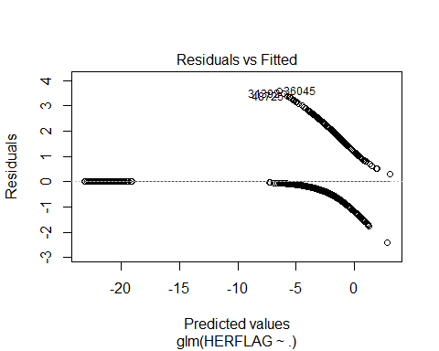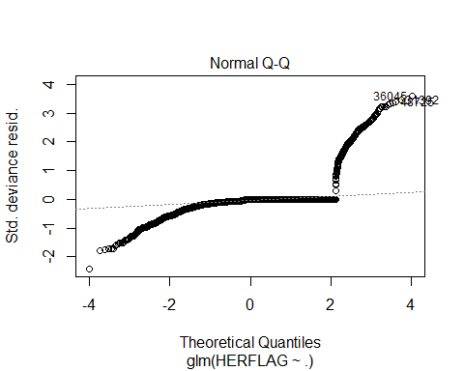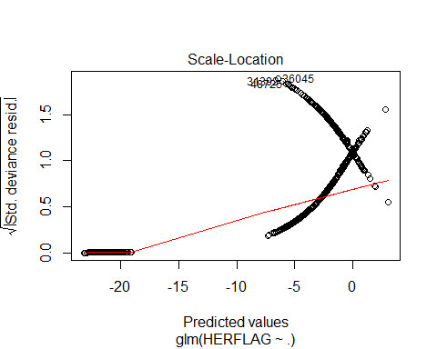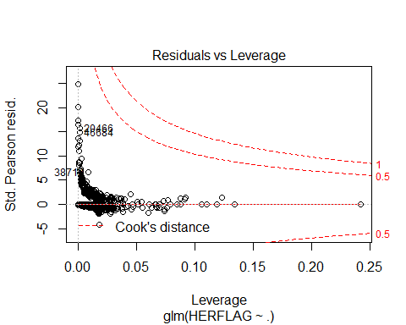

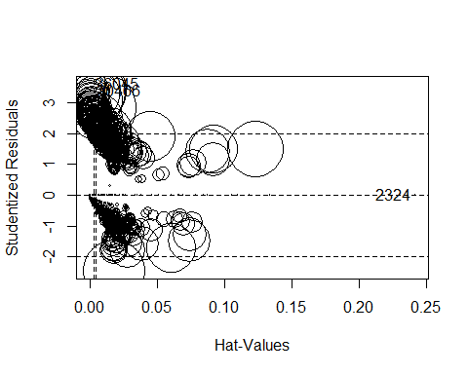

## StudRes Hat CookD  
## 2324 -4.783603e-05 0.2421087933 1.73265e-11  
## 36045 3.596920e+00 0.0001499016 3.84079e-03  
## 20466 3.383948e+00 0.0016449298 1.71076e-02

## GVIF Df GVIF^(1/(2*Df))  
## EDUCCAT2 1.192565 4 1.022257  
## SUMAGE 1.186666 6 1.014365  
## FUCRK18 1.085626 1 1.041934  
## CIGPDAY 2.025690 4 1.092249  
## CIGALCMO 2.153950 3 1.136421  
## FUCOC21 1.277222 1 1.130142  
## TXILLALC 1.061605 1 1.030342  
## LIBRIUM2 1.017008 1 1.008468  
## ANLFLAG 1.090831 1 1.044429  
## HALFLAG 1.233110 1 1.110455

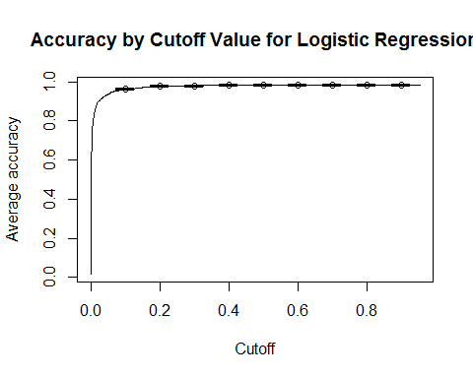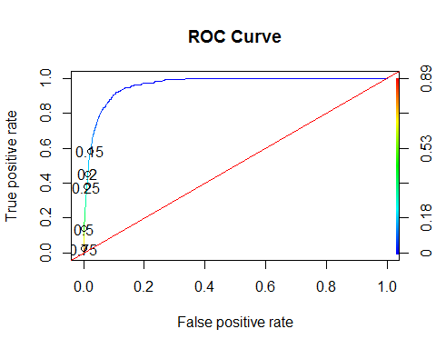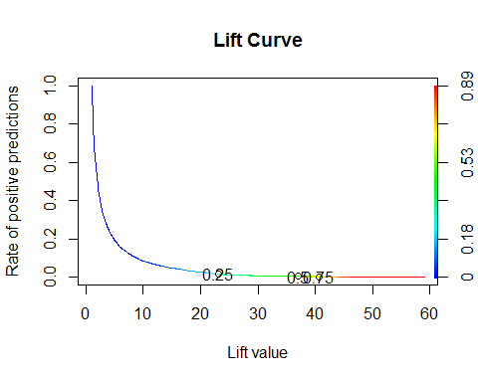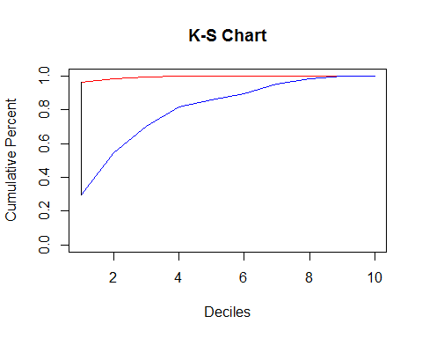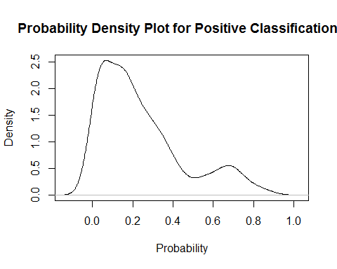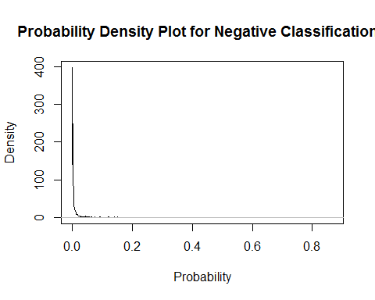

## $AUC  
## $AUC[[1]]  
## [1] 0.9627096  
##   
##   
## $`D Statistic`  
## [1] 0.2274903  
##   
## $`KS Statistic`  
## Group CumPct0 CumPct1 Dif  
## 1 1 0.9643223 0.2961832 0.6681391  
##   
## $`Confusion Matrix`  
## Confusion Matrix and Statistics  
##   
## Reference  
## Prediction 0 1  
## 0 37430 605  
## 1 324 331  
##   
## Accuracy : 0.976   
## 95% CI : (0.9744, 0.9775)  
## No Information Rate : 0.9758   
## P-Value [Acc > NIR] : 0.4168   
##   
## Kappa : 0.4042   
## Mcnemar's Test P-Value : <2e-16   
##   
## Sensitivity : 0.9914   
## Specificity : 0.3536   
## Pos Pred Value : 0.9841   
## Neg Pred Value : 0.5053   
## Prevalence : 0.9758   
## Detection Rate : 0.9674   
## Detection Prevalence : 0.9831   
## Balanced Accuracy : 0.6725   
##   
## 'Positive' Class : 0   
##