NSDUH Output

Matthew Beattie (beat0000)

December 16, 2016

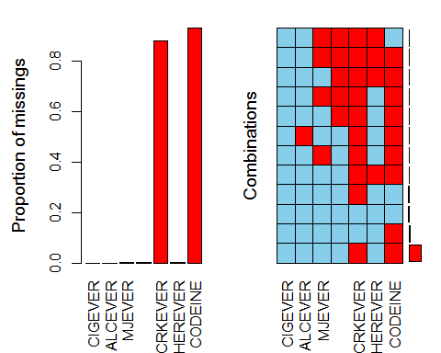

##   
## Missings per variable:   
## Variable Count  
## CIGEVER 0  
## ALCEVER 12  
## MJEVER 27  
## COCEVER 23  
## CRKEVER 48641  
## HEREVER 33  
## CODEINE 51326  
##   
## Missings in combinations of variables:   
## Combinations Count Percent  
## 0:0:0:0:0:0:0 2164 3.915253931  
## 0:0:0:0:0:0:1 4466 8.080186716  
## 0:0:0:0:1:0:0 1780 3.220495377  
## 0:0:0:0:1:0:1 46785 84.646559679  
## 0:0:0:0:1:1:1 24 0.043422410  
## 0:0:0:1:1:0:1 9 0.016283404  
## 0:0:0:1:1:1:1 4 0.007237068  
## 0:0:1:0:1:0:1 17 0.030757540  
## 0:0:1:1:1:0:1 5 0.009046335  
## 0:0:1:1:1:1:0 1 0.001809267  
## 0:0:1:1:1:1:1 4 0.007237068  
## 0:1:0:0:1:0:1 12 0.021711205

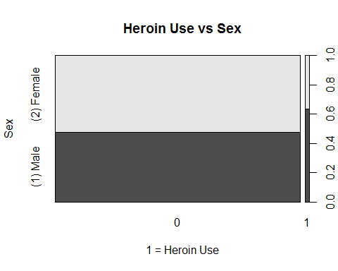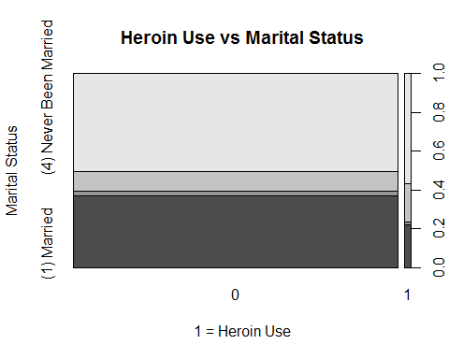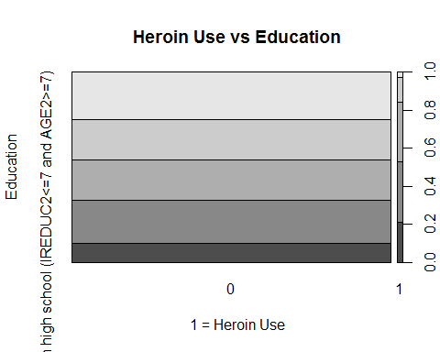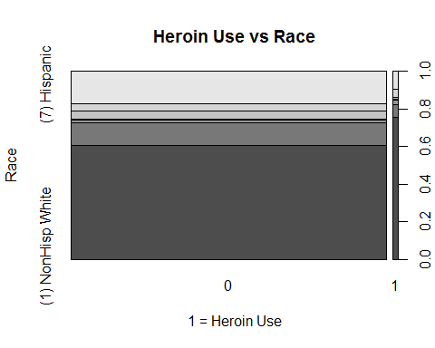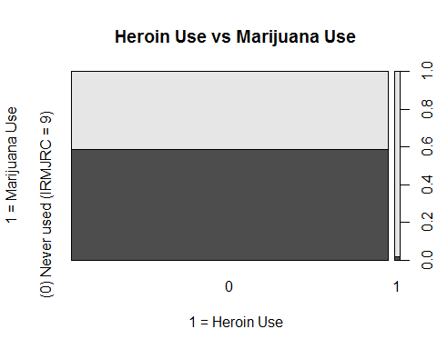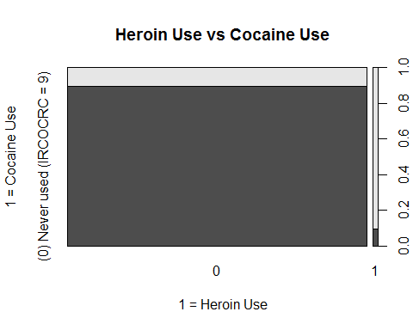

## Call:  
## rpart(formula = HERFLAG ~ ., data = dfV1.train, parms = list(split = "information"))  
## n= 27635   
##   
## CP nsplit rel error xerror xstd  
## 1 0.03856749 0 1.0000000 1.0000000 0.04505474  
## 2 0.01652893 3 0.8842975 0.8904959 0.04255787  
## 3 0.01549587 4 0.8677686 0.9070248 0.04294471  
## 4 0.01000000 6 0.8367769 0.9152893 0.04313674  
##   
## Variable importance  
## COCFLAG FUCOC21 LSDFLAG CRKFLAG FUCOC18 PSILCY2 MORPHIN2 METHDON2   
## 32 19 9 9 8 8 6 1   
## DILAUD2 SUMYFU DEMEROL2 IEMYFU PSYYFU2 ULTRAM2   
## 1 1 1 1 1 1   
##   
## Node number 1: 27635 observations, complexity param=0.03856749  
## predicted class=0 expected loss=0.01751402 P(node) =1  
## class counts: 27151 484  
## probabilities: 0.982 0.018   
## left son=2 (24306 obs) right son=3 (3329 obs)  
## Primary splits:  
## COCFLAG splits as LR, improve=785.2331, (0 missing)  
## CRKFLAG splits as LR, improve=659.0209, (0 missing)  
## HALFLAG splits as LR, improve=644.5994, (0 missing)  
## OXYCODP2 splits as LR, improve=630.0436, (0 missing)  
## FUCOC21 splits as RL, improve=620.1920, (0 missing)  
## Surrogate splits:  
## FUCOC21 splits as RL, agree=0.951, adj=0.591, (0 split)  
## LSDFLAG splits as LR, agree=0.915, adj=0.293, (0 split)  
## FUCOC18 splits as RL, agree=0.911, adj=0.263, (0 split)  
## CRKFLAG splits as LR, agree=0.910, adj=0.256, (0 split)  
## PSILCY2 splits as LR, agree=0.910, adj=0.251, (0 split)  
##   
## Node number 2: 24306 observations  
## predicted class=0 expected loss=0.002098247 P(node) =0.8795368  
## class counts: 24255 51  
## probabilities: 0.998 0.002   
##   
## Node number 3: 3329 observations, complexity param=0.03856749  
## predicted class=0 expected loss=0.1300691 P(node) =0.1204632  
## class counts: 2896 433  
## probabilities: 0.870 0.130   
## left son=6 (2990 obs) right son=7 (339 obs)  
## Primary splits:  
## MORPHIN2 splits as LR, improve=159.0079, (0 missing)  
## PERCTYL2 splits as LR, improve=156.3423, (0 missing)  
## OXYCODP2 splits as LR, improve=155.3526, (0 missing)  
## CRKFLAG splits as LR, improve=153.9010, (0 missing)  
## OTHANL splits as LR, improve=142.5513, (0 missing)  
## Surrogate splits:  
## METHDON2 splits as LR, agree=0.921, adj=0.221, (0 split)  
## DILAUD2 splits as LR, agree=0.917, adj=0.189, (0 split)  
## DEMEROL2 splits as LR, agree=0.911, adj=0.124, (0 split)  
## ULTRAM2 splits as LR, agree=0.908, adj=0.100, (0 split)  
## PHENCOD2 splits as LR, agree=0.904, adj=0.053, (0 split)  
##   
## Node number 6: 2990 observations  
## predicted class=0 expected loss=0.08829431 P(node) =0.1081961  
## class counts: 2726 264  
## probabilities: 0.912 0.088   
##   
## Node number 7: 339 observations, complexity param=0.03856749  
## predicted class=0 expected loss=0.4985251 P(node) =0.01226705  
## class counts: 170 169  
## probabilities: 0.501 0.499   
## left son=14 (161 obs) right son=15 (178 obs)  
## Primary splits:  
## CRKFLAG splits as LR, improve=19.27109, (0 missing)  
## FUCRK21 splits as RL, improve=14.65922, (0 missing)  
## PCPFLAG splits as LR, improve=14.28325, (0 missing)  
## FUPCP21 splits as RL, improve=12.81714, (0 missing)  
## TXILALEV splits as LR, improve=12.42284, (0 missing)  
## Surrogate splits:  
## FUCRK21 splits as RL, agree=0.758, adj=0.491, (0 split)  
## PSYYFU2 < 2005.5 to the right, agree=0.643, adj=0.248, (0 split)  
## IEMYFU < 1996.5 to the right, agree=0.631, adj=0.224, (0 split)  
## SUMYFU < 2003.5 to the right, agree=0.628, adj=0.217, (0 split)  
## FUCRK18 splits as RL, agree=0.625, adj=0.211, (0 split)  
##   
## Node number 14: 161 observations, complexity param=0.01652893  
## predicted class=0 expected loss=0.3229814 P(node) =0.005825945  
## class counts: 109 52  
## probabilities: 0.677 0.323   
## left son=28 (151 obs) right son=29 (10 obs)  
## Primary splits:  
## SUMYFU < 1978 to the right, improve=7.826203, (0 missing)  
## IEMYFU < 1981 to the right, improve=7.826203, (0 missing)  
## TXILALEV splits as LR, improve=7.563789, (0 missing)  
## PSYYFU2 < 1982.5 to the right, improve=6.689699, (0 missing)  
## CATAG6 splits as LLLLRR, improve=6.689699, (0 missing)  
## Surrogate splits:  
## IEMYFU < 1977 to the right, agree=0.988, adj=0.8, (0 split)  
## PSYYFU2 < 1977 to the right, agree=0.981, adj=0.7, (0 split)  
## PREGAGE2 splits as LLLR, agree=0.975, adj=0.6, (0 split)  
## TUINAL2 splits as LR, agree=0.969, adj=0.5, (0 split)  
## MILTOWN2 splits as LR, agree=0.950, adj=0.2, (0 split)  
##   
## Node number 15: 178 observations, complexity param=0.01549587  
## predicted class=1 expected loss=0.3426966 P(node) =0.006441107  
## class counts: 61 117  
## probabilities: 0.343 0.657   
## left son=30 (64 obs) right son=31 (114 obs)  
## Primary splits:  
## IEMYFU < 1993.5 to the left, improve=9.129586, (0 missing)  
## FUECS21 splits as RL, improve=8.014528, (0 missing)  
## SUMYFU < 1987.5 to the left, improve=7.357493, (0 missing)  
## FUANL21 splits as RL, improve=7.269476, (0 missing)  
## FUPCP21 splits as RL, improve=6.954535, (0 missing)  
## Surrogate splits:  
## SUMYFU < 1991.5 to the left, agree=0.955, adj=0.875, (0 split)  
## CATAG6 splits as RRRLLL, agree=0.921, adj=0.781, (0 split)  
## PSYYFU2 < 1993.5 to the left, agree=0.910, adj=0.750, (0 split)  
## PREGAGE2 splits as RRRL, agree=0.831, adj=0.531, (0 split)  
## FUOXY21 splits as RL, agree=0.742, adj=0.281, (0 split)  
##   
## Node number 28: 151 observations  
## predicted class=0 expected loss=0.2847682 P(node) =0.005464085  
## class counts: 108 43  
## probabilities: 0.715 0.285   
##   
## Node number 29: 10 observations  
## predicted class=1 expected loss=0.1 P(node) =0.00036186  
## class counts: 1 9  
## probabilities: 0.100 0.900   
##   
## Node number 30: 64 observations, complexity param=0.01549587  
## predicted class=0 expected loss=0.453125 P(node) =0.002315904  
## class counts: 35 29  
## probabilities: 0.547 0.453   
## left son=60 (47 obs) right son=61 (17 obs)  
## Primary splits:  
## FUPCP21 splits as RL, improve=4.662734, (0 missing)  
## PSYYFU2 < 1977.5 to the right, improve=4.537438, (0 missing)  
## OTHSED splits as LR, improve=4.486270, (0 missing)  
## PCPFLAG splits as LR, improve=4.335591, (0 missing)  
## IEMYFU < 1977 to the right, improve=4.134729, (0 missing)  
## Surrogate splits:  
## PCPFLAG splits as LR, agree=0.875, adj=0.529, (0 split)  
## FUPCP18 splits as RL, agree=0.859, adj=0.471, (0 split)  
## PHENOBR2 splits as LR, agree=0.812, adj=0.294, (0 split)  
## ETHER2 splits as LR, agree=0.797, adj=0.235, (0 split)  
## FIORINL2 splits as LR, agree=0.797, adj=0.235, (0 split)  
##   
## Node number 31: 114 observations  
## predicted class=1 expected loss=0.2280702 P(node) =0.004125204  
## class counts: 26 88  
## probabilities: 0.228 0.772   
##   
## Node number 60: 47 observations  
## predicted class=0 expected loss=0.3404255 P(node) =0.001700742  
## class counts: 31 16  
## probabilities: 0.660 0.340   
##   
## Node number 61: 17 observations  
## predicted class=1 expected loss=0.2352941 P(node) =0.0006151619  
## class counts: 4 13  
## probabilities: 0.235 0.765

## Overall  
## CATAG6 6.689699  
## COCFLAG 785.233068  
## CRKFLAG 832.193013  
## FUANL21 7.269476  
## FUCOC21 620.192013  
## FUCRK21 14.659219  
## FUECS21 8.014528  
## FUPCP21 24.434407  
## HALFLAG 644.599428  
## IEMYFU 21.090518  
## MORPHIN2 159.007936  
## OTHANL 142.551278  
## OTHSED 4.486270  
## OXYCODP2 785.396181  
## PCPFLAG 18.618843  
## PERCTYL2 156.342279  
## PSYYFU2 11.227137  
## SUMYFU 15.183695  
## TXILALEV 19.986625  
## CIGFLAG 0.000000  
## CIGYR 0.000000  
## CIGMON 0.000000  
## CGRFLAG 0.000000  
## CGRYR 0.000000  
## CGRMON 0.000000  
## PIPFLAG 0.000000  
## PIPMON 0.000000  
## SMKFLAG 0.000000  
## SMKYR 0.000000  
## SMKMON 0.000000  
## CHWFLAG 0.000000  
## CHWYR 0.000000  
## CHWMON 0.000000  
## SNFFLAG 0.000000  
## SNFYR 0.000000  
## SNFMON 0.000000  
## TOBFLAG 0.000000  
## TOBYR 0.000000  
## TOBMON 0.000000  
## ALCFLAG 0.000000  
## ALCYR 0.000000  
## ALCMON 0.000000  
## MRJFLAG 0.000000  
## MRJYR 0.000000  
## MRJMON 0.000000  
## COCYR 0.000000  
## COCMON 0.000000  
## CRKYR 0.000000  
## CRKMON 0.000000  
## HALYR 0.000000  
## HALMON 0.000000  
## LSDFLAG 0.000000  
## LSDYR 0.000000  
## LSDMON 0.000000  
## PCPYR 0.000000  
## PCPMON 0.000000  
## ECSFLAG 0.000000  
## ECSYR 0.000000  
## ECSMON 0.000000  
## INHFLAG 0.000000  
## INHYR 0.000000  
## INHMON 0.000000  
## ANLFLAG 0.000000  
## ANLYR 0.000000  
## ANLMON 0.000000  
## OXYFLAG 0.000000  
## OXYYR 0.000000  
## OXYMON 0.000000  
## TRQFLAG 0.000000  
## TRQYR 0.000000  
## TRQMON 0.000000  
## STMFLAG 0.000000  
## STMYR 0.000000  
## STMMON 0.000000  
## CPNSTMFG 0.000000  
## CPNSTMYR 0.000000  
## CPNSTMMN 0.000000  
## MTHFLAG 0.000000  
## MTHYR 0.000000  
## MTHMON 0.000000  
## CPNMTHFG 0.000000  
## CPNMTHYR 0.000000  
## CPNMTHMN 0.000000  
## SEDFLAG 0.000000  
## SEDYR 0.000000  
## SEDMON 0.000000  
## PSYFLAG2 0.000000  
## PSYYR2 0.000000  
## PSYMON2 0.000000  
## PSYAGE2 0.000000  
## CPNPSYFG 0.000000  
## CPNPSYYR 0.000000  
## CPNPSYMN 0.000000  
## SUMFLAG 0.000000  
## SUMYR 0.000000  
## SUMMON 0.000000  
## SUMAGE 0.000000  
## MJOFLAG 0.000000  
## MJOYR2 0.000000  
## MJOMON2 0.000000  
## IEMFLAG 0.000000  
## IEMYR 0.000000  
## IEMMON 0.000000  
## IEMAGE 0.000000  
## CDUFLAG 0.000000  
## DCIGMON 0.000000  
## CDCGMO 0.000000  
## CDNOCGMO 0.000000  
## CIGALCMO 0.000000  
## BINGEDRK 0.000000  
## HVYDRK2 0.000000  
## BINGEHVY 0.000000  
## ILTOALMN 0.000000  
## ILALMON 0.000000  
## TOBALCMN 0.000000  
## NILALMON 0.000000  
## ILANDALC 0.000000  
## ILORALC 0.000000  
## PEYOTE2 0.000000  
## MESC2 0.000000  
## PSILCY2 0.000000  
## AMYLNIT2 0.000000  
## CLEFLU2 0.000000  
## GAS2 0.000000  
## GLUE2 0.000000  
## ETHER2 0.000000  
## SOLVENT2 0.000000  
## LGAS2 0.000000  
## NITOXID2 0.000000  
## SPPAINT2 0.000000  
## AEROS2 0.000000  
## DARVTYL2 0.000000  
## VICOLOR2 0.000000  
## CODEINE2 0.000000  
## DEMEROL2 0.000000  
## DILAUD2 0.000000  
## FIORICT2 0.000000  
## FIORINL2 0.000000  
## HYDROCD2 0.000000  
## METHDON2 0.000000  
## PHENCOD2 0.000000  
## PROPOXY2 0.000000  
## SK65A2 0.000000  
## STADOL2 0.000000  
## TALACEN2 0.000000  
## TALWIN2 0.000000  
## TALWINX2 0.000000  
## TRAMADL2 0.000000  
## ULTRAM2 0.000000  
## PROCODNP 0.000000  
## HYDCODOP 0.000000  
## TRAMADP 0.000000  
## KLONOPI2 0.000000  
## XNAXATV2 0.000000  
## VALMDIA2 0.000000  
## ATARAX2 0.000000  
## BUSPAR2 0.000000  
## EQUANIL2 0.000000  
## FLEXERL2 0.000000  
## LIBRIUM2 0.000000  
## LIMBTRL2 0.000000  
## MEPROB2 0.000000  
## MILTOWN2 0.000000  
## ROHYPNL2 0.000000  
## SERAX2 0.000000  
## SOMA2 0.000000  
## TRANXEN2 0.000000  
## VISTAR2 0.000000  
## OTHTRN 0.000000  
## BENZOS 0.000000  
## MEPROBPD 0.000000  
## MUSCRELX 0.000000  
## METHDES2 0.000000  
## DIETPIL2 0.000000  
## RITMPHE2 0.000000  
## CYLERT2 0.000000  
## DEXED2 0.000000  
## DETAMP2 0.000000  
## DIDREX2 0.000000  
## ESKAT2 0.000000  
## IONAMIN2 0.000000  
## MAZANOR2 0.000000  
## OBLA2 0.000000  
## PLEGINE2 0.000000  
## PRELUDN2 0.000000  
## SANOREX2 0.000000  
## TENUATE2 0.000000  
## OTHSTM 0.000000  
## AMDXPHEN 0.000000  
## MAZINDOL 0.000000  
## METHDEXM 0.000000  
## METHAQ2 0.000000  
## NEMBBAR2 0.000000  
## RESTTMA2 0.000000  
## AMYTAL2 0.000000  
## BUTISOL2 0.000000  
## CHHYD2 0.000000  
## DALMANE2 0.000000  
## HALCION2 0.000000  
## PHENOBR2 0.000000  
## PLACIDY2 0.000000  
## TUINAL2 0.000000  
## RTDALHAL 0.000000  
## ANYBARB 0.000000  
## CIGAFU 0.000000  
## DCIGAFU 0.000000  
## ALCAFU 0.000000  
## MJAFU 0.000000  
## ALCYDAYS 0.000000  
## MRJYDAYS 0.000000  
## COCYDAYS 0.000000  
## HALYDAYS 0.000000  
## INHYDAYS 0.000000  
## STMYDAYS 0.000000  
## CIGMDAYS 0.000000  
## ALCMDAYS 0.000000  
## MRJMDAYS 0.000000  
## COCMDAYS 0.000000  
## HALMDAYS 0.000000  
## INHMDAYS 0.000000  
## CIGPDAY 0.000000  
## CIG1PACK 0.000000  
## CIGAVGD 0.000000  
## CIGAVGM 0.000000  
## ALCAVGM 0.000000  
## FUCIG18 0.000000  
## FUCIG21 0.000000  
## FUCD218 0.000000  
## FUCD221 0.000000  
## FUCGR18 0.000000  
## FUCGR21 0.000000  
## FUSLT18 0.000000  
## FUSLT21 0.000000  
## FUALC18 0.000000  
## FUALC21 0.000000  
## FUMJ18 0.000000  
## FUMJ21 0.000000  
## FUCOC18 0.000000  
## FUCRK18 0.000000  
## FUHAL18 0.000000  
## FUHAL21 0.000000  
## FULSD18 0.000000  
## FULSD21 0.000000  
## FUPCP18 0.000000  
## FUECS18 0.000000  
## FUINH18 0.000000  
## FUINH21 0.000000  
## FUANL18 0.000000  
## FUOXY18 0.000000  
## FUOXY21 0.000000  
## FUTRN18 0.000000  
## FUTRN21 0.000000  
## FUSTM18 0.000000  
## FUSTM21 0.000000  
## FUMTH18 0.000000  
## FUMTH21 0.000000  
## FUSED18 0.000000  
## FUSED21 0.000000  
## FUPSY18 0.000000  
## FUPSY21 0.000000  
## FUSUM18 0.000000  
## FUSUM21 0.000000  
## FUIEM18 0.000000  
## FUIEM21 0.000000  
## NDSSDNSP 0.000000  
## FTNDDNSP 0.000000  
## DNICNSP 0.000000  
## DEPNDALC 0.000000  
## DEPNDANL 0.000000  
## DEPNDCOC 0.000000  
## DEPNDHAL 0.000000  
## DEPNDINH 0.000000  
## DEPNDMRJ 0.000000  
## DEPNDSED 0.000000  
## DEPNDSTM 0.000000  
## DEPNDTRN 0.000000  
## DEPNDPSY 0.000000  
## DPILLALC 0.000000  
## DPILANAL 0.000000  
## ABUSEALC 0.000000  
## ABUSEANL 0.000000  
## ABUSECOC 0.000000  
## ABUSEHAL 0.000000  
## ABUSEINH 0.000000  
## ABUSEMRJ 0.000000  
## ABUSESED 0.000000  
## ABUSESTM 0.000000  
## ABUSETRN 0.000000  
## ABUSEILL 0.000000  
## ABUSEIEM 0.000000  
## ABUSEXMJ 0.000000  
## ABUSEPSY 0.000000  
## ABILLALC 0.000000  
## ABILANAL 0.000000  
## ABODALC 0.000000  
## ABODANL 0.000000  
## ABODCOC 0.000000  
## ABODHAL 0.000000  
## ABODINH 0.000000  
## ABODMRJ 0.000000  
## ABODSED 0.000000  
## ABODSTM 0.000000  
## ABODTRN 0.000000  
## ABODILL 0.000000  
## ABODPSY 0.000000  
## ABODILAL 0.000000  
## ABDILAAL 0.000000  
## ALCTRMT 0.000000  
## ILLTRMT 0.000000  
## TXALNOIL 0.000000  
## TXILNOAL 0.000000  
## TXILLALC 0.000000  
## TXILANAL 0.000000  
## TXLTALC2 0.000000  
## TXLTMJ2 0.000000  
## TXLTCOC2 0.000000  
## TXLTHAL2 0.000000  
## TXLTINH2 0.000000  
## TXLTANL2 0.000000  
## TXLTTRN2 0.000000  
## TXLTSTM2 0.000000  
## TXLTSED2 0.000000  
## TXLTILL2 0.000000  
## TXPINS2 0.000000  
## TXPCARE2 0.000000  
## TXPCAID2 0.000000  
## TXPPUBP2 0.000000  
## TXPSAVE2 0.000000  
## TXPFMLY2 0.000000  
## TXPCORT2 0.000000  
## TXPMILC2 0.000000  
## TXPEMPL2 0.000000  
## ALCPINS 0.000000  
## ALCPCARE 0.000000  
## ALCPCAID 0.000000  
## ALCPPUBP 0.000000  
## ALCPSAVE 0.000000  
## ALCPFMLY 0.000000  
## ALCPCORT 0.000000  
## ALCPMILC 0.000000  
## ALCPEMPL 0.000000  
## ILLPINS 0.000000  
## ILLPCARE 0.000000  
## ILLPCAID 0.000000  
## ILLPPUBP 0.000000  
## ILLPSAVE 0.000000  
## ILLPFMLY 0.000000  
## ILLPCORT 0.000000  
## ILLPMILC 0.000000  
## ILLPEMPL 0.000000  
## SPECTALC 0.000000  
## SPECTILL 0.000000  
## AMHINP2 0.000000  
## AMHOUTP3 0.000000  
## AMHRX2 0.000000  
## AMHTXRC3 0.000000  
## K6SCMON 0.000000  
## SPDMON 0.000000  
## K6SCYR 0.000000  
## K6SCMAX 0.000000  
## SPDYR 0.000000  
## MHSUITHK 0.000000  
## MHSUTK_U 0.000000  
## MHSUIPLN 0.000000  
## MHSUITRY 0.000000  
## GOVTPROG 0.000000  
## INCOME 0.000000  
## POVERTY2 0.000000  
## HLCALLFG 0.000000  
## HLCALL99 0.000000  
## ANYHLTI2 0.000000  
## IRINSUR4 0.000000  
## IIINSUR4 0.000000  
## OTHINS 0.000000  
## IRSEX 0.000000  
## IRMARIT 0.000000  
## IIMARIT 0.000000  
## IREDUC2 0.000000  
## IIEDUC2 0.000000  
## PREGAGE2 0.000000  
## SEXAGE 0.000000  
## NEWRACE2 0.000000  
## SEXRACE 0.000000  
## EDUCCAT2 0.000000  
## HEALTH2 0.000000  
## EMPSTATY 0.000000

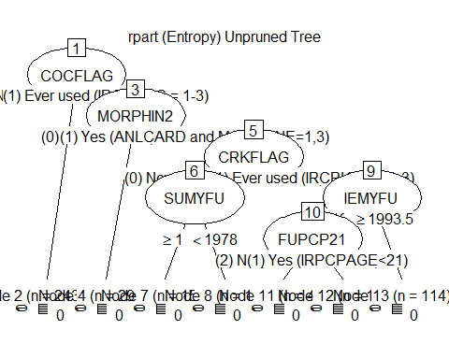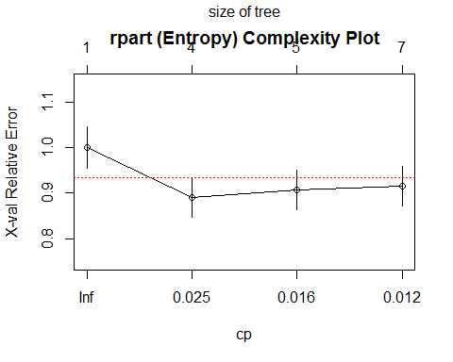

##   
## Model formula:  
## HERFLAG ~ CIGFLAG + CIGYR + CIGMON + CGRFLAG + CGRYR + CGRMON +   
## PIPFLAG + PIPMON + SMKFLAG + SMKYR + SMKMON + CHWFLAG + CHWYR +   
## CHWMON + SNFFLAG + SNFYR + SNFMON + TOBFLAG + TOBYR + TOBMON +   
## ALCFLAG + ALCYR + ALCMON + MRJFLAG + MRJYR + MRJMON + COCFLAG +   
## COCYR + COCMON + CRKFLAG + CRKYR + CRKMON + HALFLAG + HALYR +   
## HALMON + LSDFLAG + LSDYR + LSDMON + PCPFLAG + PCPYR + PCPMON +   
## ECSFLAG + ECSYR + ECSMON + INHFLAG + INHYR + INHMON + ANLFLAG +   
## ANLYR + ANLMON + OXYFLAG + OXYYR + OXYMON + TRQFLAG + TRQYR +   
## TRQMON + STMFLAG + STMYR + STMMON + CPNSTMFG + CPNSTMYR +   
## CPNSTMMN + MTHFLAG + MTHYR + MTHMON + CPNMTHFG + CPNMTHYR +   
## CPNMTHMN + SEDFLAG + SEDYR + SEDMON + PSYFLAG2 + PSYYR2 +   
## PSYMON2 + PSYAGE2 + PSYYFU2 + CPNPSYFG + CPNPSYYR + CPNPSYMN +   
## SUMFLAG + SUMYR + SUMMON + SUMAGE + SUMYFU + MJOFLAG + MJOYR2 +   
## MJOMON2 + IEMFLAG + IEMYR + IEMMON + IEMAGE + IEMYFU + CDUFLAG +   
## DCIGMON + CDCGMO + CDNOCGMO + CIGALCMO + BINGEDRK + HVYDRK2 +   
## BINGEHVY + ILTOALMN + ILALMON + TOBALCMN + NILALMON + ILANDALC +   
## ILORALC + PEYOTE2 + MESC2 + PSILCY2 + AMYLNIT2 + CLEFLU2 +   
## GAS2 + GLUE2 + ETHER2 + SOLVENT2 + LGAS2 + NITOXID2 + SPPAINT2 +   
## AEROS2 + DARVTYL2 + PERCTYL2 + VICOLOR2 + CODEINE2 + DEMEROL2 +   
## DILAUD2 + FIORICT2 + FIORINL2 + HYDROCD2 + METHDON2 + MORPHIN2 +   
## PHENCOD2 + PROPOXY2 + SK65A2 + STADOL2 + TALACEN2 + TALWIN2 +   
## TALWINX2 + TRAMADL2 + ULTRAM2 + OTHANL + PROCODNP + OXYCODP2 +   
## HYDCODOP + TRAMADP + KLONOPI2 + XNAXATV2 + VALMDIA2 + ATARAX2 +   
## BUSPAR2 + EQUANIL2 + FLEXERL2 + LIBRIUM2 + LIMBTRL2 + MEPROB2 +   
## MILTOWN2 + ROHYPNL2 + SERAX2 + SOMA2 + TRANXEN2 + VISTAR2 +   
## OTHTRN + BENZOS + MEPROBPD + MUSCRELX + METHDES2 + DIETPIL2 +   
## RITMPHE2 + CYLERT2 + DEXED2 + DETAMP2 + DIDREX2 + ESKAT2 +   
## IONAMIN2 + MAZANOR2 + OBLA2 + PLEGINE2 + PRELUDN2 + SANOREX2 +   
## TENUATE2 + OTHSTM + AMDXPHEN + MAZINDOL + METHDEXM + METHAQ2 +   
## NEMBBAR2 + RESTTMA2 + AMYTAL2 + BUTISOL2 + CHHYD2 + DALMANE2 +   
## HALCION2 + PHENOBR2 + PLACIDY2 + TUINAL2 + OTHSED + RTDALHAL +   
## ANYBARB + CIGAFU + DCIGAFU + ALCAFU + MJAFU + ALCYDAYS +   
## MRJYDAYS + COCYDAYS + HALYDAYS + INHYDAYS + STMYDAYS + CIGMDAYS +   
## ALCMDAYS + MRJMDAYS + COCMDAYS + HALMDAYS + INHMDAYS + CIGPDAY +   
## CIG1PACK + CIGAVGD + CIGAVGM + ALCAVGM + FUCIG18 + FUCIG21 +   
## FUCD218 + FUCD221 + FUCGR18 + FUCGR21 + FUSLT18 + FUSLT21 +   
## FUALC18 + FUALC21 + FUMJ18 + FUMJ21 + FUCOC18 + FUCOC21 +   
## FUCRK18 + FUCRK21 + FUHAL18 + FUHAL21 + FULSD18 + FULSD21 +   
## FUPCP18 + FUPCP21 + FUECS18 + FUECS21 + FUINH18 + FUINH21 +   
## FUANL18 + FUANL21 + FUOXY18 + FUOXY21 + FUTRN18 + FUTRN21 +   
## FUSTM18 + FUSTM21 + FUMTH18 + FUMTH21 + FUSED18 + FUSED21 +   
## FUPSY18 + FUPSY21 + FUSUM18 + FUSUM21 + FUIEM18 + FUIEM21 +   
## NDSSDNSP + FTNDDNSP + DNICNSP + DEPNDALC + DEPNDANL + DEPNDCOC +   
## DEPNDHAL + DEPNDINH + DEPNDMRJ + DEPNDSED + DEPNDSTM + DEPNDTRN +   
## DEPNDPSY + DPILLALC + DPILANAL + ABUSEALC + ABUSEANL + ABUSECOC +   
## ABUSEHAL + ABUSEINH + ABUSEMRJ + ABUSESED + ABUSESTM + ABUSETRN +   
## ABUSEILL + ABUSEIEM + ABUSEXMJ + ABUSEPSY + ABILLALC + ABILANAL +   
## ABODALC + ABODANL + ABODCOC + ABODHAL + ABODINH + ABODMRJ +   
## ABODSED + ABODSTM + ABODTRN + ABODILL + ABODPSY + ABODILAL +   
## ABDILAAL + TXILALEV + ALCTRMT + ILLTRMT + TXALNOIL + TXILNOAL +   
## TXILLALC + TXILANAL + TXLTALC2 + TXLTMJ2 + TXLTCOC2 + TXLTHAL2 +   
## TXLTINH2 + TXLTANL2 + TXLTTRN2 + TXLTSTM2 + TXLTSED2 + TXLTILL2 +   
## TXPINS2 + TXPCARE2 + TXPCAID2 + TXPPUBP2 + TXPSAVE2 + TXPFMLY2 +   
## TXPCORT2 + TXPMILC2 + TXPEMPL2 + ALCPINS + ALCPCARE + ALCPCAID +   
## ALCPPUBP + ALCPSAVE + ALCPFMLY + ALCPCORT + ALCPMILC + ALCPEMPL +   
## ILLPINS + ILLPCARE + ILLPCAID + ILLPPUBP + ILLPSAVE + ILLPFMLY +   
## ILLPCORT + ILLPMILC + ILLPEMPL + SPECTALC + SPECTILL + AMHINP2 +   
## AMHOUTP3 + AMHRX2 + AMHTXRC3 + K6SCMON + SPDMON + K6SCYR +   
## K6SCMAX + SPDYR + MHSUITHK + MHSUTK_U + MHSUIPLN + MHSUITRY +   
## GOVTPROG + INCOME + POVERTY2 + HLCALLFG + HLCALL99 + ANYHLTI2 +   
## IRINSUR4 + IIINSUR4 + OTHINS + IRSEX + IRMARIT + IIMARIT +   
## IREDUC2 + IIEDUC2 + CATAG6 + PREGAGE2 + SEXAGE + NEWRACE2 +   
## SEXRACE + EDUCCAT2 + HEALTH2 + EMPSTATY  
##   
## Fitted party:  
## [1] root  
## | [2] COCFLAG in (0) Never used (IRCOCRC = 9): 0 (n = 24306, err = 0.2%)  
## | [3] COCFLAG in (1) Ever used (IRCOCRC = 1-3)  
## | | [4] MORPHIN2 in (0) No/Unknown (Otherwise): 0 (n = 2990, err = 8.8%)  
## | | [5] MORPHIN2 in (1) Yes (ANLCARD and MORPHINE=1,3)  
## | | | [6] CRKFLAG in (0) Never used (IRCRKRC = 9): 0 (n = 161, err = 32.3%)  
## | | | [7] CRKFLAG in (1) Ever used (IRCRKRC = 1-3): 1 (n = 178, err = 34.3%)  
##   
## Number of inner nodes: 3  
## Number of terminal nodes: 4

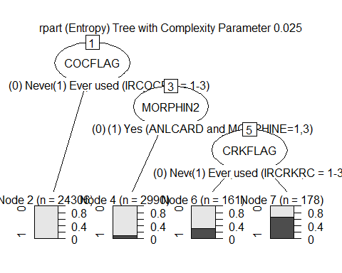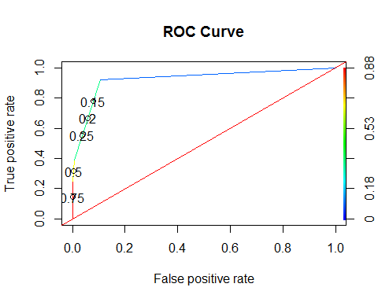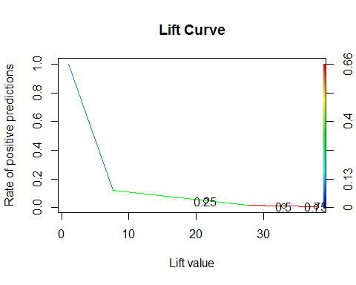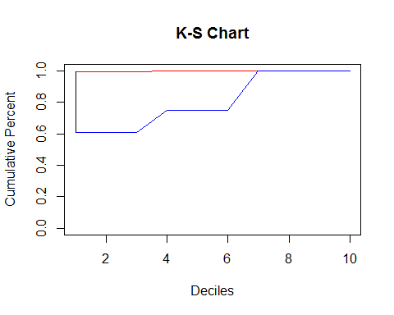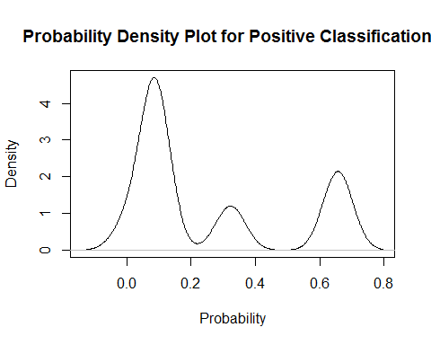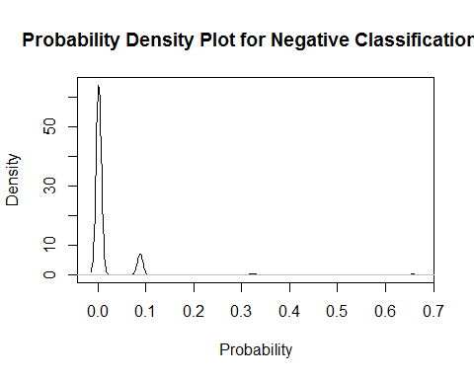

## $AUC  
## $AUC[[1]]  
## [1] 0.924047  
##   
##   
## $`D Statistic`  
## [1] 0.2418382  
##   
## $`KS Statistic`  
## Group CumPct0 CumPct1 Dif  
## 1 1 0.9921996 0.6113537 0.3808459  
## 2 2 0.9921996 0.6113537 0.3808459  
## 3 3 0.9921996 0.6113537 0.3808459  
##   
## $`Confusion Matrix`  
## Confusion Matrix and Statistics  
##   
## Reference  
## Prediction 0 1  
## 0 26966 212  
## 1 280 178  
##   
## Accuracy : 0.9822   
## 95% CI : (0.9806, 0.9837)  
## No Information Rate : 0.9859   
## P-Value [Acc > NIR] : 1.000000   
##   
## Kappa : 0.4108   
## Mcnemar's Test P-Value : 0.002523   
##   
## Sensitivity : 0.9897   
## Specificity : 0.4564   
## Pos Pred Value : 0.9922   
## Neg Pred Value : 0.3886   
## Prevalence : 0.9859   
## Detection Rate : 0.9758   
## Detection Prevalence : 0.9834   
## Balanced Accuracy : 0.7231   
##   
## 'Positive' Class : 0   
##

##   
## Call:  
## C5.0.formula(formula = HERFLAG ~ ., data = dfV1.train, trials = 5, rules  
## = FALSE)  
##   
##   
## C5.0 [Release 2.07 GPL Edition] Fri Dec 16 21:42:46 2016  
## -------------------------------  
##   
## Class specified by attribute `outcome'  
##   
## Read 27635 cases (385 attributes) from undefined.data  
##   
## ----- Trial 0: -----  
##   
## Decision tree:  
##   
## DILAUD2 = (0) No/Unknown (Otherwise):  
## :...CRKMON = (1) Used within the past month (IRCRKRC = 1):  
## : :...BENZOS = (0) No/Unknown (Otherwise): 0 (16/4)  
## : : BENZOS = (1) Yes (See comment above): 1 (16/4)  
## : CRKMON = (0) Did not use in the past month (IRCRKRC = 2-3,9):  
## : :...FUCRK18 = (1) Yes (IRCRKAGE<18):  
## : :...PCPFLAG = (1) Ever used (IRPCPRC = 1-3): 1 (34/10)  
## : : PCPFLAG = (0) Never used (IRPCPRC = 9):  
## : : :...MORPHIN2 = (1) Yes (ANLCARD and MORPHINE=1,3): 1 (24/10)  
## : : MORPHIN2 = (0) No/Unknown (Otherwise):  
## : : :...LGAS2 = (0) No/Unknown (Otherwise): 0 (69/10)  
## : : LGAS2 = (1) Yes (LGAS=1,3): 1 (4)  
## : FUCRK18 = (2) No (IRCRKAGE>=18):  
## : :...METHDON2 = (0) No/Unknown (Otherwise): 0 (27090/254)  
## : METHDON2 = (1) Yes (ANLCARD and METHDON=1,3):  
## : :...DEPNDCOC = (1) Yes (See comment above DEPNDALC): 1 (6)  
## : DEPNDCOC = (0) No/Unknown (Otherwise):  
## : :...FUPCP21 = (1) Yes (IRPCPAGE<21): 1 (15/4)  
## : FUPCP21 = (2) No (IRPCPAGE>=21): 0 (147/33)  
## DILAUD2 = (1) Yes (ANLCARD and DILAUD=1,3):  
## :...CRKFLAG = (1) Ever used (IRCRKRC = 1-3): 1 (94/24)  
## CRKFLAG = (0) Never used (IRCRKRC = 9):  
## :...MRJYDAYS in {(1) 1-11 Days (IRMJFY=1-11),(2) 12-49 Days (IRMJFY=12-49),  
## : (3) 50-99 Days (IRMJFY=50-99),  
## : (4) 100-299 Days (IRMJFY=100-299),  
## : (5) 300-365 Days (IRMJFY=300-365)}: 0 (65/16)  
## MRJYDAYS = (6) Non User or No Past Year Use (IRMJFY=991,993): [S1]  
##   
## SubTree [S1]  
##   
## EDUCCAT2 = (1) Less than high school (IREDUC2<=7 and AGE2>=7): 1 (9)  
## EDUCCAT2 in {(2) High school graduate (IREDUC2=8 and AGE2>=7),  
## : (3) Some college (IREDUC2=9-10 and AGE2>=7),  
## : (4) College graduate (IREDUC2=11 and AGE2>=7),  
## : (5) 12 to 17 year olds (AGE2<=6)}:  
## :...METHDON2 = (1) Yes (ANLCARD and METHDON=1,3): 1 (18/6)  
## METHDON2 = (0) No/Unknown (Otherwise):  
## :...TXILNOAL = (0) No/Unknown (Otherwise): 0 (24/1)  
## TXILNOAL = (1) Yes (TXYRADG=2): 1 (4)  
##   
## ----- Trial 1: -----  
##   
## Decision tree:  
##   
## COCFLAG = (0) Never used (IRCOCRC = 9):  
## :...TXLTTRN2 = (1) Yes (TXLTYTRN=1,3): 1 (85.3/9.8)  
## : TXLTTRN2 = (0) No/Unknown (Otherwise):  
## : :...IONAMIN2 = (1) Yes (STMCARD and IONAMIN=1,3): 1 (21.9/3)  
## : IONAMIN2 = (0) No/Unknown (Otherwise):  
## : :...SOMA2 = (1) Yes (TRNCARD and SOMA=1,3): 1 (140.3/43.7)  
## : SOMA2 = (0) No/Unknown (Otherwise):  
## : :...LIBRIUM2 = (1) Yes (TRNCARD and LIBRIUM=1,3): 1 (22.6/3.8)  
## : LIBRIUM2 = (0) No/Unknown (Otherwise): [S1]  
## COCFLAG = (1) Ever used (IRCOCRC = 1-3):  
## :...IIINSUR4 = (3) Statistically imputed data: 0 (27.9)  
## IIINSUR4 = (1) Questionnaire data:  
## :...EQUANIL2 = (1) Yes (TRNCARD and EQUANIL=1,3): 0 (40/1.5)  
## EQUANIL2 = (0) No/Unknown (Otherwise):  
## :...SANOREX2 = (1) Yes (STMCARD and SANOREX=1,3): 0 (22.6/0.8)  
## SANOREX2 = (0) No/Unknown (Otherwise): [S2]  
##   
## SubTree [S1]  
##   
## HALYDAYS = (5) 300-365 Days (IRHALFY=300-365): 1 (22.6/3.8)  
## HALYDAYS in {(1) 1-11 Days (IRHALFY=1-11),(2) 12-49 Days (IRHALFY=12-49),  
## : (3) 50-99 Days (IRHALFY=50-99),(4) 100-299 Days (IRHALFY=100-299),  
## : (6) Non User or No Past Year Use (IRHALFY=991,993)}:  
## :...DEPNDSTM = (1) Yes (See comment above): 1 (26.4/7.5)  
## DEPNDSTM = (0) No/Unknown (Otherwise):  
## :...BUSPAR2 = (1) Yes (TRNCARD and BUSPAR=1,3): 1 (30.2/11.3)  
## BUSPAR2 = (0) No/Unknown (Otherwise):  
## :...FUMTH18 = (1) Yes (IRMTHAGE<18): 1 (147.9/53.5)  
## FUMTH18 = (2) No (IRMTHAGE>=18): 0 (18667.8/493)  
##   
## SubTree [S2]  
##   
## INHYDAYS = (3) 50-99 Days (IRINHFY=50-99): 0 (21.1)  
## INHYDAYS in {(1) 1-11 Days (IRINHFY=1-11),(2) 12-49 Days (IRINHFY=12-49),  
## : (4) 100-299 Days (IRINHFY=100-299),  
## : (5) 300-365 Days (IRINHFY=300-365),  
## : (6) Non User or No Past Year Use (IRINHFY=991,993)}:  
## :...PCPMON = (1) Used within the past month (IRPCPRC = 1): 1 (56.6)  
## PCPMON = (0) Did not use in the past month (IRPCPRC = 2-3,9):  
## :...MILTOWN2 = (1) Yes (TRNCARD and MILTOWN=1,3): 1 (40)  
## MILTOWN2 = (0) No/Unknown (Otherwise):  
## :...ESKAT2 = (1) Yes (STMCARD and ESKAT=1,3): 0 (21.9/1.5)  
## ESKAT2 = (0) No/Unknown (Otherwise):  
## :...MRJFLAG = (0) Never used (IRMJRC = 9): 0 (79.2/18.9)  
## MRJFLAG = (1) Ever used (IRMJRC = 1-3):  
## :...FUCRK18 = (1) Yes (IRCRKAGE<18): 0 (724.6/210.6)  
## FUCRK18 = (2) No (IRCRKAGE>=18):  
## :...BUSPAR2 = (1) Yes (TRNCARD and BUSPAR=1,3): 1 (308/15.8)  
## BUSPAR2 = (0) No/Unknown (Otherwise): [S3]  
##   
## SubTree [S3]  
##   
## FIORINL2 = (1) Yes (ANLCARD and FIORINAL=1,3): 0 (99.6/21.1)  
## FIORINL2 = (0) No/Unknown (Otherwise):  
## :...TXLTTRN2 = (1) Yes (TXLTYTRN=1,3): 0 (107.9/25.7)  
## TXLTTRN2 = (0) No/Unknown (Otherwise):  
## :...TXILALEV = (1) Yes (TXEVER=1): 1 (2892.2/531.5)  
## TXILALEV = (0) No/Unknown (Otherwise): [S4]  
##   
## SubTree [S4]  
##   
## SEXRACE = (4) Female, Black, Not Hisp (IRSEX=2 and NEWRACE2=2): 0 (35.4)  
## SEXRACE in {(1) Male, White, Not Hisp (IRSEX=1 and NEWRACE2=1),  
## : (2) Female, White, Not Hisp (IRSEX=2 and NEWRACE2=1),  
## : (3) Male, Black, Not Hisp (IRSEX=1 and NEWRACE2=2),  
## : (5) Male, Hispanic (IRSEX=1 and NEWRACE2=7),  
## : (6) Female, Hispanic (IRSEX=2 and NEWRACE2=7),  
## : (7) Male or Female, Other Races (Otherwise)}:  
## :...PRELUDN2 = (1) Yes (STMCARD and PRELUDIN=1,3): 1 (79.3/3.8)  
## PRELUDN2 = (0) No/Unknown (Otherwise):  
## :...ABUSEANL = (1) Yes (Any one of above criteria and DEPNDANL=0): 1 (39.3/1.5)  
## ABUSEANL = (0) No/Unknown (Otherwise):  
## :...CLEFLU2 = (1) Yes (CLEFLU=1,3): 0 (45.2/1.5)  
## CLEFLU2 = (0) No/Unknown (Otherwise):  
## :...ROHYPNL2 = (1) Yes (TRNCARD and ROHYPNOL=1,3): 1 (59.6/3)  
## ROHYPNL2 = (0) No/Unknown (Otherwise):  
## :...PHENCOD2 = (1) Yes (ANLCARD and PHENCOD=1,3): 0 (30.9/2.3)  
## PHENCOD2 = (0) No/Unknown (Otherwise):  
## :...PHENOBR2 = (1) Yes (SEDCARD and PHENOBAR=1,3): 1 (101.9/7.5)  
## PHENOBR2 = (0) No/Unknown (Otherwise):  
## :...RESTTMA2 = (1) Yes (RESTTMAZ=1,3): 0 (29.4/0.8)  
## RESTTMA2 = (0) No/Unknown (Otherwise): [S5]  
##   
## SubTree [S5]  
##   
## CRKMON = (1) Used within the past month (IRCRKRC = 1): 0 (23.4/2.3)  
## CRKMON = (0) Did not use in the past month (IRCRKRC = 2-3,9):  
## :...DEPNDCOC = (1) Yes (See comment above DEPNDALC): 0 (9.8)  
## DEPNDCOC = (0) No/Unknown (Otherwise):  
## :...MORPHIN2 = (1) Yes (ANLCARD and MORPHINE=1,3): 1 (439.3/54.2)  
## MORPHIN2 = (0) No/Unknown (Otherwise):  
## :...SPPAINT2 = (1) Yes (SPPAINT=1,3): 0 (12.1)  
## SPPAINT2 = (0) No/Unknown (Otherwise):  
## :...INHMON = (1) Used within the past month (IRINHRC = 1): 1 (61.1/4.5)  
## INHMON = (0) Did not use in the past month (IRINHRC = 2-3,9):  
## :...DILAUD2 = (1) Yes (ANLCARD and DILAUD=1,3): 0 (105.7/2.3)  
## DILAUD2 = (0) No/Unknown (Otherwise): [S6]  
##   
## SubTree [S6]  
##   
## MRJYDAYS = (3) 50-99 Days (IRMJFY=50-99): 0 (59.5)  
## MRJYDAYS in {(1) 1-11 Days (IRMJFY=1-11),(2) 12-49 Days (IRMJFY=12-49),  
## : (4) 100-299 Days (IRMJFY=100-299),  
## : (5) 300-365 Days (IRMJFY=300-365),  
## : (6) Non User or No Past Year Use (IRMJFY=991,993)}:  
## :...CRKFLAG = (0) Never used (IRCRKRC = 9): 0 (2057.9/849.3)  
## CRKFLAG = (1) Ever used (IRCRKRC = 1-3): 1 (838.5/159)  
##   
## ----- Trial 2: -----  
##   
## Decision tree:  
##   
## IEMFLAG = (0) Never used drug/used only marijuana: 0 (11432.3)  
## IEMFLAG = (1) Illicit drug except for marijuana are ever used:  
## :...PCPMON = (1) Used within the past month (IRPCPRC = 1): 1 (50/6.1)  
## PCPMON = (0) Did not use in the past month (IRPCPRC = 2-3,9):  
## :...TXLTSED2 = (1) Yes (TXLTYSED=1,3): 1 (121.1/21.9)  
## TXLTSED2 = (0) No/Unknown (Otherwise):  
## :...SUMYFU <= 1970: 1 (1122/348.9)  
## SUMYFU > 1970:  
## :...SANOREX2 = (1) Yes (STMCARD and SANOREX=1,3): 0 (25.9)  
## SANOREX2 = (0) No/Unknown (Otherwise):  
## :...TALWINX2 = (1) Yes (ANLCARD and TALWINNX=1,3): 1 (10.9)  
## TALWINX2 = (0) No/Unknown (Otherwise):  
## :...EQUANIL2 = (1) Yes (TRNCARD and EQUANIL=1,3): 0 (31)  
## EQUANIL2 = (0) No/Unknown (Otherwise): [S1]  
##   
## SubTree [S1]  
##   
## HALCION2 = (1) Yes (SEDCARD and HALCION=1,3): 1 (112.2/19.7)  
## HALCION2 = (0) No/Unknown (Otherwise):  
## :...ABODINH = (1) Yes (ABUSEINH=1 or DEPNDINH=1): 0 (23.4)  
## ABODINH = (0) No/Unknown (ABUSEINH=0 and DEPNDINH=0):  
## :...MRJFLAG = (0) Never used (IRMJRC = 9): 0 (1034.5/81.9)  
## MRJFLAG = (1) Ever used (IRMJRC = 1-3):  
## :...DIDREX2 = (1) Yes (STMCARD and DIDREX=1,3): 0 (12.7)  
## DIDREX2 = (0) No/Unknown (Otherwise):  
## :...MEPROB2 = (1) Yes (TRNCARD and MEPROB=1,3): 0 (28.5/0.6)  
## MEPROB2 = (0) No/Unknown (Otherwise):  
## :...IEMAGE > 19: [S2]  
## IEMAGE <= 19:  
## :...IEMYFU > 2013: 0 (59.2)  
## IEMYFU <= 2013:  
## :...SK65A2 = (1) Yes (ANLCARD and SK65A=1,3): 0 (11.5)  
## SK65A2 = (0) No/Unknown (Otherwise): [S3]  
##   
## SubTree [S2]  
##   
## HALYDAYS = (5) 300-365 Days (IRHALFY=300-365): 0 (0)  
## HALYDAYS in {(3) 50-99 Days (IRHALFY=50-99),  
## : (4) 100-299 Days (IRHALFY=100-299)}: 1 (40/1.8)  
## HALYDAYS in {(1) 1-11 Days (IRHALFY=1-11),(2) 12-49 Days (IRHALFY=12-49),  
## : (6) Non User or No Past Year Use (IRHALFY=991,993)}:  
## :...DEPNDTRN = (1) Yes (See comment above DEPNDALC): 1 (5.5)  
## DEPNDTRN = (0) No/Unknown (Otherwise):  
## :...TXLTTRN2 = (1) Yes (TXLTYTRN=1,3): 1 (15.8/1.2)  
## TXLTTRN2 = (0) No/Unknown (Otherwise):  
## :...ALCFLAG = (0) Never used (IRALCRC = 9): 1 (57.4/18.5)  
## ALCFLAG = (1) Ever used (IRALCRC = 1-3): 0 (2443.1/295.8)  
##   
## SubTree [S3]  
##   
## ABUSESED = (1) Yes (Any one of above criteria and DEPNDSED=0): 0 (10.9)  
## ABUSESED = (0) No/Unknown (Otherwise):  
## :...TALACEN2 = (1) Yes (ANLCARD and TALACEN=1,3): 0 (16.4/0.6)  
## TALACEN2 = (0) No/Unknown (Otherwise):  
## :...INHMDAYS in {(2) 3-5 Days (IRINHFM=3-5),  
## : (4) 20-30 Days (IRINHFM=20-30)}: 0 (23.6)  
## INHMDAYS = (3) 6-19 Days (IRINHFM=6-19): 1 (55.8/12.1)  
## INHMDAYS in {(1) 1-2 Days (IRINHFM=1-2),  
## : (5) Non User or No Past Month Use (IRINHFM=91,93)}:  
## :...TRANXEN2 = (1) Yes (TRNCARD and TRANXENE=1,3): 0 (22.4)  
## TRANXEN2 = (0) No/Unknown (Otherwise): [S4]  
##   
## SubTree [S4]  
##   
## SEXRACE = (4) Female, Black, Not Hisp (IRSEX=2 and NEWRACE2=2): 0 (164.5/14.6)  
## SEXRACE in {(1) Male, White, Not Hisp (IRSEX=1 and NEWRACE2=1),  
## : (2) Female, White, Not Hisp (IRSEX=2 and NEWRACE2=1),  
## : (3) Male, Black, Not Hisp (IRSEX=1 and NEWRACE2=2),  
## : (5) Male, Hispanic (IRSEX=1 and NEWRACE2=7),  
## : (6) Female, Hispanic (IRSEX=2 and NEWRACE2=7),  
## : (7) Male or Female, Other Races (Otherwise)}:  
## :...AMYTAL2 = (1) Yes (SEDCARD and AMYTAL=1,3): 1 (17/2.3)  
## AMYTAL2 = (0) No/Unknown (Otherwise):  
## :...ABUSEXMJ = (1) Yes (Any above var=1 & ABUSEMRJ=0 & DEPNDXMJ=0): 1 (315.6/95.5)  
## ABUSEXMJ = (0) No/Unknown (Otherwise): [S5]  
##   
## SubTree [S5]  
##   
## ABUSEHAL = (1) Yes (Any one of above criteria and DEPNDHAL=0): 0 (46.3)  
## ABUSEHAL = (0) No/Unknown (Otherwise):  
## :...ABUSEIEM = (1) Yes (Any source variable above=1 & DEPNDIEM=0): 0 (30.3)  
## ABUSEIEM = (0) No/Unknown (Otherwise):  
## :...ABUSESTM = (1) Yes (Any one of above criteria and DEPNDSTM=0): 0 (15.8/0.6)  
## ABUSESTM = (0) No/Unknown (Otherwise):  
## :...DEPNDCOC = (1) Yes (See comment above DEPNDALC): 1 (121/29.5)  
## DEPNDCOC = (0) No/Unknown (Otherwise):  
## :...ESKAT2 = (1) Yes (STMCARD and ESKAT=1,3): 0 (21.3)  
## ESKAT2 = (0) No/Unknown (Otherwise):  
## :...DEPNDHAL = (1) Yes (See comment above): 0 (21.1)  
## DEPNDHAL = (0) No/Unknown (Otherwise): [S6]  
##   
## SubTree [S6]  
##   
## SEDMON = (1) Used within the past month (IRSEDRC = 1): 1 (99.7/26.7)  
## SEDMON = (0) Did not use in the past month (IRSEDRC = 2-3,9):  
## :...TUINAL2 = (1) Yes (SEDCARD and TUINAL=1,3): 0 (24.8/1.2)  
## TUINAL2 = (0) No/Unknown (Otherwise):  
## :...SEDYR = (1) Used within the past year (IRSEDRC = 1,2): 0 (59.4/5.5)  
## SEDYR = (0) Did not use in the past year (IRSEDRC = 3,9):  
## :...NEMBBAR2 = (1) Yes (NEMBBARB=1,3): 1 (230.4/74)  
## NEMBBAR2 = (0) No/Unknown (Otherwise):  
## :...BUTISOL2 = (1) Yes (SEDCARD and BUTISOL=1,3): 0 (11.5)  
## BUTISOL2 = (0) No/Unknown (Otherwise):  
## :...PRELUDN2 = (1) Yes (STMCARD and PRELUDIN=1,3): 1 (35.9/6.6)  
## PRELUDN2 = (0) No/Unknown (Otherwise):  
## :...IONAMIN2 = (1) Yes (STMCARD and IONAMIN=1,3): 1 (40.2/10.9)  
## IONAMIN2 = (0) No/Unknown (Otherwise): [S7]  
##   
## SubTree [S7]  
##   
## PCPYR = (1) Used within the past year (IRPCPRC = 1,2): 0 (17.6)  
## PCPYR = (0) Did not use in the past year (IRPCPRC = 3,9):  
## :...ALCPCORT = (1) Yes (TXLTALC2=1 and TXPCORT2=1): 0 (51.6/5.5)  
## ALCPCORT = (0) No/Unknown (TXLTALC2=0 or TXPCORT2=0):  
## :...KLONOPI2 = (1) Yes (KLONOPIN=1,3):  
## :...IEMYFU > 2011: 0 (56)  
## : IEMYFU <= 2011:  
## : :...FUALC21 = (2) No (IRALCAGE>=21): 0 (21.9)  
## : FUALC21 = (1) Yes (IRALCAGE<21):  
## : :...IIINSUR4 = (3) Statistically imputed data: 0 (16.4)  
## : IIINSUR4 = (1) Questionnaire data: [S8]  
## KLONOPI2 = (0) No/Unknown (Otherwise):  
## :...FIORICT2 = (1) Yes (ANLCARD and FIORICET=1,3): 1 (53.5/9.6)  
## FIORICT2 = (0) No/Unknown (Otherwise):  
## :...DEXED2 = (1) Yes (STMCARD and DEXED=1,3): 0 (97.4)  
## DEXED2 = (0) No/Unknown (Otherwise):  
## :...TXLTTRN2 = (1) Yes (TXLTYTRN=1,3): 0 (39.5)  
## TXLTTRN2 = (0) No/Unknown (Otherwise):  
## :...TXLTANL2 = (1) Yes (TXLTYANL=1,3): 1 (98.6/13.9)  
## TXLTANL2 = (0) No/Unknown (Otherwise): [S9]  
##   
## SubTree [S8]  
##   
## IREDUC2 in {(01) Fifth grade or less,(03) Seventh grade}: 0 (37.7)  
## IREDUC2 in {(02) Sixth grade,(04) Eighth grade,(05) Ninth grade,  
## : (06) Tenth grade,(07) Eleventh grade,(08) Twelfth grade,  
## : (09) Freshman/13th year,  
## : (10) Sophomore/14th year or Junior/15th year,  
## : (11) Senior/16th year or Grad/Prof School (or higher)}:  
## :...SERAX2 = (1) Yes (TRNCARD and SERAX=1,3): 0 (6.1)  
## SERAX2 = (0) No/Unknown (Otherwise):  
## :...NEWRACE2 = (4) NonHisp Native HI/Other Pac Isl: 1 (0)  
## NEWRACE2 = (5) NonHisp Asian: 0 (21.3)  
## NEWRACE2 in {(1) NonHisp White,(2) NonHisp Black/Afr Am,  
## : (3) NonHisp Native Am/AK Native,  
## : (6) NonHisp more than one race,(7) Hispanic}:  
## :...ABILANAL = (1) Yes (ABUSEILL=1 & ABUSEALC=1 & DPILLALC=0): 1 (23.6)  
## ABILANAL = (0) No/Unknown (Otherwise): [S10]  
##   
## SubTree [S9]  
##   
## DEPNDTRN = (1) Yes (See comment above DEPNDALC): 1 (16.4/1.8)  
## DEPNDTRN = (0) No/Unknown (Otherwise):  
## :...TXLTSTM2 = (1) Yes (TXLTYSTM=1,3): 0 (40.1)  
## TXLTSTM2 = (0) No/Unknown (Otherwise):  
## :...TXLTHAL2 = (1) Yes (TXLTYHAL=1,3): 0 (33.4)  
## TXLTHAL2 = (0) No/Unknown (Otherwise):  
## :...CRKMON = (1) Used within the past month (IRCRKRC = 1): 1 (11.5/0.6)  
## CRKMON = (0) Did not use in the past month (IRCRKRC = 2-3,9):  
## :...TXILNOAL = (1) Yes (TXYRADG=2): 1 (123.4/34.4)  
## TXILNOAL = (0) No/Unknown (Otherwise): [S11]  
##   
## SubTree [S10]  
##   
## ABUSEILL = (0) No/Unknown (Otherwise): 1 (2354.6/979.1)  
## ABUSEILL = (1) Yes (Any source variable above=1 & DEPNDILL=0): 0 (23.1)  
##   
## SubTree [S11]  
##   
## LSDMON = (1) Used within the past month (IRLSDRC = 1): 0 (50.8)  
## LSDMON = (0) Did not use in the past month (IRLSDRC = 2-3,9):  
## :...ILLPINS = (1) Yes (TXLTILL2=1 and TXPINS2=1): 0 (29.1)  
## ILLPINS = (0) No/Unknown (TXLTILL2=0 or TXPINS2=0):  
## :...RTDALHAL = (1) Yes (RESTTMA2=1 or DALMANE2=1 or HALCION2=1): 0 (28.5)  
## RTDALHAL = (0) No/Unknown (Otherwise):  
## :...INHMON = (1) Used within the past month (IRINHRC = 1): 0 (24)  
## INHMON = (0) Did not use in the past month (IRINHRC = 2-3,9):  
## :...IEMYFU <= 1972: 0 (56)  
## IEMYFU > 1972: [S12]  
##   
## SubTree [S12]  
##   
## HALYDAYS in {(2) 12-49 Days (IRHALFY=12-49),(4) 100-299 Days (IRHALFY=100-299),  
## : (5) 300-365 Days (IRHALFY=300-365)}: 0 (33.4)  
## HALYDAYS in {(1) 1-11 Days (IRHALFY=1-11),(3) 50-99 Days (IRHALFY=50-99),  
## : (6) Non User or No Past Year Use (IRHALFY=991,993)}:  
## :...OXYMON = (1) Used within the past month (IROXYRC = 1): 0 (31.4/1.2)  
## OXYMON = (0) Did not use in the past month (IROXYRC = 2-3,9):  
## :...FUCOC18 = (1) Yes (IRCOCAGE<18): 1 (1876.1/933.3)  
## FUCOC18 = (2) No (IRCOCAGE>=18):  
## :...CIGFLAG = (0) Never used (IRCIGRC = 9): 0 (203.8)  
## CIGFLAG = (1) Ever used (IRCIGRC = 1-4): [S13]  
##   
## SubTree [S13]  
##   
## IIMARIT = (3) Marital status statistically imputed: 0 (0)  
## IIMARIT = (9) LEGITIMATE SKIP Respondent is <= 14 years old: 1 (64.3/17.2)  
## IIMARIT = (1) Marital status from questionnaire:  
## :...TXPMILC2 = (1) Yes (TXPYMILC=1,3): 1 (20.1/5.5)  
## TXPMILC2 = (0) No/Unknown (Otherwise):  
## :...SOLVENT2 = (1) Yes (SOLVENT=1,3): 0 (78.9)  
## SOLVENT2 = (0) No/Unknown (Otherwise):  
## :...TXPCAID2 = (1) Yes (TXPYCAID=1,3): 1 (20.7/6.1)  
## TXPCAID2 = (0) No/Unknown (Otherwise):  
## :...TXALNOIL = (1) Yes (TXYRADG=1): 0 (105.5)  
## TXALNOIL = (0) No/Unknown (Otherwise): [S14]  
##   
## SubTree [S14]  
##   
## COCMDAYS in {(3) 6-19 Days (IRCOCFM=6-19),  
## : (4) 20-30 Days (IRCOCFM=20-30)}: 0 (0)  
## COCMDAYS = (1) 1-2 Days (IRCOCFM=1-2): 1 (103/35.5)  
## COCMDAYS in {(2) 3-5 Days (IRCOCFM=3-5),  
## : (5) Non User or No Past Month Use (IRCOCFM=91,93)}:  
## :...STMYDAYS in {(2) 12-49 Days (IRSTMFY=12-49),(3) 50-99 Days (IRSTMFY=50-99),  
## : (4) 100-299 Days (IRSTMFY=100-299),  
## : (5) 300-365 Days (IRSTMFY=300-365)}: 0 (115.2)  
## STMYDAYS in {(1) 1-11 Days (IRSTMFY=1-11),  
## : (6) Non User or No Past Year Use (IRSTMFY=991,993)}:  
## :...IIINSUR4 = (3) Statistically imputed data: 1 (38.4/14.8)  
## IIINSUR4 = (1) Questionnaire data:  
## :...HALYDAYS = (3) 50-99 Days (IRHALFY=50-99): 1 (19.9/5.3)  
## HALYDAYS in {(1) 1-11 Days (IRHALFY=1-11),  
## : (6) Non User or No Past Year Use (IRHALFY=991,993)}:  
## :...FUSED18 = (1) Yes (IRSEDAGE<18): 1 (73/25.8)  
## FUSED18 = (2) No (IRSEDAGE>=18): [S15]  
##   
## SubTree [S15]  
##   
## IREDUC2 in {(02) Sixth grade,(04) Eighth grade}: 1 (76.9/24)  
## IREDUC2 in {(01) Fifth grade or less,(03) Seventh grade,(05) Ninth grade,  
## : (06) Tenth grade,(07) Eleventh grade,(08) Twelfth grade,  
## : (09) Freshman/13th year,  
## : (10) Sophomore/14th year or Junior/15th year,  
## : (11) Senior/16th year or Grad/Prof School (or higher)}:  
## :...IEMAGE <= 13: 0 (197.9)  
## IEMAGE > 13:  
## :...SUMAGE <= 8: 1 (37.7/8.4)  
## SUMAGE > 8:  
## :...PROPOXY2 = (1) Yes (ANLCARD and PROPOXY=1,3): 1 (21.3/6.6)  
## PROPOXY2 = (0) No/Unknown (Otherwise):  
## :...CRKYR = (1) Used within the past year (IRCRKRC = 1,2): 1 (31.6/10.9)  
## CRKYR = (0) Did not use in the past year (IRCRKRC = 3,9):  
## :...SEDFLAG = (1) Ever used (IRSEDRC = 1-3): 0 (57.2)  
## SEDFLAG = (0) Never used (IRSEDRC = 9):  
## :...TXPSAVE2 = (1) Yes (TXPYSAVE=1,3): 1 (20.7/6.1)  
## TXPSAVE2 = (0) No/Unknown (Otherwise): [S16]  
##   
## SubTree [S16]  
##   
## ANLMON = (1) Used within the past month (IRANLRC = 1): 0 (130.8/0.6)  
## ANLMON = (0) Did not use in the past month (IRANLRC = 2-3,9):  
## :...DEPNDANL = (1) Yes (See comment above DEPNDALC): 1 (33.2/9)  
## DEPNDANL = (0) No/Unknown (Otherwise):  
## :...IEMMON = (1) Illicit drug except for marijuana used past month: 1 (167.4/47)  
## IEMMON = (0) Never used drug/used only marijuana past month:  
## :...INHYR = (0) Did not use in the past year (IRINHRC = 3,9): 0 (2686.2/617.6)  
## INHYR = (1) Used within the past year (IRINHRC = 1,2): 1 (37.8/14.2)  
##   
## ----- Trial 3: -----  
##   
## Decision tree:  
##   
## MILTOWN2 = (1) Yes (TRNCARD and MILTOWN=1,3): 1 (33.7/4.5)  
## MILTOWN2 = (0) No/Unknown (Otherwise):  
## :...IEMFLAG = (0) Never used drug/used only marijuana: 0 (9128.5)  
## IEMFLAG = (1) Illicit drug except for marijuana are ever used:  
## :...PCPMON = (1) Used within the past month (IRPCPRC = 1): 1 (48.1/13.1)  
## PCPMON = (0) Did not use in the past month (IRPCPRC = 2-3,9):  
## :...STMYDAYS in {(3) 50-99 Days (IRSTMFY=50-99),  
## : (5) 300-365 Days (IRSTMFY=300-365)}: 1 (319.3/129.4)  
## STMYDAYS in {(1) 1-11 Days (IRSTMFY=1-11),  
## : (2) 12-49 Days (IRSTMFY=12-49),  
## : (4) 100-299 Days (IRSTMFY=100-299),  
## : (6) Non User or No Past Year Use (IRSTMFY=991,993)}:  
## :...TALWINX2 = (1) Yes (ANLCARD and TALWINNX=1,3): 1 (4.4)  
## TALWINX2 = (0) No/Unknown (Otherwise):  
## :...CHHYD2 = (1) Yes (SEDCARD and CHHYD=1,3): 1 (57.1/20.6)  
## CHHYD2 = (0) No/Unknown (Otherwise): [S1]  
##   
## SubTree [S1]  
##   
## SEDMON = (1) Used within the past month (IRSEDRC = 1): 1 (136.5/62)  
## SEDMON = (0) Did not use in the past month (IRSEDRC = 2-3,9):  
## :...EQUANIL2 = (1) Yes (TRNCARD and EQUANIL=1,3): 0 (24.8)  
## EQUANIL2 = (0) No/Unknown (Otherwise):  
## :...TRANXEN2 = (1) Yes (TRNCARD and TRANXENE=1,3): 0 (24.6)  
## TRANXEN2 = (0) No/Unknown (Otherwise):  
## :...ABODINH = (1) Yes (ABUSEINH=1 or DEPNDINH=1): 0 (18.7)  
## ABODINH = (0) No/Unknown (ABUSEINH=0 and DEPNDINH=0):  
## :...COCFLAG = (0) Never used (IRCOCRC = 9): 0 (5002.4/557.5)  
## COCFLAG = (1) Ever used (IRCOCRC = 1-3):  
## :...SUMYFU > 2011: 0 (111)  
## SUMYFU <= 2011:  
## :...MRJFLAG = (0) Never used (IRMJRC = 9): 0 (47.1)  
## MRJFLAG = (1) Ever used (IRMJRC = 1-3):  
## :...IIINSUR4 = (3) Statistically imputed data: 0 (41.9)  
## IIINSUR4 = (1) Questionnaire data: [S2]  
##   
## SubTree [S2]  
##   
## ILLPMILC = (1) Yes (TXLTILL2=1 and TXPMILC2=1): 0 (24.8/4.4)  
## ILLPMILC = (0) No/Unknown (TXLTILL2=0 or TXPMILC2=0):  
## :...DEPNDHAL = (1) Yes (See comment above): 1 (34/10.8)  
## DEPNDHAL = (0) No/Unknown (Otherwise):  
## :...ALCFLAG = (0) Never used (IRALCRC = 9): 1 (134.6/48.4)  
## ALCFLAG = (1) Ever used (IRALCRC = 1-3):  
## :...TALWIN2 = (1) Yes (ANLCARD and TALWIN=1,3): 1 (32.2/9.5)  
## TALWIN2 = (0) No/Unknown (Otherwise): [S3]  
##   
## SubTree [S3]  
##   
## ABUSEXMJ = (1) Yes (Any above var=1 & ABUSEMRJ=0 & DEPNDXMJ=0): 1 (286.8/118.7)  
## ABUSEXMJ = (0) No/Unknown (Otherwise):  
## :...ABUSEANL = (1) Yes (Any one of above criteria and DEPNDANL=0): 1 (12.2)  
## ABUSEANL = (0) No/Unknown (Otherwise):  
## :...ABUSEHAL = (1) Yes (Any one of above criteria and DEPNDHAL=0): 0 (24.8)  
## ABUSEHAL = (0) No/Unknown (Otherwise):  
## :...INHMDAYS in {(2) 3-5 Days (IRINHFM=3-5),  
## : (4) 20-30 Days (IRINHFM=20-30)}: 0 (16.1)  
## INHMDAYS = (3) 6-19 Days (IRINHFM=6-19): 1 (43.9/13.4)  
## INHMDAYS in {(1) 1-2 Days (IRINHFM=1-2),  
## : (5) Non User or No Past Month Use (IRINHFM=91,93)}:  
## :...PCPYR = (1) Used within the past year (IRPCPRC = 1,2): 0 (16.7)  
## PCPYR = (0) Did not use in the past year (IRPCPRC = 3,9):  
## :...PERCTYL2 = (0) No/Unknown (Otherwise):  
## :...TUINAL2 = (1) Yes (SEDCARD and TUINAL=1,3): 1 (48.4/17.9)  
## : TUINAL2 = (0) No/Unknown (Otherwise):  
## : :...SUMAGE > 25: 1 (100.5/45)  
## : SUMAGE <= 25: [S4]  
## PERCTYL2 = (1) Yes (PERCTYLX=1,3):  
## :...IONAMIN2 = (1) Yes (STMCARD and IONAMIN=1,3): 1 (12.6/0.5)  
## IONAMIN2 = (0) No/Unknown (Otherwise):  
## :...SUMAGE <= 7: 1 (121.8/8.1)  
## SUMAGE > 7: [S5]  
##   
## SubTree [S4]  
##   
## FIORICT2 = (1) Yes (ANLCARD and FIORICET=1,3): 1 (20.3/8.6)  
## FIORICT2 = (0) No/Unknown (Otherwise):  
## :...ILLPCARE = (1) Yes (TXLTILL2=1 and TXPCARE2=1): 1 (45.7/22.3)  
## ILLPCARE = (0) No/Unknown (TXLTILL2=0 or TXPCARE2=0):  
## :...OXYYR = (1) Used within the past year (IROXYRC = 1,2): 1 (66.3/31.4)  
## OXYYR = (0) Did not use in the past year (IROXYRC = 3,9):  
## :...ALCPCAID = (1) Yes (TXLTALC2=1 and TXPCAID2=1): 1 (45.2/21.8)  
## ALCPCAID = (0) No/Unknown (TXLTALC2=0 or TXPCAID2=0):  
## :...SPECTALC = (1) Yes (See comment above): 0 (137.6)  
## SPECTALC = (0) No/Unknown (Otherwise):  
## :...TXALNOIL = (1) Yes (TXYRADG=1): 0 (52.7)  
## TXALNOIL = (0) No/Unknown (Otherwise): [S6]  
##   
## SubTree [S5]  
##   
## ABUSECOC = (1) Yes (Any one of above criteria and DEPNDCOC=0): 1 (12.2/0.5)  
## ABUSECOC = (0) No/Unknown (Otherwise):  
## :...TXLTSTM2 = (1) Yes (TXLTYSTM=1,3): 0 (132.9/17.5)  
## TXLTSTM2 = (0) No/Unknown (Otherwise):  
## :...TOBFLAG = (0) Never Used (ALL SOURCE VARIABLES = 0): 1 (72.4/14.2)  
## TOBFLAG = (1) Ever Used (ANY SOURCE VARIABLE = 1):  
## :...SUMYFU <= 1968: 0 (48.2/0.9)  
## SUMYFU > 1968:  
## :...NEWRACE2 in {(4) NonHisp Native HI/Other Pac Isl,  
## : (5) NonHisp Asian}: 0 (29.9)  
## NEWRACE2 in {(1) NonHisp White,(2) NonHisp Black/Afr Am,  
## : (3) NonHisp Native Am/AK Native,  
## : (6) NonHisp more than one race,(7) Hispanic}: [S7]  
##   
## SubTree [S6]  
##   
## LSDMON = (1) Used within the past month (IRLSDRC = 1): 0 (49.1)  
## LSDMON = (0) Did not use in the past month (IRLSDRC = 2-3,9):  
## :...HALMDAYS = (4) 20-30 Days (IRHALFM=20-30): 0 (0)  
## HALMDAYS = (3) 6-19 Days (IRHALFM=6-19): 1 (11.7)  
## HALMDAYS in {(1) 1-2 Days (IRHALFM=1-2),(2) 3-5 Days (IRHALFM=3-5),  
## : (5) Non User or No Past Month Use (IRHALFM=91,93)}:  
## :...DEXED2 = (1) Yes (STMCARD and DEXED=1,3): 0 (177.3/53.9)  
## DEXED2 = (0) No/Unknown (Otherwise):  
## :...CRKYR = (1) Used within the past year (IRCRKRC = 1,2): 0 (63.4/0.5)  
## CRKYR = (0) Did not use in the past year (IRCRKRC = 3,9):  
## :...ANLYR = (1) Used within the past year (IRANLRC = 1,2): 0 (310.5/11.7)  
## ANLYR = (0) Did not use in the past year (IRANLRC = 3,9):  
## :...ATARAX2 = (1) Yes (TRNCARD and ATARAX=1,3): 1 (8.7)  
## ATARAX2 = (0) No/Unknown (Otherwise):  
## :...CPNSTMYR = (1) Used within the past year: 0 (229.8/34.9)  
## CPNSTMYR = (0) Did not use in the past year: [S8]  
##   
## SubTree [S7]  
##   
## COCMDAYS in {(3) 6-19 Days (IRCOCFM=6-19),  
## : (4) 20-30 Days (IRCOCFM=20-30)}: 1 (38.5/4.5)  
## COCMDAYS in {(1) 1-2 Days (IRCOCFM=1-2),(2) 3-5 Days (IRCOCFM=3-5),  
## : (5) Non User or No Past Month Use (IRCOCFM=91,93)}:  
## :...SPECTILL = (1) Yes (See comment above): 1 (354.7/118.1)  
## SPECTILL = (0) No/Unknown (Otherwise):  
## :...ILLPINS = (1) Yes (TXLTILL2=1 and TXPINS2=1): 0 (52.1)  
## ILLPINS = (0) No/Unknown (TXLTILL2=0 or TXPINS2=0):  
## :...TXLTMJ2 = (1) Yes (TXLTYMJ=1,3): 0 (30.8)  
## TXLTMJ2 = (0) No/Unknown (Otherwise):  
## :...ILLPSAVE = (1) Yes (TXLTILL2=1 and TXPSAVE2=1): 1 (11.7)  
## ILLPSAVE = (0) No/Unknown (TXLTILL2=0 or TXPSAVE2=0):  
## :...IEMAGE > 26: 1 (43.3/6.7)  
## IEMAGE <= 26:  
## :...IEMAGE > 23: 0 (80.9)  
## IEMAGE <= 23: [S9]  
##   
## SubTree [S8]  
##   
## DEMEROL2 = (1) Yes (ANLCARD and DEMEROL=1,3): 1 (60/13.5)  
## DEMEROL2 = (0) No/Unknown (Otherwise):  
## :...INHYDAYS in {(3) 50-99 Days (IRINHFY=50-99),  
## : (4) 100-299 Days (IRINHFY=100-299),  
## : (5) 300-365 Days (IRINHFY=300-365)}: 0 (0)  
## INHYDAYS = (1) 1-11 Days (IRINHFY=1-11): 1 (48.6/18)  
## INHYDAYS in {(2) 12-49 Days (IRINHFY=12-49),  
## : (6) Non User or No Past Year Use (IRINHFY=991,993)}:  
## :...DETAMP2 = (1) Yes (STMCARD and DETAMP=1,3): 1 (48/13.1)  
## DETAMP2 = (0) No/Unknown (Otherwise):  
## :...ROHYPNL2 = (1) Yes (TRNCARD and ROHYPNOL=1,3): 1 (16.1/4.4)  
## ROHYPNL2 = (0) No/Unknown (Otherwise):  
## :...VISTAR2 = (1) Yes (TRNCARD and VISTAR=1,3): 0 (50/22.7)  
## VISTAR2 = (0) No/Unknown (Otherwise):  
## :...SUMYFU > 2004: 0 (634.8/75.4)  
## SUMYFU <= 2004: [S10]  
##   
## SubTree [S9]  
##   
## SEXRACE in {(3) Male, Black, Not Hisp (IRSEX=1 and NEWRACE2=2),  
## : (6) Female, Hispanic (IRSEX=2 and NEWRACE2=7)}: 0 (132.7/4.4)  
## SEXRACE in {(1) Male, White, Not Hisp (IRSEX=1 and NEWRACE2=1),  
## : (2) Female, White, Not Hisp (IRSEX=2 and NEWRACE2=1),  
## : (4) Female, Black, Not Hisp (IRSEX=2 and NEWRACE2=2),  
## : (5) Male, Hispanic (IRSEX=1 and NEWRACE2=7),  
## : (7) Male or Female, Other Races (Otherwise)}:  
## :...ABILANAL = (1) Yes (ABUSEILL=1 & ABUSEALC=1 & DPILLALC=0): 1 (46/8.9)  
## ABILANAL = (0) No/Unknown (Otherwise):  
## :...IEMAGE > 22: 1 (41.9/5.3)  
## IEMAGE <= 22:  
## :...ETHER2 = (1) Yes (ETHER=1,3): 1 (158/48.5)  
## ETHER2 = (0) No/Unknown (Otherwise):  
## :...CHWMON = (1) Used within the past month (IRCHWRC = 1): 0 (65.2/4)  
## CHWMON = (0) Did not use in the past month (IRCHWRC = 2-4,9): [S11]  
##   
## SubTree [S10]  
##   
## COCYDAYS = (1) 1-11 Days (IRCOCFY=1-11): 1 (161.1/58.9)  
## COCYDAYS in {(2) 12-49 Days (IRCOCFY=12-49),  
## : (5) 300-365 Days (IRCOCFY=300-365)}: 0 (72.3/4.8)  
## COCYDAYS in {(3) 50-99 Days (IRCOCFY=50-99),(4) 100-299 Days (IRCOCFY=100-299),  
## : (6) Non User or No Past Year Use (IRCOCFY=991,993)}:  
## :...GLUE2 = (1) Yes (GLUE=1,3): 0 (171/61.9)  
## GLUE2 = (0) No/Unknown (Otherwise):  
## :...MRJYDAYS in {(1) 1-11 Days (IRMJFY=1-11),  
## : (3) 50-99 Days (IRMJFY=50-99)}: 0 (350.5)  
## MRJYDAYS in {(2) 12-49 Days (IRMJFY=12-49),  
## : (4) 100-299 Days (IRMJFY=100-299),  
## : (5) 300-365 Days (IRMJFY=300-365),  
## : (6) Non User or No Past Year Use (IRMJFY=991,993)}:  
## :...PIPMON = (1) Used within the past month (IRPIPMN = 1): 1 (82.1/32.7)  
## PIPMON = (0) Did not use in the past month (IRPIPMN = 2,9): [S12]  
##   
## SubTree [S11]  
##   
## STMMON = (1) Used within the past month (IRSTMRC = 1): 0 (142.1/12.6)  
## STMMON = (0) Did not use in the past month (IRSTMRC = 2-3,9):  
## :...CRKYR = (1) Used within the past year (IRCRKRC = 1,2): 1 (33.5/0.5)  
## CRKYR = (0) Did not use in the past year (IRCRKRC = 3,9):  
## :...DEPNDCOC = (1) Yes (See comment above DEPNDALC): 0 (12.1)  
## DEPNDCOC = (0) No/Unknown (Otherwise):  
## :...DEPNDSTM = (1) Yes (See comment above): 1 (16.5/0.5)  
## DEPNDSTM = (0) No/Unknown (Otherwise):  
## :...IEMYFU > 2011: 1 (37.2/6.7)  
## IEMYFU <= 2011: [S13]  
##   
## SubTree [S12]  
##   
## SEXRACE in {(4) Female, Black, Not Hisp (IRSEX=2 and NEWRACE2=2),  
## : (5) Male, Hispanic (IRSEX=1 and NEWRACE2=7)}: 0 (364.8/41)  
## SEXRACE in {(1) Male, White, Not Hisp (IRSEX=1 and NEWRACE2=1),  
## : (2) Female, White, Not Hisp (IRSEX=2 and NEWRACE2=1),  
## : (3) Male, Black, Not Hisp (IRSEX=1 and NEWRACE2=2),  
## : (6) Female, Hispanic (IRSEX=2 and NEWRACE2=7),  
## : (7) Male or Female, Other Races (Otherwise)}:  
## :...MHSUTK_U = (1) Yes (AGE2>=7 and MHSUITHK=1): 0 (219.2/16.1)  
## MHSUTK_U = (0) No/Unknown (AGE2>=7 and MHSUITHK=.,0):  
## :...PRELUDN2 = (1) Yes (STMCARD and PRELUDIN=1,3): 1 (16.1/4.4)  
## PRELUDN2 = (0) No/Unknown (Otherwise):  
## :...K6SCMAX > 21: 1 (53.3/23.3)  
## K6SCMAX <= 21:  
## :...BUSPAR2 = (1) Yes (TRNCARD and BUSPAR=1,3): 1 (31.7/13.4)  
## BUSPAR2 = (0) No/Unknown (Otherwise):  
## :...MORPHIN2 = (1) Yes (ANLCARD and MORPHINE=1,3): 1 (47.7/13.4)  
## MORPHIN2 = (0) No/Unknown (Otherwise): [S14]  
##   
## SubTree [S13]  
##   
## STMYDAYS in {(1) 1-11 Days (IRSTMFY=1-11),  
## : (4) 100-299 Days (IRSTMFY=100-299)}: 1 (147.4/43.8)  
## STMYDAYS in {(2) 12-49 Days (IRSTMFY=12-49),  
## : (6) Non User or No Past Year Use (IRSTMFY=991,993)}:  
## :...SUMYFU > 2006: 0 (226.5/5.8)  
## SUMYFU <= 2006:  
## :...PREGAGE2 = (1) 15-17 Years Old: 1 (18.8)  
## PREGAGE2 in {(2) 18-25 Years Old,(3) 26-44 Years Old,  
## : (4) Otherwise (12-14, 45 or Older)}:  
## :...DPILANAL = (1) Yes (DEPNDILL=1 and DEPNDALC=1): 0 (19.4)  
## DPILANAL = (0) No/Unknown (DEPNDILL=0 or DEPNDALC=0):  
## :...DEPNDTRN = (1) Yes (See comment above DEPNDALC): 1 (8.7)  
## DEPNDTRN = (0) No/Unknown (Otherwise):  
## :...IEMYFU > 2008: 0 (36.3)  
## IEMYFU <= 2008: [S15]  
##   
## SubTree [S14]  
##   
## SMKYR = (1) Used within the past year (IRSLTRC = 1,2): 0 (193/23.4)  
## SMKYR = (0) Did not use in the past year (IRSLTRC = 3,4,9):  
## :...SEXAGE in {(1) Males Aged 12-17 (IRSEX=1 and CATAGE=1),  
## : (2) Females Aged 12-17 (IRSEX=2 and CATAGE=1),  
## : (3) Males Aged 18-25 (IRSEX=1 and CATAGE=2)}: 0 (49.8/18.8)  
## SEXAGE in {(4) Females Aged 18-25 (IRSEX=2 and CATAGE=2),(5) Otherwise}: [S16]  
##   
## SubTree [S15]  
##   
## HALYDAYS = (5) 300-365 Days (IRHALFY=300-365): 0 (0)  
## HALYDAYS in {(3) 50-99 Days (IRHALFY=50-99),  
## : (4) 100-299 Days (IRHALFY=100-299)}: 1 (39.4)  
## HALYDAYS in {(1) 1-11 Days (IRHALFY=1-11),(2) 12-49 Days (IRHALFY=12-49),  
## : (6) Non User or No Past Year Use (IRHALFY=991,993)}:  
## :...TXPMILC2 = (1) Yes (TXPYMILC=1,3): 1 (11.7)  
## TXPMILC2 = (0) No/Unknown (Otherwise):  
## :...PIPMON = (1) Used within the past month (IRPIPMN = 1): 0 (70.4)  
## PIPMON = (0) Did not use in the past month (IRPIPMN = 2,9):  
## :...STMYR = (1) Used within the past year (IRSTMRC = 1,2): 0 (22.5/0.5)  
## STMYR = (0) Did not use in the past year (IRSTMRC = 3,9):  
## :...IEMYFU <= 2006: 0 (2375.7/837.8)  
## IEMYFU > 2006: 1 (159.1/39.4)  
##   
## SubTree [S16]  
##   
## IREDUC2 in {(01) Fifth grade or less,(02) Sixth grade,(03) Seventh grade,  
## : (04) Eighth grade,(05) Ninth grade,(06) Tenth grade,  
## : (08) Twelfth grade,(09) Freshman/13th year,  
## : (10) Sophomore/14th year or Junior/15th year,  
## : (11) Senior/16th year or Grad/Prof School (or higher)}: 0 (2925.4/512.5)  
## IREDUC2 = (07) Eleventh grade: 1 (166.7/64.5)  
##   
## ----- Trial 4: -----  
##   
## Decision tree:  
##   
## METHDON2 = (1) Yes (ANLCARD and METHDON=1,3): 1 (2287.4/870.1)  
## METHDON2 = (0) No/Unknown (Otherwise):  
## :...STADOL2 = (1) Yes (ANLCARD and STADOL=1,3): 1 (29.1/8.1)  
## STADOL2 = (0) No/Unknown (Otherwise):  
## :...CRKFLAG = (0) Never used (IRCRKRC = 9):  
## :...ILLPCARE = (1) Yes (TXLTILL2=1 and TXPCARE2=1): 0 (167.6/81)  
## : ILLPCARE = (0) No/Unknown (TXLTILL2=0 or TXPCARE2=0):  
## : :...PRELUDN2 = (1) Yes (STMCARD and PRELUDIN=1,3): 1 (106.4/43.1)  
## : PRELUDN2 = (0) No/Unknown (Otherwise):  
## : :...TXLTANL2 = (0) No/Unknown (Otherwise): 0 (19701.9/1318.8)  
## : TXLTANL2 = (1) Yes (TXLTYANL=1,3): 1 (198.3/74.3)  
## CRKFLAG = (1) Ever used (IRCRKRC = 1-3):  
## :...HALCION2 = (1) Yes (SEDCARD and HALCION=1,3): 1 (48.2)  
## HALCION2 = (0) No/Unknown (Otherwise):  
## :...PCPMON = (1) Used within the past month (IRPCPRC = 1): 1 (28.6)  
## PCPMON = (0) Did not use in the past month (IRPCPRC = 2-3,9): [S1]  
##   
## SubTree [S1]  
##   
## ABUSEANL = (1) Yes (Any one of above criteria and DEPNDANL=0): 1 (25.2/0.4)  
## ABUSEANL = (0) No/Unknown (Otherwise):  
## :...PHENOBR2 = (1) Yes (SEDCARD and PHENOBAR=1,3): 1 (83.5/7.1)  
## PHENOBR2 = (0) No/Unknown (Otherwise):  
## :...IEMYFU <= 1968: 1 (153.6/28.6)  
## IEMYFU > 1968:  
## :...SUMAGE <= 6: 1 (43.9)  
## SUMAGE > 6:  
## :...TXILNOAL = (1) Yes (TXYRADG=2): 1 (136.7/25.5)  
## TXILNOAL = (0) No/Unknown (Otherwise):  
## :...K6SCMON > 21: 1 (83.7/8.9)  
## K6SCMON <= 21:  
## :...DEPNDANL = (1) Yes (See comment above DEPNDALC): 0 (155.5/4.3)  
## DEPNDANL = (0) No/Unknown (Otherwise): [S2]  
##   
## SubTree [S2]  
##   
## ABUSETRN = (1) Yes (Any one of above criteria and DEPNDTRN=0): 1 (9.5)  
## ABUSETRN = (0) No/Unknown (Otherwise):  
## :...CRKMON = (1) Used within the past month (IRCRKRC = 1): 0 (95.1/0.4)  
## CRKMON = (0) Did not use in the past month (IRCRKRC = 2-3,9):  
## :...TUINAL2 = (1) Yes (SEDCARD and TUINAL=1,3): 0 (45.8)  
## TUINAL2 = (0) No/Unknown (Otherwise):  
## :...TXLTSTM2 = (1) Yes (TXLTYSTM=1,3): 0 (39)  
## TXLTSTM2 = (0) No/Unknown (Otherwise):  
## :...TXLTANL2 = (1) Yes (TXLTYANL=1,3): 1 (7.1)  
## TXLTANL2 = (0) No/Unknown (Otherwise): [S3]  
##   
## SubTree [S3]  
##   
## INHMON = (1) Used within the past month (IRINHRC = 1): 0 (30.5)  
## INHMON = (0) Did not use in the past month (IRINHRC = 2-3,9):  
## :...OXYFLAG = (1) Ever Used (IROXYRC = 1-3): 1 (959.7/389.9)  
## OXYFLAG = (0) Never Used (IROXYRC = 9):  
## :...ECSMON = (1) Used within the past month (IRECSRC = 1): 1 (37.9/7.3)  
## ECSMON = (0) Did not use in the past month (IRECSRC = 2-3,9):  
## :...PLACIDY2 = (1) Yes (SEDCARD and PLACIDYL=1,3): 1 (24.8/7.3)  
## PLACIDY2 = (0) No/Unknown (Otherwise):  
## :...TXPMILC2 = (0) No/Unknown (Otherwise): 0 (2995.8/731.2)  
## TXPMILC2 = (1) Yes (TXPYMILC=1,3): 1 (13.1/3.6)  
##   
##   
## Evaluation on training data (27635 cases):  
##   
## Trial Decision Tree   
## ----- ----------------   
## Size Errors   
##   
## 0 16 376( 1.4%)  
## 1 39 1194( 4.3%)  
## 2 91 1504( 5.4%)  
## 3 96 587( 2.1%)  
## 4 26 490( 1.8%)  
## boost 285( 1.0%) <<  
##   
##   
## (a) (b) <-classified as  
## ---- ----  
## 27031 120 (a): class 0  
## 165 319 (b): class 1  
##   
##   
## Attribute usage:  
##   
## 100.00% COCFLAG  
## 100.00% IEMFLAG  
## 100.00% DILAUD2  
## 100.00% METHDON2  
## 100.00% MILTOWN2  
## 99.83% FUCRK18  
## 99.54% CRKMON  
## 99.35% CRKFLAG  
## 99.17% TXLTTRN2  
## 99.07% PRELUDN2  
## 98.92% STADOL2  
## 98.73% BUSPAR2  
## 98.67% TXLTANL2  
## 97.91% ILLPCARE  
## 96.68% HALYDAYS  
## 96.02% IONAMIN2  
## 89.72% DEPNDSTM  
## 87.87% SOMA2  
## 87.64% LIBRIUM2  
## 87.49% FUMTH18  
## 29.22% PCPMON  
## 29.20% TXLTSED2  
## 29.19% EQUANIL2  
## 29.18% SUMYFU  
## 29.17% STMYDAYS  
## 29.17% TALWINX2  
## 29.08% ABODINH  
## 29.04% SEDMON  
## 29.00% TRANXEN2  
## 28.93% CHHYD2  
## 28.63% SANOREX2  
## 28.45% MRJFLAG  
## 27.96% HALCION2  
## 22.46% IEMAGE  
## 22.41% DIDREX2  
## 22.39% MEPROB2  
## 19.19% DEPNDTRN  
## 18.71% INHMDAYS  
## 18.67% ESKAT2  
## 18.46% SEXRACE  
## 18.30% ABUSEXMJ  
## 18.20% DEPNDHAL  
## 18.06% ABUSEHAL  
## 17.80% PCPYR  
## 17.40% DEPNDCOC  
## 17.38% TUINAL2  
## 17.09% IIINSUR4  
## 16.52% IEMYFU  
## 15.46% INHMON  
## 15.26% FIORICT2  
## 15.26% SK65A2  
## 15.25% ABUSESED  
## 15.24% TALACEN2  
## 15.21% ALCFLAG  
## 15.18% SUMAGE  
## 15.09% DEXED2  
## 14.83% LSDMON  
## 14.67% AMYTAL2  
## 14.43% ABUSEIEM  
## 14.39% ABUSESTM  
## 14.28% TXLTSTM2  
## 14.13% SEDYR  
## 14.06% NEMBBAR2  
## 13.93% BUTISOL2  
## 13.86% ALCPCORT  
## 13.82% KLONOPI2  
## 13.46% CRKYR  
## 13.05% TXALNOIL  
## 12.99% ILLPINS  
## 12.96% TXILNOAL  
## 11.96% INHYDAYS  
## 11.66% IREDUC2  
## 11.64% TXLTHAL2  
## 11.54% ABUSEANL  
## 11.41% RTDALHAL  
## 11.27% ILLPMILC  
## 11.15% TALWIN2  
## 11.10% OXYMON  
## 11.05% FUCOC18  
## 10.91% PERCTYL2  
## 10.91% FIORINL2  
## 10.78% TXILALEV  
## 10.54% TXPMILC2  
## 10.25% COCMDAYS  
## 9.35% ROHYPNL2  
## 9.34% PHENOBR2  
## 9.23% CIGFLAG  
## 8.81% MRJYDAYS  
## 8.71% MORPHIN2  
## 8.36% IIMARIT  
## 8.34% DEPNDANL  
## 8.27% SOLVENT2  
## 8.11% TXPCAID2  
## 8.08% CLEFLU2  
## 7.92% PHENCOD2  
## 7.81% RESTTMA2  
## 7.61% FUSED18  
## 7.53% OXYYR  
## 7.49% ALCPCAID  
## 7.46% SPECTALC  
## 7.31% SPPAINT2  
## 7.29% HALMDAYS  
## 7.11% ANLYR  
## 6.84% PROPOXY2  
## 6.81% SEDFLAG  
## 6.73% ATARAX2  
## 6.73% CPNSTMYR  
## 6.70% TXPSAVE2  
## 6.69% ANLMON  
## 6.52% DEMEROL2  
## 6.47% DETAMP2  
## 6.44% VISTAR2  
## 6.44% IEMMON  
## 6.39% PIPMON  
## 6.24% INHYR  
## 5.57% COCYDAYS  
## 5.35% GLUE2  
## 4.18% MHSUTK_U  
## 3.96% K6SCMAX  
## 3.89% SMKYR  
## 3.79% NEWRACE2  
## 3.63% SEXAGE  
## 3.38% ABILANAL  
## 3.13% ABUSECOC  
## 3.07% TOBFLAG  
## 2.93% SPECTILL  
## 2.72% TXLTMJ2  
## 2.70% ILLPSAVE  
## 2.41% ETHER2  
## 2.34% K6SCMON  
## 2.31% CHWMON  
## 2.25% STMMON  
## 2.23% ABUSETRN  
## 2.13% OXYFLAG  
## 1.79% FUALC21  
## 1.78% PREGAGE2  
## 1.78% ECSMON  
## 1.78% DPILANAL  
## 1.77% PLACIDY2  
## 1.73% SERAX2  
## 1.70% ABUSEILL  
## 1.67% STMYR  
## 0.59% FUPCP21  
## 0.47% PCPFLAG  
## 0.26% LGAS2  
## 0.20% EDUCCAT2  
## 0.12% BENZOS  
##   
##   
## Time: 14.5 secs

## Overall  
## COCFLAG 100.00  
## IEMFLAG 100.00  
## DILAUD2 100.00  
## METHDON2 100.00  
## MILTOWN2 100.00  
## FUCRK18 99.83  
## CRKMON 99.54  
## CRKFLAG 99.35  
## TXLTTRN2 99.17  
## PRELUDN2 99.07  
## STADOL2 98.92  
## BUSPAR2 98.73  
## TXLTANL2 98.67  
## ILLPCARE 97.91  
## HALYDAYS 96.68  
## IONAMIN2 96.02  
## DEPNDSTM 89.72  
## SOMA2 87.87  
## LIBRIUM2 87.64  
## FUMTH18 87.49  
## PCPMON 29.22  
## TXLTSED2 29.20  
## EQUANIL2 29.19  
## SUMYFU 29.18  
## STMYDAYS 29.17  
## TALWINX2 29.17  
## ABODINH 29.08  
## SEDMON 29.04  
## TRANXEN2 29.00  
## CHHYD2 28.93  
## SANOREX2 28.63  
## MRJFLAG 28.45  
## HALCION2 27.96  
## IEMAGE 22.46  
## DIDREX2 22.41  
## MEPROB2 22.39  
## DEPNDTRN 19.19  
## INHMDAYS 18.71  
## ESKAT2 18.67  
## SEXRACE 18.46  
## ABUSEXMJ 18.30  
## DEPNDHAL 18.20  
## ABUSEHAL 18.06  
## PCPYR 17.80  
## DEPNDCOC 17.40  
## TUINAL2 17.38  
## IIINSUR4 17.09  
## IEMYFU 16.52  
## INHMON 15.46  
## FIORICT2 15.26  
## SK65A2 15.26  
## ABUSESED 15.25  
## TALACEN2 15.24  
## ALCFLAG 15.21  
## SUMAGE 15.18  
## DEXED2 15.09  
## LSDMON 14.83  
## AMYTAL2 14.67  
## ABUSEIEM 14.43  
## ABUSESTM 14.39  
## TXLTSTM2 14.28  
## SEDYR 14.13  
## NEMBBAR2 14.06  
## BUTISOL2 13.93  
## ALCPCORT 13.86  
## KLONOPI2 13.82  
## CRKYR 13.46  
## TXALNOIL 13.05  
## ILLPINS 12.99  
## TXILNOAL 12.96  
## INHYDAYS 11.96  
## IREDUC2 11.66  
## TXLTHAL2 11.64  
## ABUSEANL 11.54  
## RTDALHAL 11.41  
## ILLPMILC 11.27  
## TALWIN2 11.15  
## OXYMON 11.10  
## FUCOC18 11.05  
## PERCTYL2 10.91  
## FIORINL2 10.91  
## TXILALEV 10.78  
## TXPMILC2 10.54  
## COCMDAYS 10.25  
## ROHYPNL2 9.35  
## PHENOBR2 9.34  
## CIGFLAG 9.23  
## MRJYDAYS 8.81  
## MORPHIN2 8.71  
## IIMARIT 8.36  
## DEPNDANL 8.34  
## SOLVENT2 8.27  
## TXPCAID2 8.11  
## CLEFLU2 8.08  
## PHENCOD2 7.92  
## RESTTMA2 7.81  
## FUSED18 7.61  
## OXYYR 7.53  
## ALCPCAID 7.49  
## SPECTALC 7.46  
## SPPAINT2 7.31  
## HALMDAYS 7.29  
## ANLYR 7.11  
## PROPOXY2 6.84  
## SEDFLAG 6.81  
## ATARAX2 6.73  
## CPNSTMYR 6.73  
## TXPSAVE2 6.70  
## ANLMON 6.69  
## DEMEROL2 6.52  
## DETAMP2 6.47  
## VISTAR2 6.44  
## IEMMON 6.44  
## PIPMON 6.39  
## INHYR 6.24  
## COCYDAYS 5.57  
## GLUE2 5.35  
## MHSUTK_U 4.18  
## K6SCMAX 3.96  
## SMKYR 3.89  
## NEWRACE2 3.79  
## SEXAGE 3.63  
## ABILANAL 3.38  
## ABUSECOC 3.13  
## TOBFLAG 3.07  
## SPECTILL 2.93  
## TXLTMJ2 2.72  
## ILLPSAVE 2.70  
## ETHER2 2.41  
## K6SCMON 2.34  
## CHWMON 2.31  
## STMMON 2.25  
## ABUSETRN 2.23  
## OXYFLAG 2.13  
## FUALC21 1.79  
## PREGAGE2 1.78  
## ECSMON 1.78  
## DPILANAL 1.78  
## PLACIDY2 1.77  
## SERAX2 1.73  
## ABUSEILL 1.70  
## STMYR 1.67  
## FUPCP21 0.59  
## PCPFLAG 0.47  
## LGAS2 0.26  
## EDUCCAT2 0.20  
## BENZOS 0.12  
## CIGYR 0.00  
## CIGMON 0.00  
## CGRFLAG 0.00  
## CGRYR 0.00  
## CGRMON 0.00  
## PIPFLAG 0.00  
## SMKFLAG 0.00  
## SMKMON 0.00  
## CHWFLAG 0.00  
## CHWYR 0.00  
## SNFFLAG 0.00  
## SNFYR 0.00  
## SNFMON 0.00  
## TOBYR 0.00  
## TOBMON 0.00  
## ALCYR 0.00  
## ALCMON 0.00  
## MRJYR 0.00  
## MRJMON 0.00  
## COCYR 0.00  
## COCMON 0.00  
## HALFLAG 0.00  
## HALYR 0.00  
## HALMON 0.00  
## LSDFLAG 0.00  
## LSDYR 0.00  
## ECSFLAG 0.00  
## ECSYR 0.00  
## INHFLAG 0.00  
## ANLFLAG 0.00  
## TRQFLAG 0.00  
## TRQYR 0.00  
## TRQMON 0.00  
## STMFLAG 0.00  
## CPNSTMFG 0.00  
## CPNSTMMN 0.00  
## MTHFLAG 0.00  
## MTHYR 0.00  
## MTHMON 0.00  
## CPNMTHFG 0.00  
## CPNMTHYR 0.00  
## CPNMTHMN 0.00  
## PSYFLAG2 0.00  
## PSYYR2 0.00  
## PSYMON2 0.00  
## PSYAGE2 0.00  
## PSYYFU2 0.00  
## CPNPSYFG 0.00  
## CPNPSYYR 0.00  
## CPNPSYMN 0.00  
## SUMFLAG 0.00  
## SUMYR 0.00  
## SUMMON 0.00  
## MJOFLAG 0.00  
## MJOYR2 0.00  
## MJOMON2 0.00  
## IEMYR 0.00  
## CDUFLAG 0.00  
## DCIGMON 0.00  
## CDCGMO 0.00  
## CDNOCGMO 0.00  
## CIGALCMO 0.00  
## BINGEDRK 0.00  
## HVYDRK2 0.00  
## BINGEHVY 0.00  
## ILTOALMN 0.00  
## ILALMON 0.00  
## TOBALCMN 0.00  
## NILALMON 0.00  
## ILANDALC 0.00  
## ILORALC 0.00  
## PEYOTE2 0.00  
## MESC2 0.00  
## PSILCY2 0.00  
## AMYLNIT2 0.00  
## GAS2 0.00  
## NITOXID2 0.00  
## AEROS2 0.00  
## DARVTYL2 0.00  
## VICOLOR2 0.00  
## CODEINE2 0.00  
## HYDROCD2 0.00  
## TRAMADL2 0.00  
## ULTRAM2 0.00  
## OTHANL 0.00  
## PROCODNP 0.00  
## OXYCODP2 0.00  
## HYDCODOP 0.00  
## TRAMADP 0.00  
## XNAXATV2 0.00  
## VALMDIA2 0.00  
## FLEXERL2 0.00  
## LIMBTRL2 0.00  
## OTHTRN 0.00  
## MEPROBPD 0.00  
## MUSCRELX 0.00  
## METHDES2 0.00  
## DIETPIL2 0.00  
## RITMPHE2 0.00  
## CYLERT2 0.00  
## MAZANOR2 0.00  
## OBLA2 0.00  
## PLEGINE2 0.00  
## TENUATE2 0.00  
## OTHSTM 0.00  
## AMDXPHEN 0.00  
## MAZINDOL 0.00  
## METHDEXM 0.00  
## METHAQ2 0.00  
## DALMANE2 0.00  
## OTHSED 0.00  
## ANYBARB 0.00  
## CIGAFU 0.00  
## DCIGAFU 0.00  
## ALCAFU 0.00  
## MJAFU 0.00  
## ALCYDAYS 0.00  
## CIGMDAYS 0.00  
## ALCMDAYS 0.00  
## MRJMDAYS 0.00  
## CIGPDAY 0.00  
## CIG1PACK 0.00  
## CIGAVGD 0.00  
## CIGAVGM 0.00  
## ALCAVGM 0.00  
## FUCIG18 0.00  
## FUCIG21 0.00  
## FUCD218 0.00  
## FUCD221 0.00  
## FUCGR18 0.00  
## FUCGR21 0.00  
## FUSLT18 0.00  
## FUSLT21 0.00  
## FUALC18 0.00  
## FUMJ18 0.00  
## FUMJ21 0.00  
## FUCOC21 0.00  
## FUCRK21 0.00  
## FUHAL18 0.00  
## FUHAL21 0.00  
## FULSD18 0.00  
## FULSD21 0.00  
## FUPCP18 0.00  
## FUECS18 0.00  
## FUECS21 0.00  
## FUINH18 0.00  
## FUINH21 0.00  
## FUANL18 0.00  
## FUANL21 0.00  
## FUOXY18 0.00  
## FUOXY21 0.00  
## FUTRN18 0.00  
## FUTRN21 0.00  
## FUSTM18 0.00  
## FUSTM21 0.00  
## FUMTH21 0.00  
## FUSED21 0.00  
## FUPSY18 0.00  
## FUPSY21 0.00  
## FUSUM18 0.00  
## FUSUM21 0.00  
## FUIEM18 0.00  
## FUIEM21 0.00  
## NDSSDNSP 0.00  
## FTNDDNSP 0.00  
## DNICNSP 0.00  
## DEPNDALC 0.00  
## DEPNDINH 0.00  
## DEPNDMRJ 0.00  
## DEPNDSED 0.00  
## DEPNDPSY 0.00  
## DPILLALC 0.00  
## ABUSEALC 0.00  
## ABUSEINH 0.00  
## ABUSEMRJ 0.00  
## ABUSEPSY 0.00  
## ABILLALC 0.00  
## ABODALC 0.00  
## ABODANL 0.00  
## ABODCOC 0.00  
## ABODHAL 0.00  
## ABODMRJ 0.00  
## ABODSED 0.00  
## ABODSTM 0.00  
## ABODTRN 0.00  
## ABODILL 0.00  
## ABODPSY 0.00  
## ABODILAL 0.00  
## ABDILAAL 0.00  
## ALCTRMT 0.00  
## ILLTRMT 0.00  
## TXILLALC 0.00  
## TXILANAL 0.00  
## TXLTALC2 0.00  
## TXLTCOC2 0.00  
## TXLTINH2 0.00  
## TXLTILL2 0.00  
## TXPINS2 0.00  
## TXPCARE2 0.00  
## TXPPUBP2 0.00  
## TXPFMLY2 0.00  
## TXPCORT2 0.00  
## TXPEMPL2 0.00  
## ALCPINS 0.00  
## ALCPCARE 0.00  
## ALCPPUBP 0.00  
## ALCPSAVE 0.00  
## ALCPFMLY 0.00  
## ALCPMILC 0.00  
## ALCPEMPL 0.00  
## ILLPCAID 0.00  
## ILLPPUBP 0.00  
## ILLPFMLY 0.00  
## ILLPCORT 0.00  
## ILLPEMPL 0.00  
## AMHINP2 0.00  
## AMHOUTP3 0.00  
## AMHRX2 0.00  
## AMHTXRC3 0.00  
## SPDMON 0.00  
## K6SCYR 0.00  
## SPDYR 0.00  
## MHSUITHK 0.00  
## MHSUIPLN 0.00  
## MHSUITRY 0.00  
## GOVTPROG 0.00  
## INCOME 0.00  
## POVERTY2 0.00  
## ANYHLTI2 0.00  
## IRINSUR4 0.00  
## OTHINS 0.00  
## IRSEX 0.00  
## IRMARIT 0.00  
## IIEDUC2 0.00  
## CATAG6 0.00  
## HEALTH2 0.00  
## EMPSTATY 0.00

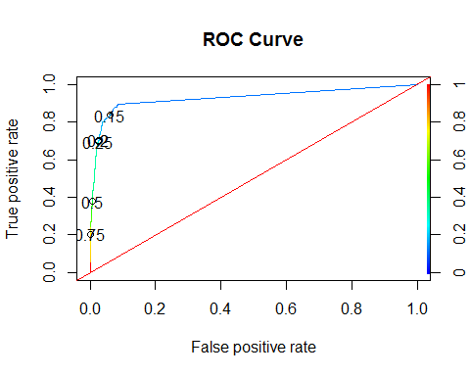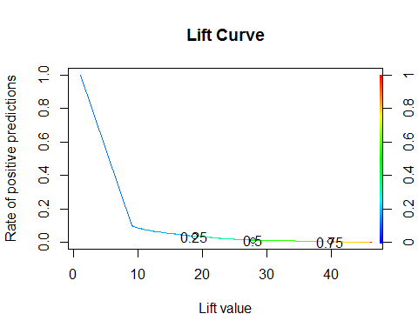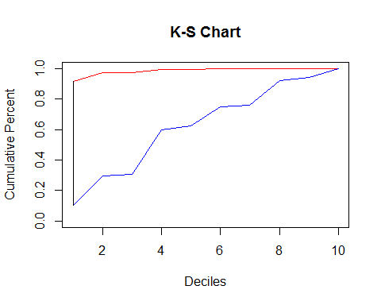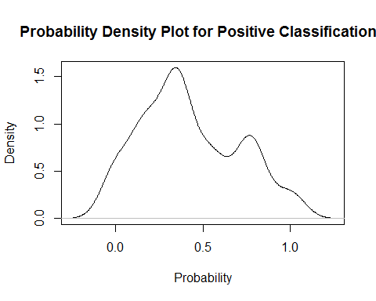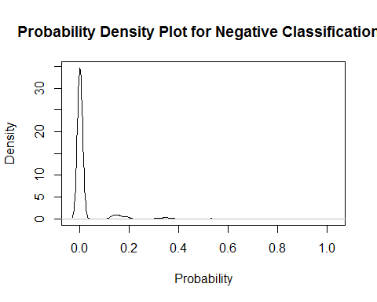

## $AUC  
## $AUC[[1]]  
## [1] 0.9279989  
##   
##   
## $`D Statistic`  
## [1] 0.4012423  
##   
## $`KS Statistic`  
## Group CumPct0 CumPct1 Dif  
## 1 1 0.9157088 0.1056911 0.8100178  
##   
## $`Confusion Matrix`  
## Confusion Matrix and Statistics  
##   
## Reference  
## Prediction 0 1  
## 0 13376 196  
## 1 112 134  
##   
## Accuracy : 0.9777   
## 95% CI : (0.9751, 0.9801)  
## No Information Rate : 0.9761   
## P-Value [Acc > NIR] : 0.1147   
##   
## Kappa : 0.4541   
## Mcnemar's Test P-Value : 2.252e-06   
##   
## Sensitivity : 0.9917   
## Specificity : 0.4061   
## Pos Pred Value : 0.9856   
## Neg Pred Value : 0.5447   
## Prevalence : 0.9761   
## Detection Rate : 0.9680   
## Detection Prevalence : 0.9822   
## Balanced Accuracy : 0.6989   
##   
## 'Positive' Class : 0   
##

## Call:  
## ada(HERFLAG ~ ., data = dfV3.train, iter = 10)  
##   
## Loss: exponential Method: discrete Iteration: 10   
##   
## Final Confusion Matrix for Data:  
## Final Prediction  
## True value 0 1  
## 0 27111 40  
## 1 270 214  
##   
## Train Error: 0.011   
##   
## Out-Of-Bag Error: 0.013 iteration= 10   
##   
## Additional Estimates of number of iterations:  
##   
## train.err1 train.kap1   
## 9 9

## Call:  
## ada(HERFLAG ~ ., data = dfV3.train, iter = 10)  
##   
## Loss: exponential Method: discrete Iteration: 10   
##   
## Training Results  
##   
## Accuracy: 0.989 Kappa: 0.575

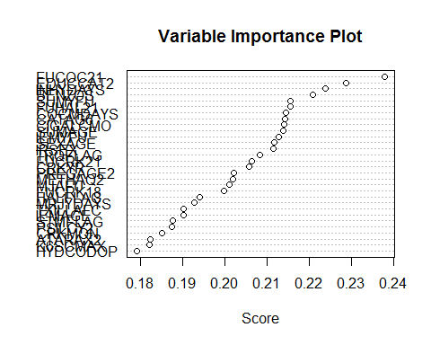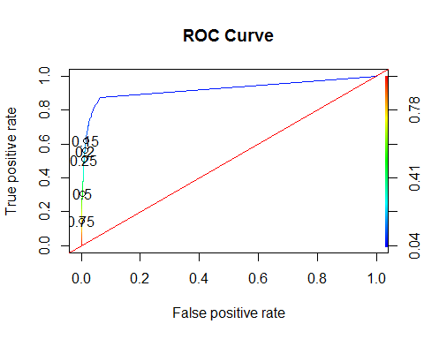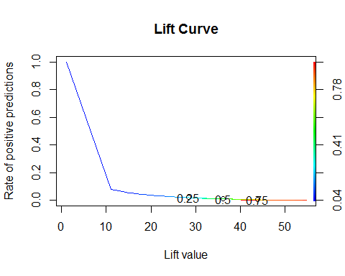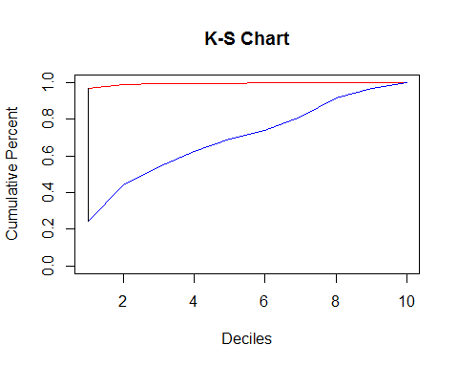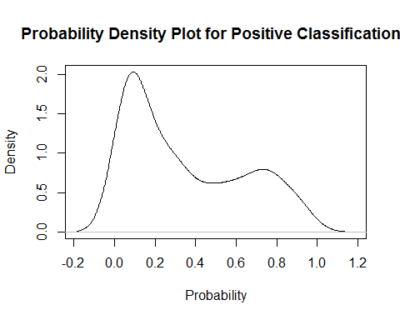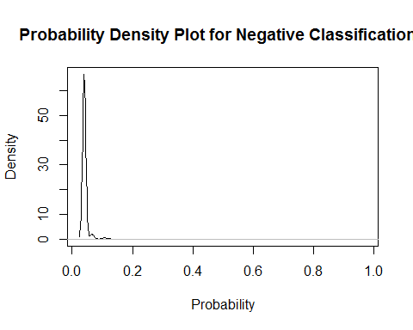

## $AUC  
## $AUC[[1]]  
## [1] 0.9222888  
##   
##   
## $`D Statistic`  
## [1] 0.3015609  
##   
## $`KS Statistic`  
## Group CumPct0 CumPct1 Dif  
## 1 1 0.9685039 0.2445415 0.7239625  
##   
## $`Confusion Matrix`  
## Confusion Matrix and Statistics  
##   
## Reference  
## Prediction 0 1  
## 0 26840 338  
## 1 195 263  
##   
## Accuracy : 0.9807   
## 95% CI : (0.979, 0.9823)  
## No Information Rate : 0.9783   
## P-Value [Acc > NIR] : 0.002323   
##   
## Kappa : 0.487   
## Mcnemar's Test P-Value : 7.714e-10   
##   
## Sensitivity : 0.9928   
## Specificity : 0.4376   
## Pos Pred Value : 0.9876   
## Neg Pred Value : 0.5742   
## Prevalence : 0.9783   
## Detection Rate : 0.9712   
## Detection Prevalence : 0.9834   
## Balanced Accuracy : 0.7152   
##   
## 'Positive' Class : 0   
##

##   
## Call:  
## glm(formula = HERFLAG ~ ., family = "binomial", data = dfImp.train)  
##   
## Deviance Residuals:   
## Min 1Q Median 3Q Max   
## -2.5556 -0.1057 0.0000 0.0000 3.5762   
##   
## Coefficients:  
## Estimate Std. Error z value  
## (Intercept) -22.28416 240.16493 -0.093  
## EDUCCAT2(2) Less than high school 1.08917 0.31559 3.451  
## EDUCCAT2(3) High school graduate 0.87361 0.30776 2.839  
## EDUCCAT2(4) Some college 0.84702 0.30946 2.737  
## EDUCCAT2(5) College graduate 0.53821 0.32856 1.638  
## SUMAGE(2) Under 18 16.27090 240.16486 0.068  
## SUMAGE(3) 18-25 15.92886 240.16489 0.066  
## SUMAGE(4) 26-34 16.13702 240.16553 0.067  
## SUMAGE(5) 35-49 -0.58362 1939.18815 0.000  
## SUMAGE(6) 50-64 -0.65557 4722.72596 0.000  
## SUMAGE(7) 65-99 -0.83575 8890.08872 0.000  
## FUCRK181 0.15749 0.17574 0.896  
## CIGALCMO(2) Past Mon Use of Cig & Alc 0.07555 0.16527 0.457  
## CIGALCMO(3) Past Mon Use of Cig & No Alc 0.74149 0.18497 4.009  
## CIGALCMO(4) Past Mon Use of Alc & No Cig -0.57586 0.18789 -3.065  
## COCMDAYS(2) 1-2 0.77717 0.28075 2.768  
## COCMDAYS(3) 3-5 0.94176 0.43504 2.165  
## COCMDAYS(4) 6-19 1.45229 0.49045 2.961  
## COCMDAYS(5) More than 19 2.94083 0.61460 4.785  
## INHYDAYS(2) 1-11 -0.03070 0.37651 -0.082  
## INHYDAYS(3) 12-49 0.09278 0.68619 0.135  
## INHYDAYS(4) 50-99 -19.63138 5043.89978 -0.004  
## INHYDAYS(5) More than 99 -0.20586 1.00735 -0.204  
## FUCOC211 1.07679 0.12869 8.367  
## CPNMTHFG1 0.97350 0.13078 7.444  
## TRQFLAG1 1.08195 0.40854 2.648  
## FUHAL211 0.93445 0.13634 6.854  
## BENZOS1 0.46050 0.40314 1.142  
## IRSEX1 0.44958 0.11052 4.068  
## Pr(>|z|)   
## (Intercept) 0.926073   
## EDUCCAT2(2) Less than high school 0.000558 ***  
## EDUCCAT2(3) High school graduate 0.004532 **   
## EDUCCAT2(4) Some college 0.006199 **   
## EDUCCAT2(5) College graduate 0.101403   
## SUMAGE(2) Under 18 0.945986   
## SUMAGE(3) 18-25 0.947119   
## SUMAGE(4) 26-34 0.946429   
## SUMAGE(5) 35-49 0.999760   
## SUMAGE(6) 50-64 0.999889   
## SUMAGE(7) 65-99 0.999925   
## FUCRK181 0.370165   
## CIGALCMO(2) Past Mon Use of Cig & Alc 0.647558   
## CIGALCMO(3) Past Mon Use of Cig & No Alc 6.10e-05 ***  
## CIGALCMO(4) Past Mon Use of Alc & No Cig 0.002177 **   
## COCMDAYS(2) 1-2 0.005636 **   
## COCMDAYS(3) 3-5 0.030404 *   
## COCMDAYS(4) 6-19 0.003065 **   
## COCMDAYS(5) More than 19 1.71e-06 ***  
## INHYDAYS(2) 1-11 0.935009   
## INHYDAYS(3) 12-49 0.892448   
## INHYDAYS(4) 50-99 0.996895   
## INHYDAYS(5) More than 99 0.838077   
## FUCOC211 < 2e-16 ***  
## CPNMTHFG1 9.80e-14 ***  
## TRQFLAG1 0.008089 **   
## FUHAL211 7.19e-12 ***  
## BENZOS1 0.253332   
## IRSEX1 4.74e-05 ***  
## ---  
## Signif. codes: 0 '***' 0.001 '**' 0.01 '*' 0.05 '.' 0.1 ' ' 1  
##   
## (Dispersion parameter for binomial family taken to be 1)  
##   
## Null deviance: 4874.8 on 27634 degrees of freedom  
## Residual deviance: 2698.0 on 27606 degrees of freedom  
## AIC: 2756  
##   
## Number of Fisher Scoring iterations: 20

## Odds factors for glm model are:

## (Intercept)   
## 2.099473e-10   
## EDUCCAT2(2) Less than high school   
## 2.971815e+00   
## EDUCCAT2(3) High school graduate   
## 2.395546e+00   
## EDUCCAT2(4) Some college   
## 2.332697e+00   
## EDUCCAT2(5) College graduate   
## 1.712936e+00   
## SUMAGE(2) Under 18   
## 1.165100e+07   
## SUMAGE(3) 18-25   
## 8.275936e+06   
## SUMAGE(4) 26-34   
## 1.019105e+07   
## SUMAGE(5) 35-49   
## 5.578749e-01   
## SUMAGE(6) 50-64   
## 5.191456e-01   
## SUMAGE(7) 65-99   
## 4.335498e-01   
## FUCRK181   
## 1.170573e+00   
## CIGALCMO(2) Past Mon Use of Cig & Alc   
## 1.078482e+00   
## CIGALCMO(3) Past Mon Use of Cig & No Alc   
## 2.099059e+00   
## CIGALCMO(4) Past Mon Use of Alc & No Cig   
## 5.622190e-01   
## COCMDAYS(2) 1-2   
## 2.175308e+00   
## COCMDAYS(3) 3-5   
## 2.564486e+00   
## COCMDAYS(4) 6-19   
## 4.272908e+00   
## COCMDAYS(5) More than 19   
## 1.893146e+01   
## INHYDAYS(2) 1-11   
## 9.697644e-01   
## INHYDAYS(3) 12-49   
## 1.097218e+00   
## INHYDAYS(4) 50-99   
## 2.979888e-09   
## INHYDAYS(5) More than 99   
## 8.139501e-01   
## FUCOC211   
## 2.935229e+00   
## CPNMTHFG1   
## 2.647191e+00   
## TRQFLAG1   
## 2.950439e+00   
## FUHAL211   
## 2.545800e+00   
## BENZOS1   
## 1.584871e+00   
## IRSEX1   
## 1.567660e+00

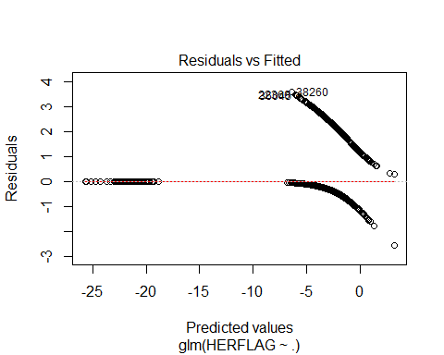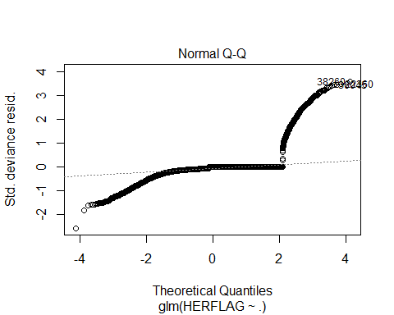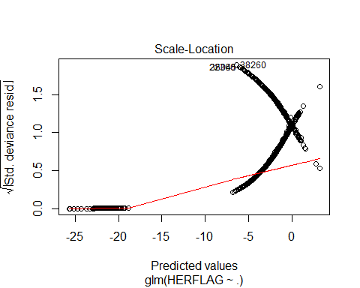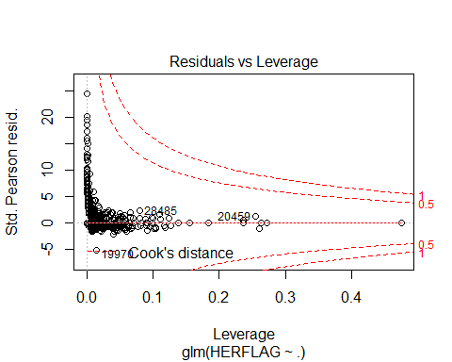

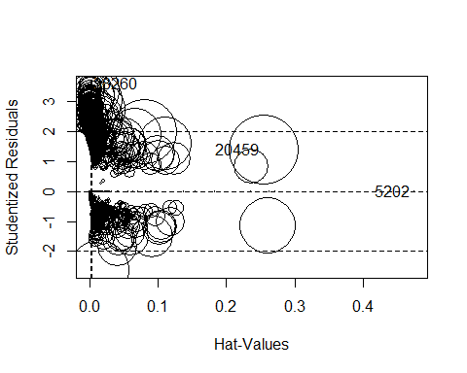

## StudRes Hat CookD  
## 20459 1.3848768575 2.546507e-01 1.81032e-02  
## 38260 3.5838977344 9.213292e-05 1.89899e-03  
## 5202 -0.0001412278 4.749065e-01 4.07866e-10

## GVIF Df GVIF^(1/(2*Df))  
## EDUCCAT2 1.191555 4 1.022149  
## SUMAGE 1.212210 6 1.016166  
## FUCRK18 1.388649 1 1.178409  
## CIGALCMO 1.187239 3 1.029018  
## COCMDAYS 1.168726 4 1.019680  
## INHYDAYS 1.113510 4 1.013530  
## FUCOC21 1.397727 1 1.182255  
## CPNMTHFG 1.461947 1 1.209110  
## TRQFLAG 13.234482 1 3.637923  
## FUHAL21 1.397185 1 1.182026  
## BENZOS 13.208718 1 3.634380  
## IRSEX 1.031408 1 1.015582

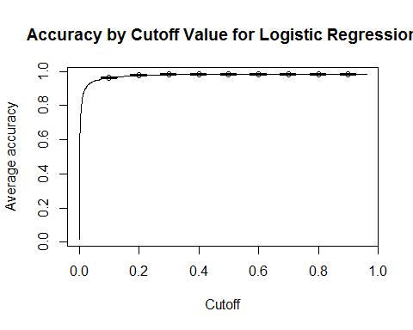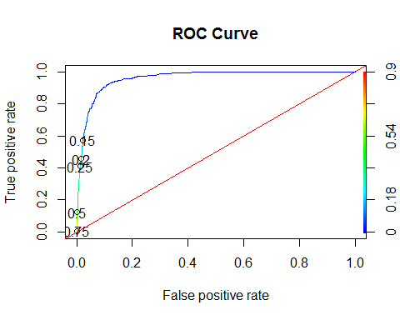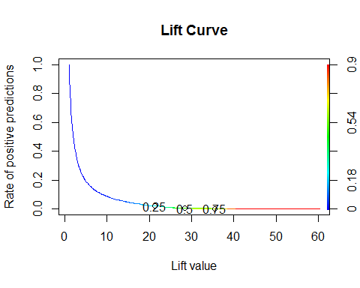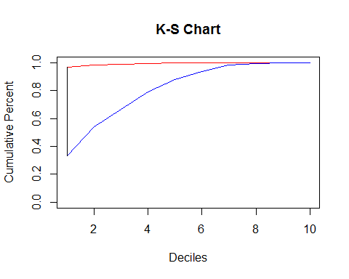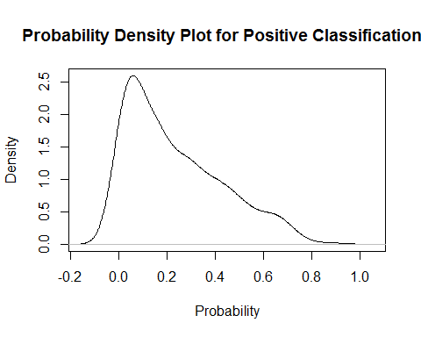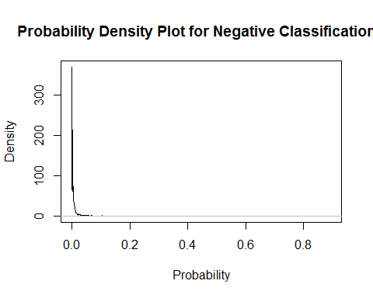

## $AUC  
## $AUC[[1]]  
## [1] 0.9604477  
##   
##   
## $`D Statistic`  
## [1] 0.2204424  
##   
## $`KS Statistic`  
## Group CumPct0 CumPct1 Dif  
## 1 1 0.966885 0.3340611 0.6328238  
##   
## $`Confusion Matrix`  
## Confusion Matrix and Statistics  
##   
## Reference  
## Prediction 0 1  
## 0 26538 640  
## 1 188 270  
##   
## Accuracy : 0.97   
## 95% CI : (0.968, 0.972)  
## No Information Rate : 0.9671   
## P-Value [Acc > NIR] : 0.002692   
##   
## Kappa : 0.3811   
## Mcnemar's Test P-Value : < 2.2e-16   
##   
## Sensitivity : 0.9930   
## Specificity : 0.2967   
## Pos Pred Value : 0.9765   
## Neg Pred Value : 0.5895   
## Prevalence : 0.9671   
## Detection Rate : 0.9603   
## Detection Prevalence : 0.9834   
## Balanced Accuracy : 0.6448   
##   
## 'Positive' Class : 0   
##