FraudLens
The triage brain for card-fraud analysts
Solution document
Maverick Mini Hackathon · Project 5: FraudLens (Fintech / Payments)
Repository: github.com/mjbharathgithub/Fraud-Lens
Live app: fraudlens-triage.streamlit.app
October 2026

On a day the model had never seen, 154 of its 200 alerts were real fraud. Reviewing the 200 largest transactions that day would have caught none.

1. Executive summary
A card issuer's fraud team can review 200 alerts a day out of roughly 140,000 transactions. The question they asked was which transactions their analysts should review first.
FraudLens answers it every day. It scores each transaction, gives the team the 200 riskiest with the reasons behind each score, recommends an action, drafts the review note, and waits for an analyst to approve. Nothing is executed without a person.
We tested it the way it would be used: trained on day 1, then asked for the day-2 queue with no knowledge of day 2. Of 200 alerts, 154 are real fraud (precision 77%, 95% range 66-85%). The queue catches 77% of the day's 201 frauds (95% range 71-82%) and 63% of the fraud value (EUR 16,428 of EUR 26,122).
How the 200 daily reviews are chosen | Real frauds caught on day 2
At random | 0.3
The 200 largest amounts | 0
Logistic regression baseline | 141
FraudLens (XGBoost champion) | 154 of 201

The work is delivered as a reproducible Python package, an analyst console (Streamlit), a scoring API, an executed analysis notebook, MLflow experiment tracking, 20 automated tests and this document. Everything is free and open source.

2. Problem statement
Client. A card issuer processing about 300,000 transactions in two days. Fraud is rare, but each miss costs money and customer trust, and each false alarm annoys a customer and uses analyst time.
The ask. "Build the triage brain: which transactions should our fraud analysts review first?" The review team can handle 200 alerts per day.
The decision being improved is how those 200 reviews are spent. The success measure is a business one: how many real frauds, and how much fraud value, the team catches with the capacity it already has. Model metrics matter only as far as they predict that.
Three things make the problem harder than it looks:
- Accuracy lies. Only 0.17% of transactions are fraud, so a system that answers "never fraud" is 99.83% accurate and catches nothing.
- The data sets traps. The file holds 1,081 exact duplicate rows, and the usual remedy for rare classes (oversampling) leaks test data into training if it is applied in the wrong place.
- Capacity is a hard limit. Day 1 holds 272 frauds, so even a perfect model could catch at most 74% of them with 200 reviews.

3. What the data told us
Before any model was trained we profiled the data, looking for what could mislead us and for what a triage model could use. The executed notebook is notebooks/01_eda.ipynb; each finding below changed the design.
Finding | Why it matters | What we did
492 frauds in 284,807 transactions | Accuracy near 99.8% for a model that catches nothing | PR-AUC and precision/recall at 200 alerts; accuracy never used
1,081 exact duplicate rows, 19 of them fraud | A random split puts 403 copies in both train and test | Duplicates removed before any split
Two days; Time is a running counter | Day-2 values of Time lie outside anything seen in training | Train on day 1, test on day 2; hour of day replaces raw Time
36% of frauds are EUR 1.00 or less (11% of genuine payments) | Reviewing the largest amounts finds no fraud at all | Log amount; a card-testing reason and advice on micro-amounts
Fraud rate at 2am is 1.45%, nine times the average | Time of day is real signal | Hour of day is a model input and a plain-language reason
A few anonymised features (V14, V4, V12, V10) separate the classes | They drive both the score and its explanation | Per-alert reasons from exact SHAP contributions

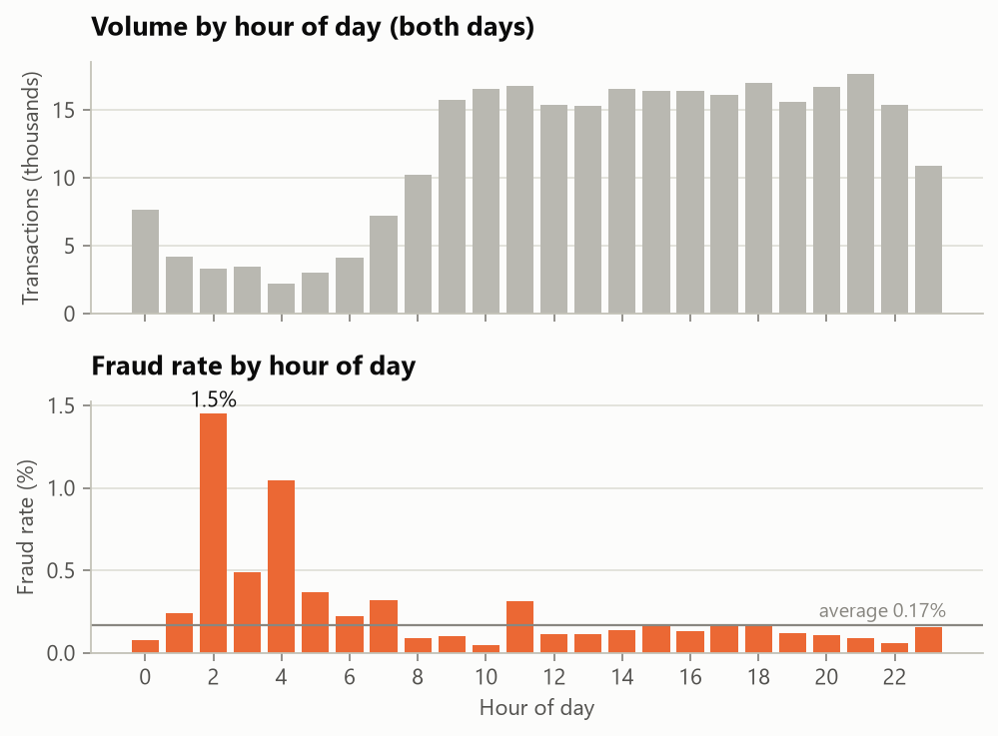
Figure 1. Fraud concentrates in the quiet overnight hours.
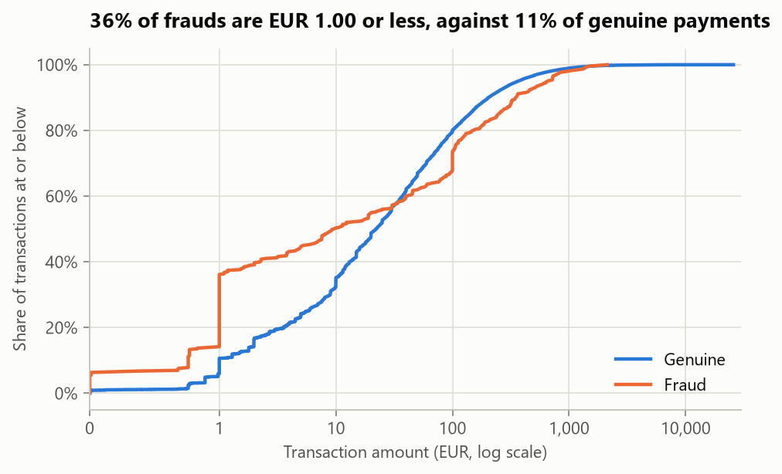
Figure 2. Fraud amounts skew small: a third are EUR 1.00 or less.

4. Solution overview
FraudLens turns a day of transactions into a ranked, explained, actionable queue in six steps.
- Score. A gradient-boosted model (XGBoost), trained on day 1 only, gives each transaction a fraud-risk score between 0 and 1.
- Rank to capacity. The 200 highest scores become the day's alert queue. The cutoff is the team's capacity, not an arbitrary probability.
- Explain. Each alert carries its top three reasons, computed as exact SHAP contributions and phrased against genuine behaviour, for example "V14 = -7.46: lower than 99.9% of genuine transactions".
- Recommend. A rule-based policy maps the risk band to an action: hold and call, step-up verification, or analyst review.
- Draft. A review-note agent writes the note for each alert, from a template or with a local open-source LLM whose output is checked against the evidence.
- Wait for a human. Every action is PENDING_APPROVAL. An analyst approves, rejects or escalates, and each decision goes to an audit log.
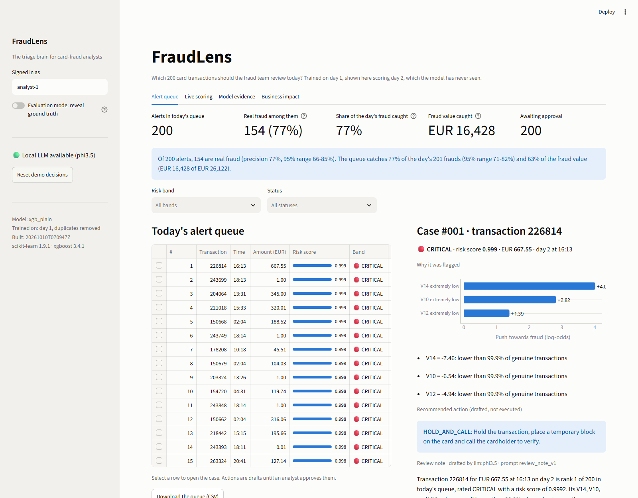
Figure 3. The analyst console: the day's queue on the left, the selected case on the right.

5. Architecture
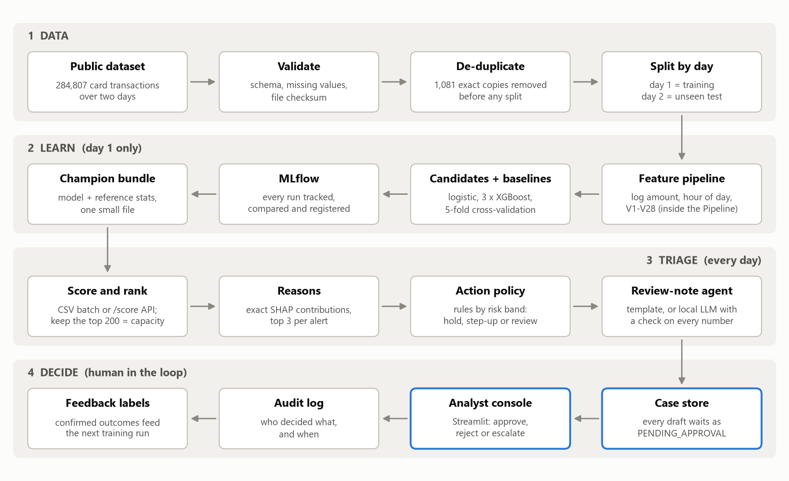
Figure 4. Four stages. The blue boxes are the human gate: nothing passes them without an approval.

Design decisions
- One pipeline object. Feature engineering, scaling, resampling and the model are steps of a single scikit-learn Pipeline, so nothing can be fitted on data it should not see.
- Capacity is a parameter. The queue is the top k scores with k = 200 in one configuration line. The capacity planner replays the day at any k.
- The agent proposes, a person disposes. Scoring, explaining and drafting are automated. Executing an action requires an approval, and the approval is logged.
- The LLM is optional and fenced. It only rephrases facts it is handed, code rejects any draft containing a number that is not in those facts, and a template takes over when no model is available.
- Artefacts are the interface. Training writes a 0.3 MB model bundle, a metrics file and the queue. The app and the API only read them, so they start in seconds, run offline, and cannot disagree with the reported numbers.

Scalability
The scoring service is stateless and loads the model once, so it scales horizontally. A million transactions a day needs no architectural change. For a shared deployment the SQLite case store would move to PostgreSQL behind the same functions, and the MLflow registry would gain an approval step before a model is promoted.

6. Model and evaluation

Evaluation design
- Selection: 5-fold stratified cross-validation on day 1 only. The rule, highest mean PR-AUC, was fixed before looking at day 2.
- Final test: the winner is refitted on all of day 1 and scores day 2 once. The top 200 scores are a literal daily queue.
- Uncertainty: 95% ranges from 1,000 bootstrap resamples of the test day, because one day holds only about 200 frauds.
- Comparability: the textbook random 75/25 split is also reported.

Results
Model | Imbalance handling | CV PR-AUC (day 1) | PR-AUC (day 2) | ROC-AUC (day 2) | Frauds in top 200
Logistic regression (baseline) | class_weight=balanced | 0.702 ± 0.055 | 0.735 | 0.942 | 141
XGBoost, plain (champion) | none (ranking only) | 0.877 ± 0.012 | 0.769 | 0.981 | 154
XGBoost, weighted | scale_pos_weight | 0.868 ± 0.018 | 0.792 | 0.979 | 156
XGBoost + SMOTE in fold | SMOTE inside training folds | 0.849 ± 0.030 | 0.774 | 0.965 | 153

The weighted model caught two more frauds on day 2. We kept the plain model because the rule was set in advance, and switching after seeing the test day would be choosing on the test set. The three XGBoost variants are within noise of each other; the step from logistic regression to boosting is the real gain.
ROC-AUC is between 0.94 and 0.98 for every model, which is why it is not our headline: it barely separates the baseline from the champion. On the random split the champion scores PR-AUC 0.831; the day-ahead replay (0.769) is the harder and more honest number.
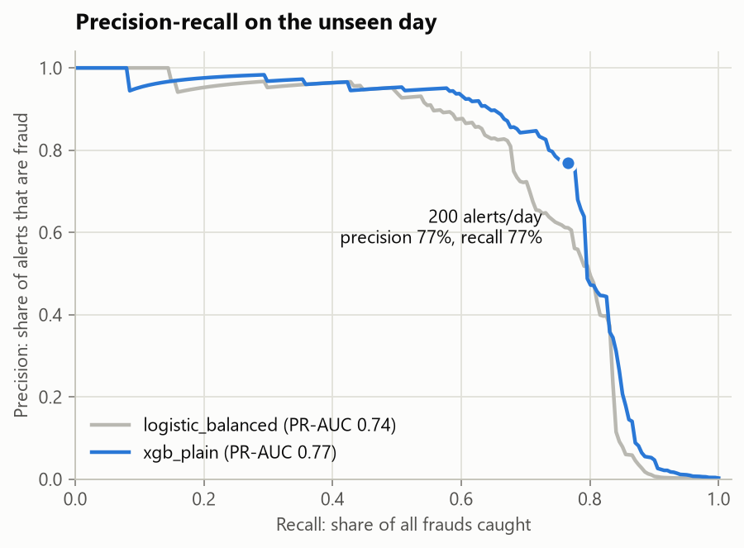
Figure 5. Precision-recall on the unseen day, with the 200-alert operating point.

The resampling trap, measured
We ran the common mistake once, on purpose. Oversampling the whole dataset with SMOTE and then splitting reports PR-AUC 0.9999. The same model with SMOTE applied to the training part only scores 0.760. The first number is fiction: synthetic copies of test frauds are in training, and half of that test set is synthetic. In FraudLens, SMOTE can only run inside the training fold of a pipeline.
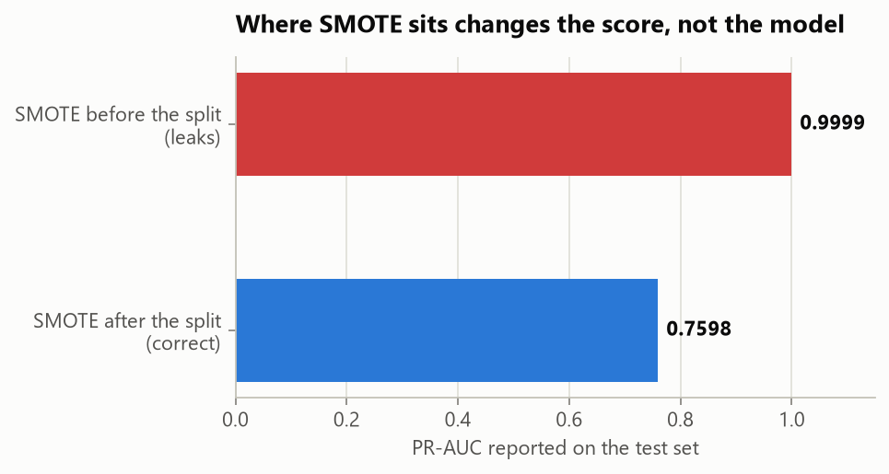
Figure 6. Same data, same model: only the position of SMOTE differs.

Risk bands
Bands decide how strong the drafted action is. They are policy thresholds for the fraud-operations lead, and we report how often each was right on the unseen day.
Band | Rule | Alerts on day 2 | Of which fraud | Drafted action
CRITICAL | score ≥ 0.99 | 62 | 97% | Hold the transaction, block the card temporarily, call the cardholder
HIGH | score ≥ 0.90 | 93 | 81% | Step-up verification; block if failed or unanswered in 30 minutes
ELEVATED | rest of the queue | 45 | 42% | Analyst review within 4 hours; no customer contact yet

7. The actionable output
The deliverable the client can use tomorrow is outputs/alert_queue_top200.csv: 200 ranked alerts, each with a risk score and band, three reasons, a recommended action, a one-line analyst note, a fuller review note and a status of PENDING_APPROVAL.

Precision and recall at the cutoff
Of 200 alerts, 154 are real fraud (precision 77%, 95% range 66-85%). The queue catches 77% of the day's 201 frauds (95% range 71-82%) and 63% of the fraud value (EUR 16,428 of EUR 26,122).

First five alerts
# | Transaction | Amount (EUR) | Score | Band | Strongest reason | Was it fraud?
1 | 226814 | 667.55 | 0.999 | CRITICAL | V14 = -7.46: lower than 99.9% of genuine transactions | yes
2 | 243699 | 1.00 | 0.999 | CRITICAL | V14 = -14.27: lower than 99.9% of genuine transactions | yes
3 | 204064 | 345.00 | 0.999 | CRITICAL | V14 = -5.39: lower than 99.9% of genuine transactions | yes
4 | 221018 | 320.01 | 0.999 | CRITICAL | V14 = -6.62: lower than 99.9% of genuine transactions | yes
5 | 150668 | 188.52 | 0.999 | CRITICAL | V14 = -14.22: lower than 99.9% of genuine transactions | yes

One-line analyst note format
#RANK | BAND SCORE | TXN id | EUR amount at Dd HH:MM | WHY reason; reason; reason | DO ACTION | STATUS
#002 | CRITICAL 0.999 | TXN 243699 | EUR 1.00 at D2 18:13 | WHY V14 extremely low; V10 very low; V4 extremely high | DO HOLD_AND_CALL | PENDING_APPROVAL

8. The review-note agent and generative AI
For each alert the agent gathers the evidence, chooses an action from a fixed policy table and drafts the note. It cannot execute anything.
Two drafters share the same evidence object. A deterministic template always works and is the default. An optional local LLM (phi3.5, run through Ollama on the analyst's machine so no transaction data leaves it) rewrites the same facts as a three-sentence narrative.

Guardrails
- The model receives only a structured evidence object, never raw data.
- The prompt is a versioned file with explicit rules (quote numbers exactly, never claim fraud is confirmed, three sentences) and one worked example.
- Code checks every draft: each number must appear in the evidence, the transaction id must be present, and overclaiming phrases cause rejection. A rejected draft is replaced by the template.
- All 25 drafts generated for the top of the queue passed the check. Drafts are cached, so rebuilding the queue does not regenerate them.

Example
LLM draft for alert #2 (accepted): Transaction 243699 for EUR 1.0 at 18:13 on day 2 is rank 2 of 200 in today's queue, rated CRITICAL with a risk score of 0.9991. Its V14 value of -14.27 is significantly lower than 99.9% of genuine transactions, V10 is also lower than 99.8%, but V4 is higher than 99.9%. Hold the transaction, block the card temporarily, and call the cardholder, initially comparing merchant, device, and location with the card's usual pattern.

9. Application walkthrough
The analyst console has four tabs. It runs offline on a laptop and on the free tier of Streamlit Community Cloud.
- Alert queue. The day's 200 alerts, filterable by band and status. Selecting one opens the case: reasons, action, drafted note, and approve, reject or escalate buttons. An evaluation switch reveals the true labels, which analysts never see.
- Live scoring. Pick any day-2 transaction, or upload a file, and it is scored and explained on the spot (about 50 ms), with its rank among the day's transactions. A what-if control changes the amount or time and shows the score move.
- Model evidence. Why accuracy is the wrong yardstick, the model comparison, the two curves side by side, the leakage exhibit and the band profile.
- Business impact. A capacity planner: replay the day at any staffing level, with adjustable cost assumptions.
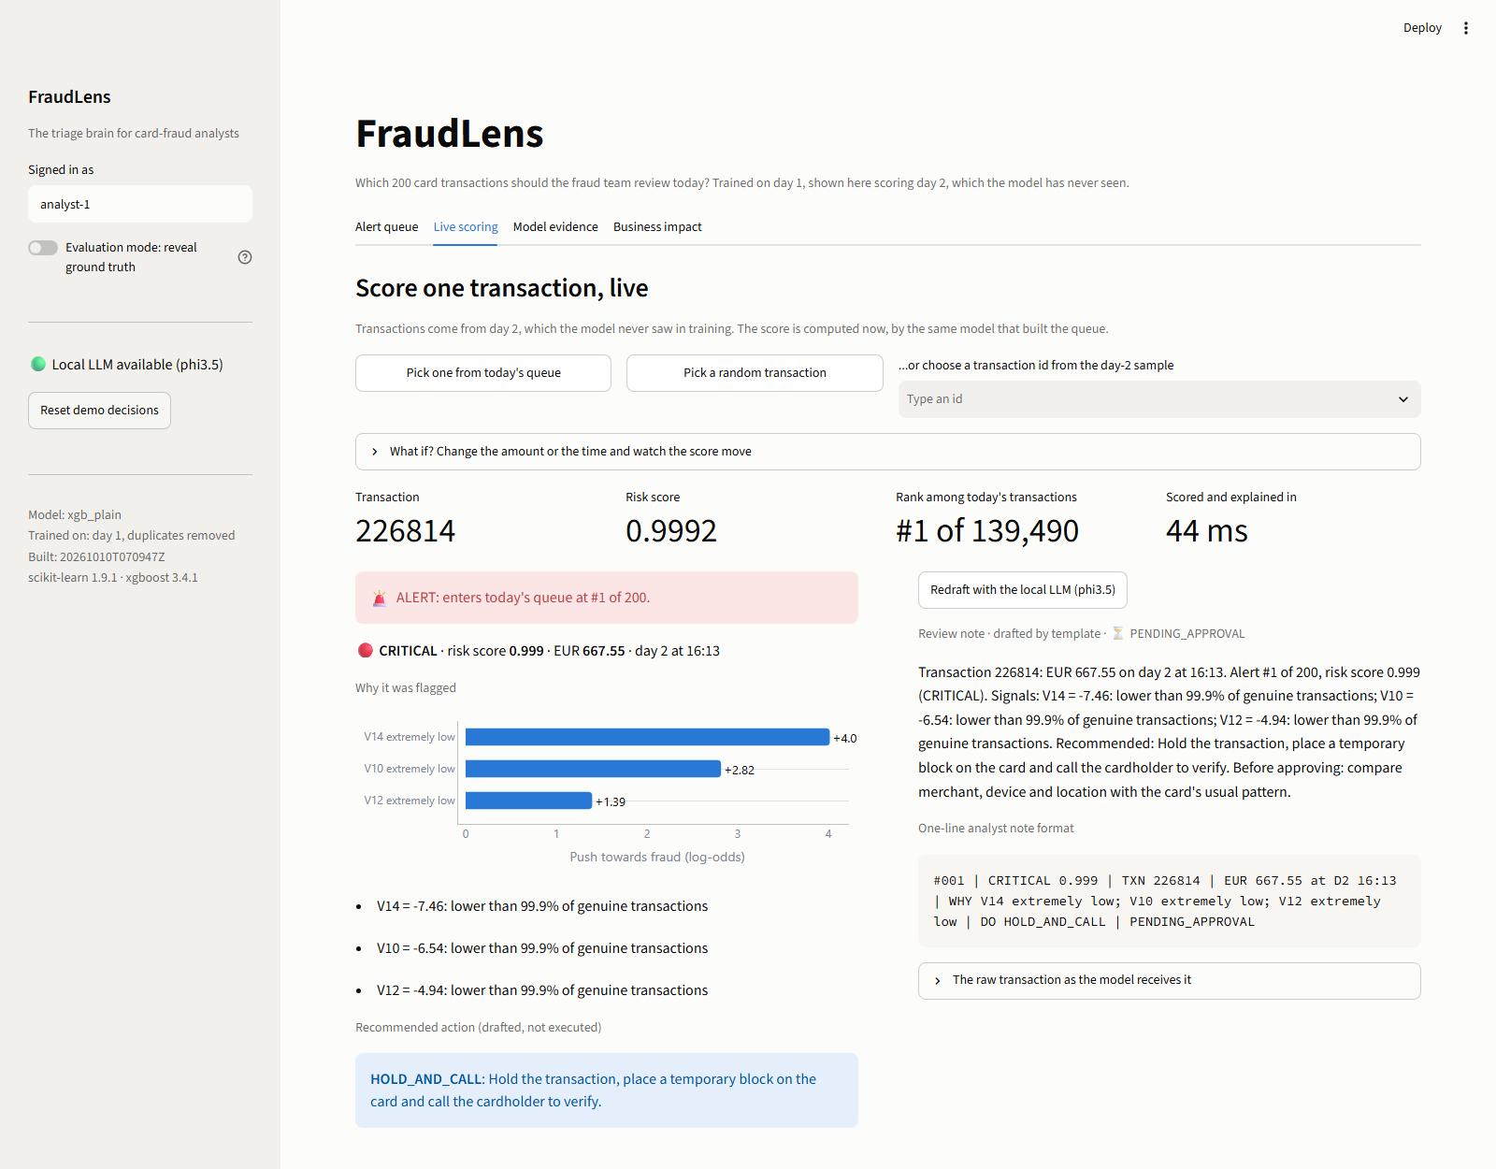
Figure 7. Live scoring: one transaction scored, ranked and explained.
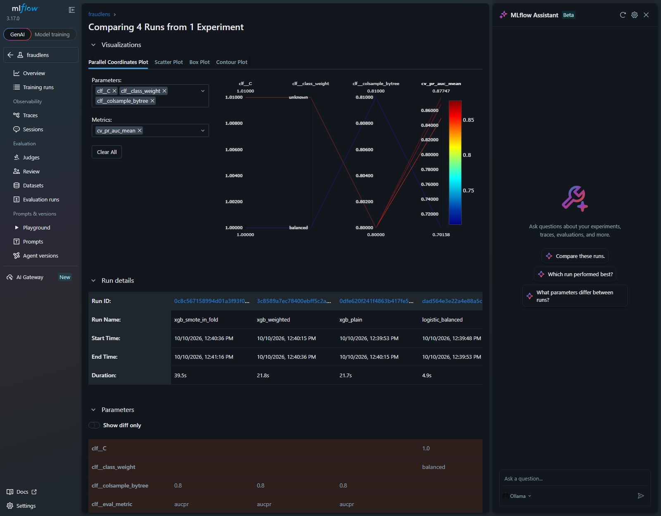
Figure 8. MLflow run comparison for the four candidates.

10. Technology stack
Everything is free and open source. There is no paid service, no API key and no secret in the repository.
Layer | Technology | Why
Data | pandas, NumPy, PyArrow | The dataset fits in memory on a laptop
Modelling | scikit-learn, XGBoost, imbalanced-learn | Pipelines that prevent leakage; SMOTE confined to training folds
Explanations | XGBoost built-in SHAP values | Exact contributions with no extra dependency
Experiment tracking | MLflow | Every run logged, compared, and the champion registered
Generative AI | Ollama with phi3.5 (local) | Note drafting with no data leaving the machine
Application | Streamlit, Plotly | Analyst console, live scoring, capacity planner
Integration | FastAPI | A /score endpoint for the payment flow
Case store | SQLite | Approval workflow and audit log
Quality | pytest (20 tests), ruff | Leakage guards, artefact consistency, agent guardrails

11. Business benefits
- The same team catches far more fraud. With no extra headcount, 200 reviews go from finding almost nothing to finding 154 real frauds on the test day, worth EUR 16,428 that day.
- Analyst time goes where it pays. About three in four alerts are real, and the band tells the analyst how much scrutiny an alert needs: 97% of CRITICAL alerts were fraud, against 42% of ELEVATED ones.
- Faster, more consistent decisions. Each alert arrives with its reasons, an action and a drafted note, so the analyst verifies and approves instead of starting from a blank page.
- Fewer good customers interrupted. Calls and card blocks are reserved for the alerts most likely to be fraud.
- A staffing answer, not only a score. On the test day, going from 200 to 300 reviews finds only 5 more frauds. The team is already near the knee of the curve, so the next gain comes from better signals, not more reviewers.
- Safe to adopt. Nothing executes without a human approval, every decision is logged, and every headline number carries a 95% range.
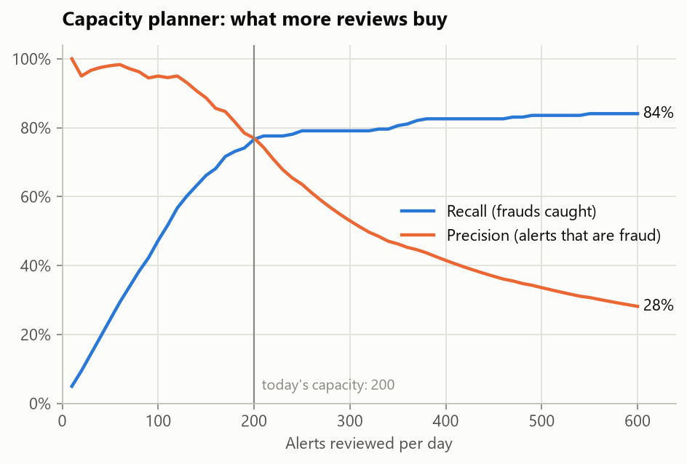
Figure 9. What more reviews buy on the test day.
One finding for the client's attention. Twenty of the 46 false alarms are near-identical EUR 0.77 transactions spread through the day. One pattern produces almost half of the wasted reviews. Ruling on it once, either by allow-listing it or by confirming it as unreported fraud, would free about 10% of the daily capacity.

12. Limits
- Two days of data from 2013. The results show the method works on an unseen day; they are not a forecast of production performance.
- The PCA behind V1-V28 was fitted by the data provider on the whole file, a mild upstream leak that cannot be undone from here.
- Hour of day assumes the dataset's clock starts near midnight, which the overnight dip in volume supports but does not prove.
- Cross-validated PR-AUC on day 1 (0.877) is higher than on day 2 (0.769). Fraud patterns shifted between the two days, which is the drift a client would meet on the first morning.
- The cost figures in the capacity planner are assumptions for the client to replace with their own.

13. Future enhancements
- Close the feedback loop. Analyst decisions are already stored as labels; retrain on them on a schedule and track precision by band.
- Monitor drift. Add input-drift checks and a weekly precision-at-200 report before trusting the model for long.
- Group look-alike alerts so an analyst rules once on a repeating pattern such as the EUR 0.77 cluster.
- Card-level features. With card identity, velocity features such as transactions per card per hour usually add the most signal.
- Rank by expected loss, combining risk with amount and remaining credit limit.
- Real-time path. Put the scoring endpoint behind the authorisation flow with a threshold recalibrated daily.
- Calibrated probabilities and a formal model review before any regulated use.

14. Setup, and how AI-assisted tools were used
Run the app: clone the repository, create a virtual environment, run pip install -r requirements.txt and then streamlit run streamlit_app.py. The trained model and a day-2 sample are in the repository, so no download is needed. Rebuild everything: pip install -r requirements-dev.txt, then python -m fraudlens all. Full instructions are in the README.
AI-assisted development. The solution was built with Claude Code inside VS Code: reading the requirements, profiling the data, proposing a plan that the team approved, writing the code and tests, and drafting the documents from measured results. Its output was checked rather than trusted. Reading results critically, inspecting every chart and running the test suite each caught real defects, which are listed in docs/AI_ASSISTED_DEVELOPMENT.md.

