Granting Students Extra Time Using the Canvas API

Michael Brydon (mjbrydon@sfu.ca)  
Created: 22 October 2020  
Last update: 22 October 2020

# Introduction

The problem this tool is meant to address is the difficulty in Canvas of accommodating students who need extra time for exams and quizzes. Adding these extensions manually in Canvas can be onerous, especially courses with weekly quizzes and multiple exams. This tool takes a spreadsheet list of students and time accommodations and applies them to all quiz/exam items within a Canvas course.

This tool is an extension of my “SetDates” tool for bulk updating open, close, and due dates for assignments and quizzes in Canvas. As such, I refer you to the opening sections of the user guide for that tool (SetDatesGuide.pdf) for background and setup instructions. We proceed here from the assumption that:

1. You have Pentaho Data Integration (PDI) installed
2. You have a valid Canvas authorization token.

# Overview of the Process

The tool writes new “quiz extension” entries to the Canvas API. To do this, it starts by reading a list of students and their time extensions from an Excel spreadsheet called “StudentExtensions.xlsx”. This is a simple spreadsheet file updated by the course instructor that contains basic student information plus an “AdditionalTime” value, such as 0.5 (meaning 50% additional time for exams and quizzes). The program also reads a list of all quiz-like objects (including exams) within the Canvas course container. It then adds a new extension record to Canvas for each student × quiz combination.

# Step 1: Update the StudentExtensions spreadsheet

Students with time-based accommodations for a course should be listed in the StudentExtentions.xlsx spreadsheet. The expected format is SFU student number, name (for confirmation when the program runs) and *additional* time expressed as a multiple of the standard time limit for the item. Thus, a multiplier of 0.5 (as below) grants the student time and a half (1.5x normal time). Each student in the list can have his or her own time extension value.

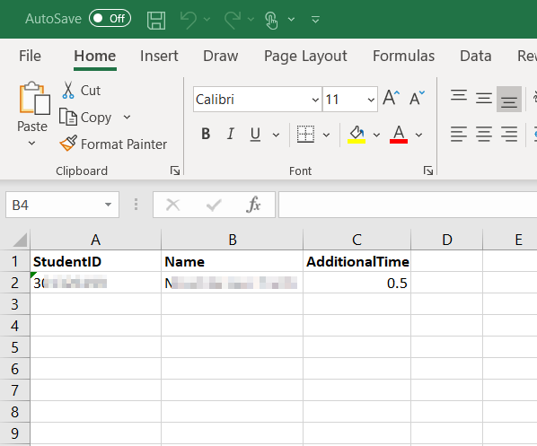

# Step 2: Run the Update

## Open the Download PDI Transformation

1. Download the “grantExtraTime.ktr” file from SFU Vault and save it somewhere (e.g., “Documents/CanvasTools/ grantExtraTime.ktr”
2. Open the file in PDI. You should see the following:  
   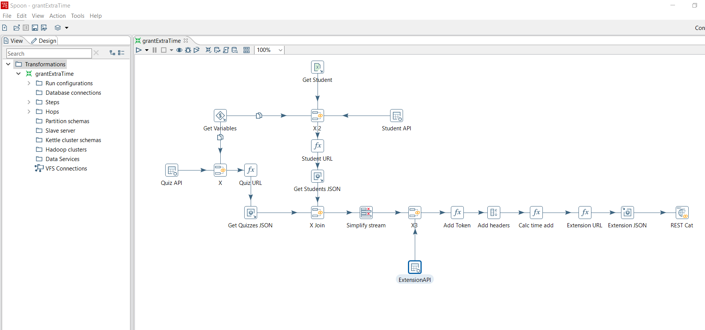

## Set the Parameters for Your Course

The grantExtraTime transformation does not know (a) anything about your course or (b) who you are (for authorization). So we need to pass it two parameters before running it:

1. Right click anywhere in the grantExtraTime transformation to bring up its properties (or Ctrl-T)
2. Click the Parameters tab, as shown below:  
   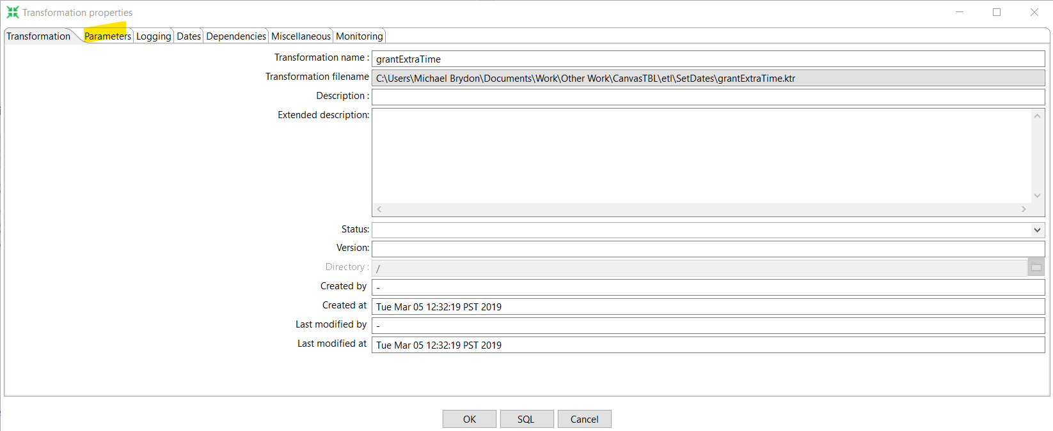
3. Set the parameter “pCourseID” to your course ID in Canvas. This can be found in your browser while your course container is open:  
   
4. Set the parameter “pToken” to your Canvas token from above, as shown below:  
   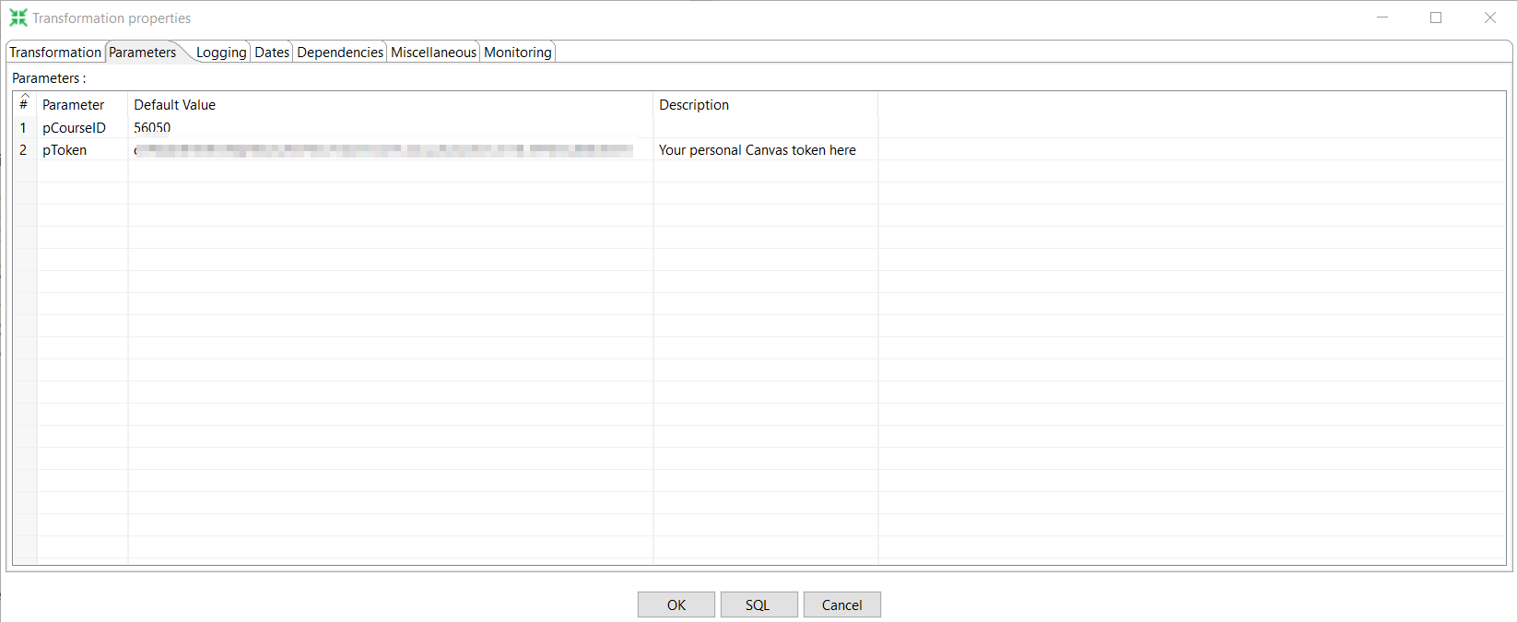
5. Save the transformation. You will only need to update the “pCourseID” parameter for other courses. If you are worried about security, you may want to remove your token from the saved file once the transformation has been run and you are happy with the results.

## Run the Transformation

We are now ready to run the transformation. Recall what this step does:

1. It accesses the Canvas course specified in the “pCourseID” parameter and logs in as you (using the token in the “pToken” parameter).
2. It gathers a list of quizzes/exams and applies an extension for every student in the list.

You run the transformation by pressing the play button at the top left:  
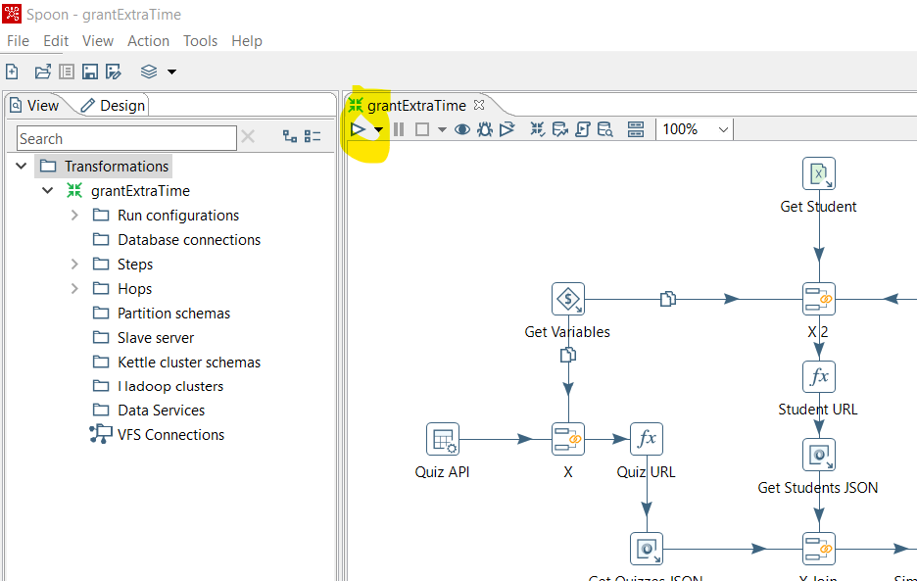

# Confirm Changes

You can now visit your Canvas page and confirm that the assignment and quiz dates have been written to your course.