Updating Canvas Assignment Dates using the Canvas API

Michael Brydon (mjbrydon@sfu.ca)  
Created: 29 April 2020  
Last update: 22 October 2020

# Introduction

The problem this tool is meant to address is the difficulty we encounter when making many changes to assignment and quiz dates in Canvas. Each change requires us to find the relevant assignment, switch to edit mode, enter the dates properly in each field, and save the result. Each click requires a round-trip to the Canvas server, which takes time and invites mistakes.

# Advantages

The key assumption behind this tool is that it is easier to edit dates in Excel than Canvas. Once in Excel, the date for each assignment/quiz can be uploaded through the Canvas Application Programming Interface (API). There are at least three advantages to this approach:

1. No manual round trips to the Canvas server. The dates are stored in a spreadsheet and written to the Canvas server in a batch.
2. Exploits Excel date functionality. Excel has several features and functions for working with dates, including:
   1. Autofill (copy dates into cells with a constant interval)
   2. Date/time functions such a DateAdd()
   3. Custom formatting (dates are stored in a uniform manner but can be displayed according to the users preferences)

# Prerequisites

There are many ways to access the Canvas API programmatically. Here, I use an open-source Extract, Transform, and Load (ETL) package called Pentaho Data Integration (PDI). PDI is essentially a visual programming language that allows one to specify data transformations. In this application, data is extracted from the Canvas API, written to a spreadsheet, the spreadsheet is then edited manually by the user, and then reloaded in Canvas. PDI has workflow tools that simplify each of these steps (e.g., reading from an API, writing to Excel, conforming dates).

An ETL tool like PDI is certainly overkill for this task. I considered writing it in Python instead. However, one important advantage of PDI is that it is visual and simple to understand. I assume that non-technical users do not have Python or PDI installed, so the added overhead of an install is not seen as a deciding factor.

Using the tool has three prerequisites:

1. Ensure an appropriate version of Java is installed in a known location
2. Download and unzip PDI
3. Get a personal OAuth token from Canvas so you can access the API (that is, login as you programmatically)

## Install Pentaho Data Integration

PDI is distributed as a collection of Java jar files. This has three implications:

1. In runs on any platform that runs Java (Windows, Mac, Linux, etc.)
2. An appropriate version of Java must be installed on the computer
3. The program is generally run with a batch file, which sets the necessary environment variables and calls the correct Java jar file.

### Install Java

Java is pre-installed on most computers. However, it might be worthwhile to install another version of Java known to work well with PDI. This practice is common in the Java world.

You can skip this step if you have a recent version of Java installed and you know where it is located on your computer

1. Download the correct installation binaries from AdoptOpenJDK: <https://adoptopenjdk.net/releases.html>. For most Windows users, this will be:
   1. x64 archecture
   2. JRE instead of JDK (development kit)
   3. .msi (install) file instead of .zip file
2. Install the package and remember its installation location

### Install PDI

1. Download PDI from: <https://sourceforge.net/projects/pentaho/files/Pentaho%208.3/client-tools/pdi-ce-8.3.0.0-371.zip/download>
2. Extract the zip file to a suitable location (e.g., <your home>/data-integration)
3. Edit the start-up batch file called “data-integration/set-pentaho-env.bat” to point to the correct Java (use the path from the “Install Java” step):
   1. Open the file in a text editor, such as Notepad
   2. Add the following two lines to the top of the file (before other commands):  
      set PENTAHO_JAVA_HOME=C:\Program Files\Java\jre1.8.0_171  
      set PENTAHO_JAVA=java.exe
4. Run “Spoon.bat” on Windows or “spoon.sh” on Mac. Spoon is the name of PDI’s visual front end.
5. You should now have Spoon running on your machine, as shown below:  
   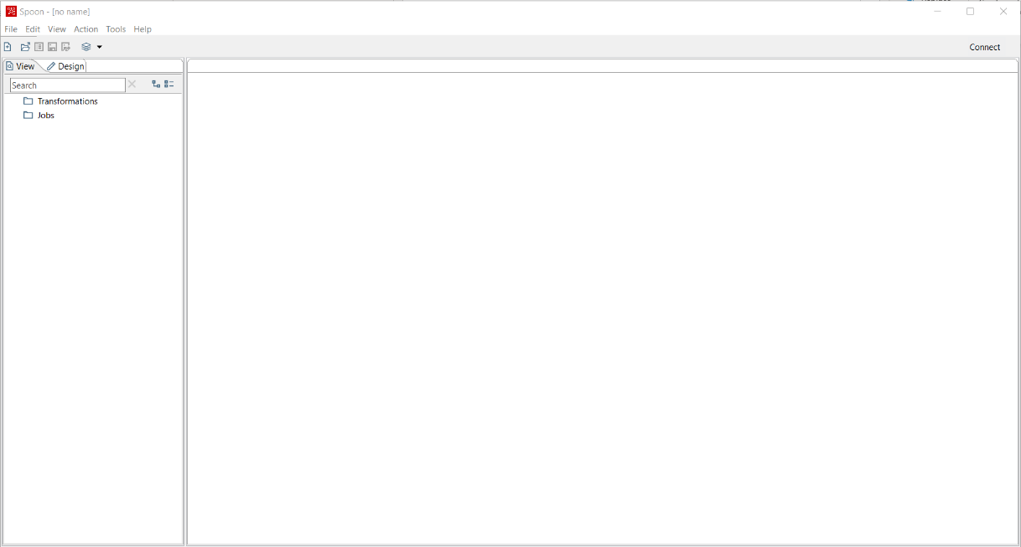

## Get an Authorization Token from Canvas

When you access Canvas through the API, you still need to *be someone*. Your personal identity controls what you can and cannot do, just as it does when you interact with Canvas in the normal way through the web interface. You should treat your personal token the same way you treat your SFU login credential—keep it private.

1. Login to Canvas in the normal way
2. Click on your face (second icon on the far left) and hit “Settings”, as shown below:  
     
   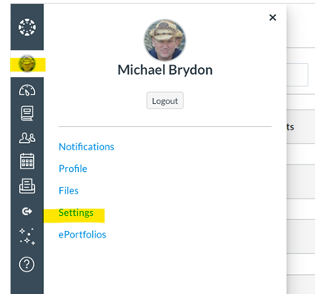
3. Find the button labeled “+New Access Token”
4. Enter a reason and leave the expiry date blank (unless you want the token to expire for some specific reason)
5. Save the token (a series of characters) somewhere memorable and safe.

# Step 1: Download Assignments from the Canvas Course

You now have what you need to use the date-setting tool: a running copy of PDI and your own personal Canvas authorization token. You are now ready for the first step of the process: download information about your existing assignments and quizzes.

This step assumes that all the assignments and quizzes for the course have been defined and placed in “assignment groups” as shown below. For example, I have an assignment group called “Exams” that contains three Canvas quizzes (“Final Exam: Part A”, and so on). The groups called “Group Assignments” and “Quizzes” are shown collapsed in this view:  
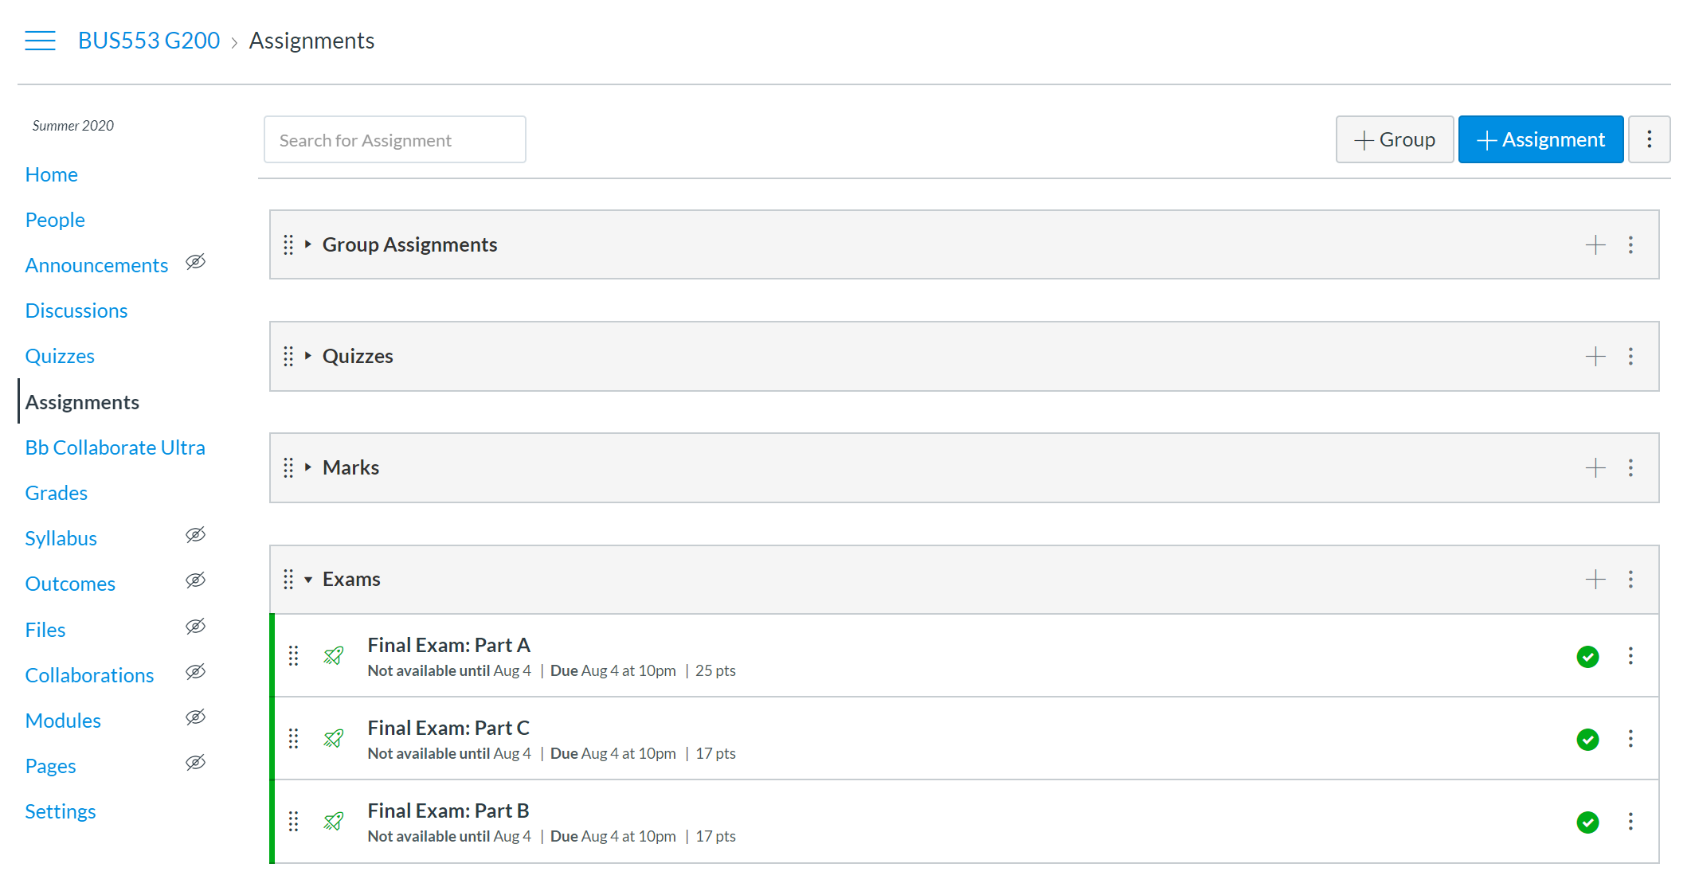

This step also assumes that you know your Canvas course ID, which can be found in the URL when your course is visible in Canvas:  


## Open the Download PDI Transformation

1. Download the “getDueDatesForCourse.ktr” file from Vault and save it somewhere (e.g., “Documents/CanvasSetDates/getDueDatesForCourse.ktr”
2. Open the file in PDI. You should see the following:  
   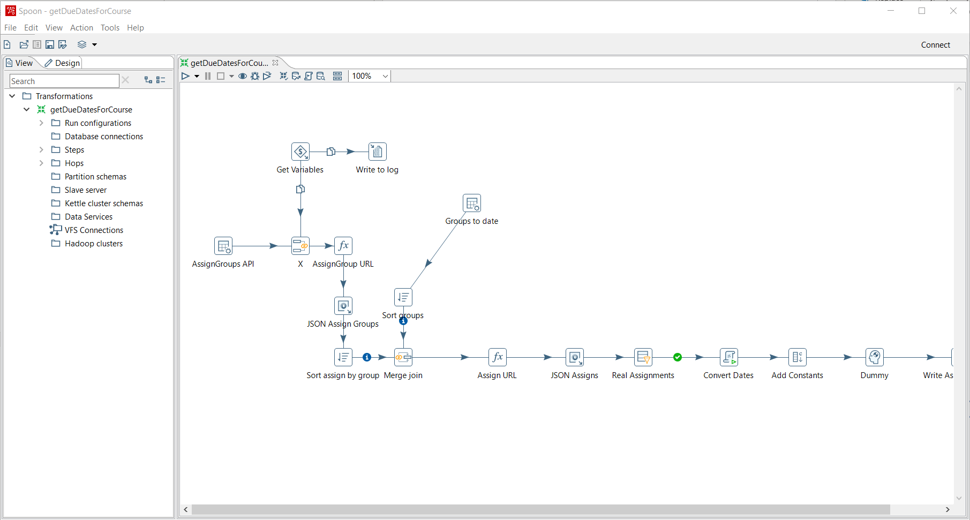

## Set the Parameters for Your Course

The getDueDatesForCourse transformation does not know (a) anything about your course or (b) who you are (for authorization). So we need to pass it two parameters before running it:

1. Right click anywhere in the getDueDatesForCourse transformation to bring up its properties (or Ctrl-T)
2. Click the Parameters tab, as shown below:  
   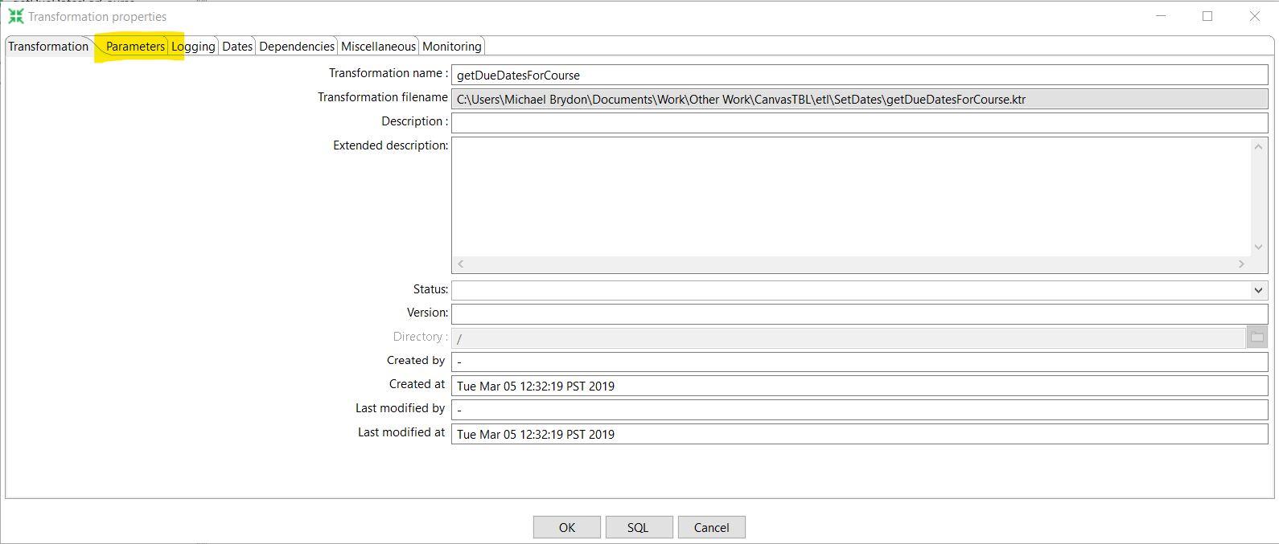
3. Set the parameter “pCourseID” to your course ID in Canvas
4. Set the parameter “pToken” to your Canvas token from above, as shown below:  
   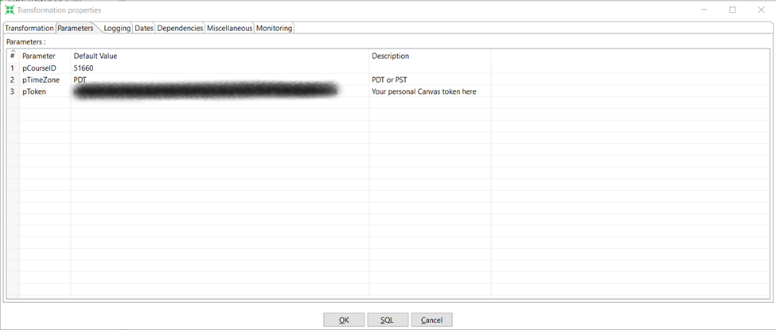
5. Set the time zone depending on whether daylight savings time is in effect (for Vancouver PST or PDT). All Canvas dates are stored internally in GMT, so this can matter.
6. Save the transformation. You will only need to update the “pCourseID” parameter for other courses. If you are worried about security, you may want to remove your token from the saved file once the transformation has been run and you are happy with the results.

## Include and Exclude Canvas Assignment Groups

You may want to manage some dates in your Canvas container manually. This step allows you to specify which Canvas assignment groups to include and exclude from this batch update process:

1. Find the step called “Groups to date”. Double-click to edit
2. Click on the “Data” tab, as shown below. My list consists of four assignment groups:  
     
   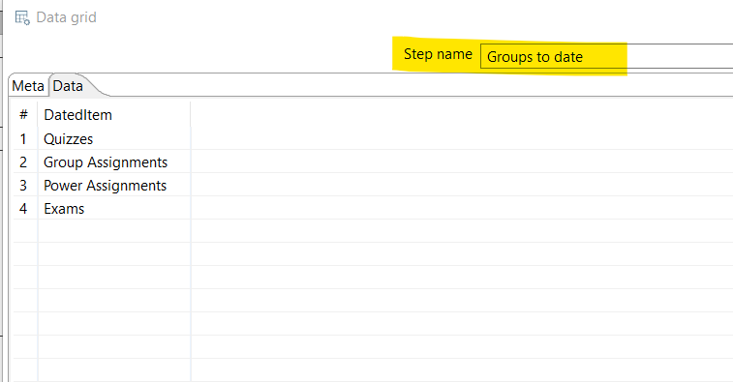

## Run the Transformation

We are now ready to run the transformation. Recall what this step does:

1. It accesses the Canvas course specified in the “pCourseID” parameter and logs in as you (using the token in the “pToken” parameter).
2. It downloads all the assignments in the specified assignment groups to an Excel spreadsheet located in the same directory as the transformation (e.g., “Documents/CanvasSetDates/AssignmentList.xlsx”).

If you want, you can change the target destination of the Excel spreadsheet to somewhere else by editing (double-click) the final step of the transformation (“Write Assign to Excel”):  
  
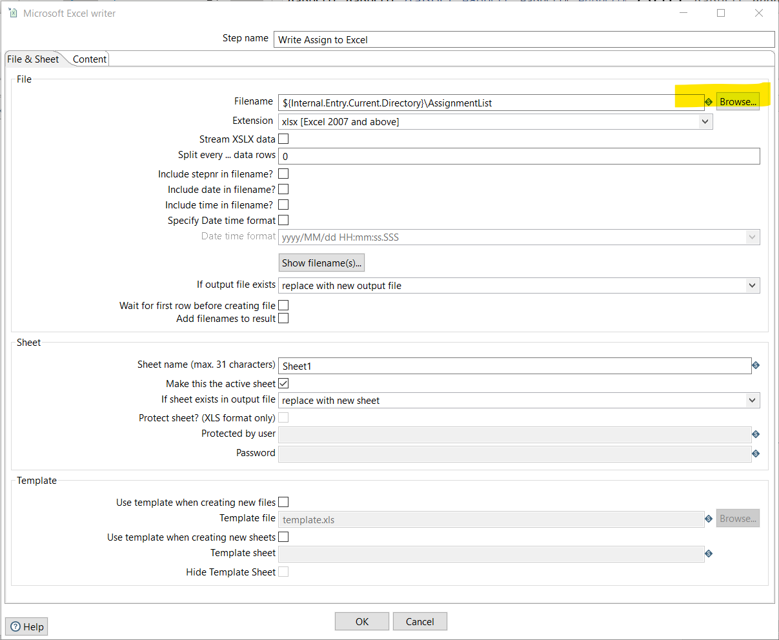

# Step 2: Update Your Assignment Dates in Excel

An assignment list in Excel is shown below. Since I copied my course over from another term, all the assignment and quizzes already have dates defined (although, even with some effort, they are all wrong for this term):  
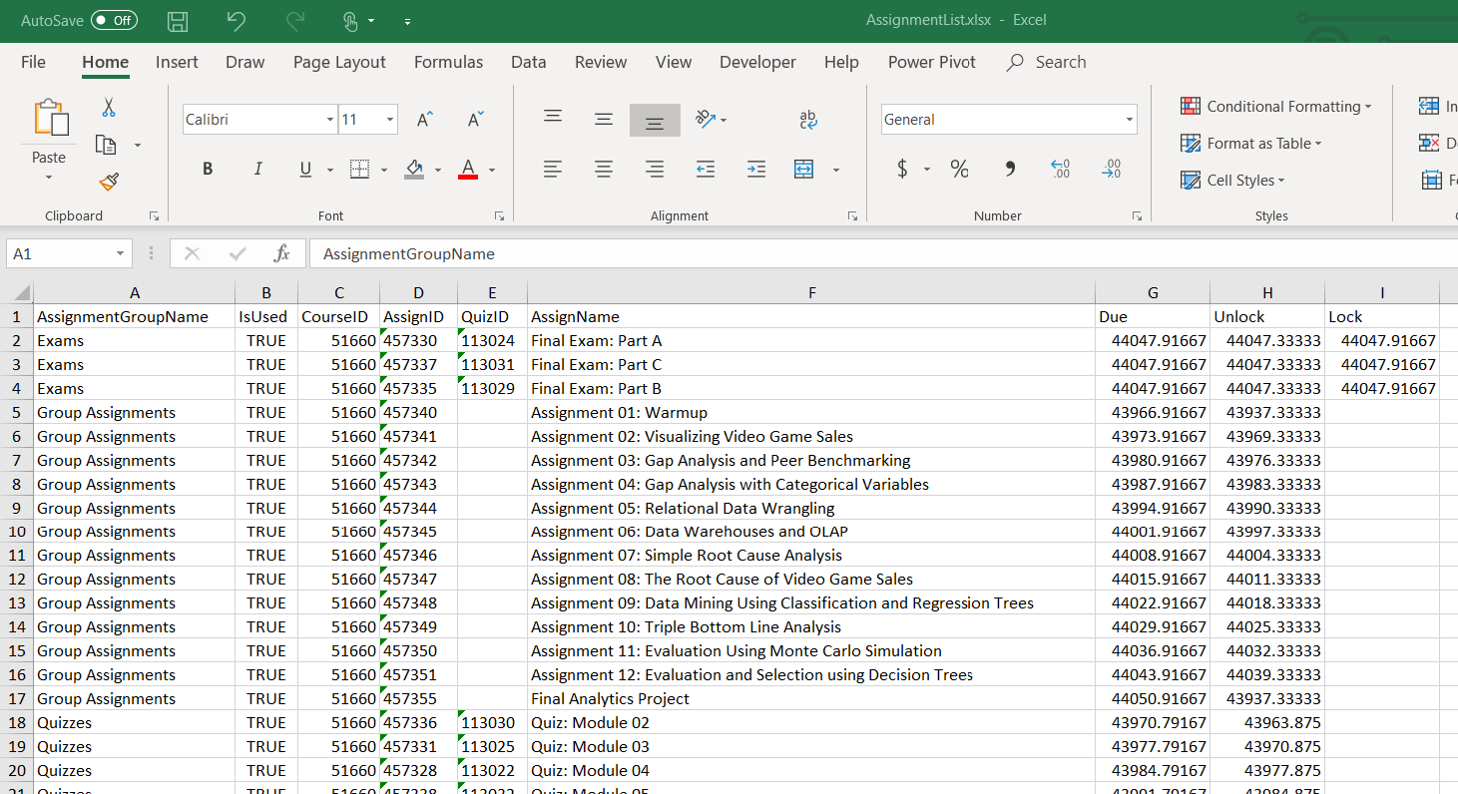

Some of the columns in the spreadsheet, such as “AssignmentGroupName” and “AssignName” are to help you navigate. The “IsUsed” column provides another layer of control over what is updated and what is not. If this value is set to FALSE, the Canvas assignment in the corresponding row is not updated in Step 3. The “CourseID”, “AssignID” and “QuizID” columns should not be changed because they are how the API refers to objects within Canvas. Finally, the three date columns are on the far right. By default, these are shown in raw date/time format.

1. Change the format of the date columns by highlighting them, right-clicking, and selecting an appropriate date/time format. I like long formats showing both date and time.
2. Use whatever technique you want to set the dates and times for due, unlock, and lock. If you leave any of these blank, they will not be updated (that is, they will remain blank in Canvas). For example:
   1. set due date in "Due" cell G2
   2. create a formula in Unlock as =(G2 - 7)
   3. create a formula in Lock as =(G2 + 7)
3. When you are happy with the dates (and have double-checked them), save the Excel file.

# Step 3: Write the Dates to Canvas

To write the dates in the Excel file back to Canvas, we use the other PDI transformation: “writeNewDueDatesForCourse.ktr”. As before, we must set up some parameters:

1. Open “writeNewDueDatesForCourse.ktr” in PDI. It will open in another tab (no need to close other file first).
2. Enter “pToken” and check the time zone as in Step 1. There is no need in Step 3 to enter the course ID because all the course and assignment information is stored in the Excel file.
3. (If you changed the location of the Excel file in Step 1 you must edit the “Get Due Dates” step to point to the correct file location.)
4. Run the transformation
5. To confirm, click on the dummy steps called “Assign Output” and “Quiz Output”, click the “Preview Data” tab at the bottom, and scroll over to the far right.  All the status codes should be 200.

# Confirm Changes

You can now visit your Canvas page and confirm that the assignment and quiz dates have been written to your course.