Document of Assignment: Histogram Equalization

This program uses the method of histogram equalization to recolor the give image, trying to make repair the defect due to underexposure.

Sometimes an image’s color range is really narrow, which makes it very difficult for human to recognize the details. However, for the computer itself, these colors still have a different value. So we can simply map one color to another, and emphasize the details hidden in the image. This algorithm uses the idea that pixels that has the same color will represent the same information both in the original image and the modified version. So this algorithm analysis the color of pixels and use the place of the pixel percentage in 0~255 to replace the place of that in the color of the original image.

The program is written in C++ and use OpenGL library. Firstly, the program scans the image and store the number of pixel of each color in an array color_cnt and calculate the pixel number in the image. Then it will scan the array to map an old color to a new color in a mapping array color_map with the follow equation: color_map[n]=sigma(i<n, color_cnt[i])/total_pixel*255. This operation will distribute the gray scale in this image to 0~255, prevent all pixel’s gray level being inside a narrow range, which may cause a bad visual effect. And at last, the program will draw on the screen the original image, the modified image, and their color histograms.

And here are these images.(the next page)

Origin vs. Modified

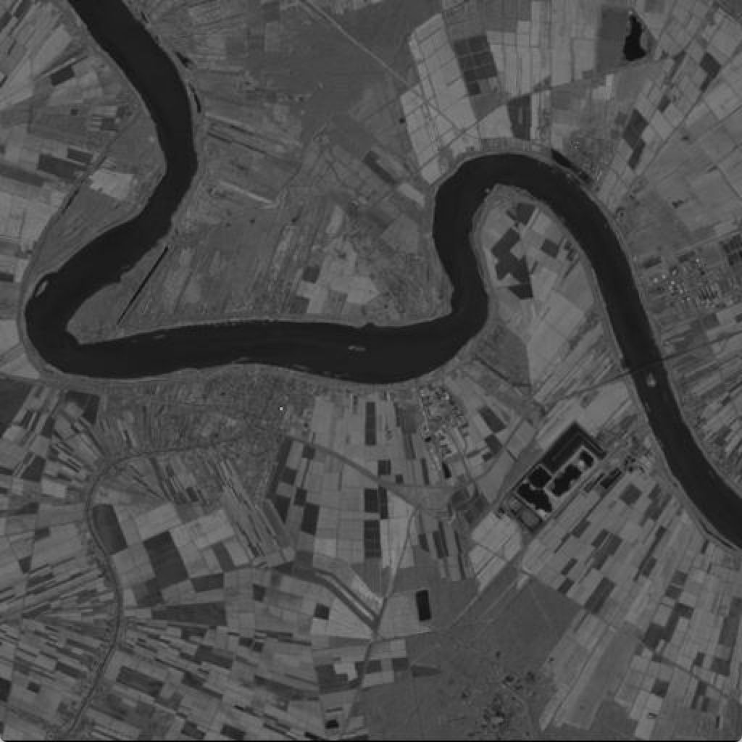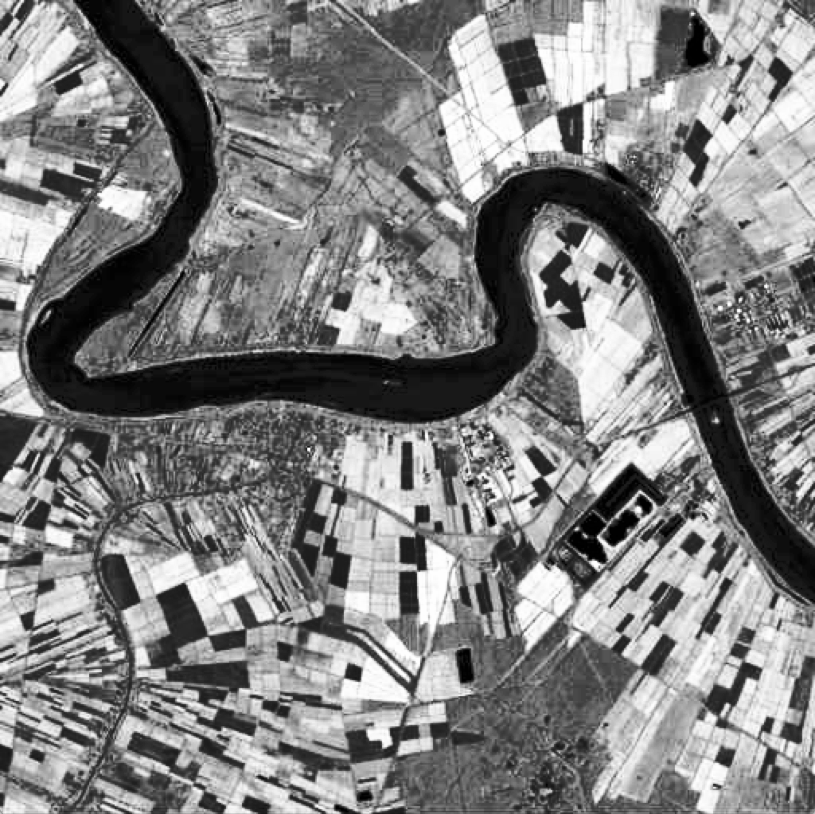

Histograms

