**Notes for the Tiny Sorter Lab**

**<https://experiments.withgoogle.com/tiny-sorter/view>**

**Sorter Cut-out**

This is a little finicky.

Follow the instructions, cut along the lines and fold. Use plenty of tape.

I have more template cards if needed.

**Arduino**

WebUSB library #include WebUSB.H

* Required for Arduino to be open to a browser (Chrome) connection.
* Check out: <https://github.com/webusb/arduino>
* WebUSB requires an Arduino model that gives the sketch complete control over the USB hardware. It does not work with the Arduino UNO but works with others such as the Leonardo. I built the solution using an Arduino MKR FOX 1200.

**Website**

Create a local copy of the Tiny Sorter tutorial website: <https://editor.p5js.org/gbose/full/2BN5HQYNK>

Use **Web_sorter.zip** from Blackboard instead of downloading their release. I had to make a couple of enhancements in sketch.js and serial.js.

Due to security restrictions with loading local resources through the browser, we have to run it on a web server. Easiest way I found is to run a local web server in Python from your project folder. See this link for explanation: <https://github.com/lmccart/itp-creative-js/wiki/SimpleHTTPServer>

A web server is required to load the local images and files through the browser. Start a CMD window. Change into the project folder and start the web server with:

**python -m http.server**

In a browser window go to <http://localhost:8000/>

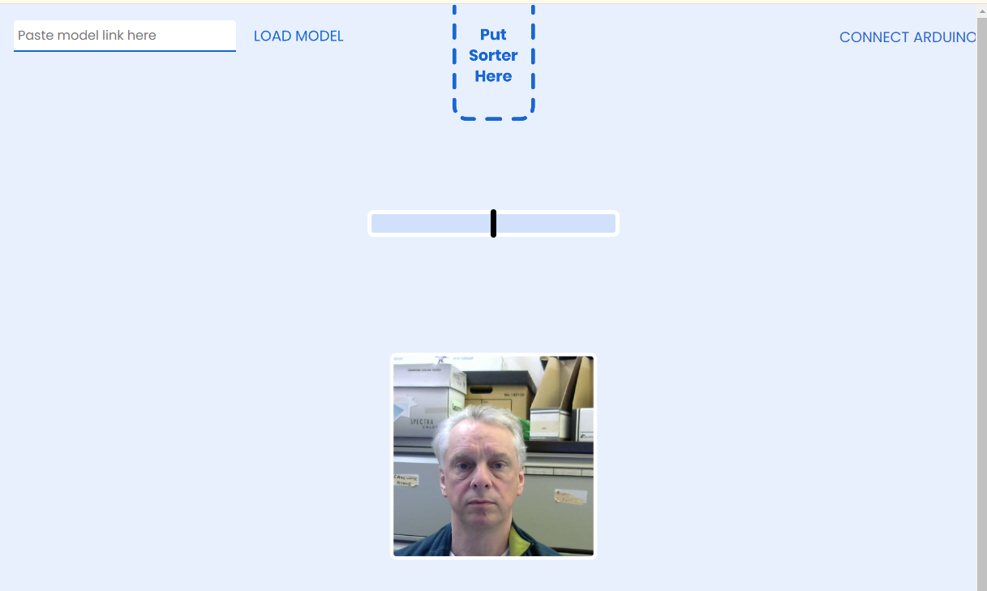

**Arduino**

Follow the instruction on connecting the Arduino.

Using a servo: <https://www.youtube.com/watch?v=SNE8axnq9gI>

Servo wiring:

Red -> 5V

Brown -> GND

Orange -> Digital Pin 9

You may some issues with the length of wires to run from the Arduino to reach the webcam. Improvise!

**Issues:**

I ran into an issue with the Arduino COM Port being grabbed by the Windows default USB driver as soon as the Arduino was plugged in. It needs to use the WinUSB driver (<https://en.wikipedia.org/wiki/WinUSB>). To override this use the following application <https://zadig.akeo.ie/>

Use it to force the **WinUSB** driver to be used instead for your particular port.

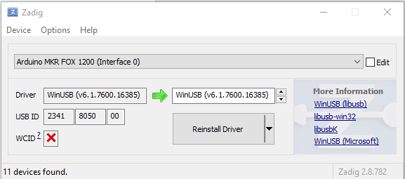

**Model Training**

This is a fairly straight forward online process once you have the sorter in place and working.

I got the tutorial to work successfully on Windows using both Chrome and Edge browsers.

<https://www.veed.io/view/810de6df-325d-4581-847a-3ecd4d47d6d9?panel=share>

Or see demo video on Blackboard.