Micro-Controller:

Bootloader installation and operation

Ver 1.0

2019/03/05

Author: Marshall Colville

Email: [mjc449@cornell.edu](mailto:mjc449@cornell.edu)

Copyright (c) 2019, Marshall Colville

All rights reserved.

This documentation, relevant source code and hardware designs are released under the FreeBSD

Redistribution and use in source and binary forms, with or without modification, are permitted provided that the following conditions are met:

1. Redistributions of product specifications, source code, and documentation must retain the above copyright notice, this list of conditions and the following disclaimer.

2. Redistributions in binary form must reproduce the above copyright notice, this list of conditions and the following disclaimer in the documentation and/or other materials provided with the distribution.

THIS PRODUCT IS PROVIDED BY THE COPYRIGHT HOLDERS AND CONTRIBUTORS "AS IS" AND ANY EXPRESS OR IMPLIED WARRANTIES, INCLUDING, BUT NOT LIMITED TO, THE IMPLIED WARRANTIES OF MERCHANTABILITY AND FITNESS FOR A PARTICULAR PURPOSE ARE DISCLAIMED. IN NO EVENT SHALL THE COPYRIGHT OWNER OR CONTRIBUTORS BE LIABLE FOR ANY DIRECT, INDIRECT, INCIDENTAL, SPECIAL, EXEMPLARY, OR CONSEQUENTIAL DAMAGES (INCLUDING, BUT NOT LIMITED TO, PROCUREMENT OF SUBSTITUTE GOODS OR SERVICES; LOSS OF USE, DATA, OR PROFITS; OR BUSINESS INTERRUPTION) HOWEVER CAUSED AND ON ANY THEORY OF LIABILITY, WHETHER IN CONTRACT, STRICT LIABILITY, OR TORT (INCLUDING NEGLIGENCE OR OTHERWISE) ARISING IN ANY WAY OUT OF THE USE OF THIS SOFTWARE, EVEN IF ADVISED OF THE POSSIBILITY OF SUCH DAMAGE.

The views and conclusions contained in the hardware, software, and documentation are those of the authors and should not be interpreted as representing official policies, either expressed or implied, of the Micro-Controller project, Paszek or Zipfel Labs or Cornell University.

Contents

Abbreviations 4

1. Introduction 5

2. Hardware 6

External connections 6

Software Installation 8

Summary 8

# Abbreviations

|  |  |
| --- | --- |
| Abbreviation | Name |
| I/O | Input/output |
| HID | Human interface device |
| ICSP | In-circuit serial programming |
| MLA | Microchip Libraries for Applications |
| PCB | Printed circuit board |
| UC | microcontroller |
| USB | Universal serial bus |
| ANx | Analog output x |
| DIx | Digital input x |
| DOx | Digital output x |
| GND | Ground / VDD |
| DCx | Bipolar analog output x |
| FNx | Function/waveform generator output x |

# Introduction

The Micro-Controller Project is an open-source solution for hardware control and synchronization of scientific instruments. The focus of the project is to provide a general-purpose platform for integrating multiple peripheral devices in custom optical microscopes, enabling rapid prototyping and development of new tools and techniques. The hardware portions of the project are designed to be flexible and generic to increase the range of applications and portability of the device.

The hardware, software, and firmware are released under the permissive FreeBSD License to encourage contributions from users and developers, expanding upon the expertise and applications of the project’s originators. The bootloader source code was derived from the Microchip® USB HID bootloader included in the MLA and is licensed under the Apache License, v2.0 (http://www.apache.org/licenses/LICENSE-2.0). Source code, design files, and documentation are hosted online at <https://github.com/mjc449/SAIMscannerV3.git>. For the latest documentation and source files please visit the project repository.

This manual covers the USB HID bootloader portions of the project. The bootloader is a small piece of code that resides below the application firmware. On a device reset the bootloader will either enter programming mode or direct execution to the application firmware. Typically, reprogramming the microcontroller is done via ICSP with a dedicated hardware programmer. Reprogramming via ICSP requires the user to open the controller enclosure, connect the programmer hardware and place the device in programming mode via a switch on the PCB. In programming mode, the bootloader can rewrite the flash memory segments reserved for application code. The updated firmware is received from the host system over the USB connection, providing a convenient update mechanism that eliminates the additional hardware and physical access to the PCB required for ICSP.

# Hardware

## External connections

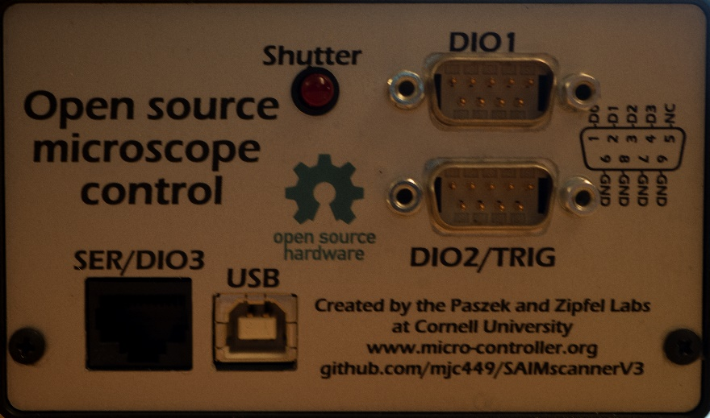

SER/DIO3 – Reconfigurable serial port (SPI, UART) or digital I/O. The function of the port is set in the application firmware and can be changed programmatically at runtime.

USB – USB full-speed type B connection to host

DIO1 – Digital I/O port 1. Reconfigurable at runtime as inputs or outputs

DIO2/TRIG - Digital I/O port 2. D2-D3 are reconfigurable as hardware interrupt sources in application firmware and can be changed programmatically at runtime to switch between interrupt and general purpose I/O.

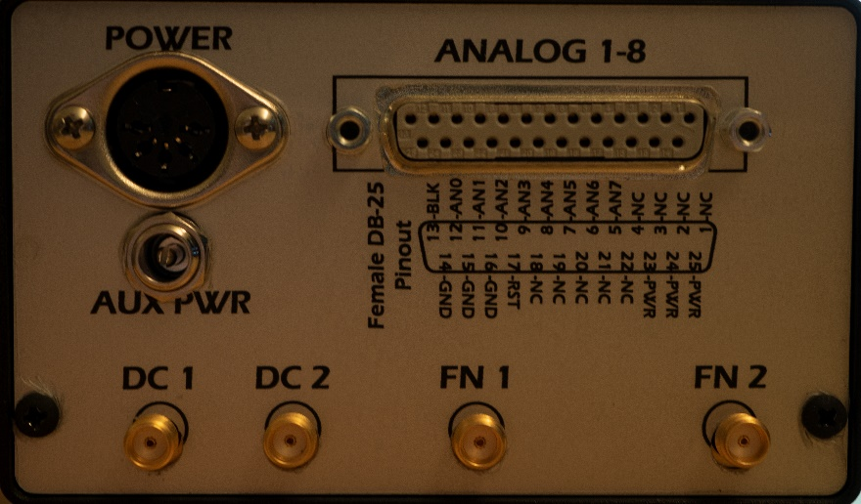

POWER – Five-pin 180° DIN power jack. Pinout going counter-clockwise from left: +5V, +12V, GND, -12V, GND

AUX PWR – Power supply pass-through to pins 23, 24, 25 on DB-25 connector.

ANALOG1-8 – 8 Channel analog output (0-10V) with 10V digital blank, ground and power.

DC1, DC2 – Bipolar analog outputs

FN1, FN2 – Function generator outputs

## Internal connections

# Software Installation

## Summary

To