CSCI-S89, Introduction to Deep Learning
Homework 1 (problems 1 & 2)
Mark Carlebach
June 26, 2020

Problem 1 (20 points)
Please load ‘Housing_Data.csv’ - the housing data in Singapore. This data set is also available at https://www.kaggle.com/chenzhiliang/housing-data. Using Keras, build a Neural Network with one hidden layer which has two neurons, predict the price based on ‘floorArea’ and ‘bedrooms’. Here, you can implement either batch or mini-batch gradient descent algorithm. Make sure to use appropriate loss and activation functions. Plot the train and test errors versus iteration step.

SOLUTION:

Attachments:
- carlebach_hw1_problem1.ipynb

Description of solution:

I read and clean the data, including dropping a few observations that have bad data or are outliers. I produce the following plot to show data prior to training.
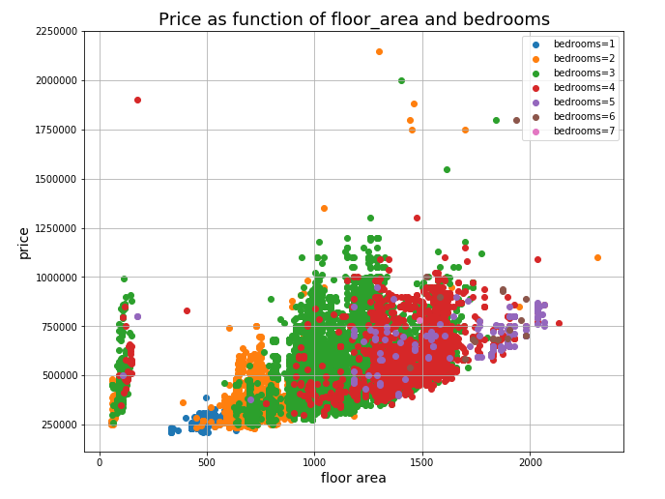
I then scale the features, build the model and fit the model as shown here.

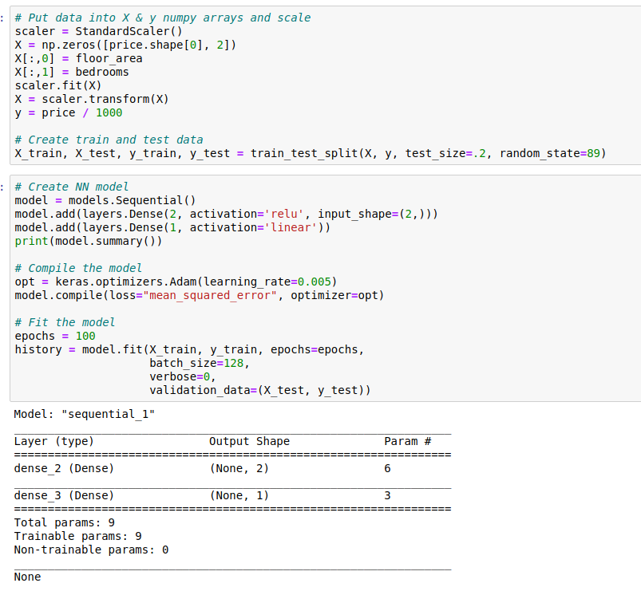
I plot the training and validation loss here.

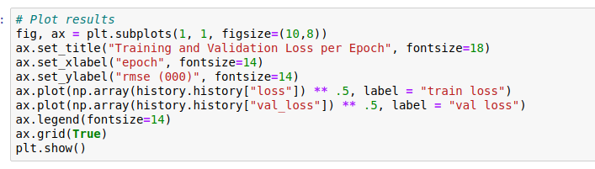

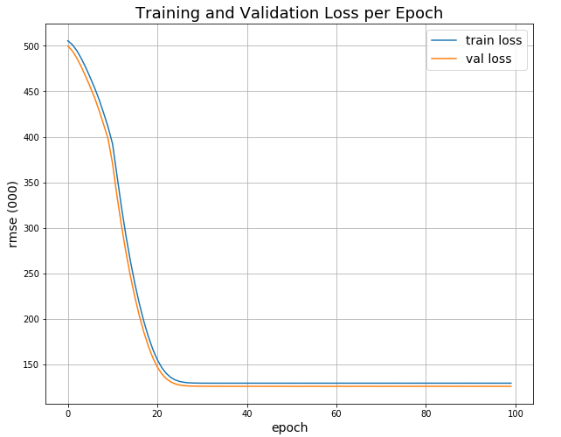
The model does not seem to do a great job based on the size of the RMSE compared to the mean of the price data.

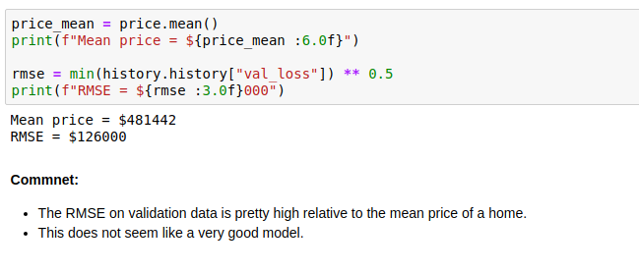
Problem 2 (45 points)
Construct the Neural Network you used in Problem 1 without the use of packages. Implement the Backpropagation “manually” and plot the test and train errors.

SOLUTION:

Attachments:
- carlebach_hw2_problem1.ipynb
- myTorch.py (should be in same directory as notebook so it is importable)

Description of solution:

NOTE: Almost identical solution as to Problem 1, except I import SequentialModel from myTorch.py rather than from Keras. I explain classes in myTorch.py below.

I read and clean the data, including dropping a few observations that have bad data or are outliers. I produce the following plot to show data prior to training.

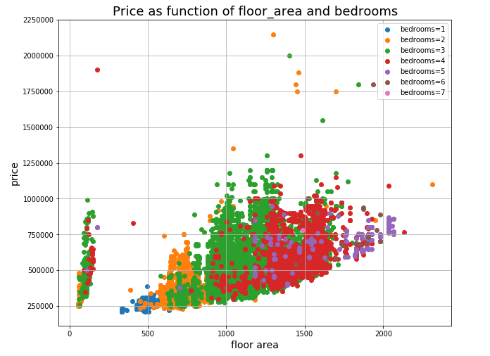
I then scale the features, build the model and fit the model as shown here.

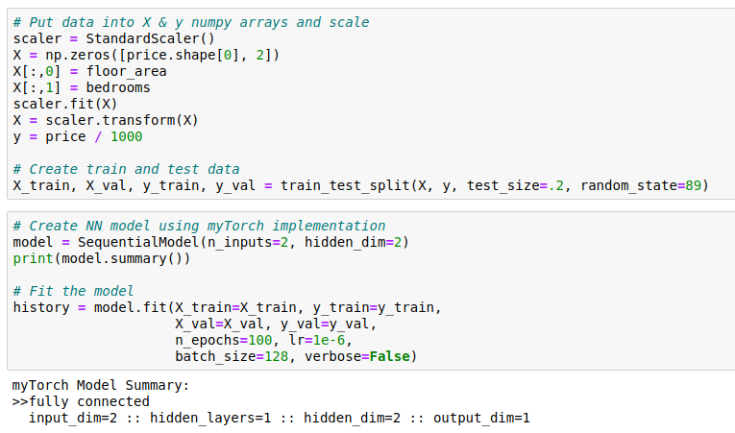

The main difference between my solution to Problem 2 and Problem 1 is this line:

model = SequentialModel(n_inputs-2, hidden_dim=2)

SequentialModel is imported from myTorch.py and performs forward and back propagation calculations. myTorch.py is a module with 3 classes that are meant to mimic the API of Keras for a very limited neural network. Here is a description of those classes with their attributes and methods:

class Node:

"""
Basic computational building block of neural network

Each node contains the following:
- node_id: unique id
- inputs: list of values passed in the forward direction
- weights_in: list of weights for each incoming connection (including bias)
- z: sum of (inputs * weights_in)
- u: act(z)
- weights_out: list of weights for each outgoing connection
- fprime: for relu, 1 if z > 0 else 0
- error: partial L wrt u
- partials: partials L wrt each weight_in

Methods:
- forward(): calculates z & u based on inputs and weights
- backward(): calculates fprime for node and error for node with fprime and error from node to right
"""

class FC_Layer:

"""
Layer is list of nodes. This is a fully connected layer so each node has weight from each node in preceding layer.

Each layer contains the following:
- layer_id: unique id
- nodes: list of nnodes nodes (initialized with random weights) where each node as weight from bias and each node of prior input layer (e.g., fully connected)

Methods:
- forward(): calculates z & u for all nodes in layer, based on inputs and weights
- backward(): calculates fprime and error for all nodes in layer
"""

class SequentialModel:

"""
A list of fully connected layers
- The first layer has n_inputs nodes
- There is only 1 single hidden layer (limitation of this implementation) with hidden_dim nodes
- The last layer has 1 output node (limitation of this implementation)
"""

If you want to see the code that implements these classes and their methods, you can look in myTorch.py. I am not sure it helps to cut and paste more from that file into this document.

After fitting the model (as with Problem 1), I plot the training and validation loss. The results are very similar to when I did the fitting in Keras.

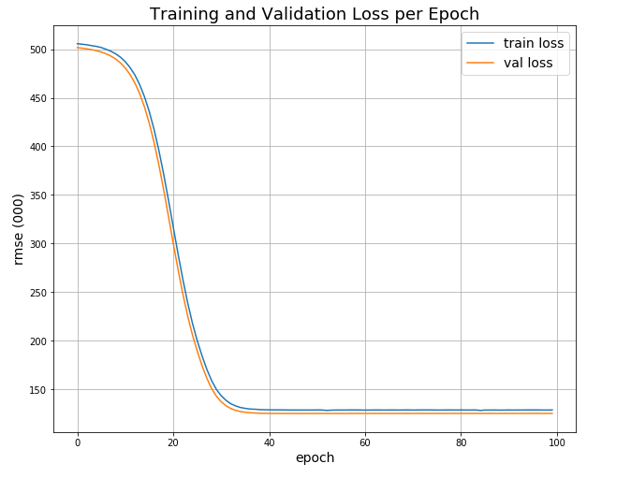
As in Problem 1, the model does not seem to do a great job based on the size of the RMSE compared to the mean of the price data.

