**Michael Cattell**

**EDTHP 518 Policy Analysis Paper**

**April 10, 2024**

Introduction

John Krill stood in a Harrisburg courtroom and posed a question to Matthew Splain: *“What use would someone on the McDonald’s career track have for Algebra 1?”* The lawyer for the Pennsylvania Senate President Pro Tempore’s line of question to the superintendent of Otto-Eldred School District was in opposition of increasing school funding in the midst of a landmark school funding lawsuit challenging the way Pennsylvania allocated school funds. Krill argued that “…[Pennsylvania] has many needs”, so why should Pennsylvania fund schools in a way that would divert would-be retail employees making minimum wage towards a possibly more lucrative engineering job?

Ultimately, however, John Krill and other lawyers for Pennsylvania Republicans would be unsuccessful, and Commonwealth Court Judge Renee Cohn Jubilerer would rule that Pennsylvania’s method of allocating school funds is not in line with the commonwealth’s own constitutional mandate to provide a “…thorough and efficient system of public schooling…”. The ruling would require the commonwealth to increase school funding and remedy disparities that have been perpetuated in the past.

Pennsylvania’s governor, Josh Shapiro, proposed a budget in February of 2024 that purports to be “historic”. A statement released by Shapiro’s office claims that his budget includes a $1,100,000,000 increase in the Basic Education Funding allocation, $900,000,000 of which goes towards a “first-year adequacy investment”; the remaining is allocated via a formula previously passed by the Pennsylvania General Assembly.

How are schools funded in Pennsylvania?

A significant portion of Pennsylvania’s allocation to its public schools comes from the Basic Education Funding (BEF) formula outlined in Act 35 of 2016. This formula weights students and their communities based on the following characteristics:

1. What the student’s poverty status is,
2. Whether a student is limited in their English proficiency,
3. Whether a student is attending a charter school in the district,
4. How rural or urban the school district as a whole is,
5. The wealth of the community,
6. The capacity of the school district to raise revenue through local sources like property taxes.

One of the most notable aspects of this formula, however, is the inclusion of a “hold-harmless” provision. This means that schools cannot receive less money than they received the year before, with the funding allocation from a year before the formula’s enactment being the baseline.

School funding as a problem

School funding is not an issue confined to Pennsylvania, but rather something that has permeated in the U.S. education system for decades. Despite research showing benefits to increased school funding, states like Pennsylvania tend to give schools too few resources to accomplish too many goals, forcing schools to rely on local revenue that is typically raised primarily through property taxes. Pennsylvania, for example, recently had its school funding system found unconstitutional by a state court, leading to proposals to increase funding and change how schools are funded in the commonwealth.

Why does funding matter?

Whether school funding matters for students has been a question percolating within education for several decades. Modern discussion of school finance can be traced back to the *Equality of Educational Opportunity* report, colloquially known as the *Coleman Report* (Hutt, 2017; Kantor & Lowe, 2017; Downey & Condron, 2016). The *Coleman Report* was commissioned by the U.S. Congress and stated that schools have a smaller influence on student outcomes and achievement gaps along racial and class lines as out-of-school environments (Downey & Condron, 2016).

Since then, a wealth of research has come out that has, over time, found that schools do play a role in students’ life outcomes and that increasing school funding can improve those outcomes. Specifically, better school funding can improve student performance (Lafortune et al., 2018), postsecondary degree attainment (Hyman, 2017), lower the chance a student ends up in poverty (Jackson et al., 2015), and increase their future income post-graduation (Jackson et al., 2015). Additionally, increasing student exposure to high quality teachers can improve their post-graduation outcomes (Chetty et al., 2014), which can be achieved in part through increasing teacher salary by increasing school funding.

Getting court mandates to reform school funding

The U.S. Supreme Court’s landmark ruling in *San Antonio v. Rodriguez* (1973) dealt two blows to education advocates: under the U.S. Constitution, wealth is not a protected class and education is not a fundamental right protected by the Constitution (Library of Congress, n.d.). This effectively removed federal courts from being able to remedy school funding disparities. School funding advocates were then forced to move to state courts that were more friendly to school funding lawsuits, due in large part to many states have a public education clause in their constitution (Murry et al., 1998). State courts largely coalesced around states needing to allocate “adequate” funds so that students would be able to meet standards set by the state (Murry et al., 1998; Candelaria & Shores, 2019). Following court mandates, poorer schools generally received more money while wealthier schools’ allocation remained largely unchanged (Murry et al., 1998). Schools subsequently saw improvements in graduation rates and spending per student (Candelaria & Shores, 2019).

Pennsylvania’s and its “McDonald’s Career Track” students

In the last 20 years, Pennsylvania has seen various changes in the way its schools are funded. Steinberg & Quinn (2015) found that despite increased state education spending from 2001 to 2011, disparities in school funding persisted. These disparities tended to be between smaller and larger districts, with smaller districts benefitting from increased state spending more than their larger counterparts. Significant cuts to state education funding occurred in 2011, however, with only about 1/3 of the school funding goal being met by the state (Kelly & Maselli, 2023).

Three years later, in 2014, six school districts brought a lawsuit against Pennsylvania, alleging that the state had not fulfilled its obligation under the commonwealth’s constitution to appropriately fund its schools (Hanna et al., 2021). During this the course of the trial, lawyers for Republican leaders in the General Assembly, such as John Krill, argued that the state had met its obligation, as the state needed students to be on the “McDonald’s career track” in order to fulfill the needs of the commonwealth.

Two years after the lawsuit had been filed, the General Assembly had passed Act 35 of 2016, which established the aforementioned BEF formula and its hold-harmless provision. The key problem with this provision is that the baseline was set prior to the enactment of the formula. Kelly (2021) found that this provision disproportionately harmed 149 of the 500 Pennsylvania school districts; 77% of Black students and 82% of Latinx students in Pennsylvania attend school within these districts, meaning that the vast majority of Black and Latinx students in Pennsylvania are harmed by this policy.

A little over one year after the trial began in 2021, Pennsylvania’s school funding system was found unconstitutional according to the commonwealth’s constitution.

Josh Shapiro’s Proposed Budget

Josh Shapiro’s budget follows the ruling declaring Pennsylvania’s school funding mechanism unconstitutional, which is the primary frame that Shapiro and other advocates are using with this year’s education budget. Shapiro is quoted by Morrison (2024) as saying, “No one here should be OK with an unconstitutional education system for our kids”, highlighting just how salient the court ruling is.

What does this proposal mean for Pennsylvania schools?

Budgets are a way to judge an entity’s values, as what is funded—or not funded—can be indicative of how much that entity truly cares about a particular issue. Josh Shapiro’s budget is judged against these factors based on valuing remedying past inequality along different lines:

1. Whether it remedies or perpetuates rural and urban resource divides,
2. Whether it remedies racial disparities perpetuated by past school funding plans,
3. Whether it remedies income disparities and reduces reliance on property taxes.

Data Sources

The majority of data is sourced from the Pennsylvania Department of Education (PDE). The PDE provides annual financial reports (AFRs) that break down how much revenue schools receive from various federal, state, and local revenue streams. They also provide data on average daily membership (ADM), which is the average number of students through a school year that are in attendance across a school district, as well as weighted ADM, which weights students based on characteristics like being an English language learner and poverty status. AFR and attendance data is only publicly available from the PDE through the 2020-2021 school year. The final dataset from the PDE categorizes urban codes for each school district (e.g., urban, rural, etc.). Student enrollment by race was sourced from the National Center for Education Statistics’ (NCES) Common Core of Data (CCD). Lastly, school district boundaries come from the U.S. Census Bureau’s TIGER/Line Shapefile database.

Initial observations of where new money is spent

As previously mentioned, nearly $900,000,000 of the new money is allocated as “adequacy investments” through a specific formula. Josh Shapiro set an adequacy target of spending $13,704 per weighted student. If a school district spent less than that in the previous school year, they are given enough money to meet the target spending per weighted student. This adequacy investment is phased in over 7 years (Pennsylvania State Education Association, n.d.). Most school districts are receiving between $0 and $250 per student through the adequacy investment, with few receiving more than $750 per student.

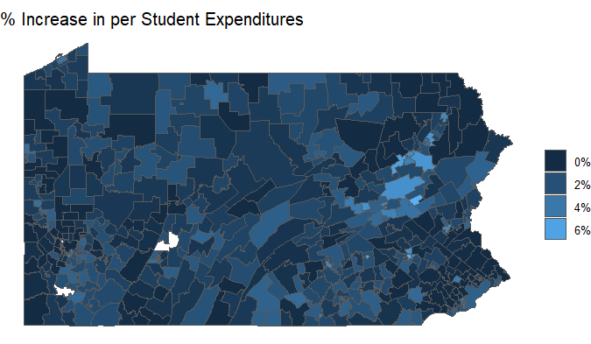 Analysis of where the adequacy investment money is going shows that school districts in the northeastern part of Pennsylvania will be receiving this money, particularly around the Scranton/Wilkes-Barre region. Calculating the Moran’s I statistic for the percent increase in per student expenditures for the state results in a statistically significant value (*p* < 2.2 * 1016) of 0.26, which indicates mild clustering[1]; no other region of Pennsylvania saw the same level of clustering.

Figure 1: Percent increase in per student expenditures by the time the entire adequacy fund is phased into school districts’ budgets. Some school districts have missing expenditure data.

A strength of this policy is the stated commitment to equalizing how much schools spend on their students. While the specific baseline can be debated, the fact that a baseline was proposed is a step towards the goal of making sure students have the same access to resources in schools given the research supporting closing funding disparities. Despite this, however, the fact that the money is being phased in over 7 years negates the added spending. This is because costs change over time, and inflation will likely cause $250 to be worth less come the end of the phase-in period.

Evaluating the proposal’s effect on rural, suburban, town, and urban districts

Between the 2014-15 and 2020-21 school years, a few patterns emerge that could be remedied by changes in school funding. The first is that instructional spending per student remained stagnant after 2015, hovering just below $9,000 per weight student, while all other school district types (i.e., suburban, town, and rural) saw consistent increases in instructional spending per student (see *Figure 2*). At the same time, city school districts continued to receive more state revenue per student during that same time (see *Figure 3*). This suggests that other revenue sources schools rely on have provided less money over that period. Upon analyzing local revenue expenditures per student between 2014-15 and 2020-21, this is a possible scenario. City and suburban school district property tax rates have oscillated around each other (see *Figure 4*), but suburban school districts are able to raise significantly more than any other type of school district by at least $3,000 per student (see *Figure 5*).

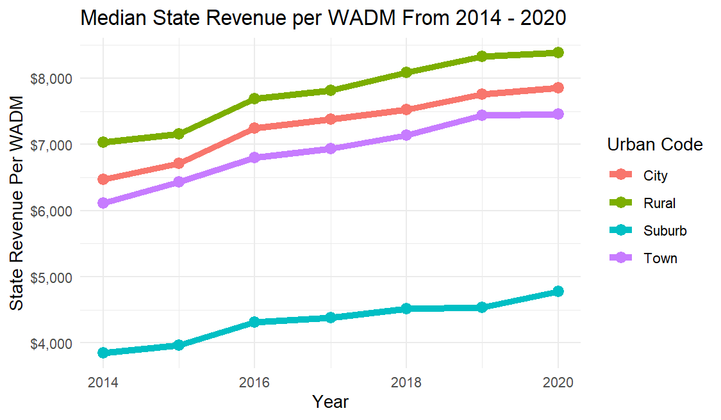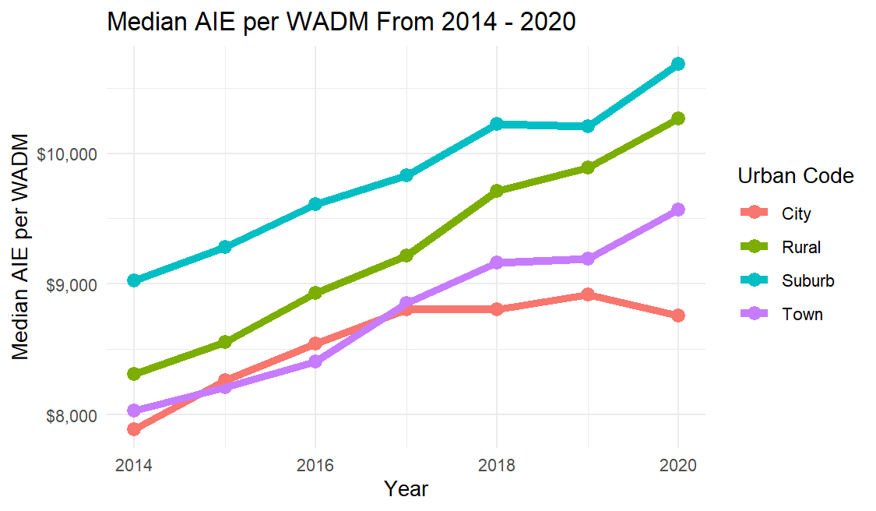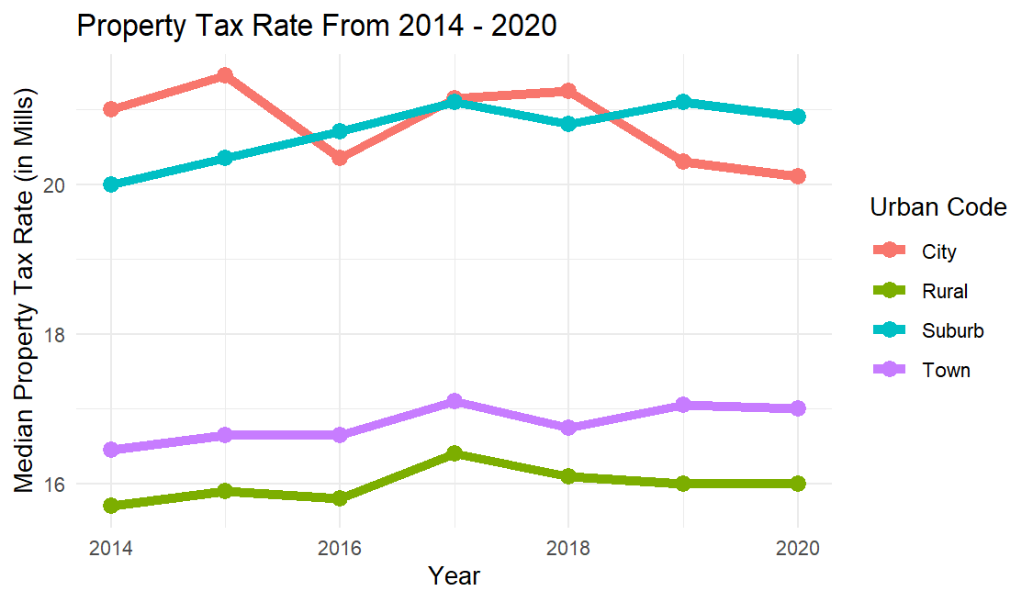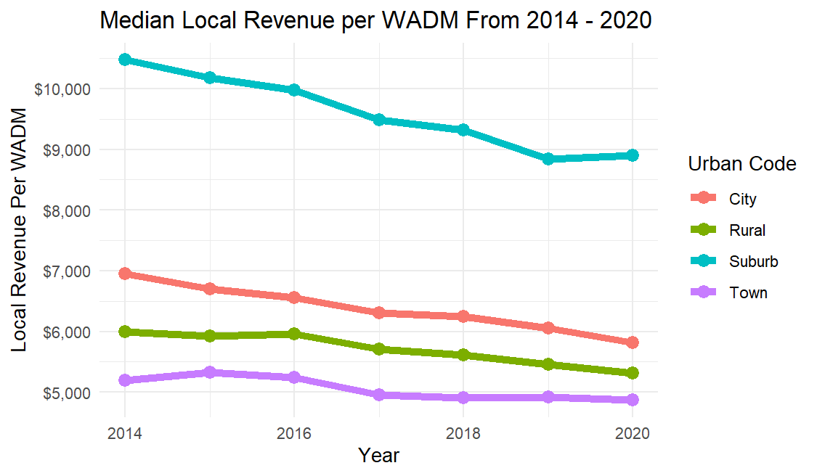 Josh Shapiro’s proposed budget is a start to remedying this disparity between suburban school districts and other school district types. The most significant increases in BEF funding go to city school districts, with those school districts seeing an approximate 24% increase in BEF funding per student. This provides a remedy to city school districts that have declining local revenue. Suburban school districts, however, see the second largest increase in BEF funding per student at approximately 10%. Town and rural school districts both have about a 7% increase in BEF funding per student. This d

Figure 2

Figure 4

Figure 5

Figure 3

Evaluating whether the proposal furthers racial disparities or offers remedies

Evaluating disparities between poor and wealthy school districts

Concluding Recommendations

References

Act of Jun. 1, 2016, P.L. 252, No. 35, 2016–35 (2016).

Chetty, R., Friedman, J. N., & Rockoff, J. E. (2014). Measuring the Impacts of Teachers II: Teacher Value-Added and Student Outcomes in Adulthood. *The American Economic Review*, *104*(9), 2633–2679. https://doi.org/10.1257/aer.104.9.2633

Candelaria, C. & Shores, K. (2017). Court-Ordered Finance Reforms in the Adequacy Era: Heterogeneous Causal Effects and Sensitivity. *Education Finance and Policy*, *14*(1), 31–60. https://doi.org/10.1162/edfp_a_00236

Dhaliwal, T. K., & Bruno, P. (2021). The Rural/Nonrural Divide? K–12 District Spending and Implications of Equity-Based School Funding: *AERA Open*, *7*, 233285842098254. https://doi.org/10.1177/2332858420982549

Downey, D. B. & Condron, D. J. (2016). Fifty Years since the Coleman Report: Rethinking the Relationship between Schools and Inequality. *Sociology Of Education*, *89*(3), 207–220. https://doi.org/10.1177/0038040716651676

Hanushek, E. A. (2002). The Failure of Input-based Schooling Policies. *National Bureau of Economic Research*. https://doi.org/10.1111/1468-0297.00099

Hutt, E. (2017). “Seeing Like a State” in the Postwar Era: The Coleman Report, Longitudinal Datasets, and the Measurement of Human Capital. *History of Education Quarterly*, *57*(4), 615–625. https://doi.org/10.1017/heq.2017.36

Evans, W. N., Murray, S. E., & Schwab, R. M. (1998). Education-Finance Reform and the Distribution of Education Resources. *The American Economic Review*, *88*(4), 789–812.

Hanna, M., & Graham, K. (2021, December 26). 5 takeaways from Pennsylvania’s ongoing, landmark school-funding trial after one month. *Philadelphia Inquirer*. https://www.inquirer.com/news/pennsylvania-school-funding-trial-testimony-20211226.html

Hanna, M., Graham, K., & McCoy, C. (2021, November 12). A landmark case that could change school funding across Pa. is going to trial. *Philadelphia Inquirer*. https://www.inquirer.com/news/pa-school-funding-trial-philadelphia-20211112.html

Kantor, H. & Lowe, R. (2017). Introduction: What Difference Did the Coleman Report Make? *History of Education Quarterly*, *57*(4), 570–578. https://doi.org/10.1017/heq.2017.32

Hyman, J. (2017). Does Money Matter in the Long Run? Effects of School Spending on Educational Attainment. *American Economic Journal: Economic Policy*, *9*(4), 256–280. https://doi.org/10.1257/pol.20150249

Jackson, C. K., Johnson, R. C., & Persico, C. (2015). The Effects of School Spending on Educational and Economic Outcomes: Evidence from School Finance Reforms. *National Bureau of Economic Research*, *131*(1), 157–218. https://doi.org/10.1093/qje/qjv036

Lafortune, J., Rothstein, J., & Schanzenbach, D. W. (2018). School Finance Reform and the Distribution of Student Achievement. *American Economic Journal: Applied Economics*, *10*(2), 1–26. https://doi.org/10.1257/app.20160567

Kelly, M. G. (2020). The Curious Case of the Missing Tail: Trends Among the Top 1% of School Districts in the United States, 2000–2015: *Educational Researcher*, *49*(5), 312–320. https://doi.org/10.3102/0013189x20922999

Kelly, M. G. (2021). How to Reform Without Reforming: School District Racial Composition and Pennsylvania’s “Fair” Funding Formula. *Education and Urban Society*, *54*(9), 1143–1165. https://doi.org/10.1177/00131245211048426

Kelly, M. G., & Maselli, A. (2022). School Finance Policies, Racial Disparities, and the Exploding Educational Debt: Egregious Evidence from Pennsylvania. *Journal of Education Human Resources*, *41*(3), 514–533. https://doi.org/10.3138/jehr-2022-0003

Gordon, L. N. (2017). If Opportunity Is Not Enough: Coleman and His Critics in the Era of Equality of Results. *History of Education Quarterly*, *57*(4), 601–615. https://doi.org/10.1017/heq.2017.35

Library of Congress. (n.d.). *1973: San Antonio ISD v. Rodriguez*. https://guides.loc.gov/latinx-civil-rights/sanantonio-isd-v-rodriguez

Morrison, O. (2024, February 6). *Shapiro proposes ‘historic’ $1 billion increase in education funding to address inequities*. WHYY. https://whyy.org/articles/shapiro-historic-1-billion-increase-education-funding-pennsylvania-budget/

Pennsylvania State Education Association. (n.d.). *Adequacy Targets and Adequacy Payments*. https://www.psea.org/issues-action/key-issues/key-issue-school-funding/adequacy-targets-and-adequacy-payments/

Steinberg, M. P., & Quinn, R. (2015). A Tale of Two Decades: New Evidence on Adequacy and Equity in Pennsylvania. *Journal of Education Finance*, *40*(3), 273–299.

1. Moran’s I measures how clustered polygons (in this case, school districts) are on a scale of -1 to 1, with -1 being as dispersed as possible and 1 being as clustered as possible.