Preliminary Results for Access to Grants in Rural PA Schools

Michael Cattell & Scott Levengood

# Introduction

Rural school districts face unique challenges. They exist distant from major economic centers, have high poverty rates, and have less infrastructure, like broadband internet, roads, or government services. Part of the effect these factors have on rural residents is the quality of their and their kids’ education.

Rural school districts are more reliant on state revenue to fund their schools. They, like town and urban school districts, generate less revenue through property taxes. Unlike

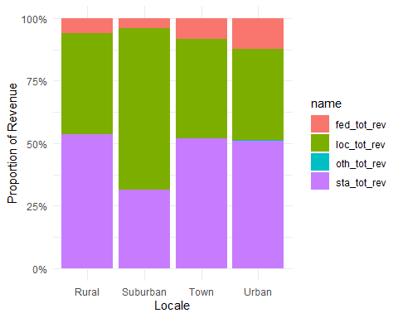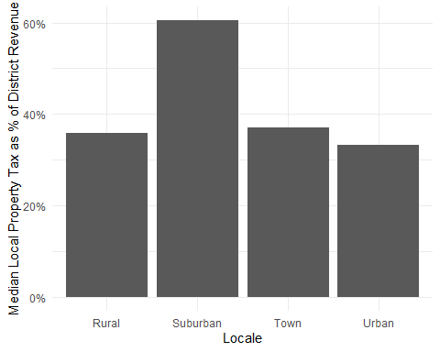

Grants and other programs from the federal government have the potential to act as an equalizer between districts situated in different contexts. This study investigates whether federal grants and programs harness this potential and actually serve as an equalizer.

# Literature Review

## Defining Rurality

* Hoggart (1990): Argues against the monolithic “rural”
* Nelson & Nguyen (2023): Creates a new measure for rurality using amenities available through OpenStreetMap

## Rural Schools

* Schaft (2016): Rural school link with community well-being
* Masumoto & Brown-Welty (2009): School and community relationship in rural districts that are “high-performing” and have high poverty rates.
* Bauch (2001): School and community partnerships in rural districts
* Boulden & Schimmel (2021): Analysis of a university-district partnership aimed at training and retaining school counselors

## Federal Funding in Schools

* Kolbe & Rice (2012): Race to the Top (RTTP) and whether it improved funding
* Brenner (2018): The impact of the ESSA on rural education
* Yettick et al. (2014): Looking at ESEA and whether (and how) the administrative aspect of ESEA disadvantages rural school districts
* Elliot et al. (2014): Impact of the Physical Education for Progress (PEP) federal grant in a school district
* Herr & Brooks (2003): Not strictly federal, but discusses the impact of a lottery program akin to RTTP and the impact the lottery system has
* Eppley (2009): Critical look at the impact of No Child Left Behind (NCLB) on rural schools, specifically the “highly qualified teacher” provision

# Data and Methods

Data for this study comes from two primary sources: the National Center for Education Statistics (NCES) and the Pennsylvania Department of Education (PDE).

NCES provides a wide range of data through their Common Core of Data (CCD). Data on school district enrollment by race and locale classification (i.e., whether a district is considered urban, suburban, a town, or rural). Sourcing locale classifications from NCES provides a standardized comparison with other states, though utilizing a different rurality classification system is certainly possible.

PDE publishes school district finance data on school districts for each fiscal year. At the time of writing, the most recent fiscal year with available finance data is FY2022-23, which encompasses the same school year. Data on average daily membership (ADM) and weighted average daily membership (WADM), as well as categorical revenue sources (e.g., revenue from specific state programs, federal grants, etc.).

An important limitation to note with the FY2022-23 is a significant rural grant program, Title V, Part B, Subpart 1 of the Elementary and Secondary Education Act (ESEA) and its subsequent re-authorizations, is grouped with other federal funds irrespective to locale classifications. Beginning with the FY2023-24 district revenue data, Title V, Part B, Subpart 1 revenue is its own classification. That data, however, is not yet available.

To assess the federal government’s role as a funding equalizer, funding across 10 funding categories that both Pennsylvania and the federal government provides funding for will be compared. These categories are derived from the Chart of Accounts file provided by the PDE; this file is used by school districts to report revenue and expenditure data to the PDE. Revenue will be normalized by comparing revenue per average daily membership between revenue and state revenue. The expectation would be that school districts receiving more money from Pennsylvania in a given category will receive less from the federal government, and vice-versa.

An important note in the classification scheme is that the Head Start program was excluded from analysis at this stage due to the way funds are distributed. Some funds are given to school districts, but funds are also given to Intermediate Units (IUs). As data could not be found on the locale classification for IUs, there was a significant swath of Head Start funding that was excluded from analysis. This data will be incorporated into analysis should locale classification data be found, or if a bridge between school districts and associated IUs is found.

# Results

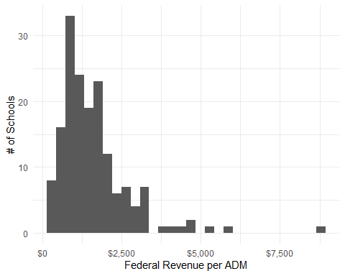

In the 2022-23 school year, the 168 rural school districts in Pennsylvania received $368,778,460. This averages out to approximately $1362.10 per student across Pennsylvanian rural school districts.

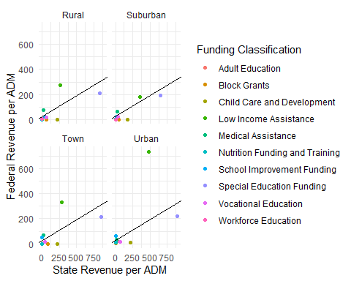A preliminary x ~ y plot provides a starting point for analysis by identifying outliers. Contrary to the initial expectation of federal revenue and state revenue having a negative relationship, these two revenue sources have a statistically significant relationship (p = 0.000149) with an R^2 of 0.3379, indicating a moderate correlation between these two revenue sources. This suggests that are not necessarily leveling the playing field.

|  | Revenue per ADM | | | |
| --- | --- | --- | --- | --- |
| Funding Classification | Rural | Suburban | Town | Urban |
| Block Grants | 0.00 | 0.00 | 0.00 | 2.11 |
| Child Care and Development | 0.00 | 0.00 | 0.00 | 8.14 |
| Low Income Assistance | 275.66 | 179.36 | 333.12 | 735.76 |
| Medical Assistance | 76.63 | 64.14 | 67.18 | 33.38 |
| Nutrition Funding and Training | 0.50 | 5.15 | 0.34 | 10.14 |
| School Improvement Funding | 25.07 | 21.55 | 51.41 | 62.19 |
| Special Education Funding | 207.50 | 189.49 | 214.76 | 218.08 |
| Vocational Education | 18.39 | 21.55 | 15.88 | 17.30 |
| Workforce Education | 7.33 | 0.00 | 0.00 | 0.00 |
| Adult Education | 0.00 | 0.00 | 0.00 | 18.91 |

Looking just at rural revenue per ADM, rural schools receive less federal funding for:

* (non-Head Start) child care funding,
* adult education,
* nutrition funding and training,
* low-income assistance,
* and school improvement funding

compared to other types of school districts. Interestingly, rural schools receive more federal funding for workforce education and medical assistance.

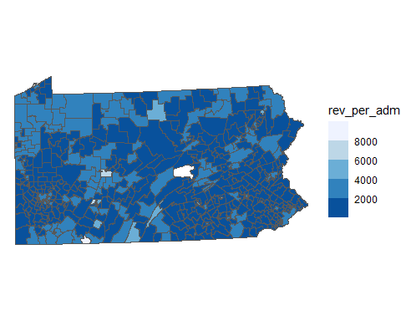Initial results do not display a particularly obvious spatial pattern, though further spatial analysis looking at clustering will reveal a more definitive answer in that regard. The most apparent pattern is rings of suburbs around Philadelphia and Pittsburgh do not have significant federal revenue, which would make sense given the lack of federal funding suburban school districts receive in general.

References

Bauch, P. A. (2001). School-Community Partnerships in Rural Schools: Leadership, Renewal, and a Sense of Place. *Peabody Journal of Education*, *76*(2), 204–221. https://doi.org/10.1207/s15327930pje7602_9

Boulden, R., & Schimmel, C. J. (2021). More Than Just an Internship: One University’s Collaboration with a Rural School District to Attract, Develop, and Retain School Counselors. *The Rural Educator*, *42*(3), 56–62. https://doi.org/10.35608/ruraled.v42i3.1237

Brenner, D. (2018). Rural Educator Policy Brief: Rural Education and the Every Student Succeeds Act. *The Rural Educator*, *37*(2), 23–27. https://doi.org/10.35608/ruraled.v37i2.271

Elliott, S., McCollum, S., Colquitt, G. T., & Pritchard, T. A. (2013). Perceptions of the Impact of a PEP Grant on Elementary Physical Education Programs in One School District. *The Physical Educator*, *70*(4), 429–446.

Eppley, K. (2009). Rural schools and the highly qualified teacher provision of No Child Left Behind: a critical policy analysis. *Journal of Research in Rural Education*, *24*(4), 1–11.

Hayes, M. S. (2015). The Differential Effect of the No Child Left Behind Act (NCLB) on States’ Contributions to Education Funding in States with Binding School District Tax and Expenditure Limitations. *Public Budgeting & Finance*, *35*(1), 49–72. https://doi.org/10.1111/pbaf.12058

Herr, L. M., & Brooks, D. W. (2003). Developing and sustaining K–12 school technology innovation through lottery grant awards: A multiple case study. *Journal of Science Education and Technology*, *12*(2), 153–182. https://doi.org/10.1023/a:1023991828205

Hoggart, K. (1990). Let’s do away with rural. *Journal of Rural Studies*, *6*(3), 245–257. https://doi.org/10.1016/0743-0167(90)90079-n

Kolbe, T., & Rice, J. K. (2012). And They’re Off Tracking Federal Race to the Top Investments From the Starting Gate. *Educational Policy*, *26*(1), 185–209. https://doi.org/10.1177/0895904811428975

Masumoto, M., & Brown-Welty, S. (2009). Case Study of Leadership Practices and School-Community Interrelationships in High-Performing, High-Poverty, Rural California High Schools. *Journal of Research in Rural Education*, *24*(1), 1–18.

Nelson, K. S., & Nguyen, T. D. (2023). Community assets and relative rurality index: A multi-dimensional measure of rurality. *Journal of Rural Studies*, *97*, 322–333. https://doi.org/10.1016/j.jrurstud.2022.12.025

Schafft, K. A. (2016). Rural Education As Rural Development: Understanding the Rural School–Community Well-Being Linkage in a 21st-Century Policy Context. *Peabody Journal of Education*, *91*(2), 137–154. https://doi.org/10.1080/0161956x.2016.1151734

Yettick, H., Baker, R., Wickersham, M., & Hupfeld, K. (2014). Rural Districts Left Behind? Rural Districts and the Challenges of Administering the Elementary and Secondary Education Act. *Journal of Research in Rural Education*, *29*(13), 1.