Federal Funds and Rural Schools

Michael Cattell, Scott Levengood

# Introduction

Rural schools face unique challenges. They exist distant from major economic centers, have high poverty rates, and have less infrastructure, like broadband internet, roads, or govern- ment services. Part of the effect these factors have on rural residents is the quality of their and their kids’ education.

Grants and other programs from the federal government have the potential to act as an equalizer between districts situated in different contexts. This study investigates whether federal grants and programs harness this potential and actually serve as an equalizer. It will also aim to understand these through the lens of racial,

# Literature Review

## Defining Rurality

* Hoggart (1990): Argues against the monolithic “rural”
* Nelson & Nguyen (2023): Creates a new measure for rurality using amenities available through OpenStreetMap

## Rural Schools

* Schaft (2016): Rural school link with community well-being
* Masumoto & Brown-Welty (2009): School and community relationship in rural districts that are “high-performing” and have high poverty rates.
* Bauch (2001): School and community partnerships in rural districts
* Boulden & Schimmel (2021): Analysis of a university-district partnership aimed at training and retaining school counselors

## Federal Funding in Schools

* Kolbe & Rice (2012): Race to the Top (RTTP) and whether it improved funding
* Brenner (2018): The impact of the ESSA on rural education
* Yettick et al. (2014): Looking at ESEA and whether (and how) the administrative aspect of ESEA disadvantages rural school districts
* Elliot et al. (2014): Impact of the Physical Education for Progress (PEP) federal grant in a school district
* Herr & Brooks (2003): Not strictly federal, but discusses the impact of a lottery program akin to RTTP and the impact the lottery system has
* Eppley (2009): Critical look at the impact of No Child Left Behind (NCLB) on rural schools, specifically the “highly qualified teacher” provision

Rural Classification Criteria

Fringe 5 miles or closer to urban area with 50,000 or more people, and is 2.5 miles or closer to urban area with less than

50,000 people.

Distant 5 - 25 miles from an urban area with 50,000 or more people, and is 2.5 - 10 miles from an urban area with less than

50,000 people.

Remote 25 miles from an urban area with 50,000 or more people, and more than 10 miles from an urban area with less than 50,000

people.

# Data and Methods

## Data

Data for this study comes from the National Center for Education Statistics (NCES), which is the statistical arm for the U.S. Department of Education, the U.S. Census Bureau, and Civil Rights Data Collection.

NCES provides a wide range of data through their Common Core of Data (CCD). Data on school district enrollment by race and locale classification (i.e., whether a district is considered urban, suburban, a town, or rural). Sourcing locale classifications from NCES provides a standardized comparison with other states, though utilizing a different rurality classification system is certainly possible. The definitions NCES uses for defining locales is in the table below.

School district revenue data comes from the most recent NCES School District Finance Survey, which was for the 2021-2022 school year. This survey collects school finance data for school districts (or local education agencies, as NCES refers to them as) in all 50 states plus Washington D.C. Revenue and expenditure data is aggregated by category, such as Title I funding, nutrition programs, and gifted education.

Initially, school district finance data from the Pennsylvania Department of Education (PDE) was used. PDE publishes school district finance data annually, with revenue and expenditure aggregated into smaller categories than NCES does. In order to get a broader view of school districts’ revenue, these codes were grouped together (e.g., categories related to nutritional education and lunch programs were aggregated together). PDE’s data, however, proved to be unreliable. Upon analysis of nutrition funding, only a handful of school districts were listed as receiving federal funds, a finding that is certainly false. Upon analysis of the NCES School District Finance Survey, this finding was confirmed and the data source used for this study was switched from PDE’s data to data from NCES.

Data from the U.S. Census Bureau on poverty estimates is also used. The Census publishes annual poverty estimates at the school district level as the Small Area Income and Poverty Estimates (SAIPE). This allows for analysis of federal funding through the lens of economic equity, as well as racial equity.

Lastly, IDEA enrollment data is provided from the 2021-2022 Civil Rights Data Collection (CRDC) survey, which is administered through the U.S. Department of Education’s Office for Civil Rights. This is a universal survey–that is, all public schools respond– done at the school level that is conducted every other school that collects data used to monitor civil rights enforcement. This includes data related to discipline, gifted education, course offerings, and special education.

## Methods

Funding categories from the NCES School District Finance Survey will be picked and coded as funding one of five categories:

* career and technical education,
* school meal programs,
* special education programs,
* teacher retention and training programs.

These categories were picked due to the clear overlap in language used in the Finance Survey between federal and state revenue. The lack of granularity within the Finance Survey is certainly a limitation of this study, though this is the best available data at the time of writing. While the PDE finance data provided more granular funding categories, the lack of actual data present in the files makes them unusable.

In order to evaluate how effective federal funding is at being an equalizer, an initial linear regression model will be run in order to test whether

# Who’s Learning in Rural Schools?

This study considers, to varying degrees, three different aspects of a school district’s demo- graphics in relation to the kind of federal funding they receive: racial composition, students’ family income distribution, and the composition of students enrolled in programs funded by the Individual with Disabilities Education Act (IDEA).

## Racial Composition

Rural (and town) school districts are more racially homogeneous than their urban and subur- ban counterparts. They enroll predominantly White students, while having low proportions of Black, Hispanic, and Asian students.

This is a trend that generally matches the communities these school districts are situated in (see Figure 1). Rural school districts also tend to have predominantly White populations reside in them and low percentages of other ethnoracial groups. There is also far less variation in how diverse these places are; while suburban and urban schools have a mix of schools

|  |  |  |  |  |
| --- | --- | --- | --- | --- |
| Race | Rural | Suburban | Town | Urban |
| White | 87.29% | 68.32% | 88.44% | 24.66% |
| Black | 2.92% | 9.54% | 2.41% | 31.98% |
| Hispanic | 5.61% | 10.76% | 4.68% | 31.89% |
| Asian | 0.91% | 5.86% | 0.68% | 5.61% |
| Other Race | 3.28% | 5.53% | 3.78% | 5.85% |

predominantly enrolling one ethnoracial group and schools with diverse enrollment, no rural school has a White student enrollment percentage under 50%.

100%

|  |  |  |  |  |  |
| --- | --- | --- | --- | --- | --- |
|  |  |  |  |  |  |
|  |  |  |  |  |  |
|  |  |  |  |  |  |
|  |  |  |  |  |  |
|  |  |  |  |  |  |
|  |  |  |  |  |  |
|  |  |  |  |  |  |
|  |  |  |  |  |  |

75%

50%

Community Population Percentage

Rural Suburban

25%

0%

100%

75%

50%

25%

0%

Town Urban

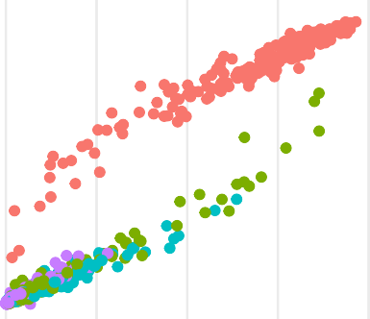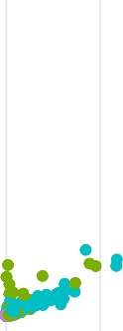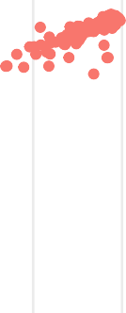

|  |  |  |  |  |  |
| --- | --- | --- | --- | --- | --- |
|  |  |  |  |  |  |
|  |  |  |  |  |  |
|  |  |  |  |  |  |
|  |  |  |  |  |  |
|  |  |  |  |  |  |
|  |  |  |  |  |  |
|  |  |  |  |  |  |
|  |  |  |  |  |  |

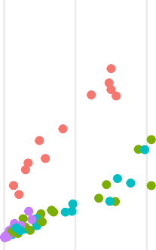

0% 25% 50% 75% 100% 0% 25% 50% 75% 100%

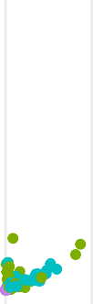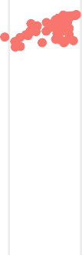

Student Enrollment %

Ethnoracial Group

 White  Black

 Hispanic  Asian

Figure 1: Student enrollment % vs. community population %, broken down by locale clas- sification and ethnoracial group.

Additionally, this is also a broad spatial pattern for rural school districts across the state (see Figure 2). Only two districts have a non-White ethnoracial group make up more than 25% of their student population; 29% of students enrolled in both Pocono Mountain and Upper Adams School Districts are Hispanic.

|  |  |  |  |  |
| --- | --- | --- | --- | --- |
| Locale | Est. % of Students in Poverty | n | Mean % | St. Dev. |
| Rural | 13.21% | 167 | 14.23% | 4.6217 |
| Suburban | 10.22% | 237 | 11.98% | 7.6406 |
| Town | 15.49% | 77 | 15.82% | 4.8078 |
| Urban | 28.55% | 19 | 23.66% | 9.3646 |

## Economic Composition

Giving schools additional funding to assist with students in poverty has been a core part of the federal Elementary and Secondary Education Act (ESEA) and its subsequent re- authorizations since it passed in the 1960s.

Though many rural areas are impoverished (Monk, 2007), data from the U.S. Census Bu- reau shows that rural school districts have poverty rates more than half that of urban areas. Poverty rates between rural and suburban areas, on the other hand, are similar. The distri- bution of poverty rates, however, looks different between locale classifications. Rural school districts have a much narrower distribution (standard deviation of 4.62%) than urban school districts (SD of 9.36%) and suburban school districts (SD of 7.64%).

Locale

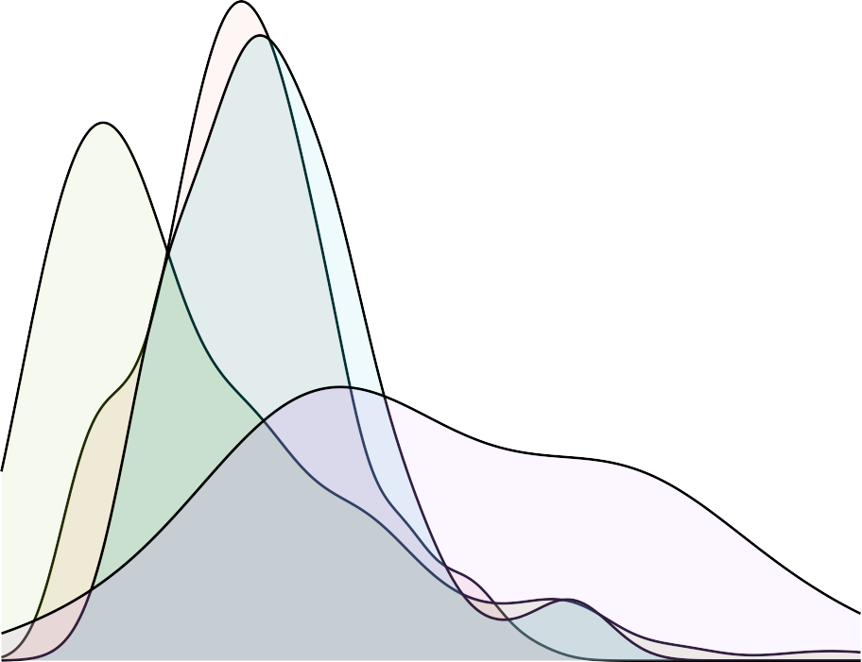

Rural Suburban Town Urban

10% 20% 30% 40%

% of Students in Poverty

Considering the economic characteristics of rural schools (and all schools, really), as students living in poverty require more resources to lift them to their potential (Ladd, 2012). School meal programs, after-school programming, and academic support programs all require addi- tional funds to operate at their full potential. With this in mind, it would be expected that school districts with a higher poverty rate among its students would receive additional fund- ing in certain funding categories than districts with a lower rate, either because of an explicit piece of the funding allocation formula that accounts for poverty (such as Title I funding) or because schools with a higher poverty rate have higher demand for certain programs (such as school meal programs).

|  |  |  |  |  |
| --- | --- | --- | --- | --- |
| Race | Rural | Suburban | Town | Urban |
| Total | 18.49% | 17.02% | 18.58% | 17.4% |
| Asian | 8.14% | 7.75% | 10.14% | 6.61% |
| Black | 22.19% | 22.45% | 21.94% | 19.21% |
| Hispanic | 20.73% | 18.25% | 19.61% | 17.64% |
| White | 18.21% | 16.74% | 18.4% | 16.58% |

## IDEA Composition

The third and final demographic this study will analyze in part is IDEA enrollment. IDEA enrollment is used over broader special education enrollment because IDEA funding to school districts is explicitly listed in the NCES School District Finance Survey, whereas Section 504 funding and other special education funding sources are not specifically outlined.

Rural school districts’ IDEA enrollment patterns are not dissimilar from that of other locales. They are, nevertheless, troubling; Black and Hispanic students are enrolled in rural schools at disproportionately high rates. Despite making up 2.92% of enrolled students in rural school districts, Black students account for 22.19% of IDEA enrollment in those same schools; that is a staggering 7.6 times difference. Hispanic students make up 5.61% of enrolled students in rural schools, and yet make up 20.73% of students enrolled in IDEA in rural schools. Mis-classification of Black and Hispanic students into special education programs has long been a practice that internally segregates schools (i.e., the school-wide demographics are racially integrated, but within the school programming is still segregated) (Parker, 2024), as students in special education programs often end up in separate classrooms for special education-related classwork.

# Results

As a starting point for analysis, linear regression was tested to see the correlation between state funding in the five selected categories and federal funding in rural school districts. If

|  |  |  |  |  |
| --- | --- | --- | --- | --- |
| Category | n | Estimate | p Value | R^2 Value |
| Career and Technical | 167 | 0.084 | 0.000 | 0.147 |
| Education  School Meal Programs | 167 | 2.535 | 0.000 | 0.207 |
| Special Education | 167 | 0.000 | 0.838 | 0.000 |
| Teacher Funding | 167 | 0.014 | 0.001 | 0.070 |

federal funding were behaving as an equalizer, the expectation is there would be a negative relationship between federal and state funding in each category; as you can increase state funding in a category, federal funding would decrease.

Bilingual education was initially included in this analysis due to the clear overlap in funding language in the NCES School District Finance Survey, but was removed as no school district was reported as having received state funding for bilingual education programs despite its presence as a line item on the Finance Survey.

A few interesting observations stick out with this initial regression model and x ~ y plot. The first observation, and the one most applicable to the central hypothesis, is that no funding category has a negative relation. Special education gets the closest with an estimated coefficient of 0.

The second observation is that three of the four funding categories produced statistically significant results (p < 0.05). The one funding category that did not produce a statistically significant result–special education–is curious and warrants further investigation later in this section.

Teacher training and retention programs did produce a statistically significant result with an Rˆ2 value of 0.0 and a circle cluster of points on the regression plot, indicating no real relationship between state and federal funding sources. This can be an issue for rural school districts, as they have historically had issues recruiting and retaining teachers in their districts (Monk, 2007; Williams et al., 2022). While rural school districts receive more revenue per student from teacher-related programs than town and suburban districts, they

$60

$40

Federal Revenue per Enrolled Student

$20

Career and Technical Education

$1,200

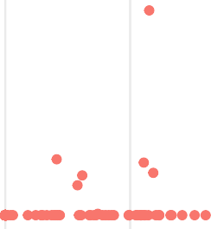

$800

$400

School Meal Programs

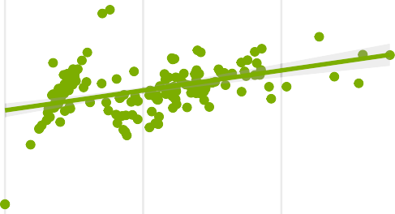$0 $0

|  |  |  |  |
| --- | --- | --- | --- |
|  |  |  |  |
|  |  |  |  |
|  |  |  |  |
|  |  |  |  |
|  |  |  |  |
|  |  |  |  |

$0 $50 $100 $150 $0 $50 $100

$20

Special Education

$150

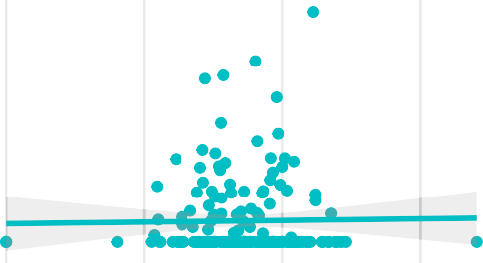

Teacher Funding

$15

$10

$5

$0

$100

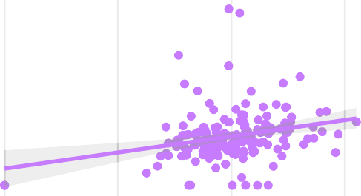$50

|  |  |  |  |
| --- | --- | --- | --- |
|  |  |  |  |
|  |  |  |  |
|  |  |  |  |
|  |  |  |  |
|  |  |  |  |
|  |  |  |  |

$0

$0 $500 $1,000 $1,500 $0 $1,000 $2,000 $3,000

State Revenue per Enrolled Student

Figure 2: x vs. y plot of State and Federal funding in four different funding categories with a line of best fit overlayed.

|  |  |  |  |
| --- | --- | --- | --- |
| Locale | Total Rev. / Enrolled | Federal Rev. / Enrolled | State Rev. / Enrolled |
| Rural | $2004.09 | $39.79 | $1964.3 |
| Suburban | $1968.18 | $29.05 | $1939.13 |
| Town | $1957.16 | $42.28 | $1914.89 |
| Urban | $2277.13 | $59.48 | $2217.65 |

still generate about 12% less revenue per student than urban schools.

The final observation is that only one funding category–school meal funding–had 1.) a large effective size of 2.535, 2.) a moderate correlation strength (Rˆ2 value of 0.2), and 3.) a statistically significant result (p < 0.05). This will be explored in more detail in a subsequent section.

Further analysis of results is broken into three parts:

* Variations in federal nutrition and school meal funding,
* Federal teacher training and retention funding,
* Rural-specific funding programs.

These further analyses will be looked at through racial and economic student composition.

## Nutrition Programs

School meal funding is somewhat unique among school funding categories; while most cat- egories are heavily reliant on state revenue to provide funding, the vast majority of school meal funding comes from the federal government. This pattern holds true in Pennsylvania.

As stated above, school meal funding is correlated relatively strongly between state and federal funding, with more funding coming from federal revenue than state; for every $1 a state contributes at a rural school, the federal governments contributes around $2.54.

|  |  |  |  |  |
| --- | --- | --- | --- | --- |
| Race | Estimate | Std. Error | t value | Pr(>|t|) |
| White | -317.9335 | 708.7313 | -0.4485953 | 6.543231e-01 |
| Black | 169.6973 | 1098.8169 | 0.1544363 | 8.774579e-01 |
| Hispanic | -542.0601 | 761.4328 | -0.7118949 | 4.775538e-01 |
| Asian | -6548.0565 | 1548.8469 | -4.2276978 | 3.934644e-05 |

### Race and Nutrition Funding

To analyze racial composition and nutrition funding, a model was assembled that correlated federal meal revenue with enrollment percentages for four ethnoracial groups: Asian, Black, Hispanic, and White students. The results of this model can be seen below.

There are a few notable takeaways from this model. The first is that all ethnoracial groups but Black students have a negative relationship; as one group’s enrollment percentage goes up, federal funding for meals goes down to varying degrees depending on the ethnoracial group. Black students have a slightly positively correlated relationship with federal meal revenue. Notably, though, only the correlation between Asian students and federal meal revenue produces a statistically significant (p < 0.05) result. While this is an interesting correlation, the Rˆ2 value is only 0.1159, indicating that while statistically significant, the relationship is not particularly strong. This pattern is likely more elaborately explained through the lens of poverty rates in schools.

### Poverty and Nutrition Funding

The purpose of federal nutrition assistance is to assist students whose families have difficulty affording lunches at school. The free and reduced meal program is a stable source of meals for many students. As a result, focusing on the poverty rate lens would likely show a clearer relationship between federal meal revenue and the poverty rate at a school, as opposed to between federal meal revenue and a school’s ethnoracial enrollment percentages.

|  |  |  |  |  |
| --- | --- | --- | --- | --- |
|  | Estimate | Std. Error | t value | Pr(>|t|) |
| sqrt(‘Est. % of Students in Poverty‘) | 125.9645 | 17.17227 | 7.335346 | 9.480571e-12 |

1200

800

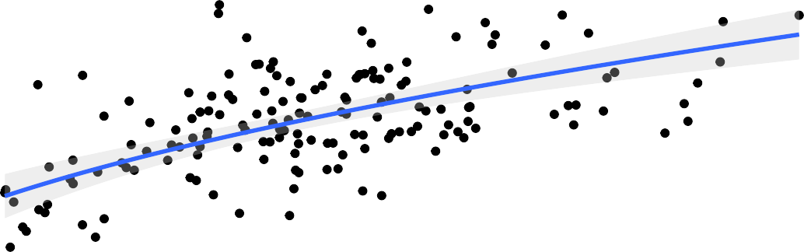

Federal Meal Revenue per Enrolled Rural Student

|  |  |  |  |  |  |  |  |  |  |  |
| --- | --- | --- | --- | --- | --- | --- | --- | --- | --- | --- |
|  |  |  |  |  |  |  |  |  |  |  |
|  |  |  |  |  |  |  |  |  |  |  |
|  |  |  |  |  |  |  |  |  |  |  |
|  |  |  |  |  |  |  |  |  |  |  |
|  |  |  |  |  |  |  |  |  |  |  |
|  |  |  |  |  |  |  |  |  |  |  |
|  |  |  |  |  |  |  |  |  |  |  |

400

0

5% 10% 15% 20% 25%

Est. % of Students in Poverty

This expectation plays out in the data, with a clear square-root relationship between fed- eral meal revenue and a school’s estimated poverty rate. This also produces a statistically significant result (p < 0.05) with an Rˆ2 correlation value of 0.2459, indicating a moder- ate correlation strength. This is a slightly stronger than applying an x vs. y relationship. This square-root based relationship does make sense given the incursion of base costs and then increasing required revenue as more students enroll in school meal programs; as more students enroll, the lower the required revenue per student becomes.

## School Staff Funding

**A Note on Title V - Part B Grants (Rural Specific Grants)**

There are two federal grant programs that this study wanted to investigate, both under the Rural Education Achievement Program (REAP): Small, Rural School Achievement (SRSA) and Rural and Low-Income School (RLIS). These programs help provide funding to rural schools that are small (< 600 average daily attendance) and/or have a high rate of poverty among its students (> 20% student poverty rate) respectively. Schools can be dual-eligible for these programs. Data on these programs is missing from the NCES School District Finance Survey, however. Only three school districts report funding from RLIS and none report funding from SRSA. This, unfortunately, makes it impossible to analyze the distribution of school districts’ receiving REAP funds racial and economic composition.

Given available data, this would be a very beneficial source of funding to analyze given their non-competitive status; PDE (n.d.) states the purpose of these grants is “. . . to help rural districts that may lack the personnel and resources to compete effectively for Federal competitive grants and that often receive grant allocations in amounts that are too small to be effective in meeting their intended purposes.” While RLIS does have an income requirement, SRSA does not. Additionally, neither have a racial component to their distribution, and thus it would be interesting

# Discussion

**Importance to Civil Rights** **Further Study**