Innovative Project Report

on

**Programming Implementation of**

**Calculating Viscosity Index from Kinematic Viscosity at**

**40 °C and 100 °C: ASTM-D2270**

By

|  |  |
| --- | --- |
| **Sunil** | **2K17/CO/350** |

For

**Bachelor of Technology**

in   
**Computer Engineering**

Under the Guidance

of

**Prof. R. C. Singh**

Submitted to

Department of Production & Industrial Engineering



**Delhi Technological University**

(Formerly Delhi College of Engineering)

Government of NCT of Delhi

Shahbad Daulatpur, Bawana Road

Delhi-110042

**October 2020**

**DECLARATION**

This is to declare that the innovative project report entitled "**Programming Implementation of Calculating Viscosity Index from Kinematic Viscosity at**

**40 °C and 100 °C: ASTM-D2270**" is carried by us at Delhi Technological University, under the supervision of **Prof. R. C. Singh .** The matter embodied in this project has not been copied as well as not submitted earlier for the award of any degree or diploma to the best of my knowledge and belief.

**(Sunil)**

(2K17/CO/350)

Date: 08/10/2020

Place: Delhi

**CERTIFICATE**

This is to certify that the above declaration made by **Sunil** (2K17/CO/350) is correct to the best of my knowledge and belief.

Prof. R. C. Singh

Department of Production and Industrial Engineering

Delhi Technological University

Delhi-110042

**ACKNOWLEDGEMENTS**

It gives me immense pleasure to take this opportunity to acknowledge our Project mentor Prof. R. C. Singh , (Mechanical Engineering), DTU, who is providing us with his guidance.

I thank Prof. R. C. Singh for their keen interest, moral support, invaluable suggestions and guidance.

I also appreciate the help of Mechanical Department and all the faculty members along with the officials of Delhi Technological University for assisting us in the realization of this project.

I am thankful to my colleagues and other staff members for their support.

I take the opportunity to thank my parents and relatives for their moral support to complete project work

At last not the least I am thankful to Almighty for their blessings.

**(Sunil)**

(2K17/CO/350)

Date: 08/10/2020

Place: Delhi

**ABSTRACT**

We have to calculate the Viscosity Index manually using long procedure ASTM-D2270. This method includes more computation and many tables which we have to refer during VI calculation. This consumes our lot of time and energy. Keeping this in mind, We implemented the ASTM-D2770 method of VI calcution in C++ program. Results show that our progam calculates the VI as accurate and precise as the manual method. By using this program, one can get the results within few seconds and hence save ones time and effort to select the lubricant of appropriate Viscosity Index.

**INDEX**

|  |  |
| --- | --- |
| **S. No.** | **Title** |
|  | **Declaration** |
|  | **Certificate** |
|  | **Acknowledgements** |
|  | **Abstract** |
| **1** | **Introduction** |
| **2** | **Literature review** |
| **3** | **Methodology** |
| **4** | **Experimentation** |
| **5** | **Results and discussion** |
| **6** | **References** |

**Introduction**

viscosity index is an arbitrary number used to characterize the variation of the kinematic viscosity of a petroleum product with temperature.

For oils of similar kinematic viscosity, the higher the viscosity index the smaller the effect of temperature on its kinematic viscosity.

The viscosity index is a widely used and accepted measure of the variation in kinematic viscosity due to changes in the temperature of a petroleum product between 40 °C and 100 °C.

***Manual method of VI calculation:***

1. If the kinematic viscosity of the sample at 100 °C is less than or equal to 70 mm2 /s, extract from Table 1 the corresponding values for L and H. Measured values that are not listed, but are within the range of Table 1, may be obtained by linear interpolation. The viscosity index is not defifined and shall not be reported for oils with kinematic viscosity of less than

2.0 mm2 /s at 100 °C.

2. If the kinematic viscosity is greater than 70 mm2 /s at 100 °C, calculate the values of L and H as follows:

L = 0.8353Y2 + 14.67Y - 216 (1)

H = 0.1684Y2 + 11.85Y - 97 (2)

Where

L = kinematic viscosity at 40 °C of an oil of 0 viscosity index having the same kinematic viscosity at 100 °C as the oil whose viscosity index is to be calculated, mm2 /s,

Y = kinematic viscosity at 100 °C of the oil whose viscosity index is to be calculated, mm2 /s, and

H = kinematic viscosity at 40 °C of an oil of 100 viscosity index having the same kinematic viscosity at 100 °C as the oil whose viscosity index is to be calculated, mm2 /s.

1. If U > H, calculate the viscosity index, VI, of the oil as

follows:

VI = [(L - U)/(L - H)] * 100 (3)

where:

U = kinematic viscosity at 40 °C of the oil whose viscosity

index is to be calculated, mm2 /s.

Calculation Example:

Measured kinematic viscosity at 40 °C of the oil whose viscosity index is to be calculated = 73.30 mm2 /s; kinematic viscosity at 100 °C of the oil whose viscosity index is to be calculated = 8.86 mm2 /s.

From Table 1 (by interpolation) L = 119.94

From Table 1 (by interpolation) H = 69.48

Substituting in Eq 3 and rounding to the nearest whole

number:

VI = [(119.94 - 73.30)/(119.94 - 69.48)] * 100 = 92.43

VI = 92

If U < H, calculate the viscosity index, VI , of the oil

as follows:

VI = [((antilogN) - 1) / 0.00715] +100 (4)

where:

N = (logH - logU) / logY (5)

Calculation Example:

Measured kinematic viscosity at 40 °C of the oil whose viscosity index is to be calculated = 22.83 mm2 /s; kinematic viscosity at 100 °C of the oil whose viscosity index is to be calculated = 5.05 mm2 /s:

From Table 1 (by interpolation) H = 28.975

Substituting by Eq 7 (by logarithms):

N = [(log(28.975)-log(22.83)]/log(5.05) = 0.1471

Substituting in Eq 6 and rounding to the nearest whole number:

[( (log(0.14719)-1)/0.00715] + 100 = 156.4235

VI = 156

***Programmable method of VI calculation:***

The calculation of viscosity index requires:

1. Input of kinematic viscosity data at 40 °C and 100 °C.
2. Calculation of L and H corresponding to the kinematic viscosity at 100 °C.
3. Calculation of the viscosity index using equations given above..
4. Values of L and H can be determined using computer software and the coefficients and equations stored in Table 2. In this set of sixteen equations, the errors in individual values of L and H so calculated are believed not to exceed 0.1 %. For a given value of Y, select the pair of equations

whose range includes this value of Y and calculate directly the values of L and H.

1. With the given values of Y and U and the calculated values of L and H corresponding to Y from Table 2, the viscosity index is calculated directly using:

5.1 (Eq 3) where U>=H or

5.2 (Eq 4) and (Eq 5) where U<=H as is described in introduction of this paper.

An example of these methods is as follows:

given kinematic viscosity at 40 °C = 73.50 mm2 /s,

and kinematic viscosity at 100 °C = 8.860 mm2 /s.

From Table 2, the equations stored in memory which include Y =

8.860 are:

L = 0.41858*Y2+16.1558 Y - 56.040

H = 0.05794*Y2+10.5156 Y - 28.240

From the given value of Y = 8.860 mm2 /s:

L = 119.9588

H = 69.4765

Since U ≥ H:

Viscosity index = (L-U)/(L-H)*100

For the data obtained

VI = (119.9588 - 73.50)/(119.9588 - 69.4765) * 100 = 92.030 = 92

**Literature Review**

In document [1], two procedures one manual computation and another by computer computation have been given, we used the second one on the cost of .1% error in the parameters(L and H) which put negligible effect on viscosity index.

**Methodology**

We reviewed the paper[1], then implemented programmable method in C++ language on Windows 10 operating system. And simulation results have been attached in next section.

**Experimentation**

**Example 1:** Measured kinematic viscosity at 40 °C of the oil whose viscosity index is to be calculated = 73.30 mm2 /s; kinematic viscosity at 100 °C of the oil whose viscosity index is to be calculated = 8.86 mm2 /s.

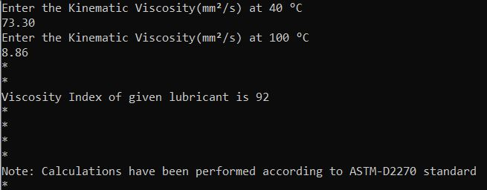

**Example 2:** Measured kinematic viscosity at 40 °C of the oil whose viscosity index is to be calculated = 22.83 mm2 /s; kinematic viscosity at 100 °C of the oil whose viscosity index is to be calculated = 5.05 mm2 /s:

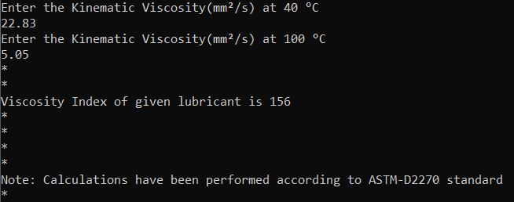

**Example 3:** Measured kinematic viscosity at 40 °C of the oil whose viscosity index is to be calculated = 53.47 mm2 /s; kinematic viscosity at 100 °C of the oil whose viscosity index is to be calculated = 7.80 mm2 /s:

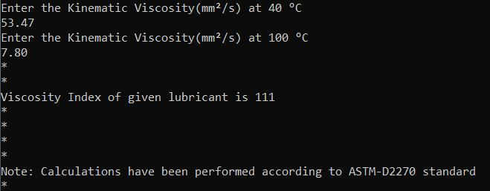

**Example 4:**

given kinematic viscosity at 40 °C = 73.50 mm2 /s,

and kinematic viscosity at 100 °C = 8.860 mm2 /s.

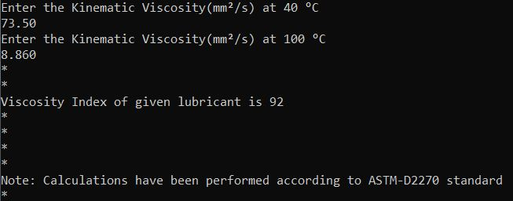

**Results and Discussion**

The program calculates viscosity index of all lubricants having kinematic viscosity greater or equal to 2 mm2/s. Program in most cases gives accurate result.We report the viscosity index to the nearest whole number, using the Rounding Method of E29 [2]. When the number is exactly halfway between the nearest two whole numbers, round to the nearest even number. For example, 108.5 shall be reported as 108.

**References**

1. <http://ppapco.ir/wp-content/uploads/2019/07/ASTM-D2270-2016.pdf>
2. https://www.astm.org/Standards/E29.htm