

NatNet
API User’s Guide
Version 2.6.0
April, 2014


NaturalPoint, Inc.
P.O. Box 2317
Corvallis OR 97339

Copyright © 2004-2014 NaturalPoint, Inc. All rights reserved.
NaturalPoint Publication Number: P-OT-054
Printed in the US.
NaturalPoint Proprietary
All data and information contained in or disclosed by this document is confidential and proprietary information of NaturalPoint, Inc. and all rights therein are expressly reserved. By accepting this material the recipient agrees that this material and the information contained therein is held in confidence and in trust and will not be used, copied, reproduced in whole or in part, nor its contents revealed in any manner to others without the express written permission of NaturalPoint, Inc. Information in this document is preliminary and subject to change and does not represent a commitment on the part of NaturalPoint, Inc.

Table Of Contents
NatNet Overview 4
SDK Contents 5
Folder Contents 5
Running the Samples 6
Running the Simple Client-Server Sample 6
Running the rigid body sample (SampleClient3D) 6
Running the .NET sample 8
Using the NatNet SDK 9
Building a Native Client to Receive NatNet Data 10
Building a Native Server to Send NatNet Data 10
Building a Managed .NET Client to Receive NatNet Data 10
API Reference 11
NatNet Data Types 11
NatNetClient Class 12
Description 12
Constructor & Destructor Documentation 16
Member Function Documentation 17
Appendix A : Bitstream Syntax 21
Building a Direct Depacketization Client (Without NatNet) 21
Technical Support 22

NatNet Overview
The NatNet SDK is a Client/Server networking SDK for sending and receiving NaturalPoint data across networks. NatNet uses the UDP protocol in conjunction with either Point-To-Point Unicast or IP Multicasting for sending data.
The following diagram outlines the major component communication of a typical NetNet setup.

Figure 1 – NatNet Component Overview
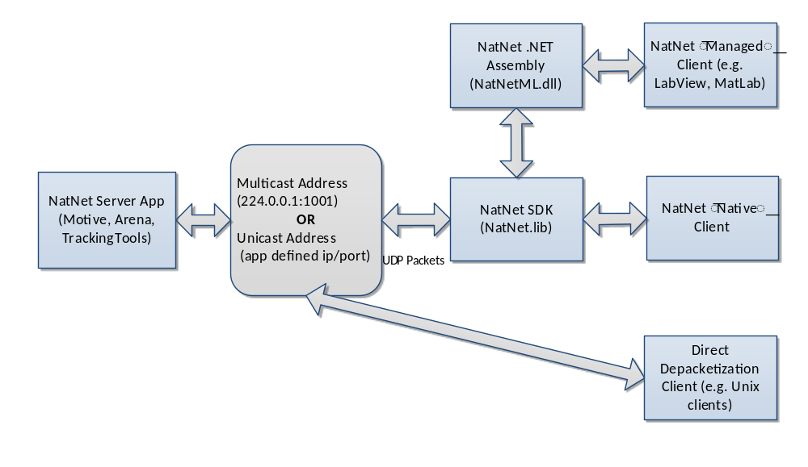
A NatNet Server has 2 threads and 2 sockets, one for sending data, and one for receiving/sending commands. A NatNet Client has 2 threads and 2 sockets, one for receiving data, and one for receiving/sending commands.
NatNet servers and clients can exist on the same or separate machines. Additionally, multiple NatNet clients can connect to a single NatNet server. When a NatNet server is configured to use IP Multicast, the data is only sent once, to the Multicast group.

SDK Contents
The NatNet SDK consists of:
NatNet Library Native C++ networking library (headers, static library (.lib) and dynamic import library (.lib/.dll))
NatNet Assembly Managed .NET assembly (NatNetML.dll) for use in .Net compatible clients.
NatNet Samples Sample projects and executables designed to be quickly integrated into your own code.

Folder Contents
Figure 2 - NatNet SDK Folder contents
Folder | Contents
\include | NatNet SDK header files. Client applications should include these.
\lib | Static and dynamic library files for the NatNet SDK.
\lib\x64 | 64-bit versions of the library files.
\Samples | VisualStudio 2005 samples. Use the solution file here to open all sample projects.
\Samples\bin | Precompiled samples with sample data files.
\Samples\SampleClient | Sample NatNet console app that connects to a NatNet server, receives a data stream, and writes that data stream to an ascii file
\Samples\SampleClient3D | Sample NatNet console app that connects to a NatNet server, receives a data stream, and displays that data in an OpenGL 3D window.
\Samples\SimpleServer | Sample NatNet console app that creates and starts a NatNet server, creates simple Marker, RigidBody, and Skeleton data, and streams that data onto the network.
\Samples\PacketClient | Simple example showing how to connect to a NatNet multicast stream and decode NatNet packets directly without using the NatNet SDK.
\Samples\WinFormsSample | Simple C# .NET sample showing how to use the NatNet managed assembly (NatNETML.dll).
\Samples\Matlab | Sample MATLAB code file (.m) for using MATLAB with the NatNet managed assembly (NatNETML.dll).
\Samples\NatCap | Sample Capture start/stop broadcast app.

Running the Samples
Pre-compiled versions of the NatNet samples have been provided in the \Samples\bin folder. These versions can be used to quickly test your application. Please refer to the instructions in this section for information on running specific samples.
Note! The Visual C++ runtime libraries are required to run the samples. If you encounter an error message when attempting to run the samples, especially on machines without Visual C++ installed, please install the VC runtime redistributable package located in Samples\VCRedist. If the problem persists, please try rebuilding the samples using Visual C++, or contact support.

Running the Simple Client-Server Sample
- Start the server:
SimpleServer.exe

- Start the client:
SampleClient.exe [IPAddress] [OutputFilename.txt]

- Start streaming by pressing 's' in the SimpleServer console window.

You should begin to see data streaming in the client window or to text file.

Note
- [parameters] are optional.
- If no IP address is specified, the client will assume the server is on the same machine (local machine).

Running the rigid body sample (SampleClient3D)
With Client/Server on same machine:
- [Arena] Load a dataset with rigid body or skeleton definitions (pt2 and skl files)
- [Arena] Enable network streaming ( Other -> Stream Frames )
- [Arena] Enable streaming rigid body data (check Other-> Rigid Body Data)
- [Sample3D] File -> Connect
With Client/Server on separate machines:
- [Arena] Load a dataset with rigid body or skeleton definitions (pt2 and skl files)
- [Arena] Set IP address to stream from ( Other -> IP address edit box )
- [Arena] Enable network streaming ( Other -> Stream Frames )
- [Arena] Enable streaming rigid body data (check Other-> Rigid Body Data)
- [Sample3D] Set Client and Server IP addresses
- [Sample3D] File -> Connect

Note
  - IP Address IP Address of client NIC card you wish to use.
  - Server IP Address IP Address of server entered in step 2 above.

Running the .NET sample
- Start a NatNet server application (e.g. Arena or TrackingTools).
- Enable NatNet streaming from the Server application.
- Start the WinForms sample application from the NatNet Samples folder.
- Update the “Local” and “Server” IP Addresses as necessary.
- Press the “Connect” button to connect to the server.
- Press the “GetDataDesc” button to request and display a detailed description of the Server’s currently streamed objects.
- Select a Row in the DataGrid to display that value in the graph.

Figure 3 – Receiving NatNet data in a .NET Environment
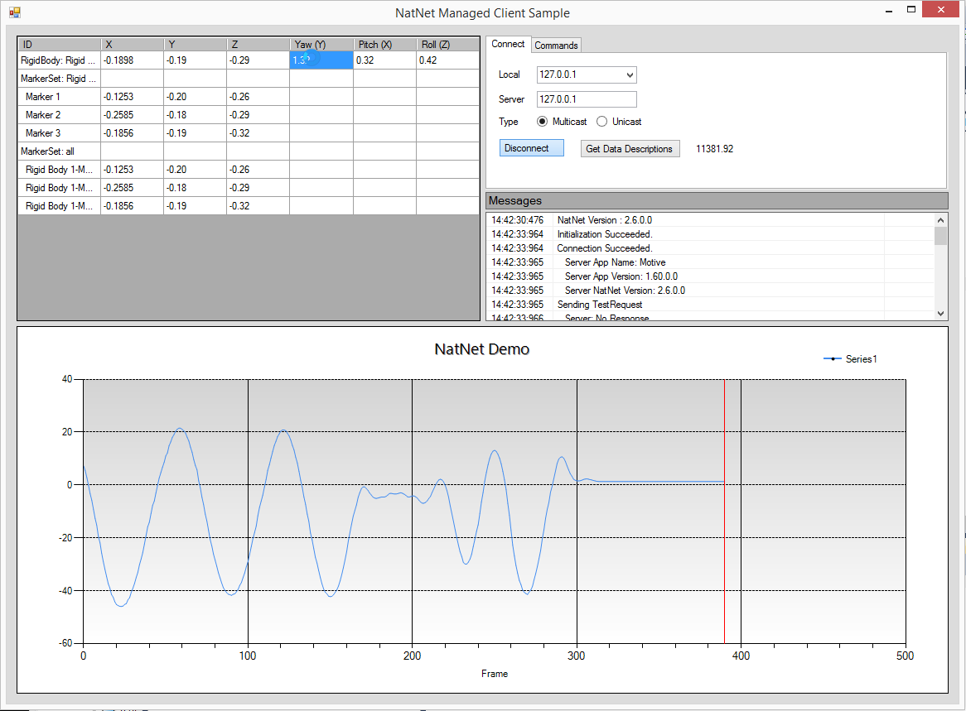

Running the Matlab sample
- Motive Start a NatNet server application (e.g. Motive).
- Motive Enable NatNet streaming from the Server application.
- Matlab Start Matlab
- Matlab Open the NatNetMatlabSample.m file.
- Matlab From the editor window, press Run
Real-Time Streaming Mocap data from Motive into Matlab
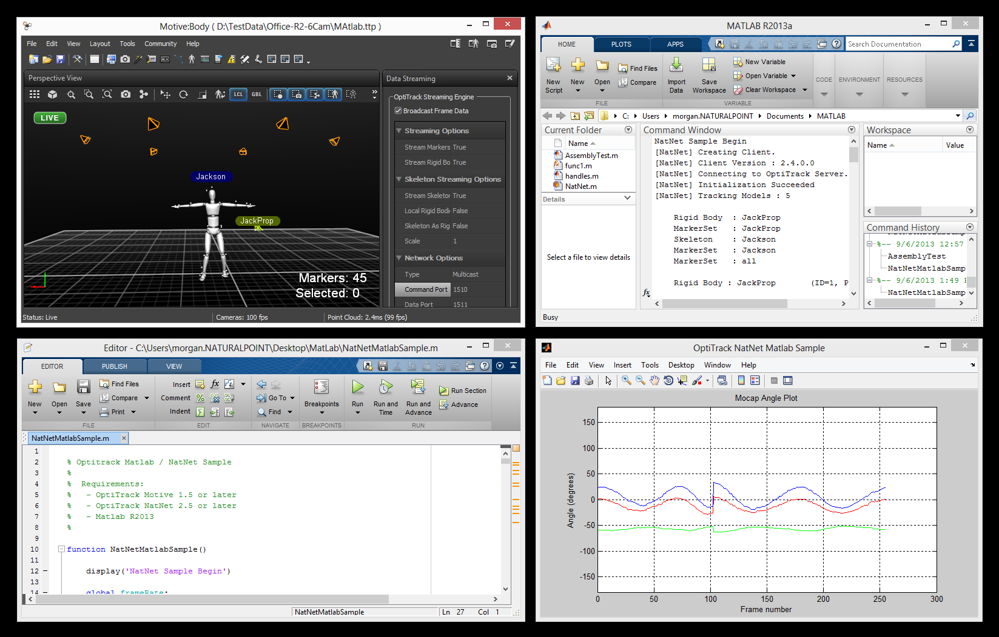

Using the NatNet SDK
The code samples are the quickest path towards getting NatNet data into your application. We typically recommend you:
- Identify your application’s development/interface requirements (managed, native, etc).
- Adapt the NatNet sample code from the corresponding NatNet sample application in the samples folder into your application.
- Use the API reference for additional information.
The Visual Studio solution file \Samples\NatNetSamples.sln will open and build all of the NatNet sample projects.
If you are creating an application from scratch, please refer to the following sections for application specific requirements.

Building a Native Client to Receive NatNet Data
Steps for building a NatNet client application/library to receive data from a NatNet server application such as Arena or TrackingTools:
- Adapt the SampleClient sample (SampleClient.cpp) to your application's code.
- Include NatNetClient.h, NatNetHelper.h, and NatNetTypes.h
- Link to NatNetLib.lib (dynamic) OR NatNetLibStatic.lib (static)
- [OPTIONAL] If linking dynamically, define NATNETLIB_IMPORTS and distribute NatNetLib.dll with your application

Note : Be sure to link to ws2_32.lib if linking to NatLetLib statically.

Building a Native Server to Send NatNet Data
Steps for building a NatNet server application/library to send/forward NatNet formatted data to a NatNet client application:
- Adapt SimpleServer (SampleServer.cpp) to your application's code.
- Include NatNetServer.h, NatNetHelper.h, and NatNetTypes.h
- Link to NatNetLib.lib (dynamic) OR NatNetLibStatic.lib (static)
- [OPTIONAL] if linking dynamically, define NATNETLIB_IMPORTS and distribute NatNetLib.dll with your application
Note : Be sure to link to ws2_32.lib if linking to NatLetLib statically.

Building a Managed .NET Client to Receive NatNet Data
Steps for building a managed NatNet client application.
- Add the NatNetML.dll .NET assembly as a reference to your VB.NET/C# project.
- The NatNetML namespace is now available to your code, in addition to intellisense library comments.

Note : When distributing your .NET application, be sure to distribute the NatNetML.dll as well.

API Reference
The NatNET API consist of the following objects:
NatNetClient The class for communicating with a NatNet Server such as Arena or Tracking Tools.

NatNetServer The class for implementing a NatNet server and sending NatNet formatted data packets.

NatNet Data Types Structures encapsulating data encoded in NatNet packets.

NatNet Assembly A managed (.NET) class library that can be called by .NET components. The NatNet assembly wraps the underlying native NatNet library, exposing the NatNetClient and NatNet Data Types for use in .NET compatible environments (e.g. VB.NET, C#, LabView, MatLab).

NatNet Data Types
NatNet server applications stream the following types of motion capture data.
Figure 4 – NatNet Data Types
Data Type | Description
MarkerSet Data | A named collection of identified markers and the marker positions (X,Y,Z)
RigidBody Data | A named segment with a unique ID, position, and orientation data, and the collection of identified markers used to define it.
Skeleton Data | A named, hierarchical collection of RigidBodies.
NatNet clients can discover what data objects a server application is currently streaming out of band or ahead of time using the DataSetDescriptions structure. NatNet clients receive actual data from a server using the FrameOfMocapData structure. Both of these packets are delivered to the client via the DataHandler callback.
Dataset Descriptions This packet contains a description of the motion capture data sets (MarkerSets, Skeletons, RigidBody) for which a frame of motion capture data will be generated.

Frame of Mocap Data This packet contains a single frame of motion capture data for all the data sets described in the Dataset Descriptions.
In addition to the formal data sets described above, FrameOfMocapData also contains additional per-frame tracking data. This additional data is not described in the DataSetDescriptions structure as it is typically not known ahead of time or out of band, but on a frame by frame basis:
Labeled Markers (TrackingTools) Labeled Markers not associated with a pre-defined MarkerSet or RigidBody. This data type is used when MarkerSets and/or RigidBodies are not explicitly defined in the Tracking Application but labeled markers are still generated.
Other Markers (Arena/TrackingTools) All 3D points that were triangulated but not labeled for the given frame.
It is possible for data to be duplicated between structures. For example, a given FrameOfMocapData may contain the same marker in LabeledMarkers as well as within the RigidBody data structure. In those cases, marker id can be used in the client code to correlate if necessary.
The SampleClient sample illustrates how to retrieve data descriptions and data and interpret this data.
Please refer to the NatNetTypes.h header file or the NatNetML.dll assembly for the most up to date descriptions of the types.

Coordinate System Conventions
In the NatNet data stream, orientation data is represented as a quaternion. Quaternion orientations are order independent, however they do indicated a handedness. When decomposing quaternions into euler angles, it is important to consider the coordinate system conventions you want to convert into. An euler angle convention must account for:
- Rotation order
- Left handed or Right handed
- Static (Global) or Relative (Local) Axes
As an example, the Optitrack Motive software uses the following "Motive" coordinate system convention:
X (Pitch), Y (Yaw), Z (Roll), Right-Handed (RHS), Relative Axes (aka 'local')

The NatNet SDK includes quaternion to euler conversion routines. Please refer to the WinForms sample or the SampleClient3D for specific implementation details and usage examples.

Remote Command and Control
NatNet provides a command / request mechanism for passing commands and request between NatNet server’s (Motive) and NatNet Client’s (your application). Examples of commands / requests are starting/stopping record, setting the current take name, or querying the server for the current framerate.
Motive Supported Command/Request
Command | Description | Parameters | Returns
UnitsToMillimeters | Request current system’s units, in terms of millimeters | none | float
FrameRate | Request current system’s tracking framerate | none | float
StartRecording | Start recording | none | none
StopRecording | Stop recording | none | none
LiveMode | Switch to Live mode | none | none
EditMode | Switch to Edit mode | none | none
TimelinePlay | Start take playback | none | none
TimelineStop | Stop take playback | none | none
TakeName | Set the current take name | Take name | none
Refer to the SendMessage(…) and SendMessageAndWait(…) functions in the API reference for more details.

Timecode
On supported systems, all frames of NatNet data will contain an OptiTrack timecode stamp, which is an extended form of the typical studio SMPTE timecode stamp.
Note: SMPTE Timecode support requires an OptiTrack eSync hub.
Because motion capture frame rates typically exceed standard SMPTE timecode frame rates, an additional “subframe” value is added to the end of the timecode stamp. This “subframe” value is the 0-based, n^{th} “in-between” frame:
Typical OptiTrack Timecode Representation
( 120 fps mocap data, 30-fps no-drop SMPTE timecode source )
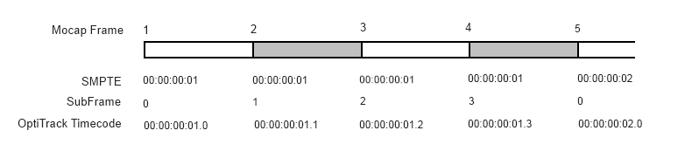
In the above representation, for a typical 120 fps motion capture session synched to a 30 fps no-drop SMPTE timecode studio-sync source, there is a 4 : 1 ratio of motion capture frames to studio frames. The extra motion capture frames are represented by the OptiTrack SubFrame field in the OptiTrack timecode.
The generic form for OptiTrack timecode is:
HH:MM:SS:FF.Y | hours:minutes:seconds:frames.subframe
OptiTrack timecode is sent to NatNet clients in the form of 2 unsigned integers.
unsigned int Timecode | OptiTrack encoded SMPTE timecode
unsigned int TimecodeSubframe | OptiTrack encoded sub-frame data

Note : The FrameOfMocapData structure contains two entries for timecode information for a given frame of timecode data.
The Timecode parameter is interpreted differently when streaming Live or from File Playback (Edit).
In Live mode, the Timecode parameter is only valid when SMPTE timecode is present in your Mocap hardware setup, typically when using the eSync and a timecode generator. When present, the Timecode parameter will be a correctly formatted SMPTE timecode value.
In Edit Mode, the Timecode parameter is the current frame number converted to SMPTE Timecode format.

The NatNet SDK provides helper routines to decode the Timecode parameter into a string friendly format as well as the subframe of mocap data that may exist between whole timecode frames.

Latency is the capture computer's hardware timestamp for the given frame, which is also displayed in Motive in the Camera Preview viewport when camera info is enabled. This is the same whether live or playback from file.
Timecode values should not be used directly, but decoded using the NatNet timecode utility functions:
bool DecodeTimecode(unsigned int inTimecode, unsigned int inTimecodeSubframe, int* hour, int* minute, int* second, int* frame, int* subframe); | Helper function to decode IOptiTrack timecode data into individual timecode values
bool TimecodeStringify(unsigned int inTimecode, unsigned int inTimecodeSubframe, char *Buffer, int BufferSize); | Helper function to decode OptiTrack timecode into a user friendly string in the form “hh:mm:ss:ff:yy”
The following is an example of how to decode timecode using the NatNet helper functions (from the SampleClient.cpp example):
// decode timecode to values
int hour, minute, second, frame, subframe;
bool bValid = pClient->DecodeTimecode(data->Timecode, data->TimecodeSubframe, &hour, &minute,
&second, &frame, &subframe);

// decode timecode to friendly string
char szTimecode[128] = "";
pClient->TimecodeStringify(data->Timecode, data->TimecodeSubframe, szTimecode, 128);
printf("Timecode : %s\n", szTimecode);

NatNetClient Class

Description
NatNetClient is a complete C++ class for connecting to NatNet server applications, such as NaturalPoint Arena and NaturalPoint TrackingTools.

Constructor & Destructor Documentation

NatNetClient::NatNetClient ()
Creates a new (multicast) instance of a NatNet Client.

NatNetClient::NatNetClient (int iConnectionType)
Creates a new instance of a NatNet Client using the specified connection protocol.

Parameters:
iConnectionType Type of connection (0 = Multicast, 1 = Unicast).

NatNetClient::~NatNetClient ()
Destructor.

NatNetClient::Uninitialize()
Disconnects from server.

Member Function Documentation

int NatNetClient::GetDataDescriptions (sDataDescriptions ** pDataDescriptions)
Requests a description of the current streamed data objects from the server app. This call blocks until request is responded to or times out.

Parameters:
pDataDescriptions Array of Data Descriptions.

Returns:
On success, number of data objects. 0 otherwise.

sFrameOfMocapData * NatNetClient::GetLastFrameOfData ()
Retrieves the most recently received frame of mocap data.

Returns:
Frame of Mocap Data

int NatNetClient::GetServerDescription (sServerDescription * pServerDescription)
Requests a description of the current NatNet server the client is connected to. This call blocks until request is responded to or times out.

Parameters:
pServerDescription Description of the NatNet server.

Returns:
On success, number of data objects. 0 otherwise.

int NatNetClient::Initialize (char * szLocalAddress, char * szServerAddress)
int NatNetClient::Initialize (char * szLocalAddress, char * szServerAddress, int HostCommandPort)
int NatNetClient::Initialize (char * szLocalAddress, char * szServerAddress, int HostCommandPort, int HostDataPort)
Initializes client socket and attempts to connect to a NatNet server at the specified address.

Parameters:
szLocalAddress IP address of client
szServerAddress IP address of server
HostCommandPort server command port (default = 1510)
HostDataPort server data port (default = 1511)

Returns:
0 if successful, error code otherwise

void NatNetClient::SetMulticastAddress (char * szMulticast)
Sets the NatNet server multicast group/address to connect to. SetMulticastAddress() must be called before calling Initialize(...).

Parameters:
szCommand application defined Message string

void NatNetClient::NatNetVersion (unsigned char Version[4])
Retrieves the version of the NatNet library the client is using.

Parameters:
Version version array (form: major.minor.build.revision)

void NatNetClient::SendMessage (char * szCommand)
Sends a message to the server and returns. Response will be delivered in-band.

Parameters:
szCommand application defined Message string

int NatNetClient::SendMessageAndWait (char * szCommand, int tries, int timeout, void ** Response, int * pnBytes)
Sends an application-defined message to the NatNet server and waits for a response.

Parameters:
szCommand Application defined message.
tries Number of times to try and send the message
timeout time to wait for response (in milliseconds) before timing out
Response Application defined response.
pnBytes Number of bytes in response

Returns:
0 if succssful, error code otherwise.

int NatNetClient::SendMessageAndWait (char * szCommand, void ** Response, int * pnBytes)
Sends an application-defined message to the NatNet server and waits for a response.

Parameters:
szCommand Application defined message.
Response Application defined response.
pnBytes Number of bytes in response.

Returns:
0 if successful, error code otherwise.

int NatNetClient:: SetDataCallback(void (*CallbackFunction)(sFrameOfMocapData *FrameOfData, void* pUserData), void* pUserData /*=NULL*/)
Sets the data callback function for NatNet frame delivery. This function will be called whenever NatNet receives an in-band data (e.g. frame of data).

Parameters:
CallbackFunction Callback Function
pUserData User-Definable data

Returns:
0 if successful, error code otherwise.

void NatNetClient::SetVerbosityLevel (int iLevel)
Sets the message reporting level for internal NatNet messages.

Parameters:
iLevel Verbosity level (see Verbosity level in NatNetTypes.h)

int NatNetClient::Uninitialize ()
Disconnects from the current NatNet Server.

Returns:
0 if successful, error code otherwise.

Appendix A : Bitstream Syntax
In order to provide the most current bitstream syntax, the NatNet SDK includes a testable working depacketization sample that decodes NatNet Packets directly without using the NatNet client library.
Note: Decoding packets directly is not recommended. The bitstream packet syntax is subject to change, requiring an application to rebuild against the latest NatNet library. NatNet packets should only be decoded directly where use of the NatNet library is not possible.
Using the NatNet client library protects client applications from future bistream syntax changes.

Building a Direct Depacketization Client (Without NatNet)
For situtions where you would like to receive a NatNet data stream but it is not possible to use the NatNet client library (e.g. on an unsupported platform such as Unix), you can use the PacketClient sample as a template for depacketizing NatNet packets directly.
- Adapt the PacketClient sample (PacketClient.cpp) to your application's code.
- Regularly update your code with each revision to the NatNet bitstream syntax.

Technical Support
NaturalPoint is committed to providing best-in-class technical support.
In order to provide you with the most up to date information as quickly as possible, we recommend the following procedure:
- Update to the latest software. For the latest versions of OptiTrack software, drivers, and SDK samples, please visit our downloads section:
http://www.naturalpoint.com/optitrack/support/downloads.html
- Check out the OptiTrack FAQs:
http://www.naturalpoint.com/optitrack/support/opti-faq.html
- Check the forums. Very often a similar issue has been reported and solved in the forums:
http://forum.naturalpoint.com/
- Contact technical support:
Phone: 541-753-6645
Fax: 541-753-6689
Email Form: http://www.naturalpoint.com/optitrack/support/contact/
Mail: NaturalPoint, Inc.
P.O. Box 2317
Corvallis, OR 97339

