Building a Better Post-Trade Platform
Discussion notes for a 10-minute presentation and demonstration
Jeremy Miller
Financial technology, post-trade architecture and embedded AI
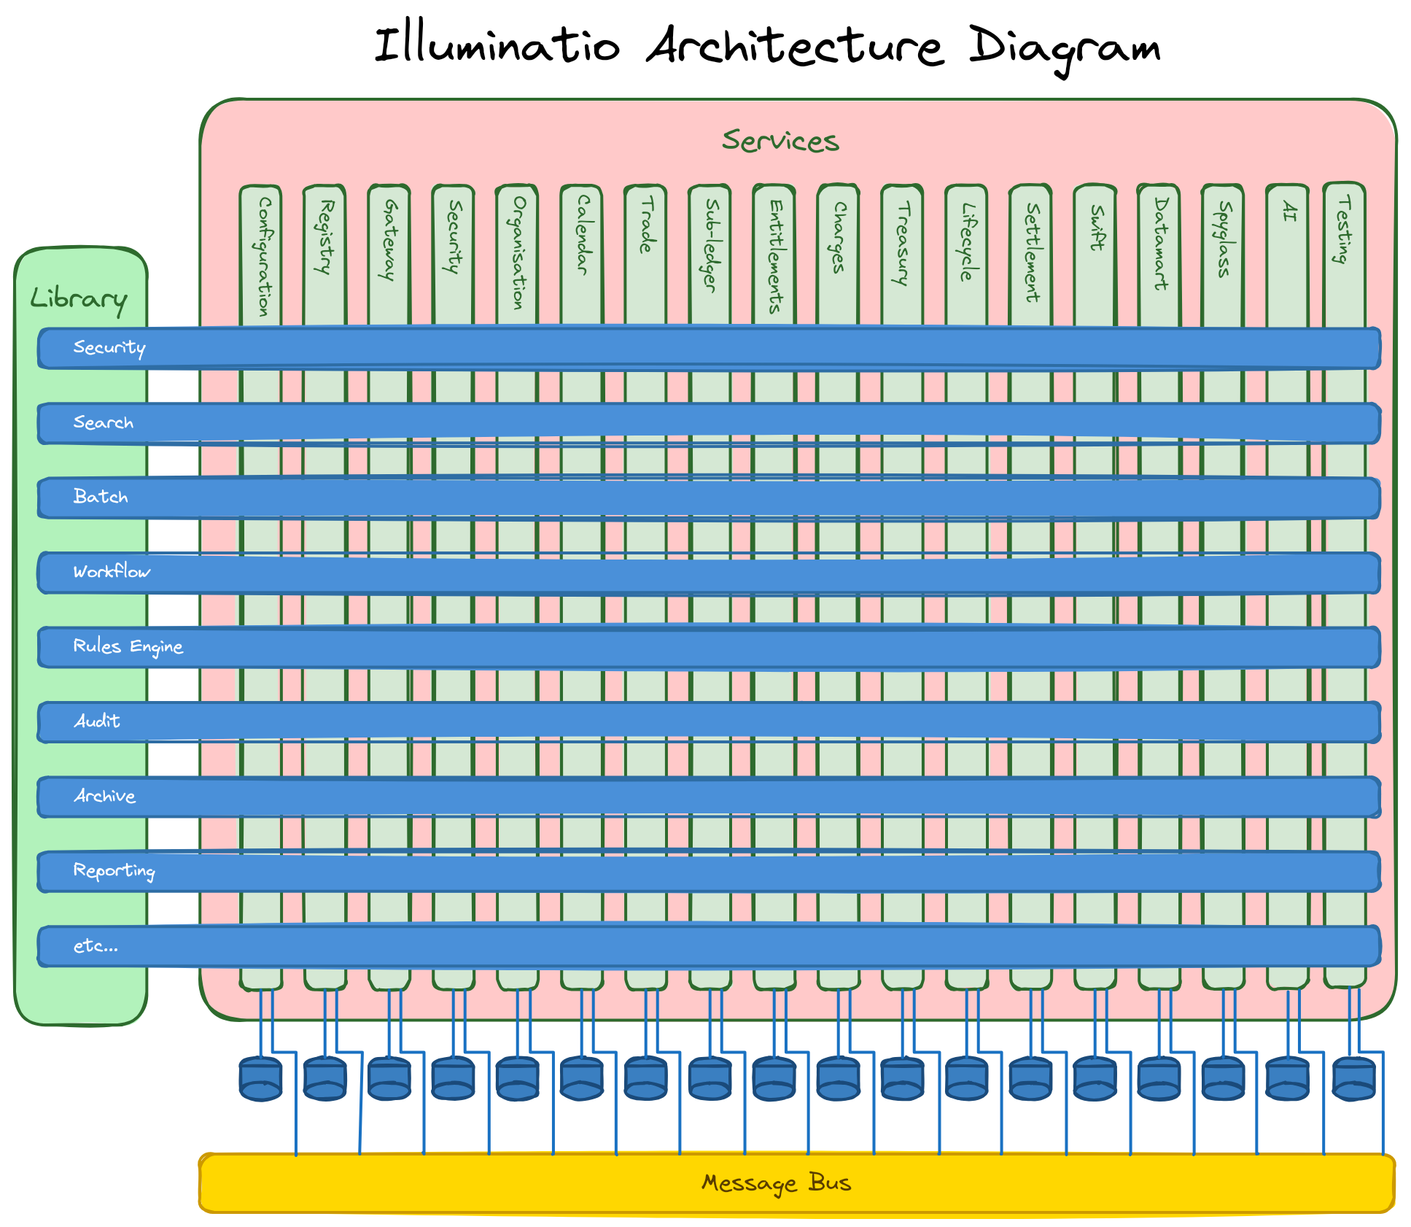
Core message
After 30 years of seeing the same expensive and fragmented systems, I decided to prove that a coherent post-trade platform could respond faster without weakening control. AI changed the economics of the experiment. Consistent architecture made it sustainable.

Run of show
The discussion takes about six minutes. The demonstration takes about four minutes.
Slide | Subject | Time
1 | Opening | 0:20
2 | The epiphany | 0:55
3 | No silver bullet | 0:55
4 | Design choices | 1:20
5 | Common foundation | 1:15
6 | No blockers | 1:05
7 | AI inside the application | 1:05
8 | Demonstration | 4:00

Delivery guidance
- Treat the slide text as prompts. Speak to the audience rather than reading the screen.
- Keep the architecture discussion at business level unless the audience asks for implementation detail.
- Protect the four-minute demonstration. If the discussion runs long, shorten Slide 4 before cutting the demo.
- Use 'shock and awe' as an internal ambition. Tell clients that they should see meaningful progress sooner than expected.

Speaker notes

Slide 1 Opening
Timing 20 seconds
Purpose Establish credibility and promise a short path to the demonstration.
My name is Jeremy. I have spent around 30 years in financial technology, working across sales, support, business analysis, development and architecture. This is the story of why I built Illuminatio, the design choices behind it, and what those choices make possible.
Transition The story starts with a frustration that became an epiphany.

Slide 2 The epiphany
Timing 55 seconds
Purpose Connect personal experience to a recognisable industry problem.
Across middle- and back-office systems I kept seeing the same pattern. Simple changes became expensive. Similar processes worked differently in each module. Identifiers changed at every boundary. Support needed several teams to follow one problem. Bespoke customer changes made the next upgrade harder. The epiphany was simple: I can do better than this. The question was whether an experienced analyst-developer, using modern tools including AI, could build a coherent enterprise post-trade platform without repeating those compromises.
Transition AI made the experiment practical, but it did not remove the hard part.
If discussion opens
- Mention experience in treasury and risk software if the audience does not already know your background.
- Avoid naming or criticising individual vendors. Describe repeated structural problems.

Slide 3 No silver bullet
Timing 55 seconds
Purpose Set a credible boundary around the AI claim.
Fred Brooks' argument still holds. AI does not remove the essential complexity of finance. It reduces a large amount of accidental complexity around implementation, tests, documentation and repeated patterns. The graph also captures the iterative development process. When a foundation proved wrong, I stopped, refactored it, and then continued. That stop-the-line discipline prevented a weak pattern from spreading across the estate. The result still depends on domain judgement, architecture, testing and taste. AI amplifies the environment it receives.
Transition I therefore designed the environment to make the correct path easy.
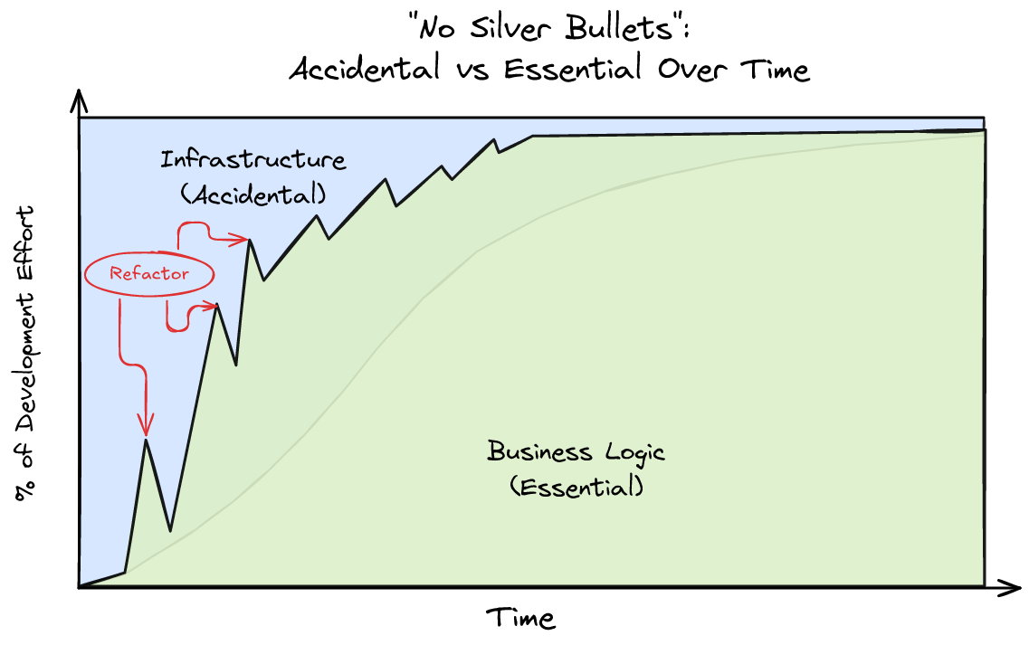

Slide 4 Design choices that remove friction
Timing 80 seconds
Purpose Explain the design without turning the talk into an architecture lecture.
Six choices matter most. Every addressable object has one canonical typed identity, with external provenance retained explicitly. Infrastructure calls concrete application use cases, which protect the domain. Command and query responsibilities separate without forcing the heaviest deployment model everywhere. Events carry accepted facts while workflow and rules provide recoverable business processing and maker-checker (four-eyes) approval. BDD scenarios, deterministic data and controlled business time make the specification executable. Familiar technology reduces invention and gives both developers and AI a deep body of knowledge.
Transition These decisions become more valuable when every service shares them.
If discussion opens
- Canonical identity means the same value in the database, API, message, workflow, report and screen.
- CQRS describes responsibility and structure. Separate infrastructure remains optional until volume justifies it.
- Maker-checker means one user proposes an authority-bearing action and another authorised user decides it.

Slide 5 One foundation beneath every service
Timing 75 seconds
Purpose Explain why breadth does not have to create inconsistency.
The vertical services own their business data and vocabulary. The horizontal capabilities provide security, search, batch, workflow, rules, audit, archive, reporting and other shared functions. Each service owns its database and communicates through explicit APIs and the message bus. A trade or settlement module should contain trade or settlement knowledge. It should not invent another workflow engine, security convention or reporting framework. When a shared foundation is missing, I fix the foundation first. This consistency reduces cognitive load for developers, support teams, users and AI.
Transition It also removes practical blockers from the complete delivery cycle.

Slide 6 No blockers from laptop to cluster
Timing 65 seconds
Purpose Connect architecture to sales, support, development and client responsiveness.
No blockers is a design requirement. Sales can demonstrate a client need without waiting for a large environment. Support can reproduce a problem and follow the same identifiers, events and workflow locally. Development can change and test the system without competing for a shared environment. Deterministic data and repeatable scenarios allow useful demonstrations on a laptop. The same architecture can then move into containers and distributed services when volume or resilience requires it. Design, investigation, testing, support and deployment should all be easy. If a common activity repeatedly requires specialist knowledge, the platform still needs work.
Transition Those same boundaries also create a safe environment for embedded AI.
If discussion opens
- The laptop claim describes a useful development and demonstration environment, not a production capacity claim.
- The external promise is meaningful progress sooner than expected. 'Shock and awe' remains the internal ambition.

Slide 7 AI inside the application
Timing 65 seconds
Purpose Explain the division between model judgement and deterministic control.
The AI does not receive arbitrary SQL or unrestricted system access. It receives a bounded language of query capabilities, datasets, rules, workflow, navigation and presentation choices. The model decides which evidence it needs. Deterministic code validates the plan, executes bounded queries, evaluates approved rules and persists the evidence with provenance. Security follows the requesting user. The current boundary matters. The AI investigates, explains and recommends. It can route a recommendation for human approval, but approval does not yet let the model execute an unrestricted business remediation.
Transition Rather than describe that process further, I will show it.
If discussion opens
- Large calculations stay in SQL or deterministic dataset operations rather than in the model.
- The application stores the evidence chain and decision record, not private model reasoning.

Slide 8 Demonstration
Timing Four minutes
Purpose Prove product breadth, architectural consistency and AI control through one story.
Start with one operational break. Follow its business references across the relevant records. Launch the investigation as the current user. Show the structured plan and bounded evidence queries. Show the deterministic comparison and resulting artifact. Navigate back to the exact evidence. Show the recommendation and maker-checker work item. Finish with the audit trail, including what the system intended, what it queried, what it found and who made the final decision.
Transition The epiphany was that I could do better than the systems that had frustrated me for years. The operating principle became simple: remove unnecessary blockers, respond quickly, and retain control.

Demonstration recovery plan
- Keep a completed investigation available in a second browser tab in case a live model call or service response is slow.
- Use deterministic demonstration data so every identifier, break and expected result remains stable.
- If time runs short, skip the detailed query plan and move directly from the break to the evidence artifact and approval record.
- If the environment fails, use the architecture and AI-control diagrams to complete the explanation without making an unsupported live claim.

Likely questions and answers
Did AI build the platform?
AI accelerated implementation, tests, documentation, refactoring and pattern completion. Domain modelling, architectural decisions, review and acceptance remained human responsibilities.
Why Java and Spring?
They are familiar in financial institutions, strongly typed, widely documented and supported by mature libraries. The compiler, tests and framework conventions also reduce ambiguity for AI-assisted development.
Why microservices?
Services provide clear ownership around business data and deployment boundaries. The design does not require every installation to run at maximum distribution. Useful configurations can run on a laptop, while larger deployments separate and scale services where justified.
What does no blockers mean in practice?
A sales demonstration, support reproduction or development feedback loop should not depend on a scarce shared environment. Deterministic scenarios run locally, and the same architectural contracts continue into distributed deployment.
Does the AI change production data?
The current AI investigates, explains and recommends. It can create an approval item for a recommendation, but it does not autonomously execute the proposed business remediation.
How does maker-checker approval work?
One user proposes an authority-bearing action. A separately authorised user approves or rejects it. The system retains the proposal, identities, decision, time and notes in the workflow and audit record.
How do you prevent AI hallucination?
The model receives bounded capabilities and structured metadata rather than arbitrary access. Deterministic code validates requested operations and performs calculations. Reports retain evidence, lineage, rejected candidates and limitations.
What makes this extensible without creating another bespoke platform?
Business modules reuse shared security, workflow, rules, messaging, reporting, testing and presentation conventions. New requirements become configuration, an extension or a bounded module rather than a permanent fork of the core.
What does quick turnaround mean without cutting controls?
Security, testing, workflow, approval and audit already exist as platform capabilities. Teams can move quickly because they reuse those controls rather than rebuilding or bypassing them for each change.

Phrases to retain
- I can do better than this.
- Make the correct path the easiest path.
- No unnecessary blockers. From laptop to distributed deployment.
- The model chooses the evidence path. Deterministic code performs the work.
- Meaningful progress sooner than the client expects.

