ENPM673 – Project 1

This report serves as a comprehensive explanation of the code usage and techniques employed to fulfill ENPM673 Project 1 requirements including the challenge task.

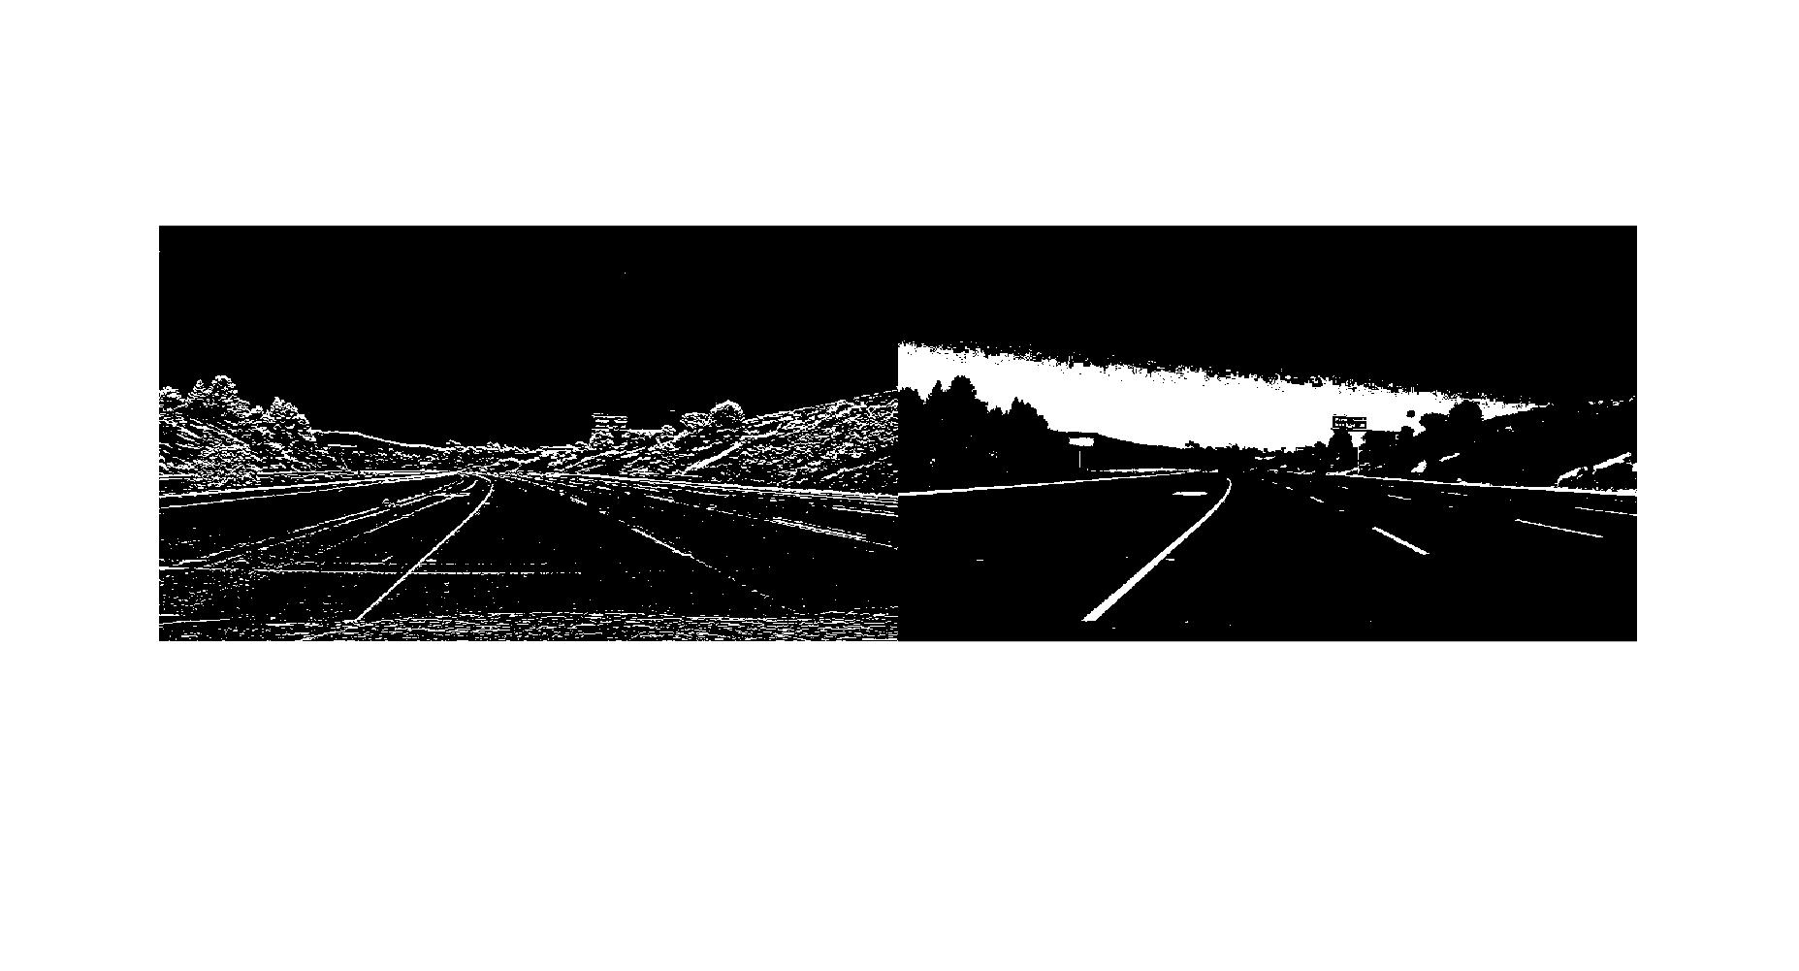
Image Conditioning
Three different masks were applied to achieve a suitable image to further process, namely sobel edge mask, red and white color regions, and area mask.

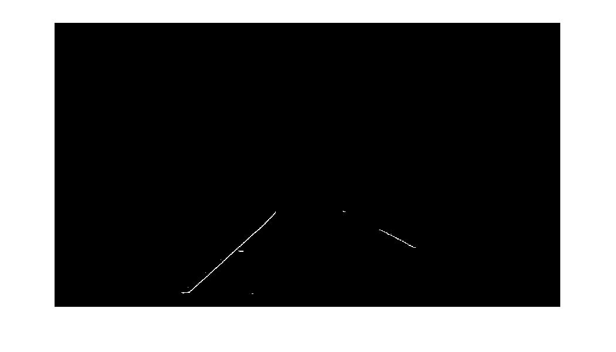


Hough Lines
Utilizing the Matlab’s built in function hough lines were extracted from the conditioned image. Although, the peaks the were not collected using the built in function rather a custom search algorithm was written to have direct control over the ‘Theta’ range as well as the ‘Rho’ range.
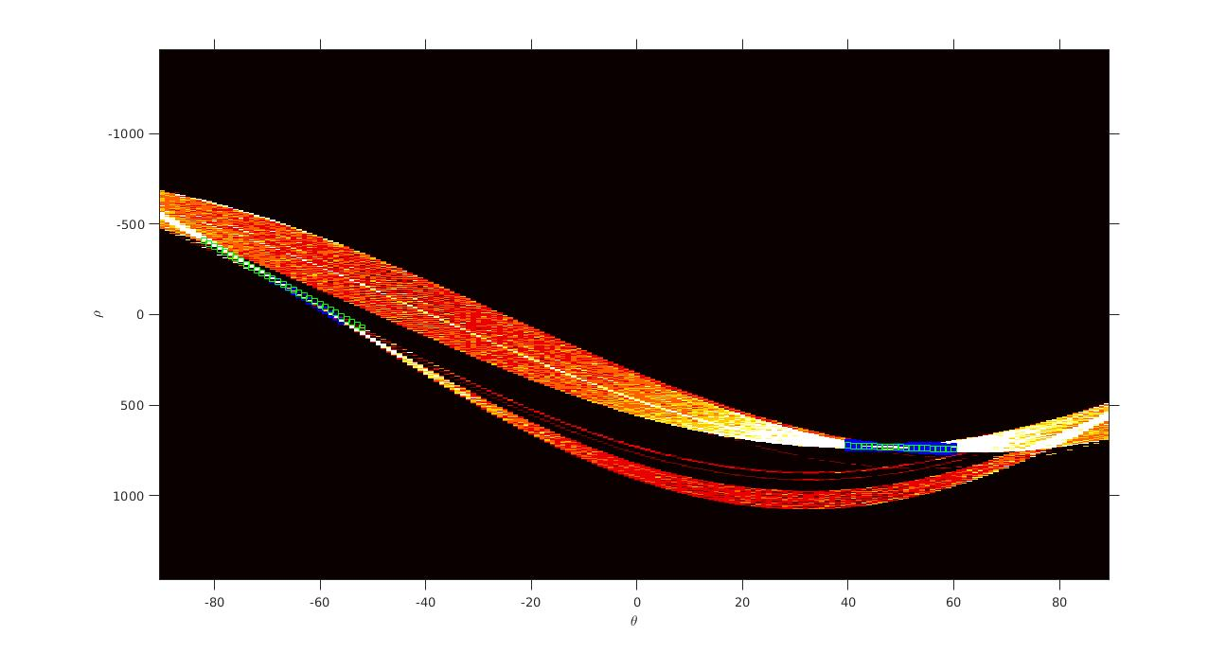

Lane extrapolation and Damping
Once the hough lines, we are interested in, are retrieved, they are extrapolated using equation of line. For each lane the gradient and position of the end points are damped over a few frames to smooth transition of the curvature of the lanes.
The smoothing factor applied is 0.75*old_position + 0.25*new_position and gradient*0.20.

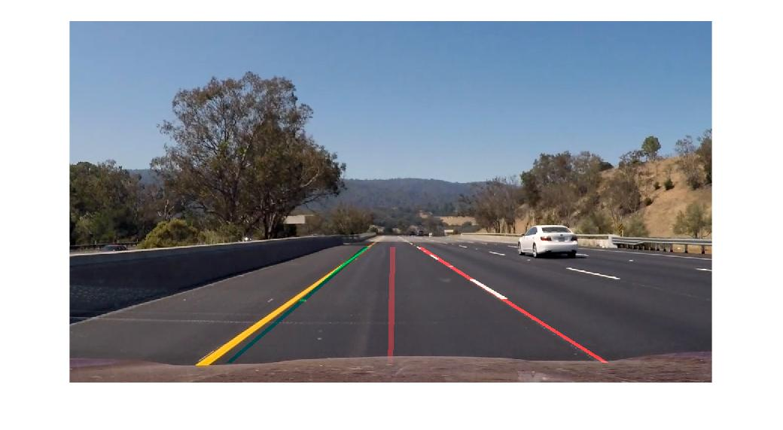

Instructions to run the Code

% Display Images and Graphs
display_info = true;

% Iterate Once for dev
iter_once = true;

% Just View as Image Video
just_view = false;

These options have been set to facilitate easy development and debugging of the code with quick switching between displaying all the information, running for just one frame and continuous viewing of output without writing the video file. If the above parameters are set to false then the code writes the final video file.

Since the project_video has too many frames for a normal computer can handle, the program processes sections of the video and stores them intermediately in the local folder. After complete processing it then stitches all the saved video sections into one file by the name of Lane_completed.

To further understand the code, it is very intuitive to read the m file. Since it has been heavily commented to facilitate that purpose.

