# Background

## Lesser Prairie Chicken

The Lesser prairie chicken (*Tympanus pallidicinctus*) is a species of grouse native to regions of Colorado, Kansas, Oklahoma, Texas, and New Mexico. Throughout their range, LPC require a mixture of sagebrush, native grass prairie, and shrublands. The current distribution of the species is a significant reduction of its historical extent. The species is susceptible to habitat loss and fragmentation, occurring primarily as the result of conversion of agricultural land, and invasive species. Lesser prairie chicken was listed as a threatened species under the Endangered Species Act (ESA) on March 27, 2014[1]. Moreover, LPC habitat can be degraded by energy development, due to the species’ avoidance of tall structures – a behavior adapted to avoid aerial predators[2]. However, a court ruling on September 1st, 2015 overturned this decision, and the Lesser prairie chicken was removed from the endangered species list in April 2016. The purpose of this analysis was to quantify the extent of energy development and habitat loss occurring since delisting, using a combination of publicly available data and remote sensing.

## Remote Sensing

Remote sensing describes the use of satellite data to describe and measure land cover and land use. With the proliferation of available data, it is a technique rapidly being used in conservation to detect changes in habitats. Important features are the frequency with which new images become available – about every two weeks – and the amount of information. Beyond recording the visible spectrum, most satellites record values in the infrared and ultraviolet spectrums, providing greater ability to distinguish land cover types and features than a simple picture.

We used Google Earth Engine - a platform providing access to terrabytes of remote sensing imagery, and cloud computing capabilities to analyze them – to create an automated process to detect disturbances and habitat loss across the entire LPC range. The basic overview of the process is:

1. Acquire ‘before’ and ‘after’ satellite data
2. Calculate changes in reflectance values
3. Select pixels exceeding reflectance change thresholds

# Findings

## Wind Energy Development

Using our automated change detection analysis, we identified 5 wind farms with a total of 713 turbines constructed after September 1st, 2015 within LPC range. The LPC range wide plan uses a buffer of 667m around turbines to determine the area for which mitigation is needed. The construction of these 713 turbines equates to 129,739 acres of potential mitigation area. Furthermore, Lesser prairie chickens’ avoidance of tall structures extends as far as 1 mile, and this area surrounding wind turbines is considered disturbed, or degraded habitat[3]. Considering a 1 mile buffer, these turbines create 257,577 acres of habitat disturbance for LPC.

## Oil and Gas

All states within LPC range have oil and gas commissions, which record information about oil and gas extraction operations, including project start dates and well locations. Not all reported locations had any detectable new well pads. These discrepancies could be caused by , or in some cases, vague construction dates reported by the states. For instance, Kansas provides ‘Year Start’, leaving the actual date at which a new well appears ambiguous. New Mexico, on the other hand, reports a ‘Spud date,’ the date on which ground is broken when drilling a new well. We confirmed new wells at 92% of reported locations that we checked in New Mexico, and only 28% of those in Kansas.

Additionally, applying our change detection algorithm across LPC range identified 179 new well pads appearing in LPC habitat, that did not correspond to any coordinates provided by the states (> 500m from any reported location). This means that about twice as many new oil and gas wells were constructed, than would be able to be accounted for using public well data. The LPC range wide plan uses a buffer of 200 meters around oil and gas wells to determine the area for which mitigation is needed. These additional disturbances created 5,800 acres of potential mitigation area, after discounting the areas around wells constructed in already degraded habitat.

## Habitat Loss

In addition to the addition of disturbances, we wanted to estimate the overall loss of LPC habitat across the species’ range since delisting. The majority of this is from conversion of native grass prairie and shrubland to agriculture. Using a measure of vegetation intensity, we identified ### acres that had been converted from LPC habitat in the growing season (April – October) of 2015 to agricultural land in the growing season of 2016.

In total, we estimate a total of ### acres of LPC habitat was disturbed or lost since the species was delisted. In our selection of thresholds across all analyses, we applied a conservative approach, meaning our estimates likely represent the minimum number of disturbances and amount of habitat loss occurring during that time.

# Methods

We then visually inspected the most recent available Sentinel 2 imagery to identify and mark turbine locations.

To discriminate between natural landcover changes and human disturbances, we used a suite of shape metrics. These included measures of convexivity, circularity, elongation, compactness. Each metric was calculated for all disturbance polygons, in addition to disturbance area, and we manually classified a validation set of ### polygons. As with reflectance threshlds, we used LDA and ROC curves to identify threshold values. To be conservative, we selected a value. We visually confirmed each polygon meeting spectral and shape thresholds as being a likely well pad. Our choice of threshold value at each step was conservative, and likely eliminated true human disturbances. Thus, the results reported represent a lower bound for the minimum number of new pads.

We further restricted this set to changes occurring within areas identified as shrub/scrub, or grassland by the NLCD 2011 classifications, thus eliminating disturbances occurring within already degraded habitat (i.e. agriculture) from further consideration. The LPC rangewide plan requires a buffer distance of 200m around oil and gas wells to determine mitigation acreage. To estimate lost potential mitigation opportunities, we applied this buffer to the final set of identified well disturbances. We eliminated buffered areas within which disturbances were already present (Figure ##a), as these could have potentially already been mitigated, or would constitute degraded habitat, and thus be subject to discounted mitigation acreage. Estimated potential was calculated as the total acreage of all remaining buffered areas.

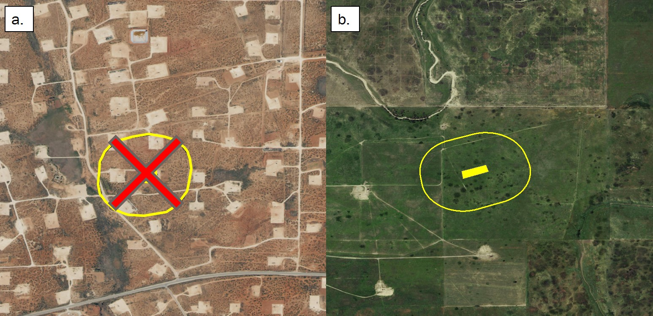

1. U.S. Fish and Wildlife Service, Determination of threatened status for the Lesser prairie chicken; Final Rule April 10, 2014
2.
3. Listing decision